
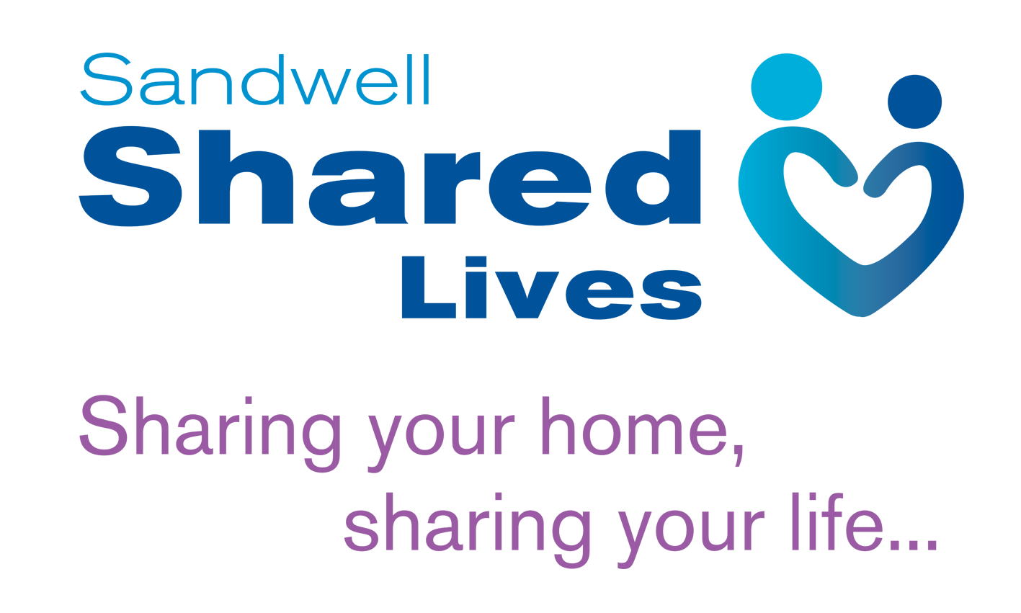

SL/AS/005
Private & Confidential IL2

Sandwell Shared Lives

Equal Opportunities Monitoring Form

Sandwell Shared Lives is committed to a policy of equality of opportunity in the assessment and approval of Shared Lives carers. Prospective carers will be judged on their merits, skills and knowledge.

In order to monitor our assessment and approval methods we would ask you to complete this form and return it with your application (in a separate envelope if you wish). This information will be separated on receipt and held in confidence and the approval panel will not see it. There is no obligation to complete this form and not doing so will have no effect upon your application.

Name:

Age: | Gender:

I would describe my marital status as:

Single  Separated 

Married  In a partnership 

I would describe my sexual orientation as:

Lesbian  Gay Man  Bisexual 

Heterosexual  Other 

White | British  Irish  Any other White Background  Please specify |  |  | Asian or Asian British |  |  | Indian  Sikh  Pakistani  Bangladeshi  Any other Asian background  Please specify
Mixed | White and Black Caribbean  White and Black African  White and Asian  Any other mixed background  Please specify |  |  | Black or Black British |  |  | Caribbean  African  Any other Black background  Please specify
Chinese, Yemeni or  other ethnic group |  | Chinese  Yemeni |  |  |  | Other  Please specify

I would describe myself as having a disability

Yes  No 

I would describe my disability as;

Please tell us of any requirements, aids or equipment which may assist you either during the assessment process or to enable you to carry out the role. Otherwise please state not applicable

