
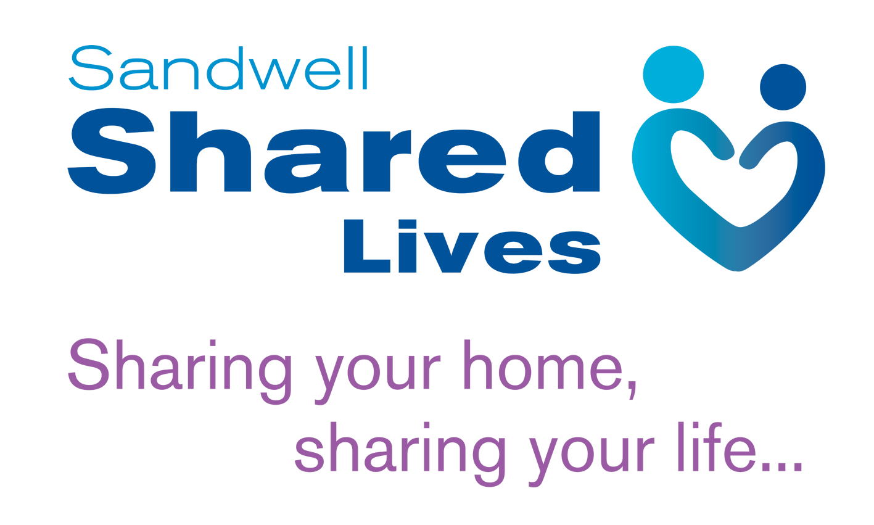
IL2
SL/AS/003

A DAY IN THE LIFE SHEET

Please outline below details of an average or typical day in the life of your household. Make this as informal or formal as you like. Let us know what happened in that day, people you saw, places you went, things you did and problems you solved.

This exercise is designed to give a picture to the Shared Lives worker and independent panel of the sort of people you are and how you live your life. This is important if you are to share your life and/or household with a disabled or vulnerable person as an Shared Lives Carer.

Use as little or as much of the space as you like and feel free to write it by hand or type it, whichever suits you best.

