
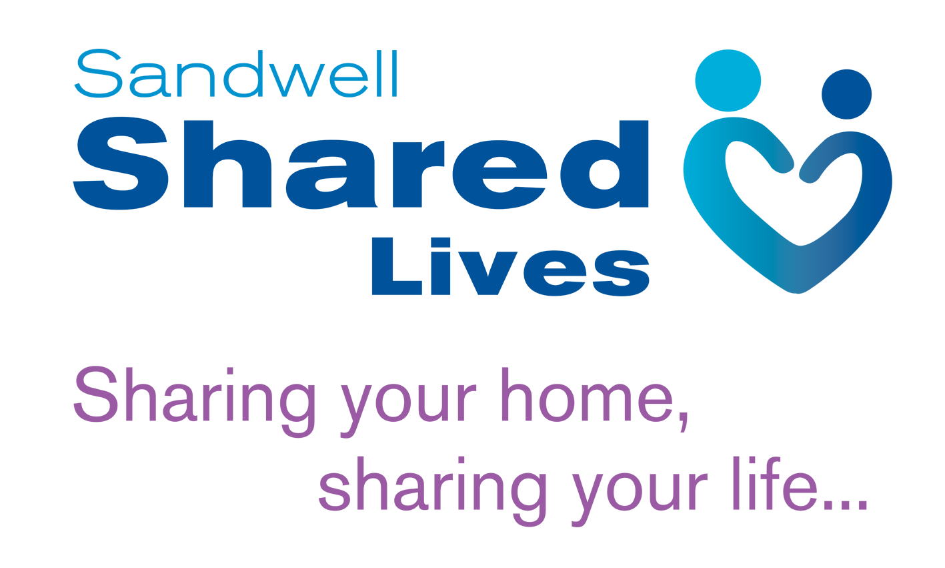
SL/AS/002
IL2
Personal Profile
Name: ……………………………………………
Please outline below a profile of you as a person. Think about your strengths and weaknesses, your likes and dislikes, your dreams and fears and what motivates you. Use the notes attached as a guide. If you find it difficult to write about yourself, maybe outline how you think your friends and family would describe you.
This exercise is designed to give a picture to the SL worker and independent panel of the sort of person you are and what makes you tick. This is important if you are to share your life and/or household with a disabled or vulnerable person as an SL Carer.
Use as little or much of the space as you like and feel free to write it by hand or type it, whichever suits you best.

Personal Profile - Notes
Please complete as much as you can – it is important for you to describe yourself in your own words.
The information in the profile will be discussed with you during “home visits” and used by the Social Worker in the completion of the report to present to Approval Panel.
You may compile the profile in any way you choose. The comments under each heading are intended to be guidelines to the sort of things you might want to include. Do not feel that you have to go into great detail or write essays, you are not limited to writing about the subjects mentioned.
The aim of this is to help you write about you!
Please add extra sheets if necessary.
- OWN CHILDHOOD AND TEENAGE YEARS
Try to include where you have lived, with whom and any significant events you can recall e.g. holidays, friends, interests, hobbies etc. Was it a sad or happy time for you, what were your parents, brothers, sisters etc like? How has your childhood contributed to making you the kind of person you are today? What was the significance of culture, ethnicity, religion and language in your up brining? Type of education you received and what it was like.
- ADULT YEARS
Please include details of work experience, further education, current employment and plans for the future, also include voluntary work and care experience (caring for your own children/parents or others).
- PERSONALITY/SELF DESCRIPTION
Self presentation and how you are viewed by others, your strengths and limitations, important values, beliefs and philosophies on people and life in general?
What sort of temperament do you have? What areas or attributes would you like to change about yourself if you could?
Hobbies and Interests?
What languages do you speak, write or understand?
- OPPRESSION
What is your understanding of oppression and the differing forms it can take? Have you yourself experienced oppression (e.g. Racism, Sexism, ageism, discrimination on the grounds of your sexuality or disability)? How have you been influenced by such experience?
- RELIGION – PRACTICING/NON PRACTICING
Your views and beliefs. How do you view religions of different denominations to your own, if any?
How could you support an adult with a learning disability to practice his or her religion?
- DISABILITY
Do you have any experience of disability with either your own family members or friends? Could you care for a young person with a disability) sensory, physical or learning)?
- RACE/ETHNICITY/CULTURE
What do you understand by the term ‘multi-racial’ Britain? How might you help a black/minority ethnic young person cope with the racism they will encounter in a dominant white society? What might you do to help an individual develop views about Britain as a multi-racial society?
How could you promote an individuals independence that was from a different culture to your own?
- SEXUALITY
How have previous relationships affected and formed your views and opinions regarding your own sexuality and sex? Who are you able to discuss issues of sex and sexuality with? How could you support a service user who had issues around sexuality? i.e. how would you support an individual who was lesbian or gay?
- OTHER ADULT CARE EXPERIENCE
Have you cared for/worked with adults with learning disabilities?
In what circumstance/capacity?
What did you find most enjoyable, rewarding and difficult?
What did you learn about yourself?
- MOTIVATION TO BECOME A CARER
Why do you want to become a Shared Lives Carer for the Shared Lives Scheme?
What kind of support would you expect from the Scheme? Why do you believe you are suited to the task?
- EXPECTATIONS OF PLACEMENT – THE SORT OF INDIVIDUAL YOU WOULD LIKE AND WITH WHOM YOU COULD COPE
Sex, personality, age, criminal offences, what behaviour would be Intolerable to you?
Other things that might worry you?
12. VIEWS OF OTHER HOUSEHOLD MEMBERS
Attitude of family/friends to you becoming a Shared Lives Carer? Who provides your main source of support – practical and emotional?
Have you discussed your application with family/friends.
What was their attitude?
Will they support you?
How important their acceptance to you?
- TYPE OF PLACEMENT THAT CAN BE OFFERED
What specifically do you feel you can offer adults with learning disabilities and how will you go about meeting their needs?
Do you prefer to offer frequent short breaks or a long-term placement?
- SKILLS
What do you believe are the necessary skills to become a good Shared Lives carer?
How could you demonstrate these skills.
- NEIGHBOURHOOD/COMMUNITY
Accommodation – please describe your accommodation and the proposed sleeping arrangements for the adult with a learning disability.
What facilities are available and accessible to individuals e.g. college, medical, resources, leisure, religious centres, facilities, public transport.
What is the ethnic mix of the neighbourhood.
- WORKING WITH PARENTS, GUARDIANS AND OTHER IMPORTANT FAMILY FRIENDS, ETC
Feelings, concerns.
How will you enable and facilitate contact?
- WORKING WITH SOCIAL WORKERS AND THE DEPARTMENT
Feelings, concerns?
- SUPPORT
Please detail the kind of support practical, emotional, training- that you feel would aid and assist you as a Shared Lives carer.
- FOR CHILDREN/TEENAGERS OF THE FAMILY TO COMPLETE (THIS MAY REQUIRE HELP FROM PARENTS)
How do you feel about another person coming to live in your home?
What sort of person would you like to come and live with you?

