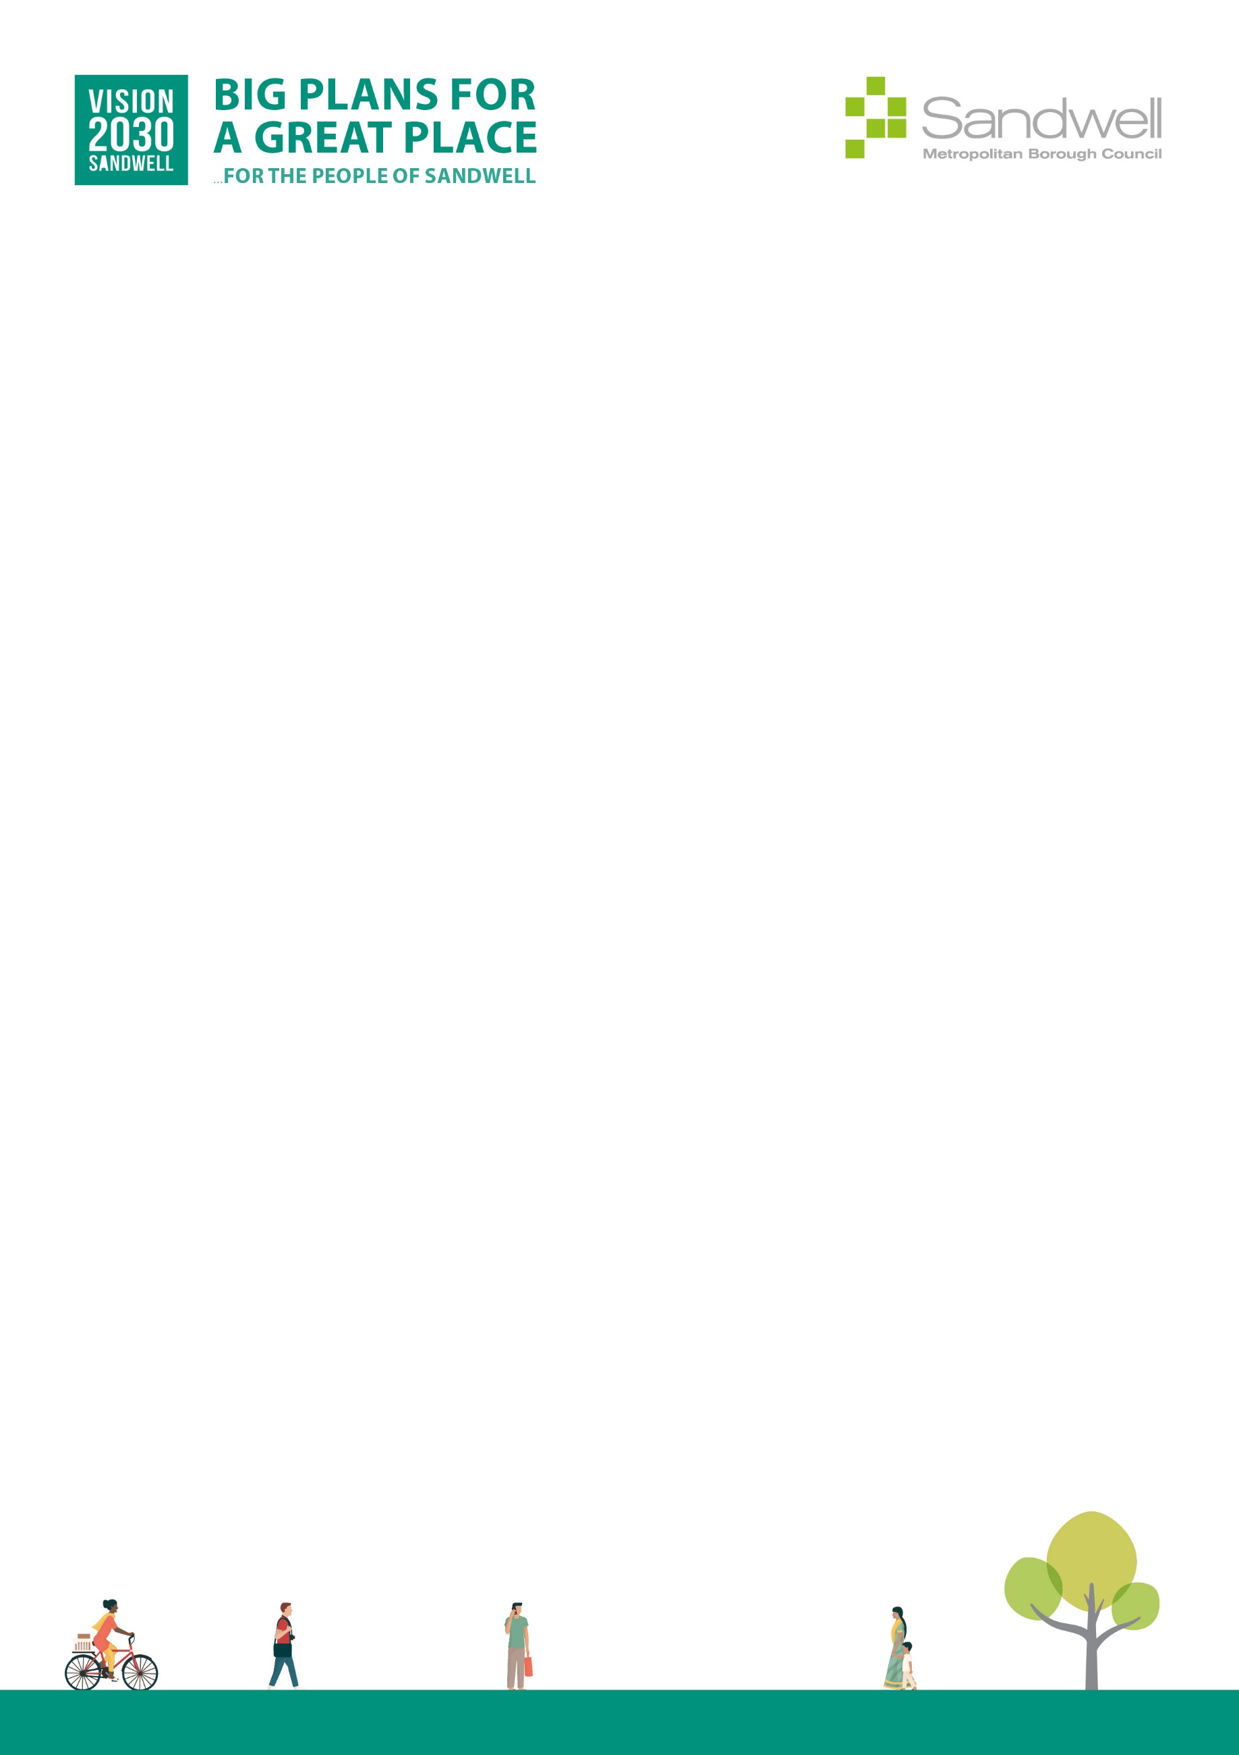

Equality Impact Assessments Toolkit

EqIA Template

You must consider the Equality Impact Assessment Guidance when completing this template.
The EDI team can provide help and advice on undertaking an EqIA and also provide overview quality assurance checks on completed EqIA documents.
EDI team contact email: edi_team@sandwell.gov.uk
Quality Control
Title of proposal | ASB Policy
Directorate and Service Area | Place (Community safety)
Officer completing EqIA | Louis Bebb
Contact Details | Louis_Bebb@sandwell.gov.uk
Other officers involved in completing this EqIA | Wendy Sims
Date EqIA completed | 06.05.2026
Date EqIA signed off or agreed by Director or Executive Director | 15.07.2026
Name of Director or Executive Director signing off EqIA | Alan Lunt
Date EqIA considered by Cabinet | 10.06.2026
Where the EqIA is Published  (please include a link to the EqIA and send a copy of the final EqIA to the EDI team) | Modern Gov

Section 1.

The purpose of the project, proposal or decision required
The purpose of this proposal is to adopt Sandwell Council’s Anti-Social Behaviour (ASB) Policy, which sets out how the Council will prevent, identify and respond to anti-social behaviour across the borough in line with its statutory duties under the Anti-Social Behaviour, Crime and Policing Act 2014 and related legislation.

The policy establishes a clear, harm-centred and trauma-informed framework for responding to ASB affecting residents, communities and places, including council housing, the private rented sector, owner-occupied homes and public spaces. It explains how ASB will be assessed based on impact, severity, persistence and cumulative harm, and how Housing and Community Safety services will work together with partner agencies to deliver proportionate, effective and accountable responses.

Approval is sought to ensure that ASB responses are consistent, transparent and defensible, that victims are supported appropriately, and that safeguarding, equality and vulnerability considerations are embedded in all ASB decision-making.

Section 2.

Evidence used and considered. Include analysis of any missing data
The Equality Impact Assessment (EqIA) has been informed by the following evidence sources:
- Anti-Social Behaviour, Crime and Policing Act 2014
- Statutory Guidance for the Anti-Social Behaviour, Crime and Policing Act 2014
- Housing Acts 1985 and 1996 (housing-related ASB duties)
- Equality Act 2010 and Public Sector Equality Duty
- Human Rights Act 1998
- Housing Ombudsman Complaint Handling Code
- Council policies relating to safeguarding, reasonable adjustments and complaints
- Operational experience from Housing and Community Safety services
- Local intelligence and data from ASB casework, complaints, case reviews and partnership referrals
- Learning from Case Reviews (Community Trigger), complaints and Ombudsman findings

No significant gaps in evidence have been identified. It is recognised that ASB can have a disproportionate impact on individuals who are vulnerable, including disabled people, older residents, victims of hate incidents and those experiencing domestic abuse or exploitation. The policy mitigates these risks by embedding harm-based assessment, professional discretion, safeguarding pathways, proportionality and reasonable adjustments.

Section 3.

Consultation
Consultation and internal engagement were undertaken with:
- Housing Services
- Community Safety and ASB officers
- Legal Services
- Safeguarding leads
- Senior management within the Place Directorate

Consultation focused on ensuring that the Council’s approach to ASB is lawful, victim‑focused, proportionate and aligned with statutory guidance, while supporting effective partnership working and safeguarding.

Summary of consultation findings
- Strong support for a single, clear ASB policy framework
- Agreement on the importance of assessing ASB based on harm and impact, not behaviour alone
- Recognition of the need for consistent thresholds and clear victim communication
- Emphasis on embedding safeguarding, vulnerability and equality considerations
- Support for a trauma-informed and prevention-focused approach alongside enforcement options

Section 4.

Summary assessment of the analysis at section 4a and the likely impact on each of the protected characteristics (if any)
Summary assessment of impacts on protected characteristics

The Anti‑Social Behaviour (ASB) Policy has been assessed for its potential impact on people with protected characteristics. Overall, the policy is expected to have a positive or neutral impact.

The policy strengthens protections for people who may experience disproportionate harm from ASB, including those who are disabled, older, subject to hate‑related behaviour or experiencing safeguarding risks. Built‑in safeguards ensure that no protected group is unfairly disadvantaged by the Council’s response to ASB.

Section 4a - What are the potential/actual impacts of the proposal on the protected characteristics?

Characteristic | Impact (P/N/Ne) | Details of impact | Actions / mitigation | Owner / timescale
Age | P | Reduces harm to older and younger residents who may be more vulnerable to ASB. | Harm-based risk assessment and safeguarding. | Housing & Community Safety / Ongoing
Disability | P | Supports disabled people experiencing ASB; considers impact and barriers to reporting. | Reasonable adjustments and accessible communication. | Housing & Community Safety / Ongoing
Gender reassignment | Ne | Policy applies equally regardless of gender identity. | Inclusive practice and staff training. | Housing & Community Safety / Ongoing
Marriage / civil partnership | Ne | No differential impact identified. | Monitor consistency. | Housing & Community Safety / Annual review
Pregnancy / maternity | P | Protects households where ASB affects family safety and wellbeing. | Consider household circumstances in case planning. | Housing & Community Safety / Ongoing
Race | P | Supports response to hate incidents and racially motivated ASB. | Link to hate crime procedures and monitoring. | Housing & Community Safety / Ongoing
Religion / belief | Ne | Neutral impact identified. | Equality-aware practice. | Housing & Community Safety / Ongoing
Sex | Ne | Neutral impact. | Monitor case outcomes. | Housing & Community Safety / Ongoing
Sexual orientation | Ne | Neutral impact. | Inclusive and respectful practice. | Housing & Community Safety / Ongoing
Carer | P | Reduces ASB-related harm affecting carers and dependants. | Take caring responsibilities into account. | Housing & Community Safety / Ongoing
Low-income groups | P | Protects households more likely to be affected by neighbourhood ASB. | Early intervention and support. | Housing & Community Safety / Ongoing
Veterans / Armed Forces | Ne | No specific impacts identified. | Monitor where relevant. | Housing & Community Safety / Review 2026
Other (vulnerable households) | P | Strong positive impact through safeguarding and harm-focused responses. | Ongoing monitoring and referrals. | Housing & Community Safety / Ongoing

If there are no adverse impacts or any issues of concern or you can adequately explain or justify them, then please move to Sections 6.

5. What actions can be taken to mitigate any adverse impacts?
No adverse impacts have been identified that cannot be adequately mitigated through existing safeguards within the policy.
6. Section 6: Decision or actions proposed
Approval of the Anti-Social Behaviour (ASB) Policy to support a fair, lawful and proportionate approach to preventing and responding to ASB, reducing harm and promoting safer, more cohesive communities across the borough.

7. Monitoring arrangements
- Ongoing monitoring of ASB cases, outcomes and patterns
- Review of complaints, Case Reviews (Community Trigger) and Ombudsman findings
- Annual policy review to reflect legislative changes and learning
- Reporting through internal governance and partnership forums

Section 8 Action planning (if required)
Not required at this stage.
Question no. (ref) | Action required | Lead officer/ person responsible | Target date | Progress

If you have any suggestions for improving this process, please contact EDI_Team@Sandwell.gov.uk

