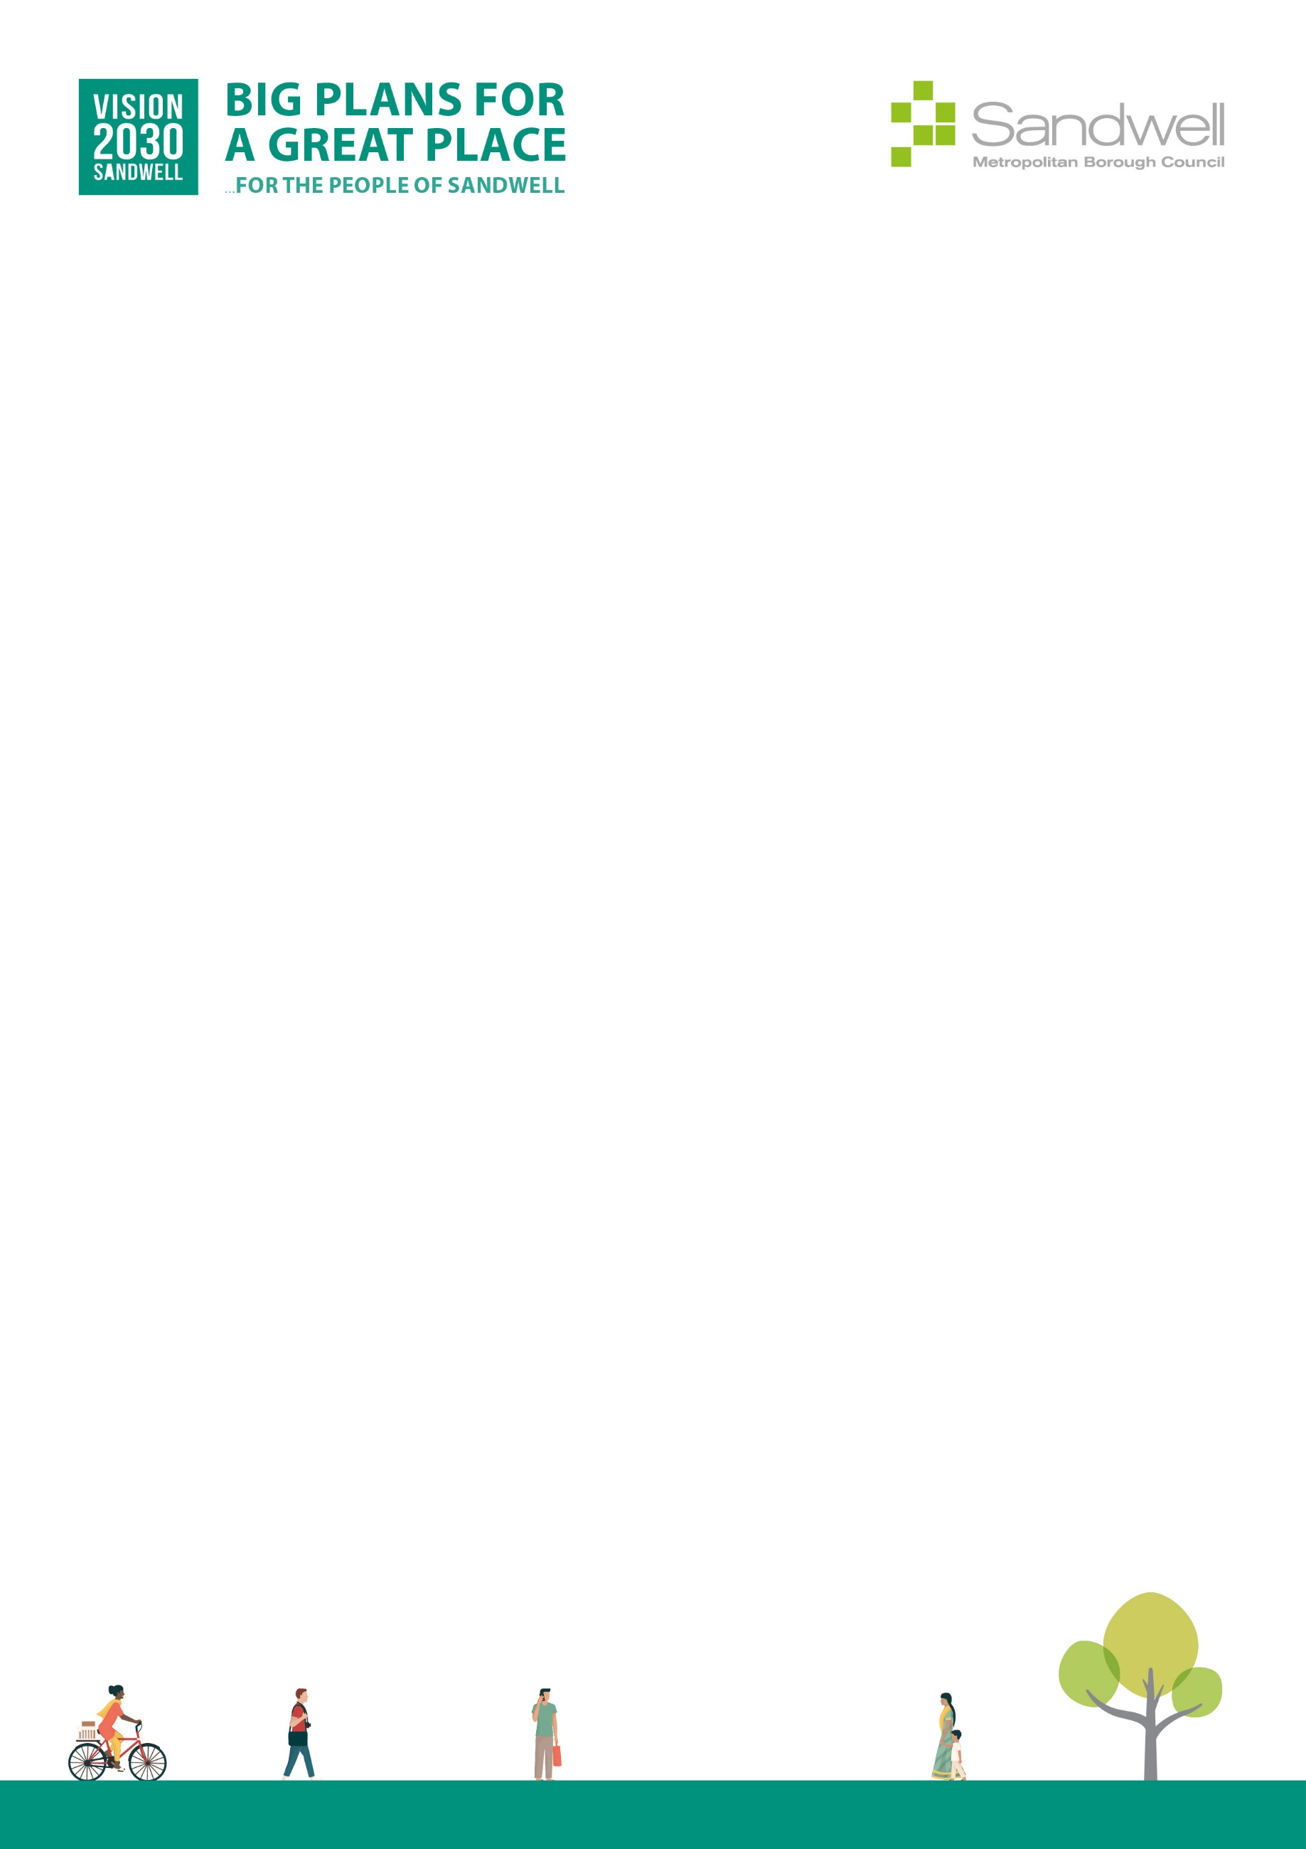

Equality Impact Assessments Toolkit

EqIA Template

You must consider the Equality Impact Assessment Guidance when completing this template.
The EDI team can provide help and advice on undertaking an EqIA and also provide overview quality assurance checks on completed EqIA documents.
EDI team contact email: edi_team@sandwell.gov.uk
Quality Control
Title of proposal | Homelessness and Rough Sleeper Strategy 2022 - 2025
Directorate and Service Area | Place (Housing)
Officer completing EqIA | Louis Bebb
Contact Details | Louis_bebb@sandwell.gov.uk
Other officers involved in completing this EqIA | Karl Robinson
Date EqIA completed | 25.03.2026
Date EqIA signed off or agreed by Director or Executive Director | 25.03.2026
Name of Director or Executive Director signing off EqIA | Alan Lunt
Date EqIA considered by Cabinet | April 2022
Where the EqIA is Published  (please include a link to the EqIA and send a copy of the final EqIA to the EDI team) | https://www.sandwell.gov.uk/housing/policies#

Section 1.

The purpose of the project, proposal or decision required
This Equality Impact Assessment (EQIA) considers the potential impacts of the Sandwell Homelessness and Rough Sleeping Strategy 2022–2025 on individuals with protected characteristics.

The strategy aims to:
- Prevent homelessness and rough sleeping
- Provide suitable and sustainable accommodation
- Deliver early intervention and holistic support
- Improve partnership working across services

Given that homelessness disproportionately affects vulnerable and marginalised groups, this EQIA ensures the strategy promotes equality, reduces disadvantage, and complies with the Public Sector Equality Duty (PSED) under the Equality Act 2010.

Section 2.

Evidence used and considered. Include analysis of any missing data
The strategy sets out Sandwell Council’s approach to tackling homelessness through:
- Early intervention and prevention
- Improved access to housing options (including Private Rented Sector)
- Reducing reliance on temporary accommodation
- Strengthening partnership working
- Eliminating rough sleeping
Key themes include:
- Preventing homelessness
- Communication and engagement
- Enhancing housing options
- Partnership collaboration
- Eliminating rough sleeping
- Making best use of resources
The strategy also introduces a system-wide redesign, shifting from crisis response to prevention-led services.

Section 3.

Consultation
Consultation and engagement were conducted with:
- Internal Council teams (Housing, Council Tax, Planning Enforcement, Environmental Enforcement)
- Regional Empty Property Officers Forum
- Members of the public reporting empty properties
- Partnership working with other services and agencies

Section 4.

Summary assessment of the analysis at section 4a and the likely impact on each of the protected characteristics (if any)
The Sandwell Homelessness and Rough Sleeping Strategy 2022–2025 is expected to have positive impacts on groups at higher risk of homelessness, including young people, families, people with disabilities, women fleeing domestic abuse, and ethnic minority communities, through early intervention, holistic support, and improved housing options. It ensures neutral impact for sexual orientation, religion/belief, gender reassignment, and marital/civil partnership status. Socio-economically disadvantaged households will also benefit from targeted support, prevention tools, and access to secure accommodation. Overall, the strategy promotes equitable access to housing and support, with ongoing monitoring to address any emerging inequalities.

Section 4a - What are the potential/actual impacts of the proposal on the protected characteristics?

Protected Characteristic | Impact (Positive/Negative/Neutral) | Evidence/Reason | Mitigation / Actions
Age | Positive | Young people are at higher risk of homelessness due to family breakdown; older people may face vulnerability in housing access | Early intervention model and tailored support improve outcomes across age groups
Disability | Positive | People with physical and mental health needs are disproportionately affected by homelessness | Holistic support model and partnership working with health and social care services
Sex | Positive | Women are more likely to experience homelessness due to domestic abuse | Integration with domestic abuse support services and targeted interventions
Race / Ethnicity | Positive | Sandwell has a diverse population; ethnic minority groups may face barriers accessing housing | Improved communication, partnership working, and inclusive service delivery
Pregnancy & Maternity | Positive | Families at risk of homelessness require stable housing | Prevention focus reduces risk of homelessness and improves housing stability
Sexual Orientation | Neutral | No specific adverse impacts identified | Services delivered inclusively to all individuals
Religion / Belief | Neutral | No specific adverse impacts identified | Equal access to services ensured
Gender Reassignment | Neutral | No specific adverse impacts identified | Inclusive and non-discriminatory service provision
Marriage & Civil Partnership | Neutral | No specific adverse impacts identified | Policy applies equally to all household types
Socio-economic disadvantage | Positive | Strong link between poverty and homelessness | Strategy directly addresses housing need, affordability and prevention

If there are no adverse impacts or any issues of concern or you can adequately explain or justify them, then please move to Sections 6.

5. What actions can be taken to mitigate any adverse impacts?
To address potential inequalities, the strategy includes:
- A holistic, person-centred support approach
- Strong partnership working across agencies
- Integration with domestic abuse services
- Multiple communication channels (not solely digital)
- Development of Private Rented Sector access and support
- Complex case support through specialist teams
- Customer-focused service redesign

These measures reduce barriers and support vulnerable groups.

6. Section 6: Decision or actions proposed
The strategy will be monitored through:
- Performance data on homelessness prevention and relief
- Monitoring of temporary accommodation usage
- Tracking repeat homelessness rates
- Monitoring rough sleeping numbers
- Equality data on service users
- Feedback from customers and partners

Governance will be provided by the Sandwell Homelessness Partnership.
The strategy will be reviewed within a five-year cycle.

7. Monitoring arrangements
The strategy is expected to have an overall positive impact on equality, particularly for vulnerable and disadvantaged groups.

It:
- Promotes early intervention and prevention
- Improves access to housing and support
- Addresses root causes of homelessness
- Strengthens partnership working

Any potential negative impacts have been mitigated through targeted actions and ongoing monitoring.

The strategy is compliant with the Equality Act 2010 and supports reducing inequality across Sandwell.

Section 8 Action planning (if required)
Question no. (ref) | Action required | Lead officer/ person responsible | Target date | Progress

If you have any suggestions for improving this process, please contact EDI_Team@Sandwell.gov.uk

