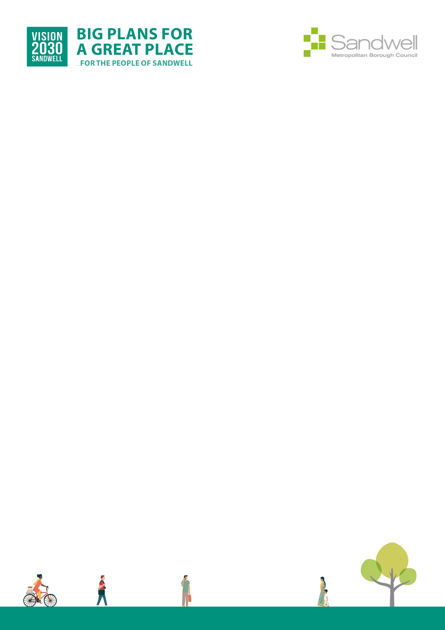

Equality Impact Assessments Toolkit

EqIA Template

You must consider the Equality Impact Assessment Guidance when completing this template.
The EDI team can provide help and advice on undertaking an EqIA and also provide overview quality assurance checks on completed EqIA documents.
EDI team contact email: edi_team@sandwell.gov.uk
Quality Control
Title of proposal | Property Compliance Policy
Directorate and Service Area | Place (Housing)
Officer completing EqIA | Louis Bebb
Contact Details | Louis_bebb@sandwell.gov.uk
Other officers involved in completing this EqIA | Sarah Ager
Date EqIA completed | 18.03.2026
Date EqIA signed off or agreed by Director or Executive Director | 18.03.2026
Name of Director or Executive Director signing off EqIA | Alan Lunt
Date EqIA considered by Cabinet | September 2024
Where the EqIA is Published  (please include a link to the EqIA and send a copy of the final EqIA to the EDI team) | https://www.sandwell.gov.uk/housing/policies#

Section 1.

The purpose of the project, proposal or decision required
The Property Compliance Policy sets out Sandwell Metropolitan Borough Council’s (SMBC) approach to meeting its legal obligations as a landlord and employer.

Approval is sought to adopt the policy to:
- Ensure compliance with statutory requirements across all key property compliance areas (“Big 6”): Gas, Fire & Building Safety, Electrical, Asbestos, Water (Legionella), and Lifts
- Maintain safe, high-quality homes for residents
- Protect SMBC assets and reputation as a responsible landlord
- Establish clear governance, reporting, and assurance mechanisms
- Provide clarity on organisational responsibilities, roles, and escalation processes

Section 2.

Evidence used and considered. Include analysis of any missing data
- Legal and regulatory framework including Health and Safety at Work Act 1974, Housing Act 2004, Building Safety Act 2022, Fire Safety Act 2021, Gas Safety Regulations 1998 (as amended), Control of Asbestos Regulations 2012, Electricity at Work Regulations 1989, PUWER 1998, LOLER 1998, CoSHH 2002, and related ACOPs
- SMBC operational experience in managing residential property compliance
- Internal audits, risk management frameworks, and three lines of defence assurance model
- Guidance from national regulators: Regulator for Social Housing (RSH), Building Safety Regulator (BSR), Health & Safety Executive (HSE), Environment Agency
- Service-level performance and compliance data across all property compliance areas
- Feedback from residents and engagement through Resident Engagement Strategies

Section 3.

Consultation
Consultation and engagement were conducted with:
- SMBC staff across Asset Management, Housing Management, Health & Safety, and Repairs teams
- Trade unions and employee representatives
- Residents through block-specific Resident Engagement Strategies, especially for high-rise buildings in line with Building Safety Act 2022 requirements
- Regulators and external technical advisors for assurance

Key findings from consultation:
- Need for clear communication and accessible reporting for residents
- Importance of structured roles and responsibilities for compliance across all “Big 6” areas
- Requirement for ongoing staff competency, training, and external verification
- Clear escalation and whistleblowing processes

Changes following consultation:
- Strengthened operational procedures and risk management approach
- Enhanced monitoring, audit, and reporting requirements for compliance
- Resident engagement strategies included in line with Building Safety Act 2022

Section 4.

Summary assessment of the analysis at section 4a and the likely impact on each of the protected characteristics (if any)
The policy is designed to have neutral or positive impacts across all protected characteristics, ensuring equality in health, safety, and housing standards.

Key considerations:
- Age, disability, gender, race, gender identity/expression, sexual orientation, pregnancy and maternity, marriage/civil partnership, religion/belief
- Vulnerable tenants, residents with socio-economic disadvantages, carers, and those with additional needs

Measures to promote positive impact:
- Reasonable adjustments for accessibility (physical and communication)
- Accessible resident communication and reporting of compliance inspections
- Staff training on equality, diversity, and human rights in property compliance activities
- Tailored engagement with vulnerable residents to ensure safety compliance without discrimination

Section 4a - What are the potential/actual impacts of the proposal on the protected characteristics?

Reviewed Characteristic | Impact (P/N/Ne) | Details of Impact | Actions to Promote Positive Impact | Owner / Timescale
Age | P | Safety inspections and engagement tailored to elderly and young residents | Resident engagement, clear instructions, and proactive support | Asset Management / Ongoing
Disability | P | Reasonable adjustments for mobility, access, or communication needs | Alternative formats, physical access adaptations, support during inspections | Asset Management / Ongoing
Gender Reassignment | Ne | Neutral; compliance measures apply to all residents | Ensure inclusive communication and awareness in staff training | Asset Management / Annual
Marriage/Civil Partnership | Ne | Neutral impact; policy applies to all households | Review service fairness periodically | Asset Management / Annual
Pregnancy and Maternity | P | Health and safety considerations for pregnant residents | Tailored guidance and support during inspections and works | Asset Management / Ongoing
Race | P | Equitable engagement and compliance communication | Monitoring for equality in service delivery and engagement | Asset Management / Ongoing
Religion or Belief | Ne | Neutral; no differential impact | Reinforce equality and cultural awareness in inspections | Asset Management / Annual
Sex | Ne | Neutral; applies to all tenants | Monitor for fairness in service provision | Asset Management / Annual
Sexual Orientation | Ne | Neutral; policy applies to all residents | Inclusive communication and awareness | Asset Management / Annual
Carer / Dependents | P | Ensures compliance and safety for households with dependents | Tailored risk assessments and engagement | Asset Management / Ongoing
Low Income / Socioeconomic disadvantage | P | Ensures safe homes and access to compliance-related support | Support and guidance to reduce exposure to hazards | Asset Management / Ongoing
Other Vulnerable Groups | P | Residents in high-risk buildings or with special needs | Proactive monitoring and targeted engagement | Asset Management / Ongoing

If there are no adverse impacts or any issues of concern or you can adequately explain or justify them, then please move to Sections 6.

5. What actions can be taken to mitigate any adverse impacts?
No adverse impacts identified. Mitigation measures include:
- Reasonable adjustments for accessibility and communication
- Resident engagement strategies for awareness of compliance checks
- Ongoing staff training in equality, diversity, human rights, and safe working practices
- Whistleblowing and escalation processes to report concerns

6. Section 6: Decision or actions proposed
Approval is sought to adopt the Property Compliance Policy to:
- Ensure statutory compliance across all major property safety areas
- Maintain safe and legally compliant homes for residents
- Provide clarity on roles, responsibilities, reporting, and assurance
- Strengthen resident engagement and transparency
- Support governance, audit, and regulator compliance

7. Monitoring arrangements
- Policy review every three years or sooner if legislation, management, or operational changes occur
- Regular monitoring and reporting on compliance across the “Big 6” themes
- Annual audits and performance assurance by the Asset Management Compliance Team
- Reporting to SMBC Executive Directors and strategic stakeholders for governance and oversight
- Resident engagement metrics reviewed annually in line with Building Safety Act 2022

Section 8 Action planning (if required)
Question no. (ref) | Action required | Lead officer/ person responsible | Target date | Progress

If you have any suggestions for improving this process, please contact EDI_Team@Sandwell.gov.uk

