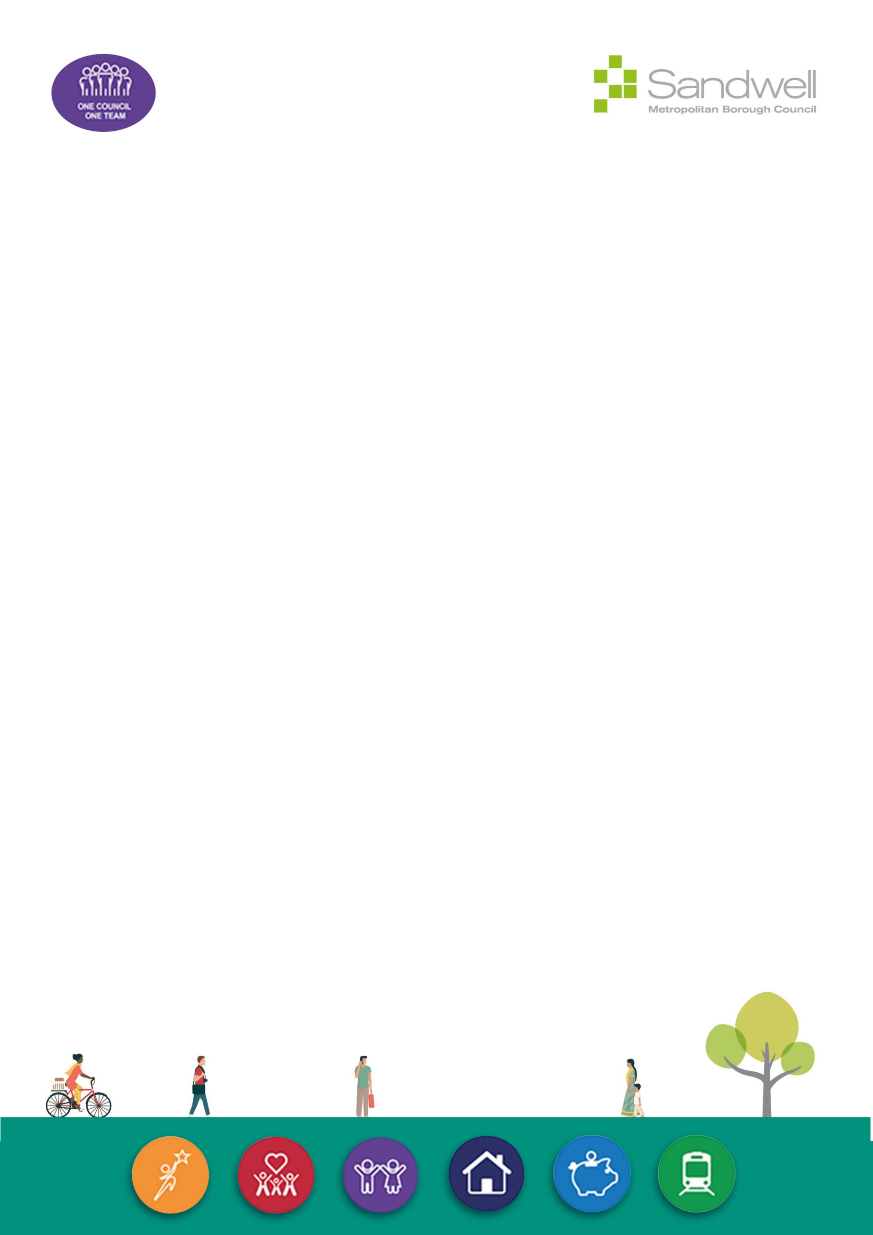



Quality Assurance and Improvement in Commissioned Social Care Services

June 2024

Overview
We want to ensure safety in the local care system and strongly believe that clear quality standards are fundamental to the delivery of safe and dependable services that promote wellbeing and help people to achieve their desired outcomes.
This process sets out our approach to promote improvement and assure the quality of commissioned adult social care services in Sandwell, and the out of borough services that are sometimes necessary to support people for whom Sandwell MBC is responsible. We are continuing to develop a shared commitment to quality and improvement with service users, adult social care providers and key partners, locally and regionally.
We have significantly invested in our Quality and Safety Team to support our oversight of the market to enable both a proactive and responsive approach to promote quality and address any concerns should they emerge.
Our Quality and Safety Team consists of both health and social care professionals to enable a robust, effective, and holistic approach to quality and service improvement. Alongside professionals with extensive social care experience, the team includes professionals with specialisms including health and safety, nursing, and medicines management.
We work in an integrated way with commissioning colleagues and our place-based partners across the health and social care system to monitor quality, reduce duplication, and strengthen our oversight and market support. Adopting this approach makes best use of the available multi-disciplinary resources and expertise, as well as ensuring our interventions are coordinated and proportionate.

Principles
The following principles underpin our approach to quality assurance and improvement:
- An overarching commitment to improving the quality, capacity, and sustainability of commissioned care services through a combination of education, monitoring, information sharing and constructive provider support.
- Early identification and resolution of issues, with proportionate interventions focused on securing improvements and best outcomes for service users.
- Emphasis on partnership working with social care providers, commissioners, and other health and social care organisations, achieving improvements through effective relationships and engagement.
- A collective understanding that the quality of care and support services is everyone's responsibility, with information and intelligence consistently shared and appropriately responded to, so that service users, family members, carers and commissioners can have confidence that the support and care provided is consistently of good quality.

Support to the Provider Market
We provide support to the social care market through our Provider Support Team to develop the quality of services and undertake proactive and bespoke activity to support improved outcomes. The team provides resources, advice, and guidance to maintain quality of life for those receiving care, whilst supporting care providers to effectively manage and deliver services of sustainable quality. This is achieved through a hybrid approach to improvement tailored to the needs of each service, utilising a combination of remote and onsite support, workshops, and observational quality of life indicator tools to provide feedback to providers.
Support can include:
- Care provider guidance to avoid hospital re-admission or manage the transition from hospital to a care setting.
- Guidance to produce person-centred care plans and records.
- Resources and workshops to support identified staff development or care needs.
- Support to improve audit and governance processes, in accordance with Care Quality Commission (CQC) standards.
- Observational audits to enhance core elements of care delivery, such as mealtimes.
- One-to-one interventions.
We recognise that social care providers continue to face challenges to service delivery and that the Council can offer support in overcoming some of these.
Examples of ongoing support and initiatives include:
- Access to Council training courses in key areas, such as safeguarding, for contracted social care providers and their staff.
- Regular provider communications, including Provider Support Team newsletters and supplementary quality and safety communications to the market where necessary to share opportunities, learning and emerging risks.
- Resources to share good practice to support providers seeking to progress from good to outstanding.
- Support to Sandwell providers with their most difficult structural challenges, such as leadership and governance infrastructure.
- Creation of resource materials to support culturally appropriate care, reflecting the diverse service user population in Sandwell care provision, further supplemented by work to support local providers to meet the needs of LGBTQ+ individuals in their care.
- Supporting providers with issues around medicines management to promote the safe and optimal use of medicines, linking with professionals in other NHS organisations as necessary to provide support, monitoring and advice, including reports and action plans to support improvement.
- Attendance at regular provider forums to share offers available to support providers and give providers the opportunity to ask questions or discuss topics of concern, alongside sessions from guest speakers to raise awareness on areas of interest, including learning from incidents, health and safety, and infection control.
Partnership Approach
We recognise that there are multiple organisations and individuals with interests in maintaining and improving quality in commissioned social care services, including service users, their families, care providers, health and social care staff, public health teams, and regulatory bodies, including the CQC, and acknowledge that service users and providers both benefit from a coordinated approach.
We promote and facilitate joint working between these organisations and individuals to focus on quality and improving outcomes, including the following activities:
- Commissioned advocacy services and directly delivered service user surveys to understand the experiences of services users in receipt of care and inform monitoring priorities.
- Weekly multi-disciplinary and multi-agency meetings involving assurance, commissioning, and operational clinical teams to support coordinated, responsive, and proactive provider assurance and clinical support at place-level.
- Bi-monthly Provider Escalation Group and information sharing meetings with the CQC to enhance market oversight and agree actions to support care provider quality and safety, with representation from a range of health, social care, and public health professionals, Healthwatch and the Safeguarding Adults team.
- A robust multi-agency Senior Strategy process (equivalent to the Large-Scale Enquiry process in other authorities) to support effective oversight and improvement in services where significant or systemic quality and safety concerns are identified.
- Care manager and provider forums to share market developments and identify and discuss social care issues impacting on local providers.
- Multi-disciplinary quality monitoring that is inclusive and supportive of care providers and proportionate to the assessed level risk, determined from a range of intelligence sources.
- Multi-agency assurance monitoring visits where appropriate, for example in nursing home provision jointly commissioned by health and social care, to enhance cohesive oversight and reduce the monitoring burden for providers.
- Collaborative working with service commissioners to ensure a shared view of quality and a coordinated response to any identified issues.
- Attendance at social work team meetings to give advice on how to raise quality concerns and promote a One Council approach to quality assurance.

Information Gathering
We take a data driven approach to our oversight of the market and our interventions, to ensure these are evidence-based and proportionate. The data we use to inform our actions is identified in the figure below.

Commissioning Cycle
The Council sets out expectations for quality and performance through its commissioning and contract arrangements and will seek assurances that providers are committed to delivering quality services that focus on positive outcomes at the point of commissioning, linking with the Council’s commitment to strength-based practice. Clear standards are set for providers in service specifications, which are validated at the point of commissioning and contracting and monitored throughout the lifetime of the contract.
Contracts between the Council and care providers set out processes to be followed where quality concerns represent a breach of contract, and the remedial actions that may be required in response to breaches.
The Council recognises the importance of market sustainability and the impact of financial pressures on provider viability, continuity of care, and quality, and has committed to a 3-year financial plan until 2026 to address these pressures.

Proactive Quality Monitoring
The Council conducts proactive monitoring of services to ensure the quality of commissioned provision, while retaining capacity to respond to concerns responsively if they are identified. We intend to conduct some form of monitoring annually or more frequently depending on risk.
The aim is to seek assurance that:
- Commissioned services continue to inspire confidence for service users and their families, commissioners, the Council, and service providers.
- Services are effectively delivering the care commissioned at an agreed level of quality.
- Services are meeting agreed support plans.
- Service users can trust the provider to provide the quality care necessary to meet their needs.
- Service users will be safe when in receipt of care from their chosen provider.
- Services promote wellbeing and are delivering positive outcomes for service users.
We recognise that local monitoring is an additional requirement for providers, alongside regulatory compliance with CQC standards, but believe this approach is essential to support the Council’s obligations to commission services that are safe, effective and provide value for money for the people of Sandwell.
The approach outlined in this document enables this ongoing monitoring of commissioned services, providing assurance that quality is maintained between CQC inspections, which can vary in frequency, while also helping to identify and address any challenges or fluctuations in quality in a timely way. Monitoring is intended to be a collaborative process to support continual provider improvement and promote best practice, helping services to best meet the needs of Sandwell service users and their regulatory obligations when the CQC inspect.
Monitoring and Review
The level of monitoring will be based on an assessment of risk that takes account of intelligence received and will be proportionate to the level of risk indicated by the information gathered. Structured tools are used to collate intelligence and monitoring information prior to and during visits, with this risk-based approach supplemented by a rolling programme of proactive monitoring for services where minimal risks are identified.
There will a be a minimum level of contact with all commissioned care and support providers on an annual basis. This may include, but is not limited to, quality assurance or commissioning visits, health and safety reviews, remote monitoring, data collection, and information sharing and review meetings.
Regular reporting of service data will be requested for key areas, and this will form part of our information collection for monitoring.
Visits to commissioned services will be undertaken to assure quality and to support providers to make improvements that promote good practice. Activity will largely be proactive, with visits considered based on available data, collaborative discussions with social care and commissioning colleagues and other professionals, and other sources of intelligence to ensure a balanced view of provision.
Monitoring activity will gather feedback from service users and staff and may observe interactions between staff and service users, assess the care environment, analyse care records and supporting documentation, and seek other evidence as required to ensure the service is maintaining effective internal oversight and operating in line with contractual obligations and any applicable regulatory requirements.
Our commitment to developing and maintaining open, transparent, and constructive relationships with providers is key to securing improvements. Positive practice will be highlighted and shared during visits and providers will receive verbal and written feedback about good practice and, where identified, any improvements required. Where necessary, providers will be supported to develop an action plan, with support offered to achieve positive outcomes. The Council encourages providers to continuously improve and aspire to outstanding and will support this aim where it can.
Where safeguarding concerns are identified, it may be agreed that a joint visit between the Safeguarding team and a relevant Quality and Safety or Commissioning team professional is required. Where necessary, visits may also involve other relevant professionals linked to the service from across the local partnership or wider networks, where this collaboration could have a positive impact on quality or outcomes.
The Council reserves the right to complete announced and unannounced visits to local services as part of the quality assurance process.
Quality assurance visits will:
- Identify ways to continuously improve the service user experience.
- Help the Council, the service provider and service users work collaboratively to identify improvements to enhance the quality of service provision.
- Provide a structured method of identifying compliance, good practice, and areas for improvement.
- Form one element of ongoing quality assurance monitoring of provider services by the Quality and Safety and Commissioning Teams.
- Support adherence to, and monitoring of, the CQC standards and other applicable regulatory requirements.
- Link evidence gained to relevant legislation, contract clauses or professional guidance to assure compliance and evidence-based practice.
Where concerns are highlighted that are likely to have a significant adverse impact on the quality of the provision, additional assurance visits or further escalation for enhanced scrutiny may be necessary. In cases where significant risks are evident, commissioning restrictions may be necessary while required improvements are made, but we will work with services to ensure any restrictions are proportionate and time limited as far as is practicable.
If it is identified that additional assurance visits are necessary, these would be completed by an allocated Quality Assurance Officer, Commissioner, or specialist professional(s), dependent on the concerns. Assurance activity would involve further service reviews, and where necessary, assisting in the development and active monitoring of an improvement plan, with agreed actions to resolve the identified issues.
Our multi-disciplinary team includes social care and health staff with considerable experience of service delivery and successful collaborative working with care providers and managers to identify, plan and monitor improvements to enhance the quality of their service.
The Quality and Safety Team is strengthened by a diverse range of professionals, including specialist clinical and health and safety staff, enabling more effective oversight of all facets of quality and safety. In addition to the Provider Support Team, Quality Assurance Officers and, where appropriate, commissioners, will assist services where quality is an issue and attempt to identify those services that may be at risk of a fluctuation in quality, referring them to other professionals for support as appropriate.
Information and updates will also be shared with relevant professionals and external organisations, including the CQC, where necessary, to ensure oversight and collaborative, proactive working to resolve any identified issues.

Out of Borough Services
There are occasions where the Council has responsibility for people who are placed in services outside Sandwell, and these services require a modified monitoring approach to address the inherent logistical challenges, while maintaining oversight and optimising the use of available resources.
At the time of placement, the Care Manager is expected to check with the Council’s Quality and Safety team, which would initiate enquiries with the host local authority to seek information about any quality, safeguarding or commissioning concerns and any prevailing commissioning restrictions. Additional checks would include review of current CQC ratings and inspection outcomes, and, as additional information is collated, any intelligence held by the Quality and Safety team.
Care Managers should ensure they are aware of the outcome of any inspection or monitoring activity prior to placements or when placements transition from temporary to permanent arrangements.
There would also be an expectation that the host local authority would notify the Council if an out of area service where a Sandwell resident is placed entered a safeguarding process. Where this occurs, the Council will participate in meetings and review action plans with the host authority to address organisational concerns and ensure the wellbeing of any placed individuals is safeguarded.
A reciprocal approach would be adopted for local authorities in other areas placing individuals in Sandwell services should concerns arise.
To supplement this, an enhanced monitoring approach has been developed for out of borough care homes, through a combination of remote and direct monitoring, with periodic structured information gathering from host local authorities and other commissioners. For nursing homes within the Black Country Integrated Care Board’s Quality Nurse Advisor team remit, additional information will also be sought on outcomes of monitoring activity where applicable, which may supplement or replace actions detailed below, subject to an assessment of risk.
Out of borough care home provision, including placement numbers and current CQC inspection rating, is tracked using a Power BI dashboard. This data is refreshed monthly in line with monitoring of CQC data for in borough provision, with mechanisms to identify commissioners of any changes.
Care Managers should identify any service quality issues during service user reviews and escalate these, as necessary.
Direct Monitoring
Out of borough care home services are prioritised for a rolling programme of direct monitoring using the relevant Council contract assurance template where there are either 5 or more Council-funded individuals, or where the cohort of Council-funded individuals represents more than 25% of the registered care home population. This latter approach is intended to support individuals in complex (and frequently smaller) services where there may be multiple funders and reduced holistic oversight from a single primary authority.
The exceptions to this approach will be where sufficient assurance can be obtained from other sources within the local health and social care partnership (for example, from a full review undertaken by the Integrated Care Board’s Quality Nurse Advisor team in the review period). Efforts will be made to reduce duplication where possible, to minimise disruption to providers and ensure the most effective use of public resources.
Additional care home services may be identified for onsite review where the assessment of risk from remote monitoring or information sharing indicates this approach is proportionate.
For non-residential services, direct monitoring, either at provider premises or virtually, where secure remote access or information transfer can be supported, will be completed in line with applicable contracts and commissioning frameworks.
Remote Monitoring (Care Homes)
Remote monitoring of commissioned out of borough care homes will be undertaken for all applicable services using a combination of structured information gathering, monitoring of placement reviews, and self-assessment, with the frequency determined by the provider’s published CQC rating. The information requests and frequency are detailed in the table below.
CQC Rating | Frequency of Information Request | Frequency of Health & Safety Self-Assessment
Inadequate | Interventions to be determined by Large Scale Enquiry process or equivalent safeguarding process in host authority – desktop monitoring not less than 3-monthly
Requires Improvement | 6-monthly | Rolling programme completed over 12 months
Good | Annually | Rolling programme completed over 12 months
Outstanding | Biennially | Rolling programme completed over 12 months

A phased implementation of this enhanced monitoring approach will be completed during 2024. This is to support resource management and completion alongside existing, in borough, monitoring obligations, and with consideration of the potential resource burdens for host authorities requested to complete information requests.

Feedback from Service Users
It is important to ensure that opportunities are offered to people with care and support needs to give their feedback on the care they receive, and the environment and way in which it is delivered.
Service user feedback is essential to help recognise where improvements and additional support are required and gives the opportunity to recognise and share positive experiences and learning, as well as the views of others about the service that they receive. This approach contributes to the Council’s commitment to co-production, particularly in respect of the co-reviewing of services.
We gain feedback from service users in a variety of ways:
- Using formal feedback from an advocacy provider commissioned to seek views from service users in services we commission.
- Direct Quality and Safety team or commissioning contact with service users to complete service satisfaction surveys.
- Using the quality assurance visit and associated reports to detail any discussions with service users or information shared during monitoring.
- Information from care management and commissioning colleagues, including service user feedback from completed reviews and any incidental feedback or concerns received.
- Engagement with Healthwatch, including reports from statutory Enter and View visits and feedback shared in provider meetings.
- Compliments and complaints received by the Council’s customer feedback team.
- CQC information sharing.
- Survey feedback from service users compiled by care providers, as monitored during provider visits and reviews.

Feedback from Providers
Provider feedback is important to us and helps us to improve our services and the support we deliver, as well as enhancing our understanding of any strategic or operational challenges affecting local providers when delivering care.
In addition to the engagement activities and forums outlined in the sections above, we will be proactive in seeking feedback following monitoring and support visits and education events, to help us to ensure that these activities are completed constructively and support provider development. Providers are encouraged to discuss any feedback with us directly or via our monitoring documents following visits and have the opportunity to review any completed reports for factual accuracy to ensure these are fair and representative.
In conjunction with partners, we aim to support continual learning and service improvement to support the development of dynamic and progressive commissioned care services. We encourage providers to share examples of good practice and innovation, as well as identifying areas where additional support would be beneficial, either for their individual services or more widely across the sector.
The Quality and Safety Team has a dedicated inbox for sharing feedback or information, which is monitored daily, Monday to Friday. The team can be contacted by email at quality_safetyteam@sandwell.gov.uk. Requests for support from the Provider Support Team can be sent to provider_supportteam@sandwell.gov.uk.

Safeguarding
The team work closely with Adult Safeguarding colleagues to understand emerging risks in commissioned services and routinely monitor and analyse incidents below the safeguarding threshold to identify themes and trends requiring action.
There may be circumstances where care providers or members of the Quality and Safety or wider Commissioning teams are required to report concerns and seek advice from the Safeguarding Adults team, either whilst providing commissioned care or when visiting or undertaking remote monitoring of services. In these instances, colleagues should follow the local procedures for reporting an incident to safeguarding, by completing an Adult Safeguarding Concern Form, emailing details to sandwell_enquiry@sandwell.gov.uk and, for Council staff, informing their line manager.
If immediate advice is required, a member of the Safeguarding Adults team can be contacted by calling 0121 569 2266, between 9am and 5.30pm Monday to Thursday, and 9am and 5pm on Fridays. Outside these hours, advice can be obtained by calling 0121 569 2355.
If Council staff are unsure of what action is required, concerns should be discussed with their line manager in the first instance.
All information relating to Sandwell’s Safeguarding Adults procedures can be found on the Safeguarding Adults web page.

Governance
The work of the Quality and Safety team sits within the Adult Social Care Commissioning portfolio and is overseen by senior members of the Adult Social Care team. A quarterly report is provided to the Safeguarding Board with quantitative data on services with quality concerns or commissioning restrictions, along with any services where it has been necessary to terminate a contract. Similar information is also presented in greater detail bi-monthly to the Directorate Management Team to support senior management assurance in relation to oversight of the care market.
A summary of services currently in the Senior Strategy process, any services with commissioning restrictions, and current market trends is also included in reports to Sandwell-place Operational Management meetings as required, to inform place-based partnership working.

