APPENDIX A – Nature Recovery Network and Biodiversity Net Gain 4
APPENDIX B – Masterplans 31
APPENDIX C - Strategic Waste Sites 54
APPENDIX D - Minerals 56
APPENDIX E – Site allocations - changes 57
APPENDIX F – Rowley Hills 69
APPENDIX G – Sandwell Local Plan Housing Trajectory 71
APPENDIX H – Open space and play provision standards for development 72
APPENDIX I - Transportation Policy 79
APPENDIX J – Transport Proposals 101
APPENDIX K – Sandwell’s Historic Environment Designations 107
APPENDIX L – Superseded Policies and Plans 110
APPENDIX M – List of strategic and non-strategic policies 135
APPENDIX N – Glossary 139

Table 1 - Strategic Waste Sites 54
Table 2 - Preferred Areas for new Waste Facilities 55
Table 3 - Key Mineral Infrastructure 56
Table 4 - Changes to previous Local Plan designations (Waste and Minerals) 57
Table 5 - Changes to previous housing allocations 58
Table 6 - Indicative Housing Trajectory and Rolling 5-year supply 71
Table 7 - Open Space Hierarchy 73
Table 8 - Existing Quantity of Unrestricted Open Space per 1,000 population ¹⁶ 74
Table 9 - Quantity and Accessibility Standards defined for Open Space Assessment ¹⁸ 75
Table 10 - Recommended Application of Quantity Benchmark Guidelines – Equipped / Designated Play Space ¹⁹ 76
Table 11 - Off-Site Open Space Planning Contribution Rates 77
Table 12 - Open Space Maintenance Rates 78
Table 13 - Minimum Parking Standards for Residential Uses 80
Table 14 - Maximum Parking Standards for Non-Residential Uses 80
Table 15 - Minimum parking standards for Community Uses 82
Table 16 - Disabled Parking Space Provision (To be applied to all applications including change of use applications for total floor area) 84
Table 17 - Minimum Cycle Parking Standards 87
Table 18 - Minimum Parking Standards for Powered Two Wheelers 91
Table 19 - Operational Parking Requirements 93
Table 20 - Transport Proposals 102
Table 21 - Proposals outside Sandwell that directly support the Spatial Strategy 106
Table 22 - Archaeological Priority Areas 107
Table 23 - Designed Landscapes of High Historic Value 108
Table 24 - Areas of High Historic Townscape Value 108
Table 25 - Areas of High Historic Landscape Value 109
Table 26 - Policies of the Black Country Core Strategy (2011) and the Sandwell Site Allocations and Delivery Document (2012) superseded by the Sandwell Local Plan 110
Table 27 - Other Superseded Documents 119
Table 28 - Historic Superseded Documents 129

APPENDIX A – Nature Recovery Network and Biodiversity Net Gain

West Midlands Local Nature Recovery Strategy
The development of a Nature Recovery Network (NRN) covering the whole of England is a major commitment in the Government’s 25 Year Environment Plan (2018). The plan states that the development of the NRN will provide 500,000 hectares of additional wildlife habitat, more effectively linking existing protected sites and landscapes, as well as urban green and blue infrastructure; and that as well as helping wildlife thrive, the NRN could be designed to bring a wide range of additional benefits: greater public enjoyment; pollination; carbon capture; water quality improvements and flood management.
The Environment Act 2021 made Local Nature Recovery Strategies mandatory in England. Together the strategies are to cover the whole of the country, and the Secretary of State is to determine the areas within England to which individual Local Nature Recovery Strategies are to relate.

A requirement of the Environment Act 2021 is a Local Habitat Map that identifies the existing distribution of different habitat types and the location of areas already important for biodiversity, overlaid by locations considered suitable for delivering the outcomes and measures identified in the Statement of Biodiversity Priorities.
The West Midlands Local Nature Recovery Strategy forms part of a region-wide approach that has been produced in partnership with the West Midlands Combined Authority (WMCA). This has been undertaken through analysis of local and national data sets including designated sites, Priority habitats, species distribution, land use and ecological connectivity. The strategy comprises several components that depict areas of current high ecological value, the ecological connectivity between these areas, and prioritises opportunities for investment in nature’s recovery on a landscape scale.
Further details can be found on the WMCA website including detailed mapping of the ecological and biodiversity value of the region showing how the LNRS will help deliver improvements and opportunities across the area.
https://www.wmca.org.uk/what-we-do/environment-energy/west-midlands-local-nature-recovery-strategy/

Biodiversity Net Gain (BNG) – Habitat Bank Sites (Policy SNE2)

See SLP Evidence base - Sandwell Biodiversity Net Gain Study (September 2023) - for more details.
The following are extracts from the report undertaken for Sandwell Council by Lepus Consulting on potential BNG habitat bank sites within the ownership of the Council. Six sites have been identified in the SLP, to help ensure that biodiversity net gain is retained within the borough as far as possible. Many of Sandwell’s new housing and employment allocations lie within heavily urbanised locations where the opportunities for on-site BNG provision are limited.
The following criteria were used to establish suitable sites for consideration:
- Sites / land wholly owned by Sandwell Council.
- Exclusion of certain open space typologies from consideration – allotments, cemeteries and churchyards, institutional land (schools, hospitals, sports grounds and reservoirs), outdoor sports facilities (including playing pitches) and provision for children and young people.
- Exclusion of sites smaller than 10ha.
- Use of the national Biodiversity Net Gain Calculator.
- Where sites under consideration contain public amenity open space, these specific areas were also excluded from consideration for improvement, as their role as accessible open space needs to be retained.
The following map identifies the sites that are identified as potential habitat banks.

Figure 1 - Location of BNG habitat bank sites

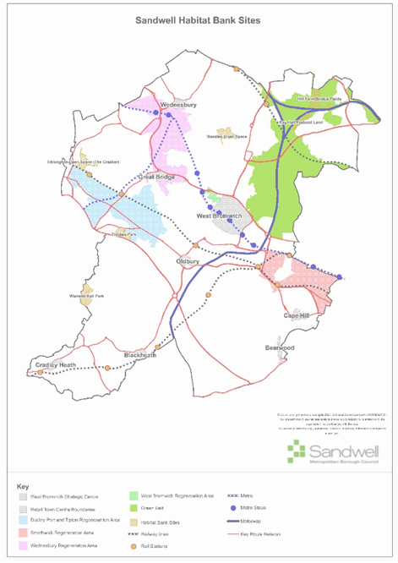

2km

The six sites included in the SLP (Policy SNE2) are detailed below:

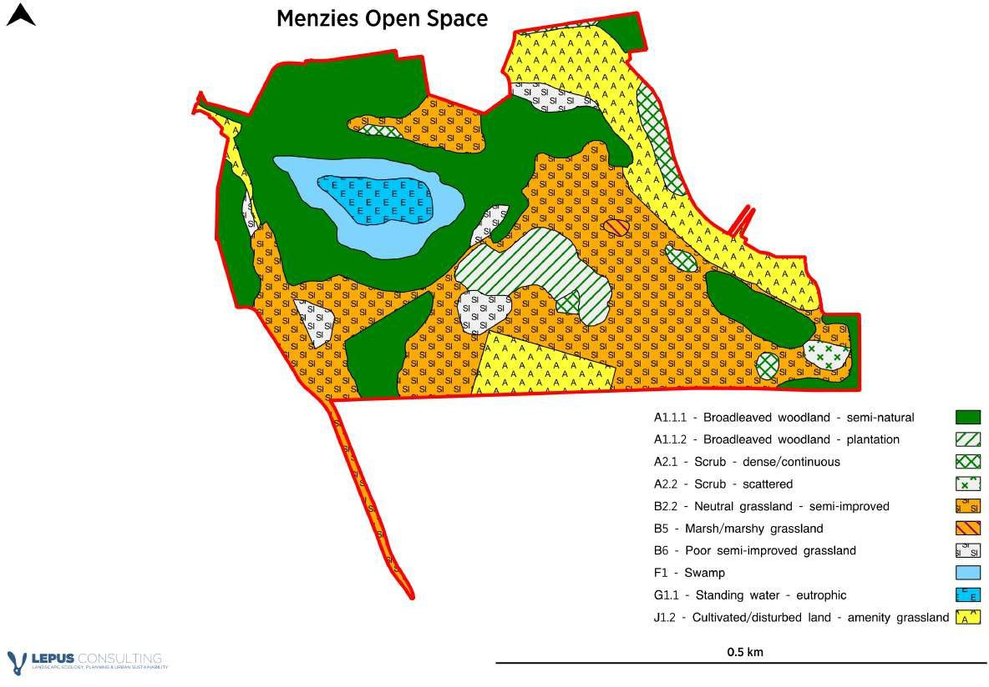

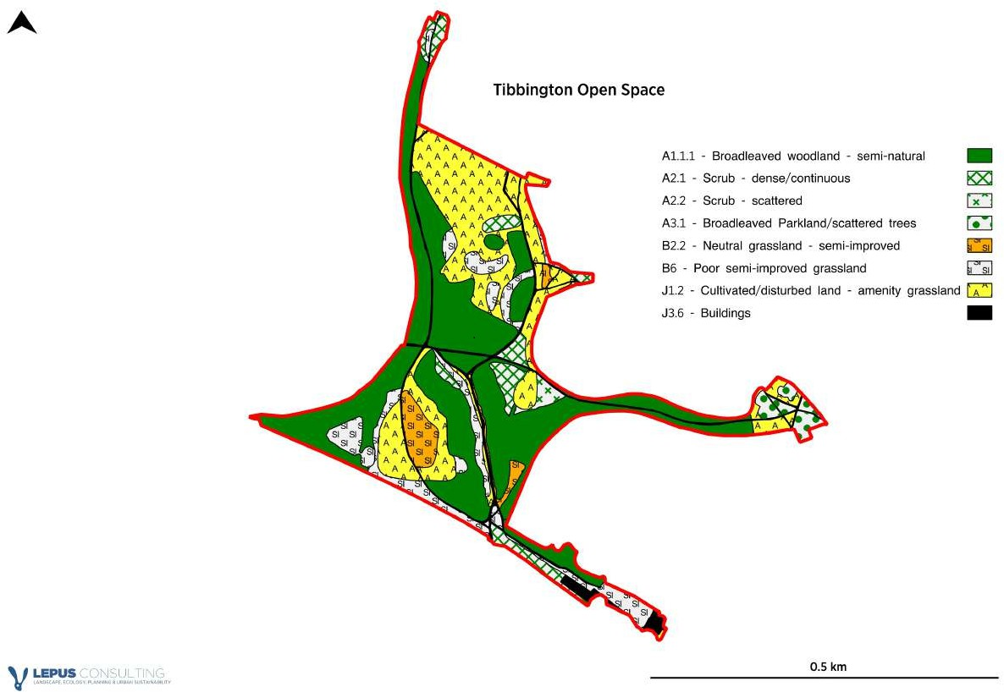

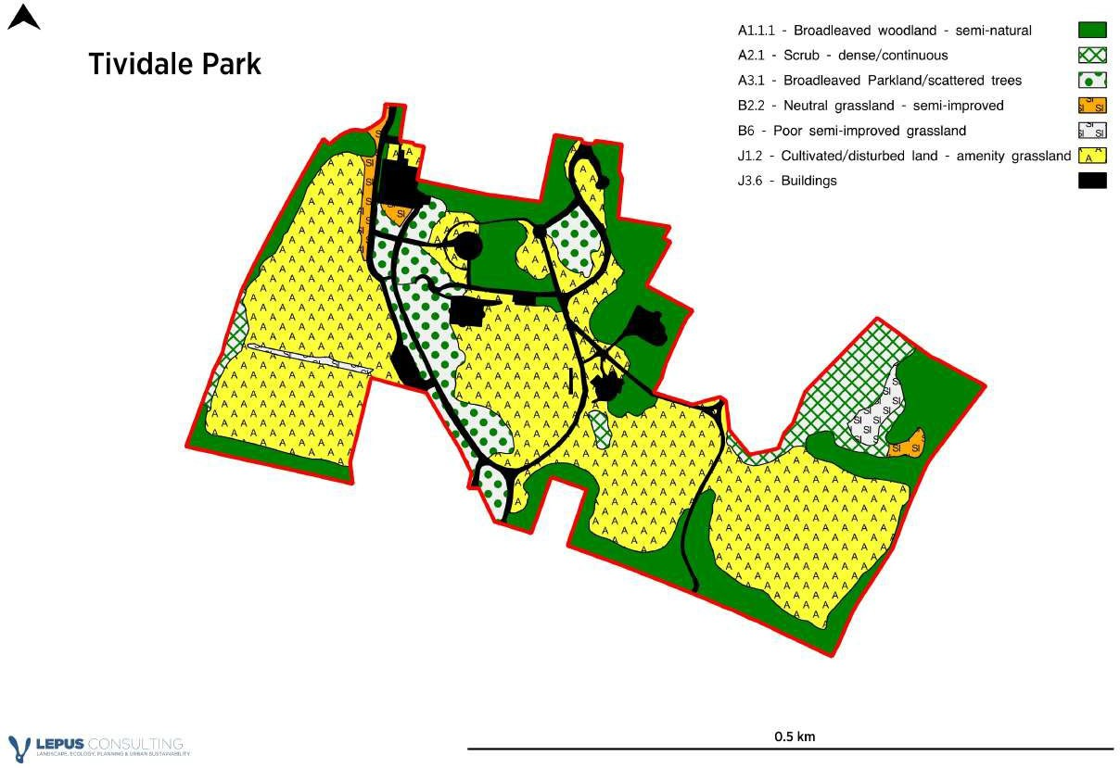

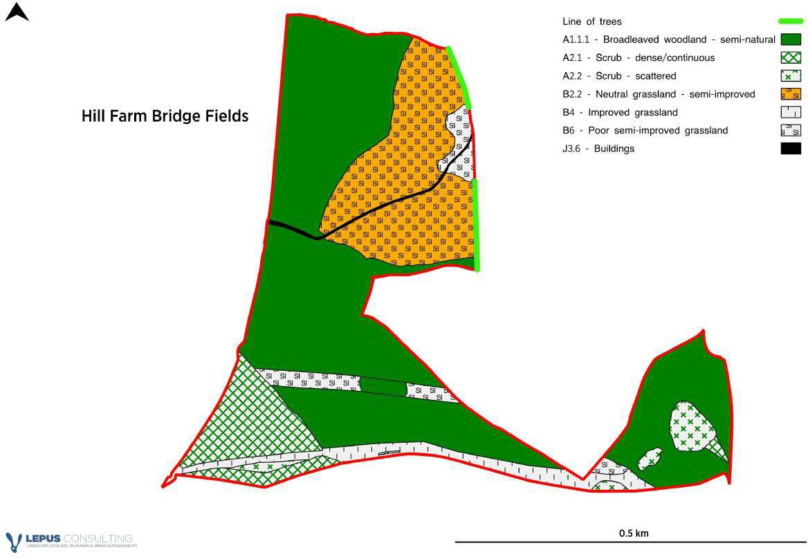

Warrens Hall Park
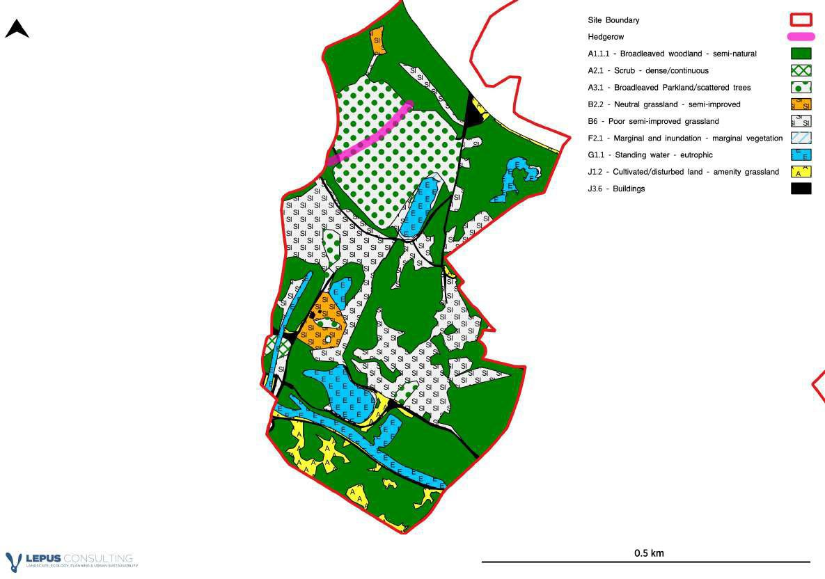

APPENDIX B – Masterplans

West Bromwich Masterplan¹ extract
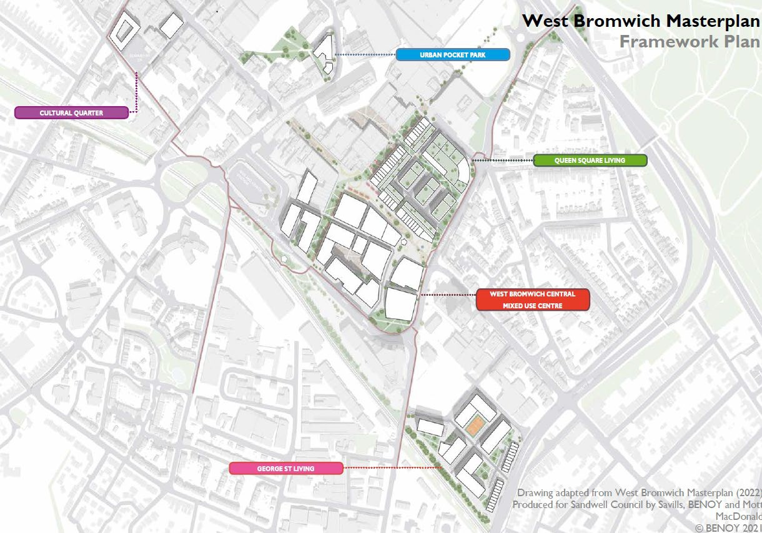

¹ https://www.sandwell.gov.uk/downloads/file/781/west-bromwich-masterplan

Carter’s Green Development Framework extract
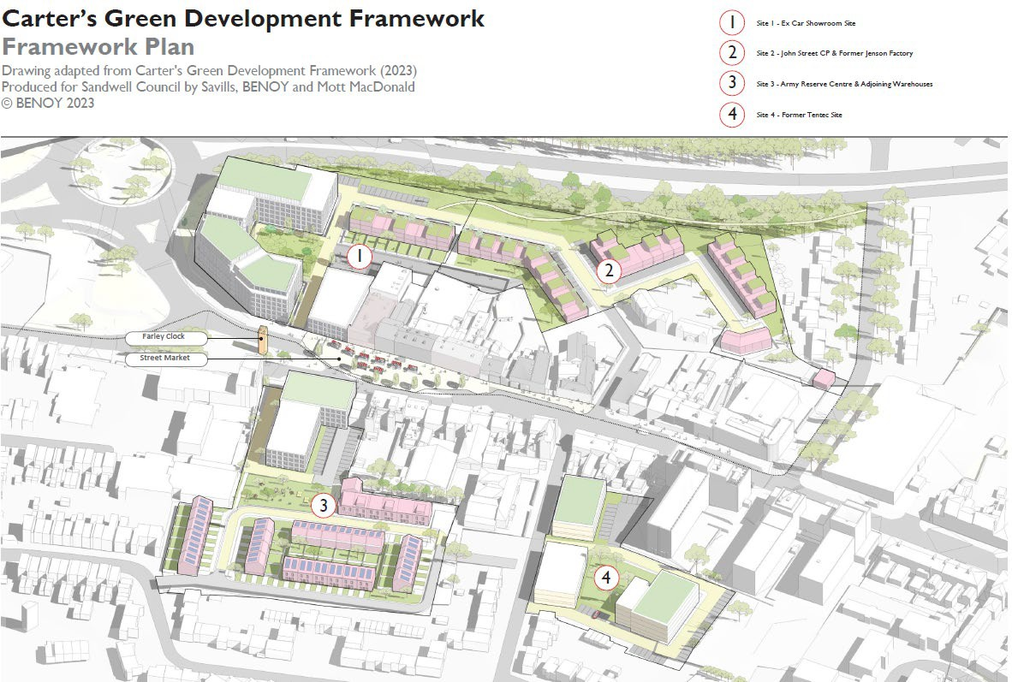

Rolfe Street Masterplan (indicative)
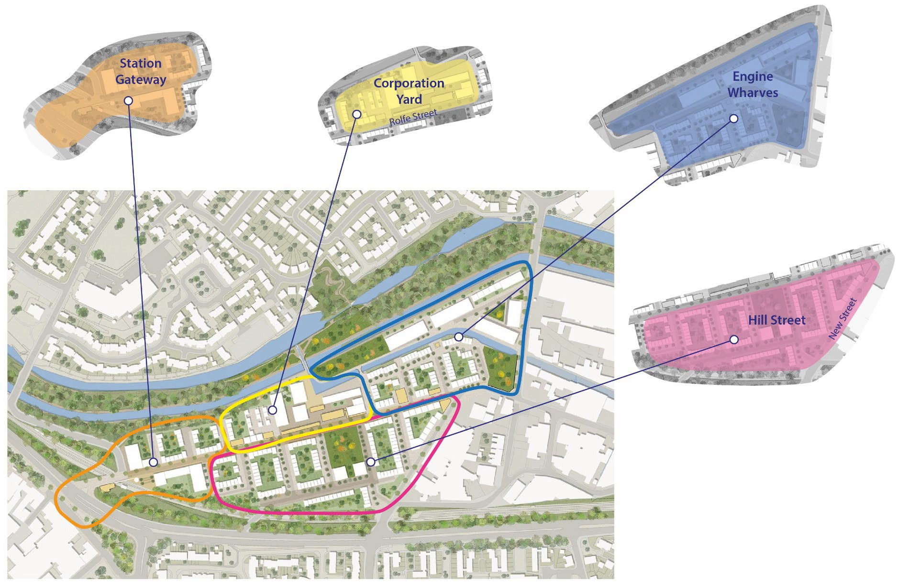
Produced from the Rolfe Street Masterplan 2023 Produced for Sandwell Council by Howells

Rolfe Street Masterplan – Smethwick Regeneration Area

Further details of the regeneration and proposed developments and improvements set out below are identified in the masterplan document, which can be viewed online and which aspiring developers will be required to have regard to when drawing up proposals.

The Smethwick to Birmingham Framework sets out a strategic plan for the whole Smethwick to Birmingham corridor. The Rolfe Street masterplan builds on the framework and sets out in more detail how the area can be developed.

The Smethwick to Birmingham corridor is Birmingham and Sandwell’s historic canal district, stretching from The Roundhouse just west of Brindley Place to Galton Bridge in Smethwick. It is the historic link between Birmingham and the Black Country and is one of the most significant areas of brownfield urban renewal in Europe with potential to deliver 4,000 new homes. Transformational change is already underway with new neighbourhoods at Port Loop and Soho Loop, and the Midland Metropolitan University Hospital nearing completion.

Rolfe Street is located at the western end of the Smethwick to Birmingham corridor. It is located adjacent to Smethwick High Street and benefits from a well-connected railway station with a six-minute journey to Birmingham; the station has seen recent investment including the provision of lift access. It is 15 minutes’ walk from the new Midland Metropolitan University Hospital, and one mile from the new Aquatics Centre (delivered as part of the 2022 Commonwealth Games).

The site itself is located largely within the Smethwick Galton Valley Conservation Area, and benefits from several formal and informal heritage assets, which together inform the area’s character. The most important of these is the Grade II* listed Engine Arm Aqueduct, which is an important artefact in the history of the development of civil engineering and transportation at the beginning of the 19th century. The retaining wall to the former Corporation Yard is Grade II listed and is an early example of the use of reinforced concrete construction, dating back to the beginning of the 20th century.

There are several other local heritage assets, identified on the Council’s Historic Environment Record2.

Due to the industrial nature of the area, piecemeal development for residential development is not considered suitable, with a more comprehensive approach seen as the most efficient means to deliver a high-quality residential community. Fragmented ownerships make this difficult to provide, hence the need for a strong Masterplan that will guide delivery and support cohesive development.

Analysis | Outcomes | Relevant SLP Policies³
Strengths | Very well connected by both public transport and active travel, with regular trains to Birmingham and Wolverhampton, high frequency bus connections to Dudley and Birmingham, accessible Metro links and cycleways including along the canal.  Further improvements to cycle routes are planned. | STR3, STR5, STR6
Strengths | Strong heritage significance, including conservation area and nationally and locally listed buildings and structures. | SHE1 - 4

² https://www.sandwell.gov.uk/planning/historic-environment
³ This list is not closed – other SLP policies will also apply in each case.

Analysis | Outcomes | Relevant SLP Policies³
 | Successful redevelopment and regeneration projects have already taken place in the vicinity, at Galton Locks and Crocketts Lane, including the conversion of historic buildings to apartments | SDS3, SHE1 – 4,
Challenges | Rolfe Street and New Street bisect the site, and both are busy and narrow. | STR1, SID1
Challenges | The location of the railway line | -
Challenges | Site topography - changes in level of about 1–2 storeys in various locations | SDS5
Challenges | The existing industrial nature of the site creates an environment unsuitable for a high-quality residential community, as the current activities generate extensive HGV movements and noise pollution. | SDS5, STR4, STR9, SCO2, SCO3
Challenges | Informal and fly parking, including across the full width of pavements, making streets feel hostile and inaccessible. | STR8, Appendix I
Challenges | Alongside the railway line, the busy Tollhouse Way to the south of the site acts as a barrier to pedestrian movement within the existing community and to and from Smethwick High Street - lack of formal crossing points. | STR5, STR6
Challenges | The site would benefit from a cycle-friendly crossing between the Rolfe Street and New Street junctions with the A457, ideally located at Cross Street. | STR5, SID1,
Challenges | Pedestrian links to the canals and into the communities to the north are poor, as there is no access across the aqueduct from the site except via a convoluted route alongside the Engine Peninsula. | SNE6, STR5, SID1
Opportunities | Opportunity to open a link through the Enterprise Centre onto the west towpath of the Aqueduct through a former gateway, and to link with the communities and park to the south across Tollhouse Way (given improved crossings). | SHW4, STR5, SID1
Opportunities | The canal and heritage assets lending a strong sense of place and a green corridor for recreation. | SDS8, SNE6, SHE1 – 4, SHW4
Opportunities | The proximity of Smethwick High Street, new segregated cycle routes, and the on-site railway station. | SDS4, SCE1, SCE2, SCE4, STR5, STR6, SID1
Opportunities | Transformation of Rolfe Street into a lower traffic environment - via street treatment and changes to junctions, or more defined restrictions to create gateway features at either end of Rolfe Street. | SDS5, STR5, STR6

Analysis | Outcomes | Relevant SLP Policies³
 | Opportunity to enhance sustainability and achieve faster delivery at Rolfe Street by using Modern Methods of Construction (MMC).  The re-use of existing buildings to reduce embodied carbon. | SDS2, SHE1 - 4, SCC1 – 4
 | New public open spaces provided at key nodes, including at the Engine, Engine Peninsula, and alongside the Fire Station and Rolfe House. | SDS8, SHW4

The Rolfe Street masterplan demonstrates how the agreed objectives can be translated into an environment that:

encourages active travel such as walking and cycling;

provides access to green space and nature;

builds on the nationally important history of the site, following the success of recent development at Port Loop and Galton Locks, and the successful Towns Fund bid for enabling works at the Enterprise Centre;

offers local employment opportunities, improved accessibility and affordable homes;

addresses issues around climate change and net zero by employing solutions such as consideration of orientation and shading, shared heat pumps and Passivhaus principles.

The masterplan envisages a distinctive, well-designed community being created in this well connected and attractive location.

Heritage Character

A series of heritage character areas have been identified. These have informed the masterplan’s character areas analysis and include:

Historic High Street: a cluster of civic and public service buildings reflecting the former status of Rolfe Street as a high street;

Eroded High Street: where buildings contributing to the high street character have been lost;

Industrial Backlands: the area around Buttress Way with detracting character

Canalside Industrial: area with strong connections to the canal;

Canals: the historic canal infrastructure, now a green corridor.

These character areas are explored in more detail in the Rolfe Street Heritage Assessment by Donald Insall (December 2022)4.

This document, and the character areas identified within it, have informed the approach to retention, building form and materiality illustrated in the masterplan.

Character Areas

Four character areas are identified within the masterplan area, which help define distinctive spaces within it. Each has unique characteristics that respond to specific site aspects, to local conditions and to the wider local context. Many of the policies identified above will also apply to these sites and must be considered when detailed schemes are proposed and determined.

⁴ https://sandwell.moderngov.co.uk/documents/s14594/Rolfe%20Street%20Characterisation%20Study.pdf

Although there is no direct comparison in terms of notional boundaries, reading the historic characterisation work alongside the masterplan provides a useful guide to the appearance and potential of each of the character areas, as indicated in the following table.

Character area | Rolfe Street Heritage Assessment descriptor | Description | Opportunities for improvement
Station Gateway | Eroded High Street | Area is suitable for a higher density development of apartments given its highly accessible location, acting as a gateway for the new community at Rolfe Street.  Would support the provision of a new area of public realm (Station Square). | A Mobility Hub could be provided, integrating rail and bus with cycle storage, cycle hire and e-mobility, to provide a ‘last mile’ solution.  Station Square will tie together the Baths Site, Mobility Hub and Rolfe Street, linking to Smethwick High Street through crossing and pavement enhancements.  Homes along the canal should be dual aspect, taking advantage of high-level views and providing activation onto a pathway facing the canal.
Corporation Yard | Historic High Street and Canalside Industrial | Enterprise Centre should be transformed into a new community, Corporation Yard. Enabling works have been undertaken, as part of Sandwell’s Towns Fund programme.  An opportunity for a higher density mix of apartments, duplexes and mews houses. Built form should respect the height, scale and materiality of the retained buildings from the former Corporation Yard, including Block 300 at four storeys, as documented in the Rolfe Street Heritage Assessment.  Retention and conversion of historic buildings if feasible. | The existing bricked up gateway onto the western side of the Aqueduct should be restored, providing direct access to the Old and New Main Lines, tying Rolfe Street into the green corridor of the Canal, and linking to existing communities.  The opportunities created by the changes in level across the site should be maximised, including potential for undercroft parking and high-level views across the canal,  Potential for a new bridge to better connect the engine peninsula.  Conversion - potential uses include residential conversion, workspace, business start-up / incubation and maker space.
Engine Wharfs | Canalside Industrial and Canals | A new community located either side of the Engine Arm with a close relationship to the canal. The existing elevations of warehouses along the south side of the canal have high heritage significance.  There is potential to retain these elevations within any  development, and to maintain | Canalside Industrial – opportunities noted in the heritage report include:  - Open access to the Engine Arm Peninsula via Bridge Street North and from Rolfe Street via Enterprise Centre  - Removal of foliage from the canal side of the listed concrete wall and introduce appropriate painted interpretation  (subject to using an appropriate

Character area | Rolfe Street Heritage Assessment descriptor | Description | Opportunities for improvement
 |  | the relationship with the water on the south side of the canal in any new development, by using bespoke house types.  Historic canal features such as the towpath bridge on the Engine Peninsula should be retained.  Rear garden walls should be low, as at Port Loop, to maintain a direct connection to the canal.  The Engine Peninsula provides a challenge to development due to a long thin site area. Apartment development is possible and would reflect the historic form. Alternatively, residential development of high-quality townhouses, relating to the canal, would provide much needed family homes. | medium and carrying out an assessment of the ecological value of the foliage)  - Remove some of the less significant 20th century buildings in the Enterprise Centre  - The condition of many buildings is poor, so a pragmatic approach is required. Buildings should be categorised in terms of their significance, followed by an assessment of their condition and convertibility on a case-by case basis; a recreation of gabled forms fronting the canal may be the result and if this is so, the reuse of materials should be pursued.  Canals – opportunities identified in the heritage report include:  - Enhancing the visual appearance of concrete terracing on the north side of the canal (public art, planting)  - Exposing the concrete wall (Grade II), with the potential for appropriate artistic interpretation  - Introducing connectivity to the canal, potentially via the Enterprise Centre  - Engine Arm Aqueduct – modern railings and surfaces could be improved (some original surfaces have been removed) to enhance its setting – and provide connection from Enterprise Centre  - Improving landscaping adjacent to Bridge Street North (Pope Bridge / Rolfe Bridge)  - Landscaping the existing tarmacked enclave / plant north of the feeder arm
Hill Street | Industrial Backlands | Hill Street should become a high-quality residential community, around central public open space. A townhouse-led approach, as at Port Loop, would provide the density needed to make a community on the site viable and not isolated | Opportunities identified in the heritage report include:  - Redeveloping the area, following its historic character, and taking the opportunity to restore a finer grain and historic uses (e.g., residential)  - Improve pedestrian / car relationship and restore appropriate hard surfaces.

Character area | Rolfe Street Heritage Assessment descriptor | Description | Opportunities for improvement
- Improve views in and out of the area.
- There may be scope to retain gable ends or walls as part of redevelopment

Grove Lane Masterplan⁵ – Smethwick Regeneration Area

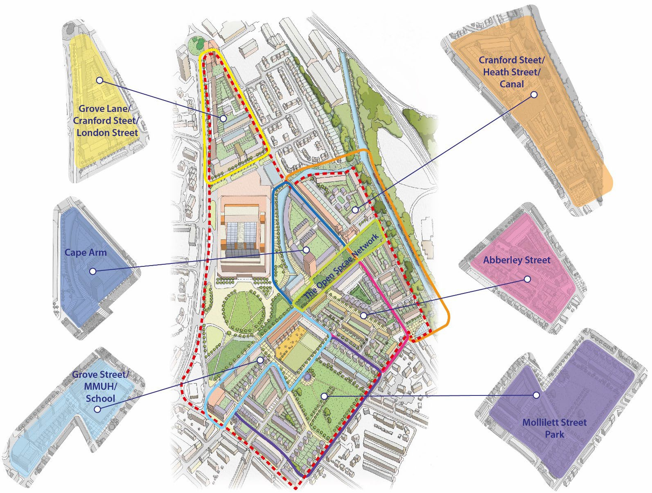

Produced from the Smethwick to Birmingham Corridor Framework – Grove Lane Masterplan (2022) Produced for Sandwell Council by Tibbalds

⁵ https://regeneratingsandwell.co.uk/sandwell_projects/grove-lane-masterplan/

Grove Lane Masterplan

Further details of the regeneration objectives, proposed developments and improvements set out below are identified in the masterplan document, which can be viewed online and which aspiring developers will be required to have regard to when drawing up proposals.

The Smethwick to Birmingham Framework sets out a strategic plan for the corridor that runs between Smethwick and Birmingham. The Grove Lane masterplan builds on this framework and sets out in more detail how the area surrounding the Midland Metropolitan University Hospital can be developed. The corridor itself is Birmingham and Sandwell’s historic canal district, stretching from The Roundhouse to the west of Brindley Place to Galton Bridge in Smethwick. It represents the historic link between Birmingham and the Black Country. The Masterplan area itself is one of the most significant areas of brownfield urban renewal in Europe.

At the heart of this corridor, the Grove Lane area houses the new Midland Metropolitan University Hospital (MMUH). With the surrounding land, it forms one of the most significant intervention sites in Sandwell. A masterplan and a high-level strategic framework have been prepared to guide development across the area and have been approved by the Council.

The Grove Lane area comprises land between Grove Lane to the west, Dudley Road to the south, Moilliett Street Park and Winson Street to the east and the Birmingham Canal to the north. The new hospital is located centrally within this area, abutting Grove Lane. A series of brownfield sites surround the hospital to the north, east and south. It has been awarded Housing Zone status and has the potential to deliver approximately 800 new homes across almost 18ha of brownfield land.

Some of these have already been provided, with around 140 dwellings constructed north of Cranford Street.

Analysis | Outcomes | Relevant SLP Policies⁶
Strengths | Proximity of the canal; the canal is a potential asset, providing recreational value and historic context.  Cape Arm branch; the branch off the Main Line offers additional waterfront potential for development | SDS5, SDS6, SDS8, SNE6, SHE1 – 4, SHW4, SID2, SDM1 – 3
Strengths | Potential for new / improved public realm and spaces around hospital; the scale of the hospital gives it the potential to frame significant public spaces. This could lead to a range of interesting spaces for varied purposes | SDS3, SDS5, SDS8, SHW4, SDM1
Strengths | Good connections by road; the nearby road network links well to surrounding places of note, particularly radial routes | STR1, STR2
Strengths | Some interesting heritage / older buildings, particularly in Cranford Street | SHE1 - 4
Strengths | Proximity to local centres, including Cape Hill and Dudley Road, which offer diverse commercial and retail services | SCE1 – 6, Cape  Hill Profile

⁶ Not a closed list – other SLP policies will also apply in each case.

Analysis | Outcomes | Relevant SLP Policies⁶
Challenges | Poor pedestrian and cycling infrastructure; pavements and roads are often narrow and can be compromised by rat-running and heavy traffic. The non-vehicular network is poorly maintained. | STR5, STR6
Challenges | Poor connections to rail-based public transport. Links to the Metro and traditional rail are difficult, and stations are not within easy walking distance. | STR3, STR5, STR6
Challenges | The area is dominated by a traditional industrial built environment | SDS3, SDS5, SHE1 – 4, SEC1 – 6, SCO3, SDM1
Challenges | Heavy traffic serving the industrial area | STR4
Challenges | Pavement parking | STR8
Opportunities | Integrating the area with Dudley Road high street | SDS3, SDS4, SCE1 – 6, STR5
Opportunities | Incorporating the Cape Arm canal into the design strategy | SDS5, SDS6, SDS8, SNE6, SHE1 – 4, SHW4, SID2, SDM1 – 3
Opportunities | Reconnecting Cranford Street / Heath Street with Dudley Road | SDS3, SDS4, STR5
Opportunities | Replacing a large industrial employment site with a predominantly residential neighbourhood (element of mixed use / education campus  / school) | SDS3, SDS5, SHE1 – 4, SHO1 – 4, SHO9, SHO11, SEC1 – 6, STR3, STR5, STR8 – 10, SID1 – 4, SCO3,  SDM1 – 3, SDM8
Opportunities | Addressing the scale of, and provide connectivity to, the new hospital | SDS5, SHW2, STR5, SDM1, SDM3
Opportunities | Reinforcing the network of mutually supporting uses required to help the neighbourhood function | SDS3, SID1, SCE5,
Opportunities | Overcoming land ownership constraints to enable the creation of a unified and seamless network of streets and spaces with an attractive public realm | SDS3

Analysis | Outcomes | Relevant SLP Policies⁶
 | Converting some existing buildings to maintain an element of history and add variety to the built fabric | SDS3, SHE1 – 4, SDM1
 | Establishing a mix of houses and flats to offer a range of accommodation to existing and new residents | SDS2, SDS3, SDS5, SHO1, SHO3 - 5, SHO7  - 8, SHO11
 | Enabling the creation of a green and blue open space network within the neighbourhood, to help meet recreational demands, including improvements to Moilliett Street Park | SDS8, SNE2, SNE6, SHW4
 | Distributing scale and density to reflect the changing character of the area | Vision, SDS1
 | Locating taller buildings at focal points / gateway sites. | SDS5, SDM1, SDM3

Wider Corridor objectives pertinent to the Grove Lane area | SLP Policies⁷
Housing provision – a mix of good quality housing typologies, tenures and densities that reflect local need, meet design standards, and which can adapt to changing lifestyles and property market considerations. | SHO1 – 7, SDM2
Economic regeneration - through construction opportunities and the expansion of healthcare, research, commerce, environmental science and technology and the enabling of start-up and small businesses | SDS1, SDS3, SEC6
Active travel and connectivity – prioritise active travel and create ‘20-minute neighbourhoods’ (i.e. the availability of most services or facilities meeting local needs within a 20-minute walk or cycle from home) | STR5
Canal network – enhance its recreational and daily commuting role. Create direct and barrier free linkages. Green the canal corridor. Create opportunities for waterside living. | SDS8, SNE1 - 3, SNE6, STR5
Place-making - people-centred communities and existing local centres. Enhance the existing characteristics of the area as well as creating a distinct identity informed by the historic environment. | Vision, SDS5, SDS8, SNE2, SNE6, SHE1 – 4, SCC3, SCC5 – 6, SHW4, SHO1 – 7, SCE1 – 5, STR5, SID1, SDM1 - 9
Education – meet defined education needs through provision of a new primary school at Grove Lane.  Seek a higher education presence linked to the Midland Metropolitan University Hospital. | SHO9, SID1

⁷ Not a closed list – other SLP policies will also apply in each case.

Wider Corridor objectives pertinent to the Grove Lane area | SLP Policies⁷
Sustainability – reduce air pollution and help decarbonise transport. Explore opportunities for renewable energy generation, sustainable construction and a heat network. | SDS2, SCC1 – 6, SHW3

The Grove Lane masterplan demonstrates how the agreed objectives can be translated into an environment that:

encourages walking and cycling through delivering compact development forms and attractive street environments that prioritise people, such as mews streets;

provides access to green space and nature;

provides a variety of different housing typologies, enabling the creation of mixed communities;

while meeting local standards, allows future flexibility should the anticipated modal shift towards less car usage be achieved.

Potential Heat Network

Sandwell Council is currently exploring the opportunity for a heat network within the Grove Lane area as part of its regeneration. If this is taken forward, Policy SCC1 – Energy Infrastructure – would become even more relevant.

Character Areas

Seven character areas are identified in the masterplan, which each relate to distinctive spaces within it. Each one has unique characteristics that reflect its specific location, local conditions and wider context.

Many of the SLP policies identified above will also apply to these sites and must be considered when detailed schemes are proposed and determined.

Character area | Description | Opportunities for improvement
Cranford Street / Heath Street / Canal | This area lies between Cranford Street and the canal in the north of the Grove Lane area. The masterplan envisages the retention of some of the existing buildings on Cranford Street, and the provision of a mix of housing typologies that will establish a frontage to the Canal feeder. | A new north-south public space to help connect Cranford Street to the northern boundary.
Cape Arm | This area sits within the boundary formed by the canal branch and Cranford Street. The masterplan envisages a primarily residential development that will sit comfortably alongside the scale and massing of the hospital, perhaps providing a landmark building on the canal basin. | Public space along the canal front / towpath will help create an area that generates activity within the waterside context.  Potential for highway widening to include additional cycleways
The open space network | These areas provide structure to the Grove Lane area, enabling movement between different spaces and beyond the site into adjoining areas. The spaces are of different | Additional open space to be provided to enhance the current network.  Explore potential for a more direct link to the canal.

Character area | Description | Opportunities for improvement
 | scales, character and function, related to their immediate context.
Grove Street / Hospital / School | This area creates a key link between two main community functions required in the area.  Grove Street needs to enclose the space and enable access across the character area to Moilliett Street Park and beyond to Dudley Road. Residential blocks should be taller the closer they stand to the hospital. | A new school on Grove Street.
Moilliett Street Park | This area lies at the heart of the residential neighbourhood; a reimagined park will be a central feature. The current park is not well used. | A smaller and more accessible park is proposed, framed by existing and new development. This should enable the space to function more effectively and be a greater asset for residents.
Abberley Street | This area is central to the residential neighbourhood and forms an important link between the north-south open space and Heath Street. The western end has a relationship with the canal basin and will be an important focal point both there and on the proposed north-south link. | Opportunities for a higher density development scheme, retention and conversion of historic buildings (subject to a decision on any potential road widening).
Grove Lane / Cranford Street / London Street | This area is a more isolated triangular parcel of mixed uses, compromised to some extent by the tapering nature of the northern end of the site and its proximity to the roundabout and the road junctions. A mix of housing typologies could be provided throughout the area. | A prominent site on the main road that can accommodate taller / landmark buildings to act as focal points along the strategic road network and within the corridor.

Wednesbury Town Centre Masterplan
Further details of the regeneration objectives, proposed developments and improvements set out below are identified in the masterplan document, which can be viewed online and which aspiring developers will be required to have regard to when drawing up proposals.
The Wednesbury Town Centre Masterplan⁸ has been designed to provide a framework for the ongoing regeneration and improvement of the main town centre, drawing on the town’s significant historic character and exploiting its increasing connectivity, represented by the extension of the West Midlands Metro between Wednesbury and Brierley Hill.
Wednesbury benefits from the wealth of historic and heritage-related development within the town centre, which was subject to a Heritage Action Zone project in partnership with Historic England. It contains a conservation are of significant size (around three hectares) and several listed buildings and other important heritage assets. It is well-connected to both public transport and the wider strategic network and is reasonably walkable. Improvements to walking routes, cycleways and public transport networks are also being considered.
The town has received a significant degree of public funding for various improvements in recent years. The sources have included:
- Investment from Historic England and the Council in the Wednesbury High Street Heritage Action Zone⁹ between March 2020 and March 2024 to deliver improvements to the historic town core and Market Place, with a focus on streetscape enhancements and uplift to surrounding historic buildings.
- A Levelling Up Partnership¹⁰ between the Council and the Department for Levelling Up, Housing and Communities to help deliver new homes, tackle crime and antisocial behaviour, improve green spaces and the overall environment of Wednesbury town centre, and expand the Millennium Centre in the town.
- Investment in transport infrastructure in conjunction with Transport for West Midlands, including the Metro extension and related walking and cycling provision.
The masterplan focusses on the town centre and incorporates both the retail centre boundary identified in the draft SLP and some additional areas containing possible development sites. It also reflects the link to the Metro station to the south of the town centre and the library to the north.

Analysis | Outcomes | Relevant SLP Policies¹¹
Strengths | A largely intact historic townscape, typically of two and three-storey buildings with continuous frontage and distinctive corner | SDS4, SDS5 SHE1 – 4, SDM1, SDM3

⁸ https://consultationhub.sandwell.gov.uk/regeneration-growth/wednesbury-masterplan-consultation/supporting_documents/Wednesbury%20Town%20Centre%20Masterplan%20DRAFT.pdf
⁹ https://regeneratingsandwell.co.uk/sandwell_projects/wednesbury-high-street-heritage-action-zone/
¹⁰ https://regeneratingsandwell.co.uk/about/wednesbury-levelling-up-partnership/
¹¹ Not a closed list – other SLP policies will also apply in each case.

Analysis | Outcomes | Relevant SLP Policies¹¹
buildings, covering a range of eras, architectural styles and materials.
A distinctive and historic street pattern and urban grain, including the triangular Market Place, which has been in existence since at least the late medieval period.
 | Significant / landmark buildings, including (but not limited to) the Grade II listed market clock tower, John Taylor Duce & Sons building (Talbot House), the Golden Cross public house, the former Gaumont Cinema, Wednesbury Town Hall and Wednesbury Museum and Art Gallery.  Wednesbury Library and Memorial Gardens are located directly to the north of the study area. | SDS4, SDS5, SHE1 – 4  SDM1, SDM3
 | A large proportion of active ground floors on Union Street, Upper High Street, Lower High Street and Market, including many traditional shopfronts and public houses, maintaining a commercial character. | SDS4, SCE1 – 6, SDM4 - 8  Wednesbury Town Centre Profile
Challenges | Areas of weak townscape character including poorly designed modern infill buildings.  Inferior quality property elevations / boundaries facing High Bullen where the historic urban grain has been disrupted, creating a negative impression of the town for people travelling into or through the centre by car and bus.  Examples of dilapidation, vacancy and gap sites that have an adverse impact on visual amenity and foster an appearance of neglect, and access / views to areas of poor-quality townscape. | SDS3 - 5, SDS8, SHE1 – 4, SDM1  Wednesbury Town Centre Profile
Challenges | Significant backlog of repair and maintenance issues across the town, with many buildings in a poor state of repair.  Various buildings that have been subject to inappropriate modern alterations and shop front signage, detracting from their historic character. | SDS3 – 5  SHE1 – 4 SDM1, SDM3 - 5  Wednesbury Town Centre Profile

Analysis | Outcomes | Relevant SLP Policies¹¹
 | High status / prominent vacant buildings such as the Gaumont Cinema negatively impact views into and out of the town and attract anti-social behaviour. | SDS3 – 5, SDM1, SDM3
 | Unsatisfactory welcome to the town centre and resulting adverse impact on user perceptions, including a lack of wayfinding.  Access is via back lanes, such as Hitchin’s Croft, which lead pedestrians through areas of poor-quality public realm and townscape and provide access / views to the rear elevations of properties.  Distance to Metro Stop, poor quality of surrounding environment and routes to the town centre.  Presence of dual carriageways and their associated substandard environment have an adverse impact on the perception of the town and its accessibility from adjacent areas using active travel methods. | SDS3, SDS4, SDS6, SEC1 – 6, STR5,
 | Changing retail context including an anticipated continued decline in town centre retail demand. Current limited retail offer and small-scale evening economy. | SDS6, SCE1 - 6
 | Lack of green infrastructure and open spaces within the town centre. | SDS5, SDS8, SNE1 – 3, SHW4, SDM1  Wednesbury Town Centre Profile
Opportunities | Strong sense of community pride.  An existing range of successful community events in the town centre that are helping to change local perceptions. | SDS6, SDS8, SCE2, SCE3
Opportunities | Existing character, identity and heritage, which can be enhanced and used as an asset.  Existing green spaces and green infrastructure close to the town centre, which can be better integrated. | SDS2, SDS5, SDS8, SNE1 – 3, SHE1 – 4 SHW4, SHW4, SDM1

Analysis | Outcomes | Relevant SLP Policies¹¹
 | Numerous potential development sites that can bring new uses to the town centre.  Existing residential and employment uses within walking distance of the town centre, which can be better connected to bring more footfall to the area.  Existing pedestrian spaces with the potential to enhance them following recent investment in Market Place. | SDS1, SDS3, SDS4, SHO3, SEC6, SCE3, SCE6, STR5
 | Generally good accessibility by road, bus and Metro, and potential to improve the quality of and connections to points of arrival by these modes. | STR1, STR3, STR5, STR6, STR8
 | The Wednesbury to Tipton Metro Corridor Regeneration Area brings the opportunity to transform existing lower value industrial uses into a wider range of higher value employment and other uses close to the town centre and metro stop. | SEC5, STR1
The Town Centre Masterplan includes five strategies that will help to shape the future of Wednesbury as both a destination and as a built and natural environment. The strategies consider how change will be implemented, based on a short-term time frame of five years and a longer term one of five years and beyond.

Strategy | Approach¹² | Link to SLP objectives
Development strategy | This will support the vibrancy of the town centre by densifying and diversifying the types of land uses present, in part by providing for a variety of housing types, tenures and affordability. This will help to increase footfall throughout the day and evening, support the viability of local businesses, and promote sustainable patterns of movement by increasing accessibility to services and facilities.  Good development that reflects local townscape character will enhance the built environment by infilling gap sites, re-using existing and historic buildings, creating a stronger urban presence in relation to existing roads, increasing the visibility of the town centre. | 4, 6, 13, 15

¹² Abridged – full details can be found in the masterplan.

Strategy | Approach¹² | Link to SLP objectives
Movement Strategy | This will increase the accessibility of the town centre by all modes, with an emphasis on supporting active travel, integrating with surrounding neighbourhoods and encouraging a shift to more sustainable travel modes. This will ensure that the town centre acts as a focal point for the community, and is convenient, welcoming and inclusive on a day-to-day basis for them and first-time and occasional visitors.  Improved connections to the metro and bus station will help to make the town centre more accessible within the region, and will promote new development in an accessible, sustainable location. Improving the points of arrival and interchange between modes will simplify journeys. | 10, 16, 18
Public Realm Strategy | This will create a series of attractive, vibrant spaces along key streets within the town centre. It will help ensure that the town centre reads as welcoming, safe, comfortable and inclusive for all visitors. The centre will become easier to understand and use, promoting a positive user experience that encourages people to visit the town centre more frequently and stay for longer.  Public realm will integrate high quality materials with urban greening, street furniture, lighting, wayfinding, public art and provision for children’s play. It will reflect the distinctive character of the town by integrating aspects of the historic environment, incorporating the recently completed Market Place scheme and linking the town centre with surrounding locations including the metro stop and nearby green spaces. | 3, 4, 12, 13
Greening Strategy | This will promote the integration of additional urban greening, ensuring that visitors experience an attractive environment with opportunities for greater interaction with nature. The approach will help to improve air quality and water resilience and promote increased biodiversity, as well as reconnecting the centre with a wider green network.  The consideration of human health and wellbeing will be promoted using high quality biophilic designs, which incorporate greening and | 3, 10, 12, 14,

Strategy | Approach¹² | Link to SLP objectives
 | natural solutions into public realm enhancements, including sustainable drainage and the greening of buildings.
Sustainability Strategy | This will support Sandwell’s wider sustainability strategy, promoting its commitment to reach carbon neutrality borough-wide by 2041, promote equality and inclusivity in access to energy and heating for all, and support other connected aspirations such as the transition from fossil fuels to low-carbon energy in transport, buildings and other areas of influence.  This will include the creation of a ‘net zero neighbourhood’ strategy that identifies key priorities for local sustainability based on engagement with the local community and other key stakeholders. | 1, 3, 12
The Wednesbury Masterplan goes on to identify several projects that will help to deliver the proposed regeneration of the town centre. These include site redevelopments / refurbishments / new buildings, enhancements to the local landscape and environment (both natural and built), infrastructure improvements and the delivery of cultural and activity-related opportunities to increase public participation in and enjoyment of the centre.
While the following list provides an abridged description of some of the schemes (full details of these and other schemes can be found in the masterplan), proposals include:

Project | Description
Wayfinding, Heritage & Arts Trails | Make provision for a co-ordinated wayfinding system that helps visitors on foot and in cars to navigate the town and access the town’s assets and facilities and provides a joined-up visual identity for visitor information.  - Digital material supporting wayfinding, including a directory of retailers and facilities. This could include a ‘visit Wednesbury’ online shop for independent retailers.  - Simplified wayfinding map identifying key locations in and surrounding the town centre and facilities such as public toilets.  - Interpretation material providing information about the history of locations and landmarks, potentially including a heritage trail.  - Provision of distinctive art installations including murals on blank building façades.

Project | Description
Leisure & Social Hub | Create new leisure and social destination(s) at the former Gaumont Cinema, with consideration given to the desire to create an expanded evening economy and a destination for families and other groups that currently don’t visit the town centre.  - A new cinema and theatre space.  - Themed social experiences such as adventure golf.  - Food and drink venue(s).  - Flexible arts, exhibition and events spaces e.g. a community-led multifunctional performance space.  Proposals should reflect the desire to retain the historic frontage and other elements of the former cinema where possible / appropriate.
Wednesbury Net Zero Neighbourhood | Develop a net zero neighbourhood plan to understand the local area, recognise opportunities that improve sustainability and support a commitment to net zero carbon and identify other considerations relating to the climate emergency and energy resilience / affordability.  A net zero neighbourhood is a community where energy requirements are reduced through demand reduction measures, and remaining energy needs are met through decarbonised energy sources. It will also include employing additional measures to create a sustainable place to live.  Development of this strategy should be Wednesbury-specific and include full engagement with local communities, businesses and infrastructure providers. When considering the pathway to Net Zero, a whole-system approach should be applied, considering the interactions, feedback and dependencies needed to identify suitable interventions.  - Grant funding for sustainable building improvements and replacement of fossil fuel-dependent household and business infrastructure.  - Provision for larger-scale community-owned renewable generation projects.  - Commitment from Sandwell Council (and partners) to promote sustainable buildings for all new developments where they have direct influence (e.g., ownership, funding).  - Improvement to the existing energy grid to support increased usage, including provision for smart grids and local energy storage (subject to engagement with Distribution Network Operator).

Project | Description
- Improved digital infrastructure / strategy to support home working and local co-working communities.
- Promotion of electric vehicles (EVs), EV charging infrastructure and EV car clubs with the aim of providing alternatives to car ownership.
- Promoting growth in green industries and encouraging skills development.

APPENDIX C - Strategic Waste Sites
The existing strategic sites, identified on the Waste Diagram and listed in the table below, are the most significant waste management facilities operating in Sandwell. They have been identified through a detailed analysis of all known licensed and exempt facilities. Sandwell Council will safeguard all existing strategic and other waste management facilities from inappropriate development, to maintain existing levels of waste management capacity and meet Strategic Objective 13.

Table 1 - Strategic Waste Sites
Site Ref | Site | Operational Capacity (tpa)
Municipal Waste Recovery – Supporting Infrastructure
WS07 | Eagle Recovery and Transfer Hub | 140,000
WS08 | Sandwell HWRC (Shidas Lane) | 20,000
Waste Disposal Installations (1)
WS17 | Edwin Richards Landfill | 250,000
WS17 | Edwin Richards Landfill | 9,171,000¹³
Significant Hazardous Waste Treatment Infrastructure
WS19 | Wednesbury Treatment Centre | 40,000
Significant Metal Recycling Sites (MRSs)
WS23 | Alutrade | 24,000
WS24 | Enablelink | 165,000
WS25 | ELG CSR Depot (Rowley Regis) ^{[1]} | 20,000
WS26 | EMR Smethwick | 60,000
WS27 | Sims MRS Smethwick (Rabone Lane) | 200,000
WS28 | Sims MRS Smethwick (Unit 60 Anne Road) | 20,000
Other Significant Waste Management Infrastructure
WS37 | Bescot LDC, Bescot Sidings | 150,000
WS38 | Biffa Tipton WTS | 65,000
WS39 | Midland Waste Treatment | 200,000
WS40 | Edwin Richards Inert Recycling and Soil Treatment Facility | 75,000

13 Estimated Total Landfill Capacity in tonnes has been calculated from the remaining landfill capacity in cubic metres at the end of 2018, using the following formula: 0.85 tonne = 1 cubic metre, therefore tonnes = cubic metres x 0.85.

Site Ref | Site | Operational Capacity (tpa)
WS41 | Envira Recycling | 50,000
WS42 | Giffords Recycling | 20,000
WS43 | Jayplas | 70,000
WS44 | Recycle Lives (Cox’s Lane) | 25,000
WS46 | Biffa Waste Management Oldbury | 60,000
WS47 | Union Road Inert Waste Recycling Facility | 40,000
WS48 | Wednesbury Aggregates Recycling Facility | 35,000
[1] Operational in 2018 but currently (April 2020) ‘mothballed.’
Sources: Environment Agency: Waste Data Interrogator (WDI) 2007 – 2018, Operational Incinerators, 2018, Public Register, Remaining Landfill Capacity in England as at end of 2018 Version 2.

Preferred Areas for New Waste Facilities
Several employment areas have been identified in the Black Country Waste Study (BCWS) as being most suited to the development of new waste recovery, treatment and transfer infrastructure. In Sandwell, they are the sites contained in Table 26. Under Policy W3, these areas are considered least likely to give rise to land use conflicts, and in several cases, there is already co-location of existing waste facilities to which new sites would contribute.
Table 2 - Preferred Areas for new Waste Facilities

Site Ref | Address | Potentially Suitable Waste Use ^{[1]} | Area
WPSa1 | Cornwall Road and Parkrose Industrial Estates, Soho | Energy from waste treatment, in-vessel composting, anaerobic digestion, transfer, recycling | 60.1
WPSa2 | Tat Bank, Langley | Energy from waste treatment, in-vessel composting, anaerobic digestion, transfer, recycling | 53.1
WPSa3 | Charles Street Enterprise Park, Queens Court Trading Estate, Swan Village | Treatment, in-vessel composting, anaerobic digestion, transfer, recycling | 42.7
WPSa4 | Hill Top and Bilport Lane Industrial Estates, Wednesbury | Treatment, in-vessel composting, anaerobic digestion, transfer, recycling | 19.9
WPSa5 | Powke Lane and Waterfall Lane Trading Estates, Rowley Regis | Treatment, in-vessel composting, anaerobic digestion, transfer, recycling | 46.1
WPSa6 | Dartmouth Road | n/a | 26.2
¹ As indicated in the Black Country Waste Study, Wood 2020

APPENDIX D - Minerals
The Black Country Minerals Study (BCMS, Tables 12.9 and 12.10) lists all known existing mineral sites and mineral infrastructure sites in the Black Country.
Existing Black Country mineral infrastructure sites include secondary / recycled aggregates production, rail-linked aggregates depots, coating plants, ready-mix (RMX) concrete batching plants, manufacture of concrete products, and dry silo mortar (DSM) plants.
The Council will safeguard existing mineral infrastructure sites against inappropriate development – this is necessary to retain existing capacity, thereby helping to make best use of / conserve existing resources.
The locations of these mineral infrastructure sites are identified on the Policies Plan, and are listed in the following table:
Table 3 - Key Mineral Infrastructure

Site Ref | Site | Location | Type
MIS1 | Anytime Concrete | Gerard House, Kelvin Way, West Bromwich | Concrete batching plant
MIS2 | Bescot LDC - Rail Ballast Facility | Land at Bescot Sidings, off Sandy Lane, Wednesbury | Rail-related aggregates depot/ Aggregates recycling
MIS3 | Breedon Oldbury Concrete Plant | Engine Street, Oldbury | Aggregates recycling
MIS4 | Breedon Oldbury Concrete Plant | Cemex House, Wolverhampton Road, Oldbury | Concrete batching plant
MIS5 | Former Hanson Site (West Bromwich) | Grice Street, West Bromwich | Aggregates recycling
MIS6 | Hanson Ready Mixed Concrete Plant | Roway Lane, Oldbury | Concrete batching plant
MIS7 | Wednesbury Asphalt Plant | Smith Road, Wednesbury | Coating plant
MIS8 | Cradley Special Brick | Corngreaves Trading Estate, Overend Road, Cradley Heath | Brickworks
MIS9 | Oldfields Inert Recycling Facility | Oldfields, off Corngreaves Road, Cradley Heath | Aggregates recycling

APPENDIX E – Site allocations - changes

Table 4 - Changes to previous Local Plan designations (Waste and Minerals)
Local Plan Document | Designation / Site Reference | Site Name | Description of Change | Reason for Change
BCCS (also mapped in the DBDS) | MSA (BCCS  Policy MIN1) | Mineral Safeguarding Area (covers almost the whole of the Black Country) | Removed | Replaced in the draft BCP by more tightly defined MSAs in Walsall Borough

Table 5 - Changes to previous housing allocations
Allocation Ref | Site Ref | Old SAD Ref | Address | Site Area (ha) | Est. Capacity | proposed use
(1130) | 3016 |  | 230 Oldbury Road | 1.48 | 52 | employment
(300) | 2966 |  | Alexandra Industrial Estate, Locarno Road / Alexandra Road, Tipton | 2.2 | 77 | employment
H9.8 | 3398 | 302 | Alexandra Road / Upper Church Lane / Locarno Road, Tipton | 10.43 | 142 | employment
H13.6 | 3226 | 1303 | Bank Street, Cradley Heath (west of Kimber Drop Forgings site) | 1.3 | 41 | employment
 | 5450 |  | Barnfield Trading Estate Tipton | 2.24 | 78 | employment
H9.7 | 1401 | 801 | Bell Street / Dudley Road, Tipton | 0.62 | 20 | employment
H9.1 | 2945 | 968 | Beswick Paper, Dudley Road, Oldbury | 0.96 | 33 | employment
H9.1 | 2944 | 967 | Birmingham Board Co Ltd, Dudley Road East, Oldbury | 1 | 32 | employment
(911) | 2967 |  | Black Country Park, Great Bridge Street, Great Bridge | 2.18 | 76 | employment
H16.2 | 3219 | 753 | Bloomfield Road / Barnfield Road | 0.83 | 26 | employment
H16.3 | 3221 | 842 | Bloomfield Road / Fountain Lane | 1.5 | 53 | employment
WBPr32 | 2385 |  | Brandon Way / Albion Road (North) | 6.2 | 248 | employment
WBPr33 | 2386 |  | Brandon Way / Albion Road (South) | 1.5 | 494 | employment

Allocati on Ref | Site Ref | Old SAD Ref | Address | Site Area (ha) | Est. Capacity | proposed use
WBPr34 | 2387 |  | Brandon Way / Brandon Close | 1 | 43 | employment
H13.4 | 3027 | 280 | Bridge Trading Estate | 0.57 | 19 | employment
H9.1 | 2949 | 1196 | British Gas Plc, land off Dudley Road, Oldbury | 1.04 | 33 | employment
H13.8 | 3020 | 656 | Broadcott and Broadway Industrial Estates | 1.49 | 47 | employment
 | 5623 |  | Brook Street Business Centre, Brook Street Community Centre, 196- 200 Bloomfield Road. | 1.5 | 53 | employment
 | 5139 |  | Brymill Industrial Estate, Brown Lion Street, Tipton | 1.98 | 69 | employment
(144) | 2973 |  | Burnt Tree Industrial Estate, Groveland Road | 0.82 | 29 | employment
H9.7 | 2938 | 265 | Castle Street, Tipton | 1.49 | 47 | employment
H9.4 | 2936 | 1239 | CBF LTD, Wade Building Services, Groveland Road, Oldbury | 1.26 | 40 | employment
WBPr38 | 2389 |  | Church Lane / Gladstone Street | 2.8 | 111 | employment
H8.1 | 2924 | 657 | Church Lane, West Bromwich | 0.75 | 24 | employment
H9.5 | 2463 | 150, 856 | Coneygre Business Park | 7.61 | 300 | employment
H9.5 | 2943 | 878 | Coneygre Road / Burnt Tree, Tipton | 1.11 | 35 | employment

Allocati on Ref | Site Ref | Old SAD Ref | Address | Site Area (ha) | Est. Capacity | proposed use
H8.4 | 2926 | 791 | Corner of Bridge Street and Mounts Road, Wednesbury | 3.15 | 110 | employment
H13.2 | 3010 | 1301 | Corngreaves Road | 2.8 | 98 | employment
H8.5 | 2906 | 15 | Darlaston Road / Old Park Road, Kings Hill, Wednesbury | 5.2 | 200 | employment
(247) | 2960 |  | Diamond Buses, Hallbridge Way, Oldbury | 3.13 | 110 | employment
(148) | 2957 |  | Dudley Road / 28 Dudley Road West | 1.78 | 62 | employment
(375)  Post 2021 | 2969 |  | Dudley Road West, Oldbury | 0.46 | 16 | employment
H9.5 | 2937 | 151 | Fisher Street / Coneygre Road, Tipton | 1.7 | 60 | employment
H12.6 | 2990 | 200 | Fitzgerald Lighting Ltd, Rood End Road | 1.39 | 44 | employment
 | 5972 |  | Former Corus Premises, Bloomfield Road, Tipton | 0.56 | 20 | employment
H13.6 | 3225 | 217 | Foxoak Street / St Annes Road (Kawasaki Garage) | 0.4 | 14 | employment
H13.6 | 3034 | 933 | Foxoak Street, Newtown Lane, Providence Street | 4.82 | 168 | employment
(248) | 2963 |  | Groveland Road | 1.18 | 41 | employment
H9.5 | 6109 | 80 | Groveland Road, Dudley Port, Tipton | 0.11 | 7 | employment

Allocati on Ref | Site Ref | Old SAD Ref | Address | Site Area (ha) | Est. Capacity | proposed use
H8.4 | 2907 | 34 | Holloway Bank, Wednesbury | 5.71 | 149 | employment
(836) | 2971 |  | Hurst Lane / Birmingham Canal / Sedgley Road, West Tipton | 2.19 | 77 | employment
(789) | 3013 |  | JAS Industrial Park, Titford Lane, Oldbury | 0.93 | 33 | employment
H8.5 | 2921 | 642 | Kings Hill Trading Estate, Darlaston Road, Wednesbury | 3.28 | 86 | employment
H9.4 | 2950 | 1240 | Land adjacent to Cleton Business Park, Tipton Road, Tipton | 0.56 | 18 | employment
 | 5648 |  | Land at Potters Lane, Wednesbury | 0.74 | 26 | employment
(578) | 2965 |  | Land between Great Bridge Street and William Street, Tipton | 1.92 | 67 | employment
 | 5642 |  | Land between Potters Lane and Stafford Street Wednesbury | 0.85 | 30 | employment
H8.2 | 2915 | 550 | Land between Tinsley Street and Whitehall Road, Tipton | 0.28 | 10 | employment
H8.2 | 2917 | 555 | Land between Whitehall Road and Walsall Canal, Great Bridge | 0.75 | 23 | employment
H8.1 | 2920 | 634 | Land to north and west of Ridgacre Road | 1.63 | 51 | employment
H8.1 | 2923 | 654 | Land to the south of Ridgacre Road, West Bromwich | 1.11 | 35 | employment
H8.4 | 2911 | 334 | Mounts Road, Wednesbury | 1.1 | 39 | employment

Allocati on Ref | Site Ref | Old SAD Ref | Address | Site Area (ha) | Est. Capacity | proposed use
H13.5 | 3004 | 259, 896 | Newlyn Road | 3.37 | 103 | employment
 | 5138 |  | Nicholls Road, Tipton | 3.96 | 139 | employment
H8.5 | 2922 | 643 | Old Park Trading Estate site on Old Park Road, Wednesbury | 2.62 | 68 | employment
WBPr31 | 2384 |  | Oldbury Road | 16.8 | 588 | employment
H12.7 | 2994 | 854 | Oldbury Road Industrial Estate | 0.57 | 18 | employment
(855) | 3014 |  | Oldbury Road, Oldbury | 2.89 | 102 | employment
H13.5 | 3032 | 260 | Oldfields | 1.64 | 51 | employment
H13.7 | 3043 | 297 | Palmers Timber Site, Station Road, Old Hill | 3.21 | 84 | employment
 | 5265 |  | Phase 9, The Parkway, site between Stafford Street, Victoria Street and Potters Lane, Wednesbury | 0.94 | 33 | employment
 | 5129 |  | Portway Road, Wednesbury | 10.7 | 375 | employment
H12.8 | 2372 | 121 | Rabone Lane, Smethwick | 5.98 | 209 | employment
 | 5551 |  | Ridgacre Enterprise Park, Ridgacre Road, West Bromwich | 0.8 | 28 | employment
 | 5553 |  | Rimstock Plc, Ridgacre Road, Black Lake, West Bromwich | 1.05 | 37 | employment

Allocati on Ref | Site Ref | Old SAD Ref | Address | Site Area (ha) | Est. Capacity | proposed use
H13.8 | 3017 | 284 | Sandwell MBC Depot and surrounds, Waterfall Lane, Cradley Heath | 1.36 | 43 | employment
(834) | 2953 |  | Sedgley Road West, High Street, Tipton | 1.12 | 39 | employment
 | 5641 |  | Site between Great Western Street and Potters Lane, Wednesbury | 1.14 | 49 | employment
H8.4 | 2925 | 788 | Site off Mount Road Wednesbury | 0.49 | 17 | employment
H8.4 | 2927 | 795 | Site on corner of Woden Road South and Bridge Street, Wednesbury | 1.61 | 56 | employment
 | 5646 |  | Site on Stafford Street, Wednesbury | 1.45 | 51 | employment
H13.5 | 3142 | 1302 | Spinners End | 0.71 | 25 | employment
3019 | 3019 |  | Station Road (South), Rowley Regis | 0.85 | 30 | employment
H13.4 | 3026 | 268 | Station Street / Graingers Lane | 1.3 | 41 | employment
H9.6 | 1448 | 81 | Station Street, Tipton | 1.37 | 43 | employment
WBPr36 | 2975 |  | Swan Village Industrial Estate, West Bromwich | 0.8 | 25 | employment
(149) | 2958 |  | Tipton Road, Oldbury | 1.76 | 62 | employment
(145) | 2955 |  | Unit 1, Groveland Road | 0.36 | 13 | employment

Allocati on Ref | Site Ref | Old SAD Ref | Address | Site Area (ha) | Est. Capacity | proposed use
HOC11 | 2232 | 263 | United Steels Ltd, Upper Church Lane Tipton | 1.58 | 73 | employment
(147) | 2956 |  | Upper Chapel Street / Brittania Street / 70 - 74 Dudley Road West | 0.63 | 22 | employment
H9.4 | 2951 | - | Vaughan Trading Estate | 19.92 | 349 | employment
 | 5556 |  | Vector Industrial Park, Church Lane, West Bromwich | 5.2 | 182 | employment
H13.8 | 1461 | 665, 80  and 82 | Waterfall Lane and 101-126 Station Rd | 0.34 | 8 | employment
H9.1 | 2935 | 966 | Wellman Robey Ltd, Newfield Road, Oldbury | 4.91 | 129 | employment
H8.2 | 2916 | 553 | Whitehall Industrial Estate, Whitehall Road, Great Bridge | 2.51 | 65 | employment
H9.2 | 3224 | 310 | 10 - 60 Dudley Road East, Oldbury | 2.00 | 70 | employment SEC4
H16.5 | 2370 | 303 | Bradleys Lane / High Street | 0.38 | 13 | employment SEC4
H9.7 | 2942 | 779 | Castle Street / High Street, Tipton | 0.7 | 23 | employment SEC4
H12.4 | 2980 | 109 | Clay Lane, Oldbury | 0.28 | 12 | employment SEC4
H9.5 | 354 | 91 | Park Lane West (South Staffs Depot), Tipton | 2.95 | 77 | employment SEC4
H9.9 | 2947 | 1117 | Railway Street, Horseley Heath, Tipton | 0.35 | 12 | employment SEC4

Allocati on Ref | Site Ref | Old SAD Ref | Address | Site Area (ha) | Est. Capacity | proposed use
 | 3223 |  | Summerton Road | 0.52 | 18 | employment SEC4
 |  |  | Zion Street, Tipton | 2.43 |  | employment SEC4
 |  |  | 70-74 Crankhall Lane | 1.78 |  | employment SEC4 (VT ROUTE TWR (001A - 016):  400Kv Overhead Transmission Line route: BERKSWELL - OCKER HILL)
(724) | 3140 |  | Land at Dolton Way, between Factory Road, Bloomfield Road and railway line, Tipton. | 2.62 | 99 | employment SEC4 subject to assessment
H8.3 | 2929 |  | Site on corner of New Street, Hill Top, West Bromwich | 1.11 | Allocated as both community open space and housing | Propose to delete the housing allocation and retain the community open space allocation.
(1129) | 3015 |  | 104 -110 Oldbury Road, Smethwick | 0.68 | 24 | white land
HOC13 | 2983 | 1135 | Allsops Hill Rowley Regis | 0.38 | 13 | white land
H8.7 | 2933 | 45 | Bannister Road, Wednesbury | 2.22 | 76 | white land
H16.5 | 3141 | 863 | Batmanshill Road / Hobart Road | 0.25 | 8 | white land
HOC9 | 2085 | 1047 | Brunswick Park Trading Estate, Wednesbury | 0.36 | 42 | white land

Allocati on Ref | Site Ref | Old SAD Ref | Address | Site Area (ha) | Est. Capacity | proposed use
WBPr30 | 2381 |  | Bus Depot, Oak Road, West Bromwich | 1.1 | 68 | white land
H12.10 | 2997 | 123 | Cape Hill / Durban Road | 2.97 | 94 | white land
H8.1 | 1443 | 51 | Cardigan Close / Sussex Avenue | 0.14 | 5 | white land
H12.7 | 2423 | 210 | Churchill Road, Smethwick | 0.5 | 60 | white land
H13.4 | 3031 | 1124 | Cradley Road (East) | 0.41 | 12 | white land
H13.4 | 3029 | 587 | Cradley Road (West) | 0.99 | 33 | white land
H12.5 | 585 | 466 | Flash Road / Broadwell Road, Oldbury | 0.68 | 5 (36) | white land
H12.3 | 1919 | 1032 | Former Starlight Auto Sales, Wolverhampton Road | 0.23 | 14 | white land
H8.2 | 2931 | 1120 | Garage on Whitehall Road, Great Bridge, Tipton | 0.14 | 5 | white land
H13.11 | 3044 | 613 | High Street, Blackheath | 0.35 | 12 | white land
H12.7 | 1446 | 482 | Holly Lane, Smethwick | 0.53 | 29 | white land
WBPr37 | 1440 |  | John Street North | 0.49 | 18 | white land
H12.6 | 1698 | 614 | Land adjacent to 88 Wellesley Road | 0.26 | 9 | white land

Allocati on Ref | Site Ref | Old SAD Ref | Address | Site Area (ha) | Est. Capacity | proposed use
HOC3 | 3048 | 1014 | Land at Newton Road, Great Barr | 0.2 | 16 | white land
HOC13 | 2984 | 1282 | Land at Tippity Green, Rowley Regis | 4.47 | 150 | white land
H8.7 | 2910 | 269 | Leabrook Road / Willingsworth Road, Tipton | 0.37 | 13 | white land
(765) | 2952 |  | Lower Church Lane, Tipton | 0.38 | 13 | white land
H9.7 | 265 | 93 | Old Cross Street, Tipton | 0.48 | 14 | white land
H8.2 | 2932 | 1121 | Old Inn site, Sheepwash Lane, Great Bridge, Tipton | 0.04 | 1 | white land
H9.5 | 440 | 89 | Orchard Street, Burnt Tree, Tipton | 0.28 | 30 | white land
H8.1 | 2930 | 804 | Pembroke Way, Hateley Heath, West Bromwich | 2.3 | 81 | white land
 | 5301 |  | Potters Lane / Great Western Street, Wednesbury | 0.19 | 6 | white land
H9.9 | 2948 | 1119 | Salem Street, Great Bridge, Tipton | 0.32 | 11 | white land
H13.9 | 2259 | 1071 | Sentinel Plastics Ltd, Wrights Lane | 0.17 | 13 | white land
H8.2 | 2913 | 439 | Sheepwash Lane / Whitehall Road, Great Bridge | 0.08 | 3 | white land
 | 5643 |  | Site between Dudley Street and Victoria Street, Wednesbury | 1.18 | 41 | white land

Allocati on Ref | Site Ref | Old SAD Ref | Address | Site Area (ha) | Est. Capacity | proposed use
H8.8 | 2934 | 154 | Site on New Road, Great Bridge inc St Lukes Centre | 0.4 | 14 | white land
(205) | 2999 |  | South Road / Broomfield, Smethwick | 0.27 | 10 | white land
H13.6 | 1436 | 71 | St. Anne’s Road, Cradley Heath | 1.13 | 36 | white land
HOC11 | 2368 | 262 | Summerhill Primary School, Central Avenue, Tipton | 1.09 | 40 | white land
HOC13 | 2982 | 40 | Tippity Green, Hawes Lane, Rowley Regis | 1.13 | 40 | white land
H12.10 | 1997 | 1037 | Tudor Works, 36A Windmill Lane | 0.25 | 24 | white land
H12.10 | 3462 | 122 | Unett Street / Raglan Road | 4.6 | 81 | white land
 | 5381 |  | Victoria Street / Albert Street, Wednesbury | 0.19 | 7 | white land
 | 6206 |  | West Cross Centre. Oldbury Road / Mallin Street, Smethwick | 1.06 | 37 | white land
HOC18 | 841 | 431 | Wilson Road / Sycamore Road Smethwick | 1.07 | 37 | white land
H12.1 | 2987 | 5 | Wolverhampton Road and Anvil Drive, Oldbury | 0.31 | 9 | white land

APPENDIX F – Rowley Hills

Rowley Hills – Extent of Strategic Open Space Designation
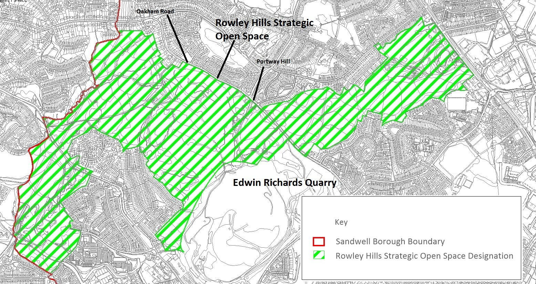

Rowley Hills – Ecological and Nature Conservation Designations

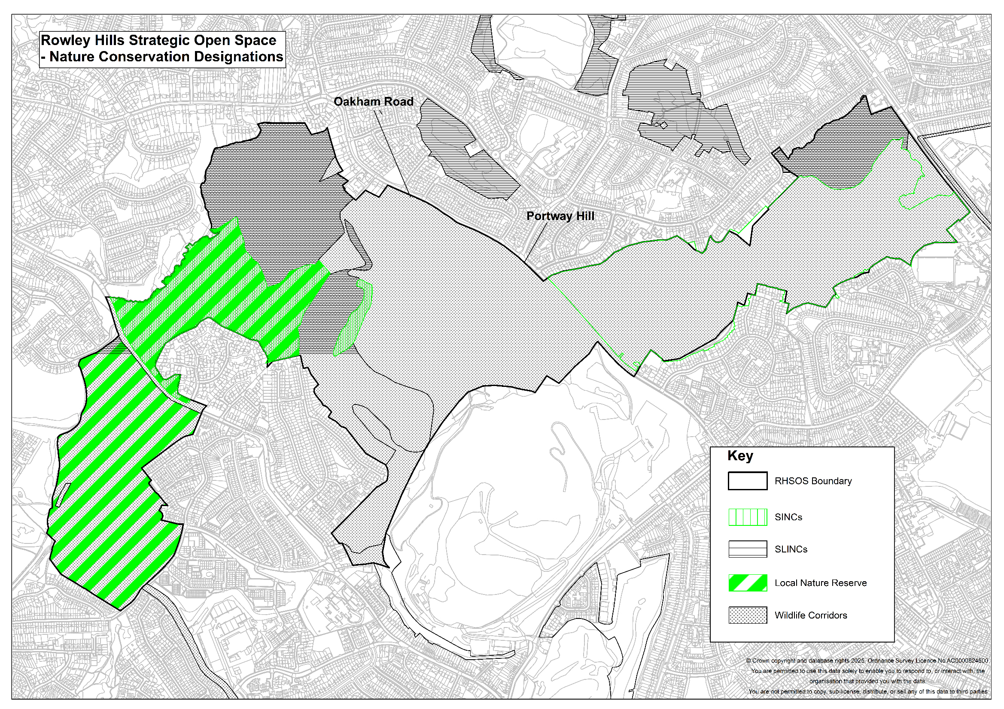

APPENDIX G – Sandwell Local Plan Housing Trajectory

Table 6 - Indicative Housing Trajectory and Rolling 5-year supply
 | 2025/26 | 2026/27 | 2027/28 | 2028/29 | 2029/30 | 2030/31 | 2031/32 | 2032/33 | 2033/34 | 2034/35 | 2035/36 | 2036/37 | 2037/38 | 2038/39 | 2039/40 | 2040/41 | Total
Total Housing Supply | 455 | 463 | 535 | 944 | 1555 | 1120 | 807 | 601 | 504 | 464 | 603 | 511 | 468 | 594 | 635 | 1027 | 11286
5-year supply | 3952 | 4617 | 4961 | 5027 | 4587 | 3496 | 2979 | 2683 | 2550 | 2640 | 2811 | 3235 | 2724 | 2256 | 1662 | 1027
Rolling 5-year supply | 4.36 | 5.10 | 5.48 | 5.55 | 5.06 | 3.86 | 3.29 | 2.96 | 2.81 | 2.91 | 3.10 | 3.57 | 3.01 | 2.49 | 1.83 | 1.13
Annualised requirement | 906

APPENDIX H – Open space and play provision standards for development

Note: the availability, accessibility and quality of sports facilities / playing pitches will be assessed using data from the Playing Pitch and Outdoor Sports Strategy (2022); please refer to Policy SHW5
This appendix provides guidance on the minimum quantity of unrestricted open space required per 1,000 residents, the accessibility of open space (walking distance) and the quantity standards and high-level quality requirements for different typologies of open space. Further detail on the quality requirements for new open space will be set out in the Council’s Design Code.

Definitions
Open Space is defined in the NPPF (Dec 2023) as:

All open space of public value, including not just land, but also areas of water (such as rivers, canals, lakes and reservoirs) which offer important opportunities for sport and recreation and can act as a visual amenity.
Examples of open space include: -
- parks and gardens
- natural and semi natural green places
- green corridors
- amenity green space
- play provision for children and young people
- allotments¹⁴
- cemeteries
- institutional land
- playing fields and sports pitches (see note above)
Accessibility standards refer to open spaces within a set distance away from people’s homes / communities. All open space in a given category within the set distance are determined as serving those homes / communities.
In terms of its accessibility, open space can be unrestricted, limited or inaccessible. This is defined in the Green Spaces Strategy as follows: -
- unrestricted - sites have unrestricted public access although some sites may have limitations to access between dusk and dawn;
- limited - sites may be publicly or privately owned but access is limited either by a physical barrier such as membership, or a psychological barrier such as the sense that a green space is private;
- not accessible - sites are out of bounds to the public.
Land could have limited or no public access but will still deliver many of the benefits of open space e.g. land for ecological habitats, green and blue infrastructure, climate change mitigation and improvements to air quality.

Provision
The Council will seek the provision of unrestricted open space at a minimum ratio of 3.235 hectares per 1,000 population, measured at a ward level. The Council will also seek to ensure that at a site of least one

¹⁴ Allotments are covered in more detail in Policy SHW6.

hectare in size of unrestricted open space is provided within walking distance (0.4 km) of all the Borough’s residents. This will be achieved both through the creation of new areas of unrestricted open space as part of development proposals and by improving accessibility to existing areas of open space.
Sandwell’s minimum ratio for unrestricted open space is derived in part from the 2024 Sandwell Open Space Assessment
The SLP Policies Map¹⁵ allocates land that meets the NPPF definition of open space and that has unrestricted access as identified in the Sandwell Open Space Assessment 2024. Any subsequent update of this document may result in the identification of other existing open spaces over the plan period. Where practicable, the Council will identify land as open space, to address current shortfalls and provide much-needed community facilities.
The standards shown below relate to the quantity, quality and accessibility of each typology of open space. More specifically:
- Quantity standards refer to the minimum area of open space in hectares required for every 1,000 residents at ward level.
- Quality standards refer to a subjective rating of the quality of existing open space based on physical characteristics, value of the space, and benefits to the wider environment. The quality standards are high-level, and more detailed guidance will be provided in the Council’s Design Code.

Open Space Hierarchy
Open spaces in Sandwell are set within a hierarchy that classifies them according to their significance and thus the importance they will have when considering planning proposals that may impact on them:

Table 7 - Open Space Hierarchy
Hierarchy Level | Description
Borough | Sandwell Valley, which attracts visitors from across and beyond the borough.
Town | Those sites whose significance can attract people from across the borough. Usually large sites with a range of facilities or designated importance for history or nature conservation.
Neighbourhood | Those sites that serve a more immediate community. Unlikely to attract people from across the borough
Local | Those sites that perform a function for a small area – typically areas of amenity green space.

Development and open space provision
The quantum and typology of open space that may be applicable to a housing site will depend upon its intended occupants; for example, specialist housing for older people will not create demand for the typical amount and type of open space required for children and young people.
New open space should be designed and located so that it performs multiple functions. It should be considered as part of the wider approach to green infrastructure planning, as set out in Policy SDS8.
Where open space is to be provided on the same site as a development, this should be identified as part of the development’s green infrastructure within the design and access statement that accompanies the planning

¹⁵ Smaller areas of open space that are not identified on the Policies Map will also be subject to Policy SHW4

application. Reference should be made to those green space assets and / or corridors that apply to / exist near a site, and to what measures will be taken to enhance, extend and /or link to them.
The incorporation of open space into new developments should also consider Policy SDS5, the principles set out in Secured by Design and Sport England and the Government’s Active Design initiative (May 2023). This document contains ten main principles, one of which relates to open space:
Principle 5 — Network of multi-functional open spaces
Accessible and high-quality open space should be promoted across cities, towns and villages to provide opportunities for sport and physical activity, as well as active travel connections and natural or civic space for people to congregate in and enjoy.
The inclusion of open space in new development is also an opportunity to have regard to features that minimise crime and perception of crime such as natural surveillance of public spaces.
Where redevelopment of an open space is being considered, regard will be had to whether its loss would have a detrimental impact on the character and appearance of the area. Adverse impacts on habitats and ecological value are also important factors and will be taken into consideration when decisions are made. If, exceptionally, an existing open space is to be redeveloped, it must be replaced nearby to an equivalent standard or better.
Proposals will be assessed in accordance with the standards set out below. Open space assessments that are submitted in support of planning proposals should have regard to the Council’s most up-to-date evidence on quantity and quality of open space.

Open space standards in Sandwell
There are 298 open spaces with unrestricted access in Sandwell, covering an area of 1,113 hectares. This equates to 12.9% of the total area of the borough. The quantum of open spaces with unrestricted access equates to 3.235 hectares of space per 1,000 population.

Table 8 - Existing Quantity of Unrestricted Open Space per 1,000 population ¹⁶

Open Space Typology | Area (Ha) | Ha per 1,000 population¹⁷
Amenity Greenspace | 180.10 | 0.523
Cemeteries & Churchyards | 79.15 | 0.230
Green Corridor | 45.65 | 0.133
Institutional Land | 0.35 | 0.001
Natural & Semi-Natural Greenspace | 438.67 | 1.274
Outdoor Sports Facilities | 100.35 | 0.292
Parks & Gardens | 263.71 | 0.766
Provision for Children & Young People | 5.42 | 0.016
Total | 1,113.4 | 3.234
Including all levels of accessibility, there are a total of 542 open spaces covering nearly 2,000 hectares. This is equivalent to 23.2% of the total land area of the Borough. Natural and semi-natural green space makes up the largest percentage by area at 36.8% of all open space covering over 726 hectares. Outdoor sports facilities

¹⁶ Sandwell Open Space Assessment 2024
¹⁷ Population based on mid-year estimate for 2022 showing a Borough population of 344,210 people.

make up 16.7% by area, followed by parks and gardens at 13.4%. Amenity green spaces are the most common open space type with 198 such spaces, but each site is typically relatively small. However, amenity green space makes up 12.7% of the supply by area.
The distribution of open space across the borough is not even, with some areas and wards containing more open space than others. This pattern masks a dearth of suitable and accessible space in other areas. For example, residents of West Bromwich Central Ward enjoy nearly fifteen times more green space than those in Old Warley Ward, primarily due to the presence of Sandwell Valley.
Given Sandwell’s urban nature and the viability issues associated with providing additional facilities on sites, accessibility to high quality open space is therefore a significant consideration when proposals for new housing development are being considered.
Where possible, new open space provision (which may also provide a basis for biodiversity net gain and sustainable drainage requirements on site as well, as part of a multi-functional green and blue infrastructure approach) will be required on development sites, especially where this will help meet local shortfalls by ward. Where this is not possible, the delivery / improvement of land adjacent to or within a suitable walking distance from new residential areas will be considered.
Accessibility thresholds should be measured as a distance walked rather than as a simple straight-line measurement / radius. Significant obstacles or impediments to local access that sever walking routes, such as canals and motorways, should be considered when assessing the accessibility of open spaces. Open spaces and play facilities should be located close to and be accessible from bus stops, pedestrian and cycle routes, to help promote sustainable travel.
Indicative walking distances can be determined from the broad data set out below: -
- 250m - 2-3 minutes’ walk
- 400m - 5 minutes’ walk
- 800m - 10 minutes’ walk
- 1,200m - 15 minutes’ walk
- 1,600m - 20 minutes’ walk

Table 9 - Quantity and Accessibility Standards defined for Open Space Assessment ¹⁸

Open Space Type | Quantity guideline (hectares per 1,000 residents) | Walking guideline (walking distance: metres from houses) | Quality guideline
Amenity Green Space | 0.6 | 480m | Appropriately landscaped.  Positive management. Provision of footpaths.  Designed to be free of the fear of harm or crime.
Parks and Gardens | 0.8 | 710m
Natural / Semi-Natural Greenspaces | 1.8 | 720m
Provision for Children and Young People | 0.25 |  | Quality appropriate to the intended level of

¹⁸ Taken from Fields in Trust’s Guidance for Outdoor Sport and Play - Beyond the Six Acre Standard (2015) -
https://www.fieldsintrust.org/Upload/file/guidance/Guidance-for-Outdoor-Sport-and-Play-England.pdf

Open Space Type | Quantity guideline (hectares per 1,000 residents) | Walking guideline (walking distance: metres from houses) | Quality guideline
Local Areas for Play (LAP) - aimed at very young children |  | LAP – 100m  (suggested minimum size 0.01ha) | performance, designed to appropriate technical standards.  Located where they are of most value to the community to be served.  Sufficiently diverse recreational use for the whole community.  Appropriately landscaped.  Maintained safely and to the highest possible condition with available finance.  Positively managed taking account of the need for repair and replacement over time as necessary.  Provision of appropriate ancillary facilities and equipment.  Provision of footpaths.  Designed to be free of the fear of harm or crime.
Locally Equipped Areas for Play (LEAP) - aimed at children who can go out to play independently |  | LEAP – 400m  (suggested minimum size 0.04ha)
Neighbourhood Equipped Areas for Play (NEAP) - aimed at older children |  | NEAP - 1,000m  (suggested minimum size 0.1ha)
Other outdoor provision (Multi Use Games Areas and skateboard parks) | 0.3 | 700m  (suggested minimum size 0.1ha)
Allotments and Community Gardens | 0.2 | 1200m | See Policy SHW6
Table 10 sets out recommended benchmark guidelines for the provision of equipped / designated play space. A financial contribution (i.e. through S106 or CIL) towards improvement of an existing equipped / designated play space may be sought in lieu of on-site provision for larger scale play spaces, or where existing play space lies within the walking distance guidelines of a proposed development.

Table 10 - Recommended Application of Quantity Benchmark Guidelines – Equipped / Designated Play Space ¹⁹

Scale of Development | LAP | LEAP | NEAP | MUGA
5 - 10 dwellings | ✓

¹⁹ Taken from Fields in Trust’s Guidance for Outdoor Sport and Play - Beyond the Six Acre Standard (2015) - https://www.fieldsintrust.org/Upload/file/guidance/Guidance-for-Outdoor-Sport-and-Play-England.pdf

Scale of Development | LAP | LEAP | NEAP | MUGA
11 - 200 dwellings | ✓ | ✓ |  | Contribution
201 - 500 dwellings | ✓ | ✓ | Contribution | ✓
501+ dwellings | ✓ | ✓ | ✓ | ✓

Table 11 sets out the financial contributions that will be sought for off-site open space. The rates are indexed for 2024 prices and may be updated periodically to reflect price inflation.
Contributions towards the provision of new open space or the improvement of existing open space are calculated using the same rates, as the improvement of existing open space will normally include at least some new provision.
Where the required level of open space of a particular typology is provided partly on-site and partly through contributions to off-site provision and /or improvement, credit will be given for the space provided on-site in calculating the off-site contributions.
The rates do not include the cost of providing playing pitches or fixed sports facilities (such as tennis or bowls), which are additional costs which may need to be agreed in addition to the rates below.
The rates are separate to the costs of delivering biodiversity net gain.

Table 11 - Off-Site Open Space Planning Contribution Rates

Open space typology | Proposed standard (ha  /1000 population) | Proposed standard (sqm  /person)²⁰ | Rate (per sqm) | Contribution per person (£)
Amenity greenspace | 0.523 | 5.3 | £18.34 | £97
Parks and gardens | 0.766 | 7.7 | £130.28 | £1,003
Natural and semi-natural greenspace | 1.407 | 14 | £18.34 | £257
Provision for children and young people (equipped / designated play space) | 0.016 | 1.5 | £182.57 | £274
Other outdoor sports provision | 0.292 | 2.9 | £130.28 | £378
Allotments and community gardens | 0.120 | 1.2 | £38.24 | £46
Total | 3.124²¹ | 32.6 | - | £2,055

²⁰ The number of persons that will occupy a residential development scheme will be calculated using the Nationally Described Space Standards (NDSS) unless agreed otherwise between the Council and the applicant prior to the determination of the planning application. The NDSS can be viewed here: https://www.gov.uk/government/publications/technical-housing-standards-nationally-described-space-standard
²¹ The proposed total is less than the existing 3.235ha/1000 population provision as some areas of accessible open space (e.g. cemeteries, churchyards and institutional land) are excluded.

Where open space provided on site is to be adopted by Sandwell Council, or where contributions are provided to off-site provision or improvements, maintenance contributions for 15 years for equipped/designated play space and 30 years’ maintenance for all other types of open space will be sought through a S106 legal agreement. Maintenance contributions will be calculated using the rates set out in Table 12.
The open space maintenance contribution excludes the maintenance of fixed sports facilities, which would be in addition. The contributions above also exclude tree establishment costs, set-up costs, professional and admin costs.

Table 12 - Open Space Maintenance Rates
Typology | Maintenance Rate (£/sqm/per year)
Amenity greenspace | £0.86
Parks and gardens | £3.88
Natural and semi-natural greenspace | £0.86
Provision for children and young people (equipped / designated play space) | £14.91
Other outdoor sports provision | £10.30
Allotments and community gardens | £0.85

APPENDIX I - Transportation Policy

Sandwell Parking Standards Purpose of this Statement
The purpose of this work is to ensure future developments provide sufficient parking that will not result in on-street parking congestion to the detriment of the safe and efficient operation of the public highway and the amenity of the surrounding residential community. In implementing this approach, there must be a balance so that there is not an overprovision of parking that would result in the inefficient use of land or discourage sustainable travel choices. Public safety will also be at the centre of the parking consideration.
Tables 13 and 14 of this appendix set out the appropriate levels of parking for residential and non-residential developments, to inform discussions between Highway Engineers and Planning Officers. However, local sustainability factors may allow for a reduction in off-street parking requirements, but this will require transport, accessibility and parking assessments to be undertaken and for robust evidence to be provided that any proposed reductions would not unduly affect, or be to the detriment of, the safe and efficient operation of the surrounding highway network.
Regardless of whether developments achieve the required parking standards or not, the Council will not be able to support developments that may give rise to road safety issues, or which may have a detrimental impact on the free flow of the highway network or be considered to potentially cause severe residential amenity issues.
A balance has to be struck between encouraging new development and investment, against providing adequate parking levels, potential increased traffic congestion and community amenity issues.

Transport, Accessibility & Parking Assessments (TAPA)
The information provided in transport-related assessments helps to clarify the impact of any development on the Highway Network. The site’s impact, sustainability, accessibility and safety will be assessed using the TAPAs (see Appendix 4). Sites that benefit from closely located public transport facilities, cycle routes and other useful facilities that encourage linked trips will be assessed to have a higher degree of accessibility and sustainability.
This assessment may be used to help justify a reduction in the parking requirements through discussion with the Local Authority, coupled with robust evidence that any reductions in required parking standards would not have a detrimental effect on the operation and safety of the surrounding network.
It is noted that the extent of detail required by the TAPA may not be known in the case of outline planning applications. As such, it is accepted that consideration will be given to the information which is available at outline application stage and be conditioned to ensure all the information is provided at full application stage.

Residential Parking Standards for Housing
The council recognises that ensuring the right amount of parking provision in the right location and of the right size is essential in the creation of new residential developments, both in terms of layout and design highway safety and future amenity and access. The following standards have been derived from extensive practice, evidence gathering, benchmarking and feedback from previous schemes.
Developments that are considered to result in on-street parking that would create or exacerbate issues of highway safety will not be supported.
The council may consider reduced off street parking provision in highly sustainable locations based on local sustainability and access assessments, evidence from local surveys and census data published by the Office of National Statistics.

Visitor Parking for Residential Properties
On all housing schemes developers will be expected to provide additional space for visitor parking at a ratio of one space per three dwellings for developments of less than ten properties, and one space per four dwellings for developments of ten or more properties. On-street visitor parking provision may be considered appropriate if the local road network design allows for on-street parking without causing any detriment to capacity or safety.

Houses in Multiple Occupation (HMO)
For houses in multiple occupancy, (HMO), one off-street space per two beds will be required within the curtilage of the site. However, reductions in parking provision in agreed highly sustainable locations may be considered.

Garages
For garages to be considered as practical parking spaces they should have minimum internal dimensions of
2.8m x 6m. Garages used to satisfy off street parking requirements will be conditioned to be retained as such, by removing development rights to convert them into a habitable room.

Innovative use of design solutions
Car parking provision can be provided in a variety of ways and can help create attractive and safe streets. Positive consideration will be given to innovative design solutions that deliver parking requirements safely and in the context of well-designed layouts.

Table 13 - Minimum Parking Standards for Residential Uses
Residential Dwellings
one to two bedrooms | one dedicated space
three to four bedrooms | two dedicated spaces
five to six bedrooms | three dedicated spaces
seven to eight bedrooms | four dedicated spaces
Visitor spaces – development less than ten dwellings | one space per three dwellings
Visitor spaces – development of ten or more dwellings | one space per four dwellings

Non-Residential Parking Standards Baseline Parking Standards
Baseline parking standards are set out in Table 14 below. These maximum standards can be applied to smaller developments or used as a basis to calculate a reduced maximum standard for larger developments located in accessible areas.

Table 14 - Maximum Parking Standards for Non-Residential Uses
(Table 14 will be applied to the total floor area on all applications including change of use applications)
Use Class | Description | Baseline Parking Level Parking Standard per m²
Class B – Businesses that primarily serve people
B2 | General industry (office components to be assessed as Class E use) | 1:50
B8 | Distribution and warehouse (office components to be assessed as Class E use) | Up to 250m² - 1:50 251m² -1250m² - 1:100 Over 1250m² - 1:200
Class C – Locations where people sleep

Use Class | Description | Baseline Parking Level Parking Standard per m²
C1 | Hotels and guest houses (bar / restaurant to be assessed as sui generis and Class E uses) | one space per bedroom  one space per member of staff
C2 | Residential institutions | Residents: one space per four bedrooms.  Staff: one manager’s space and one space per three FTE other staff
C2a | Secure residential institutions
C4 | Houses in multiple occupation incl. large HMO | one per two beds
Class E - Commercial, Business and Service Users
E | Medical facilities, clinics, health centres, creches, day nurseries, day centre | one space per member of staff  two spaces per treatment room
E | Hospitals | one space per member of staff  one space per three visitors
E | Food retail (other than those shops that fall under Class F2) | 1:14
E | Non-food retail (other than those shops that fall under Class F2) | 1:20
E | Offices | 1:30
E | Restaurants and cafes | 1:10
E | Research and development | 1:30
E | Industrial processes that can be carried out in a residential area | 1:30
E | Gymnasiums and indoor recreations not involving motorised vehicles or firearms or those that fall under F2 | 1:22
Class F1 - Learning and Non-Residential Institutions
F1 | Further education establishments and training centres | one space per member of staff  one space per 15 students
F1 | Primary, secondary and special schools | one space per member of staff (FTE)
F1 | Museums, public libraries, public halls, exhibition halls, law courts | 1:30

Use Class | Description | Baseline Parking Level Parking Standard per m²
Class F2 - Local Community Uses
F2 | Shop not more than 280m² mostly selling essential goods, including food and at least 1km from another similar shop | 1:14
F2 | Indoor or outdoor swimming baths, skating rinks, and outdoor sports or recreations not involving motorised vehicles or firearms | 1:22
F2 | Stadia | one space per 15 seats  (Note: coach parking should be agreed with SMBC and treated separately to car parking)
Class Sui Generis – Locations that are unique in themselves
Sui Generis | Drinking establishments | 1:8
Sui Generis | Hot food takeaway | 1:20
Sui Generis | Cinemas, concert halls and conference facilities | one space per five seats
Sui Generis | Public transport interchanges, metro stops, railway stations | Discuss with SMBC
Sui Generis | Theatres, large HMOs, hostels, petrol filling stations, vehicle sales, scrap yards, retail warehouse clubs, night clubs, launderettes, taxi / PHV business, amusement arcades, casinos, funfairs, waste disposal facilities | Discuss with SMBC

The parking requirements for places of worship and community facilities require different considerations due to the particular patterns of demand that they create. The following standards have been derived from extensive practice, evidence gathering, benchmarking and feedback from previous schemes. Lower levels of car parking will only be permitted if fully evidence through a Transport assessment or Transport statement, as appropriate.
Table 15 - Minimum parking standards for Community Uses
(Table 15 will be applied to the total floor area on all applications including change of use applications)
Use Class | Description | Parking Requirement spaces per m²
F1 | Places of worship | 1:5
F2 | Hall or meeting place for the principal use of the local community | 1:30

Developments in Town Centres
Parking requirements for developments in town centres should be assessed by baseline standards, through TAPAs to give guidance as to the potential reduction in maximum standards and impact on the Highway Network. Appropriate development in town centres coupled with sustainable travel choices creates the opportunity for linked trips and more efficient land use. Existing and proposed transport infrastructure and proposed developments within the plan period for each centre will guide the decision-making process to determine the allowable minimum parking requirements for each successive development in a town centre.
Parking standards will be determined based on local need and circumstances. The flexibility of any potential acceptable parking reduction will depend on the distance of the development from the core of the town centre. For instance, a proposed development on a town centre boundary may be considered differently to the same development proposed in the core of the centre, taking into consideration other factors such as how much parking is currently available in the surrounding area. The quantum of parking available in each town centre will be monitored and the required parking standard may vary over time for similar developments in similar locations dependent on improvements to sustainable infrastructure and modal shift evidence or saturation of existing parking infrastructure in the centres.

Minimum Parking Standards for People with Disabilities
Parking for people with disabilities is an important consideration. Guidance on the design and location of parking for people with disabilities can be found in the Department of Transport (DfT) leaflet 5/95 (April 1995), DfT report ‘Inclusive Mobility’ and BS8300:2009.

Residential Developments
Disabled parking bays are required as a percentage of the total off-plot communal parking provision in new residential developments. For smaller developments with up to ten off-plot communal spaces, at least one space should be provided as a widened bay and for all other developments 5% of the parking allocation should be designed as disabled parking bays.

Non-Residential Developments
The minimum parking standard for non-residential developments is a percentage of the baseline maximum standard as shown in Table 16 below. Parking for disabled people should be additional to the maximum vehicle parking standards for non-residential development.
For smaller non-residential developments with parking up to ten spaces, at least one parking bay should be designated to accommodate disabled people. For developments up to 20 spaces one wider space and one marked disabled bay should be provided.
Generally, for shopping, recreation and leisure facilities 6% of the total parking provision should be in the form of marked bays with 4% as widened bays. All other uses will be 5% marked and 5% widened bays.
Parking spaces for people with disabilities should be created within 50m of the main entrance of the destination so that a round trip of no more than 100m has to be made. Provision for pick up and set down with level access to the pavement should also be made close to the main entrance.

Table 16 - Disabled Parking Space Provision (To be applied to all applications including change of use applications for total floor area)
Use Class | Description | Marked Disabled Bay % of Max Baseline Standard | Widened Bay  3.7m x 6m % of Max Baseline Standard
Class B – Businesses that primarily serve people
B2 | General industry (office components to be assessed as Class E use | 5% plus one space for each disabled employee | 5%
B8 | Distribution and warehouse (office components to be assessed as Class E use | 5% plus one space for each disabled employee | 5%
Class C – Locations where people sleep
C1 | Hotels and guest houses (bar / restaurant to be assessed as Sui Generis and Class E uses) | 6% plus one space for each disabled employee | 4%
C2 | Residential institutions | 5% plus one space for each disabled employee plus | 5%
 |  | additional spaces dependent on the need of the establishment
C2a | Secure residential institutions | 5% plus one space for each disabled employee plus additional spaces dependent on the need of the establishment | 5%
C3 | Dwellings | 5% of unallocated parking provision | 5% of unallocated parking provision
C4 | Houses in multiple occupation incl. large HMO | 5% | 5%
Class E - Commercial, Business and Service Users
E | Medical facilities, clinics, health centres, creches, day nurseries, day centre | 6% plus one space for each disabled employee plus additional spaces dependent on the need of the establishment | 4%
E | Hospitals | 6% plus one space for each disabled employee plus additional spaces dependent on the need of the establishment | 4%
E | Food retail (other than those shops that fall under Class F2) | 6% plus one space for each disabled employee | 4%
E | Non-food retail (other than those shops that fall under Class F2) | 6% plus one space for each disabled employee | 4%
E | Offices | 5% plus one space for each disabled employee | 5%
E | Restaurants and cafes | 5% plus one space for each disabled employee | 5%
E | Research and development | 5% plus one space for each disabled employee | 5%
E | Industrial processes that can be carried out in a residential area | 5% plus one space for each disabled employee | 5%
E | Gymnasiums and indoor recreations not involving motorised vehicles or firearms or those that fall under F2 | 6% plus one space for each disabled employee | 4%
Class F1 - Learning and Non-Residential Institutions
F1 | Further education establishments and training centres | 6% plus one space for each disabled employee | 4%
F1 | Primary, secondary and special schools | 6% plus one space for each disabled employee | 4%
F1 | Museums, public libraries, public halls, exhibition halls, law courts | 6% plus one space for each disabled employee | 4%
F1 | Places of Worship | 6% plus one space for each disabled employee | 4%
Class F2 - Local Community Uses
F2 | Shop not more than 280m² mostly selling essential goods, including food and at least 1km from another similar shop | 5% plus one space for each disabled employee | 5%
F2 | Indoor or outdoor swimming baths, skating rinks, and outdoor sports or recreations not involving motorised vehicles or firearms | 6% plus one space for each disabled employee | 5 -10%
F2 | Stadia | 6% plus one space for each disabled employee | 5 -10%
F2 | Hall or meeting place for the principal use of the local community | 5% plus one space for each disabled employee | 5%
Class Sui Generis – Locations that are unique in themselves
Sui Generis | Drinking establishments | 6% plus one space for each disabled employee | 4%
Sui Generis | Hot food takeaway | Discuss with SMBC | Discuss with SMBC
Sui Generis | Cinemas, concert halls and conference facilities | 6% plus one space for each disabled employee | 4%
Sui Generis | Public transport interchanges, metro stops, railway stations | Discuss with SMBC | Discuss with SMBC
Sui Generis | Theatres, large HMOs, hostels, petrol filling stations, vehicle sales, scrap yards, retail warehouse clubs, night clubs, launderettes, taxi / PHV business, amusement arcades, casinos, funfairs, waste disposal facilities | Discuss with SMBC | Discuss with SMBC

Parking for Cyclists
Overlooked, well-lit, secure and undercover cycle parking facilities should be incorporated into any development that has the potential to attract cyclists. Cycle parking should be in positions that are convenient to encourage their use and where possible within the building.
The minimum standards set out in Table 17 below, will be required for development proposals in addition to the vehicle parking standards. In cases where reduced numbers off street parking can be justified as part of a development, the Council may require a significant increase in the number of cycle parking spaces to be provided above the minimum standards specified in Table 17.

Table 17 - Minimum Cycle Parking Standards
Use Class | Description | Cycle Parking Standard | Cycle Storage Type
Class B – Businesses that primarily serve people
B2 | General industry (office components to be assessed as Class E use | one space per 300m² for staff  one space per 1000m² for visitors | Long Stay
B8 | Distribution and warehouse (office components to be assessed as Class E use | one space per 300m² for staff  one space per 1000m² for visitors | Long Stay
Class C – Locations where people sleep
C1 | Hotels and guest houses (bar / restaurant to be assessed as sui generis and Class E uses | one space per ten bedrooms | Long Stay
C2 | Residential institutions | one space per ten members of staff | Long Stay
C2a | Secure residential institutions | one space per ten members of staff | Long Stay
C3 | Dwelling houses | One-bed - one space Two-bed - two spaces Three-bed - two spaces Four-bed - three spaces Five-bed - three spaces Six-bed - four spaces Seven-bed - four spaces Eight-bed - five spaces  Visitor spaces – discuss with SMBC | Long stay for residents Short stay for visitors

Use Class | Description | Cycle Parking Standard | Cycle Storage Type and Shower Facility
C3 | Dwellings (apartments only) | one space per one and two bed dwellings  two spaces per 3+ bed dwelling  one space per five apartments for visitors | Long stay for staff / residents  Short stay for visitors
C4 | Houses in multiple occupation incl. large HMO | one space per five bedrooms  one space per five bedrooms for visitors | Long stay for residents Short stay for visitors
Class E - Commercial, Business and Service Users
E | Medical facilities, clinics, health centres, creches, day nurseries, day centre | one space per 300m² for staff  one space per 1000m² for visitors | Long stay for staff Short stay for visitors
E | Hospitals | one space per 300m² for staff  one space per 1000m² for visitors | Long stay for staff Short stay for visitors
E | Food retail (other than those shops that fall under Class F2) | one space per 200m² | Long stay for staff Short stay for visitors
E | Non-food retail (other than those shops that fall under Class F2) | one space per 200m² | Long stay for staff Short stay for visitors
E | Offices | one space per 300m² for staff  one space per 1000m² for visitors | Long Stay
E | Restaurants and cafes | one space per 100m² | Long stay for staff Short stay for visitors
E | Research and development | one space per 300m² for staff  one space per 1000m² for visitors | Long Stay
E | Industrial processes that can be carried out in a residential area | one space per 300m² for staff | Long Stay

Use Class | Description | Cycle Parking Standard | Cycle Storage Type and Shower Facility
 |  | one space per 1000m² for visitors
E | Gymnasiums and indoor recreations not involving motorised vehicles or firearms or those that fall under F2 | one space per 200m² for staff  one space per ten person trips for visitors | Long stay for staff Short stay for visitors
Class F1 - Learning and Non-Residential Institutions
F1 | Further education establishments and training centres | one space per five students  one space per five members of staff  one space per 150 students for visitors | Long stay for staff / students  Short stay for visitors
F1 | Primary, secondary and special schools | one space per five students  one space per five members of staff  one space per 150 students for visitors | Long stay for staff / students  Short stay for visitors
F1 | Museums, public libraries, public halls, exhibition halls, law courts | one space per 200m² for staff  one space per ten-person trips for visitors | Long stay for staff Short stay for visitors
F1 | Places of worship | one space per 200m² for staff  one space per ten-person trips for visitors | Long stay for staff Short stay for visitors
Class F2 - Local Community Uses
F2 | Shop not more than 280m² mostly selling essential goods, including food and at least 1km from another similar shop | one space per 100m² | Long stay for staff Short stay for visitors
F2 | Indoor or outdoor swimming baths, skating rinks, and outdoor sports or recreations not involving motorised vehicles or firearms | one space per 200m² for staff  one space per ten person trips for visitors | Long stay for staff Short stay for visitors
F2 | Stadia | one space per 200m² for staff | Long stay for staff Short stay for visitors

Use Class | Description | Cycle Parking Standard | Cycle Storage Type and Shower Facility
 |  | one space per ten person trips for visitors
F2 | Hall or meeting place for the principal use of the local community | one space per 200m² for staff  one space per ten person trips for visitors | Long stay for staff Short stay for visitors
Class Sui Generis – Locations that are unique in themselves
Sui Generis | Drinking establishments | one space per 100m² | Long stay for staff Short stay for visitors
Sui Generis | Hot food takeaway | one space per 100m² | Long stay for staff Short stay for visitors
Sui Generis | Cinemas, concert halls and conference facilities | one space per 200m² for staff  one space per ten-person trips for visitors | Long stay for staff Short stay for visitors
Sui Generis | Public transport interchanges, metro stops, railway stations | one space per 200m² for staff  one space per ten-person trips for visitors | Long stay for staff Short stay for visitors
Sui Generis | Theatres, large HMOs, hostels, petrol filling stations, vehicle sales, scrap yards, retail warehouse clubs, night clubs, launderettes, taxi / PHV business, amusement arcades, casinos, funfairs, waste disposal facilities | Discuss with SMBC | Long stay for staff Short stay for visitors

Powered Two Wheeled Vehicles
Powered two wheeled vehicles can play an important part in delivering integrated and sustainable transport. They offer reduced journey times, are easier to park in areas of limited on-street parking, offer cheaper travel choices relative to a car and can potentially benefit climate change by generally producing lower emissions than cars.
As a minimum it is proposed that developers should provide for safe, overlooked, well-lit and secure parking for powered two wheeled vehicles equal to 2% of the car parking spaces provided at retail developments and 4% of the car parking spaces at all other developments except residential.
For housing developments space shall be made available within the dwelling curtilage or in allocated or bays.

Table 18 - Minimum Parking Standards for Powered Two Wheelers
Use Class | Description | Percentage of Baseline Standard | Threshold for at least 1 parking space and shower facility
Class B – Businesses that primarily serve people
B2 | General industry (office components to be assessed as Class E use) | 4% | 100m² or greater
B8 | Distribution and warehouse (office components to be assessed as Class E use) | 4% | 100m² or greater
Class C – Locations where people sleep
C1 | Hotels and guest houses (bar / restaurant to be assessed as sui generis and Class E uses) | 4% | When total vehicle parking provision is 20 or greater
C2 | Residential institutions | 4% | When total vehicle parking provision is 20 or greater
C2a | Secure residential institutions | 4% | When total vehicle parking provision is 20 or greater
C3 | Residential dwellings | Not required | Not required
C4 | Houses in multiple occupation incl. large HMO | Not required | Not required
Class E - Commercial, Business and Service Users
E | Medical facilities, clinics, health centres, creches, day nurseries, day centre | 4% | When total vehicle parking provision is 20 or greater
E | Hospitals | 4% | When total vehicle parking provision is 20 or greater
E | Food retail (other than those shops that fall under Class F2) | 2% | 200m² or greater
E | Non-food retail (other than those shops that fall under Class F2) | 2% | 200m² or greater
E | Offices | 4% | 50m² or greater
E | Restaurants and cafes | 2% | 200m² or greater
E | Research and development | 4% | 100m² or greater
E | Industrial processes that can be carried out in a residential area | 4% | 100m² or greater

Use Class | Description | Percentage of Baseline Standard | Threshold for at least 1 parking space and shower facility
E | Gymnasiums and indoor recreations not involving motorised vehicles or firearms or those that fall under F2 | 4% | 200m² or greater
Class F1 - Learning and Non-Residential Institutions
F1 | Further education establishments and training centres | 4% | 200m² or greater
F1 | Primary, secondary and special schools | 4% | 200m² or greater
F1 | Museums, public libraries, public halls, exhibition halls, law courts | 4% | 200m² or greater
F1 | Places of worship | 4% | 200m² or greater
Class F2 - Local Community Uses
F2 | Shop not more than 280m² mostly selling essential goods, including food and at least 1km from another similar shop | Not required | Not required
F2 | Indoor or outdoor swimming baths, skating rinks, and outdoor sports or recreations not involving motorised vehicles or firearms | 4% | 200m² or greater
F2 | Stadia | 4% | 200m² or greater
F2 | Hall or meeting place for the principal use of the local community | 4% | When total vehicle parking provision is 20 or greater
Class Sui Generis – Locations that are unique in themselves
Sui Generis | Drinking establishments | 2% | 200m² or greater
Sui Generis | Hot food takeaway | 2% | 200m² or greater
Sui Generis | Cinemas, concert halls and conference facilities | 4% | 200m² or greater
Sui Generis | Public transport interchanges, metro stops, railway stations | 4% | When total vehicle parking provision is 20 or greater
Sui Generis | Theatres, large HMOs, hostels, petrol filling stations, vehicle sales, scrap yards, retail warehouse clubs, night clubs, launderettes, taxi | 4% | When total vehicle parking provision is 20 or greater

Use Class | Description | Percentage of Baseline Standard | Threshold for at least 1 parking space and shower facility
 | / PHV business, amusement arcades, casinos, funfairs, waste disposal facilities

Provision of Infrastructure to Support Electric Vehicle Technology
Applications for development should be designed to enable charging of plug-in and other ultra-low emission vehicles in safe, accessible and convenient locations.

Electric Vehicle Charging Point Specification Residential Development
Infrastructure to allow an external charging point shall be provided adjacent to at least one parking space for each private dwelling. For flatted developments and apartments where the parking may be some distance from the dwellings, one charging point for every ten unallocated spaces is required.

Non-Residential Development
It will be the responsibility of the developer to provide 5% of all parking spaces in these developments to be covered with an electric charging point. Appropriate cable provision shall be in place for a further 5% to meet any future increase in demand.

Operational Parking Requirements
The parking requirements in Table 19 below will be applied to the total additional floor area on all applications including change of use applications.

Table 19 - Operational Parking Requirements
Use Class | Description | Operational Parking Requirement
Class C – Locations where people sleep
C2 | Residential institutions | Space for ambulance, minibus or van. Space for one pick-up and drop off point
C2a | Secure residential institutions | 5% plus one space for each disabled employee plus additional spaces dependent on the need of the establishment | 5%
C3 | Dwellings | Adequate provision for refuse collecting vehicles and emergency vehicle access which should normally be separate from car parking spaces will need to be demonstrated.
Class E - Commercial, Business and Service Users
E | Medical facilities, clinics, health centres, day centre | Space for one pick-up and drop off point
E | Hospitals | Space shall be reserved for ambulances adjacent to the main entrance.

Use Class | Description | Operational Parking Requirement
 |  | Space shall be allocated for large delivery or refuse vehicles which shall be accessed in a manner that avoids conflict with access ways required by ambulances
E | Retail | Gross floor space | Minimum load and unload
E | Retail | 500m² | 50m²
E | Retail | 1000m² | 100m²
E | Retail | 2000m² | 150m²
E | Retail | Service areas for loading and unloading must be laid out to allow lorries to enter and exit the site in forward gear
E | Financial and professional services | Banks, building societies and other financial services used by the public – no operational parking required.  50m² for loading and unloading
E | Restaurants and cafes | Service areas for loading and unloading must be laid out to allow lorries to enter and exit the site in a forward motion
E | Gymnasiums and indoor recreations not involving motorised vehicles or firearms or those that fall under F2 | 50m² loading and unloading area
Class F1 - Learning and Non-Residential Institutions
F1 | All schools | Adequate space should be allocated for coaches which may be used either to bring students to school or for school trips. For large schools, an on-site traffic flow system should be provided to accommodate a larger number of vehicles
F1 | Special schools | Space shall be allocated for minibuses / ambulances adjacent to the main entrance of the building
F1 | Secondary schools | Where on site provision cannot be made, it must be clearly shown that on-street parking of coaches will not detrimentally affect the free flow of traffic on the highway
F1 | Primary schools and nurseries | Pick up and drop off areas for parents’ vehicles should be provided in a safe place that will not have a detrimental impact on the highway or highway safety
F1 | Museums, galleries and libraries | Minimum loading and unloading 50m²

Use Class | Description | Operational Parking Requirement
F1 | Places of worship | Adequate spaces for wedding and funeral vehicles either within the site or on-street
Class F2 - Local Community Uses
F2 | Shop not more than 280m² mostly selling essential goods, including food and at least 1km from another similar shop | Discuss with SMBC
F2 | Indoor or outdoor swimming baths, skating rinks, and outdoor sports or recreations not involving motorised vehicles or firearms | 50m² loading and unloading area
F2 | Stadia | To be determined on a case-by-case basis having regards to the type of activity proposed
Class Sui Generis – Locations that are unique in themselves
Sui Generis | Drinking establishments | Service areas for loading and unloading must be laid out to allow lorries to enter and exit the site in a forward motion
Sui Generis | Hot food takeaway | Service areas for loading and unloading must be laid out to allow lorries to enter and exit the site in a forward motion
Sui Generis | Cinemas, concert halls and conference facilities | 50m² for loading and unloading area Space for one pick-up and drop off point
All Other Uses |  | Discuss with SMBC

Transport, Accessibility and Parking Assessment Form
National Planning Policy recommends a broad approach to assessing the transport implications of development proposals. This Transport, Accessibility and Parking Assessment (TAPA) Form should be completed in conjunction with a planning application form.

Reference 1. Transport, Accessibility and Parking Assessment Form

Application Details
Ref Number
Description of proposed development land use/ sq. metres/ number of units/ proposed car parking spaces (public / private)
Address / Location
Transport Characteristics of Scheme
Non-residential:

Expected number of employees visiting the site per day (if relevant):
Of which approximately how many are expected to arrive by: Car
Car Sharing Bus
Train Bicycle Walking
Other (please specify)
Expected number of visitors per day visiting the development (if relevant):
Of which approximately how many are expected to arrive by: Car
Car Sharing Bus
Train Bicycle Walking
Other (please specify)
Of which approximately how many are expected to be: Light good vehicles
Other good vehicles
Residential:
Expected number of residential movements per day including likely destinations (if relevant):
Of which approximately how many are expected to come and go by: Car
Car Sharing Bus
Train Bicycle Walking
Other (please specify)
All Uses:
Identify any expected times of day and week for peak departures and arrivals:

Identify any special transport characteristics of the development:
State the relationship (if any) of the development to the Local Transport Plan proposals affecting the site:
Provide details of the number of parking spaces to be provided: Cars
Disabled Bays
Cycles (state if covered) Motorbikes (state if covered)
Outline of any planned measures to limit transport impacts (please read attached note 1)
Describe any measures planned to influence the way employees and visitors access the site (such as encouraging walking, cycling and public transport):
Describe any measures you propose to ensure freight and delivery traffic is efficient and causes as little disruption as possible:
Describe any proposed measures to alter or improve the surrounding road network:
Identify any improvements proposed to enhance walking, cycling and public transport within or outside the development site:
Provide an explanation of any parking controls and parking management:
Note 1. As part of the planning application the Local Planning Authority may require additional information on proposed measures to reduce the impact of traffic generated activities at the site. This may take the form of a Travel Plan or changes to the layout and design of the buildings. It may also cover proposed changes to the surrounding road network. Emphasis will be placed upon addressing the likely impact of freight movements and deliveries.

Reference 2. Accessibility

Accessibility Assessment |  | Accessibility Level High: 30 - 21  Medium: 20 - 11  Low: 10 or less
Access Type | Criteria | Criteria Scores | Score | Sub Score
Walking | Distance to nearest bus stop from | <200m | 5
 | main entrance of building (via direct,  safe route) | <300m | 3
 |  | <500m | 1
 |  | >500m | 0
 | Distance to nearest railway station | <400m | 3
 | from main entrance of building (via  direct, safe route) | <1km | 2
 |  | >1km | 0
Cycling | Proximity to defined cycle routes | <100m | 3
 |  | <500m | 2
 |  | <1km | 1
 |  | >1km | 0
Public | Bus frequency of principal service from | 15 mins or less | 5
Transport | nearest bus stop during operational  hours of the development | 30 mins or less | 3
 |  | >30 minutes | 1
 | Number of bus services serving | Localities
 | different localities stopping within 200m of the main entrance | served  4 or more | 5  3
 |  | 3 | 2
 |  | 2 | 1
 |  | 1
 | Train frequency from nearest station | 30 mins or less | 3
 | (Mon-Sat daytime) | 30 - 59 mins | 2
 |  | Hourly or less | 1
 | Drive to nearest station | Facilities on site
 |  | or within 100m that reduce the need to travel:
 |  | Food shop/café | 1
 |  | Newsagent | 1
 |  | Creche | 1

Accessibility Assessment |  | Accessibility Level High: 30 - 21  Medium: 20 - 11  Low: 10 or less
Access Type | Criteria | Criteria Scores | Score | Sub Score
 |  | Other | 1

National Planning Policy Framework
National Planning Policy Framework (NPPF) promotes that Local Planning Authorities when setting local parking standards for residential and non-residential development should take into account:
- The accessibility of the development;
- The type, mix and use of development;
- The availability of and opportunities for public transport;
- Local car ownership levels; and
- The need to ensure an adequate provision of spaces for charging plug-in and other ultra-low emission vehicles.
However, there is no mention of minimum or maximum parking standards and the onus is firmly upon the Local Planning Authority to determine what is appropriate for their area by using local knowledge, benchmarking and best practice, taking into consideration the above criteria based on locally derived evidence.
NPPF states that transport issues should be considered from the earliest stages of plan-making and development proposals and significant development should be focused on locations which are or can be made sustainable, through limiting the need to travel and offering a genuine choice of transport modes.
This can help to reduce congestion and emissions and improve air quality and public health. However, opportunities to maximise sustainable transport solutions will vary between urban and rural areas, and this should be taken into account in both plan-making and decision-making.
Maximum parking standards for residential and non-residential development should only be set where there is a clear and compelling justification that they are necessary for managing the local road network, or for optimising the density of development in city and town centres and other locations that are well served by public transport.
In town centres, local authorities should seek to improve the quality of parking so that it is convenient, safe and secure alongside measures to promote accessibility for pedestrians and cyclists.
In assessing development sites, proposals should ensure that:
- Appropriate opportunities to promote sustainable transport modes can be – or have been – taken up, given the type of development and its location;
- Safe and suitable access to the site can be achieved for all users;
- The design of streets, parking areas, other transport elements and the content of associated standards reflects current national guidance;
- Any significant impacts from the development on the transport network (in terms of capacity and congestion), or on highway safety, can be cost effectively mitigated to an acceptable degree.
The NPPF states that development should only be prevented or refused on highways grounds if there would be an unacceptable impact on highway safety, or the residual cumulative impacts on the road network would

be severe. However, there is no definition or value given to what should be considered severe; this relies on analysis, best practice, previous inspector rulings and local evidence to be used to instigate discussions between developers and the local authority.
In addition, all developments that will generate significant amounts of movement should be required to provide a travel plan, and the application should be supported by a transport statement or transport assessment so that the likely impacts of the proposal can be assessed.

APPENDIX J – Transport Proposals

Acronyms
LNIP | Local Network Improvement Fund
CRSTS | City Region Sustainable Transport Settlement
TBD | To be determined
FBC | Full Business Case
OBC | Outline Business Case
DfT | Department for Transport
MRNF | Major Roads Network Fund
LLMF | Large Local Majors Fund
RIS | Roads Investment Strategy
BSIP | Bus Service Improvement Plan
LCWIP | Local Cycling & Walking Infrastructure Plan
TfWM | Transport for West Midlands

Table 20 - Transport Proposals
Project | SLP  Transport Policies | Details | Delivery Body | Status at October 2024 | Funding | Anticipated Delivery Period
A4123 Birchley Island  / M5 Junction 2 Improvement | STR1 STR2 STR4 STR5 | Major junction improvement at Birchley Island to reduce congestion, improve road safety and provide dedicated walking and cycling facilities. Includes some works to adjacent M5, J2. | Sandwell MBC | Full Business Case | Fully funded - DfT MRNF, SMBC | 2025 - 2028
M5 Junction 1 Improvement | STR1 STR2 STR4 STR5 | Major junction improvement M5, J1 to reduce congestion, improve road safety and provide bus priority, along with dedicated walking and cycling facilities. | Sandwell MBC /  National Highways | Feasibility | Subject to approval - DfT LLMF / RIS, SMBC | Post 2028
Wednesbury to Brierley Hill Extension, Phase 1 (Wednesbury to Dudley) | STR1 | Extension to West Midlands Metro linking existing Birmingham to Wolverhampton Line with Dudley town centre via Dudley Port railway station. Phase 2 (see below) will continue the route to Brierley Hill / Merry Hill. | TfWM | Under construction | Fully funded | Anticipated completion - late 2024
A34 / A45 SPRINT,  Phase 2 | STR1 | Completion of Bus Rapid Transit highways improvement works consisting of bus lanes and other bus priority measures on the corridor between Walsall and Solihull / Birmingham Airport via Great Barr and Birmingham city centre. | TfWM | Under construction | CRSTS | Anticipated completion - early 2025
Wednesbury to Brierley Hill Extension Sustainable Access Measures | STR1 STR5 | Walk and cycle routes to link local neighbourhoods with new Metro stops in Sandwell and Dudley on the Wednesbury to Brierley Hill Extension. | Sandwell MBC / Dudley MBC | Under construction | CRSTS | 2024 - 2027
Wednesbury to Walsall Rapid Transit | STR1 | Rapid Transit link from Wednesbury to Walsall - The actual mode is to be determined through a feasibility study, but an existing rail corridor is | TfWM | Feasibility | Feasibility - CRSTS Delivery - TBD | Post 2032

Project | SLP  Transport Policies | Details | Delivery Body | Status @ October 2024 | Funding | Anticipated Delivery Period
 |  | available.
A4123 Bus, Cycle & Walking Corridor | STR1 STR2 STR4, STR5 | Bus priority measure, segregated cycling and walking improvements on the A4123 (Birmingham New Road, New Birmingham Road, Wolverhampton Road) between Wolverhampton city centre and Hagley Road. | Sandwell MBC / Dudley MBC / City of Wolv'ton | Full Business Case | CRSTS & (subject to approval) CRSTS2 | Phase 1:  2025-27  Phase 2:  2027-32
A461 Bus, Cycle & Walking Corridor | STR1, STR2, STR4, STR5 | Bus priority measures, segregated cycling and walking improvements on the A461 (Horseley Heath, Dudley Port, Burnt Tree, Birmingham Road) between Great Bridge and Castle Gate in Dudley. | Sandwell MBC / Dudley MBC | Full Business Case | CRSTS & (subject to approval) CRSTS2 | Phase 1:  2025-27  Phase 2:  2027-32
Smethwick to Birmingham Inclusive Growth Corridor Transport Package | STR1, STR2, STR4, STR5 | Highway measures to provide bus priority, segregated walking and cycling routes in support of housing growth in Grove Lane/Midland Metropolitan University Hospital area. Cycle route includes a section within the boundary of Birmingham City Council to link with its route to the city centre. | Sandwell MBC /  Birmingham CC | Full Business Case | CRSTS | 2025 - 2027
West Midlands LCWIP Programme | STR5, STR6 | Package of works to deliver West Midlands LCWIP projects across the Black country. | Sandwell MBC / TfWM | Varies | Active Travel Fund  CRSTS & (subject to approval) CRSTS2 | 2025-32
Black Country LCWIP Programme | STR5, STR6 | Package of works to deliver cycling & walking projects across the Black country. | Black Country Local Authorities | Varies | Active Travel Fund  CRSTS & (subject to approval) | 2025-32

Project | SLP  Transport Policies | Details | Delivery Body | Status @ October 2024 | Funding | Anticipated Delivery Period
 |  |  |  |  | CRSTS2
Sandwell LCWIP Programme | STR5, STR6 | Package of works to deliver Sandwell LCWIP projects across the Black Country. | Sandwell MBC | Varies | Active Travel Fund  CRSTS & (subject to approval) CRSTS2 | 2025-32
West Midlands Bus Service Improvement Plan infrastructure programme | STR1, STR2, STR5, STR6, STR7 | Bus priority measures on the West Midlands Core Bus Network. Covers numerous corridors in Sandwell. | TfWM / West Midlands Local Authorities | Varies - early delivery routes at FBC stage, later routes are at Feasibility | BSIP Fund, CRSTS (subject to approval) CRSTS2 | 2024-32
Black Country EV Infrastructure Programme | STR9 | Introduction of Electric Vehicle Charge Points on-street and in public car parks. | Black Country Local Authorities | Full Business Case  First round in delivery | ORCS, CRSTS &  (subject to approval) CRSTS2 | 2024-25
Blackheath Interchange | STR1, STR6 | Modifications to town centre street pattern to enable improved interchange between bus services, road safety measures and upgraded public realm. | Sandwell MBC | Full Business Case | Towns Fund | 2024-25
Dudley Port Integrated Transport Hub, Phase 1A | STR1 | Improvements at the station at concourse level to integrate bus stops and the metro stop, including step-free access. Introduction of improved lighting, security and EV chargers. | TfWM / Network Rail / SMBC | Full Business Case | CRSTS | 2025-2027
Dudley Port Integrated Transport | STR1 | Major alterations at platform level to improve passenger shelter, enable longer trains, step- | Network Rail / | Feasibility | TBD | Post 2027

Project | SLP  Transport Policies | Details | Delivery Body | Status @ October 2024 | Funding | Anticipated Delivery Period
Hub, Phases 1B and 2 |  | free access between platforms and concourse. May be delivered in sub-phases. | TfWM
Stourbridge to Walsall Freight Line Re-opening | STR4 | Reinstatement of heavy rail freight services between Stourbridge Junction and Bescot. Involves an element of track sharing with metro, so subject to approval of tram-train technology. | Network Rail / TfWM | Feasibility | TBD | Post 2041
A41 Albion Junction (Carters Green) Improvement | STR1, STR2, STR4, STR5 | Junction improvement improve capacity, provide bus priority and improved active travel provision. | Sandwell MBC | Feasibility | CRSTS2 (subject to approval) | 2027-32
A4100, Lower High Street / Forge Lane / Woods Lane Junction Improvement, Cradley Heath | STR1, STR2, STR4 | Junction improvement to improve road safety. | Sandwell MBC | In Design | CRSTS - LNIP | 2025-27
Greets Green Road  / Ryders Green Road Junction Improvement, West Bromwich | STR1, STR2, STR4 | Junction improvement | Sandwell MBC | Under review | LNIP | TBD
Lower Church Lane Improvement, Tipton | STR1, STR2, STR4 | Carriageway re-alignment | Sandwell MBC | Under review | LNIP | TBD
Oldbury Road / Albion Road Junction  Improvement, West | STR1, STR2, STR4 | Junction improvement | Sandwell MBC | Under review | LNIP | TBD

Project | SLP  Transport Policies | Details | Delivery Body | Status @ October 2024 | Funding | Anticipated Delivery Period
Bromwich

Table 21 - Proposals outside Sandwell that directly support the Spatial Strategy
Project | Transport Policies | Details | Delivery Body | Status at October 2025 | Funding | Anticipated Delivery Period
Wednesbury to Brierley Hill Extension, Phase 2 (Dudley to Brierley Hill) | STR1 | Completion of West Midlands Metro Extension from Dudley Town Centre to Brierley Hill via Merry Hill Centre. | TfWM | Full Business Case | TBC | 2025-27
Stourbridge to Brierley Hill Rapid Transit | STR1 | Rapid Transit link from Brierley Hill to Stourbridge  - The actual mode is to be determined through a feasibility study, but an existing rail corridor is available. | TfWM | Feasibility | Feasibility - CRSTS Delivery  - TBD | Post 2032
Midlands Rail Hub | STR1 | Major package of works to increase capacity on lines into Birmingham including Bordesley Cords, Snow Hill Platform 4, reinstatement and increased use of Moor Street Station. | Network Rail | Outline Business Case | DfT | Post 2032
Walsall to Aldridge Line Re-opening | STR1 | Re-introduction of passenger services on current freight-only line. | Network Rail / TfWM | Feasibility | TBD | 2027-32
Wolverhampton to Shrewsbury Railway Line Upgrade | STR1 | Electrification of line between Wolverhampton and Shrewsbury via Telford. Provides increased capacity through improved headways. | Network Rail | Feasibility | TBD | Post 2032

APPENDIX K – Sandwell’s Historic Environment Designations

(Policy SHE2, paragraph 4.131)

Table 22 - Archaeological Priority Areas
ID | Name | Designation
3 | All Saints Church | Archaeological Priority Area
30 | Birmingham Mainline Canal | Archaeological Priority Area
28 | Bromford Mill | Archaeological Priority Area
0 | Cradley Forge Millpond | Archaeological Priority Area
14 | Crown Iron Works Site | Archaeological Priority Area
21 | Friary and moated site (possible), Carrington Road | Archaeological priority Area
29 | Hedges Mill | Archaeological Priority Area
27 | Lyndon Mill site | Archaeological Priority Area
22 | Oak House | Archaeological Priority Area
31 | Old Birmingham Mainline Canal | Archaeological Priority Area
18 | Oldbury Medieval Town | Archaeological Priority Area
1 | Peak House Farm Moated Site | Archaeological Priority Area
4 | River Tame | Archaeological Priority Area
10 | Sheepwash Mill and Iron Works | Archaeological Priority Area
16 | Smethwick Corporation Cemetery | Archaeological Priority Area
25 | Smethwick Old Church | Archaeological Priority Area
2 | Sot's Hole Stream | Archaeological Priority Area
13 | St Bartholomew’s Church Yard, Wednesbury | Archaeological Priority Area
8 | St Giles Church Yard, Rowley | Archaeological Priority Area
24 | St Nicholas Chapel Site | Archaeological Priority Area
17 | St Pauls Cemetery | Archaeological Priority Area
11 | Thimble Mill and Pool | Archaeological Priority Area
15 | Tipton Cemetery | Archaeological Priority Area
20 | Tipton Green, Medieval settlement | Archaeological Priority Area
7 | Victoria Park, possible moated site | Archaeological Priority Area
6 | Warren's Hall Park, possible moated site | Archaeological Priority Area
19 | Wednesbury | Archaeological Priority Area
12 | Wednesbury Municipal Sports Centre | Archaeological Priority Area
9 | Wellington Pit Iron Work | Archaeological Priority Area
23 | Wesleyan chapel and burial ground, Oldbury | Archaeological Priority Area
5 | West Bromwich Manor House | Archaeological Priority Area

ID | Name | Designation
26 | Windmill site at Hall Green Road | Archaeological Priority Area

Table 23 - Designed Landscapes of High Historic Value
ID | Name | Designation
7 | Barnford Hill Park | Designed Landscape of High Historic Value
12 | Farley Park | Designed Landscape of High Historic Value
9 | Haden Hill Park | Designed Landscape of High Historic Value
8 | Harry Mitchell Park | Designed Landscape of High Historic Value
6 | Heath Lane Cemetery, Wednesbury | Designed Landscape of High Historic Value
13 | Lightwoods Park | Designed Landscape of High Historic Value
2 | Red House Park | Designed Landscape of High Historic Value
1 | Sandwell Park | Designed Landscape of High Historic Value
3 | Smethwick Hall Park | Designed Landscape of High Historic Value
4 | Victoria Park, Smethwick | Designed Landscape of High Historic Value
10 | West Smethwick Park | Designed Landscape of High Historic Value
5 | Wood Green Cemetery, Wednesbury | Designed Landscape of High Historic Value

Table 24 - Areas of High Historic Townscape Value
ID | Name | Designation
10 | Bearwood | Area of High Historic Townscape Value
20 | Birmingham Mainline Canal | Area of High Historic Townscape Value
6 | Blackheath | Area of High Historic Townscape Value
2 | Broadwaters Extension, Walsall Canal | Area of High Historic Townscape Value
4 | Cradley Heath | Area of High Historic Townscape Value
17 | Crosswells Brewery | Area of High Historic Townscape Value
18 | Golds Green Iron Foundry | Area of High Historic Townscape Value
13 | Izons Industrial Estate | Area of High Historic Townscape Value
7 | Langley | Area of High Historic Townscape Value
12 | Nut and Bolt Works, Park Lane East | Area of High Historic Townscape Value
5 | Old Hill | Area of High Historic Townscape Value
21 | Park Rose Industrial Estate | Area of High Historic Townscape Value
15 | Providence Street Industrial Estate | Area of High Historic Townscape Value

ID | Name | Designation
19 | Rushall Canal | Area of High Historic Townscape Value
11 | Soho Foundry and area industry | Area of High Historic Townscape Value
1 | Tame Valley Canal | Area of High Historic Townscape Value
16 | Tiger Works | Area of High Historic Townscape Value
3 | Titford Canal and Pool | Area of High Historic Townscape Value
9 | Wednesbury Canal | Area of High Historic Townscape Value
8 | West Bromwich High Street | Area of High Historic Townscape Value
14 | Woods Lane Industrial Estate | Area of High Historic Townscape Value

Table 25 - Areas of High Historic Landscape Value
ID | Name | Designation
12 | Brandhall Ridge and Furrow | Area of High Historic Landscape Value
3 | Bury Hill Park | Area of High Historic Landscape Value
6 | Chambers Wood | Area of High Historic Landscape Value
7 | Codsall Coppice | Area of High Historic Landscape Value
8 | Dartmouth Golf Course Wood | Area of High Historic Landscape Value
10 | Galton Valley | Area of High Historic Landscape Value
5 | Haden Cross Wood | Area of High Historic Landscape Value
1 | Peak House Farm Field System | Area of High Historic Landscape Value
15 | River Stour Corridor | Area of High Historic Landscape Value
11 | Sheepwash Local Nature Reserve | Area of High Historic Landscape Value
13 | Tibbington Colliery | Area of High Historic Landscape Value
9 | Warley Rack | Area of High Historic Landscape Value
4 | Warren Hill Nature Reserve | Area of High Historic Landscape Value
16 | Wednesbury Oak Works and Colliery | Area of High Historic Landscape Value
14 | Wednesbury Old Canal disused segment | Area of High Historic Landscape Value
2 | Wigmore Farm Ridge and Furrow | Area of High Historic Landscape Value

APPENDIX L – Superseded Policies and Plans

Table 26 - Policies of the Black Country Core Strategy (2011) and the Sandwell Site Allocations and Delivery Document (2012) superseded by the Sandwell Local Plan
Theme/Topic | Black Country Core Strategy (2011) | Sandwell Site Allocations and Delivery Document (2012) | Proposed Sandwell Local Plan Policy
Introduction | Text | Text | New Vision, Spatial Strategy and Objectives
Vision | Vision | Vision | New Vision, Spatial Strategy and Objectives
Spatial Strategy and objectives | Text | Text | New Vision, Spatial Strategy and Objectives
Spatial Strategy | CSP1 The Growth Network | No equivalent | Policy SDS1 – Spatial Strategy for Sandwell  Policy SDS3 – Regeneration in Sandwell  Policy SDS7 – Sandwell’s Green Belt
Spatial Strategy | CSP2 – Development Outside the Growth Network | No equivalent | Policy SDS4 – Towns and Local Areas
Spatial Strategy | CSP3 Environmental Infrastructure | SAD EOS 5 - Environmental Infrastructure | Policy SDS8 - Green and Blue Infrastructure in Sandwell
Spatial Strategy | CSP4 Place Making | SAD EOS 9 - Urban Design Principles | Policy SDS2 – Increasing efficiency and resilience  Policy SDS5 - Achieving Well-designed Places  Policy SDS6 – Cultural and Community Facilities and the Visitor Economy
Spatial Strategy | CSP5 Transport Strategy | No equivalent | Policy STR1 – Priorities for the Development of the Transport Network
Spatial Strategy | GB1 – The Black Country Green Belt | SAD EOS 2 - Green Belt | Policy SDS7 – Sandwell’s Green Belt
Spatial Strategy | GB2 – Extensions and Replacement Buildings in the Green Belt | SAD EOS 2 - Green Belt | Policy SDS7 – Sandwell’s Green Belt

Theme/Topic | Black Country Core Strategy (2011) | Sandwell Site Allocations and Delivery Document (2012) | Proposed Sandwell Local Plan Policy
Infrastructure & Delivery | DEL1 – Infrastructure Provision | No equivalent | Policy SID1 – Infrastructure Provision and Viability Assessments
Infrastructure & Delivery | DEL2 – Balance between employment land and housing | No equivalent | Policy SDS1 – Spatial Strategy for Sandwell  Policy SDS3 – Regeneration in Sandwell  Policy SHO1 - Delivering Sustainable Housing Growth  Policy SEC1 – Providing for Economic Growth and Jobs
Housing | HOU1 Delivering Sustainable Housing Growth | SAD H1 - Housing Allocations | Policy SHO1 - Delivering Sustainable Housing Growth
Housing | HOU2 – Housing Density, Type and Accessibility | No equivalent | Policy SHO3 - Housing Density, Type and Accessibility
Housing | HOU3 – Delivering Affordable Housing | SAD H3 – Affordable Housing | Policy SHO4 - Affordable Housing
Housing | HOU3 – Delivering Affordable Housing | SAD H4 – Housing for People with Specific Needs | Policy SHO5 - Delivering Accessible and Self / Custom Build Housing
Housing | HOU3 – Delivering Affordable Housing | SAD H4 – Housing for People with Specific Needs | Policy SHO10 - Housing for people with specific needs
Housing | HOU4 – Accommodation for Gypsies and Travellers and Travelling Show People | No equivalent | Policy SHO9 – Accommodation for Gypsies, Travellers and Travelling Showpeople
Housing | HOU5 – Education Facilities | No equivalent | Policy SHO8 – Education Facilities
Housing | No equivalent | SAD H2 – Housing Windfalls | Policy SHO2 – Windfall developments
The Borough Economy | EMP1 Providing for Economic Growth | SAD EMP 1 –  Employment Land Development Sites | Policy SEC1 – Providing for Economic Growth and Jobs

Theme/Topic | Black Country Core Strategy (2011) | Sandwell Site Allocations and Delivery Document (2012) | Proposed Sandwell Local Plan Policy
 | EMP2 Actual and Potential Strategic High Quality Employment Areas | SAD EMP 1 -  Employment Land Development Sites | Policy SEC2 – Strategic Employment Areas
 | EMP3 Local Quality Employment Areas | SAD EMP 1 -  Employment Land Development Sites | Policy SEC3 – Local Employment Areas
 | EMP4 Maintaining a Supply of Readily Available Employment Land | SAD EMP 1 -  Employment Land Development Sites | Policy SEC4 – Other Employment Sites
 | EMP5 – Improving Access to the Labour Market | SAD EMP 2 – Training & Recruitment | Policy SEC5 – Improving Access to the Labour Market
 | EMP6 Cultural Facilities and the Visitor Economy | No equivalent | Policy SDS6 - Cultural and Community Facilities and the Visitor Economy
 | No equivalent | SAD EMP 3 – Design of New Waste Management Facilities | Policy SWA4 – Locational Considerations for New Waste Facilities
 | No equivalent | SAD EMP 4 –  Relationship between Industry and sensitive Uses | Policy SEC6 – Relationship between Industry and Sensitive Uses
The Borough's Centres | CEN1 The Importance of the Black Country Centres for the Regeneration Strategy | SAD CEN 1 – Non-retail Uses in Town Centres | Policy SCE1 - Sandwell's Centres  Policy SCE3 - Town Centres (Tier-Two centres)
The Borough's Centres | CEN2 Hierarchy of Centres 98 | No equivalent | Policy SCE3 - Town Centres (Tier-Two centres)  Policy SCE4 - District and Local Centres (Tier-Three centres)
The Borough's Centres | CEN3 Growth in the Strategic Centres 102 | SAD CEN 1 - Non Retail uses in Town Centres | West Bromwich  Policy SCE2 - Non-E Class Uses in Town Centres

Theme/Topic | Black Country Core Strategy (2011) | Sandwell Site Allocations and Delivery Document (2012) | Proposed Sandwell Local Plan Policy
 | CEN4 Regeneration of Town Centres 105 | SAD CEN 1 - Non Retail uses in Town Centres | Policy SCE3 - Town Centres (Tier-Two centres)  Policy SCE2 - Non-E Class Uses in Town Centres  Town Centre Profiles
 | CEN5 District and Local Centres 108 | SAD CEN 1 – Non-retail Uses in Town Centres | Policy SCE4 - District and Local Centres (Tier-Three centres)  Town Centre Profiles
 | CEN6 Meeting Local Needs for Shopping and Services 109 | SAD CEN 1 – Non-retail Uses in Town Centres | Policy SCE4 - District and Local Centres (Tier-Three centres)  Policy SCE5 - Provision of Small-Scale Local Facilities not in Centres  Town Centre Profiles
 | CEN7 Controlling Out-of-Centre Development 111 | No equivalent | Policy SCE6 - Edge of Centre and Out of Centre Development
 | CEN8 Car Parking in Centres | SAD TRAN 3 - Car  Parking | Town Centre Profiles, Policy STR8 and Appendix L
 | Town Centre Insets | No equivalent West Bromwich  Masterplan and SAD Regen Corridors | West Bromwich chapter Town Centre Profiles
Transport | TRAN1 Priorities for the Development of the Transport Network | SAD TRAN 2 - Road  Improvement | Policy STR1 – Priorities for the Development of the Transport Network
Transport |  | SAD TRAN 2 - Road  Improvement | Policy STR2 – Safeguarding the Development of the Key Route Network (KRN)
Transport |  | SAD TRAN 2 - Road  Improvement | Policy STR7 – Network Management
Transport | TRAN2 Managing Transport Impacts of New Development 122 | SAD TRAN 2 - Road  Improvement | Policy STR3 – Managing Transport Impacts of New Development

Theme/Topic | Black Country Core Strategy (2011) | Sandwell Site Allocations and Delivery Document (2012) | Proposed Sandwell Local Plan Policy
 | TRAN3 The Efficient Movement of Freight 123 | No equivalent | Policy STR4 – The Efficient Movement of Freight and Logistics
 | TRAN4 Creating Coherent Networks for Cycling and for Walking 127 | No equivalent | Policy STR5 – Creating Coherent Networks for Cycling and Walking
 | TRAN5 Influencing the Demand for Travel and Travel Choices | No equivalent | Policy STR6 – Influencing the Demand for Travel and Travel Choices
 | No equivalent | SAD TRAN 1 - Hackney Carriages / Private Hire Vehicles | No equivalent
Environmental Transformation and Climate Change | ENV1 Nature Conservation | SAD EOS 5 -  Environmental Infrastructure | Policy SNE1 – Nature Conservation  Policy SNE2 – Protection and Enhancement of Wildlife Habitats  Policy SNE3 – Provision, Retention and Protection of Trees, Woodlands and Hedgerows
Environmental Transformation and Climate Change | ENV2 Historic Character and Local Distinctiveness | SAD HE 1 - Listed Buildings  SAD HE 2 - Conservation Areas  SAD HE 3 - Buildings and Structures of Local Historic / Architectural Importance  SAD HE 4 - Registered Parks and Gardens and other undesignated green spaces  SAD HE 5 - Archaeology & Development Proposals  SAD HE 6– Areas of Townscape Value | Policy SHE1 – Heritage Assets  Policy SHE2 – Development in the Historic Environment  Policy SHE3 – Non-designated Heritage Assets  Policy SHE4 - Archaeology  Policy SDS5 - Achieving Well-designed Places
Environmental Transformation and Climate Change | ENV3 Design Quality | SAD EOS 9 - Urban Design Principles | Policy SDS5 - Achieving Well-designed Places  Policy SDM1 – Design Quality

Theme/Topic | Black Country Core Strategy (2011) | Sandwell Site Allocations and Delivery Document (2012) | Proposed Sandwell Local Plan Policy
 |  | SAD EOS 10 - Design Quality & Environmental Standards | Policy SDM2 – Development and Design Standards
 | ENV4 Canals | SAD EOS 8 - Water Sports and Recreation Uses  SAD DM 7 - Residential Moorings | Policy SNE6 – Canals
 | ENV5 Flood Risk, Sustainable Drainage Systems and Urban Heat Island | No equivalent | Policy SDS2 – Increasing efficiency and resilience Policy SCC1 – Reducing operational carbon in new build residential development  Policy SCC2 – Reducing operational carbon in new build non-residential development  Policy SCC3 – Climate-adapted Design and Construction  Policy SCC4 - Embodied carbon and waste  Policy SCC5 – Flood Risk  Policy SCC6 - Sustainable drainage
 | ENV6 Open Space, Sport and Recreation | SAD EOS 1 - The Green Space Hierarchy  SAD EOS 3 - Rowley Hills Strategic Open Space  SAD EOS 4 - Community Open Space  SAD EOS 6 - Allotments SAD EOS 7 -  Floodlighting, Synthetic Turf Pitches and Multi Use Games Areas  SAD EOS 8 - Water Sports and Recreation Uses | Policy SHW4 – Open Space and Recreation  Policy SHW5 – Playing Fields and Sports Facilities  Policy SHW6 - Allotments
 | ENV7 Renewable Energy | No equivalent | Policy SDS2 – Increasing efficiency and resilience

Theme/Topic | Black Country Core Strategy (2011) | Sandwell Site Allocations and Delivery Document (2012) | Proposed Sandwell Local Plan Policy
 | ENV8 Air Quality | No equivalent | Policy SHW3 – Air Quality
Waste | WM1 Sustainable Waste and Resource Management | No equivalent | Policy SWA1 – Waste Infrastructure Future Requirements
Waste | WM2 Protecting and Enhancing Existing Waste Management Capacity | No equivalent | Policy SWA1 – Waste Infrastructure Future Requirements
Waste | WM3 Strategic Waste Management Proposals | No equivalent | Policy SWA2 – Waste Sites
Waste | WM4 Locational Considerations for New Waste Management Facilities | No equivalent | Policy SWA4 – Locational Considerations for New Waste Facilities
Waste | WM5 Resource Management and New Development | No equivalent | Policy SWA3 – Preferred Areas for New Waste Facilities  Policy SWA5 – Resource Management and New Development
Minerals | MIN1 Managing and Safeguarding Mineral Resources | No equivalent | Policy SMI1 - Minerals Safeguarding  Policy SMI2 - Managing the Effects of Mineral Development
Minerals | MIN2 Production of Aggregate Minerals | No equivalent | Policy SMI1 - Minerals Safeguarding  Policy SWA5 – Resource Management and New Development
Minerals | MIN3 Maintaining Supplies of Brick Clay | No equivalent | Policy SMI1 - Minerals Safeguarding  Policy SWA5 – Resource Management and New Development
Minerals | MIN4 Exploitation of Other Mineral Resources | No equivalent | Policy SWA5 – Resource Management and New Development

Theme/Topic | Black Country Core Strategy (2011) | Sandwell Site Allocations and Delivery Document (2012) | Proposed Sandwell Local Plan Policy
 | MIN5 New Proposals for Mineral Development |  | Policy SWA5 – Resource Management and New Development
Development Constraints | No equivalent | SAD DC 1 - Areas affected by Abandoned Limestone Mines | Policy SCO3 - Land contamination and instability
Development Constraints | No equivalent | SAD DC 2 - Zones Around Hazardous Installations | Policy SCO1 - Hazardous Installations and Substances
Development Constraints | No equivalent | SAD DC 3 - New  Developments and Hazardous Substances | Policy SCO1 - Hazardous Installations and Substances
Development Constraints | No equivalent | SAD DC 4 - Pollution Control | Policy SCO2 - Pollution Control
Development Constraints | No equivalent | SAD DC 5 - Land  Affected by Tipped Material Generating Landfill Gas | Policy SCO3 - Land contamination and instability
Development Constraints | No equivalent | SAD DC 6 - Land  Affected by Contaminants, Ground Instability, Mining Legacy, Land of Unsatisfactory Load Bearing Capacity or Other Constraints | Policy SCO3 - Land contamination and instability
Telecommunications | No equivalent | SAD TEL 1 -  Telecommunications Antenna and Masts | Policy SID2 – Digital Infrastructure  Policy SID3 – 5G Network Infrastructure  Policy SID4 - Communications Infrastructure / Equipment
Telecommunications | No equivalent | SAD TEL 2 - Telephone Kiosks | No equivalent
Development Management | No equivalent | SAD DM 1 - Access for Disabled People | No equivalent
Development Management | No equivalent | SAD DM 2 - Poster Panels | Policy SDM4 - Advertisements
Development Management | No equivalent | SAD DM 3 - Amusement Arcades | Policy SDM7 - Gambling Activities and Alternative Financial Services

Theme/Topic | Black Country Core Strategy (2011) | Sandwell Site Allocations and Delivery Document (2012) | Proposed Sandwell Local Plan Policy
 |  | SAD DM 4 - Car Parking for Disabled People and People with Mobility Difficulties | No equivalent
 |  | SAD DM 5 - The  Borough’s Gateways | Policy SDM3 – Tall Buildings and Gateway Sites
 |  | SAD DM 6 - Community Facilities including Places of Worship and/or Religious Instruction | Policy SDM8 - Community Facilities
 |  | SAD DM 7 - Residential Moorings | Policy SNE6 – Canals
 |  | SAD DM 8 – Design and Installation of Shop Front Roller Shutters | Policy SDM5 - Shop Fronts and Roller Shutters
 |  | SAD DM 9 - Hot Food Take-Aways | Policy SDM6 - Hot Food Takeaways
 |  | SAD DM 10 - Shop Front Design | Policy SDM5 - Shop Fronts and Roller Shutters

Table 27 - Other Superseded Documents
Title | Status | Black Country Core Strategy | Adopted SAD Policy | NEW SLP Policy
Area-based documents
Dudley Port SPD (2017) | Superseded | Regen Corridor 9  CSP3 Environmental Infrastructure | SAD EOS 5:  Environmental Infrastructure  SAD H1: Housing Allocations  SAD H3 – Affordable Housing  SAD EMP 1:  Employment Land Development Sites  SAD CEN 1: Non Retail uses in Town Centres  SAD TRAN 2: Road  Improvement  SAD EOS 5:  Environmental Infrastructure  SAD HE1 – HE6  various historic environment policies  SAD EOS 8: Water Sports and Recreation Uses  SAD DM 7: Residential Moorings | Vision for Sandwell  SDS3: Regeneration in Sandwell  SDS5: Achieving Well-designed Places  SNE1: Nature Conservation  SNE2: Protection and Enhancement of Wildlife Habitats  SNE3: Provision, Retention and Protection of Trees, Woodlands and Hedgerows  SNE6: Canals  SHE1: Heritage Assets  SHE2: Development in the Historic Environment  SHE3: Non-designated Heritage Assets  SHE4: Archaeology  SHO1: Delivering Sustainable Housing Growth  SHO4: Affordable Housing  SHO5: Delivering Accessible and Self / Custom Build Housing  SHO10: Housing for people with specific needs  SEC1: Providing for Economic Growth and Jobs  SCE1: Sandwell's Centres  SCE3: Town Centres (Tier-Two centres)
 |  | CSP4 Place Making
 |  | DEL1 – Infrastructure Provision
 |  | DEL2 – Balance between employment land and housing
 |  | CEN4 Regeneration of Town Centres
 |  | CEN5 District and Local Centres
 |  | HOU1 Delivering Sustainable Housing Growth
 |  | HOU3 – Delivering Affordable Housing
 |  | EMP3 Local Quality Employment Areas
 |  | EMP4 Maintaining a Supply of Readily Available Employment Land
 |  | TRAN1 Priorities for the Development of the Transport Network
 |  | TRAN5 Influencing the Demand for Travel and Travel Choices
 |  | ENV1 Nature Conservation
 |  | ENV2 Historic Character and Local Distinctiveness
 |  | ENV4 Canals
 |  | WM2 Protecting and Enhancing Existing Waste Management Capacity

Title | Status | Black Country Core Strategy | Adopted SAD Policy | NEW SLP Policy
STR3: Managing Transport Impacts of New Development
SWA1: Waste Infrastructure Future Requirements
Black Patch Interim Planning Statement and Masterplan (2018) | Superseded | Regen Corridor 12  CSP1 The Growth Network  DEL1 Infrastructure Provision  DEL2 Balance between employment land and housing  EMP3 Local Quality Employment Areas  TRAN2 Managing Transport Impacts of New Development  HOU1 Delivering Sustainable Housing Growth  HOU2 Housing Density, Type and Accessibility  HOU3 Delivering Affordable Housing  ENV3 Design Quality  ENV5 Flood Risk, Sustainable Drainage Systems and Urban Heat Island  ENV6 Open Space, Sport and Recreation  CSP3 Environmental Infrastructure | SAD EMP 1:  Employment Land Development Sites  SAD EMP4:  Relationship between Industry and sensitive Uses  SAD H1: Housing Allocations  SAD H3 – Affordable Housing  SAD H4 – Housing for People with Specific Needs  SAD EOS4 Community Open Space  SAD EOS5:  Environmental Infrastructure  SAD EOS9 Urban Design Principles  SAD EOS 10: Design Quality & Environmental Standards  SAD TRAN 2: Road  Improvement | Vision for Sandwell  SDS2: Increasing efficiency and resilience  SDS3: Regeneration in Sandwell  SDS5: Achieving Well-designed Places  SDS8: Green and Blue Infrastructure in Sandwell  SCC2: Reducing operational carbon in new build non-residential development  SCC3: Climate-adapted Design and Construction  SCC4: Embodied carbon and waste  SHW4: Open Space and Recreation  SHW6: Allotments  SHO1: Delivering Sustainable Housing Growth  SHO3: Housing Density, Type and Accessibility  SHO4: Affordable Housing  SHO5: Delivering Accessible and Self / Custom Build Housing  SHO10: Housing for people with specific needs  SEC3: Local Employment Areas

Title | Status | Black Country Core Strategy | Adopted SAD Policy | NEW SLP Policy
SEC6: Relationship between Industry and Sensitive Uses
STR3: Managing Transport Impacts of New Development
STR4: The Efficient Movement of Freight and Logistics
STR6: Influencing the Demand for Travel and Travel Choices
SDM1: Design Quality
SDM2: Development and Design Standards
Smethwick to Birmingham Corridor Framework and Grove Lane Masterplan (2022) | Extant | CSP1 The Growth Network  Oldbury – West Bromwich – Smethwick Regeneration Corridor  HOU2 Housing Density, Type and Accessibility | Regen Corridor 12: Oldbury – West Bromwich – Smethwick  Area 7: Smethwick High Street and Environs  Area 8 – North Smethwick Canalside  Area 9: Cranford Street.  SAD H1– Housing Allocations  SAD CEN 1 – Non-  retail Uses in Town Centres | Appendix B – Masterplans  Vision  Cape Hill Profile  SDS1: Spatial Strategy for Sandwell  SDS2: Increasing efficiency and resilience  SDS3: Regeneration in Sandwell  SDS4: Towns and Local Areas  SDS5: Achieving Well-designed Places  SDS6: Cultural and Community Facilities and the Visitor Economy  SDS8: Green and Blue Infrastructure in Sandwell  SNE2: Protection and Enhancement of Wildlife Habitats  SNE6: Canals  SHE1: Heritage Assets  SHE2: Development in the Historic Environment

Title | Status | Black Country Core Strategy | Adopted SAD Policy | NEW SLP Policy
SHE3: Non-designated Heritage Assets
SHE4: Archaeology
SHW2: Healthcare Infrastructure
SHW4: Open Space and Recreation
SHO1: Delivering Sustainable Housing Growth
SHO2: Windfall developments
SHO3: Housing Density, Type and Accessibility
SHO4: Affordable Housing
SHO5: Delivering Accessible and Self / Custom Build Housing
SHO7: Houses in Multiple Occupation
SHO8: Education Facilities
SHO9: Accommodation for Gypsies, Travellers and Travelling Showpeople
SHO10: Housing for people with specific needs
SEC1: Providing for Economic Growth and Jobs
SEC2: Strategic Employment Areas
SEC3: Local Employment Areas
SEC4: Other Employment Sites
SEC5: Improving Access to the Labour Market
SEC6: Relationship between Industry and Sensitive Uses

Title | Status | Black Country Core Strategy | Adopted SAD Policy | NEW SLP Policy
SCE1: Sandwell's Centres
SCE2: Non-E Class Uses in Town Centres
SCE3: Town Centres (Tier-Two centres)
SCE4: District and Local Centres (Tier-Three centres)
SCE5: Provision of Small-Scale Local Facilities not in Centres
SCE6: Edge of Centre and Out of Centre Development
SID1: Infrastructure Provision and Viability Assessments
SID2: Digital Infrastructure
SID3: 5G Network Infrastructure
SID4: Communications Infrastructure / Equipment
STR1: Priorities for the Development of the Transport Network
STR2: Safeguarding the Development of the Key Route Network
STR3: Managing Transport Impacts of New Development
STR4: The Efficient Movement of Freight and Logistics
STR5: Creating Coherent Networks for Cycling and Walking
STR6: Influencing the Demand for Travel and Travel Choices
STR8: Parking Management
STR9: Planning for Low Emission Vehicles

Title | Status | Black Country Core Strategy | Adopted SAD Policy | NEW SLP Policy
STR10: Transport Innovation and Digital Connectivity
SCO3: Land contamination and instability
SDM1: Design Quality
SDM2: Development and Design Standards
SDM3: Tall Buildings and Gateway Sites
SDM8: Community Facilities
West Bromwich Town Centre Masterplan  (2022) | Extant | CSP1 The Growth Network  HOU1 Delivering Sustainable Housing Growth  EMP6 Cultural Facilities and the Visitor Economy  CEN1 The Importance of the Black Country Centres for the Regeneration Strategy  CEN2 Hierarchy of Centres  CEN3 Growth in the Strategic Centres  TRAN1 Priorities for the Development of the Transport Network  Town Centre insets | Corridor 12: Oldbury  /West Bromwich  /Smethwick  West Bromwich Masterplan  SAD TRAN 3: Car  Parking | Appendix B – Masterplans  Vision  SWB1: West Bromwich Town Centre  SWB2: Development in West Bromwich
West Bromwich Interim Planning Statement (2022) | Superseded | CSP1 The Growth Network  HOU1 Delivering Sustainable Housing Growth  EMP6 Cultural Facilities and the Visitor Economy  CEN1 The Importance of the Black Country Centres for the Regeneration Strategy | Corridor 12: Oldbury / West Bromwich / Smethwick  West Bromwich Masterplan  SAD TRAN 3: Car  Parking | Appendix B – Masterplans  SLP Vision  SWB1: West Bromwich Town Centre  SWB2: Development in West Bromwich

Title | Status | Black Country Core Strategy | Adopted SAD Policy | NEW SLP Policy
CEN2 Hierarchy of Centres
CEN3 Growth in the Strategic Centres
TRAN1 Priorities for the Development of the Transport Network
Town Centre insets
Rolfe Street Masterplan (2023) | Extant | Regeneration Corridor 12: Oldbury/ West Bromwich/ Smethwick  CSP1 The Growth Network  HOU2 Housing Density, Type and Accessibility | Corridor 12: Oldbury/ West Bromwich/ Smethwick | Appendix B – Masterplans  Vision Appendix I  SDS2: Increasing efficiency and resilience  SDS3: Regeneration in Sandwell  SDS4: Towns and Local AreasSDS5:  SDS8: Green and Blue Infrastructure in Sandwell  SNE6: Canals  SHE1: Heritage Assets  SHE2: Development in the Historic Environment  SHE3: Non-designated Heritage Assets  SHE4: Archaeology  SCC1: Energy Infrastructure  SCC2: Reducing operational carbon in new build non-residential development  SCC3: Climate-adapted Design and Construction  SCC4: Embodied carbon and waste  SHW4: Open Space and Recreation

Title | Status | Black Country Core Strategy | Adopted SAD Policy | NEW SLP Policy
SCE1: Sandwell's Centres
SCE2: Non-E Class Uses in Town Centres
SCE4: District and Local Centres (Tier-Three centres)
SID1: Infrastructure Provision and Viability Assessments
STR1: Priorities for the Development of the Transport Network
STR3: Managing Transport Impacts of New Development
STR4: The Efficient Movement of Freight and Logistics
STR5: Creating Coherent Networks for Cycling and Walking
STR6: Influencing the Demand for Travel and Travel Choices
STR8: Parking Management
STR9: Planning for Low Emission Vehicles
SCO2: Pollution Control
SCO3: Land contamination and instability
Friar Park Urban Village Masterplan (2023) | Extant | No equivalent | SAD HOC8 Friar Park | No equivalent
Wednesbury Masterplan (2024) | Extant | Regeneration Corridor 8 – Hill Top – proposals:  - Rapid transit: Wednesbury – Brierley Hill. Metro based park and ride extensions.  - Protection of historic buildings | Regen Corridor 8  Area H8.6 – Wednesbury Town Centre  SAD TRAN 3: Car  Parking  SAD HE 1: Listed Buildings | Wednesbury Town Centre Profile  SDS1: Spatial Strategy for Sandwell  SDS2: Increasing efficiency and resilience  SDS3: Regeneration in Sandwell

Title | Status | Black Country Core Strategy | Adopted SAD Policy | NEW SLP Policy
 |  | on Wednesbury Town Centre.  TRAN3 The Efficient Movement of Freight  ENV2 Historic Character and Local Distinctiveness  CEN2 Hierarchy of Centres  CEN3 Growth in the Strategic Centres | SAD HE 2:  Conservation Areas  SAD HE 3: Buildings and Structures of Local Historic/Architectural Importance  SAD HE 4: Registered Parks and Gardens and other undesignated green spaces | SDS4: Towns and Local Areas  SDS5: Achieving Well-designed Places  SDS6: Cultural and Community Facilities and the Visitor Economy  SDS8: Green and Blue Infrastructure in Sandwell  SNE1: Nature Conservation  SNE2: Protection and Enhancement of Wildlife Habitats  SNE3: Provision, Retention and Protection of Trees, Woodlands and Hedgerows  SHE1:Heritage Assets  SHE2: Development in the Historic Environment  SHE3: Non-designated Heritage Assets  SHE4: Archaeology  SHW4: Open Space and Recreation  SHO3: Housing Density, Type and Accessibility  SEC1: Providing for Economic Growth and Jobs  SEC2: Strategic Employment Areas  SEC3: Local Employment Areas  SEC4: Other Employment Sites  SEC5: Improving Access to the Labour Market

Title | Status | Black Country Core Strategy | Adopted SAD Policy | NEW SLP Policy
SEC6: Relationship between Industry and Sensitive Uses:
SCE1: Sandwell's Centres
SCE2: Non-E Class Uses in Town Centres
SCE3: Town Centres (Tier-Two centres)
SCE4: District and Local Centres (Tier-Three centres)
SCE5: Provision of Small-Scale Local Facilities not in Centres
SCE6: Edge of Centre and Out of Centre Development
STR1: Priorities for the Development of the Transport Network
STR3: Managing Transport Impacts of New Development
STR5: Creating Coherent Networks for Cycling and Walking
STR6: Influencing the Demand for Travel and Travel Choices
STR8: Parking Management
SDM1: Design Quality
SDM2: Development and Design Standards
SDM3: Tall Buildings and Gateway Sites
SDM4: Advertisements
SDM5: Shop Fronts and Roller Shutters
SDM6: Hot Food Takeaways

SDM7: Gambling Activities and

Title | Status | Black Country Core Strategy | Adopted SAD Policy | NEW SLP Policy
Alternative Financial Services
SDM8: Community Facilities
Given their age, issues raised in the following documents are deemed to have been addressed in previous local plans before the Sandwell Local Plan emerged:
Brades Village SPD (2006) Grove Lane SPD (2011)
Hill Top SPD (2006) West Bromwich Civic Quarter SPD (2011)
The Lyng SPD (2006) Windmill Eye Neighbourhood Plan SPD (2011) Brindley II Planning and Design Brief SPD (2007) Eastern Gateway Masterplan

Title | Status | Black Country Core Strategy | Adopted SAD Policy | NEW SLP Policy
 |  | UD3: Security and Safety  DC12 – Roller Shutters  DC14 – Shopfront Design  BCCS:  CSP4 Place-Making  CSP5 Transport Strategy  HOU4 Accommodation for Gypsies and Travellers and Travelling Showpeople  TRAN1 Priorities for the Development of the Transport Network  TRAN2 Managing Transport Impacts of New Development  ENV3 Design Quality | SAD TRAN 3: Car  Parking  SAD DC 1: Areas affected by Abandoned Limestone Mines | SHW4 – Open Space and Recreation  SCE1: Sandwell's Centres  SCE2: Non-E Class Uses in Town Centres  SCE3: Town Centres (Tier-Two centres)  SCE4: District and Local Centres (Tier-Three centres)  SCE5: Provision of Small-Scale Local Facilities not in Centres  STR5: Creating Coherent Networks for Cycling and Walking  SCO3 - Land contamination and instability  SDM1: Design Quality  Policy SDM4 - Advertisements  SDM5: Shop Fronts and Roller Shutters  SDM7: Gambling Activities and Alternative Financial Services  SDM8: Community Facilities
The Preparation of Transport Assessments and Travel Plans SPD (2006) | Superseded in part by SLP policies – also requires update | CSP5 Transport Strategy  TRAN2 Managing Transport Impacts of New Development  Appendix 5 The Transport Assessment and Travel Plan Process | No equivalent | STR2: Safeguarding the Development of the Key Route Network  STR3: Managing Transport Impacts of New Development  Appendices I and J
Developing and Managing | Superseded in part by SLP policies | ENV2 Historic Character and Local Distinctiveness | SAD HE 3: Buildings and Structures of Local Historic/Architectural Importance | SHE2: Development in the Historic Environment

Title | Status | Black Country Core Strategy | Adopted SAD Policy | NEW SLP Policy
Local Lists SPD (2012) |  |  |  | SHE3: Non-designated Heritage Assets
Black Country Air Quality SPD (2016) | Superseded by SLP | ENV8 Air Quality | No equivalent | The following policies all have direct or indirect positive benefits for air quality in Sandwell:  SDS1 Spatial Strategy for Sandwell  SDS2 Increasing efficiency and resilience  SDS3 Regeneration in Sandwell  SDS4 Towns and Local Areas  SDS5 Achieving Well designed Places  SDS6 Cultural and Community Facilities and the Visitor Economy  SNE3 – Provision, Retention and Protection of Trees, Woodlands and Hedgerows  SNE6 Canals  SHW2 Health Infrastructure  SWH3 Air Quality  SWH4 Open Space and Recreation  SHW5 Playing Fields and Sports Facilities  SHO3 Housing Density, Type and Accessibility  SHO9 Education Facilities  SEC5 Improving Access to the Labour Market  SCE1 Sandwell’s Centres  SCE5 Provision of Small-Scale Local Facilities not in Centres

Title | Status | Black Country Core Strategy | Adopted SAD Policy | NEW SLP Policy
SCE6 Edge of Centre and Out of Centre Development
SWB1 West Bromwich Town Centre
SWB2 Development in West Bromwich
STR1 Priorities for the Development of the Transport Network
STR2 Safeguarding the Development of the Key Route Network
STR3 Managing Transport Impacts of New Development
STR4 The Efficient Movement of Freight and Logistics
STR5 Creating Coherent Networks for Cycling and Walking
STR6 Influencing the Demand for Travel and Travel Choices
STR7 Network Management
STR8: Parking Management
STR9: Planning for Low Emission Vehicles
STR10: Transport Innovation and Digital Connectivity
SCO2: Pollution Control
SDM3: Tall Buildings and Gateway Sites
Hot Food Takeaway SPD (2016) | Superseded by SLP | No equivalent | SAD DM 9: Hot Food Take-Aways | SHW1: Health Impact Assessments  SHW2: Healthcare Infrastructure  SDM6: Hot Food Takeaways

Title | Status | Black Country Core Strategy | Adopted SAD Policy | NEW SLP Policy
Residential Intensification SPD (2007) | Superseded in part by SLP policies – also requires update.  To be replaced by Sandwell Design Guide on adoption | HOU1 Delivering Sustainable Housing Growth | SAD H2 – Housing Windfalls | SHO2: Windfall Developments  SHO7: Houses in Multiple Occupation
Building for Life SPD (2011) | Superseded by SLP  To be replaced by Sandwell Design Guide on adoption | ENV3 Design Quality | SAD EOS 9: Urban Design Principles  SAD EOS 10: Design Quality & Environmental Standards  SAD DM 1: Access for Disabled People | SDS2: Increasing efficiency and resilience  SDS5: Achieving Well-designed Places  SDS8: Green and Blue Infrastructure in Sandwell  SNE2: Protection and Enhancement of Wildlife Habitats  SNE3 – Provision, Retention and Protection of Trees, Woodlands and Hedgerows  SCC1: Energy Infrastructure  SCC2: Reducing operational carbon in new build non-residential development  SCC3: Climate-adapted Design and Construction  SCC4: Embodied carbon and waste  SCC5: Flood Risk  SCC6: Sustainable drainage  SHO5: Delivering Accessible and Self / Custom Build Housing  SHO10: Housing for people with specific needs  SDM1: Design Quality  SDM2: Development and Design Standards  SDM3: Tall Buildings and Gateway Sites

Title | Status | Black Country Core Strategy | Adopted SAD Policy | NEW SLP Policy
Residential Design Guide SPD (2014) | Extant – due for review.  To be replaced by Sandwell Design Guide on adoption | ENV3 Design Quality | SAD EOS 9: Urban Design Principles  SAD EOS 10: Design Quality & Environmental Standards  SAD DM 1: Access for Disabled People | SDS2: Increasing efficiency and resilience  SDS5: Achieving Well-designed Places  SDS8: Green and Blue Infrastructure in Sandwell  SNE2: Protection and Enhancement of Wildlife Habitats  SNE3 – Provision, Retention and Protection of Trees, Woodlands and Hedgerows  SCC1: Energy Infrastructure  SCC2: Reducing operational carbon in new build non-residential development  SCC3: Climate-adapted Design and Construction  SCC4: Embodied carbon and waste  SCC5: Flood Risk  SCC6: Sustainable drainage  SHO5: Delivering Accessible and Self / Custom Build Housing  SHO10: Housing for people with specific needs  SDM1: Design Quality  SDM2: Development and Design Standards  SDM3: Tall Buildings and Gateway Sites
Planning Obligations SPD (2015) | Extant – due for review | DEL1 Infrastructure Provision | No direct equivalent | SID1: Infrastructure Provision and Viability Assessments

APPENDIX M – List of strategic and non-strategic policies

Policy Reference | Policy Heading | Strategic / Non-Strategic
Policy SDS1 | Spatial Strategy for Sandwell | Strategic
Policy SDS2 | Increasing efficiency and resilience | Strategic
Policy SDS3 | Regeneration in Sandwell | Strategic
Policy SDS4 | Towns and Local Areas | Strategic
Policy SDS5 | Achieving Well-designed Places | Strategic
Policy SDS6 | Cultural and Community Facilities and the Visitor Economy | Strategic
Policy SDS7 | Sandwell’s Green Belt | Strategic
Policy SDS8 | Green and Blue Infrastructure in Sandwell | Strategic
Policy SNE1 | Nature Conservation | Strategic
Policy SNE2 | Protection and Enhancement of Wildlife Habitats | Non-Strategic
Policy SNE3 | Provision, Retention and Protection of Trees, Woodlands and Hedgerows | Non-Strategic
Policy SNE4 | Geodiversity and the Black Country UNESCO Global Geopark | Strategic
Policy SNE5 | The Rowley Hills | Non-Strategic
Policy SNE6 | Canals | Non-Strategic
Policy SHE1 | Listed Buildings and Conservation Areas Heritage Assets | Non-Strategic
Policy SHE2 | Development in the Historic Environment Non-Designated Heritage Assets | Strategic
Policy SHE3 | Locally Listed Buildings | Non-Strategic
Policy SHE4 | Archaeology | Non-Strategic
Policy SCC1 | Energy Infrastructure Reducing operational carbon in new build residential development | Strategic
Policy SCC2 | Reducing Operation Carbon in New Build Non-residential Development | Non-Strategic
Policy SCC3 | Climate-adapted Design and Construction | Non-Strategic
Policy SCC4 | Embodied Carbon and Waste | Non-Strategic
Policy SCC5 | Flood Risk | Non-Strategic
Policy SCC6 | Sustainable Drainage | Non-Strategic
Policy SHW1 | Health Impacts Assessments | Non-Strategic
Policy SHW2 | Healthcare Infrastructure | Non-Strategic
Policy SHW3 | Air Quality | Non-Strategic
Policy SHW4 | Open Space and Recreation | Non-Strategic
Policy SHW5 | Playing Fields and Sports Facilities | Non-Strategic
Policy SHW6 | Allotments | Non-Strategic
Policy SHO1 | Delivering Sustainable Housing Growth | Strategic
Policy SHO2 | Windfall developments | Strategic Non-Strategic
Policy SHO3 | Housing Density, Type and Accessibility | Strategic
Policy SHO4 | Affordable Housing | Strategic
Policy SHO5 | Delivering Accessible and Self/Custom Build Housing | Strategic Non-Strategic
Policy SHO6 | Protecting Family Housing (Use Class C3) | Non-Strategic
Policy SHO7 | Houses in Multiple Occupation | Non-Strategic
Policy SHO8 | Education Facilities | Strategic Non-Strategic
Policy SHO9 | Accommodation for Gypsies, Travellers and Travelling Showpeople | Strategic
Policy SHO10 | Housing for People with Specific Needs requirements | Non-Strategic
Policy SEC1 | Providing for Economic Growth and Jobs | Strategic
Policy SEC2 | Strategic Employment Areas | Strategic
Policy SEC3 | Local Employment Areas | Strategic Non-Strategic
Policy SEC4 | Other Employment Sites | Strategic Non-Strategic
Policy SEC5 | Improving Access to the Labour Market | Strategic Non-Strategic
Policy SEC6 | Relationship between Industry and Sensitive Uses | Strategic
Policy SCE1 | Sandwell’s Centres | Strategic
Policy SCE2 | Non-E Class Uses in Town Centres | Non-Strategic
Policy SCE3 | Town Centres (Tier-Two Centres) | Strategic
Policy SCE4 | District and Local Centres (Tier-Three Centres) | Strategic Non-Strategic
Policy SCE5 | Provision of Small-Scale Local Facilities not in Centres | Non-Strategic
Policy SCE6 | Edge of Centre and Out of Centre Development | Non-Strategic
Policy SWB1 | West Bromwich Town Centre | Strategic
Policy SWB2 | Development in West Bromwich | Strategic
Policy STR1 | Priorities for the Development of the Transport Network | Strategic
Policy STR2 | Safeguarding the Development of the Key Route Network (KRN) | Strategic
Policy STR3 | Managing Transport Impacts of New Development | Non-Strategic
Policy STR4 | The Efficient Movement of Freight and Logistics | Strategic Non-Strategic
Policy STR5 | Creating Coherent Networks for Cycling and Walking | Strategic Non-Strategic
Policy STR6 | Influencing the Demand for Travel and Travel Choices | Strategic Non-Strategic
Policy STR7 | Network Management | Strategic Non-Strategic
Policy STR8 | Parking Management | Non-Strategic
Policy SID1 | Infrastructure Provision and Viability Assessments | Strategic
Policy SID2 | Digital Infrastructure | Strategic
Policy SID3 | 5G Network Infrastructure | Strategic
Policy SID4 | Communications Infrastructure / Equipment | Non-Strategic
Policy SWA1 | Waste Infrastructure Future Requirements | Strategic
Policy SWA2 | Waste Sites | Strategic
Policy SWA3 | Preferred Areas for New Waste Facilities | Strategic
Policy SWA4 | Locational Considerations for New Waste Facilities | Strategic
Policy SWA5 | Resource Management and New Development | Non-Strategic
Policy SMI1 | Minerals Safeguarding | Strategic Non-Strategic
Policy SMI2 | Managing the Effects of Mineral Development | Strategic Non-Strategic
Policy SCO1 | Hazardous Installations and Substances | Non-Strategic
Policy SCO2 | Pollution Control | Non-Strategic
Policy SCO3 | Land Contamination and Instability | Non-Strategic
Policy SDM1 | Design Quality | Strategic
Policy SDM2 | Development and Design Standards | Non-Strategic
Policy SDM3 | Tall Buildings and Gateway Sites | Non-Strategic
Policy SDM4 | Advertisements | Non-Strategic
Policy SDM5 | Shop Fronts and Roller Shutters | Non-Strategic
Policy SDM6 | Hot Food Takeaways | Non-Strategic
Policy SDM7 | Management of Hot Food Takeaways | Non-Strategic
Policy SDM7 | Gambling Activities and Alternative Financial Services | Non-Strategic
Policy SDM8 | Community Facilities | Non-Strategic
Policy SDM9 | Telecommunications | Non-Strategic

APPENDIX N – Glossary

Word / Phrase | Acronym | Meaning
Active Design | - | Active Design is an approach to development that encourages and promotes sport and physical activity through the design and layout of the built environment, to support a step change towards healthier and more active lifestyles.  All environments should support physical activity equitably across all ages, ethnicities, genders, and abilities, enabling everyone to be active and build long-term active habits and behaviours. This is essential for the delivery of all the principles of Active Design and is its foundational principle.  It is promoted by Sport England and Public Health England.
affordable housing | - | Housing for sale or rent, for those whose needs are not met by the market (including housing that provides a subsidised route to home ownership and / or is for essential local workers).
Area Action Plan | AAP | A type of Development Plan Document focused upon a specific location or an area subject to conservation or significant change (for example major regeneration).  These have now been replaced by Supplementary Plans, as part of the Government’s changes to planning guidance and legislation in 2023.
biodiversity net gain | BNG | An approach to development and land management that aims to leave the natural environment in a measurably better state than it was beforehand.  The objective requires the biodiversity value attributable to a development to exceed pre-development biodiversity value by at least 10%. Post-development biodiversity value may comprise onsite habitat, offsite biodiversity gain and biodiversity credits.
Black Country authorities | BCA | The four local authorities of Dudley Council, Sandwell Council, Walsall Council and City of Wolverhampton Council
Black Country Core Strategy | BCCS | Shared strategic plan covering the four Black Country districts.  The four Black Country authorities worked together to produce the Black Country Core Strategy, covering the period 2006 to 2026.  The Core Strategy was adopted in 2011 and provided the framework for various Site Allocation Documents and Area Action Plans, which set out local policies and site allocations for individual authority areas
Black Country Employment Area Review | BEAR | Study produced by the Black Country authorities to assess the suitability of existing employment land across the Black Country for continued business and industrial use. The study:  - reviews the stock of existing operational employment land that is already in use;

Word / Phrase | Acronym | Meaning
- identifies the best quality Strategic Employment Areas that should be safeguarded primarily for manufacturing and logistics activity;
- identifies those employment areas that have a key role in meeting more local needs, where a wider range of uses can be supported;
- identifies those employment areas that have a more limited economic role and could be suitable for release for alternative uses such as housing.
Black Country Plan | BCP | The intended replacement for the Black Country Core Strategy. Work was undertaken on it by the four Black Country authorities between 2016 and 2022, when production of the BCP ceased for political reasons.
brownfield land / site (see also previously developed land) | - | Land that is or was occupied by a permanent structure, including the curtilage of the developed land and any associated fixed surface infrastructure.
climate change | - | Climate change refers to long-term shifts in temperatures and weather patterns²². Human activities have been the main driver of climate change since the 1800s, primarily due to the burning of fossil fuels like coal, oil and gas.  Burning fossil fuels generates greenhouse gas emissions that act like a blanket wrapped around the Earth, trapping the sun’s heat and raising temperatures.  Examples of greenhouse gas emissions that are causing climate change include carbon dioxide and methane. These come from using petrol or diesel for driving a car or gas for heating a building, for example. Clearing land and forests can also release carbon dioxide. Landfills for waste are a major source of methane emissions. Energy, industry, transport, buildings, agriculture and land use are among the main emitters²³.
climate change adaptation | - | Adjustments to natural or human systems in response to actual or expected climatic factors or their effects, including from changes in rainfall and rising temperatures, which moderate harm or exploit beneficial opportunities.
climate change mitigation | - | Action to reduce the impact of human activity on the climate system, primarily through reducing greenhouse gas emissions.
conservation covenant | - | A conservation covenant agreement is a private, voluntary agreement to conserve the natural or heritage features of a piece of land. This can include any buildings on it as well.

²² https://www.metoffice.gov.uk/weather/climate-change/what-is-climate-change#:~:text=Climate%20change%20refers%20to%20a,greenhouse%20gases%20into%20the%20air. 23 https://www.un.org/en/climatechange/what-is-climate-change

Word / Phrase | Acronym | Meaning
 |  | Those parts of a conservation covenant agreement that set out what a landowner and responsible body must or must not do to help conserve the land become legally binding as part of it.
Development Plan Document | DPD | Development Plan Documents were prepared by local planning authorities and outlined the key development goals of the local development framework. They included the core strategy and, where needed, area action plans. There was also an adopted proposals map, which illustrated the spatial extent of policies, that was prepared and maintained to accompany all DPDs.  These are now replaced by supplementary plans, as part of the Government’s changes to planning guidance and legislation in 2023.
Duty to Co-operate | DtC | The Duty to Co-operate was created by the Localism Act 2011. It places a legal duty on local planning authorities, county councils and public bodies in England to engage constructively, actively and on an ongoing basis with each other to maximise the effectiveness of local plan preparation relating to strategic cross-boundary matters.  Schedule 7 of the Levelling Up and Regeneration Act 2023 includes a provision that will make changes to the plan making process in England, including the repeal of the Duty to Co-operate.  The Schedule is not yet enacted and will need secondary legislation.
Economic Development Needs Assessment | EDNA | The Black Country EDNA is a study that advises on the overall demand for employment land to 2040, with specific regard to the impact of the COVID-19 pandemic on overall demand and specific sectors including logistics and offices.  The study confirms the land requirement and level of land supply over the Sandwell Local Plan period. It provides a basis for ongoing Duty to Cooperate engagement with neighbouring local authorities by confirming the gap between demand and supply.
flood risk assessment | FRA or SFRA  (Strategic FRA) | An assessment of the likelihood of flooding in a particular area so that development needs and mitigation measures can be carefully considered.
Functional Economic Market Area | FEMA | FEMAs are used to highlight the spatial level at which economies operate, which can be beyond the levels of political jurisdictions.  The Black Country FEMA primarily comprises the four Black Country Local Authorities (BCLAs), based on well-established socio-economic, market and administrative relationships between the four authorities, and also drawing on the strong economic interactions of the four authorities with Birmingham and South Staffordshire.

Word / Phrase | Acronym | Meaning
green belt  (not to be confused with the term greenfield) | GB | A statutory planning designation for land around certain cities and large built-up areas, which aims to keep this land permanently open or largely undeveloped.  The purposes of the green belt are to:  - check the unrestricted sprawl of large built-up areas  - prevent neighbouring towns from merging  - safeguard the countryside from encroachment  - preserve the setting and special character of historic towns  - assist urban regeneration by encouraging the recycling of derelict and other urban land  Green Belts are defined in a local planning authority's development plan. There are strict rules over what can be built in a green belt.  Most types of development are considered inappropriate, with a few identified exceptions.
green / blue infrastructure | GI / GBI | A network of multi-functional green and blue spaces and other natural features, located in both urban and rural areas, which can deliver a wide range of environmental, economic, health and wellbeing benefits for nature, climate, local and wider communities and prosperity.  Blue infrastructure refers to water elements, like rivers, canals, ponds, wetlands, floodplains, water treatment facilities, etc.
greenfield land / site  (not to be confused with the term green belt) | - | Land (or a defined site) that has never been developed / built on. It may be located within or outside a built-up area and can be of any size.
heritage asset | - | A building, monument, site, place, area or landscape identified as having a degree of significance meriting consideration in planning decisions, because of its heritage interest. It includes designated heritage assets and assets identified by the local planning authority (including local listing).
High Speed 2 | HS2 | A high-speed rail project linking London and the West Midlands.
historic environment | - | All aspects of the environment resulting from the interaction between people and places through time, including all surviving physical remains of past human activity, whether visible, buried or submerged, and landscaped and planted or managed flora.
Historic Environment Record | HER | Historic Environment Records are information services that provide access to comprehensive and dynamic resources relating to the archaeology and historic built environment of a defined geographic area.  HERs contain details on local archaeological sites and finds, historic buildings and historic landscapes and are regularly

Word / Phrase | Acronym | Meaning
updated. This information is usually held in a database with a digital mapping system (Geographic Information System).
Most HERs maintain three types of record dealing with:
- Monuments (these can define any type of heritage feature, including buildings)
- Events (fieldwork such as excavation or building survey)
- Sources and archives
These are combined into a single database with monuments and events linked to layers in a Geographical Information System (GIS).
In addition to all known non-designated archaeological sites, HER records may cover:
- Non-designated buildings and standing structures of historic interest, and where a Local List is held, those identified as locally significant
- Designated Heritage Assets (e.g. listed buildings, scheduled monuments, protected wrecks, registered parks and gardens and registered battlefields)
- Conservation areas
- Sites with known paleo-environmental interest
- Historic landscape character studies including urban surveys
- Regional and local thematic studies of archaeological sites or historic buildings
- Finds recorded under the Portable Antiquities Scheme
Housing Market Area | HMA | A geographical area defined by household demand and preferences for all types of housing, reflecting the key functional linkages between places where people live and work. HMAs do not necessarily coincide with local authority administrative boundaries.
infrastructure | - | Basic services necessary for development to take place; e.g., roads, electricity, sewerage, water, education, health facilities, and public service infrastructure and facilities (including emergency services).
irreplaceable habitat | - | Habitats that would be impossible or technically very difficult (or would take a very significant amount of time) to restore, recreate or replace once destroyed, considering their age, uniqueness, species diversity or rarity. They include ancient woodland, ancient and veteran trees, blanket bog, limestone pavement, sand dunes, salt marsh and lowland fen.
Issues and Options document / consultation | - | This is usually the first stage in the production of a new local plan, when the Council brings possible issues and options into the public domain to generate responses, gauge public feeling on various topics and inform the development of a preferred strategy.  Sandwell Council undertook an Issues and Options stage at the end of 2022. In February – March 2023, the Council held a public consultation on the issues facing Sandwell and some possible options for addressing these challenges. The responses from the

Word / Phrase | Acronym | Meaning
Issues and Options consultation and a large amount of technical evidence were used to produce the draft local plan. Some of the information used to prepare the Black Country Plan remained relevant and it was reused for the new local plan.
The issues and options stage is an opportunity for early consultation that will eventually result in the preparation of a proposed submission document for the statutory public representation period (Regulation 18, 19 and 20 stages).
Limestone Consideration Zones | - | These have been defined around areas that would be seriously affected by surface subsidence in the event of the collapse of an abandoned limestone mine. If new development is to be allowed within a Consideration Zone, the developer will be required to demonstrate that a collapse in the mine would not prejudice public safety or compromise the structural integrity of the proposed structures.
Local Enterprise Partnership | LEP | A body, designated by the Secretary of State for Department for Levelling Up, Housing and Communities, established to create or improve the conditions for economic growth in an area. The Black Country Local Enterprise Partnership is now closed (as of 2023), with its operations moving to the West Midlands Combined Authority (WMCA).
local nature reserve | LNR | Non-statutory habitats of local significance designated by local authorities where protection and public understanding of nature conservation is encouraged.
Local Nature Recovery Strategy | LNRS | Local nature recovery strategies are a nationwide system of spatial strategies for nature and environmental improvement required by law under the Act. Each strategy must:  - agree priorities for nature’s recovery;  - map the most valuable existing areas for nature; and  - map specific proposals for creating or improving habitat for nature and wider environmental goals (adopting nature-based solutions).  Together, the strategies will cover the whole of England with no gaps or overlaps. The main purpose of the strategies is to identify locations and opportunities to create or improve habitat types most likely to provide the greatest benefit for nature and the wider environment.  The strategies do not require the owners and managers of the land identified to make any changes. Instead, the government is encouraging action through, for example, opportunities for funding and investment. Having both actions for nature recovery and nature-based solutions will help join up work to improve how land is managed for different environmental reasons and find activities that have multiple benefits.  Responsible authorities will work with other organisations and partners in their area to agree what should be included in their local nature recovery strategy. The responsible body for the West Midlands is the WMCA.  Each local nature recovery strategy is specifically tailored to its area. The responsible authorities and people involved in preparing the strategy can choose how they want it to look, but every strategy must contain:  - A local habitat map.  - A written statement of biodiversity priorities.
Master plan / masterplan | - | A type of planning brief outlining the preferred usage of land and the overall approach to the layout of a developer. It is designed to provide detailed guidance for subsequent planning applications.
Memorandum of Understanding | MoU | A memorandum of understanding outlines the main points of agreement that the parties involved in a negotiation have reached. The MoU is a mutually agreed summary of the areas of agreement and expectations of all signatories (those involved in the negotiations). It is not legally binding.

Word / Phrase | Acronym | Meaning
Midland Metro / West Midlands Metro | - | West Midlands Metro (originally named Midland Metro) is a light-rail  / tram system. Opened on 30 May 1999, it currently consists of a network operating between Birmingham, Dudley and Wolverhampton via Bilston, West Bromwich and Wednesbury, running on a mixture of reopened disused railway line and on-street running in urban areas. The line originally terminated at Birmingham Snow Hill station, but following extensions opened in 2015 and 2019, it now runs into Birmingham City Centre to terminate in Centenary Square. Further extensions to Edgbaston and Wolverhampton opened during 2022.
Mineral Safeguarding Area | MSA | An area designated by minerals planning authorities, which covers known deposits of minerals that are intended to be kept safeguarded from unnecessary sterilisation by non-mineral development.
National Design Guide | - | Guidance on how to recognise and deliver well-designed places, outlining and illustrating the government’s priorities for them in the form of ten characteristics. These relate to context, identity, built form, movement, nature, public spaces, uses, homes & buildings, resources and lifespan. The guide also illustrates how well-designed places can be achieved in practice using a range of good practice examples.
National Model Design Code | - | The National Model Design Code sets out design considerations that local planning authorities are expected to consider when developing local design codes and guides, and when determining planning applications.
National Planning Policy Framework | NPPF | The National Planning Policy Framework sets out the UK Government's policies for planning, along with information on how those policies are expected to be applied. The NPPF is not a statutory document, but local authorities are expected to take account of its contents when making decisions on planning applications or drafting new local plans.
National Planning Practice Guidance | NPPG | The PPG provides more in-depth advice and guidance on planning topics outlined in the NPPF.
national vocational qualification | NVQ | Work-based awards that are achieved through assessment and training. To achieve an NVQ, candidates must prove that they can carry out their job to the required standard. NVQs are based on National Occupational Standards that describe the 'competencies' expected in any given job role.
Nature Recovery Network | NRN | An expanding, increasingly connected, network of wildlife-rich habitats supporting species recovery, alongside wider benefits such as carbon capture, water quality improvements, natural flood risk management and recreation. It includes the existing network of protected sites and other wildlife rich habitats as well as and landscape or catchment scale recovery areas where there is co-ordinated action for species and habitats.

Word / Phrase | Acronym | Meaning
net zero / zero carbon | - | Net zero²⁴ means that the UK’s total greenhouse gas emissions are equal to or less than the emissions the UK removes from the environment. This can be achieved by a combination of emission reduction and emission removal.  Reaching net zero would require continuing to reduce emissions from the energy generation industry, households and from other industries, particularly those with the highest associated emissions such as transport, manufacturing and agriculture.
Park Mark | - | The Safer Parking Scheme is a national standard for UK car parks that have low crime and measures in place to ensure the safety of people and vehicles. Each car park undergoes a rigorous assessment by specially trained police assessors and a Park Mark is awarded to each car park that achieves the challenging standards.  A Park Mark is awarded to parking facilities that have met the requirements of a risk assessment conducted by the Police, meaning the operator has put in place measures that deter criminal activity and anti-social behaviour.
playing field | - | The whole of a site that encompasses at least one playing pitch, as defined in the Town and Country Planning (Development Management Procedure) (England) Order 2015.
previously developed land (see also brownfield land) | PDL | Land which is or was occupied by a permanent structure, including the curtilage of the developed land (although it should not be assumed that the whole of the curtilage could be developed) and any associated fixed surface infrastructure. This excludes:  - land that is or has been occupied by agricultural or forestry buildings;  - land that has been developed for minerals extraction or waste disposal by landfill purposes where provision for restoration has been made through development control procedures;  - land in built-up areas such as private residential gardens, parks, recreation grounds and allotments;  - and land that was previously developed but where the remains of the permanent structure or fixed surface structure have blended into the landscape in the process of time
regeneration areas | - | Regeneration is the long-term upgrading of existing urban, industrial and commercial areas to bring about social and economic change. Regeneration can involve the investment of public money to encourage and direct private finance into an area. Governments often define regeneration as being a supportive measure in areas of economic and social decline where market forces have failed.

²⁴ Taken from ONS article https://www.ons.gov.uk/economy/environmentalaccounts/articles/netzeroandthedifferentofficialmeasuresoftheuksgreenhou segasemissions/2019-07-24

Word / Phrase | Acronym | Meaning
- Regulation 18  - Regulation 19  - Regulation 20  of the Town and Country Planning (Local Planning) Regulations 2012 | - | (See also Issues and Options)  Regulation 18 requires that various bodies and stakeholders, including the public, be notified that the Council is preparing a plan. Public consultation is undertaken on the Council’s proposed draft plan, which includes detailed policies and allocations People are invited to comment on the policies and allocations the draft plan proposes. Comments made at this stage will be considered by the Council and used to help amend the draft plan as necessary.  The publication of the Regulation 19 Submission Local Plan update is not itself a consultation stage. Rather it is the point at which the Council publishes the updated local plan policies that it intends to adopt, having been informed by the responses to the earlier consultation and engagement.  It will however seek representations under Regulation 20. This stage sets out the final draft version of the local plan prior to its submission to the Secretary of State and involves a public consultation on the legal compliance and ‘soundness’ of the plan. Any subsequent representations to it will be considered by the Inspector directly, rather than by the council.
renewable and low carbon energy | - | Includes energy for heating and cooling as well as generating electricity. Renewable energy covers those energy flows that occur naturally and repeatedly in the environment – from the wind, the fall of water, the movement of the oceans, from the sun and from biomass and deep geothermal heat. Low carbon technologies are those that can help reduce emissions (compared to conventional use of fossil fuels).
Sandwell Local Plan | SLP | This is the proposed local plan for the borough of Sandwell, which sets out a series of strategic and non-strategic local policies designed to support the delivery of housing, employment and infrastructure development, mitigate the impacts of climate change and protect the natural environment and areas of historic character.
Secured by Design | SBD | Secured by Design is the official police security initiative, owned by the UK Police Service, with the specific aim of reducing crime and helping people live safer lives. The aim is to improve the physical security of buildings using products, such as doors, windows, locks and walling systems that meet SBD security requirements. In addition, the initiative includes proven crime prevention techniques and measures to be incorporated into the layout and landscaping of new developments, such as maximising natural surveillance and limiting excessive through movement.  Through SBD, the Police work closely with builders, developers, local authorities and registered housing associations to incorporate police crime prevention standards from initial concept and design through to construction and completion. West Midlands Police have specially trained Designing Out Crime Officers (DOCOs) who offer police designing out crime and Secured by Design advice free of charge

Word / Phrase | Acronym | Meaning
sequential approach / sequential test | - | A planning principle that seeks to identify, allocate or develop certain types or locations of land before others. For example, brownfield housing sites before greenfield sites, or town centre retail sites before out-of-centre sites.
Site of Special Scientific Interest | SSSI | A site designated by Natural England under the Wildlife and Countryside Act 1981 as an area of special interest by reason of any of its flora, fauna, geological or physiographical features (plants, animals and natural features relating to the Earth's structure).  SSSI land is protected by the provisions of the Wildlife and Countryside Act. The Act gives legal protection to SSSIs against damaging activities undertaken by owners, occupiers, public bodies and any persons.
Sites of Importance for Nature Conservation | SINC | Sites of Importance for Nature Conservation (SINCs) are areas that are recognised for the value of their geology, wildlife and biodiversity.  These areas are given a high level of protection within the local planning system and have been used as a hard constraint when considering site allocations for the SLP – any proposed site containing a SINC that would be affected by development has been excluded from further consideration / allocation.  Natural England and the local Wildlife Trust are consulted on any development that may affect them.
Sites of Local Importance for Nature Conservation | SLINC | Sites of Local Importance for Nature Conservation (SLINCs) were introduced in the 1980s. They provide protection for places of geological and ecological interest.  These sites are protected by planning policy – only where sufficient mitigation can be provided will proposals for development impacting on a SLINC be allowed.  They are identified by council officers, the Wildlife Trust and local stakeholder groups, as well as Natural England, who are consulted on any development likely to affect a SLINC.
Special Area of Conservation | SAC | A Special Area of Conservation is land designated under Directive 92/43/EEC on the Conservation of Natural Habitats and of Wild Fauna and Flora, which has been given special protection as an important conservation site.  There are significant restrictions on development affecting a SAC. The authority is required to undertake an appropriate assessment of any plan or project that is likely to have a significant effect on an SAC. This is known as a Habitats Regulations assessment (HRA) in England and Wales.  Importantly, if a plan or project has a negative assessment and there is no alternative solution, it can only be undertaken if it is for "imperative reasons of overriding public interest", including those of a social or economic nature.

Word / Phrase | Acronym | Meaning
 |  | Local SACs include the Cannock Extension Canal in Walsall and Fens Pools in Dudley. In some cases, development in Sandwell may be considered to have a potential impact on those sites, depending on its nature and location.
statement of common ground | SCG | A written statement containing information about a proposal that is the subject of discussion between the developer / landowner and the council that the promoter reasonably considers will not be disputed by the local planning authority.  An agreed statement of common ground is essential to ensure that the evidence considered at a hearing or inquiry focuses on the material differences between the appellant and the local planning authority. It will provide a commonly understood basis for the developer and the local planning authority and provide context to inform the statements of case and, for an inquiry, the subsequent production of proofs of evidence.
strategic centre | - | In the Sandwell context, this refers to West Bromwich
Strategic Economic Plan | SEP | A plan created by the LEP for its area setting out economic development and growth priorities as the basis for negotiation with government.
Strategic Housing Land Availability Assessment | SHLAA | A SHLAA is a study of sites that have the potential to accommodate residential development. It identifies the site, the constraints, the likely number of dwellings and determines when the land might be developed for housing. It is a technical exercise to determine the quantity and suitability of potentially available sites.  A SHLAA is not a site allocations exercise and does not mean that a site will be allocated / developed for housing.  It includes sites that may already be under construction but that still have further dwellings to be delivered, and those that have planning permission or a resolution to grant planning permission.  Also included are housing allocations in the Local Plan that do not yet have planning permission, and other sites without permission that have been identified by the authority or promoted by landowners, agents or developers, and are considered suitable for development.
sui generis | - | A term given to the uses of land or buildings not falling into any of the use classes identified by the Use Classes Order, for example theatres, launderettes, car showrooms and filling stations.
Supplementary Planning Document | SPD | Supplementary Planning Documents are used to add further detail to the policies in the Local Plan. They provide further guidance for development on specific sites, or on issues such as design.  Supplementary planning documents are capable of being a material consideration in planning decisions but are not part of the development plan.

Word / Phrase | Acronym | Meaning
Supplementary Plan | SP | SPDs are now replaced by Supplementary Plans. The Levelling Up and Regeneration Act provides for the creation of new supplementary plans. These plans are intended to be produced quickly to enable planning authorities to react and respond positively to unanticipated changes in their area separate from the local plan preparation process. This could include allocating and shaping an unexpected regeneration opportunity or introducing new site-specific policies including in relation to design, infrastructure or affordable housing.  Supplementary Plans are not intended to be used routinely; planning authorities should prioritise including all policies in their local plan or minerals and waste plan, leaving supplementary plans only for exceptional or unforeseen circumstances that need resolving between plans
Sustainability Appraisal | SA | An appraisal of the economic, environmental and social effects of a plan from the outset of the preparation process, to allow decisions to be made that accord with sustainable development.
Tests of soundness | - | The soundness of the local plan is measured against four tests, which the Inspector appointed to scrutinise it will consider when making their decision:  - Positively prepared – the plan should be prepared based on a strategy that seeks to meet objectively assessed development and infrastructure requirements, including unmet requirements from neighbouring authorities where it is reasonable to do so and consistent with achieving sustainable development;  - Justified – the plan should be the most appropriate strategy, when considered against the reasonable alternatives, based on proportionate evidence;  - Effective – the plan should be deliverable over its period (in Sandwell’s case, by 2041) and based on effective joint working on cross-boundary strategic priorities; and  - Consistent with national policy – the plan should enable the delivery of sustainable development in accordance with the policies in the National Planning Policy Framework.
Unitary Development Plan | UDP | An old-style development plan prepared by a metropolitan council and some unitary local authorities. It contained policy like those found in both a structure plan and a local plan. These plans existed for a while after the introduction of the new development system under the Planning and Compulsory Purchase Act 2004 due to the transitional provisions provided for in that Act.
Use Classes Order | - | The Town and Country Planning (Use Classes) Order 1987 (and subsequent amendments) categorises different types of property and land into classes. Change between uses within the same class does not constitute development and therefore does not require planning permission. Further related legislation identifies some  permitted development rights that allow the change of use from one

Word / Phrase | Acronym | Meaning
 |  | class to another, subject to conditions, limitations and / or a prior approval process.
viability | - | An individual development can be said to be viable if, after taking account of all costs, including central and local government policy and regulatory costs and the costs and availability of development finance, the scheme provides a competitive return to the developer to ensure that development takes place and generates a land value sufficient to persuade a landowner to sell the land for the development proposed. If these conditions are not met, a scheme will not be delivered.
West Midlands Combined Authority | WMCA | The WMCA was established by statutory instrument under the Local Democracy, Economic Development and Construction Act 2009. It is a strategic authority with powers over transport, economic development and regeneration. The authority formally came into being on 17 June 2016 and is led by an elected mayor.
white land | - | Land within an area that may be either developed, undeveloped and / or in use, but which is not specifically allocated for anything in the SLP.
windfall sites | - | Sites for housing or other forms of development not specifically identified in the development plan when it was adopted.

