Table of Contents
Introduction 11
Sandwell Local Plan - contents 11
Why does Sandwell need a Local Plan? 12
What will the Local Plan replace? 13
The Context of the Local Plan 13
National Planning Policy Framework (NPPF) 13
Duty to Co-operate 14
Previous consultations on the Sandwell Local Plan 15
Black Country Core Strategy 16
Sandwell Spatial Portrait 17
1. Sandwell 2041: Spatial Vision, Priorities and Objectives 31
What is driving the Vision for Sandwell? 31
Vision for Sandwell 35
Priorities and Objectives 36
Ensuring delivery of the Vision, priorities and strategic objectives 41
2. Spatial Strategy 42
3. Framework Policies 49
Policy SDS1 – Spatial Strategy for Sandwell 49
Policy SDS2 – Increasing efficiency and resilience 54
Policy SDS3 – Regeneration in Sandwell 58
Policy SDS4 – Towns and Local Areas 68
Policy SDS5 - Achieving Well-designed Places 70
Policy SDS6 - Cultural and Community Facilities and the Visitor Economy 74
Policy SDS7 – Sandwell’s Green Belt 80
Policy SDS8 - Green and Blue Infrastructure in Sandwell 84
4. Sandwell’s Natural and Historic Environment 87
Policy SNE1 – Nature Conservation 87
Policy SNE2 – Protection and Enhancement of Wildlife Habitats 92
Policy SNE3 – Provision, Retention and Protection of Trees, Woodlands and Hedgerows 101
Policy SNE4 - Geodiversity and the Black Country UNESCO Global Geopark 112
Policy SNE5 - The Rowley Hills 115
Policy SNE6 – Canals 118
Policy SHE1 – Heritage Assets 126
Policy SHE2 – Non-designated Heritage Assets 128
Policy SHE3 – Locally Listed Buildings 131
Policy SHE4 - Archaeology 133
5 Climate Change 136
Policy SCC1 – Reducing operational carbon in new build residential development. 140
Policy SCC2 – Reducing operational carbon in new build non-residential development 150
Policy SCC3 – Climate-adapted Design and Construction 156
Policy SCC4 - Embodied carbon and waste 160
Policy SCC5 – Flood Risk 163
Policy SCC6 - Sustainable drainage 168
6. Health and Wellbeing in Sandwell 172
Policy SHW1– Health Impacts 175
Policy SHW2 – Healthcare Infrastructure 178
Policy SHW3 – Air Quality 182
Policy SHW4 – Open Space and Recreation 188
Policy SHW5 – Playing Fields and Sports Facilities 193
Policy SHW6 - Allotments 197
7. Sandwell’s Housing 199
Policy SHO1 - Delivering Sustainable Housing Growth 199
Policy SHO2 – Windfall developments 203
Policy SHO3 - Housing Density, Type and Accessibility 205
Policy SHO4 - Affordable Housing 209
Policy SHO5 - Delivering Accessible and Self / Custom Build Housing 214
Policy SHO6 - Protecting Family Housing (Use Class C3) 217
Policy SHO7 - Houses in Multiple Occupation 219
Policy SHO8 – Education Facilities 224
Policy SHO9 – Accommodation for Gypsies, Travellers and Travelling Showpeople 227
Policy SHO10 - Housing for people with specific requirements 231
8. Sandwell’s Economy 233
Policy SEC1 – Providing for Economic Growth and Jobs 235
Policy SEC2 – Strategic Employment Areas 238
Policy SEC3 – Local Employment Areas 240
Policy SEC4 – Other Employment Sites 242
Policy SEC5 – Improving Access to the Labour Market 243
Policy SEC6 – Relationship between Industry and Sensitive Uses 245
9. Sandwell’s Centres 247
Policy SCE1 - Sandwell's Centres 248
Policy SCE2 - Non-E Class Uses in Town Centres 254
Policy SCE3 - Town Centres (Tier-Two centres) 256
Policy SCE4 - District and Local Centres (Tier-Three centres) 258
Policy SCE5 - Provision of Small-Scale Local Facilities not in Centres 260
Policy SCE6 - Edge of Centre and Out of Centre Development 263
Town Centre Profiles 267
Bearwood 268
Blackheath 277
Cape Hill 283
Cradley Heath 292
Great Bridge 299
Oldbury 306
Wednesbury Town 314
10. West Bromwich 323
Policy SWB1 - West Bromwich Town Centre 325
Policy SWB2 – Development in West Bromwich 332
11. Transport 335
Policy STR1 – Priorities for the Development of the Transport Network 337
Policy STR2 – Safeguarding the Development of the Key Route Network (KRN) 343
Policy STR3 – Managing Transport Impacts of New Development 344
Policy STR4 – The Efficient Movement of Freight and Logistics 346
Policy STR5 – Creating Coherent Networks for Cycling and Walking 348
Policy STR6 – Influencing the Demand for Travel and Travel Choices 350
Policy STR7 – Network Management 351
Policy STR8 – Parking Management 352
Policy STR9 – Planning for Low Emission Vehicles 353
Policy STR10 – Transport Innovation and Digital Connectivity 355
12. Infrastructure and Delivery 357
Policy SID1 – Infrastructure Provision and Viability Assessments 359
Policy SID2 – Digital Infrastructure 362
Policy SID3 – 5G Network Infrastructure 366
Policy SID4 - Communications Infrastructure / Equipment 367
13. Waste and Minerals 368
Policy SWA1 – Waste Infrastructure Future Requirements 368
Policy SWA2 – Waste Sites 374
Policy SWA3 – Preferred Areas for New Waste Facilities 377
Policy SWA4 – Locational Considerations for New Waste Facilities 381
Policy SWA5 – Resource Management and New Development 385
Policy SMI1 - Minerals Safeguarding 390
Policy SMI2 - Managing the Effects of Mineral Development 392
14. Development Constraints and Industrial Legacy 395
Policy SCO1 - Hazardous Installations and Substances 395
Policy SCO2 - Pollution Control 398
Policy SCO3 - Land contamination and instability 401
15. Development Management 403
Policy SDM1 – Design Quality 403
Policy SDM2 – Development and Design Standards 410
Policy SDM3 – Tall Buildings and Gateway Sites 413
Policy SDM4 - Advertisements 416
Policy SDM5 - Shop Fronts and Roller Shutters 418
Policy SDM6 - Hot Food Takeaways 421
Policy SDM7 - Gambling Activities and Alternative Financial Services 428
Policy SDM8 - Community Facilities 431
Policy SDM9 - Telecommunications 435
16. Strategic Site Allocations 437
17. Non-Strategic Site Allocations 477
18. Delivery, Monitoring, and Implementation 495

Table 1 – Duty to Cooperate Contributions 14
Table 2 – Crime Statistics 20
Table 3 - Employment and Unemployment in Sandwell 23
Table 4 - Distribution of Jobs in Sandwell 24
Table 5 – Priorities, Strategic Objectives and Policies 36
Table 6 - Summary of regeneration projects 67
Table 7 - Housing Land Supply - Sources 200
Table 8 - Minimum Housing Densities and Accessibility 206
Table 9 - New housing types and tenures in Sandwell 208
Table 10 - Methodology for calculating concentration of HMOs within a relevant area. 220
Table 11 - Need and Supply of Gypsy and Traveller Permanent Pitches and Travelling Showpeople Plots 227
Table 12 – Sandwell’s Hierarchy of Centres 251
Table 13 - West Bromwich Masterplan Projects 332
Table 14 - Black Country Waste Study – Waste Management Scenarios 378
Table 15 - Preferred Areas for new waste facilities in Sandwell 385
Table 16 - Ten-year rolling average annual sand and gravel sales in the WMMA 2011 - 2021 (million tonnes) 393
Table 17 - Sand and Gravel – WMMA Landbank Requirement December 2017 394
Table 18 - Key Mineral Infrastructure 397

Figure 1 - Sandwell Metropolitan Borough 19
Figure 2 - Sandwell Spatial Map 49
Figure 3 - Regeneration Areas in Sandwell 64
Figure 4 - Determinants of health and wellbeing (Barton and Grant, 2010) 174
Figure 5 - Sandwell Affordable Housing Value Zones 213
Figure 6 - Bearwood Town Centre 271
Figure 7 - Blackheath Town Centre 281
Figure 8 - Cape Hill Town Centre 287
Figure 9 - Cradley Heath Town Centre 297
Figure 10 - Great Bridge Town Centre 304
Figure 11 - Oldbury Town Centre 311
Figure 12 - Wednesbury Town Centre 318
Figure 13 - West Bromwich Town Centre 331
Figure 14 – Existing Transport Network 340
Figure 15 - Transport Improvements Plan 346
Figure 16 - Core Bus Network Plan 348

Introduction

Sandwell Local Plan - contents
- The Sandwell Local Plan (SLP) has been produced by Sandwell Metropolitan Borough Council, referred to in this document as the Council.
- The Plan is structured as follows:
- This chapter sets out how the Plan has been prepared and establishes the local context, highlighting the strategic challenges Sandwell faces.
- Chapter 1 provides the spatial Vision, strategic objectives and priorities of the SLP that provide the basis for the policy and spatial approach.
- Chapter 2 sets out the Spatial Strategy for Sandwell and the background to the Council’s decision to adopt the Balanced Green Growth approach.
- Chapter 3 sets out the overarching policies intended to provide a framework for and inform the rest of the Plan.
- Chapters 4 - 15 set out the detailed policies, organised by themes and reflecting the role of the Vision in delivering sustainable growth for Sandwell.
- Chapter 16 identifies strategic site allocations for housing, mixed use and employment in the borough.
- Chapter 17 identifies non-strategic allocations for housing, employment, mixed use and gypsy and traveller sites.
- Chapter 18 sets out monitoring targets
- In addition to this, the Plan contains appendices that address in more detail certain aspects of the policies and contain further information on them, and a glossary of terms used in the plan. Alongside the Plan sits a focussed evidence base that contains the up-to-date information and data used to inform the Council’s approach.

Purpose of the document
- The Sandwell Local Plan (SLP) contains strategic and non-strategic planning policies and land allocations intended to support the growth of Sandwell over the years to 2041. The planning policies will:
- guide land use and development across the borough; and
- set strong standards for design, growth and transformation.
- The SLP contains a Vision for Sandwell in 2041, underpinned by strategic objectives and priorities designed to deliver the Vision and its associated objectives.
- The SLP provides a clear and robust strategy for bringing development sites forward, with a strong presumption in favour of sustainable development on brownfield land. It will provide certainty and transparency to residents, businesses and developers around how Sandwell is expecting to grow to 2041.

Why does Sandwell need a Local Plan?
- National planning legislation requires all local authorities to develop a long-term plan that sets out how and where land can be developed over a minimum timescale of 15 years, to meet the needs of local people and businesses. The SLP, which sets out strategic and development management policies for Sandwell, will provide a policy framework to:
- provide certainty over the types of development that are likely to be approved;
- address the issue of climate change;
- protect and enhance designated areas of ecological and environmental importance;
- promote and enhance physical and mental health in accordance with health and well-being strategies;
- facilitate the delivery of the right development in sustainable locations to help meet identified and emerging needs;
- help address housing needs between now and 2041;
- attract new businesses and jobs and offer existing businesses the space to grow by helping to meet employment land needs;
- increase employment opportunities;
- support the aims of wider Black Country and West Midlands Combined Authority economic strategies;
- prevent uncoordinated development;
- ensure infrastructure, such as roads, public transport, new schools, new healthcare facilities, upgraded utilities and broadband, waste and sewage disposal, is provided at the right time to serve new homes and employment provision.

What will the Local Plan replace?
- The SLP replaces the Black Country Core Strategy (adopted in 2011), the Sandwell Site Allocations and Development Plan Document (the SAD, adopted in 2012) and Area Action Plans for Smethwick (2008), Tipton (2008) and West Bromwich (2012).
- It also incorporates elements of former supplementary planning documents as appropriate and includes details from the West Bromwich Masterplan and Interim Planning Statement (2022). It contains details from and links to other masterplans being used to drive regeneration in Smethwick (Grove Lane and Rolfe Street) and Wednesbury.
- The SLP includes some policies based on original versions found in the SAD and BCCS, and others based on the policies set out in the draft Black Country Plan. A list of previously adopted policies and other planning documents that are superseded by the SLP is included in Appendix L, together with references to the specific SLP policies that replace them.

The Context of the Local Plan
- The SLP has been prepared in the context of national and local guidance and strategies. A range of evidence has been commissioned by the Council to support the spatial strategy and policies within this plan.

National Planning Policy Framework (NPPF)
- The NPPF sets out the Government’s planning guidance for England and how it should be applied. It provides the framework within which locally prepared plans for housing and other development will be produced.
- Planning law requires that applications for planning permissions are determined in accordance with the development plan unless material considerations indicate otherwise. The NPPF must also be considered when preparing the development plan and is a material consideration in planning decisions. Planning policies and decisions must reflect relevant international obligations and other statutory requirements.

Duty to Co-operate
- The Localism Act (2011) introduced a requirement for all local authorities to co-operate with neighbouring local authorities and other bodies with a regulatory or strategic interest in Local Plan issues. The duty requires ongoing, constructive and effective engagement on plan-making, which may have strategic cross-boundary implications.
- The Council has been working collaboratively with neighbouring authorities on cross-boundary issues for a number of years and will continue to do so.
- Agreement through Statements of Common Ground (SoCG) are now a necessity and document the cross-boundary matters that are being addressed and what progress has been made in dealing with them.
- The table below sets out the potential contributions following discussions to date:
Table 1 – Duty to Cooperate Contributions
Contributing Authority | Contribution to | Land Type | Total Potential Contribution | Sandwell’s Confirmed apportionment
Shropshire Council*
South Staffordshire | GBBC HMA | Residential | 640 | 0
South Staffordshire | Black Country Authorities | Employment | 112.2ha | 0 ha
Cannock | GBBC HMA | Residential | 500 | 0
Telford | Black Country Authorities | Residential | 153 per annum (2020 – 2040) ** | 0
*Shropshire withdrew their plan in July 2025, so their contribution has also now been withdrawn.
** Contribution based on publication version of Telford’s plan, February 2025

Regional and Local Context
- The West Midlands Combined Authority (WMCA) seeks to deliver a more prosperous West Midlands. To this end, it promotes economic growth through a combination of direct investment and funding and the production of strategies and guidance focussing on key sectors and initiatives. It is responsible for the West Midlands Plan for Growth, which is intended to deliver the conditions for future economic activity and expansion. In addition, it is championing a portfolio of support packages intended to deliver improvements to regional transport, skills, climate change, the environment, well-being and the delivery of brownfield sites for additional development.
- To deliver further economic success for the region, the West Midlands Local Industrial Strategy was agreed with government and published in May 2019. It sets out various priorities intended to help increase the productivity of the West Midlands.
- The Sandwell Local Plan also provides a basis for public and private investment decisions in Sandwell, including for Towns Fund projects and devolved housing and land funds. Sandwell Council will continue to work with the WMCA and neighbouring authorities to ensure that investment and delivery in the Black Country continues across the plan period.

Previous consultations on the Sandwell Local Plan
- The preparation of the draft SLP commenced in late 2022 with the production of an Issues and Options Review; a public consultation was undertaken on it early in 2023. This used both traditional and online mechanisms to support consultation and draw responses from residents, the development industry and statutory bodies.
- A total of 265 representations were received, covering various issues including the need to address climate change, protect open spaces, promote accessible and sustainable travel, deliver sufficient additional housing to meet Sandwell’s needs and preserve the historic environment, ecology and canals.
- In addition, 18 sites were identified through a Call for Sites exercise that ran in parallel with the consultation, identified by landowners and promoters / consultants. These were subsequently considered as part of the SLP site assessment process.
- Following the Issues and Options consultation the next stage of the Plan was the production of the Regulation 18 draft version. When producing the Draft Plan, the Council considered the representations received to the Issues and Options consultation, along with a range of evidence produced to inform decision-making. Consultation on the Draft Plan took place in November - December 2023. Over 650 representations were received from interested parties and again the responses were used to inform the Regulation 19 version of the SLP.
- The SLP is supported by a Sustainability Appraisal and Habitat Regulation Assessment, and an Equalities Impact Assessment. It also contains a series of appendices in an annex to this main document, which should be considered alongside the plan as necessary.

Black Country Core Strategy
- The Black Country encompasses the areas administered by Dudley Metropolitan Borough Council (MBC), Sandwell MBC, Walsall MBC and the City of Wolverhampton Council (CWC). The four authorities worked together to produce the Black Country Core Strategy, which was adopted in 2011. The existing Core Strategy has provided the framework for various Site Allocation Documents and Area Action Plans, which themselves set out local policies and site allocations for individual areas.
- The Core Strategy covers the period between 2006 and 2026. From the outset there was a clear intention to review it five years after adoption, to ensure the spatial objectives and strategy were being effectively delivered and to keep the plan up to date. This is in line with national planning guidance. The most immediate issues both Sandwell and the Black Country are facing is that their population and economy are continuing to grow; as a result, there is a need to identify additional housing and employment sites. This increased level of demand is now beyond the capacity of’ the existing Core Strategy to address.
- The national economic situation has also changed. The Core Strategy was prepared at a time when the country was emerging from the global recession of 2008, and the Black Country itself was recovering from a period of economic and population decline. This was reflected in the Core Strategy through its clear emphasis on the intended recycling of land previously in industrial use to provide for housing and other forms of employment, e.g., office-based activities. However, the manufacturing and industrial markets of the Black Country unexpectedly remained stable, and in some cases grew, including in Sandwell. This meant that an anticipated surplus of vacant former employment land becoming available to provide opportunities for additional housing did not occur in practice. There is also a significant and ongoing demand for additional land to meet employment needs across the area, particularly in Sandwell.
- Looking to the future, the opening of HS2 and the planned extension to Midland Metro are likely to have a significant impact on the wider Black Country in the medium to longer term. There have also been several changes to national policy, including revisions to the National Planning Policy Framework and associated guidance, national design guidance and changes to building regulations and environmental legislation.
- The COVID19 pandemic during 2020 – 2022 caused a significant shift in the way the area’s residents work, shop and access services. There are likely to be longer-term changes in the way communities operate that will have implications for land use, and the SLP seeks to address those issues using policies focussed on Sandwell’s needs and aspirations.

Sub-regional Context
- The Black Country forms a distinctive sub-region on the western side of the West Midlands conurbation, close to the City of Birmingham. It shares an eastern boundary with Birmingham and to the north, west and south it is bounded by districts within Staffordshire, Shropshire and Worcestershire. It is relatively close to centres such as Cannock and Bromsgrove. It has a unique and rich history, settlement form and topography / geology and is very much shaped by its industrial past.
- The four local authorities within the Black Country face a similar set of social, economic, and environmental challenges and have found it effective to tackle many strategic issues on a cross-boundary basis. The authorities have worked closely together since the early 2000s to establish a clear and collective set of ambitions and directions of travel, expressed in an agreed economic and spatial strategy. Joint working has strengthened and deepened over that time – moving from establishing a 30-year Vision in 2003, to adopting a Joint Core Strategy in 2011, through to securing funding through the Black Country LEP and the West Midlands Combined Authority in 2017 to deliver priority projects.

Sandwell Spatial Portrait
- Background: Sandwell is a multi-centred and highly urbanised metropolitan borough. It comprises six historic former boroughs:
- Oldbury;
- Rowley Regis (including the town centres of Blackheath and Cradley Heath);
- Smethwick (including the town centres of Bearwood and Cape Hill);
- Tipton (including the town centre of Great Bridge);
- Wednesbury;
- West Bromwich.
- These historic former boroughs all maintain their own distinct identities and local communities. West Bromwich is designated as Sandwell's strategic centre and is the largest town in the borough, while Sandwell Council House (the headquarters of the local authority) is situated in Oldbury, the main civic centre.
- The Metropolitan Borough of Sandwell was formed in 1974 under the Local Government Act 1972 and is an amalgamation of the former county boroughs of Warley and West Bromwich. These in turn had been created from the previous boroughs of Oldbury, Rowley Regis, and Smethwick (Warley County Borough); and Tipton, Wednesbury and West Bromwich (West Bromwich County Borough).
- Historically, metalworking in Sandwell dates from the Middle Ages, and coal was mined from the 13th century onwards. Sandwell’s main industrial growth, based on local coal and ironstone reserves, followed the coming of the canals in the 18th century. Several ironworks were established here, including the Soho Foundry (1795 - 1798) at Smethwick, which was associated with the engineers James Watt and Matthew Boulton.
- The cities of Birmingham and Wolverhampton and the metropolitan boroughs of Dudley and Walsall all share a border with Sandwell. Spanning the borough are the parliamentary constituencies of Smethwick, Tipton & Wednesbury, and West Bromwich, whilst the Halesowen constituency, which is primarily in Dudley, includes parts of Rowley Regis.
- The borough covers an area of 86 square kilometres. It contains 1,200 hectares of parks, playing fields and local green space and around 66km of canals.

Figure 1 - Sandwell Metropolitan Borough
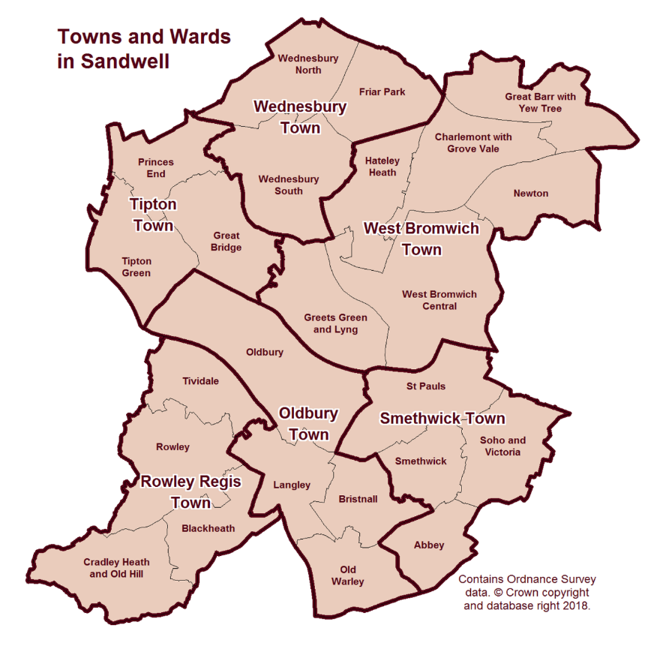
- The borough has excellent access to the wider national motorway network via two junctions of the M5 motorway (Junction 1 in West Bromwich and Junction 2 at Birchley Island), and two junctions of the M6 motorway (Junction 7 at Great Barr and Junction 9 at Wednesbury), which between them serve the southwest, southeast and northwest regions of the UK. The interchange between the two motorways (M6, J8) lies in the north of the borough. Sandwell also benefits from access to the national railway network via a mainline station (Sandwell and Dudley Railway Station), and the West Midland Metro runs between Wednesbury and Birmingham city centre with a 15-minute journey time.
- In recent years, Sandwell has seen the successful delivery of several prestigious and highly visible projects and developments and this transformational growth trend is continuing. Projects that have been undertaken include:
- Sandwell Aquatics Centre – the brand-new centre was built and delivered in time for the 2022 Birmingham Commonwealth Games and was used throughout the Games for swimming and aquatics events. Following the Games, the venue has been refurbished into a community health and wellbeing asset;
- Birchley Island – a £25.5m scheme to improve connectivity to the adjacent M5 Junction 2 by providing a new through lane for improved motorway access, enhanced facilities for pedestrians and cyclists and widened connected roads with signal control;
- National Foundry Training Centre - as part of the £12.7m Elite Centre for Manufacturing Skills scheme, this centre provides access to industrial facilities and a purpose-built training block of 950 sqm in Tipton;
- Wednesbury to Brierley Hill Metro Extension via Dudley – this will create a direct public transport route from Wednesbury to the Wolverhampton / Birmingham New Street / Walsall rail line at the Dudley Port interchange.
- Demographic Trends: The 2021 Census estimates that Sandwell has 341,900 residents, a rise of 11.0% since 2011. This compares with a rise of 6.3% in England and Wales. The 11% rise in Sandwell since 2011 is the highest in the West Midlands Metropolitan County area, the next highest being in Coventry (8.9%).
- In 2021, Sandwell ranked 27th for total population out of 309 local authority areas in England, moving up six places in a decade. The borough’s population is predicted to grow at a faster rate than both the population of the West Midlands and the national average and is forecast to increase by 30,000 between 2016 and 2030. This area is the second-most densely populated local authority area across the West Midlands (after Birmingham).
- Sandwell has a young and diverse population, with more than 40% of its residents under the age of 30, compared to around 30% elsewhere in the UK. Just over 40% of residents are from an ethnic minority background, making the population more diverse than the regional and UK average of 18.8% and 14% respectively.
- The most common main languages spoken in Sandwell, other than English, are Panjabi (6.4%), Polish (1.7%), Bengali (1.0%) and Urdu (1.0%).
- Health - the health of people in Sandwell does not on the whole compare well with national averages. Sandwell is one of the 20% most deprived districts / unitary authorities in England and around 25.5% (18,495) of its children live in low-income families. Life expectancy for both men and women is lower than the England average; 76.3 years for men and 80.8 years for women compared to 79.1 years (male) and 83.1 years (female) nationally. Life expectancy inequality also exists within Sandwell itself – life expectancy is 8.6 years lower for men and 8 years lower for women in the most deprived areas of the borough compared to the least deprived areas.
- Crime in Sandwell - In the twelve months to the end of 2024 Q2, Sandwell recorded 102.17 crimes per 1000 people. This represented a decrease from 110.63 crimes per 1000 people during the previous equivalent Q2 period. The number of recorded offences (excluding fraud) in Sandwell for the past 12 months was 35,511 crimes.
- Sandwell therefore currently ranks at 21 out of 36 in all English metropolitan boroughs for crime. Wirral had the lowest number of offences - 71.79 crimes per 1000 people in this quarter - with Manchester having the largest number at 158.71 crimes per 1000 people offences.
- West Midlands Police (WMP) have also identified an indicative level of crime in Sandwell, taken from the ONS and their own crime figures (offences / incidents / calls) for 2023:
Table 2 – Crime Statistics
 | Households | Calls for Service | Offences | Calls for service per household | Offences per household
West Midlands | 1,170,711 | 770,335 | 340,094 | 0.66 | 0.29
Sandwell | 130,399 | 87,775 | 37,469 | 0.67 | 0.29
- According to WMP, the proposed numbers of new homes (based on the figure of 10,434 set out in the Regulation 19 Consultation version of the SLP) would represent an 8% increase in the number of households within Sandwell. If the same percentage increase is applied to the actual incident and crime statistics for the area, the predicted proportional additional and total incidents / crimes likely to occur within a calendar year is likely to be in the order of 7,000 additional calls for service and 3,000 additional offences.
- Economy and Skills: Sandwell has a long history of industrial activity, especially in manufacturing. Until the 1980s the Black Country, together with neighbouring Birmingham, was the powerhouse of Britain’s manufacturing economy. The recessions in the early 1980s and during 2008 – 09 had major and lasting adverse impacts on the local economy and saw the closure of a significant number of companies and a high level of unemployment, but the sub-region has subsequently recovered.
- The West Midlands was one of the economies hit hardest by the COVID19 pandemic. Sandwell’s demography and urban structure exposed it to COVID, most notably in its central corridor of older, poor-quality housing and in ethnic minority groups where infection rates were highest.
- The impact of successive lockdowns in 2020-21 that were needed to contain the pandemic caused significant economic damage. Sandwell was already in recession when COVID hit and subsequently experienced many business failures, most visibly on high streets. It also saw widespread rises in unemployment, particularly among young people.
- Sandwell borough is around the same size in population terms as Nottingham (c323,700; Census 2021) and is bigger than Newcastle upon Tyne (c300,100), Milton Keynes (c287,000), and Oxford (c162,000), but these locations all have larger economies than Sandwell.
- Sandwell has many growing and productive businesses, with a higher-than-average proportion of its businesses being small, but residents are not always able to take up opportunities related to employment and economic activities. Local businesses will often need a highly skilled workforce to enable them to adapt to meet modern demands; that workforce may also need training and support to help both deliver and accelerate innovation. Sandwell has a limited amount of the type of high-quality land needed to enable businesses to expand and grow within the borough’s industrial core.
- Productivity - Sandwell’s economy (Gross Value Added) was worth £6.644 billion in 2020, which represents a value of £20,192 per head. While lower than both the West Midlands Metropolitan Area and the UK averages, Sandwell’s productivity is higher than that of the other authorities in the Black Country.
- Business Population - Sandwell has around 11,680 active local business units:
- 9,620 (82.4%) are micro businesses;
- 2,015 (17.3%) are small and medium units; and
- 45 (0.4%) are large units.
- Of these businesses, 45 are designated as ‘high growth’ enterprises. There is evidence of a considerable entrepreneurial spirit in the area, with approximately 1,485 new businesses being created in 2023; however, there are concerns given that 1,625 also shut down over the same period.
- Economic Activity - In Sandwell, 71% of employees work full time, with 29% working part time. The challenge in Sandwell is in generating and maintaining positive economic growth, particularly following the pandemic, while ensuring that this growth is sustainable.
- Two other factors that had a major underlying legacy effect on Sandwell’s economy were:
- the global financial crisis of 2007-2008, which reduced access to private sector finance;
- a sustained period of public sector austerity beginning in 2010; this reduced both the overall capacity of local government to protect vulnerable communities and their ability to spend locally on projects that helped support economic growth in businesses and generate better prospects of employment and skills for residents.
- During the early 2020s a range of economic shocks (including the COVID19 pandemic, the UK’s exit from the EU market in 2020, higher inflation, and a more volatile energy and commodity market ensuing from the Russian invasion of Ukraine in 2022) have resulted in significant challenges for businesses of all sizes. Other changes to the economy have come about through variations in working patterns, such as a considerable rise in the number of Sandwell residents working from home.
- It was within the context of this period of economic instability that the SLP was developed. In effect this means that the underlying resilience of the local economic base has been tested by a period of major disruption. In terms of mitigating these challenges, Sandwell Council had to prioritise a range of measures that have helped to lessen the impacts of the cost-of-living crisis on both local communities and businesses.
- Ensuring economic growth is sustainable remains a major priority for future development in Sandwell and the SLP helps to deliver a key part of that process by identifying the right sites and policies to support economic growth.
- Sandwell has a higher-than-average level of economic inactivity and unemployment.
Table 3 - Employment and Unemployment in Sandwell
Economic Activity | Sandwell numbers | Sandwell % | West Midlands Met % | Great Britain %
Economically active | 161,100 | 74.3 | 78.8 | 78.8
In employment | 151,900 | 69.8 | 75.2 | 75.8
Employees | 143,200 | 65.8 | 66.3 | 66.3
Self employed | 8,700 | 4.0 | 8.7 | 9.3
Unemployed | 9,600 | 6.0 | 4.4 | 3.7
- Over the same period, NOMIS identified that 53,700 residents (25.7% of residents aged 16 - 64) were economically inactive (compared with 21.2% in Great Britain).
Economically inactive (age 16-64) | Sandwell Nos. | % of overall workforce
Total inactive | 53,700 | 25.7%
Students | 10,300 | 19.2%
Looking after family / home | 18,000 | 33.5%
Long-term sick | 18,900 | 35.2%
- 6% of the working population are classed as unemployed (as a proportion of economically active residents), with 20.2% of households classed as ‘workless’ (where households contain at least one person aged 16 to 64 and where no-one aged 16 or over is in employment). Gross weekly incomes are below the national average. However, in 2023, full time average annual resident earnings for Sandwell reached £29,594, an annual increase of 7.8% (+£2,134) compared to an increase of 5.5% nationally
- Qualifications and Skills: Around a third of the Sandwell working age population are graduates. This is significantly lower than the UK average rate for the equivalent group, forming the most highly skilled band of National Vocational Qualification (NVQ) level 4 or above. As a result, Sandwell has a smaller pool of workers able to compete for more highly skilled vacancies. 11.8% of the Sandwell working age population have no qualifications at all; this figure compares poorly to the UK average of 6.5%. This means that members of the Sandwell workforce are more likely than those in the rest of the UK to work in lower skilled occupations.
- Employment: In terms of job numbers, the three main employment sectors in Sandwell are retail and wholesale, manufacturing, and health and social care. In terms of critical or Sandwell-specific sectors, where Sandwell plays a stronger or disproportionate role within the wider economy than the national average, the highest contributors are manufacturing (+111% greater than the national average); electricity, gas and air conditioning (+100% greater); water supply and waste management (+71% greater); transportation and storage (+59% greater); and retail and wholesale (+40% greater).
Table 4 - Distribution of Jobs in Sandwell
Sandwell Economic Sectors | Workers | % of workers in Sandwell | % of workers in GB | Relative comparison
Wholesale, Retail & Vehicle Repair | 23,000 | 18.3 | 14 | +30%
Manufacturing | 22,000 | 17.5 | 7.6 | +130%
Human Health and Social Work Activities | 18,000 | 14.3 | 13.5 | +5.9%
Transportation & Storage | 12,000 | 9.5 | 5 | +90%
Education | 10,000 | 7.9 | 8.6 | -8.1%
Admin & Support Services | 7,000 | 5.6 | 9 | -37.7%
Construction | 6,000 | 4.8 | 4.9 | -2%
Professional, Scientific & Technical | 5,000 | 4.0 | 9.1 | -56%
Accommodation & Food Service | 5,000 | 4.0 | 8 | -50%
Other Service Activities | 4,500 | 3.6 | 2 | +80%
Real Estate | 3,500 | 2.8 | 1.9 | +47.3%
Public Administration & Defence; Compulsory Social Security | 3,500 | 2.8 | 4.7 | -40.4%
Arts, Entertainment & Recreation | 2,500 | 1.6 | 2.4 | -33.3%
Information & Communication | 1,500 | 1.2 | 4.6 | -73.9%
Finance & Insurance | 1,250 | 1.0 | 3.3 | -69.6%
Electricity, Gas & Air Conditioning | 1,000 | 0.8 | 0.4 | +100%
Water Supply; Sewerage, Waste Management and Remediation Activities | 800 | 0.6 | 0.7 | -14.2%
- Workforce and travel to work: each day, 59,000 people come into Sandwell from neighbouring areas to work, and almost 62,000 of Sandwell’s residents travel to work outside the borough. The job density per working age population is 0.64, compared to 0.83 in the West Midlands metropolitan area and 0.87 in the UK.
- Housing: In March 2021, Sandwell had 130,246 household spaces. 54% of households were in owner-occupation, 27% were social rented and 19% were rented from a private landlord. The average household size in Sandwell is 2.42, which is slightly above the England and Wales average of 2.4. In terms of household composition, in 2021 38,042 households in Sandwell were made up of only one person, which equates to just under 30% of the total.
- Transport: Sandwell lies at the heart of the national strategic road network. The intersection between the M5 and M6 motorways is in the north of the borough and four motorway junctions, Junctions 7 and 9 of the M6 and Junctions 1 and 2 of the M5, provide access to and from all parts of the borough. The local road network consists of 880km (547 miles) of highways, including the strategic A41, A461, A457 and A4123 routes, which link the borough’s centres to each other, the wider Black Country and Birmingham.
- There are three rail lines that pass through the borough, serving thirteen stations:
- the Stour Valley section of the West Coast Main Line provides local services from Tipton, Oldbury and Smethwick to Birmingham and Wolverhampton as well as inter-city links to London and the north;
- the Chase Line links Birmingham New Street to Walsall and Cannock and serves the north of Sandwell;
- the Birmingham Snow Hill to Worcester line serves Smethwick and the southwest of the borough.
- In addition, large parts of the borough are served by the West Midlands Metro network, which provides connections to Birmingham and Wolverhampton. An extension to Dudley Town Centre is expected to open in 2024, with a further phase to Brierley Hill expected to complete within the first half of the plan period.
- To complete the picture, there is an extensive 66km (41-mile) canal network throughout the borough.
- The COVID19 pandemic combined with the shift to home working, particularly in the office sector, changed the way people move around; this is true of both the times at which they make journeys and the mode by which these journeys are made.
- Car use has returned almost to pre-pandemic levels, with 1.29bn vehicle miles being travelled on Sandwell’s roads during 2022, which is around the same as the figure for 2016 and was approaching the record peak of 1.35bn vehicle miles seen during 2019. The 2023 figures are expected to continue this upward trend.
- In contrast the number of public transport journeys, particularly during commuter periods, has not recovered to the same degree. Bus use in 2021-22 was at around 70% of pre-pandemic levels, whilst for the Metro the figure was 60% and for rail it was 50%. Whilst a recovery in journey numbers has continued, the 2022-23 figures are still expected to be significantly below pre-pandemic levels. In Sandwell, bus continues to be the most important mode of public transport, accounting for approximately four out of every five such journeys made.
- Centres: Sandwell’s origins lie in six distinct Urban District Councils, which merged to form a seamless and significant part of the wider West Midlands conurbation.
- Sandwell is a heavily urbanised metropolitan area, with a strategic centre (West Bromwich), seven town centres, 13 district and local centres and many small parades of shops. It is a genuinely polycentric borough.
- Sandwell has been subject to the same trends in retailing as other areas but also suffers from significant levels of deprivation and lower incomes, which in turn has had an impact on retailing activity across the borough. The rise of ‘big box’ supermarkets, internet shopping, limited range discounters, out-of-centre retail parks and standalone out-of-centre supermarkets have all impacted on the vitality of its centres. The pandemic lockdown conversely provided a boost to local centres as people tended to shop more locally.
- West Bromwich received a major boost with the delivery of the New Square development in 2013 but has fallen back in comparative terms against other centres nationally. New Square shifted the ‘centre of gravity’ of the retail area, with a subsequent decline in footfall and occupancy levels at parts of its periphery towards Bull Street, but also in Queens Square. West Bromwich’s vacancy rate was 17.74%, compared to 13.81% nationally (as at 2022).
- As with other urban areas, comparison shopping (i.e., for clothes, electrical goods etc.) is increasingly concentrated in the strategic centre, with other centres taking on a more service-orientated role.
- Built heritage and natural environment: Despite its industrial heritage and highly urban nature, Sandwell is home to large tracts of open space, areas with environmental value, and a number of heritage assets.
- Sandwell is home to 205 listed buildings and nine conservation areas. There are also five registered parks and gardens (all listed at Grade II) and seven scheduled monuments. There are many pressures on built heritage assets - to modernise or demolish historic buildings, change their uses, develop within conservation areas and the setting of heritage assets and remove landscaping. Given the irreplaceable contribution heritage assets make, the government has made it clear that it is important that heritage assets and their settings are preserved or enhanced as a reminder of the history and evolution of the area, and the SLP promotes a positive strategy to achieve this.
- All features of the outdoor environment contribute to environmental infrastructure, including natural and semi-natural habitats, parks and other open spaces, formal and informal recreation and sports facilities, historic buildings and landscapes, the public realm of spaces and streets, rivers, canals and drainage systems.
- Sandwell benefits from 542 green spaces, with 298 of those spaces (55%) offering unrestricted public access. This provides 3.235 hectares of open space per 1,000 population and offers more unrestricted green space access than some comparable local authorities, including Birmingham, Oldham, Hull, and Knowsley. More formal green and open spaces in Sandwell include:
- 32 parks and gardens (including 16 Green Flag parks)
- 198 amenity green spaces (from small local spaces to larger communal green spaces)
- 74 natural and semi-natural green spaces (including nine recognised nature reserves)
- 22 green corridors (such as green walkways and other networks that connect areas)
- 47 outdoor sports sites
- 34 allotment sites (with 1,336 plots)
- 110 play areas (including toddler and junior play facilities).
- Following aerial surveys completed as part of the recent Black Country iTree project, it is estimated that Sandwell contains around 265,000 trees, covering 18.1% of the borough. This is higher than the UK average of 16%. It is estimated that 81% of these trees are in good or excellent condition.
- Broadband and 5G: Sandwell has high levels of broadband connectivity – in February 2024 92.8% of premises were gigabit capable, compared to 80.92% in the UK. As of February 2024, Sandwell had superfast broadband coverage of approximately 99.7% and full fibre coverage of 57.7%; this compares to the UK average for superfast broadband of 97.49% and full fibre coverage of 62.4%.

Challenges and Issues
- The following summarises the key issues that have arisen since the Core Strategy was adopted in 2011. These issues provide the main challenges and opportunities that the Spatial Strategy, objectives and suite of policies are seeking to address:
  - Climate change and protecting and enhancing the environment - the Plan needs to address the challenge of mitigating and adapting to the impacts of climate change by ensuring the principles of sustainable development are embedded across all policy areas. It will also need to create a strategy for the enhancement and protection of Sandwell’s environment and to make provision for new environmental infrastructure required to support sustainable growth.
  - Providing good quality housing that meets the needs of a growing population - the Plan needs to identify as much land as possible for housing to help meet the needs of people who are likely to live in the area over the coming years. Despite the additional housing sites that have been identified and allocated in the SLP, there is still going to be a significant shortfall in the numbers of houses available to meet identified needs over the plan period, as calculated using the Government’s standard method based on household growth projections. Sandwell needs to identify land for 26,350 homes by 2041. The supply of suitable residential land based on the most recent evidence equates to the future provision of 11,901 homes. As such, there will remain an unmet need of 14,449 homes. Sandwell has a finite supply of land readily available for development; it is very unlikely that additional land to help meet housing need will be found within Sandwell itself. In part, this is due to a reduction in the availability of vacant brownfield / industrial / employment sites. Economic activity strengthened unexpectedly following the adoption of the Black Country Core Strategy and the Sandwell Site Allocations and Delivery DPD, and the quantum of redundant brownfield land that was anticipated to result from a predicted contraction in manufacturing activity did not appear.
  - Supporting a resurgent economy that provides access to employment and opportunities for investment - the Plan should provide for a range of employment sites capable of providing for a variety of investment needs. The resurgence of economic activity has also had an impact on the availability of employment land for new and expanding businesses; companies are choosing to reinvest in their current sites rather than moving elsewhere, reducing the amount of land available to incomers. Employment land need is based on economic forecasts undertaken jointly by the Black Country authorities up to 2041. Based on past completions, a figure of 229.5ha is considered deliverable in Sandwell over the plan period; a higher target would be unachievable / unrealistic, as the market would struggle to deliver it. The supply of new land available and suitable for employment use in Sandwell is currently 44.5ha (including past completions since 2020). This includes windfall sites, generated through intensification / recycling. Vacant land accounts for 28ha of the supply. Including the level of windfall / churn land available, Sandwell is 185ha short of its need figure. In addition, the SLP supports a further 1,193ha of employment land through protecting existing allocations as well as allocating new sites. Demand for employment land within Sandwell remains high, especially for sites capable of providing for larger companies.
  - Supporting strong and competitive centres – the SLP needs to address the health and enhance the vitality and viability of centres and ensure that Sandwell maintains realistic ambitions for their growth. The Plan should provide a flexible policy framework that will:
    - support centres in serving future levels of growth in Sandwell (particularly housing and employment),
    - allow centres to diversify, and
    - provide strict tests to defend towns and other centres against proposals that could undermine them, such as out-of-centre developments.
  - Keeping Sandwell connected - a balanced approach to transport investment is required that recognises the need to invest in all modes of transport but identifies a priority in increasing the proportion of people using public transport, walking and cycling.
  - Providing infrastructure to support growth - physical and social infrastructure is required to enable and support the growth proposed over the plan period. New housing and economic development will put pressure on existing services (including emergency services), utilities and utility companies but may also create opportunities to deliver infrastructure-based solutions.
  - Health and Wellbeing - the role of the environment in shaping the social, economic and environmental circumstances that determine health and wellbeing is increasingly recognised and understood, particularly where opportunities occur through new development and infrastructure provision to link communities with open and green spaces and opportunities for both active and passive recreation.

Sandwell 2041: Spatial Vision, Priorities and Objectives

What is driving the Vision for Sandwell?
  - The Vision reflects a pragmatic idea of what Sandwell could be like in the future if the needs and aspirations of those who live, work in or visit the borough were met. It allows the Council the scope to respond to likely future challenges in a way that is right for Sandwell, its residents and its businesses.
  - The Vision has been written in the context of national, regional and local policy frameworks, including the Council’s Corporate Plan and its own vision. The Sandwell Vision 2030 is as follows:
It’s where we call home and where we’re proud to belong - where we choose to bring up our families, where we feel safe and cared for, enjoying good health, rewarding work, feeling connected and valued in our neighbourhoods and communities, confident in the future, and benefiting fully from a revitalised West Midlands.
  - The Sandwell Vision 2030 also sets out ten ambitions for a successful Sandwell and what success will look like; the SLP and its policies is directly or indirectly relevant to all of them. These ambitions can be read in full in the Council’s Vision 2030 document, which is available to view on the Sandwell Council website. They are set out in summary below, together with an indication of the role the SLP will play in delivering them.
Ambition 1
Sandwell is a community where our families have high aspirations and where we pride ourselves on equality of opportunity and on our adaptability and resilience.
SLP relevance:
- promoting and supporting sustainable development that helps to meet local need / demand
- providing for sufficient services and facilities in locations accessible to all in Sandwell’s communities
- delivering a healthy supply of land for economic growth and employment
- delivering strong policy support to combatting climate change through mitigation and adaptation
- protecting and enhancing the natural environment, nature conservation and open spaces
- delivering opportunities for biodiversity net gain, landscaping and tree planting.
Ambition 2
Sandwell is a place where we live healthy lives and live them for longer, and where those of us who are vulnerable feel respected and cared for.
SLP relevance:
- protecting, enhancing and making accessible land for sport and leisure including active and passive recreation
- protecting and enhancing the natural environment, nature conservation and open spaces
- providing clear policy support for development aimed to deliver health and welfare infrastructure
Ambition 3
Our workforce and young people are skilled and talented, geared up to respond to changing business needs and to win rewarding jobs in a growing economy
SLP relevance:
- delivering a healthy supply of land for economic growth and employment
Ambition 4
Our children benefit from the best start in life and a high-quality education throughout their school careers with outstanding support from their teachers and families.
SLP relevance:
- providing land and sites for sufficient services and facilities in locations accessible to all in Sandwell’s communities including schools, colleges and opportunities for higher education.
Ambition 5
Our communities are built on mutual respect and taking care of each other, supported by all the agencies that ensure we feel safe and protected in our homes and local neighbourhoods.
SLP relevance:
- promoting the development and improvement of attractive, safe and accessible public realm, support services and community infrastructure as part of new development and project delivery.
Ambition 6
We have excellent and affordable public transport that connects us to all local centres and to jobs in Birmingham, Wolverhampton, the airport and the wider West Midlands.
SLP relevance:
- delivering a co-ordinated and strategic travel and transport network through Sandwell that links communities to opportunities both within and beyond its boundaries, supported by appropriate planning policies and land use designations
- continuing to work closely with other local authorities and partner organisations on strategic transport schemes and shared infrastructure.
Ambition 7
We now have many new homes to meet a full range of housing needs in attractive neighbourhoods and close to key transport routes.
SLP relevance:
- delivering a healthy supply of land for the delivery of zero and low carbon housing across the borough
- supporting the creation of additional affordable and sustainable communities
- supporting the production and adoption of a Design Code.
Ambition 8
Our distinctive towns and neighbourhoods are successful centres of community life, leisure and entertainment where people increasingly choose to bring up their families.
SLP relevance:
- promoting and supporting sustainable development that helps to meet local need / demand
- providing for sufficient services and facilities in locations accessible to all in Sandwell’s communities.
Ambition 9
Sandwell has become a location of choice for industries of the future where the local economy and high performing companies continue to grow.
SLP relevance:
- delivering a healthy supply of land for economic growth and employment
- supporting the delivery of sufficient high-quality physical / digital infrastructure
- delivering a co-ordinated and strategic travel and transport network through Sandwell
- providing land and sites for sufficient educational services and facilities in locations accessible to all.
Ambition 10
Sandwell now has a national reputation for getting things done, where all local partners are focused on what really matters in people’s lives and communities.
SLP relevance:
- being an up-to-date local plan backed by sound evidence and robust policies that enable planning permissions to be granted swiftly and in close co-operation with applicants, developers and local communities.

Vision for Sandwell
  - The Sandwell Local Plan Vision is set out below:
Sandwell Local Plan Vision 2041
In 2041, Sandwell is a thriving, growing and active borough, leading the urban renaissance of the West Midlands conurbation. It is a place with a united and resilient community, a place of innovation and industry and a place with a vibrant and strong cultural heritage.
Sandwell is at the forefront of tackling climate change, in its role as a hub for climate adaptation and mitigation technologies and industries. Its new buildings are clean and green in their design, materials and operations, its old buildings are carefully adapted to deliver low and zero carbon outputs. It sets the standard in both public and private sectors for embedding climate change awareness and sensitivity in all its actions, outcomes and decisions.
Notwithstanding its urban character, Sandwell’s residents enjoy access to country and town parks, open spaces, green networks, natural corridors and pocket parks. They benefit from high quality green spaces, additional landscaping schemes and increased tree cover during their everyday activities and leisure time. Sandwell’s natural environment is valued for its own sake as well as for its role in creating a healthy, attractive and climate change-resistant background for people living, working, learning in and enjoying the borough. Sandwell’s commitment to increasing its ecological resources has seen the creation of new habitats and biodiversity-related projects across the borough, delivering improvements to local environments and playing its part in supporting the nature recovery network across the West Midlands.
Sandwell’s historic environment is a source of pride for its communities and continues to reflect its industrial and architectural heritage, in restoration and renovation schemes and in the sensitive design of new buildings. Historic buildings in Sandwell are reused, repurposed and retrofitted to enable their retention and occupation for years to come. The borough’s historic landscapes, parks and gardens are protected and enjoyed by residents and its archaeology is valued and recorded in both urban and rural areas.
Sandwell was at the heart of the first Industrial Revolution, reflected in its historic buildings such as Soho Foundry and the canal network running across the borough. It now lies at the forefront of another one. It is where the technology is produced to make tomorrow work. Sandwell is home to highly specialised companies and industries in the vanguard of delivering advanced manufacturing, advanced materials production, next-level energy generation, e-commerce and specialist sensors. It continues to deliver sustained and sustainable economic growth and investment opportunities from its extremely accessible location at the heart of the country. It provides high-quality goods and services from its powerful industrial base; as a result, levels of employment, wages and economic activity are high and rising.
As part of this forward-looking economic activity, Sandwell has also continued to support investment in critical waste, energy and transport infrastructure that has resulted in a robust circular economy, where not only does less waste end up in landfill, but less waste is produced overall in Sandwell, more recycling takes place, and cutting-edge waste-to-energy operations provide the fuel for local heating networks.
Sandwell’s residents enjoy longer and healthier lives than in previous decades, thanks to the increase in accessible open spaces, the provision of services and facilities designed to promote active recreation and leisure, the improvement of and increased accessibility to healthcare infrastructure and the promotion of healthy lifestyle choices. They have access to well-performing schools, higher and further education provision at all levels and to continued opportunities for skills development and training.
There is a wide range of housing available to Sandwell residents, aiming to help meet housing needs, designed to support green living and suitable for adaptation to benefit all sections of the community. Affordable, social and local authority-provided homes are available to those who need them. New developments deliver high-quality designs and are located within attractively landscaped areas, with access to district and low-cost energy and heating projects, sustainable drainage designed to improve the local environment as well as provide reliable protection against flooding and run-off and all necessary services and facilities within walking and cycling distance or a short bus ride away.
Sandwell’s town centres thrive by day and by night, with an expanded range of retail, leisure and socialising opportunities as well as acting as the foci for new residential developments, community activities and social enterprises. They are safe, welcoming and accessible locations at all times, designed to encourage positive public interactions and minimise antisocial behaviour.

Priorities and Objectives
  - To assist in the delivery of the Vision, a set of priorities have been identified, which form the basis of individual policies contained in the SLP. These priorities directly address the key strategic challenges and opportunities that have arisen since the Core Strategy was adopted in 2011 and the SAD was produced.
  - The Vision will be delivered by the achievement of the strategic objectives identified in Table 5. The policy references identified here (and linked to in policies elsewhere in the SLP) are not intended as a closed list – other policies that are not mentioned specifically will carry similar weight and can be taken into consideration when planning decisions are made.
Table 5 – Priorities, Strategic Objectives and Policies
Priority | Strategic Objective | Policy
Climate Change | Objective 1: Ensure new development takes a proactive approach to climate change mitigation, adaptation and carbon reduction, and that development is resilient to climate change. | Policy SDS1 – SDS2, Policy SDS4, Policy SDS5, Policy SDS8  Policy SNE1 - Policy SNE3  Policy SCC1 - Policy SCC6  Policy SHW3 – SHW6  Policy STR5, Policy STR6, Policy STR9, Policy STR10  Policy SDM1, Policy SDM2
Climate Change | Objective 2: Deliver sustainable development in locations where people can access jobs and services, delivering wider positive social and economic outcomes and protecting and enhancing local built and natural environments. | Policy SDS1 - Policy SDS8  Policy SCC1 - Policy SCC6  Policy SHO1, Policy SHO3  Policy SEC1 – Policy SEC6  Policy SCE1  Policy STR1 – STR10  Policy SDM1 - Policy SDM9
Enhancing our natural environment | Objective 3: To protect and enhance Sandwell’s natural environment, natural resources, biodiversity, wildlife corridors, geological resources, countryside and landscapes, whilst ensuring that residents have equitable access to interlinked green infrastructure. | Policy SDS7, Policy SDS8  Policy SNE1 - Policy SNE6  Policy SHW4 - Policy SHW6  Policy SHO1
Enhancing our historic environment | Objective 4: To protect, sustain and enhance the quality of the historic built environment and the significance of heritage assets, ensuring the retention of distinctive and attractive places and beautiful buildings, including listed parks, scheduled monuments and their settings. | Policy SDS2, Policy SDS5, Policy SDS6  Policy SHE1 - Policy SHE4  Policy SHW4
Enhancing our historic environment | Objective 5: To manage and maintain the wider historic environment across Sandwell, including landscapes, parks and gardens, areas of industrial heritage value, sites of geological and archaeological interest and locally listed buildings, structures and heritage assets. | Policy SDS5, Policy SDS6  Policy SNE6  Policy SHE1 - Policy SHE4  Policy SHW4  Policy SDM1, Policy SDM2
Housing that meets all our needs | Objective 6: Address Sandwell’s identified and wide-ranging housing needs by supporting the provision of high-quality new homes, to include a wide mix of housing type and tenure, that:  - are capable of being adapted to meet the future needs of occupiers  - provide sufficient internal and external space and  - promote and support climate change adaptation and mitigation through good design, and in the materials and techniques used in their construction. | Policy SDS1– SDS5  Policy SNE1 - Policy SNE3  Policy SCC1 - Policy SCC6  Policy SHO1 - Policy SHO10  Policy SDM1, Policy SDM2
Housing that meets all our needs | Objective 7: Ensure communities in Sandwell are safe and resilient and social cohesion is promoted and enhanced. | Policy SDS5, Policy SDS6  Policy SHW2  Policy SHO4, Policy SHO5, Policy SHO7
Enabling a strong, stable and inclusive economy | Objective 8: Support regeneration, business investment and job creation to maintain and grow a prosperous and resilient local and regional economy in ways that consider environmental and climate change factors. | Policy SDS1- Policy SDS3, Policy SDS8  Policy SCC1 - Policy SCC6  Policy SEC1 - Policy SEC6  Policy STR4, Policy STR5, Policy STR6, Policy STR10  Policy SID1 - Policy SID4
Enabling a strong, stable and inclusive economy | Objective 9: To enable communities to share the benefits of economic growth through securing access to new job opportunities and enhanced skills and training programmes. | Policy SDS1  Policy SHO8  Policy SEC5  Policy STR1, Policy STR5
Improving the Health and Wellbeing of residents and promoting social inclusion | Objective 10: To provide a built and natural environment that supports the making of healthier choices through provision for physical activity and recreation, active travel, encouraging social interaction and discouraging harmful behaviours. | Policy SDS7, Policy SDS8  Policy SNE6  Policy SHW1 - Policy SHW6  Policy STR5  Policy SDM6 – Policy SDM8
 | Objective 11: To ensure new development and open spaces support health and wellbeing for all, reduce health inequalities and encourage active and healthy lifestyles. | Policy SDS5, Policy SDS6, Policy SDS8  Policy SNE3, Policy SNE6  Policy SCC3  Policy SHW3 - Policy SHW6  Policy STR5
 | Objective 12: To provide a built and natural environment that protects health and wellbeing through minimising pollution (air, noise and other forms), providing healthy homes, reducing the negative health effects of climate change and providing streets safe for active, low emission travel for all. | Policy SDS1 - Policy SDS5, Policy SDS7 - Policy SDS8  Policy SNE1 - Policy SNE6  Policy SCC1 - Policy SCC6  Policy SHW3  Policy SHO5
Good Design | Objective 13: To require new development to deliver a high standard of design reflecting local character and distinctiveness and that creates greener and safer places that people feel proud to live and work in. | Policy SDS5  Policy SCC1, Policy SCC3, Policy SCC5 - Policy SCC6  Policy SDM1
Brownfield First | Objective 14: To encourage the effective and prudent use of previously developed land, including the efficient use of land and buildings and the use of sustainable and climate-aware construction techniques within new developments, as well as providing for waste management and disposal. | Policy SDS1 - Policy SDS5  Policy SCC1 - Policy SCC4  Policy SWA1 - Policy SWA5  Policy SCO1 - Policy SCO3
Enhancing the vitality of our centres | Objective 15: To support Sandwell’s towns and local centres as places for economic, residential and cultural activity, with good access to services, in ways that protect their heritage, character and identity. | Policy SDS5, Policy SDS6  Policy SHE1 - Policy SHE3  Policy SCE1 - Policy SCE7  Town Centre Profiles  Policy STR8  Policy SID1 - Policy SID4  Policy SDM1 - Policy SDM9
Promoting sustainable transport and active travel | Objective 16: To prioritise sustainable and active travel and seek to improve transport infrastructure, to ensure efficient and sustainable accessibility within an integrated network. | Policy SDS4  Policy SNE6  Policy STR1 - Policy STR10
Meeting our resource and infrastructure needs | Objective 17: To manage waste as a resource and minimise the amount produced and sent to landfill, including ensuring that the reliance on primary minerals during construction and development are kept to a minimum and that greater use is made of recycled or alternative building materials. | Policy SWA1 - Policy SWA5
Meeting our resource and infrastructure needs | Objective 18: To ensure development is supported by essential infrastructure and services and promotes safe movement and more sustainable modes of travel, through promoting greener travel networks for walking, cycling and public transport. | Policy SDS4, Policy SDS5  Policy SNE6  Policy STR5, Policy STR6  Policy SID1 - Policy SID4  Policy SDM9

Ensuring delivery of the Vision, priorities and strategic objectives
  - Primarily, the Vision, objectives and priorities set out above will be delivered via the application of the policies of this Plan. The monitoring section at the end of the SLP identifies targets for key indicators that will need to be achieved if these policies are to be considered successful.
  - The West Midlands Combined Authority and its constituent local authority members agreed to a single settlement funding arrangement with Government, which will consolidate many of the different funding streams through which money is devolved to the region. The mechanisms that the authorities propose to use to equitably and effectively distribute the single settlement funding are:
  - Functional Strategies
  - Place-Based Strategies.
  - The Functional Strategies will be plans aligned to the Government’s spending review periods. They will be agreed via the Combined Authority Board and will seek to deliver against the Combined Authority’s functional responsibilities of:
- local growth and place
- local transport
- adult skills
- housing and regeneration
- building retrofit
  - The Place-Based Strategies will be long-term visions for each constituent local authority member. They will define a geographical area of focus and will set out a strategic case for investment and intervention, which will be delivered using single settlement funds, other investment sources and policy levers.
  - Sandwell’s Place-Based Strategy will complement and build on the Vision and Strategic Objectives of the Local Plan. Its geographical area of focus will be the Regeneration Areas (Policy SDS2) and the Sandwell Levelling Up Zone.

Spatial Strategy

Introduction
  - The Sandwell Local Plan (SLP) will help achieve sustainable development by ensuring that Sandwell benefits from the right development in the right place at the right time. This development will help meet the needs of people living and working in the borough, while protecting and enhancing its environment and the unique character of the area.
  - The Spatial Strategy, as set out in policies and illustrated by the Policies Map, provides an overarching framework supporting the SLP’s proposals for growth and infrastructure improvements. In determining a spatial strategy for the Sandwell Local Plan, Sandwell Council balanced sometimes-conflicting elements to ensure it produced a strategy that is sound, realistic and sustainable.
  - The final choice of spatial strategy for the SLP also took account of the following:
- known environmental and other planning constraints
- evidence base
- Vision and objectives
- consultation feedback
- ongoing engagement with key stakeholders, including adjoining local authorities
- testing of options through:
    - the Sustainability Appraisal (SA) process, which incorporates Strategic Environmental Assessment (SEA); and
    - a Habitats Regulations Assessment (HRA)
- consideration of land availability, viability and existing / future infrastructure capacity; and
- other plans and strategies relating to Sandwell.
  - In March 2020 Sandwell Council declared a Climate Emergency. Council Members agreed that greenhouse gas emissions needed to be reduced to a level compatible with keeping global warming below 1.5^{C} above pre-industrial levels. To achieve that, the Council committed to becoming carbon neutral in its own activities by 2030 and to seeing Sandwell become a carbon neutral borough by 2041.
  - The SLP addresses this through adopting a suite of policies designed to help Sandwell mitigate and adapt to the changing climate at a strategic level, in line with the Council's adopted Climate Change Strategy. Climate change is a cross-cutting theme for the SLP, and every opportunity will be taken to promote appropriate mitigation and adaptation across all topic areas.
  - There is still, despite the number of housing sites that have been identified and allocated, a significant shortfall in the amount of housing available to the SLP to meet identified needs. Housing need is calculated using the Government’s standard method based on household growth projections.
- Sandwell needs to identify land for 26,350 homes by 2041.
- The supply of suitable residential land based on the most recent evidence stands at 11,901 homes.
- There is an unmet need for 14,449 homes.
The SLP provides for nearly half of its housing need on the land that is available in Sandwell.
  - There is a finite supply of land readily available for development, and it is the case that there is insufficient scope to meet Sandwell’s housing need within Sandwell itself. The Duty to Co-operate means that the Council is in communication with neighbouring authorities and is actively seeking their agreement to accommodate some of Sandwell’s unmet need through their own housing provision.
  - Sandwell is a borough with high levels of poor health and deprivation and a lower-than-average life expectancy. The people of Sandwell experience significant inequalities in health when compared to the rest of England. On average, they do not live for as long as people in other areas of England and spend more of their lives ill or disabled.
  - The largest influences on physical and mental health are the social determinants of health such as education, employment, social networks, housing, access to blue and green spaces and active modes of travel. The SLP will look to support the right development in the right places to help ensure these aspects can be addressed.
  - Health and wellbeing is another cross-cutting theme that will be considered throughout the Plan. The SLP promotes healthy living and seeks to create opportunities for active lifestyles and healthy transport choices, including walking, cycling and outdoor recreation.
  - In recent years patterns of shopping have changed radically, and perhaps permanently in some cases, mainly due to the rise in online shopping and the impacts of the COVID19 pandemic. The role of centres is moving away from their traditional, retail-led primary functions. While there will remain a clear demand for in-person shopping opportunities and retail-related activities, centres will also need to provide additional draws (such as for leisure, education, community uses and recreation) to offset the loss in shopping-related footfall and to help retain their vitality and viability.
  - The Plan provides a flexible policy framework that allows centres both to serve the future growth identified in Sandwell (particularly housing and employment) and to diversify. It also provides strict tests to defend centres against proposals that could undermine them, such as further out-of-centre developments.
  - In terms of job numbers, the major employment sectors in Sandwell are retail and wholesale, manufacturing, and health and social care. Sandwell plays a larger role than the national average in the provision of employment in several sectors, as set out in paragraph 67 (and Table 4) above.
  - Employment land need is based on economic forecasts in the EDNA up to 2041.
- Sandwell is subject to a demand for 229.5ha of employment land.
- The current supply of land available and suitable for employment use is 44.5ha (after completions between 2020 – 2022 are considered). This includes windfall supply, generated through intensification / recycling, and also includes a vacant land supply of 28ha (sites identified under Policy SEC1).
- Based on the amount of land required to grow the economy, there is a shortfall of around 185ha.
- In addition, the plan allocates / retains 1,193ha of existing occupied employment as strategic, local or other employment land.
  - Therefore, ensuring that an adequate supply of employment land is maintained throughout the plan period will be essential in enabling long-term balanced growth to be sustained. The key issues to be addressed in the SLP are as follows:
- Allocate land for new development within Sandwell, to facilitate economic growth and diversification.
- Accommodate a variety of business needs, including in the high technology manufacturing and logistics sectors.
- Protect and enhance land and premises within existing employment areas where this continues to provide for the needs of jobs and businesses.
- Recognise that some sites will become unsuitable for continued employment uses and facilitate their redevelopment to alternative uses.
- Enable local communities to share the benefits of economic growth.
  - New housing and economic development will put pressure on existing services and utilities but may also create opportunities to provide infrastructure solutions. The SLP will need to provide clear guidance on the provision of suitable and sufficient infrastructure to support the regeneration and growth of Sandwell. Much of this infrastructure will need to be provided before or alongside new development and will need to be subject to viability considerations to ensure it does not make the development financially undeliverable.
  - Despite its industrial heritage and highly urban nature, Sandwell is home to several significant areas of green and open space, a network of wildlife corridors, sites with significant ecological and environmental value and several historic and architecturally significant buildings and locations.
  - The key environmental issues addressed in the SLP include:
- nature conservation
- nature recovery network and biodiversity net gain
- provision, retention and protection of trees, woodlands and hedgerows
- historic character and local distinctiveness of the Black Country
- geodiversity and the Black Country UNESCO Global Geopark
- canals
- green belt
- the protection and enhancement of designated and undesignated heritage assets
- rejecting poor design
  - In view of the levels of both housing and employment land needs, it is becoming apparent that Sandwell will not be able to meet them in full, either within the borough or across the plan period. To try to do so would result in significant and harmful levels of overdevelopment in the urban areas and the loss of open and green spaces across the district; even then, development needs would not be fully met.
  - This degree of overdevelopment would inevitably have an adverse effect on the living environment, health and wellbeing of Sandwell’s residents, alongside the exacerbation of climate change impacts and the degradation of the natural and built environment, habitats and green and blue infrastructure.
  - Sandwell has very little green belt (it falls mainly within and adjacent to Sandwell Valley) and very few vacant / unused open spaces; the areas of undeveloped and open land it does contain are extremely important to the borough’s environment and the health and wellbeing of its population.
  - During the preparation of the SLP, Sandwell Council identified and tested a series of options relating to the potential quanta and distribution of housing and employment growth. These were then subjected to an impartial assessment of their sustainability, which demonstrated that the social, environmental and economic implications of the options identified for the spatial strategy were interrelated and varied.
  - Given the outcomes of the assessment, the Council then considered what the most appropriate direction of growth might be for Sandwell, in relation to both opportunities and constraints and given the fact that the borough would not be able to meet its housing and employment requirements in full even if significant areas of open land were further identified and allocated for development.
  - The Council needed to strike a balance between maximising the realistic amount and capacity of development land available to it and working towards delivering the aims set out in the SLP Vision. The Vision pictures a borough that can deliver both economic and housing growth while improving the health and life chances of its residents, addressing the challenges of climate change and protecting and enhancing its natural and built environment.
  - There was little scope to identify or allocate greenfield land for new housing or employment development without adversely affecting vulnerable land uses, and to do so would also run counter to the Council’s stated aims in relation to creating a healthy and active borough, maintaining and enhancing the natural and built environment and tackling the impacts of climate change. As a result, allocation of greenfield land has only been undertaken if that site was of a strategically significant size and in a sustainable location, and the loss of any open or green space could be fully mitigated, by being replaced by better quality green / blue infrastructure, open spaces and / or facilities.
  - Intended land uses have also been considered, with proposals for housing and employment taking precedence over other forms of use or activities more suited to town centres or in previously developed areas.
  - The original Black Country Core Strategy identified a number of sites in employment use as suitable for reallocation to help meet housing needs. This was undertaken on the basis that the Black Country’s employment base was understood to be reducing in size as the nature of economic activity in the area changed. However, the anticipated fall-off in the level of manufacturing and industrial activity did not occur, and it became apparent during the drafting of the Black Country Plan that there was not only the need to maintain a healthy supply of employment land but also an increasing demand for additional appropriate and sizeable sites for such uses. As a result, the potential supply of brownfield sites suitable for conversion from employment to housing use has effectively been reduced, to maintain economic stability and allow for growth.
  - The Council undertook an assessment of the various housing and employment options available to it for meeting local needs and promoting climate change mitigation, environmental protection and the delivery of renewed and healthy communities. As a result of these considerations, it identified a strategic approach to development that combines the delivery of a realistic and meaningful amount of growth to meet local needs with a forward-looking and innovative environmental approach to development in Sandwell. This will deliver what is known as the Balanced Green Growth strategy for the delivery of development in Sandwell.

Balanced Green Growth
  - The Balanced Green Growth approach allows Sandwell to provide a significant quantum of housing and additional employment opportunities in the borough. At the same time, it promotes a bold green strategy that supports the delivery of climate change adaptation and mitigation, environmental protection and enhancement, the conservation and enhancement of the historic environment and the delivery of green and blue infrastructure. This in turn will support the Council’s wider aims and objectives in improving the health (physical and mental), wellbeing and life chances of people in Sandwell.
  - Balanced Green Growth will provide for the quantum of development identified previously using the following approach, which is also included in Policy SDS1:
- maximise climate change adaptation and mitigation through the creation, protection and improvement of parks, woodland and tree planting, open spaces, landscapes and habitats across the borough
- protect valuable areas of ecological interest, habitats and open spaces within and beyond urban areas
- conserve the historic and archaeological environment and protect areas with geological and landscape value
- create additional accessible public open spaces to serve new housing developments
- promote the use of zero- and low-carbon designs, building techniques, materials and technologies in all new development
- deliver as much new development as possible on previously developed land and sites
- allocate housing sites in locations with very high levels of sustainable transport access to residential services (e.g., retail provision, schools, healthcare facilities, fresh food, employment)
- support the regeneration of existing housing and employment areas and help them deliver:
  - cleaner, more energy-efficient and more intensive areas of growth; and
  - improvements to the environmental, climate change, accessibility and socio-economic capacity of existing residential and employment areas
- allocate new employment sites where sustainable access and good public transport links are available now or in the future
- take advantage of existing and improved infrastructure capacity to maximise development on new sites, where this would be in keeping with the character and environment of the surrounding area.
  - The Balanced Green Growth approach forms the basis of the Sandwell Local Plan’s Spatial Strategy (Policy SDS1) and supports the aims and objectives of both the strategic and local policies in the rest of the plan. This is a positive, deliverable and sustainable approach to meeting development needs for the plan period. It has been informed by the Sustainability Appraisal and reflects local priorities and national policy, including the NPPF.
  - The Spatial Strategy shapes the pattern of growth that will occur over the plan period and has formed the basis for the allocation of strategic sites across Sandwell. It also helps to ensure that planned housing and employment growth is supported by appropriate investment in the infrastructure needed to create sustainable communities.

Figure 2 - Sandwell Spatial Map
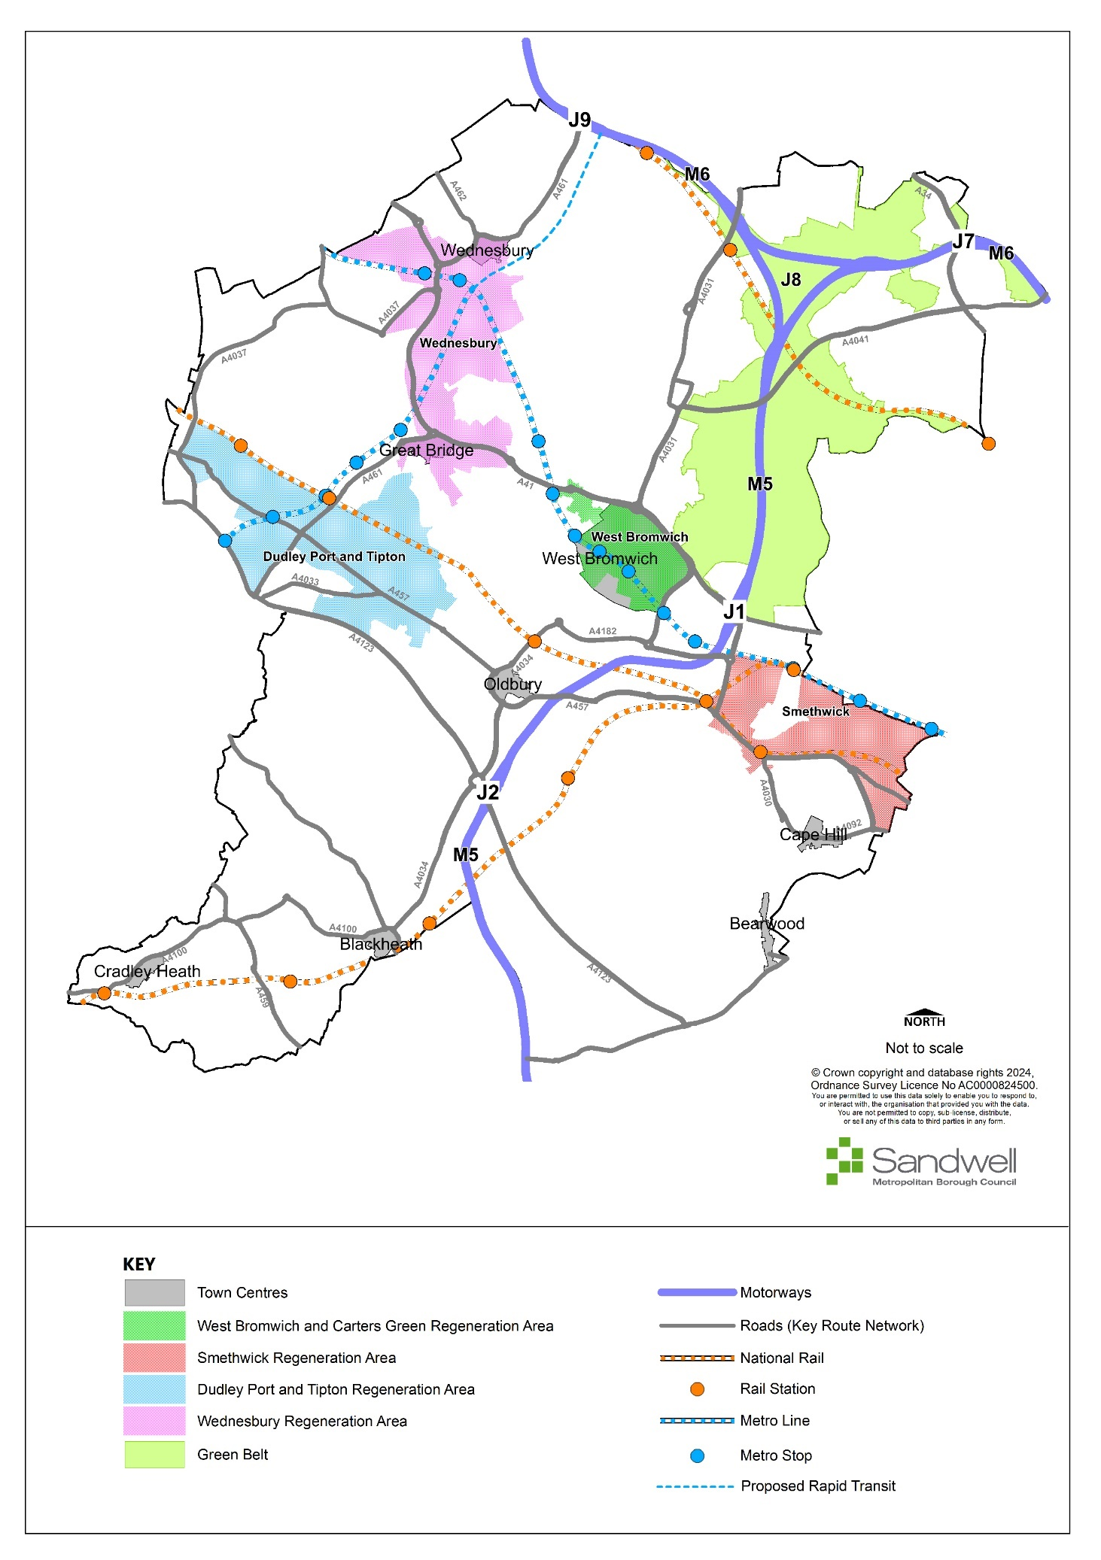

Framework Policies
- The SLP contains various overarching themes that appear throughout the policy narrative, which are intended to form a broad framework within which the Plan’s objectives and aims will be delivered. These themes are effectively laid out in the following high-level policies, which are intended to provide strategic guidance for decisions on land use issues across the borough.

Spatial Strategy for Sandwell
- Policy SDS1 provides the overarching strategy for Sandwell, setting out the broad scale and distribution of new development for the Plan period to 2041.

Policy SDS1 – Spatial Strategy for Sandwell
- To support the attainment of the Sandwell SLP Vision, drive sustainable and strategic economic and housing growth and meet local aspirations, Sandwell, working with local communities, partners and key stakeholders, will make sure that decisions on planning proposals:
  - deliver at least 11,901 net new homes across the plan period and create sustainable mixed communities including a range and choice of new homes supported by adequate infrastructure;
  - seek to meet existing Gypsy, Travellers and Travelling Showpeople needs as far as possible.
  - maintain the ongoing provision of around 1,221ha of allocated employment land across the plan period (of which 28ha is currently vacant) (Policies SEC1 – SEC3);
  - ensure that sufficient physical, social, emergency services, utility and environmental infrastructure is delivered to meet identified requirements;
  - support improvements to the health and wellbeing of Sandwell’s communities by requiring new development to address the following:
    - increased access to green spaces;
    - active and passive recreation;
    - active travel;
    - improved and accessible education and healthcare infrastructure;
    - opportunities for people to make healthier choices.
  - minimise and mitigate the likely effects of climate change, recognising the multifunctional benefits that open spaces, landscaping, trees, nature conservation habitats and both green and blue infrastructure can deliver in doing so;
  - create new public open spaces to serve new housing developments;
  - protect and improve parks, woodland and tree planting, open spaces, landscapes and habitats across the borough;
  - protect the openness, integrity and function of Sandwell’s designated green belt by resisting inappropriate development in it, except in circumstances as set out in national guidance;
  - protect habitats and areas of ecological value and support nature recovery;
  - conserve the significance of the historic environment, particularly in relation to heritage assets and their settings, and protect areas with geological and landscape value;
  - promote the use of zero- and low-carbon designs, building techniques, materials and technologies in all new development.
- The SLP seeks to ensure this growth is sustainable by requiring the following issues are addressed in planning proposals:
- delivering as much new development as possible on previously developed land and sites in the urban area;
- ensuring housing is delivered in locations with the highest levels of sustainable transport access to residential services (e.g. retail provision, schools, healthcare facilities, fresh food, employment), such as near railway stations, metro stops and public transport hubs, and making effective use of land through the application of minimum densities (Policy SHO3);
- regenerating existing housing and employment areas and help them deliver:
- cleaner, more energy-efficient and more intensive areas of growth; and
- improving the environmental, climate change, accessibility and socio-economic capacity of existing residential and employment areas;
- ensuring new employment land is delivered in locations where sustainable access and good public transport links are available;
- taking a comprehensive and co-ordinated approach to development, including respecting existing site constraints including utilities situated within sites;
- taking advantage of existing and improved infrastructure capacity to maximise development on new sites;
- ensuring all new development is designed to encourage sustainable travel and minimise detrimental impacts on the transport network;
- ensuring all new development is designed to minimise the opportunities for crime and antisocial behaviour to occur, and to optimise public and individual safety;
- supporting and enhancing the sustainability of existing communities through the focussing of growth and regeneration into West Bromwich and other town centres and regeneration areas (Policy SDS3);
- protecting and enhancing the quality of existing towns and local areas and re-balancing the housing stock by delivering homes supported by jobs and local services.
- Chapters 16 and 17 show how the housing and employment land ambitions for Sandwell will be met. They include strategic site policies for housing and employment and mixed use, and non-strategic allocations. Those development needs that cannot be accommodated within the borough will be exported to sustainable locations in neighbouring local authority areas, following consultation.

Justification
- The economy and population of Sandwell are both growing. The Council needs to plan for continued economic recovery and growth and enhanced business productivity. It has also identified a housing supply for at least 11,901 new homes within the plan period. This comprises identified sites, windfall allowance, additional floorspace in centres and additional supply identified in the Wednesbury Masterplan. To accommodate this future growth, sites and locations that are both sustainable and deliverable have been identified for development, at levels that do not breach the environmental capacity of the area.
- In Chapter 16, the Council has identified sites that it considers to be of strategic importance in delivering the housing and employment land needed in Sandwell. Reflecting local circumstances, strategic housing sites are defined as sites capable of delivering over 500 dwellings; sites identified in the West Bromwich and Grove Lane Masterplans are identified as providing strategic benefits. These sites represent a significant proportion of the planned housing growth and are critical to achieving housing requirement of the Sandwell Local Plan.
- One strategic employment site has been allocated. It is a vacant site of over seven hectares that was identified and assessed through the Black Country Economic Development Needs Assessment and Black Country Employment Area Review as important to the delivery of strategic economic growth.
- A mixed-use site has also been identified as of strategic importance, as it provides for a significant amount of housing and employment land in a location with very good links to the strategic highways network.
- The Spatial Strategy is based on various considerations, including:
    - the Vision, objectives and priorities;
    - environmental constraints;
    - the availability and viability of land for development;
    - national planning policy.
- The Spatial Strategy has been arrived at through the assessment of a comprehensive range of alternative options. The Sustainability Appraisal demonstrates that the chosen approach will enable Sandwell to meet a considerable amount of its growth needs in a manner that takes full account of environmental, climate change, accessibility and social requirements. By promoting the right type and amount of development in the most sustainable locations, the Strategy also plays a crucial role in delivering an equitable Sandwell that supports local people in achieving their personal goals.
- The areas identified for major inward investment and funding are also the primary foci for co-ordinated and sustained renewal and infrastructure development, supporting the delivery of significant growth and wider benefits to local communities. The SLP sets out realistic development targets for Sandwell’s main centres, based on up-to-date evidence.
- Sandwell’s strategic centre, West Bromwich, is already served by an extensive transport system and therefore provides a suitable location for economic and housing growth. Improvements are however required to enhance its connectivity, accessibility and environmental quality.
- Strong links will be created between the strategic town centre, the areas identified for regeneration and existing town and local centres and communities, through high-quality design, green infrastructure and transport investment. This will help to spread regeneration benefits more widely, improve community cohesion and support an effective travel network.
- The Council is aiming to utilise land efficiently, but there is still a significant shortage of deliverable sites to meet housing and economic growth needs. Sandwell has identified and made effective and extensive use of brownfield and urban sites and has also undertaken density uplifts in relation to both existing and new allocations. Sites have also been assessed in terms of their accessibility by all modes of transport, to ensure links with existing and proposed areas of employment can be maintained and enhanced where possible.
- There is a need to provide for growth in Sandwell, to enable it to provide capacity for economic prosperity, while also recognising and protecting the most sensitive environmental resources and ensuring that proposed development does not adversely affect certain areas unduly. The overall effect of Sandwell’s strategy therefore is to direct housing growth and employment land development to the existing built-up area and onto brownfield sites wherever possible.
- The Spatial Strategy also seeks to protect green spaces within Sandwell, including parks, open spaces and land with value for biodiversity, nature conservation and ecology. All these areas provide valuable open areas for recreation and ecology and contribute to a network of spaces across the wider Black Country that allows access to the surrounding countryside, including for wildlife.
Duty to Co-operate
- This Plan will look to meet housing and employment land needs within Sandwell in the first instance. However, it is apparent that the capacity of the borough is very limited. The Council recognises that it is not possible to provide for all the identified housing and employment land needs within its administrative boundaries, given the circumstances around land deliverability, extant land-use constraints and the need to protect its unique natural and built heritage. It will continue to regularly monitor the land supply position and keep under review any opportunities for additional supply with the borough over the plan period. Mechanisms for such monitoring and review include:
- an annual Strategic Housing Land Availability Assessment (wherein density and other capacity assumptions can be reconsidered and a Call for Sites undertaken);
- the Brownfield Register;
- the forthcoming Sandwell Design Code, Masterplans or any equivalent for specific areas or sites;
- the Housing Delivery Test Action Plan (where applicable); and
- the Authority Monitoring Report.
- The SLP aims to allocate sites for 11,901 new homes in Sandwell over the period 2024-41, compared to a local housing need of 26,350 (2024 – 2041) homes; this means there is a shortfall of 14,449 homes.
- For employment land, the EDNA establishes a need for 229.5ha of vacant land for new employment development, an anticipated level of allocations of 1,221ha of existing employment land (of which 28ha is currently vacant) and a shortfall of 185ha (accounting for additional completions identified between 2020 and 2022).
- Current national planning policy requires this unmet housing and employment land need to be provided for across the Housing Market Area, Functional Economic Market Area (FEMA) and other areas with which Sandwell has a strong physical or functional relationship.
- Sandwell has worked openly and constructively with neighbouring authorities to help provide as much certainty as possible about how and where its housing and employment land needs might be delivered..
- Sandwell recognises that this process may address only a small proportion of the housing and employment shortfall, as it is beyond the legal powers of the Council to establish the limits of sustainable development in neighbouring authorities. Sandwell will undertake further work as appropriate to identify how the shortfall might be addressed. This work includes those mechanisms set out at paragraph 3.15 to monitor and review land supply within Sandwell borough.
- Notwithstanding this, Sandwell is committed to ongoing engagement with its neighbours to secure the most appropriate and sustainable locations for housing and employment growth to meet local needs. In terms of housing, the engagement will extend beyond the adoption of this plan and will build on the partnership approach developed across the Greater Birmingham and Black Country Housing Market Area.
- Where it is shown to be desirable, sustainable and deliverable, Sandwell will support its neighbours in bringing forward land for employment and housing that sits adjacent to existing administrative boundaries and will work in partnership to ensure related infrastructure needs are addressed across those boundaries.

Increasing efficiency and resilience
- The Government has stated that all buildings need to be net zero carbon by 2050. Section 19 of the Planning and Compulsory Purchase Act (2004), Section182 of the Planning Act (2008), the Planning and Energy Act (2008), and Chapter 14 of the NPPF (2023) all empower local planning authorities to enforce policies that seek to reduce carbon emissions from new homes.
- The NPPF (December 2023) states that plans should take a proactive approach to mitigating and adapting to climate change. As part of this, new development should be planned for in ways that can help to eliminate greenhouse gas emissions, through careful consideration of matters such as location, orientation and design. The following policy aims to ensure that future development address national energy and climate change objectives.
- Policy SDS2 sets out how new development proposals will be required to demonstrate that they are designed to maximise resistance and resilience to climate change, through addressing various requirements.

Policy SDS2 – Increasing efficiency and resilience
- Development should be designed to mitigate climate change impacts and provide adaptations that will help communities and individuals to continue to avoid or mitigate adverse effects on human health. It should also consider and address the need for net zero outcomes for all new residential buildings and major non-residential buildings.
- Proposals for development will need to demonstrate how they have been designed to maximise resistance and resilience to climate change through addressing the following requirements where relevant and in accordance with other policy obligations:
  - the design of new buildings should employ passive design to minimise internal heat generation by giving consideration to orientation, shading, thermal mass and insultation; be located, orientated and designed to maximise opportunities for both natural heating and ventilation; and to reduce exposure to wind and other elements (Policy SDS5; Policy SCC3; Policy SDM1);
  - development will need to meet the needs of all sections of the community by including a range of sustainable and low carbon transport modes as alternatives to private car use (Policy STR6);
  - use of trees and other planting in landscaping schemes will be required throughout Sandwell, to provide for the shading of amenity areas, buildings and streets, mitigate against poor air quality and help connect fragmented habitats and protect and support biodiversity networks (Policy SNE3);
  - landscaping schemes should be designed using a mix of native tree species and plants where appropriate and should also use species that are able to adapt to changing climate conditions (Policy SNE3);
  - where practicable, development will utilise sustainable drainage systems, which should be built into landscaping schemes / open space provision as appropriate (Policy SCC6), and prioritise natural drainage solutions to minimise the impact of surface water runoff, including grey water recycling and rainwater collection and the use of permeable surfaces where possible (Policy SCC5 – SCC6);
  - development will be required to incorporate mitigation and resilience measures designed to reduce the risk of river, surface and other potential water flooding (Policy SCC5);
  - the conversion of non-domestic buildings to residential use will be expected to employ high environmental standards, incorporating improved thermal insulation, appropriate levels of natural ventilation and measures to improve water efficiency (Policy SCC3);
  - proposals for development should promote circular economy outcomes and seek to reduce whole life-cycle carbon emissions of development proposals by considering the reuse of existing resources, including the conversion of existing buildings, early in the design stage;
  - proposals for increasing the energy efficiency and resilience to climate change of designated heritage assets will be supported only where this will not cause harm to the historic fabric, character, setting or appearance of the asset (Policies SHE1 – SHE4);
  - Proposals for development related to climate change adaptation and mitigation that would adversely affect the significance of heritage assets should be designed to avoid such impacts. Where this cannot be demonstrated, the presumption will be against the grant of planning permission (Policies SHE1 – SHE4).

Justification
- Buildings, services, and infrastructure need to be able to cope with the impacts of climate change. This will mean ensuring that development is able to cope with more intense rainfall, the possibility of flooding, heat waves and droughts. The design of development therefore needs to address shading, insulation and ventilation, surface water runoff and storage and the use of appropriate tree planting and landscaping, to help futureproof schemes against more extreme weather conditions and events.
- Where possible and appropriate, the retrofitting of residential and other properties to achieve higher standards of energy and water efficiency will be encouraged and supported. Where such a proposal would affect the character, appearance or setting of a heritage asset, care should be taken to exclude or minimise adverse impacts in accordance with the relevant policies elsewhere in this Plan.
- This policy should be read in conjunction with Policy SCC1, which covers the use of renewable and low carbon energy and energy-saving measures. It should also be read in conjunction with Policy SDM1, which promotes good design including the management of water resources, and Policies SCC5 and SCC6, which look in more detail at the provision of SuDS and the control and mitigation of flooding.
- Policies in the SLP demonstrate that adaptation to and mitigation of climate change can be achieved across all forms of development.
- The Planning Practice Guidance section on climate change identifies various examples of mitigating such impacts, which include promoting low and zero carbon technologies, supporting sustainable modes of transport and the use of innovative design and energy production.
- The provision of trees and other elements of green infrastructure will be essential in helping to mitigate and adapt to changing climates. Their positive impacts on air quality, heat reduction and ecological networks and habitats will be vital in helping to deliver sustainable and comfortable living and working environments across Sandwell. Development will be expected to increase local tree canopy cover through habitat creation, landscaping and biodiversity net gain. This is explained in more detail in Policy SNE3.
- Examples of adapting to climate change include:
    - considering future climate-related risks when allocating development sites, to ensure risks are understood and accounted for over the development’s lifetime;
    - considering flood risk in the design of developments;
    - considering the availability of water and water infrastructure, and using design to promote water efficiency and protect water quality;
    - promoting adaption in design policies, developments and works in the public realm.
- Whole life carbon emissions are the entire amount of carbon produced by buildings and infrastructure and can be divided into embodied and operational emissions. Embodied carbon refers to the carbon emissions that are released during the manufacture, transportation, construction and end of life phases of all buildings and infrastructure. The retention and reuse of existing resources and buildings can reduce the embodied carbon associated with a development project.
- The UK generates 50 - 60 million tonnes of non-hazardous construction and demolition waste each year. The Green Construction Board published The Routemap for Zero Avoidable Waste in Construction in 2021 with support from Government. This recommends steps that could be taken to reduce construction and demolition waste, including giving first consideration to the retention and reuse of existing resources and buildings.

Regeneration Areas
- Sandwell is committed to the regeneration of its towns and employment areas and has adopted a Regeneration Strategy that sets out exactly how this will be achieved. The strategy contains a vision for this process, set out below:
Our vision is to create a wealthier Sandwell, regenerating our place and using the limited amount of new land available to create:
- an inviting place to live, with thriving communities and energy efficient housing in well planned neighbourhoods;
- high quality employment space for decent jobs;
- a convenient and reliable public transport and active travel network, which people prefer to private cars;
- exciting, busy, and green centres where people meet throughout the day, with a thriving cultural and night-time economy.
Taken from SANDWELL REGENERATION STRATEGY March 2022- 2027
- Policy SDS3 sets out the strategic approach to Sandwell’s economic and regenerative growth. More detailed policy guidance on the role of West Bromwich and its importance to Sandwell’s economic, social and regeneration activities can be found in Chapter 10 of the SLP.

Policy SDS3 – Regeneration in Sandwell
- The Regeneration Areas identified on the Policies Map and the strategic centre of West Bromwich will be the focus for new development, regeneration, and public and private investment in the borough.
- Proposals will be subject to relevant development plan policies, and the form and location of regeneration will be guided by design codes, masterplans and /or design briefs, which will be prepared by the Council in partnership with developers, promoters and other stakeholders.
- West Bromwich
  - West Bromwich is a major destination for residents and visitors and will benefit from a step change in the quality of its public realm, including new green links, squares and parks.
  - As set out in the West Bromwich Masterplan residential and employment growth will be sought at a transformational level to help create a vibrant and sustainable town centre with a diverse range of uses, including commercial, educational, cultural, recreational, leisure and community facilities.
  - Sustainable and active travel modes will be the default choice for accessing and moving within the town.
- Carter’s Green
  - Carter’s Green will accommodate new residential development on under-used land. The scale of growth will be complementary and subordinate to the transformation of West Bromwich.
- Dudley Port
  - The regeneration of Dudley Port will include employment development and the construction of new residential communities developed along Garden City principles.
  - A new public transport hub will be developed around the interchange of the Midland Metro Extension and Dudley Port railway station.
- Smethwick
  - The historic Smethwick to Birmingham canal corridor will accommodate accessible active travel routes and new green neighbourhoods on re-purposed employment land allocated for residential uses on the SLP Policies Map.
  - Regeneration at Grove Lane will be focussed on the area around the new Midland Metropolitan University Hospital, and will include the development of new homes, employment, and education facilities.
  - Industrial land at Rolfe Street will be regenerated to create a well-designed residential community that respects the heritage of the area and its canal-side setting.
- Wednesbury to Tipton Metro Corridor
  - Proposals for the regeneration of industrial land along the corridor of the Midland Metro Extension will be supported, including new employment development on vacant and underdeveloped land.
  - Retail, residential, and mixed-use development will be encouraged in Wednesbury Town Centre, Great Bridge Town Centre and Owen Street District Centre in line with their position within the hierarchy of centres and the requirements of the relevant policies in the Centres chapter of the SLP.
Development within Regeneration Areas
- Excluding West Bromwich (Policy SWB2) the regeneration areas will provide:
  - the principal locations for strategic employment areas;
  - high-quality employment areas to support the long-term success of Sandwell’s economy (Policy SEC2);
  - the main clusters of local employment land providing for local jobs (Policies SEC3 and SEC4);
  - the principal locations for new industrial and logistics development - providing at least 459ha of employment land, designated as SEC1, 2 and 3 sites on the SLP Policies Map, to meet growth needs;
  - a minimum of 3,037 new homes of mixed type and tenure in sustainable locations well-supported by community services and local shops, set within and linked by comprehensive networks of green infrastructure with cycling and pedestrian routes;
  - investment in existing, new, and improved transportation infrastructure with a focus on public transport routes and hubs, to maximise their use by residents, workers and visitors;
  - strong links with surrounding communities and the wider network of centres; and
  - enhanced green infrastructure, including enhancements to nature conservation sites and wildlife habitats, new and improved green spaces, and new urban greening features (Policy SDS8).

Justification
- The re-energising and repurposing of West Bromwich is of fundamental importance to the regeneration of Sandwell and the wider Black Country. It is one of the most important drivers of the Black Country’s economy and supports one of the main hubs of the sub-regional transport network. It is a sustainable location and is well-placed to provide the community with easy access to comparison shopping, leisure, entertainment and cultural facilities and office-based employment.
- Concerning the rest of Sandwell, much of the growth and proposed regeneration taking place up to 2041 will be concentrated around the transportation network (including in West Bromwich and within regeneration areas), providing an opportunity to enhance both sustainability and viability. Promoting the distinctive strengths and unique opportunities provided by West Bromwich will also help to encourage investment.
- The regeneration areas reflect the broad distribution of employment land across Sandwell and accommodate most of its manufacturing and logistics businesses and jobs. The backbone of this network is a system of sustainable transport routes (including rail, metro, bus and walking and cycling infrastructure) and the extensive canal system. The key characteristics of the regeneration areas are as follows:
a) they are recognised as priority locations for existing or programmed multi-agency public sector intervention;
b) they contain existing or programmed multi-modal transport infrastructure;
c) they include clusters of housing / employment development opportunities providing at least 3,037 homes (these sites are already included in the supply detailed in Policy SHO1) and 495ha of strategic and local employment areas.
- The regeneration areas represent an update of the network of Regeneration Corridors identified in the 2011 Core Strategy. These Regeneration Corridors served the Black Country by providing a clear focus for concerted intervention and growth. The SLP has taken the opportunity to review the Regeneration Corridors in the light of more up-to-date information on the deliverability of previously allocated development opportunities, changing infrastructure priorities and reflecting where planned investment and growth has already taken place.
- The strategy for the regeneration areas reflects two key issues arising from the evidence base; firstly, the need to provide for economic growth through the protection and enhancement of sustainable employment land and premises; and secondly, delivering housing growth through the release of poor quality and underused land to support the ongoing regeneration of Sandwell.
- Achieving the right balance of jobs and housing by 2041 is a key aim of the SLP. Sandwell’s annual Strategic Housing Land Availability Assessment (SHLAA), the Black Country Economic Development Needs Assessment (EDNA) and the Black Country Employment Area Review (BEAR) all provide key evidence on supply and demand to 2041 and this work has directly informed the employment land and housing allocations in this Plan.

Regeneration Areas
Figure 3 - Regeneration Areas in Sandwell
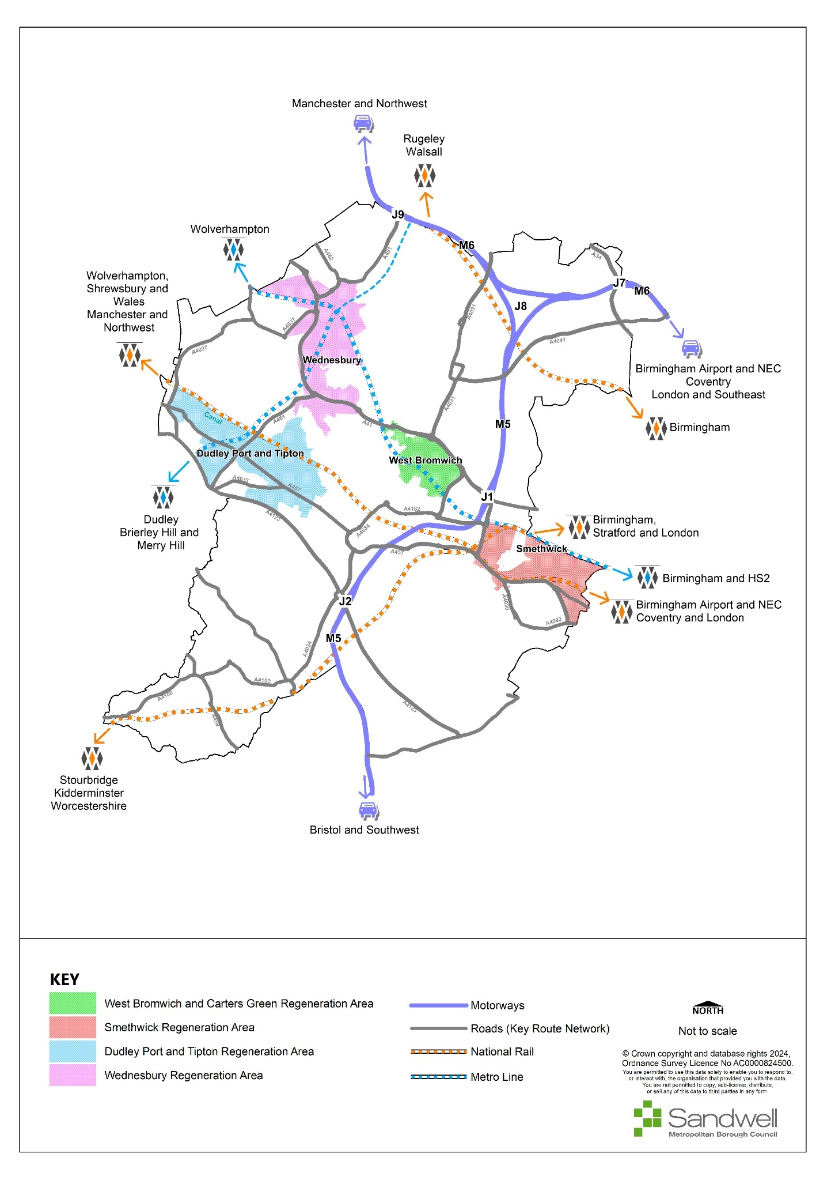
- The following sections set out in more detail the areas identified in the policy and should be read in conjunction with the relevant sections in the Centres chapter and Chapter 10 (West Bromwich).

WEST BROMWICH AND CARTERS GREEN
- West Bromwich is the strategic centre of Sandwell and as such is the focus for major investment opportunities for retail, commercial, leisure and educational uses.
- Carters Green lies to the northwest of the central core and acts very much as a separate retail centre. Apart from the Lidl supermarket centrally located within Carters Green, the shops are predominantly independents providing a wide range of goods, especially European and world foods. To the rear of the main high street units lie various uses, including residential areas, places of worship and commercial operations.
- The Carters Green Development Framework sets out an overarching vision for the opportunities that will help in the transformational change in this area. This allows the centre to continue to operate independently of West Bromwich Town Centre, but also allows a natural link to the town, picking up the aspirations and vision from the West Bromwich Masterplan. The Development Framework identifies key opportunity sites that will be the subject of future funding bids, investing in the development of new residential units on currently underused sites. The Framework and details of individual sites focus on providing good quality new homes with new public realm, urban greening and improved linkages through the area, as well as celebrating built heritage such as the Grade II listed Farley Clocktower.

DUDLEY PORT AND TIPTON
- Dudley Port and Tipton Regeneration Area comprises a mix of both residential and employment uses, dissected by the Birmingham Canal and Rail line. The area contains several areas of greenspace, including the extensive Sheepwash Nature Reserve and Victoria Park. Access to and through the area is provided by both the canal and rail links, with Tipton and Dudley Port railway stations lying within the area. The canal also links this area with other green spaces through to Tipton town centre and Dudley. In 2023 following a bid to the Levelling Up Fund, Tipton was awarded £20m capital funding from the Government to regenerate sites within the town centre.
- Recent years have seen very little investment and development within the area. There have been very few residential sites brought forward and investment in industrial development has been limited. Owen Street district centre, often referred to as Tipton town centre, has seen a steady decline in the take up of units, resulting in vacancies and underutilised sites. The Government-funded project seeks to address several underutilised and poor quality residential and commercial premises and regenerate the town centre through the consolidation of retail floorspace and the creation of new high-quality homes.
- The regeneration area is in the southern part of the Sandwell Levelling Up Zone. In 2024 Government enacted secondary legislation to allow the Council to retain business rates generated above a baseline within specific sites within the Zone for 25 years. The retained business rates can be used to fund regeneration and economic growth initiatives. The Levelling Up Zone and the funding for Tipton is intended to be the catalyst for wider investment opportunities within this regeneration corridor. Further employment development will be directed towards Coneygre and Vaughan Trading Estate. Whilst these sites were identified for residential development in the last Local Plan, this has not occurred. Both are expected to deliver further employment development.
- Residential development is anticipated at Rattlechain, south of Sheepwash Nature Reserve. This would see the remediation of a long-standing, problematic and heavily contaminated site, with it brought back into more efficient use and being able to assist in meeting the shortfall in housing numbers. The vision for the Dudley Port area is directed by a Garden City approach and principles, working with the area’s existing attributes, namely the green space, canals and linkages.
- The construction of the Midland Metro extension from Wednesbury to Brierley Hill will improve accessibility, providing sustainable modes of transport and link Sandwell to Dudley for those at work or visiting for leisure or recreation. Whilst much of the investment will be focussed on Dudley once completed, there may be opportunities along the Sandwell link for investment and regeneration at a smaller scale. There is an opportunity for a link to HS2 with the construction of the Interchange at Dudley Port railway station.
- Further opportunities exist to build upon the existing infrastructure, making the canals and greenspace a destination, linking to wider attractions such as the Dudley Canal Trust, Black Country Museum and Dudley Zoo, and joining up with Tipton High Street.

SMETHWICK
- The Smethwick corridor encompasses a wide range of uses including residential, employment, education, health, retail and commercial activity. Lying in the southeast of the borough, the area was at the heart of the industrial revolution and includes the site of the nationally significant Soho Foundry near Black Patch, created by Matthew Boulton and James Watt. The corridor contains several heritage structures, listed buildings and conservation areas including the Grade I listed Galton Bridge designed by Thomas Telford, which, following its completion in 1829, was reputedly the highest single-span arch bridge in the world. The area’s proximity to Birmingham has resulted in close cross-boundary working with Birmingham City Council and other partners, culminating in the production of the Smethwick to Birmingham Corridor Framework. The Framework sets out a vision and principles for bringing forward development on opportunity sites within the area, focussing on the delivery of good quality housing, linked to quality open spaces and the canal, and setting out a joined-up transport strategy that will contribute to the formation of a healthy and sustainable community.
- The area has seen investment in recent years with new housing at Windmill Eye and Brindley 2, and the construction of the Midland Metropolitan University Hospital at Grove Lane that will serve Sandwell and West Birmingham. Funding has recently been granted from the Towns Fund and the Levelling Up Fund to bring forward residential development at Grove Lane and Rolfe Street. Both areas have been the subject of recently approved Masterplans to help guide development. Additional funding will deliver improved walking and cycling routes linking Smethwick Galton Bridge to the new hospital and further afield into Birmingham City Centre and other areas of Sandwell. Furthermore, the Council has the opportunity to develop a ten-year Long-Term Plan to access Government investment and regeneration in the town. The Long-Term Plan will address the themes of safety and security; high street, heritage and regeneration; and transport and connectivity. Input from residents and businesses will be key with oversight provided by a Town Board.
- However, due to the extensive size of the area and its fragmented ownerships, comprehensive development has not been forthcoming overall. The Towns Fund, Levelling Up Fund and Long-Term Plan grants will act as a catalyst to attract further funding and private sector interest for regeneration on many of the vacant and underutilised sites across the corridor. The area surrounding the hospital is earmarked for housing, providing canalside living, and has easy access to public transport routes. New social infrastructure will also feature within this area, to help meet the needs of the residents. Grove Lane and Rolfe Street will receive most of the investment for the delivery of new housing.
- Opportunities exist to invest in the historic Soho Foundry and surrounding area to strengthen and grow Sandwell’s industrial and manufacturing base and revitalise this part of the borough. The area has also been identified as a location for waste operators, which could detract from its amenity; the challenge will be to improve negative environmental impacts.

WEDNESBURY
- This regeneration area focuses on Wednesbury Town Centre, moving south towards the industrial area of Hill Top and encompassing part of the Sandwell Levelling Up Zone. Wednesbury is a traditional market town and like many other similar places, has suffered a decline in the take-up of units in recent years. The quality of the public realm has recently been restored as part of the High Streets Heritage Action Zone fund, with an injection of £3.6m to reintroduce a relocated marketplace in the centre of the town, new public realm works, repair works to the Grade II listed clocktower and shopfront improvements within the Conservation Area.
- The council is working with the Government to:
- deliver new homes;
- tackle crime and antisocial behaviour;
- improve green spaces;
- revitalise Wednesbury town centre;
- improve connections to the metro; and
- expand community facilities;
through the creation of a Levelling Up Partnership. A Masterplan has been prepared with local people that identifies regeneration priorities for the town.
- Hill Top is identified as a focus for employment uses. Existing investment in the nearby Midland Metro extension from Wednesbury to Brierley Hill would make this area attractive for further investment due to the demand for high quality employment land. However, access remains problematic due to the area’s existing infrastructure; overcoming this would require significant funding to be made available.
- Further south, the regeneration area encompasses land around Great Bridge town centre. Promotion of this area for mixed uses including the introduction of more residential development would inject additional vitality into the town, assist in delivering new homes to meet housing targets and repurpose underutilised land for more efficient uses.
Table 6 - Summary of regeneration projects
Regeneration Area | Project | Proposed delivery date
West Bromwich | Urban Greening  Retail Diversification Programme  West Bromwich mixed-use community | 2024  2026  2041
Carter’s Green | Carter’s Green residential community | 2037
Dudley Port and Tipton | Dudley Port Integrated Transport Hub  Dudley Port Garden City  Tipton Town Centre Regeneration (Owen Street District Centre) | 2026  2041  2027
Smethwick | Construction of Midland Metropolitan University Hospital and associated University Learning Campus | 2026
Smethwick | Transport improvements as part of the Smethwick to Birmingham Inclusive Growth Corridor | 2027
Smethwick | Rolfe Street Canalside Regeneration | 2029
Smethwick | Grove Lane Regeneration | 2029
Smethwick | Long-Term Plan for Smethwick | 2034
Wednesbury | Wednesbury to Brierley Hill Metro Extension  Wednesbury High Street Heritage Action Zone  Wednesbury Town Centre Improvements (Levelling Up Partnership) | 2026  2025  2025
Up-to-date information about regeneration projects can be found on the Regenerating Sandwell website.

Towns and Local Areas
- Policy SDS4 sets out the strategic approach for towns and local areas outside of the regeneration areas..

Policy SDS4 – Towns and Local Areas
- Towns and local communities outside West Bromwich and the regeneration areas identified in Figure 3 will provide:
- a minimum of 6,503 new homes delivered through:
  - the allocation of previously identified housing sites or ones submitted as part of the local plan Call for Sites exercise;
  - the repurposing of a small number of brownfield employment sites and other previously developed and surplus land for new housing;
  - residential development on windfall sites submitted through the planning application process;
  - housing renewal areas;
  - estimating the capacity of vacant retail floorspace;
- Clusters of local employment land that provide land and premises to meet localised business needs;
- Approximately 726ha of identified employment land, designated as SEC1, 2 and 3 sites on the SLP Policies Map, to meet employment needs;
- An integrated and (where possible) continuous network of green infrastructure and walking and cycling routes, as well as a network of centres, health, leisure, sports, recreation and community facilities; and
- Improved access and infrastructure links between regeneration projects, local areas and West Bromwich, to allow related positive outcomes to be integrated into existing and newer communities.

Justification
- Sandwell is made up of several towns and smaller local communities and is a highly urbanised area. It also contains various existing local employment areas. Towns and local areas outside of the regeneration areas (SDS3) will provide at least 6,507 new homes and 726ha of identified employment land.
- A key spatial priority for the SLP is to support the delivery of new housing development. A significant amount of new housing will be accommodated in existing town centres and their surrounding areas.
- These locations are intended to be places of choice for living, supported by sustainable access to job opportunities and a range of other services and facilities to meet the day-to-day needs of residents. They will provide housing choice for people, regardless of age and income, to help underpin the areas’ economic competitiveness and support the working population.
- Given that new development will generate the need for new infrastructure it is important that these uses are planned together, regardless of ownership. Sandwell Council has produced an Infrastructure Delivery Plan that sets out requirements for specific sites and wider areas.
- In some cases, especially on larger sites or where several smaller sites are in proximity to each other, phasing plans will be required that set out the triggers for the provision of required infrastructure (including green and blue infrastructure), and legal agreements will need to be put in place to deliver that infrastructure.
- Where appropriate, masterplans may be prepared through a collaborative process involving the landowner / developer(s) and the Council, together with other interested parties such as statutory bodies and relevant stakeholders.

Housing renewal
- An essential requirement of any strong and stable community is for residents to have access to decent and secure homes. In the past, significant housing market renewal and regeneration programmes have taken place across Sandwell, to address poor quality housing and living environments.
- These interventions have been successful, and there are now a limited number of areas where housing market intervention activity is likely to be targeted over the plan period.
- Housing renewal also provides opportunities to upgrade housing stock to meet carbon reduction and climate change mitigation and adaptation requirements. This is also addressed in the climate change section of the SLP.

Placemaking – achieving well-designed places
- The environmental and physical transformation of Sandwell is one of the fundamental principles of its regeneration agenda. Placemaking and high-quality urban design are key mechanisms through which this transformation will be achieved, and they will also help to mitigate and adapt to climate change and promote low and zero carbon growth.
- Sandwell’s ongoing transformation will be supported by the development of places and buildings providing a range of functions, tenures, facilities and services, intended to support the needs of its diverse local communities. The design of spaces and buildings will be influenced by their context; development should enhance the unique attributes of Sandwell’s character and heritage whilst responding to locally identified community needs, changes in society and cultural diversity.

Policy SDS5 - Achieving Well-designed Places
- A Design Code supplementary plan will be produced for Sandwell, reflecting local character and design preferences, and providing a framework for creating high-quality places. Prior to this being produced and adopted, the Council expects applicants to have regard to the requirements of the National Model Design Code, the West Midlands Design Code and Sandwell’s extant design guidance, as well as to the design-related requirements of all relevant policies in the SLP itself.
- In some cases, the Council may work with applicants to approve a masterplan or site-specific design code to meet the requirements of a site and its surrounding environment (see Policy SDM1 and supporting text).
- The design of new development will be expected to adhere to the extant Design Code requirements once it is adopted; schemes that do not do so will be refused planning permission unless a reason for adopting a different approach can be clearly demonstrated and evidenced. In such cases, the proposed scheme should still accord with the requirements for good design set out in this and other relevant policies in the SLP.
- New building designs will be sought that are appropriate to Sandwell and that are of a quality, size, scale and type that integrate well into their neighbourhood and make a positive contribution to their environment.
- Innovative design will be received positively where it accords with the extant Design Code and other policies in this Plan. Development proposals should employ innovative design, materials and sustainable technologies in their schemes to deliver climate change mitigation and adaptation, and the Council will welcome schemes and projects using a climate-sensitive approach (Policies SDS2, SCC1 – SCC6).
- All proposals will be required to demonstrate a clear understanding of the local and wider context, character, heritage and local distinctiveness of its location and show how development will make a positive contribution to place-making and environmental improvement, (Policies SNE1 – SNE3), including through the provision of green and blue infrastructure and improvements to local biodiversity, using design codes, design and access statements, planning statements and where necessary Heritage Assessments.
- Where relevant, new development will be expected to conserve or enhance the setting and significance of heritage assets (Policies SHE1 – SHE4).
- To facilitate permeability and accessibility, transport proposals of a high design quality and utility will be sought. These should:
    - include connections to and between transport hubs;
    - promote active travel;
    - ensure that transport and travel infrastructure make a positive contribution to place-making; and
    - increase connectivity for all modes of travel.
- Development should contribute positively to creating high quality, active, safe and accessible places. Design approaches that will help contribute to healthier communities and reduce health inequalities should be incorporated in developments.
- To support the development of safe neighbourhoods, ensure quality of life and community cohesion are not undermined and minimise the fear of crime, the design of new development should create secure and accessible environments where opportunities for crime and disorder are reduced or designed out.
- An integrated and well-connected multifunctional open space network will be pursued throughout Sandwell (linking to opportunities in the wider Black Country where possible), including through the design and layout of new developments.

Justification
- The importance of high-quality design in creating places where people want to live, work and invest with renewed confidence is a fundamental aspect of both national and local policy. Designing high-quality places will result in environmental, economic and social benefits, including:
- community safety,
- health and well-being,
- inclusive communities,
- better public services,
- environmental sustainability,
- climate resilience,
- greater financial value of buildings, and
- lower levels of unemployment.
- The aim of the SLP is to create the best conditions for economic and social growth, which will take place within a safe, attractive and accessible built and natural environment. The SLP also encourages and supports the growth of locations that promote participation and community engagement. Successful placemaking in Sandwell will foster community stability, incorporating elements that create resilience to adverse economic and environmental impacts and resulting in a place that residents can be proud of.
- The use of efficient building design, the choice of low- and zero-carbon materials, and intelligent site layout and building orientation can all help to reduce reliance on carbon-based products, energy and non-renewable resources. The Government has published national design guidance that states planning permission should be refused for poorly designed development, especially where it fails to reflect local policies and government guidance on design. National guidance emphasises that good design and beautiful places should be at the centre of plan-making and decision-making.
- Sandwell enjoys a unique heritage, reflected in its urban structure, which requires a sensitive approach to place-making and an insistence on a high quality of design for proposals that affect the historic environment. Designs should ensure that the significance of local heritage is recognised and reflected in designs and that new development retains and protects that significance to the greatest extent possible.
- Designs and layouts that create and support a higher quality of life in Sandwell will depend on many factors; good design will play an increasingly important role in attracting private sector investment and skilled workers and the success of this will be defined by its outcomes:
- The creation of streets and spaces with their own distinct character that provide the framework for a coherent and interconnected network of places, supporting social interaction and a sense of personal wellbeing, and displaying a clear hierarchy of private, commercial and civic functions.
- A permeable street network that encourages freedom of movement and a choice of sustainable means of transport, including support for the provision and extension of walking, cycling and public transport infrastructure.
- A local hierarchy of centres providing a focus for essential local services and activities with easy access to residential areas.
- Towns and centres that encourage commercial activity, promote prosperity and support the well-being of the area’s inhabitants.
- An appropriate intensity of human activity in centres and elsewhere, the creation of natural surveillance and defensible spaces, active frontages and the provision of well-located and accessible infrastructure.
- Properly designed and well-located open spaces that help mitigate flood risk, provide space for wildlife, support biodiversity in the urban area and encourage informal recreation for local people as well as help create a high-quality living environment.
- The importance of high-quality design and place-making is central to the ambitions of other stakeholders in the region. The West Midlands Design Charter, launched by WMCA in 2020, confirms the West Midlands as a place to drive design innovation and creativity. The Charter aims to secure high-quality design in housing, civic architecture, urban spaces, parks and transport infrastructure.
- All new development should include measures to increase community safety and incorporate crime prevention measures, for example by using Secured by Design or Park Mark principles as appropriate. Proposals must look to address crime, the fear of crime and anti-social behaviour for both residents and users of the new development and the existing local community.

Cultural and Community Facilities and the Visitor Economy
- The Vision for Sandwell involves the delivery of transformational change whilst respecting and promoting the borough’s culture and heritage. The protection, promotion and expansion of existing cultural facilities, visitor attractions and associated activities will ensure their role as key economic drivers stimulating and regenerating the local economy is supported and will be enhanced as often as possible.
- As well as contributing directly to the local economy, the visitor economy promotes health and wellbeing as well as generating additional demand and growth in supporting services and facilities, which will also benefit residents and businesses.

Policy SDS6 - Cultural and Community Facilities and the Visitor Economy
Development proposals
- Cultural, tourist, leisure and community facilities within Sandwell will, wherever possible, be protected, enhanced and expanded (where appropriate) in partnership with key delivery partners and stakeholders (see Policy SDM9).
- Proposals for new development or uses that contribute to the attractiveness of Sandwell as a visitor destination (including for business tourism) will be supported in principle, subject to national guidance and the policy requirements set out elsewhere in this Plan.
- Proposals for new cultural, tourist, leisure and community facilities or uses, or extensions to existing ones, should:
  - be of a high-quality design;
  - be highly accessible and sustainable, being located within centres wherever possible;
  - not adversely impact on residential amenity or the operation of existing businesses; and
  - be designed to be flexible, adaptable, and where possible be capable of alternative or community use.
- Well-designed and accessible ancillary facilities in appropriate locations will be supported. Additional facilities within centres that support the visitor economy and business tourism sectors will be encouraged and promoted.
- An assessment should be undertaken (as part of the design of new developments likely to attract large numbers of people) to demonstrate and document how potential security and crime-related vulnerabilities have been identified, assessed and where necessary, addressed in a manner that is appropriate and proportionate.
- Development that would lead to the loss of an existing cultural / tourism / community facility in Sandwell will be resisted unless:
  - the intention is to replace it with a facility that will provide an improved cultural, tourist or community offer;
- it can be demonstrated that there would be significant benefits to the local and wider community in removing the use and / or redeveloping the site; or
- An appropriate contribution is made to support and sustain an alternative local cultural, tourist, leisure or community facility;
- In cases where an established community or cultural facility is declared redundant, prior to considering any application for its change of use or redevelopment the Council will require robust evidence to be submitted that demonstrates the owners / occupiers have sought to retain it in its current or a very similar use. This could vary depending on the nature of the use but might typically include evidence of the marketing of the facility over a 6 – 12-month period for its current use (depending on the nature or complexity of that use or the facility).
The Visitor Economy
- The improvement and further development of visitor attractions will be supported where appropriate, to ensure that accessibility is maximised and to continue to raise the quality of the visitor experience throughout Sandwell. This can be achieved by:
  - enhancing / extending current attractions;
  - providing inclusive access, particularly within town centres;
  - enhancing the visitor experience; and
  - delivering necessary infrastructure.
- Links should be made to town centres and those parts of Sandwell and beyond that are well-connected by public transport, considering the needs of business as well as leisure visitors, to encourage more sustainable local use of cultural and tourist attractions.
- The canal network is also a significant visitor attraction within the Black Country, providing waterway links to Birmingham, Staffordshire, Worcestershire and beyond. Facilities adjoining and serving the canal network should be maintained and expanded to help provide a network of linked amenities and visitor hubs.
- Physical and promotional links to visitor attractions close to Sandwell will be enhanced and encouraged, particularly in relation to Birmingham as a global city and a business economy destination.
- Proposals for heritage-related tourism will be supported where they provide positive and sustainable opportunities for social, educational and / or economic activity; heritage assets forming part of a tourist attraction will be protected from development or new or intensified activities that would adversely impact on their significance and setting (Policy SHE2).
Cultural facilities and events
- Libraries across Sandwell together act as one of the borough’s main locations for the delivery of cultural events and activities (e.g., music, theatre, dance, poetry, literature). Their role as community venues should be maintained and supported as part of the wider cultural offer of the borough.
- To ensure Sandwell can provide opportunities for growth in cultural activities and participation in them, the retention and protection of venues (including public houses and social or community hubs) providing performance spaces, recording facilities and practice amenities will be sought. The provision of new venues and facilities in sustainable and accessible locations will also be welcomed and supported, particularly within town centres, where they accord with other SLP policies (Policy SDM9).
- In cases where new development could potentially prejudice the successful ongoing operation of an adjacent cultural / performance venue, the agents of change principle will be applied. This will be supported by a general presumption against the loss of such facilities unless the parameters set out in Section 6 can be met.
- The promotion and protection of attractions and events that represent and celebrate the wide cultural and ethnic diversity across Sandwell will be encouraged, including spectator sports and other activities. This will include the protection of valuable cultural and religious buildings and the promotion of cultural, religious and community festivals on a Sandwell-wide basis in a range of suitable locations.

Justification
- The Black Country has a unique past, having been at the forefront of the Industrial Revolution, which has left it a rich and varied industrial and cultural legacy as well as an extensive and historically significant canal network. The area’s former industrial activity and its geological richness is also reflected in a distinctive natural and built topography, consisting of small villages and settlements that retain their individual characteristics. There are other areas where attractions and facilities are found together, due to their industrial heritage and / or cultural value.
- In addition, the Black Country contains one of the world’s few urban geoparks, identified by UNESCO as a single, unified geographical area where sites and landscapes of international geological significance are located (Policy SNE4).
- These assets are attracting an increasing number of visitors to the sub-region and the visitor economy is a key growth sector. Business tourism is also a growing sector, particularly in terms of high-quality hotel and conferencing facilities and the proximity to Birmingham, a global business destination.
- The range and diversity of cultural, tourist and community assets in the Black Country include a historic built environment, museums and art galleries, markets, music venues and theatres, which are often part of town and city centres; parks and open spaces; and high-level sporting venues. There is also a strong and diverse culinary scene, including several longstanding Desi pubs.
- In Sandwell, attractions include, but are not limited to, the following venues and locations:
- Sandwell Valley Country Park – this includes Sandwell Park Visitor Centre (formerly Sandwell Park Farm) and Forge Mill Farm, RSPB Sandwell Valley Reserve and wider facilities for leisure and recreation;
- Sandwell Aquatics Centre;
- The Hawthorns stadium – home of West Bromwich Albion FC;
- Smethwick Jamia Masjid;
- Guru Nanak Gurdwara, Smethwick;
- Shri Venkateswara (Balaji) Temple of UK;
- Wednesbury Museum;
- Bromwich Hall - West Bromwich Manor House Museum;
- Galton Valley Pumping Station;
- Lightwoods House;
- Oak House;
- Bishop Asbury Cottage;
- Traditional street and covered markets across the borough;
- Sites related to the Black Country Global Geopark, e.g., the Rowley Hills.
- Across the wider Black Country, significant attractions include:
- The Black Country Living Museum;
- Dudley Castle and Zoo;
- Walsall Arboretum;
- Walsall Art Gallery and Museum;
- Wolverhampton Civic Suite and Assembly Halls;
- Wolverhampton Theatre.
- The sensitive development of heritage and cultural facilities appealing to the very diverse range of local communities will also contribute to social inclusion, health and wellbeing and improvements in quality of life for all sectors of the local population. Culture is also recognised by national government as making a significant contribution to ‘place making’ and delivering sustainable communities.
- The nature and often the scale of cultural festivals and entertainment events may mean that they will be best delivered at an open-air location. In Sandwell, such sites are likely to include (but are not limited to) key outdoor venues such as Sandwell Valley. Suitable locations for outdoor events will have appropriate levels of infrastructure, car parking and accessibility to local travel networks and use of them for events and activities should be in accordance with the other policies of this plan and wider legislation and guidance.
- Public venues used for entertainments and leisure purposes will also produce waste, especially relating to food and its packaging. Entertainment and environmental considerations are not always compatible, with a significant amount of waste being generated by festivals and large events. Consideration will be given to requiring the developers, operators and organisers of large-scale public events on open spaces in Sandwell to design in systems to manage waste and litter at outdoor sites, should such systems not already be in place.
- All locations that will generate crowds in public places should consider the need for appropriate security measures when buildings and spaces are designed. The NPPF requires planning policies and decisions to promote public safety and consider wider security and defence requirements by addressing potential threats and hazards, especially in locations where large numbers of people are expected to congregate. This will be achieved by using up-to-date information available from the police and other agencies about the nature of potential threats and their implications.
- Canals form a significant part of the heritage of both Sandwell and the Black Country and form an integral part of both its cultural history and its attraction for tourists. Sandwell’s canals also play a vital role in delivering both blue and green infrastructure throughout the borough, as they link into the canal network across Birmingham and the other Black Country authorities. They are also a potential focus for biodiversity and regeneration projects.
- Locations in or adjacent to Sandwell include:
- Galton Valley Canal Heritage Area, Smethwick;
- Bumble Hole and Warrens Hall Nature Reserve and Conservation Area on the Sandwell / Dudley border at Netherton / Rowley Regis.

Green Belt
- Green Belts are identified and designated to prevent urban sprawl (including the coalescence of settlements) by keeping land permanently open. The essential characteristics of green belts are their openness and their permanence. The detailed boundaries of the West Midlands Green Belt in Sandwell are identified on the Policies Map.
- Green belt policy aims to prevent inappropriate development within designated areas. The following policies respond to local circumstances and provide clarity and interpretation of several of the terms set out in the NPPF.
- The protection of the green belt is a key aspect of the Vision and the overarching strategic priority ensuring development takes place in the most appropriate and sustainable locations whilst protecting the most vulnerable assets.

Policy SDS7 – Sandwell’s Green Belt
- Sandwell Council will maintain a boundary around the Sandwell green belt, to help promote urban renaissance, to maximise its role in helping to mitigate climate change impacts and to support easy access to the countryside for residents.

- Opportunities will be taken to improve the value and recreational role of the green belt in Sandwell Valley:
  - through improving safe accessibility for all users;
  - by providing facilities for active and passive recreation (if this preserves the openness of the Green Belt and does not conflict with the purposes of including land within it);
  - by protecting tranquil areas and locations with ecological and historic value.
- In determining planning applications, the Council will apply national policy either in the NPPF or its successor.

Justification
- Sandwell attaches great importance to the ongoing protection of the Black Country Green Belt, whose boundary is drawn tightly around parts of its urban edges, and which encompasses some of the most sensitive and important tracts of green and open space in the borough. The largest section of Sandwell’s designated green belt lies within the Sandwell Valley area, and links into Walsall’s green belt to the north-east of the borough.
- The Green Belt will be preserved from inappropriate development unless very special circumstances have been demonstrated in accordance with national planning policy and guidance. Inappropriate development is, by definition, harmful to the Green Belt and should not be approved except in very special circumstances.
- In accordance with the implementation arrangements set out in the NPPF published on 12 December 2024 (revised 7 February 2025), this plan was examined under the relevant previous version of the NPPF dated December 2023. However, for decision-making purposes, the NPPF (2024) paragraphs 231 – 233 states that policies within the 2024 framework are material considerations in dealing with applications.

- While green belt is not itself a reflection of landscape quality or value, large parts of the local green belt are also identified as being of significant historic, environmental and landscape importance. Should a permission be granted in very special circumstances, the Council will require particularly high-quality design and materials to be used in such locations, in line with Policy SDS5, Policy SDM1 and the policies in the Natural and Historic Environment chapter of the SLP.
- It is the Council’s view that there are no exceptional circumstances in Sandwell that would justify amending current boundaries and releasing any areas of green belt for new development. While there is an identified shortfall of land suitable for housing and economic development, this of itself does not outweigh the need to maintain the openness and permanence of the green belt within Sandwell, especially given the densely developed and urban character of the rest of the borough.

Green and Blue Infrastructure
- Green and blue infrastructure are terms used to describe a multi-functional and connected network of green spaces, water and other environmental features in both urban and rural areas. It represents a collection of assets that provide multiple functions and services to people, the economy and the environment. It includes (but is not limited to) the following land types:
    - woodland,
    - watercourses, including canals,
    - highway verges and railway embankments,
    - parks, playgrounds, allotments and other public open spaces,
    - urban trees,
    - private gardens,
    - the grounds of hospitals, schools and business parks,
    - sport pitches and recreational areas.
- Green infrastructure can contribute to the provision of 'ecosystem services’, the direct and indirect contributions the natural environment provides for human wellbeing and quality of life. These services can be delivered in a practical sense, e.g., by providing food and water and regulating the climate, and through supporting cultural and social aspects such as the provision of green spaces that can then help reduce stress and anxiety. They include flood protection, water purification, carbon storage, land for food production, places for recreation, landscape and nature conservation.
- Green infrastructure performs multiple functions, some of which include:
  - biodiversity and geodiversity – providing habitats for wildlife,
  - access and recreation – places for sports, play, walking and cycling,
  - health and wellbeing – supporting healthy lifestyles,
  - energy – providing an energy resource using biomass, hydro-electric and wind power,
  - townscape – making towns and villages better places in which to live,
  - economic development – supporting the economy by improving the image and 'liveability' of places.
- In 2023 Natural England published guidance on the delivery and enhancement of green infrastructure. As a key resource for developers and local planning authorities, the framework integrates green infrastructure tools, principles, standards and design guidance. It is structured through five key standards, addressing:
- urban nature recovery,
- an urban greening factor,
- an urban tree canopy cover standard,
- accessible greenspace standards; and
- a green infrastructure strategy.
- Of these elements, Sandwell Council already addresses most of them through existing Council strategies and many of the policies proposed in this plan. Relevant plan policies include those on biodiversity net gain, the Local Nature Recovery Strategy, the retention of trees and hedgerows, canals, SuDs, climate change mitigation and good design, which cover:
- urban nature recovery and urban greening (policies in the Natural and Historic Environment section);
- urban canopy cover (part of the adopted Sandwell Tree Strategy);
- accessible green space standards (part of the Council’s Green Spaces Strategy and Audit).
- In respect of a Green Infrastructure Strategy, this standard supports the National Planning Policy Framework’s requirement that local authorities should develop strategic policies for green infrastructure. At an area-wide scale, the Green Infrastructure Standard will see local authorities develop delivery plans to support the creation and enhancement of new and existing greenspaces.
- This issue is also addressed across a range of policies in the Sandwell Local Plan and is addressed in the following strategic policy.
- A focussed green infrastructure approach could also provide an overarching framework against which the Council’s success in achieving many of these positive outcomes could be monitored and measured.

Policy SDS8 - Green and Blue Infrastructure in Sandwell
- The Council will support a strategic approach to green and blue infrastructure by:
  - working with relevant partners to prepare, adopt and implement a Green Infrastructure Strategy for the borough;
  - planning, designing and managing green infrastructure in an integrated way to achieve multiple benefits;
  - identifying key green infrastructure assets, their current function and their potential future contributions;
  - identifying opportunities for addressing environmental and social challenges through strategic green infrastructure interventions.
- Sandwell’s green and blue infrastructure networks, including open spaces, green spaces, nature conservation sites, parks and gardens (including registered parks and gardens), habitats, rivers, canals, other waterways, trees and green features, should be enhanced where possible (Policies SNE1 - SNE6, SHE1 – SHE4).
- Development in Sandwell will be expected to maintain and where possible enhance the existing network of green infrastructure across the borough, particularly in relation to its contribution to meeting the social and health-related needs of Sandwell’s population (Policies SHW1 – SHW6).
- Major developments will be required to ensure green spaces and urban greening features (including tree planting, vegetation, gardens, green roofs and green walls, sustainable drainage systems, etc.) are planned, designed and managed in an integrated way so that they deliver multiple climate change and environmental benefits over the lifetime of the development (Policies SDS2, SCC1 – SCC6).
- Proposals that would result in the loss of existing green infrastructure will be resisted unless it can be demonstrated that new opportunities will be provided that mitigate or compensate for this loss and ensure that the ecosystem services of the area are retained (Policy SNE2).
- Major developments will be expected to maximise opportunities for enhancing existing green spaces and waterways by incorporating appropriate urban greening to improve the visual quality and ecological functions of the site.

Justification
- A green infrastructure approach to development recognises that the network of green and blue spaces, street trees, green roofs and other major assets such as natural or semi-natural drainage features must be planned, designed and managed in an integrated way. This will include considering and enhancing where possible links to green and blue networks beyond Sandwell’s boundaries, in collaboration with neighbouring authorities and stakeholders.
- Green infrastructure creates a sense of place. It is a multifunctional benefit generally located close to where people live, work and relax. It will help to support a healthy lifestyle, can reduce health inequalities in communities and offers social benefits by creating a sense of social cohesion and shared space.
- Policy SDS8 sets out a strategic green infrastructure approach and provides guidance on how this can be assessed and planned for. Further policies in the environment and climate change sections of the SLP provide more detail on specific aspects of green infrastructure, alongside other Plan policies designed to deliver multiple outcomes.
- Objectives include:
- promoting mental and physical health and wellbeing,
- adapting to the impacts of climate change and the urban heat-island effect,
- improving air and water quality,
- encouraging walking and cycling,
- supporting landscape and heritage conservation,
- learning about the environment,
- supporting food growing, and
- conserving and enhancing biodiversity and ecological resilience
alongside the more traditional functions of green space, such as play, sport and recreational activity.
- All development takes place within a wider environment and green infrastructure should be an integral element and not an ‘add-on’. Its economic and social value should be recognised, as highlighted in the Black Country i-Tree Assessment and Sandwell’s Green Spaces Strategy and Trees Strategy.
- It is important to ensure that green and blue infrastructure are connected to each other and to the wider environment, and are resilient, to enable them to respond to climate change in a positive way. The use of green infrastructure should be optimised, but not necessarily maximised, to ensure more environmentally sensitive green spaces will not be damaged by excessive activity. This means that as well as supporting the physical and mental health of Sandwell’s residents, they will retain their importance as part of a wider network of spaces and places for wildlife, ecology and habitats.

Sandwell’s Natural and Historic Environment
  - The Black Country enjoys a unique physical and cultural heritage thanks to its origins as a mainstay of heavy industry and driver of the Industrial Revolution. The geological complexity of the area, its topography, its settlement pattern and the existence of significant areas of green and open space within one of the most densely developed parts of the country merit a set of robust and relevant planning policies. These policies will help to protect and enhance what gives Sandwell (and the wider Black Country) its unique physical, ecological and historic character and appearance.

Nature Conservation
  - The protection and improvement of Sandwell’s biodiversity and geodiversity will safeguard and improve the environmental attractiveness and value of the borough for residents and visitors. At the same time, this approach will also enhance the physical and natural sustainability of communities within the conurbation in the face of climate change. Doing so will directly contribute to delivering Strategic Objective 11, which is also associated with supporting the physical and mental wellbeing of residents.

Policy SNE1 – Nature Conservation
- Development will not be permitted where it would, alone or in combination with other plans or projects, have an adverse impact on the integrity of an internationally designated site, such as Cannock Chase Special Area of Conservation or Fens Pools Special Area of Conservation.
- Development will not be permitted where it would harm nationally (Sites of Special Scientific Interest and National Nature Reserves) or regionally (Local Nature Reserves and Sites of Importance for Nature Conservation) designated nature conservation sites.
- Species and habitats that are legally protected, in decline, are rare within Sandwell / the Black Country or that are covered by national, regional, or local Biodiversity Action Plans will be protected when development occurs in accordance with Part I of the Wildlife and Countryside Act 1981.
- Where, exceptionally, the strategic benefits of a development clearly outweigh the importance of a local nature conservation site (Sites of Local Importance for Nature Conservation), protected or priority species, habitat, or geological feature damage must be minimised. Any remaining impacts, including any reduction in area, must be fully mitigated. A mitigation strategy must accompany relevant planning applications. Compensation will only be accepted in exceptional circumstances.
- The movement of wildlife within Sandwell and into / out of adjoining areas, through both linear habitats (e.g., wildlife corridors) and the wider urban matrix (e.g., stepping-stone sites) should not be impeded by development. Developers must take account of the Local Nature Recovery Strategy (Policy SNE2) when preparing their schemes. Areas identified on the Sandwell Policies Map as wildlife corridors will be particularly suitable for enhancement and protection, and this will be required when planning proposals are brought forward that would affect them. Where such sites also fall within the West Midlands LNRS in areas of strategic significance a 15% uplift in the value of biodiversity net gain units located within them will also apply.
- Details of how improvements (appropriate to their location and scale) will contribute to the natural environment, and their ongoing management for the benefit of biodiversity and geodiversity, will be expected to accompany planning applications. Adequate information must be submitted with applications for proposals that may affect any designated site or important habitat, species, or geological feature, to ensure that the likely impacts of the proposal can be fully assessed. Where the necessary information is not made available, there will be a presumption against granting planning permission.
- Over the plan period, Sandwell will update evidence on designated nature conservation sites and Local Nature Reserves as necessary in conjunction with the Local Sites Partnership and Natural England and will amend existing designations in accordance with this evidence. Consequently, sites may receive amended levels of protection over the Plan period, including occasionally their de-designation as a SINC or SLINC.

Justification
  - The past development and redevelopment of the Black Country has led to it being referred to as an “endless village”, which describes both the interlinked settlements and the many patches of encapsulated countryside present within it. The Black Country is home to internationally and nationally designated nature conservation sites and has the most diverse geology, for its size, of any area on Earth. Many rare and protected species exist within its matrix of greenspace and the built environment.
  - Development in Sandwell should contribute positively to the protection, enhancement and expansion of the natural environment across the wider Black Country by:
- extending and improving the condition of habitats and nature conservation sites,
- improving opportunities for the movement of wildlife within and beyond urban areas,
- restoring or creating habitats / geological features that actively contribute to the implementation of Nature Recovery Networks, Biodiversity Action Plans (BAPs) and / or Geodiversity Action Plans (GAPs) at a national, regional, or local level,
- ensuring that developments adjacent to canals and natural watercourses deliver improved and extended corridors for the movement of wildlife and people.
  - A report was commissioned by a group of local authorities in the region (including Sandwell and the other Black Country councils) to gauge the potential impacts of development on the region’s Special Areas of Conservation, in relation to likely impacts on air quality. This resulted in the carrying out of an Appropriate Assessment on plans and proposals during the drafting of the Sandwell Local Plan, which itself formed part of the assessment.
  - During the production of the report, changes were made to the Nitrogen Deposition Critical Load Ranges in the UK’s Air Pollution Information System (APIS). The work being undertaken was based on the old Nitrogen Deposition Critical Load Ranges in APIS. Natural England advised that any local plan currently at Regulation 19 stage could continue using the old critical load ranges, but that acknowledgement should be made of the changes in critical loads since the air quality was modelled. For plans at other stages, councils were informed that they should ensure their local plans reflected the current critical load ranges in APIS. The work in question, the Assessment of Air Quality Impacts on European Sites in Staffordshire, Wolverhampton, Walsall, Sandwell, and Dudley Report should be updated to reflect the changes in the figures.
  - Criterion 1 of Policy SNE1 ensures that where development (alone or in combination with other separate development proposals) may have an adverse impact on sites of European importance, it undergoes an appropriate assessment. This will be in the form of a Habitats Regulation Assessment (HRA). The purpose of a HRA is to determine if a plan or project would affect the protected features of certain habitat sites, such as Special Areas of Conservation (SAC), Special Protection Areas (SPA) or Ramsar sites.
  - While Sandwell does not itself contain any European sites, it does lie close to several SACs and just outside the 15km zone of influence of Cannock Chase, also a SAC. As a result, the Council undertook work through the HRA for the Sandwell Local Plan, and with the Cannock Chase SAC Partnership, to ensure that the SLP (alone or in combination) would not have adverse impacts on European sites in the vicinity or further afield.
  - Sandwell lies at the heart of the British mainland, and the Birmingham and Black Country conurbation, and therefore plays an important role in helping species migrate and adapt to climate change across the urban area as their existing habitats are rendered unsuitable. It is very important to increase the ability of landscapes and their ecosystems to adapt in response to changes in the climate by increasing the range, extent, and connectivity of habitats.
  - To protect vulnerable species, the Local Nature Recovery Strategy will allow isolated nature conservation sites to be protected, buffered, improved and linked to others. When considering the movement of wildlife, development proposals should incorporate the recommendations from the West Midlands Local Nature Recovery Strategy Map and the ecological networks it identifies. Species dispersal will be aided by extending, widening, and improving the habitats of wildlife corridors. Conversely, fragmentation and weakening of wildlife sites and wildlife corridors by development will be opposed.
  - Sites of Importance for Nature Conservation (SINCs) and Sites of Local Importance for Nature Conservation (SLINCs) are identified though the process of local site assessment. This process is overseen by the Birmingham and Black Country Local Sites Partnership, whose role is to provide expert advice to the area’s local authorities and other organisations as appropriate on the selection, management, protection and review of the network of local sites throughout Birmingham and the Black Country. It is particularly important to protect and enhance SINCs; an up-to-date Local Site Assessment will be required to support any proposal that could harm a SINC.
  - Development offers an opportunity to improve the local ecological and geological environment, and this is especially so in an urban area. The Council is committed to meeting its “Biodiversity Duty” under the Natural Environment and Rural Communities Act (2006) and to delivering the principles of the NPPF by proactively protecting, restoring and creating a richer and more sustainable wildlife and geology. The local Biodiversity Partnership, Geodiversity Partnership, Birmingham and Black Country Local Nature Partnership and Local Sites Partnership will identify, map, and regularly review the priorities for protection and improvement throughout the Black Country, in accordance with the Local Nature Recovery Network strategy. These will be used to inform planning decisions. As set out in criterion 4, where the planning merits of a proposed development have the potential to outweigh the ecological, geological or environmental value of a SLINC, any suggested mitigation strategy for its loss or partial loss will need to be based on a clear understanding of the current value of the site, using up-to-date evidence. The Local Environmental Records Centre hold, collate and disseminate the definitive and up-to-date register of locally designated nature conservation sites on behalf of the Black Country Authorities.
  - The Council’s most recent Green Spaces Strategy Implementation and Business Plan (2022 – 23) states that Sandwell is currently failing to meet the national ANGSt standard for local nature reserves and has committed to meeting the standard’s requirement of at least one hectare of Local Nature Reserve per 1,000 population. This equates to around 35ha or 0.35km² for Sandwell.
Potential Sites of Importance
  - Potential Sites of Importance (PSIs) are areas that may support notable species, valuable semi-natural habitats, or important geological features but that have not yet been formally assessed against local wildlife and geological sites selection criteria. These sites are identified using aerial photography, historic mapping, existing environmental records, and local knowledge and EcoRecord holds details of their locations. PSIs are often undeveloped or semi-natural areas that contribute to local ecological networks by providing habitat, supporting biodiversity, and offering opportunities for restoration and enhancement. They play an important role in delivering Local Nature Recovery Strategy objectives and wider national biodiversity goals.
  - Where a planning application is likely to have an impact on a PSI, the potential effects on its ecological or geological value must be assessed. If effects are identified, appropriate mitigation or compensation measures will be sought where appropriate. Undertaking a local site assessment at the pre-application stage may help determine whether the site meets the criteria for designation.

Protection and Enhancement of Wildlife Habitats
  - The Environment Act (2021) states that development proposals are required to provide a minimum 10% uplift in habitat quality on those sites that are being built on. This is referred to as biodiversity net gain (BNG) and it is a process that attempts to leave the environment in a more valuable condition than previously following development. This is a mandatory requirement on most development sites.
  - This process involves the use of a nationally agreed formula to help identify what negative impacts on a site’s current ecological value will arise from a proposed development, and then calculating how much new or restored habitat, and of what type(s), is required to deliver an overall net gain in biodiversity value following that development. This formula is known as the Statutory Biodiversity Metric, and it is produced by DEFRA and Natural England. A simplified beta test version of the Biodiversity Metric has also been developed specifically for use on small development sites.
  - Mandatory biodiversity net gain will also provide an incentive for development to support the delivery of nature recovery networks, through the calculation of biodiversity units at sites identified by the strategy. These networks have been designed to help local planning authorities to focus policy and delivery on conserving and enhancing biodiversity in the most effectual and depleted parts of the local ecological system and to reflect this in land use plans for their area.
  - Nature recovery networks are designed to be relevant to local areas, but also to link up with networks in adjacent areas too, with the intention of producing a national nature recovery network in due course. This will enable nature and wildlife to be planned for and protected at a much larger scale than is possible at present. Cross-boundary working between Sandwell and neighbouring local authorities will also be supported and encouraged where that could create wider-than-local opportunities for BNG provision.

Policy SNE2 – Protection and Enhancement of Wildlife Habitats
Biodiversity Net Gain
- Development proposals in Sandwell shall deliver a minimum 10% net gain in biodiversity value when measured against baseline site information. Losses and gains will be calculated using the extant national Biodiversity Metric. Proposals that offer more than 10% BNG on development sites will be welcomed and the additional ecological value will be considered positively when a decision is made on the relevant planning application.
- Biodiversity net gain must be provided in line with the following principles:
    - there will be a requirement for on-site habitat provision / enhancement wherever practicable, followed by improvements to sites within the local area, and then other sites elsewhere within Sandwell;
    - where off-site measures are needed to meet biodiversity net gain requirements, it is expected that the off-site habitat enhancement or creation will be located as close to the development site as possible;
    - the maintenance and enhancement of the ability of plants and animals (including pollinating insects) to move, migrate and genetically disperse across Sandwell and the wider Black Country must be supported; and
    - the provision / enhancement of priority habitats identified at the national, regional, or local level will be supported, particularly where those habitats are currently scarce in Sandwell.
- Compensation in the form of national biodiversity credits will only be accepted as a fall-back if mitigation is not possible within the development site boundary, elsewhere in its immediate vicinity or in the wider Sandwell area.
- Provision of on- or off-site compensation should not adversely impact on existing alternative / valuable habitats in those locations, nor on areas identified as heritage assets or that are considered highly likely to contain unrevealed archaeological assets. Compensatory works on them should be established via a legal agreement or be under way prior to the related development being undertaken.
- Monitoring of BNG compensation measures will be required to ensure its successful delivery, with further compensation being required in the event of initial measures being ineffective. Ongoing management of any new or improved BNG habitats together with monitoring and reporting will need to be planned for and funded for 30 years by developers, using a Conservation Covenant or s106 agreement as necessary.
- Sandwell Council has identified the following site(s) as suitable for the provision of biodiversity units to developers unable to provide a minimum 10% net gain on their own sites (Appendix A ):
Location | Potential project types | Baseline units | Potential uplift units (%)
Ray Hall pastoral land | Comprises an area of natural and semi-natural greenspace containing several fields of pastures divided by hedgerows with trees. Ray Hall pastoral land contains pockets of poor and moderate ‘other neutral grassland’ which is divided by woodland and scrub. The grassland and woodland habitats offer the most potential for uplift.  NB – Ray Hall pastoral land and Hill Farm Bridge Fields will be treated as a single site. | 87.75 | +48.05 (54.76)
Hill Farm Bridge Fields | Vary sward height and increase species diversity to improve the condition of the grasslands. Condition of the woodland can be improved through introduction of deadwood and management of habitat regeneration. | 181.24 | +65.90 (36.36)
Menzies Open Space | Woodland improvement, some grassland improvement  Areas of ‘other neutral grassland’ can provide uplift.  Site contains a pond (non-priority). There is potential to create more uplift by improving the condition of the pond from poor to good. | 157.4 | +42.28 (26.86)
Tibbington Open Space (The Cracker) | Some grassland management / improvement, woodland improvement  Relatively large areas of woodland offer strong uplift potential.  ‘Other neutral grassland’ habitats and the parkland habitat both provide uplift opportunities. | 90.57 | +32.91 (36.17)
Warrens Hall Local Nature Reserve and Strategic Open Space | Woodland improvement, some grassland improvement | 211.70 | +26.93 (12.72)
Tividale Park | Scrub species and structural improvement, tree and woodland improvement | 49.65 | +10.39 (20.92)
Note: Developers are not required to buy units on Council-owned sites; other public or private landowners may also provide them elsewhere in Sandwell.
Local Nature Recovery Strategy
- All development should help deliver the Local Nature Recovery Strategy in line with the following principles:
- take account of where in the Local Nature Recovery Network the development is located and deliver benefits appropriate to that zone, in accordance with section 2d above;
- follow the mitigation hierarchy of avoidance, mitigation and compensation, and provide for the protection, enhancement, restoration and creation of wildlife habitat and green infrastructure;
- follow the principles of Making Space for Nature - recognise that spaces are needed for nature and that these should be of sufficient size and quality and must be appropriately connected to other areas of green infrastructure, to address the objectives of the local Nature Recovery Network Strategy.
- Priority locations for habitat creation and enhancement are as shown on the West Midlands Local Nature Recovery Strategy map. Development sites within areas of particular importance for biodiversity will be expected to contribute towards the creation of appropriate habitat linkages and types to support those areas.
- Development should be designed to protect and enhance existing habitats and ecological networks, including wildlife corridors and stepping stones. Development should minimise any potential disturbance to species and habitats, including from site lighting.
Local opportunities for habitats and wildlife
- All development shall secure the eradication of invasive species within site boundaries, where opportunities to do so arise.
- All major development proposals with an eaves height or roof commencement height of 5m and above are required to provide integrated swift nesting bricks for various species of small birds, and bat boxes as appropriate, to help preserve endangered fauna and support urban biodiversity in Sandwell.
- All applicants, including those undertaking householder schemes and smaller-scale developments are asked to consider including additional enhancement opportunities for wildlife and conservation in their proposals; the Council will consider such contributions positively when determining planning applications.

Justification
Biodiversity net gain
  - Biodiversity net gain (BNG) has been described as a measurable target for development projects where impacts on biodiversity are outweighed by a clear mitigation hierarchy approach to first avoid and then minimise impacts, including through restoration and / or compensation. Net gain is an approach to development and land management that aims to leave the natural environment of a site in a measurably better state than before development occurred.
  - The Environment Act requires a minimum 10% increase in biodiversity within or near new development sites. New development should always seek to enhance rather than reduce levels of biodiversity present on a site. This will require a baseline assessment of what level of biodiversity is currently present, and an estimation of how proposed designs will add to that current level, supported by evidence that a minimum 10% net gain has been delivered. Where a development proposal is designed in such a way that more than 10% BNG will be delivered, the Council will look favourably on this higher provision, in particular where it addresses other policy objectives and helps to meet the wider aims of the Local Nature Recovery Strategy such as strengthening ecological networks and creating stepping stone sites between larger green areas.
  - The government have established the date of 30th January 2020 as a baseline for the assessment of BNG. Any site clearance that occurs after this date that is not related to the grant of planning permission will have its BNG measured against what was on site at the baseline date, using historic records, aerial imagery, habitat data and other relevant information. The baseline ecological value is also taken as being at a level commensurate with the most important or sensitive ecological records applying to the site, as part of a precautionary approach. This means that the level of BNG required to be delivered would be at the highest level possible for that site.
  - Including BNG in the Local Plan will also link biodiversity to other strategic objectives and the overall place-making strategy for Sandwell, enabling a more rounded approach to the environment. On-site biodiversity improvements will also be vital to enhancing the liveability of urban areas, and improving the connection of people to nature, particularly as development densities increase.
  - Development should also contribute to wildlife and habitat connectivity in the wider area, in line with the Biodiversity Action Plan, River Basin Management Plans and the Black Country and West Midlands Local Nature Recovery Strategy.
  - The ways in which developments secure a net gain in biodiversity value will vary depending on the scale and nature of the site. On some sites, the focus will be on the retention of existing habitats. For others, this may be impracticable, and it may be necessary instead to make significant provision for new habitats either on- or off-site.
  - It can be challenging to establish new habitats. It is essential that the most important and irreplaceable habitats in Sandwell are protected, and so mitigation rather than retention will not be appropriate in some circumstances. BNG is not applied to irreplaceable habitats, such as ancient woodlands. Any mitigation and / or compensation requirements for sites identified and protected under European law or successor legislation should be dealt with as appropriate, and separately to biodiversity net gain provision.
  - Under the Environment Act (2021), all planning applications granted (with few exemptions) will be required to deliver at least 10% Biodiversity Net Gain, measured through the application of the statutory Biodiversity Metric and necessitating the submission of a Biodiversity Gain Plan.
  - Some application types have been excluded from the requirements of the Environment Act and so the relevant regulations should be referred to once in effect to confirm this. Exemptions to the need to provide 10% BNG are made for:
  - development impacting habitat of an area below a de minimis threshold of 25m², or 5m for linear habitats such as hedgerows;
  - householder applications;
  - biodiversity gain sites (where habitats are being enhanced for wildlife);
  - small-scale self-build and custom housebuilding; and
  - temporary impacts that will be restored within two years.
Existing sealed surfaces (such as tarmac or existing buildings) are given a zero score under the BNG metric.
  - It is important to note however that the development of brownfield or previously developed land is not exempt from the requirement to provide a minimum 10% net gain.
  - Biodiversity net gain plans should be agreed prior to commencement. Sites and areas identified to provide for biodiversity net gain requirements should be managed and monitored for at least 30 years post-provision, via s106 obligations or Conservation Covenants. Monitoring plans will be required as part of the grant of planning permission and should include indicators designed to demonstrate the amount and type of biodiversity net gain provided through development, which should be as specific as possible to help build an evidence base for future reviews of the plan.
  - The identification and allocation of sites in Sandwell for offsite BNG habitat provision is intended to recognise the dearth of opportunities for on-site provision in the most urban parts of the borough. While developers do not have to purchase units on these sites, the Council is keen to retain as much BNG value within the borough as possible and so will make these sites available by identifying habitat creation opportunities on them.
  - The allocated sites are intended to accommodate those units that cannot be provided directly on a development site rather than as a wholesale receptor for all units. This is intended to promote the need for BNG on or adjacent to development sites wherever possible, but also to recognise the need for a degree of flexibility in delivery, especially where land availability and site viability are issues. As these sites are included on the national register, their accessibility solely to developers operating in Sandwell cannot be guaranteed.
  - Most development generates some opportunities to help achieve an overall nature conservation benefit. It will often be possible to secure worthwhile improvements through relatively simple measures, even where there is no formal or mandatory requirement for biodiversity net gain to be delivered, such as for domestic or householder schemes and small scale or permitted development proposals.
  - Many types of development can contribute to increasing opportunities for nature conservation by including design choices that allow wildlife to continue to inhabit the same area. Artificial nest boxes / bricks can be incorporated within new buildings relatively easily, especially on taller buildings and / or at eaves level (refurbishments, extensions and / or new build).
  - Swift bricks are a universal nest brick suitable for use by a range of small bird species and on diverse types of development. Best practice guidance on their installation and use should be followed and can be found in BS 42021. This will provide nesting and roosting opportunities for various species, including ones under threat such as swifts, house martins, starlings and house sparrows. Where appropriately located and where the presence of bats has been confirmed, bat boxes can also be installed on new buildings / structures.
  - Other examples of such measures may include:
- hedgehog gates in new boundary fences or walls
- insect “hotels”
- the retention of trees, hedges and other vegetation (Policy SNE3)
- wildlife–friendly green walls and roofs on new buildings and places such as communal bin areas, bus shelters and bike stores
- the use of native, wildlife-friendly plants, trees and shrubs in planting and landscaping schemes
- the incorporation of green and blue infrastructure, such as wildlife-friendly SuDS
  - Biodiversity features of value frequently occur beyond designated wildlife and ecological sites and should be conserved and enhanced where this can be achieved as part of nearby development.

Local Nature Recovery Strategies (LNRS)
  - The Nature Recovery Network is a major commitment in the government’s 25-Year Environment Plan. The government has set out in the Environment Act (2021) that a Local Nature Recovery Strategy (LNRS) will be prepared locally and published for all areas of England, and that these will:
- agree priorities for nature’s recovery;
- map the most valuable existing habitat for nature using the best available data; and
- map specific proposals for creating or improving habitat for nature and wider environmental goals.
  - The LNRS will help restore many ecosystem functions and improve the services upon which society depends, benefitting nature, people and the economy, and helping to address three of the biggest challenges society faces: biodiversity loss, climate change and human wellbeing. LNRS will help to map the Nature Recovery Network locally and nationally, and will help to plan, prioritise and target action and investment in nature at a regional level across England.
  - LNRS will support the delivery of mandatory biodiversity net gain and provide a focus for a strengthened duty on all public authorities to conserve and enhance biodiversity. They underpin the Nature Recovery Network and support partnership working and the greater integration of ecological and biodiversity considerations into other areas of land management.
  - The Environment Act introduces a new duty on all public bodies to have regard to any relevant LNRS, creating an incentive for a wide range of organisations to engage with the creation of an LNRS and to take steps to support its delivery. Local authorities and other public bodies designated by the Secretary of State will also have to report on what steps they have taken, at least every five years.
  - .
  - The Local Nature Recovery Strategy for Sandwell forms an integral part of the West Midlands LNRS that has been produced by the West Midlands Combined Authority. . A detailed map showing the various LNRS opportunities and objectives as they apply to Sandwell can be viewed on the WMCA website.

Provision, Retention and Protection of Trees, Woodlands, And Hedgerows
  - Sandwell benefits from an estimated 265,000 trees, covering 18.1% of the borough. It is estimated that 81% of these trees are in good or excellent condition. Sandwell Council will continue to support and protect a sustainable, high-quality tree population and will aim to significantly increase tree cover across its area during the Plan period.
  - A main theme of the Government’s 25-Year Environment Plan is the need to plant more trees. This is to be achieved not only as part of the creation of extensive new woodlands but also in urban areas; this will be accomplished in part by encouraging businesses to offset their emissions in a cost-effective way through planting trees. The national ambition is to deliver one million new urban trees and a further 11 million new trees across the country.
  - It is important to encourage and support the delivery of green infrastructure and ecological networks through urban areas, especially in relation to their role in climate change mitigation and adaptation and to mitigate the health problems associated with air pollution. The provision of new trees and the protection of existing ones throughout Sandwell will be a key component of this approach.
  - The Council’s aim is to increase Sandwell’s canopy cover by at least 6% over the plan period, based on data establishing its current levels of provision and identifying opportunities for doing so derived from the Nature Recovery Network and biodiversity net gain targets.

Policy SNE3 – Provision, Retention and Protection of Trees, Woodlands and Hedgerows
Tree Replacement
- Development schemes that involve the removal of trees must ensure suitable replacement trees are provided onsite. Where sufficient suitable onsite replacements cannot be provided, off-site planting or woodland enhancement, including support for natural regeneration, in the near vicinity of the removed tree(s) must be provided, in line with the mitigation hierarchy set out in Policy SNE2 (criterion 7b).
- For every tree to be removed from a development site, a minimum of three replacement trees will be required to be planted, in accordance with the Council’s aim to increase tree canopy cover across the district by 6% and to ensure that the minimum requirement of 10% biodiversity net gain is met and preferably exceeded.
- The species, eventual size and amenity value of replacement trees must be commensurate with the size, stature, rarity, and / or public amenity of the tree(s) to be removed. Where trees to be replaced form a group of amenity value (rather than individual specimens), replacements must also be in the form of a group commensurate with the area covered, size and species of trees and established quality of the original group. Where possible, they must be planted in a position that will mitigate the loss of visual amenity associated with the original group.
- Replacement trees must not be planted in locations where they would impact on sites identified / designated as ecologically important (see also Policy SNE2(4)) unless this has been specifically agreed with the Council.
Retention and protection of ancient woodland and veteran or ancient trees
- Development that would result in the loss of or damage to ancient woodland and / or ancient or veteran trees will be refused unless wholly exceptional reasons to allow it and a suitable compensation strategy both exist.
- Development adjacent to ancient woodland and / or groups of ancient or veteran trees will be required to provide an appropriate landscaping buffer, with a minimum depth of 15m.
- Provision should be made for the protection of individual veteran or ancient trees likely to be impacted by development, by providing a buffer around such trees of a minimum of 15 times the diameter of the tree. The buffer zone should be 5m from the edge of the tree’s canopy if that area is larger than 15 times its diameter.
Habitat Creation
- Opportunities for increasing tree cover across Sandwell through habitat creation and the enhancement of ecological networks, including connecting areas of ancient woodland, should be maximised in public and private sector development layouts and landscaping, particularly through biodiversity net gain and nature recovery network initiatives (Policy SNE2).

Shading and air quality issues
- New houses and other buildings must be carefully designed and situated to prevent an incompatible degree of shade being cast on them by both existing and new trees, which might generate subsequent pressure for the trees to be removed.
- The positioning of trees in relation to streets and buildings should not worsen air quality for people using and living in them. Care should be taken when choosing and positioning new street trees, and designing streets and buildings, to allow for street-level ventilation to occur and to avoid trapping pollution between ground level and tree canopies (Policy SHW3).
Canopy cover
- The planting of new, predominantly native, trees and woodlands will be sought in appropriate locations, to increase the extent of canopy cover in Sandwell by around 6% by 2030, in line with the Council’s Tree Strategy.
- Tree planting on major development sites should contribute to a minimum of 20% canopy cover (calculated by considering both the current level of canopy cover on a site and identifying the likely contribution made once new trees have established and matured) and a recommended level of 30% canopy cover across the site, especially in areas where evidence demonstrates that current levels of canopy cover are lower than the local average.
- Development proposals should use large-canopied species where possible, as they provide a wider range of health, biodiversity and climate change mitigation and adaptation benefits because of their larger surface area; they will also make a positive contribution to increasing overall canopy cover within Sandwell, as set out in the Sandwell Tree Strategy.
Trees and Design
- Development proposals should be designed around the need to incorporate trees already present on sites, using sensitive and well-designed site layouts to maximise their retention. Existing mature and healthy trees, trees that are ecologically important, and ancient / veteran trees should be retained and integrated into landscaping schemes, recognising the important contribution they make to the character and amenity of a development site and to local biodiversity networks.

- Where new trees are to be planted on a development site, the species of trees and their location within the site should be informed by a site-specific survey carried out by a qualified ecologist / arboriculturalist.
- New trees on development sites should be planted in accordance with arboricultural best practice, including the use of suitably-sized planting pits, supporting stakes, root barriers, underground guying, and appropriate protective fencing during the construction phase.
Hedgerows
- There will be a presumption against the wholesale removal of hedgerows for development purposes, especially where ecological surveys have identified them to be species-rich and where they exist on previously undeveloped land.
- New hedgerows will be sought as part of site layouts and landscaping schemes.
- Protection of existing hedgerows before and during development must be undertaken.

Justification
  - Section 15 of the NPPF (2023) identifies the importance of trees in helping to create an attractive and healthy environment. The NPPF expects local plans to identify, map and safeguard components of ecological networks and promote their conservation, restoration, and enhancement. Ancient woodlands and ancient and veteran trees are an irreplaceable aspect of both the ecological and historic landscape and the NPPF is very clear about the need to protect such resources where they occur.
  - Hedgerows are also a finite and vulnerable resource, and their provision, retention and enhancement will be expected when new development is proposed.
  - Wildlife corridors are important in helping overcome habitat fragmentation, by ensuring that species can reach the resources they need and that their populations do not become isolated, inbred, and prone to the adverse impacts of climate change. Supporting wildlife corridors will mean:
- creating and maintaining a diverse tree population (including trees of all ages and sizes),
- controlling invasive species,
- promoting the reintroduction of native species in locations where they are appropriate and would have a positive impact on biodiversity,
- retaining standing dead wood,
- making sure that any new planting is in the right location and of the right species, and
- recognising that woodlands are not simple monoculture habitats and will also contain glades, wet areas, understoreys, and grassland.
  - The requirement to plant trees on development sites will also help support and deliver increased biodiversity and green network opportunities on sites that at present do not contain tree cover, e.g., some sites currently in managed agricultural use where trees and hedgerows have previously been removed.
  - An example of the importance of trees in helping to manage and mitigate adverse impacts relating to air quality and climate change can be found in the report produced for the Black Country iTree project in 2021 - 22. This identified that the tree population of Sandwell (265,000 trees) stores 361,000 tonnes of carbon (a service valued at £328m), sequestering 5,500 tonnes annually (£5m), which is equivalent to 1.6% of the borough’s annual emissions. They remove 15.3 tonnes of air pollution annually, an outcome that is valued at £828,000. They also intercept 130,000m³ of surface water annually, saving an estimated £128,000 in treatment costs.
  - The loss of trees from urban environments has been demonstrated to have negative outcomes for human health. Social costs, such as an increase in crime, have also been associated with the loss of trees. There is a growing body of evidence that the presence of trees in and around urban environments provides major public health and societal benefits.
  - Trees in the urban landscape have a vital role to play in delivering ecosystem services, such as in:
- helping to improve residents’ physical health
- helping to improve residents’ mental health
- helping to mitigate climate change by sequestering carbon dioxide
- providing shading and cooling benefits (including associated savings to the NHS from avoided skin cancer and heat stroke)
- improving air quality and reducing atmospheric pollution
- reducing wind speeds in winter, thereby reducing heat loss from buildings
- reducing noise
- improving local environments and bringing people closer to nature
- supporting ecological networks and green infrastructure
- maximising people’s enjoyment of and benefits from their environment
- contributing towards the aesthetic value of the urban area
Trees on development sites
  - It will be important to ensure that Sandwell’s existing stock of trees and woodlands is protected, maintained, and expanded as far as possible. Developers will be expected to give priority to the retention and protection of landscaping, trees and hedgerows on development sites. Trees on development sites should be physically protected during development. Care must be taken to ensure that site engineering / infrastructure works, the storage of plant and machinery, excavations and new foundations do not adversely impact their continued retention, in line with current arboricultural and Building Regulation requirements.
  - There will be circumstances where the ratio of replacement planting will be different to that required in the policy – especially in cases where significant / mature trees contributing to the visual and ecological amenity of an area and its character are to be removed. Where a development site cannot accommodate additional planting, replacement trees will be expected to be planted in an appropriate off-site location nearby.
  - Tree species specified in submitted planting plans will be evaluated by either a chartered Landscape Architect or accredited arboriculturist employed by the local authority. This will ensure that a suitable variety of species and standard / size of tree is being planted and will deliver the most appropriate solution for a specific location.
  - If the canopy cover balance on a major development site is less than 20%, new canopy cover must be provided based on data establishing the current levels of provision and identifying opportunities for doing so. This data can be derived from the Sandwell Tree Strategy and Action Plan, the Black Country Nature Recovery Network or the West Midlands Nature Recovery Network (its successor) and biodiversity net gain targets.
Canopy cover area can be calculated in two ways:
- By identifying the canopy radius for individual trees. When two or more trees overlap, measurements must ensure that these areas are not double counted.
- By entering the area for groups of trees using CAD or GIS to measure it.
The existing canopy for a tree or tree group can be included if:
- It is entirely within the site.
- The tree is not subject to any planned tree surgery works.
- The Root Protection Area will not be encroached upon by development and associated works.
Trees must not be included in these canopy calculations if their BS5837:2012[2] categorisation is 'U' (those in such a condition that they cannot realistically be retained as living trees in the context of the current land use for longer than ten years).
  - Where possible, and in appropriate locations, broad-canopied trees should be planted to help maintain and increase Sandwell’s overall canopy cover. In accordance with other policies in the SLP, such trees should not be located where they would have adverse impacts on air quality or create excessive shading to residential properties that could result in requests for their removal. Suitable species may include (but are not limited to) oaks, members of the Acer family, planes, beeches, and limes amongst others.
  - To ensure that good tree protection measures are maintained through the construction project, Sandwell Council will support and encourage the use of arboricultural clerks of work on development sites where trees are to be managed, removed and / or planted on the site. Where the likelihood of trees being adversely affected by construction activity is significant, or there are many trees on site that are likely to be affected (e.g., on larger sites) the Council will use appropriate conditions to require this level of oversight.
  - An arboricultural survey, carried out to an appropriate standard, should be undertaken prior to removal of any trees or site groundworks and used to inform a proposal’s layout at the beginning of the detailed design process. Where proposed development will impact on the character, protection, safety and / or retention of trees of importance to the environment / landscape, the use of an arboricultural clerk of works may be required and will be made subject to a condition on the relevant planning permission.
  - Other appropriate conditions will be included in planning permissions to ensure that new trees that fail on development sites are replaced within a specified period by trees of a suitable size, species, and quality.
  - There will be a requirement to:
- replace trees and woodlands that cannot be retained on development sites with a variety of suitable tree specimens (species and size);
- ensure that where individual or groups of trees are of landscape or amenity value, they are retained and that developments are designed to fit around them;
- encourage diversity in the tree population to help to counter ecological causes of tree loss, such as diseases, pests, or climate change; and
- balance the impacts of the loss of trees on climate change and flooding by identifying opportunities to plant replacements via appropriate tree and habitat enhancement and creation schemes.
Climate change and biodiversity
  - There will be a presumption against the removal of trees that contribute to public amenity and air quality management unless sound arboricultural reasons support their removal.
  - As part of the requirement for biodiversity net gain (Policy SNE2), developers and others will need to pursue adequate replacements for trees and woodlands lost to allocated and approved development, as well as additional trees and other habitat creation to achieve appropriate compensatory provision on sites. The main imperative will be to ensure that trees are maintained in good health on development sites in the first instance but where this is not possible, the grant of planning permission will be conditional upon the replacement and enhancement of tree cover nearby.
  - Native tree species able to withstand climate change should be used in landscaping schemes or as replacement planting, to maximise habitats for local wildlife / species and maintain and increase biodiversity. In circumstances where non-native tree species are also considered to be appropriate, a mix of native and non-native species should be provided, to help maintain a healthy and diverse tree population.
  - Housing layouts should ensure that tree shading does not adversely affect houses in winter when the sun is lower in the sky but maximises it when the sun is higher in summer. The solution will lie in part through choosing suitable species (e.g., deciduous trees) in proximity to housing and locating them at an appropriate distance from the properties.
  - The clearance of trees from a site prior to the submission of a planning application is imprudent. Robust local evidence is generally available to prove that trees were until recently present on a cleared site, so there will still be a requirement to provide suitable and sufficient replacement trees.
  - This is also addressed in the Environment Act (2021), which makes provision for sanctions against the clearance of sites prior to a planning application being submitted in relation to the requirement for biodiversity net gain. Under paragraph 6 of Schedule 7A of the Act, if the developer undertakes activities such as clearing the site that reduces its biodiversity value, then the pre-development value to be considered is the one that existed before clearance took place.
Ancient woodland and veteran trees
  - The NPPF defines ancient woodland and veteran trees as an irreplaceable habitat. Ancient woodland is an area that has been wooded continuously since at least 1600 AD. It includes ancient semi-natural woodland and plantations on ancient woodland sites. An ancient or veteran tree is a tree which, because of its age, size, and condition, is of exceptional biodiversity, cultural or heritage value. Veteran trees are of exceptional value culturally, in the landscape, or for wildlife, due to their great age, size or location. The soils in which these trees sit has been identified as having a high biodiversity value, given the length of time the trees have been successfully established. Natural England and the Forestry Commission have issued joint advice on how to assess a planning application that may have an impact on ancient woodland, ancient trees or veteran trees standing near to or on a development site
  - Individual trees can have historic and cultural value and can be linked to specific historic events or people, or they may simply have importance because of their appearance, contribution to landscape character and local landmark status. Some heritage trees may also have great botanical interest, for example as rare native trees or cultivars of historic interest.
  - Very few trees of any species can be classed as ancient or veteran. Such trees / areas are a finite resource of great biodiversity value. For this reason, the Council considers that it is essential to provide absolute protection for ancient and veteran trees and ancient woodland sites in Sandwell.
Hedgerows
  - The planting of hedgerows not only enhances opportunities for wildlife but can also significantly improve the appearance of new development. It is particularly suitable on frontages and along plot and site boundaries, both softening the appearance of the built form and supplementing the design of the overall scheme.
  - Hedgerows are integral to ecological networks, given their linear form, and will be essential elements of habitat corridors within and beyond the Black Country. Planting additional hedgerows will help to support and increase the movement of wildlife and plants through the Black Country. The planting of bare root hedgerow plants is an economical way of providing green infrastructure on sites.
  - Hedgerow retention and reinforcement will be of particular importance where hedgerows form part of an established ecological network currently enabling the passage of flora and fauna into and out of rural, suburban, and urban areas. If hedgerow removal is needed to accommodate a high-quality site layout, replacement hedgerow planting will be required.
  - Hedgerow protection on development sites and elsewhere where potentially damaging work is to be carried out will include the provision of landscape buffers where appropriate; protective fencing; and careful management of plant and materials on site to avoid damage to the hedgerow(s) and root systems.

Geodiversity and the Black Country UNESCO Global Geopark
  - The Black Country enjoys a rich geological heritage. Limestone, ironstone, fireclay, coal and other minerals provided the ingredients to make iron and paved the way for the Industrial Revolution to begin in the area.
  - The Black Country UNESCO Global Geopark was declared on Friday 10 July 2020. The Executive Board of UNESCO confirmed that the Black Country had been welcomed into the network of Global Geoparks as a place with internationally important geology, because of its cultural heritage and the extensive partnerships committed to conserving, managing and promoting it. The boundary of the Black Country UNESCO Global Geopark is the same as that of the Black Country itself.
  - A UNESCO Global Geopark uses its geological heritage, in connection with all other aspects of the area’s natural and cultural heritage, to enhance awareness and understanding of key issues facing society in the context of the dynamics of modern society, mitigating the effects of climate change and reducing the impact of natural disasters. By raising awareness of the importance of the area’s geological heritage in history and society today, UNESCO Global Geoparks give local people a sense of pride in their region and strengthen their identification with the area. The creation of innovative local enterprises, new jobs and high-quality training courses is stimulated as new sources of revenue are generated through sustainable geotourism, while the geological resources of the area are protected.

Policy SNE4 - Geodiversity and the Black Country UNESCO Global Geopark
- Development proposals in Sandwell will not be supported where they would have significant adverse impact on Black Country UNESCO Global Geopark geosites, except:
  - where suitable mitigation and / or compensation is provided to address the adverse impacts of the proposed development;
or
  - where any residual harm following mitigation / compensation, along with any other harm, is clearly outweighed by the benefits of the development.
- Development proposals in Sandwell should:
  - wherever possible, make a positive contribution to the protection and enhancement of geodiversity within the boundaries of the Black Country UNESCO Global Geopark and in relation to the geosites identified within it;
  - give locally significant geological sites a level of protection commensurate with their importance;
  - consider, and avoid any disruption to, the importance of the inter-connectivity of greenspace and public access between geosites within the boundary of the Black Country UNESCO Global Geopark;
  - ensure geological sites of importance are clearly identified where they are within or close to development proposals;
  - make it easy to access geoheritage features – including temporary exposures – for research and educational purposes; and / or
  - enable access to records and samples as part of local and national geological record keeping.
- Where necessary, conditions will be put in place on approvals for planning permission to ensure appropriate monitoring is undertaken and to make sure mitigation, compensation and offsetting is delivered effectively.

Justification
  - Paragraph 180 of the NPPF (2023) requires local authorities to protect sites of geological value, “… in a manner commensurate with their statutory status or identified quality in the development plan”. The Overarching National Policy Statement for Energy (November 2023) states that development should at the very least aim to avoid significant harm to geological conservation interests including through mitigation and consideration of reasonable alternatives.
  - Areas of geological interest also form a significant part of the industrial landscapes of Sandwell and the wider Black Country. They reflect the area’s history of mining and extraction and will often co-exist with, and form part of the setting of, protected / sensitive historic landscapes. In many cases they also form an intrinsic part of the green infrastructure network, contributing to landscape and ecological diversity as part of the wider natural environment. Geological and historic significance are closely linked elements of Sandwell’s environmental and cultural heritage. Geological significance relates to features such as rock strata, landforms, and mineral seams that reveal the area’s natural history and contribute to the character of the Black Country UNESCO Global Geopark. Historic significance, as addressed in Policy SHE4, refers to archaeological remains and historic landscapes that record past human activity and cultural development.
  - These forms of significance often overlap. The borough’s geology has shaped patterns of settlement, building materials, and industrial growth, while many historic and archaeological sites expose or incorporate geological features such as former quarries, mines, and cuttings. Likewise, geological landforms frequently define the setting and visual context of heritage assets.
  - As part of this strategic network of green infrastructure, geosites should be retained wherever possible and their contribution to GI recognised and considered when development is proposed that would affect the areas they form part of.
  - New development should have regard to the conservation of geological features and should take opportunities to achieve gains for conservation through the form and design of development.
  - Where development is proposed that would affect an identified geological site the approach should be to avoid adverse impact to the existing geological interest. If this is not possible, the design should seek to retain as much as possible of the geological interest and enhance this where achievable, for example by incorporating permanent sections within the design, or creating new interest of at least equivalent value by improving access to the interest.
  - The negative impacts of development should be minimised, and any residual impacts mitigated.
UNESCO Global Geoparks
  - A UNESCO Global Geopark is a single, unified geographical area where sites and landscapes of international geological significance are located. It is an area of geological significance, managed with three main objectives in mind:
- to protect the geological landscape and the nature within it;
- to educate visitors and local communities; and
- to promote sustainable development, including sustainable tourism.
  - All UNESCO Global Geoparks contain internationally significant geology and are managed through community-led partnerships that promote an appreciation of natural and cultural heritage while supporting the sustainable economic development of the area.
  - UNESCO Global Geopark status is not itself a statutory designation.

The Rowley Hills
  - The Rowley Hills are a range of four hills – Turner’s Hill, Bury Hill, Portway Hill and Darby’s Hill – located mostly within Sandwell (a small section lies in Dudley). Together they form a ridge that divides the Black Country into two parts with distinctly differing topographic features. The ridge also coincides closely with the main watershed of England, between the rivers Severn to the west and Humber to the east. Turner’s Hill at 271m (870ft) is the highest point, visible from most parts of the Black Country and is a distinctive landscape feature that can be seen from the adjacent motorway and railways.
  - Traditionally the Hills have been the location for stone quarrying and coal mining but are now mostly used for informal recreation. The Hills have importance both for historic landscape reasons and for their value for nature conservation. Most of the Rowley Hills have either SLINC (Site of Local Importance for Nature Conservation) or SINC (Site of Importance for Nature Conservation) designations (Policy SNE2). There is a Local Nature Reserve located on Dudley Road. The Rowley Hills also form an important part of the Black Country Global Geopark designation and contain sites of geological importance and interest.
  - The extent of the identified Rowley Hills area is around 135ha (of which Turner’s Hill covers approximately 7.3ha, Portway Hill and Bury Hill together cover around 38ha, and Darby’s Hill covers 4ha) and is encapsulated within the urban areas of Sandwell and Dudley.
  - Evidence suggests that there is pressure for additional development on the Rowley Hills. To date, the Council has been successful in preventing inappropriate development from occurring, which has been helped by SAD policy EOS3, formal recognition of the ecological and geological value of the area and through the adoption of the Rowley Hills District Plan. This sought to maintain and improve the area as open space for recreation and to protect the skyline from inappropriate and intrusive development.

Policy SNE5 - The Rowley Hills
- The strategic importance of the Rowley Hills to the character and amenity of Sandwell and the wider Black Country is derived from their prominent location, open appearance and importance for the natural environment and recreation, which will be defended from the incursion of built development or other inappropriate uses.
- Development will not be permitted within the Rowley Hills Strategic Open Space that would impact on any of the following valued qualities, which include natural, cultural, historic, perceptual and aesthetic aspects:
  - an open and undeveloped skyline;
  - expansive panoramic views into and out of the strategic open space;
  - wildlife habitats that support biodiversity;
  - ecological and geological designations;
  - historic character, including non-designated heritage assets and features and the heritage components of landscape;
  - areas of relative tranquillity;
  - the setting of designated heritage assets;
  - multi-functional green infrastructure assets;
  - highly valued open spaces for informal recreation.

Justification
  - The Rowley Hills form a prominent and distinctive upland landscape feature on the horizon of the Black Country.
  - The Rowley Hills Strategic Open Space (RHSOS) designation was identified in part at the time of the West Midlands Structure Plan. The local area was subject to the Rowley Hills District Plan, adopted in 1988; this plan was designed to address issues considered to be of strategic significance, including minerals, waste disposal, sub-regional recreation and transportation. The importance of the open character and appearance of the Hills was also recognised, and the District Plan reiterated the need to avoid development that would adversely affect the open space and the visual amenity of the skyline.
  - Given their:
- role as part of an open green wedge running between Sandwell and Dudley,
- historic significance,
- value for recreation and the environment,
- importance as a source of minerals,
the Rowley Hills were identified as performing a strategic function. While the Hills are no longer a source of active mineral extraction, their importance as open space, as a site of ecology and geodiversity value and as a significant and sensitive part of the skyline of the Black Country has not changed since the original designation was made. If anything, the importance of the Hills - to the environment, visual amenity and the mitigation of climate change impacts - has increased.
  - The area exists as a coherent green network of open spaces and wildlife corridors from Bumble Hole, Dudley across the Rowley Hills themselves to Wolverhampton Road, Sandwell. The RHSOS designation expresses numerous valued landscape qualities that will be protected from development:
- highly valued open spaces for informal recreation - the network of public rights of way provides opportunities to benefit residents’ physical health and well-being and provides opportunities for contact with nature within an otherwise heavily built-up area;
- the open and undeveloped skyline, which rises above the surrounding urban areas;
- expansive panoramic views across the Black Country and beyond;
- multi-functional green infrastructure assets such as broadleaved woodlands, grasslands and soils that provide a range of ecosystem services for biodiversity, carbon storage and recreation;
- a range of habitats supporting biodiversity, including deciduous woodlands, good quality semi-improved grasslands, scrub, hedgerows, ponds and canals;
- biodiversity designations that contribute to landscape character including Warrens Hall Local Nature Reserve and conservation area, three Sites of Importance for Nature Conservation, five Sites of Local Importance for Nature Conservation (Policy SNE2) and five Potential Sites of Importance;
- rich geological and industrial history, evidenced by rock exposures and residual landscape morphology associated with former industries notably former coal mining and quarrying of dolerite (Rowley Rag), recognised through three UNESCO Black Country Global Geopark Geosites (Policy SNE4);
- the setting to designated heritage assets, including three Grade II Listed Buildings, Cobb’s Engine House Scheduled Monument, Windmill End Conservation Area, Warrens Hall Nature Reserve and Bury Hill Park Areas of High Historic Landscape Value (AHHLV) and an Archaeological Priority Area (APA);
- relative tranquillity within enclosed and wooded parts of the designation particularly in the west.
  - There is a Town and Country Planning (General Development Procedure) Order 1995 Direction made under Article 4(1) to which Article 5(4) applies at land off Portway Hill that has been in place since 2007. The direction removes all permitted development rights within its boundary. This was intended to protect and preserve the openness of the area by preventing any intrusive development.
  - The Article 4 Direction is located at the highest western extent of Portway Hill and to the east of the summit of Turner’s Hill, the highest point in the Rowley Hills at 271m AOD. Development in this open and exposed location would potentially impact on the highly valued open and undeveloped skyline and the expansive panoramic views outwards across the Black Country and beyond. For these reasons, the boundary of the Article 4 Direction remains appropriate and should be retained to preserve the openness of the area.

Canals in Sandwell
  - The canal network is one of the Black Country’s defining historical and environmental assets and its preservation and enhancement remains a major objective. Canals play a multifunctional role, providing economic, social, environmental and infrastructure benefits. They form a valuable part of the green and blue infrastructure and historic environment of Sandwell and have a significant role to play in promoting both mental wellbeing and physical health, allowing people opportunities for exercise and access to nature.
  - Sandwell’s canal network provides a focus for future development through its ability to contribute towards the delivery of a high-quality environment and enhanced accessibility for boaters, pedestrians, cyclists, and other non-car-based modes of transport.
  - Sandwell is home to 66km of canal, including the New Main Line Canal and Old Main Line Canal, which offer many opportunities for residents and visitors.
  - As structures that made the industrial revolution possible, the canals in Sandwell offer opportunities to observe and experience key sites of historical interest such as the Galton Valley Bridge, Smethwick Pump House and the site of Smethwick Engine Arm. The canals in Sandwell have also been afforded Conservation Area status in both Tipton (Factory Locks) and Smethwick (Smethwick Summit, Galton Valley) owing to their historic significance; there are several valuable heritage buildings located adjacent to the canals and they play an important part in the industrial heritage of the Borough. They include Soho Foundry and Chances Glassworks in Smethwick and Malthouse Stables in Tipton.

Policy SNE6 – Canals
- Sandwell’s canal network (see Figure 14) comprises the canals and their surrounding landscape corridors, designated and non-designated heritage assets, character, settings, views and interrelationships.
- All development proposals likely to affect the canal network must:
  - demonstrate that they will not adversely affect the structural integrity of canal infrastructure to avoid increased flood risk, land instability and / or harm to the usability of the canal (including its towpath) as a green-blue infrastructure asset;
  - ensure that any proposals for reinstatement or reuse would not adversely impact on locations of significant environmental value where canals are not currently navigable;
  - protect and enhance its special historic, architectural, archaeological, and cultural significance and its setting, including the potential to record, preserve and restore such features;
  - protect and enhance its nature conservation value including habitat creation and restoration along the waterway and its surrounding environs;
  - protect and enhance its visual amenity, key views and setting; and / or
  - protect and enhance water quality in the canal and protect water resource availability both in the canal and the wider environment.
  - reinstate, introduce and / or upgrade towpaths, including through the introduction of suitably designed and sized wayfinding information, and link them into high quality, wider, integrated pedestrian and cycle networks (including through the creation of new links and access points onto and across the canal network), particularly where they can provide improved access to transport hubs, centres and opportunities for employment to be delivered through the reasonable use of planning conditions or S106 / CIL obligations.
  - consider where appropriate the use of canals for surface water management purposes, if SuDS and other mitigation measures are built into a scheme in the vicinity.
- Where opportunities exist, all development proposals within the canal network must:
  - support and complement its role in providing opportunities for leisure, recreation and tourism activities and in the delivery of the wider well-being agenda;
  - enhance and promote opportunities for off-road walking, cycling, and boating access, including for small-scale commercial freight activities;
  - protect and enhance the historical, geological, and ecological value of the canal network and its associated infrastructure;
  - relate positively to the adjacent waterway by promoting high-quality design, including active frontages onto the canal and improving the public realm;
  - incorporate crime prevention measures such as Secured by Design principles to reduce crime, the fear of crime and anti-social behaviour along the canal network and towpaths;
  - include a management plan where appropriate to ensure any new planting does not provide concealment or facilitate illegal access to boats, property or premises;
  - integrate sensitively with the canal and any associated canal-side features and, where the chance to do so arises, incorporate canal features into the new development;
  - explore opportunities associated with alternative or new uses for the canals and their towpaths, such as to help mitigate the effects of climate change or support the delivery of fibre networks and communications technology (Policy SID1, Policy SCC3);
  - facilitate continued access to privately-owned waterways assets for inspection and maintenance purposes.
- Development proposals must be supported by evidence that the above factors have been fully considered and properly incorporated into their design and layout.
- Where proposed development overlays any disused canal features, the potential to record, preserve and restore such features must be fully explored unless canals have been removed in their entirety.
- Development on sites that include sections of disused canals should protect the line of the canal through the detailed layout of the proposal.
- Development will not be permitted that would sever the route of a disused canal or prevent the restoration of a canal link where there is a realistic possibility of restoration, wholly or in part.
- Proposals must safeguard the amenity of existing residential moorings when planning consent is sought on sites adjacent to them.
Residential Canal Moorings
- For residential moorings, planning consent will only be granted for proposals that include the provision of:
  - all necessary boating facilities;
  - appropriate access to cycling and walking routes; and
  - an adequate level of amenity for boaters, not unduly impacted upon by reason of noise, fumes or other nearby polluting activities.
- In determining a planning application for residential moorings, account will be taken of the effect that such moorings and their associated activities may have on the amenities or activities of nearby residential or other uses. Proposals for moorings near existing uses that currently generate potentially adverse amenity impacts, e.g., fumes or noise, will need to demonstrate that they have taken these aspects into consideration and can provide suitable levels of mitigation for incoming residents, in accordance with the ‘agent of change’ principles.

Justification
  - The development of the Black Country’s canal network had a decisive impact on the evolution of industry and settlement during the 18th, 19th, and 20th centuries. It was a major feat of engineering and illustrates a significant stage in human history - development of mercantile inland transport systems in Britain’s industrial revolution during the pre-railway age. As such, the historic value of the canal network today should be acknowledged, protected, and enhanced. The network also plays a major part in the Black Country Geopark, as the mineral wealth of the area meant that canals were a vital link to areas within and beyond Sandwell and the wider Black Country and continue to provide this link today.
  - The canal network is a major unifying characteristic of Sandwell’s historic landscape. The routes of the canals that make up the network have created landscape corridors with a distinctive character and identity based on the industries and activities that these transport routes served and supported. The network has significant value for nature conservation, tourism, health and wellbeing and recreation, and the potential to make an important contribution to economic regeneration through the provision of high-quality environments for new developments and a network of pedestrian, cycle and water transport routes. The canal system forms a valuable and continuous habitat network that links to other ecological sites. Many canals are also designated as local wildlife sites and corridors, either in part or for long sections of their course.
  - It is also important for development in Sandwell to take account of disused canal features, both above and below ground; for example, a network of tramways also served the canals. Only 54% of the historic canal network has survived in use to the present day. Proposals should preserve the line of the canal through the detailed layout of the development. Where appropriate, opportunities should be explored for the potential to preserve the line of the canal as part of the wider green and blue infrastructure network.
  - It is acknowledged that there are aspirations to restore disused sections of the canal network. Where feasible and sustainable, proposals should consider the potential for the restoration of disused sections of canal. However, it is also recognised that there are very limited opportunities to reinstate such canal sections as navigable routes because of the extensive sections that have been filled in, built over or removed making their reinstatement (and necessary original realignment) financially unviable and unachievable within the Plan period.
  - There are also disused parts of the canal network that have naturally regenerated into locations with significant ecological and biodiversity value. To re-open them or intensify activity on these sections of the network could have an adverse impact on sensitive habitats and species. An ecological impact assessment may be required prior to restoration.
  - Any development proposals that come forward to restore sections of the canal network will be expected to demonstrate that the proposals are sustainable, sufficient water resources exist and that works will not adversely affect the existing canal network or the environment.
  - Residential moorings must be sensitive to the needs of the canal-side environment in conjunction with nature conservation, green belt and historic conservation policies. They should also, like all residential development, accord with sustainable housing principles in terms of design and access to local facilities and a range of transport choices. Considerations will include, but not be limited to, bin storage, collection and waste disposal, water and power supplies, and car parking provision on a case-by-case basis, to allow flexibility in relation to site-specific needs. The need for parking and access requirements for residential moorings will also be assessed against other relevant SLP policies and car parking standards as required.
  - Extant residential moorings in Sandwell include:
- Walsall Canal Arm, Bayley’s Lane / Bankfield Road, Ocker Hill (30 spaces)
- Engine Arm Branch, Rolfe Street / Rabone Lane Smethwick (15 spaces)
- Titford Canal Arm, Engine Street, Oldbury (ten spaces)
- Malthouse Stables, Hurst Lane, Tipton (up to six spaces)
- Churchbridge, Oldbury (up to six spaces – informal)
- Caggy’s Boatyard, Watery Lane Tipton (up to six spaces - informal)
- The leisure mooring sites currently available in Sandwell include the Canal and River Trust (CRT) mooring sites, which include those at Titford Pump House, Engine Arm residential and Ocker Hill Moorings.
  - Non-CRT permanent moorings are found at the Malthouse Stables and Caggy’s Boatyard; there are also two in Oldbury, on either side of Seven Stars Road.
  - Where new residential development is proposed adjacent to canals, there may also be the potential to increase the number of long-term and residential moorings, as new canalside development can provide greater access to facilities and a more secure and naturally surveyed environment.

The Historic Environment
  - The Black Country has a rich and diverse historic environment, which is evident in the survival of individual heritage assets and in the local character and distinctiveness of the broader landscape. The geodiversity of the Black Country underpins much of the subsequent development of the area, the importance of which is acknowledged by the inclusion of the Black Country Geopark in the UNESCO Global Geopark Network. The exploitation of abundant natural mineral resources, particularly those of the South Staffordshire coalfield, together with the early development of the canal network, gave rise to rapid industrialisation and the distinctive settlement patterns that characterise the area.
  - Towns and villages with medieval origins survive throughout the area and remain distinct in character from the later 19th century industrial settlements, which typify the coalfield and gave rise to the description of the area as an “endless village” of communities, each boasting a particular manufacturing skill for which many were internationally renowned.
  - Beyond its industrial heartland, the character of the Black Country is highly varied. The green borderland, most prominent in parts of Dudley, Walsall, and the Sandwell Valley, is a largely rural landscape containing fragile remnants of the ancient past. Undeveloped ridges of high ground punctuate the urban landscape providing important views and points of reference that define the character of the many communities. Other parts of the Black Country are characterised by attractive, well-tree’d suburbs with large houses in substantial gardens and extensive mid-20th century housing estates designed on garden city principles.
  - This diverse character is under constant threat of erosion from modern development, some small-scale and incremental and some large-scale and fundamental. As a result, some of the distinctiveness of the more historic settlements has already been lost to more homogenised development. In many ways the Black Country is characterised by its ability to embrace change, but future changes are likely to be greater and more intense than those sustained in the past. Whilst a legislative framework supported by national guidance exists to provide for the protection of both statutorily designated and non-designated heritage assets, the key challenge for the future is to manage change in a way that realizes the regeneration potential of the area while maintaining its proud local heritage and distinctive character, including in Sandwell.
  - To ensure that heritage assets make a positive contribution towards wider economic, social and environmental regeneration aims, it is important that they are not considered in isolation but are conserved and enhanced within their wider context. A holistic approach to the built and natural environment maximises opportunities to improve the overall image and quality of life in the Black Country, by ensuring that historic context informs planning decisions and provides opportunities to link with other environmental infrastructure initiatives.
  - An analysis and understanding of the local character and distinctiveness of the area has been made using historic landscape characterisation principles. Locally distinctive areas of the Black Country were defined and categorised in the Black Country Historic Landscape Characterisation Study (2019) as Areas of High Historic Townscape Value, Areas of High Historic Landscape Value, Designed Landscapes of High Historic Value, and Archaeology Priority Areas. This builds on the work of the original Black Country Historic Landscape Characterization work (2009), other local historic landscape characterisation studies and plans, and the Historic Environment Records.
  - The historic character of Sandwell itself reflects the dominance of the mining and extractive industries that saw it form a major part of the Industrial Revolution. The development of heavy industry and the mining and processing of coal and other minerals also led to rapid housing growth and the provision of transport infrastructure, in particular the canal network. Housing development continued in the 20th century, with significant inter-war and post-war growth across the borough, resulting in the high-density housing seen in many places that also reflects the pattern of industrial activity. Sandwell is very densely developed in many places, with little now remaining of its former agricultural role.

Heritage Assets
  - Historic England maintains a statutory list of buildings of special architectural or historic interest, known as listed buildings.
  - Buildings are listed so that:
- care is taken over decisions affecting their future;
- their significance as heritage assets can be protected;
- any alterations respect the character and special interest of the building;
- indiscriminate demolition is prevented;
- irreparable damage to historic buildings caused by poorly executed alterations and extensions is avoided.
  - Heritage assets are irreplaceable resources. When development is proposed, any substantial public benefits identified to be balanced against substantial harm to a designated heritage asset must directly relate to the development itself, must benefit the local community in the long term and must not otherwise be achievable. In addition, demolition or major alteration will not be considered without acceptable detailed plans for the site's development.
  - The whole of a building is listed, both its interior and exterior, as well as objects or structures fixed to the building, or which have been in the curtilage or formed part of the land associated with the building prior to 1948. This means that it is the main building, both inside and out, as well as anything within the garden or associated outside area (including the boundary walls) that are listed.
  - Conservation Areas may be created where a local planning authority identifies an area of special architectural or historic interest, which deserves careful management to protect that character. In conservation areas there are some extra planning controls and considerations in place to protect the historic and architectural elements that make the place worthy of further consideration.
  - Heritage assets are of two types: designated heritage assets, and non-designated heritage assets.
  - Designated heritage assets are largely designated nationally under the relevant legislation (listed buildings, scheduled monuments, registered historic parks and gardens and registered battlefields), but also include world heritage sites, which are designated by UNESCO, and conservation areas, which are designated locally under relevant legislation.
  - Designated heritage assets, with the exception of conservation areas and World Heritage Sites, are listed in the National Heritage List for England (NHLE), the official and up-to-date database of all nationally protected historic buildings and sites in England. Designated heritage assets receive a greater degree of protection within the planning system than non-designated heritage assets; works to some assets, such as listed buildings and scheduled monuments, are subject to additional consent regimes. Information on conservation areas can be found on local planning authority websites.
  - Non-designated heritage assets are locally identified ‘buildings, monuments, sites, places, areas or landscapes identified by plan-making bodies as having a degree of heritage significance meriting consideration in planning decisions, but which do not meet the criteria for designated heritage assets’ (National Planning Policy Guidance). It is important to note that non-designated archaeological heritage assets are equivalent to designated heritage assets in terms of significance.
  - Research by the London School of Economics has found that people value living in conservation areas. This is evidenced by properties in conservation areas fetching higher prices and seeing greater price appreciation, even after adjusting for location and other factors that affect house prices.

Policy SHE1 – Heritage Assets
- Heritage assets, including listed buildings, conservation areas and scheduled monuments, are an irreplaceable resource. The impact of development proposals on the significance of Sandwell’s heritage assets and their settings will be considered in accordance with case law, legislation, and the National Planning Policy Framework.
- Development proposals will be required to protect the significance of heritage assets, both designated and non-designated, and to conserve and enhance local character and those aspects of heritage assets together with their settings that are recognised as being of special historic, archaeological, architectural, landscape or townscape quality. The general presumption will be in favour of retaining and protecting heritage assets from adverse impacts.
- Planning applications for development that may affect a heritage asset (designated or non-designated), or its setting must be accompanied by a Heritage Impact Assessment. Proposals likely to require an assessment may include (but not be limited to) the following:
  - Extension or alteration to, or demolition (full or partial) of, a listed building
  - New development within a conservation area
  - Development adjacent to or within the setting of a heritage asset
  - Changes in land use that could affect a heritage asset
  - Infrastructure projects (roads, pipelines, utilities) crossing or adjacent to heritage-rich areas
  - Major developments likely to impact archaeology or historic landscapes
They should set out clearly the significance of the heritage asset, including any contribution made by its setting, the level of harm that is likely to be generated by the proposal, how harm can be avoided or mitigated against and any opportunities for enhancement. The proposals should demonstrate how they respond to the significance of the asset.
- Sandwell Council will seek to preserve the significance of a listed building or its setting by exercising appropriate control over the design of new development in their vicinity and the use of adjacent land; and, where appropriate, by the preservation of trees and landscape features. In areas of historic importance, the potential impacts of matters such as design, materials, views and massing will require additional consideration.
- Proposals for new build, alterations or extensions within Sandwell’s conservation areas must respect the local historic character and architectural styles. This will include considering building scale, grouping, materials and fenestration. Design and Access Statements should highlight the significant components of the conservation area in relation to the proposal and clearly demonstrate how these proposals conserve or enhance the character and appearance of the conservation area.
- The loss of any heritage asset / historic features to development will be resisted. Where such development is permitted, every attempt should be made to secure the asset in as complete a form as possible. Where this is not possible, details of the asset should be fully recorded, and those details passed to the Council for inclusion on Sandwell’s Historic Environment Record.

Justification
  - The protection and promotion of the historic character and local distinctiveness of Sandwell’s buildings, settlements and landscapes are key elements of sustainability and transformation and help to deliver Strategic Objective 4, to protect, sustain and enhance the quality of the built and historic environment, whilst ensuring the delivery of distinctive and attractive places.
  - Local distinctiveness arises from the cumulative contribution made by various features and factors, both special and commonplace. It is the ordinary and commonplace features of Sandwell that, in fact, give it its distinctiveness and help to create a unique sense of place. This is beneficial for community identity and wellbeing as well as making places attractive to investment.
  - Policy SHE1 aims to ensure that where any physical evidence of local character persists, it should be conserved. Where development is proposed, every effort should be made to ensure that Sandwell’s historic environment is fully appreciated and enhanced in terms of its townscape, landscape and individual heritage assets, and that new development makes a positive contribution to the local character and distinctiveness of Sandwell.

Development in the Historic Environment
  - The NPPF states that plans should set out a positive strategy for the conservation and enjoyment of the historic environment, including heritage assets most at risk through neglect, decay or other threats.

Policy SHE2 – Development in the Historic Environment
- New development in Sandwell that impacts on the historic environment should demonstrate that:
  - all aspects of the historic character and distinctiveness of the locality, including any contribution made by their setting, and (where applicable) views into, from, or within them, have been fully assessed and used both to inform proposals and to ensure that harm to the historic environment is avoided, minimised and / or mitigated; and
  - proposals have been prepared with full reference to the Black Country Historic Landscape Characterisation Study (October 2019), the Historic Environment Record, relevant conservation area appraisals and national and local policy.
- Development proposals that could have an impact on historic significance should be supported by evidence that their historic character and distinctiveness has been fully assessed and used to inform proposals.
- All heritage assets that contribute positively to the local character and distinctiveness of Sandwell’s specific townscapes should be retained and, wherever possible, enhanced and their settings respected.
- The locally specific urban grain, vernacular and other architectural and historic details that contribute to local character and distinctiveness should be used to inform the design of new developments, including but not limited to their form, scale, appearance, details, and materials.
- All proposals should be designed to sustain and reinforce special character and conserve the locally distinctive historic aspects of Sandwell; for example (the following list is indicative only and not exclusive):
  - The surviving pre-industrial settlements of medieval origin such as Wednesbury and Oldbury;
  - Areas of Victorian and Edwardian higher-density development, which survive with a high degree of integrity, including terraced housing and its associated amenities, such as residential areas within West Bromwich Conservation Area;
  - Areas of extensive lower density suburban development of the early and mid-20th century, including public housing and private developments of semi-detached and detached housing;
  - Public open spaces, including Victorian and Edwardian municipal parks, often created upon land retaining elements of relict industrial landscape features such as Windmill End;
  - The canal network and its associated infrastructure, surviving canal-side pre-1939 buildings and structures, and archaeological evidence of the development of canal-side industries and former canal routes;
  - Buildings, structures and archaeological remains of the traditional industries of Sandwell, including metal trades like chain-making and extractive industries such as quarrying on the Rowley Hills;
  - The Rowley Hills (Turners Hill) and other largely undeveloped high prominences and views to and from these locations.

Justification
  - It is important to recognise that the historic character of Sandwell is made up of various heritage assets. Individually, some of these may be more important than others, but even the lesser ones are important in contributing to the borough’s overall character and quality.
  - Different elements of the historic environment need to be taken into consideration, conserved and enhanced where possible as part of any proposed development in the area. Guidance for this can be obtained through a wide range of existing resources, such as landscape character assessments, conservation area appraisals, listed building and scheduled monuments information and archaeological records; but it is also usually necessary to undertake a heritage impact assessment. This should be undertaken by suitably qualified and experienced personnel using the HER, as required by the NPPF.
  - The Black Country Historic Landscape Characterisation (2009), along with other urban historic landscape characterisation studies, has provided a key evidence base to inform an understanding of the historic character of the Black Country. This work was built upon during the preparation of the Black Country Historic Landscape Characterisation Study (2019). This was a review of the existing historic environment evidence base carried out to identify areas of significance to the historic environment, based upon the area’s historic landscape and townscape, as well as its archaeological and designed landscape value.
  - Development lying within or affecting these areas, where they exist within Sandwell, will need to demonstrate through an appropriate heritage assessment that the requirements set out in the historic landscape assessment have been considered / addressed as necessary and used to inform proposals where applicable.
  - These locally distinctive areas of the Black Country are defined as follows:
- Areas of High Historic Townscape Value (AHHTV) - exhibit a concentration of built heritage assets and other historic features that, in combination, make a particularly positive contribution to local character and distinctiveness.
- Areas of High Historic Landscape Value (AHHLV) - demonstrate concentrations of important wider landscape elements of the historic environment, such as areas of open space, woodland, watercourses, hedgerows, and archaeological features, that contribute to local character and distinctiveness.
- Designed Landscapes of High Historic Value (DLHHV) - make an important contribution to local historic character but do not meet the criteria for inclusion on the national Register for Parks and Gardens.
- Archaeology Priority Areas (APA) - have a high potential for the survival of archaeological remains of regional or national importance that have not been considered for designation as scheduled monuments, or where there is insufficient data available about the state of preservation of any remains to justify a designation.

Non-Designated Heritage Assets
  - A Local List contains details of buildings, structures or features that are not included by the Government on the statutory record of listed buildings, but which the Council believes are an important part of Sandwell’s heritage. Buildings and other structures included on the Local List need not be less significant in their context than designated assets; they will have important local significance.

Policy SHE3 – Non-Designated Heritage Assets
- Proposals for the alteration, extension and change of use of locally listed buildings or structures should clearly demonstrate that they will positively contribute towards the significance of the heritage asset and will avoid harm. Schemes should be accompanied by a Heritage Assessment and should contain a clear and convincing justification for the proposals.
- Demolition of locally listed buildings will be resisted unless it can be demonstrated that no viable use can be found for the building or that material considerations indicate otherwise..
- When demolition of a locally listed building is unavoidable as part of a wider development, the Council will require an appropriate level of building recording prior to demolition taking place through the imposition of planning conditions. The approved recording shall be incorporated within the Historic Environment Record. Permission for the development replacing the historic building should be secured before any demolition occurs.

Justification
  - Under the National Planning Policy Framework, the conservation of locally listed heritage assets and the contribution they make to the local area will be a material consideration in planning decisions that directly affect them or their setting. Demolition of a building in a conservation area will need planning permission.
  - Any works carried out to buildings on the local list should preserve or improve the building and any features of architectural or historical interest should be kept, and suitable materials used in any development affecting it.
  - In considering planning applications involving locally listed buildings or heritage assets, the council will consider the need to preserve their character or appearance. It will look to protect locally listed buildings and assets and will encourage owners and developers to work to find suitable alternative uses for them wherever possible.

Archaeology
  - Archaeological assets provide important evidence of earlier human activity within the borough. They are particularly sensitive to damage from development and understanding of their significance may change as development takes place. In line with the requirements of the NPPF (2023, footnote to paragraph 206) non-designated heritage assets of archaeological interest, which are demonstrably of equivalent significance to scheduled monuments, should be considered subject to the policies for designated heritage assets. The loss of or substantial harm to such assets will only be allowed on a wholly exceptional basis.
  - Opportunities to sustain and enhance an archaeological asset or its setting, and where appropriate improve its educational or visual value, should be considered as part of any relevant development proposals.
  - Where an archaeological assessment is deemed to be required to support a proposed development, it should include the following as a minimum:
- a description of the significance of the heritage assets affected by the proposed development and their contribution to the site;
- a desk-based assessment of the impact of the proposal, showing the sources that have been considered and the expertise that has been consulted;
- any relevant supporting documentation, such as plans to identify historic features that may exist on or adjacent to the development site, including listed buildings and structures, historic parks and gardens, archaeological records, conservation areas and any other heritage asset.

Policy SHE4 - Archaeology
- Development should protect and conserve both designated and non-designated archaeological assets and the character and setting of areas of acknowledged archaeological significance.
- In considering proposals for development, Sandwell Council will seek to ensure that designated archaeological assets are preserved in situ, avoiding loss or harm to their significance, and their settings are also conserved and enhanced, to fully understand and utilise their archaeological, recreational and educational value.
- Development proposals that are likely to harm designated archaeological assets and their settings that cannot be avoided, or where the asset cannot be conserved in situ, will be resisted.
- For proposed development sites with known or likely archaeological potential, or where such potential is considered likely to exist (e.g., on land containing, or adjacent to, a designated heritage asset or scheduled monument), Sandwell Council will require developers to provide archaeological assessments and field evaluations carried out by appropriately qualified professionals to support their proposals. This information will be used to assess the archaeological implications of the development and to identify requirements for archaeological preservation or investigation.
- Non-designated archaeological assets must be conserved wherever possible and where of equivalent significance to monuments of national significance, should be treated as such. Where it would be unreasonable to withhold planning permission for the development of such sites, provision will be made through legal agreements and / or conditions of planning permissions for archaeological excavation and recording to be undertaken, prior to impact on or loss of the asset. This should be done in accordance with a written scheme to be approved by the Council, followed by analysis and publication of the results.

Justification
  - Sandwell’s heritage assets of archaeological interest include six Scheduled Monuments. Further locations within the borough have known archaeological potential.
  - Scheduled monuments in Sandwell currently consist of:
- Chances Glassworks, Smethwick
- Cobb’s Engine House
- Engine Arm Aqueduct, Warley
- Remains of the Boulton and Watt Soho foundry and mint, Birmingham Canal, Smethwick
- Sandwell Priory, a Benedictine monastery
- Smeaton's Summit Bridge
- Smethwick Engine House
  - Sandwell's archaeological heritage is a vital component of its historic environment comprising sites, buildings and structures. All archaeological remains potentially hold the key to a better understanding of the borough's past.
  - Sandwell has identified several areas of archaeological importance to date; when new development is proposed within these areas an archaeological desk-based assessment should accompany the planning application. A record of all Sandwell's known archaeological sites is kept on the Historic Environment Record (HER).
  - Desk-based assessment should include the results of a search of the HER, information taken from the Heritage List for England, and any other relevant sources. It should determine the nature, extent and significance of archaeological remains and identify the need for, and scope of, any further evaluation that might be necessary prior to the consideration of development proposals.
  - In some cases, a field-based evaluation may be required as well. An evaluation entails the excavation of trial trenches by a suitably qualified archaeologist to identify the presence, extent and character of any archaeological deposits that may be affected. Evaluations will normally include the production of a Written Scheme of Investigation, the excavation of trial trenches by machine acting under archaeological supervision, the sampling and recording of archaeological features revealed and the production of a final report including specialist post fieldwork analyses. Such work should only be carried out by a qualified archaeologist or under their direct supervision.

Climate Change
  - The impacts of flooding, overheating and other consequences of climate change will hinder the creation of vibrant, healthy and sustainable communities in Sandwell. The outcomes of climate change will also have serious impacts on vulnerable and deprived communities and those least able to respond.
  - In response to this, the Council declared a climate change emergency and adopted a climate change strategy in 2020, with the aims of reaching carbon neutrality across all Council functions by 2030 and reaching carbon neutrality borough-wide by 2041. Sandwell Council will lead by example by seeking to maximise energy efficiency and incorporation of renewable and low carbon energy generation through the refurbishment and redevelopment of land and buildings in its ownership.
  - Without comprehensive action, climate change will severely limit economic growth. However, the approaches now required present a significant opportunity to deliver a decarbonised and resilient economy that supports job creation.
  - Through the Climate Change Act 2008 and as a signatory of the Paris Agreement, the UK Government has committed to:
- reduce emissions by at least 100% of 1990 levels by 2050; and
- contribute to global emissions reductions aimed at limiting global temperature rise to well below 2°C and to pursue efforts to limit temperatures to 1.5°C above pre-industrial levels.
  - Information from the Met Office indicates that under projections looking at potential climate change over land to the 2070s, a location in the middle of England is likely to experience changes in precipitation and temperature in both summer and winter equating to:
Summer rainfall change
41% drier to 9% wetter [low emissions scenario].
57% drier to 3% wetter [high emissions scenario]
Winter precipitation change
3% drier to 22% wetter [low emissions scenario].
2% drier to 33% wetter [high emissions scenario]
Summer temperature change
No change to 3.3 °C warmer [low emissions scenario].
1.1°C warmer to 5.8 °C warmer [high emissions scenario]
Winter temperature change
-0.1 °C cooler to 2.4 °C warmer [low emissions scenario].
0.7 °C warmer to 4.2 °C warmer [high emissions scenario]
  - Local planning authorities are bound by the legal duty set out in Section 19 of the 2004 Planning and Compulsory Purchase Act, as amended by the 2008 Planning Act, to ensure that planning policy contributes to the mitigation of and adaptation to climate change. According to guidance issued by the Town and Country Planning Association and the Royal Town Planning Institute (updated in 2023),
The Section 19 duty is much more powerful in decision-making than the status of the NPPF, which is guidance, not statute. Where local development plan policy which complies with the duty is challenged by objectors or a planning inspector on the grounds, for example, of viability, they must make clear how the plan would comply with the duty if the policy were to be removed.
  - Chapter 14 of the NPPF addresses the duty of planning in helping to contend with a changing climate and the vulnerabilities it generates in the built and natural environments. This includes planning for zero and low carbon development, requiring renewable and low carbon energy supply, reducing emissions and greenhouse gases, the mitigation of flood risks and employing appropriate policy and design solutions to address rising temperatures, ventilation, the need for additional green infrastructure and the protection of the natural environment.
  - Addressing climate change using strategic policies and requiring development to meet and sometimes exceed current standards makes economic sense both for local authorities and for homeowners and businesses potentially impacted by climate change for several reasons:
    - ensuring projects, plans and processes are resilient to climate change strengthens the ability to achieve identified objectives over the long-term, helping local authorities and other organisations achieve their wider plans and ambitions;
    - screening public and strategic regeneration plans for climate risks can make them more attractive to inward investors by ensuring mitigation and adaptation aspects are considered at an early stage, while also making sure buildings provide adequate heating and cooling supports workforce health and productivity;
    - appropriate adaptation and mitigation allow assets and activities to continue performing during climate changes and will help to protect occupiers and users of buildings to continue to use them during times of environmental stress, such as flooding;
    - pre-emptive adaptation action is generally more cost effective over time than the outlays incurred in responding to the outcomes of extreme weather events;
    - through careful planning, adaptation actions can deliver multiple benefits to projects / activities, such as improving health and wellbeing, increasing property values, skills, and employment, reducing emissions, and supporting biodiversity.
  - The West Midlands Combined Authority declared a climate change emergency in June 2019. In July 2019, it committed to net zero carbon emissions by 2041. This means that the region will be working towards meeting these targets through the timescale of the Sandwell Local Plan.
  - To help Sandwell become a more efficient and resilient place, policies in the SLP will encourage development to:
    - improve energy efficiency and move towards becoming zero carbon, in accordance with national targets and with the aims of the West Midlands Combined Authority commitment to achieve net zero carbon by 2041;
    - help decarbonise the transport system by locating developments sustainably to reduce new trips and encouraging less energy intensive and more sustainable modes of transport (as set out in the Transport section);
    - ensure buildings and infrastructure are designed, landscaped, and made suitably accessible to help adapt to a changing climate, making efficient use of water, reducing impacts from natural hazards like flooding and heatwaves, and avoiding contributing to the urban heat island effect;
    - create a safe and secure environment that is resilient to the impacts of climate-related emergencies;
    - take an integrated approach to the delivery of strategic and local infrastructure by ensuring that public, private, community and voluntary sectors plan and work together. Factors which may lead to the exacerbation of climate change (through the generation of more greenhouse gases) must be avoided (e.g., pollution, habitat fragmentation, loss of biodiversity) and the natural environment’s resilience to change should be protected.
  - Changes to Part L of Building Regulations came into effect in June 2022, which introduced a carbon reduction improvement of c.31% for all major developments. The changes also significantly improve energy efficiency standards for new homes and further improvements under the “Future Homes Standard” are anticipated during the Plan period. However, given the urgency of the climate change crisis and the amount of development planned in Sandwell across the Plan period, it is vital that use of energy from non-renewable sources by new homes, and other types of development, is minimised as far and as early as possible, until overtaken by any further changes to Building Regulations.
  - Although there is currently limited renewable energy generation in the borough, evidence shows that there is considerable untapped capacity to produce and export renewable energy at a local level. Therefore, it is important that all new developments should make the maximum contribution towards renewable and low carbon energy generation, where this is financially viable and feasible to implement.
  - According to the Canal and River Trust, the canals of England and Wales can provide enough latent thermal energy to support the heating and cooling needs of around 250,000 homes, using water source heat pumps. Sandwell’s network of canals and the proposed development of canal-side development sites will therefore provide opportunities for developers to install water source heat pumps.
  - Many types of renewable and low carbon energy generation can be developed in Sandwell, including solar photovoltaics (PV), solar thermal, air, water and ground source heat pumps and other technologies. The Black Country Utilities Infrastructure Capacity Study concluded that there were no parts of the Black Country that would be suitable for large-scale wind turbine development. However, there is no evidence to suggest that any other type of renewable or low carbon energy technology would be inappropriate. Therefore, any form of renewable or low carbon energy proposal will be treated on its merits in accordance with this policy, Policy SCC1, other relevant local plan policies and national guidance.
  - The SLP includes a range of aspirations for high quality design and climate change mitigation and adaptation, particularly those set out in Policies SDM1 and SDS2. An effective way of ensuring these aspirations are delivered in a consistent manner is by using tools for assessing and improving design quality. The Building Research Establishment (BRE) administers a range of robust national standards that can support this approach. BREEAM standards are well established and certify quality and sustainability in the built environment, including running costs, health and wellbeing and environmental impact. Minimum standards are first applied – these will include the national water efficiency and space standards for housing set out in Policy SDM2. Developers are then able to choose from a menu of other measures to reach the total credits necessary to achieve certification to the required level.
  - Application of the standards set out in Policy SCC1 will ensure that all major developments in Sandwell meet a minimum level of quality and sustainability that is independently certified throughout the planning and construction process and, in most cases, following completion. To allow for an improvement in standards over time, the level of certification required for medium-sized developments of 1,000 - 5,000m² gross will be increased after 2028 in line with larger developments.
  - The use of other standards, such as Passivhaus and the BRE Home Quality Mark, which use third party assessment and certification to verify that the quality of approved development is not materially diminished between permission and completion, will also be supported.
  - The Sustainable Development Scorecard draws on the three pillars of sustainability set out in the NPPF (economic, social and environmental) to “score” a proposed development and assess its overall impact. The use of the Scorecard is primarily aimed at residential, commercial and retail projects, and the Council would welcome its use as part of the overall consideration of the suitability and sustainability of larger development proposals in particular.

Reducing operational carbon in new build residential development
  - The NPPF (2023) states that plans should take a proactive approach to mitigating and adapting to climate change. Development should be planned for in ways that help eliminate greenhouse gas emissions, such as through consideration of its location, orientation and design. As part of this approach, the opportunity to reduce carbon in both the fabric of new buildings and the generation of related energy has also been taken into account.
  - To help increase the use and supply of renewable and low carbon energy and heat, plans should provide a positive strategy for energy from these sources. Policy SCC1 sets out how energy infrastructure will be considered, including how opportunities for decentralised energy and district heating will be identified.

Policy SCC1 – Reducing operational carbon in new build residential development.
An energy statement will be required for all new build dwellings (use class C3 and C4) demonstrating that the development meets the requirements set out in the following sections.
- Building Efficiency - Part L % improvement
  - ≥63% improvement (reduction) on Part L 2021 TER (Target Emissions Rate), from energy efficiency measures.
  - Heat pumps are to be calculated as an energy efficiency measure, rather than a renewable energy measure.
  - As a measure in aid of this TER target, achieve an improvement (reduction) on Part L 2021 TFEE (Target Fabric Energy Efficiency) as follows:
    - End terrace: ≥12%
    - Mid terrace: ≥16%
    - Semi-detached with room in roof: ≥15%
    - Detached: ≥17%
    - Bungalow: ≥9%
    - Flats / apartments: ≥24% (weighted average, whole block).
The above should be calculated using SAP10.2 or an updated version (or the Home Energy Model (HEM) once it is implemented).
- Alternative compliance
  - Positive weight will be given to development proposals that demonstrate the following absolute energy metrics:
    - Energy Use Intensity: 35 kWh/m²/year
    - Space heating demand: 15 kWh/m²/year
Performance in these targets must be evidenced using a methodology that accurately predicts buildings’ operational energy use. Suitable methodologies include the PassivHouse Planning Package (PHPP). Where a building achieves Passivhaus certification, it will be deemed to have complied with these targets.
  - Where this section is demonstrated to have been achieved, it will be assumed that Policy SCC1 section 1 is also achieved, as the section 2 targets reflect an improved and preferable standard that more robustly reflects actual energy performance.
- Clean energy supply
  - The use of fossil fuels and connections to the gas grid will not be considered acceptable.
  - Major developments (residential development of ten or more dwellings) should include an assessment of decentralised energy networks within the Energy Statement:
    - This assessment should outline existing or planned decentralised energy networks in the vicinity of the development and should assess the opportunity to connect to them.
    - Where there is an existing or imminently planned network, the general expectation to pursue a connection may be waived if it can be demonstrated that the development is not suitable, feasible or viable for district heat or decentralised energy networks, or that an individualised solution would result in lower overall carbon emissions than connecting to the decentralised network, taking into account that network’s carbon emissions factors.
  - For developments of over 100 dwellings, applicants are expected to identify and address:
    - Current or proposed major heat supply plants, or networks (for example, industrial uses, data centres)
    - Possible opportunities to utilise energy from waste, or waste heat from an industrial process
    - Opportunities for private wire electricity supply from renewable sources
    - Utilisation of natural and engineered heating or cooling systems.
- On-site renewable energy
  - On-site renewable electricity generation is required to match, at a minimum, 39% of regulated energy (residual energy use in kWh after the requirements identified in section 1 have been achieved).
  - Positive weight will be given to applications that can demonstrate an on-site energy balance, whereby on-site renewables match regulated and unregulated energy demand.
  - Where full compliance with the 39% target is not feasible or viable having regard to the type of development involved and its design, proposals must demonstrate through the energy statement that renewable energy technologies have been provided to the greatest extent feasible and viable.
  - Where for technical reasons it is not possible to meet the target of 39% described above, it should be demonstrated that the amount of on-site renewable energy generation equates to >35 kWh/m² projected building footprint /year.
  - Where a building in a multi-building development cannot individually achieve the requirements of this section, the shortfall is to be made up across other units on-site before carbon offsetting (section 5) is considered.
  - Large-scale development (50 residential units or more) should demonstrate that opportunities for on-site renewable energy infrastructure (on-site but not on or attached to individual dwellings), such as solar photo voltaic (PV) canopies on car parks, have been explored.
  - Regulated and unregulated energy use can both be calculated with Part L Standard Assessment Procedure (SAP) or BREDEM, but a more accurate method such as PHPP is advised. Any other proposed methods are subject to Council confirmation of acceptability.
  - The annual renewable energy generation and the annual energy use are whole-building figures, not per m² figures (except for the renewable energy generation fallback target of 35kWh, which is per m² of building footprint, and not floor space).
  - Renewable energy output should be calculated in line with MCS guidance for the relevant technology (expected to be PV in most cases).
- Energy offsetting
  - Only in exceptional circumstances and as a last resort where it is demonstrably unfeasible to achieve a provision of on-site renewable electricity generation equivalent to 39% of regulated energy demand, any shortfall in on-site renewable energy generation that does not match that 39% target is to be offset via S106 financial contribution, reflecting the cost of the solar PV that will need to be delivered off-site.
  - The energy offset price is set as £1.37/kWh, based on cost of solar PV data from the Department for Energy Security and Net Zero. The price should be revised annually. This is set as a one-off payment, where the annual shortfall in on-site renewable energy generation is multiplied by the energy offset price. This amount does not need to be multiplied by any number of years.
- Reduced performance gap
  - For major development, an assured performance method must be implemented throughout all phases of construction to ensure operational energy in practice performs as closely as possible to levels predicted at the design stage.
- Smart energy systems
  - Proposals should demonstrate how they have considered the difference (in scale and time) of renewable energy generation and the on-site energy demand, with a view to maximising on-site consumption of energy generated on site and minimising the need for wider grid infrastructure reinforcement.
  - Where the on-site renewable energy generation peak is not expected to coincide with sufficient regulated energy demand, resulting in a need to export or waste significant amounts of energy, major proposals should demonstrate how they have explored the scope for energy storage and /or smart distribution systems. The aim of this is to optimise on-site or local consumption of the renewable energy (or waste energy) that is generated by the site. Where appropriate, feasible and viable, major proposals should demonstrate that they have integrated the optimisation of these carbon- and energy-saving benefits and minimised the need for grid reinforcements.
  - Opportunities may include smart local grids, energy sharing, energy storage and demand-side response, and /or solutions that combine elements of the above.
- Post-occupancy evaluation
  - Large-scale development (50 units or more) must monitor and report on total energy use and renewable energy generation values on an annual basis. An outline plan for the implementation of this should be submitted with the planning application. The monitored in-use data are to be reported to the Council for five years upon occupation.
- Viability
  - Where compliance with the suite of requirements in sections 1 – 8 of this policy is proved to be unviable, applicants will be expected to prioritise and deliver the fabric efficiency improvements set out in section 1 first, before demonstrating whether on-site provision of renewable energy (section 4) and then offsetting (section 5) are unviable.
  - Applicants are required to submit a Viability Assessment demonstrating why it is not viable to comply with sections 1 - 5, and outline in the Energy Statement how the requirements of the policy are being met to the greatest extent possible.

Justification
  - The ways in which heating and power are delivered to and used in development will need to change to meet the requirements of a zero-carbon future and the intended elimination of greenhouse gas emission. The use of fossil fuels and traditional forms of energy generation will need to be phased out and replaced by zero-carbon, non-polluting and energy-efficient sources. These methods will include the use of heat networks and communal heating systems wherever possible.
  - Sections 1 – 4 of the policy should be addressed at design and post-completion stages, to ensure that the development has been built to intended standards. Post-completion resubmission of the original energy statement including energy performance calculations, informed by the relevant tests to systems and fabric, should be required as a condition as part of the planning application process. Compliance with sections 6 and 8 should also be demonstrated post-completion through planning condition.
  - Sections 1, 4 and 9 should also be demonstrated at planning application stage through the submission of an energy statement (and corresponding Viability Assessment if required), which should include associated output reports from energy modelling software (e.g. SAP, BREDEM, PHPP, or HEM when available for general use).
Fabric efficiency
  - Applicants are expected to target reductions in the energy demand of buildings under section 1; a minimum 63% improvement is sought. Reducing the total energy demand of a building will reduce the overall provision of renewable energy required by section 4. The Council will expect applicants to deliver energy savings to the greatest extent possible before renewable energy provision is designed, or if offsetting is proposed.
  - In addition, where it is not feasible or viable to deliver the required renewable energy generation to meet section 4, the Council will expect applicants to reduce the energy demand of the building(s) to the greatest extent possible. This seeks to ensure that the building reduces its energy demand first and operational costs are minimised for occupiers.
Non-mandatory energy targets in section 2
  - Achievement of these energy efficiency performance levels will reduce the amount of solar PV required under section 4. This can save the applicant costs in renewable energy provision and / or energy offsetting.
  - Performance against these non-mandatory targets would need to be calculated using a method that accurately predicts energy use. SAP is not suitable for this due to its poor predictive accuracy. PHPP is a suitable methodology. The Council may subsequently take a view on whether the incoming Home Energy Model (HEM) may be suitable when HEM’s final form is known.
Steps to calculating and narrating amount of renewable energy provision
  - Section 4 should contain the following steps, to be expressed in an energy statement:
- Calculate the predicted annual regulated energy use in kWh for all proposed new buildings (whole buildings, after all the measures proposed in the application towards compliance with section 1).
- This can be modelled using SAP, BREDEM (the methodology on which SAP is based), or PHPP. PHPP is the preferred model due to its accuracy, to avoid SAP’s inaccuracies at predicting actual energy use in operation (SAP underestimates space heat demand, and total energy use, but may overestimate hot water use). The Council may later take a view on whether the incoming Home Energy Model (HEM) is a suitable method for energy use prediction when the final form of HEM is available.
- Subsequently, calculate the annual renewable energy generation for the whole site in accordance with the MCS guidance for the relevant renewable energy technology (anticipated to be solar PV in most cases as this is typically the most suitable technology in an urban setting). This does not have to be exclusively on the buildings themselves and can include provision of new standalone renewable energy installations within the site. The figure does not include renewable heat delivered by heat pumps, as that would count instead towards section 1.
- Divide the total annual renewable electricity production by the total regulated annual energy use.
- If the result does not meet at least 39% of regulated energy, explore further how to provide more on-site renewable energy (for example through an adjustment to roof orientation, and ensuring PV area provision has been explored up to at least the equivalent of 15% of the projected building footprint including roof overhangs and using reasonably efficient panels available on the market).
- If it proves unfeasible to increase renewable energy generation on-site to result in an annual balance of energy generation with energy use, divide the total annual renewable energy generation by the area of the building footprint. This result should be at least 35kWh. If this is impossible, provide evidence as to why this is not possible even with a PV area equivalent to 15% of projected building footprint (or an explanation of why that cannot be provided) and reasonably efficient panels available on the market.
- Calculate the residual energy demand (whole building, not per m²) for all proposed new buildings after all measures proposed towards sections 1 - 4, then proceed to use this figure to calculate the required amount of offsetting provision.
Offsetting calculations
  - This is a one-off payment, where the annual shortfall in on-site renewable energy generation is multiplied by the energy offset price. Because the kWh energy use of the home and the kWh of energy generation that the offset fund will install are both annual figures, this amount does not need to be multiplied by a number of years.
  - The requirement for offsetting may be applied flexibly where it is demonstrated that this makes social and affordable housing unviable due to unique site circumstances that result in cost uplifts significantly higher than assessed in the Whole Plan Viability Assessment. As detailed previously, the flexibility could include a reduction in the scope of energy that has to be offset, or a reduced price per kWh if the Council is confident the scheme can still deliver the required amount of PV for that reduced price. The per-kWh price stated in the policy reflects an average of several recent years’ per-kWp median cost for PV installations sized 4-50kWp (source: Department for Energy Security and Net Zero data), divided by a typical output (kWh per kWp) with Sandwell’s annual average sunlight. The national data set gives costs for installations at three different sizes: 0-4kWp, 4-10kWp, or 10-50kWp. The larger-scale installations have a lower cost per kWp.
  - If the Council chooses to allow a lower offset price, a good guideline minimum would be no lower than the lowest price stated in the most recent available version of that national data set – unless the Council can deliver the PV at an even lower price (for example, via the Council’s access to more affordable sites, local supply chains or combining the PV installation with other planned works). The degree of flexibility will depend on the unique scheme characteristics and evidence submitted the local authority about what could be viably accommodated.
Assured performance methods
  - These are processes to follow throughout design, construction, commissioning and building handover that reduce the energy performance gap (the gap between predicted energy use and actual energy use). These processes aim to minimise a building’s actual carbon emissions (as opposed to predicted emissions using less precise methods like SAP) and enhance occupant satisfaction. Examples of suitable methods include BSRIA Soft Landings, NEF / GHA Assured Performance Process, and Passivhaus certification. Alternative processes proposed by the applicant will also be considered, provided they demonstrate evidence-based merit and meet the same objectives. Additional tools, such as BS40101 are available to support improvements in energy performance but are not in themselves assured performance processes. . Other methods may emerge over the course of the plan period and will also be considered.
Applicability to outline applications
  - Compliance with the policies will be conditioned at outline stage and must be confirmed in detailed reserved matters. However, the Council accepts that the degree of detail provided in the outline energy strategy will be less than that for full and reserved matters applications. It is also recognised that this means the outline energy calculations may be largely based on assumptions. The aim should be to demonstrate that options have been identified by which the development could comply with the policy targets, considering the broad mix of anticipated floorspace, typologies and site conditions. Statements made about estimated carbon and energy performance based on a high degree of assumptions at outline stage should be reassessed at detailed reserved matters, albeit the reserved matters may diverge in how the required compliant performance will be achieved.
  - Where more detail is known, it should be reflected in the outline application; for example, if development is expecting to connect to a site-specific low-carbon energy source. As a further illustration, if a limited number of repeated home types are expected on a site, the energy modelling would ideally reflect similar house types and identify a specification by which they could meet the policy targets for energy efficiency and renewable energy (taking into account site conditions). The modelled homes could reflect, for example, a sample of the intended housebuilder’s house types that are most likely to be built on the site. This exercise benefits the developer in that it gives an early understanding of the degree of amendment needed to their existing regular specifications. This will then allow them to set up supply chains and benefit from economies of scale in advance of commencing on site; outline proposals typically relate to large-scale developments that can take several years to reach commencement.
  - The estimated offsetting contribution (if required) for an outline application should be stated in the outline Energy Assessment. These will be subject to a Section 106 agreement but not paid at the time of the outline application. In that case the offset contribution must be recalculated within the subsequent reserved matters application and paid prior to occupation.
Post-occupancy energy monitoring
  - The purpose of this element is to reveal the real energy performance of buildings compared to the energy use predicted using Building Regulations calculations. This is not intended as a policing or enforcement mechanism but as means of gathering data for both developers and the Council, to inform both future development and construction work and ongoing policy development. This data will help enable the development of local performance benchmarks. There is often a significant difference between Building Regulations energy use predictions and reality, because there is currently no nationwide feedback mechanism on actual energy performance for those who consented, designed or built the homes. This is an issue which will need to be improved in order to meet the UK’s carbon targets; this policy is intended to contribute to that learning process. Similar policies have been successfully implemented elsewhere for several years.
  - At design stage (and therefore planning application stage), it will be important to put metering arrangements in place to enable this data collection, with as little disturbance to occupants as possible (e.g. ideally automated meters and /or meters located in an area accessible by the reporter without entering individual homes or units). Residential data should be aggregated to a level that enables anonymisation before reporting (other locations’ similar policies suggest a minimum of five homes’ data should be aggregated together before reporting). For residential data collection, households’ consent should be acquired.

Reducing operational carbon in new build non-residential development
  - As part of the plan’s proactive approach towards mitigating and adapting to climate change, Policy SCC2 sets out the requirements for reducing carbon in new non-domestic development proposals.

Policy SCC2 – Reducing operational carbon in new build non-residential development
All new build non-domestic development over 1,000sqm of non-residential floorspace including C1, C2 and C2a and C5 are required to submit an energy statement demonstrating that the development meets the following requirements:
- Building Efficiency Part L % improvement
- % improvement on Part L 2021TER (or equivalent reduction on future Part L updates), through on-site measures as follows:
    - Offices: ≥25%
    - Schools: ≥35%
    - Industrial buildings: ≥45%
    - Hotels (C2, C5) and residential institutions (C2, C2a): ≥10%
    - Other non-residential buildings: ≥35%
- Energy metrics guidelines
  - Positive weight will be given to applications that can demonstrate the following absolute energy metrics:
    - Total Energy Use: 65 kWh/m²/year
    - Space heating demand: 15 kWh/m²/year
  - Employing absolute energy metrics reduces the amount of solar PV required under section 4 for an on-site net zero balance of regulated energy. Applicable methodologies to calculate this include CIBSETM54 and the Passivhaus Planning Package. At present, the Part L calculation method (SBEM) is not considered suitable as it does not provide accurate predictions of a building’s actual energy use.
- Clean energy supply
  - The use of fossil fuels and connection to the gas grid will not be considered acceptable.
  - Major non-residential developments (over 1,000sqm of non-residential floorspace including C1, C2 and C2a and C5) should include an assessment of decentralised energy networks within the Energy Statement.
  - This assessment should outline existing or planned decentralised energy networks in the vicinity of the development and should assess the opportunity to connect to them unless it can be demonstrated that the development is not suitable, feasible or viable for district heat or decentralised energy networks.
  - For developments over 10,000sqm of non-residential floorspace, applicants are expected to identify and address:
    - Current or proposed major heat supply plants, or networks (for example, industrial uses, data centres)
    - Possible opportunities to utilise energy from waste, or waste heat from an industrial process
    - Opportunities for private wire electricity supply from renewable sources
    - Utilisation of natural and engineered heating or cooling systems
- On-site renewable energy
  - On-site renewable electricity generation is required to match 39% of the regulated energy demand (residual energy use in kWh after the requirements of section 1 have been achieved).
  - Where full compliance with the 39% target is not feasible or viable having regard to the type of development involved and its design, proposals must demonstrate through the energy statement that renewable energy technologies have been provided to the greatest extent feasible and viable. In the case of a failure to meet the 39% target, it should be demonstrated that the amount of on-site renewable energy generation equates to >35kWh/m²projected building footprint/year.
  - Where a building in a multi-building development cannot individually achieve the requirements of this section, the shortfall must be made up across other units on-site before carbon offsetting (section 5) is considered.
  - Large-scale development (≥5000m² floorspace) should demonstrate that opportunities for on-site renewable energy infrastructure (on-site but not on or attached to individual buildings), such as solar PV canopies on car parks, have been explored.
  - Positive weight will be given to applications that can demonstrate an on-site energy balance, whereby on-site renewables match regulated and unregulated energy demand.
- Energy offsetting
  - Only in exceptional circumstances and as a last resort where it is demonstrably unfeasible to achieve an on-site net zero regulated energy balance, any shortfall in on-site renewable energy generation that does not match regulated energy use is to be offset via S106 financial contribution, reflecting the cost of the solar PV delivered off-site.
  - The energy offset price is set as £1.37/kWh. This price is based on the cost of solar PV data from the Department for Energy Security and Net Zero to enable delivery of off-site solar PV by the Council or its appointed partners. The price should be revised annually. This is set as a one-off payment, where the shortfall in annual on-site renewable energy generation is multiplied by the energy offset price.
- Reduced performance gap
  - For major development, an assured performance method must be implemented throughout all phases of construction to ensure operational energy in practice performs to predicted levels at the design stage.
- Smart energy systems
  - Proposals should demonstrate how they have considered the difference (in scale and time) of on-site renewable energy generation and the on-site energy demand, with a view to maximising on-site consumption of energy generated on site and minimising the need for wider grid infrastructure reinforcement.
  - Where the on-site renewable energy generation peak is not expected to coincide with peak onsite energy demand, resulting in a need to export or waste significant amounts of energy, major proposals should demonstrate how they have explored scope for energy storage and / or smart distribution systems. The goal is to optimise on-site or local consumption of the renewable energy (or waste energy) that is generated by the site. Where appropriate, feasible and viable, major proposals should demonstrate that they have integrated these to optimise carbon- and energy-saving benefits and minimise the need for grid reinforcements. This may include smart local grids, energy sharing, energy storage, demand-side response, or solutions combining elements of the above.
- Post-occupancy evaluation
  - Large-scale development (over 5000m² floorspace) is to monitor and report total energy use and renewable energy generation values on an annual basis. An outline plan for the implementation of this should be submitted with the planning application. The monitored in-use data are to be reported to the Council for five years upon occupation.

Justification
  - Sections 1 - 4 must be addressed at design and post-completion stages, to ensure that the development has been built to intended standards. Post-completion resubmission of the original energy statement including energy performance calculations, informed by the relevant tests to systems and fabric, should be required as a condition as part of the planning application process. Compliance with sections 6 and 8 should also be demonstrated post-completion through planning condition.
  - Sections 1 - 5 should be demonstrated at planning application stage through the submission of an energy statement, alongside associated output reports from energy modelling software (e.g. SBEM).

Compliance with section 1 target emission rates (TER) reductions
  - TER reduction targets are not limited to delivery solely through energy efficiency measures. There could be an element of clean energy supply or renewable energy measures included in them. However, further renewable energy will be needed to subsequently meet the requirement of section 4; applicants are advised to pursue energy efficiency measures as far as feasible in the first instance in pursuit of section 1, so that section 4 renewable energy requirements (to match 39% of regulated energy use) are not rendered excessively expensive or unfeasible. Designing to use less energy in the first place reduces the amount of renewable energy needed to match this, and / or the amount of carbon offset payment needed. The Council therefore expects applicants to demonstrate that energy efficiency has been maximised to the greatest extent feasible and viable, before renewable energy generation and / or offsetting is provided.
  - Applicants should be aware that in the current Part L for non-domestic buildings, the type of heating system in the ‘notional’ building (from which the TER is derived) is the same as the type of heating system in the actual proposed building. Therefore, no TER improvements will be made simply by switching from a gas or oil boiler to a heat pump or other all-electric or otherwise low-carbon heat system. However, Part L does define an assumed efficiency rate for each heating system type. Therefore, TER improvements can be made through selecting a heating system that is more efficient than Part L 2021’s notional efficiency for that heating type.

On-site renewable energy target
  - As with the residential target, this is 39% of the regulated energy demand as it would be measured at point of use, not the ‘primary energy demand’ target set by Part L.
  - This target of 39% (or fallback target of 35kWh/m² building footprint) reflects that of the residential policy, in order to ensure a single simple target across all schemes. This simplifies the process for mixed-use schemes in particular. The 35kWh/m² building footprint fallback target is considered to be deliverable using only circa 14% of a typical pitched roof area. The 39% target is also considered to be feasible; the policy includes the option of offsetting instead in rare cases where it is demonstrated not to be so due to unique site constraints or the unavoidable energy use profile of a specific proposal.

Assured Performance Processes for energy performance
  - Regarding assured performance processes, in addition to those mentioned in SCC1 (paragraph 5.32), there is also one additional method for non-residential development: NABERS UK (administered by CIBSE). NABERS is currently only available for offices but is likely to extend to other building types in future.

Offsetting
  - The requirement for offsetting may be applied flexibly where it is demonstrated that this makes otherwise desirable development unviable due to the unique energy use profile of the proposed building and site characteristics. The flexibility could include a reduction in the scope of energy that has to be offset, or a discounted price per kWh if the Council is confident this can still deliver the required offset projects within this price (when pooled into the offsetting fund, which will primarily consist of full price offset contributions). The justification for Policy SCC1 includes further information on the available national guidance on cost of solar PV, which achieve economies of scale with greater amounts of PV installation. The degree of flexibility available will depend on the unique scheme characteristics and evidence submitted to the Council about what can be viably accommodated. It may also depend on the degree to which the proposed development represents a socially desirable facility that meets unmet community needs (such as for healthcare, education, or similar).
  - Please see also the supporting text for Policy SCC1 regarding:
  - calculating renewable energy provision and offset payments,
  - applicability to outline applications, and
  - assured performance processes.

Climate-adapted Design and Construction
  - It is essential for the successful delivery of the SLP that a high standard of sustainable design is secured on all new developments over the Plan period. This will reduce carbon emissions from new development, improve design quality and “liveability”, and help create an attractive and high-quality environment. This in turn will maximise the economic competitiveness and housing choice available in Sandwell.
  - All new build residential and non-residential buildings should therefore mitigate against and adapt to climate change by employing sustainable design and construction principles. Applicants are expected to demonstrate that these elements have been considered, and evidenced where appropriate by the corresponding assessment methodology, in an Energy Statement. The following measures should be demonstrated as part of this approach.

Policy SCC3 – Climate-adapted Design and Construction
- BREEAM
- For new non-residential developments (including C1, C2, C2a and C5) over 1,000sqm or more should achieve the following BREEAM certification, including full water credits for category Wat 01 (water efficiency):
Threshold | Standard | Year
1,000-5,000 sqm | BREEAM Very Good | Up to 2029
 | BREEAM Excellent | 2029-2039
>5,000sqm | BREEAM Excellent
- Sustainable Construction
  - All development should demonstrate consideration to reducing carbon emissions and waste through construction in accordance with SCC4.
- Cooling hierarchy
- All development proposals should show how designs have optimised the internal and solar heat gains to balance the need to minimise space heating demand with the need to passively maintain comfortable temperatures during hot summers.
- This should be evidenced by demonstrating that overheating risk mitigation measures have been incorporated in accordance with the cooling hierarchy, pursuing measures in the following order of priority from highest to lowest:
  - Minimise internal heat generation through energy efficient design and equipment selection.
  - Reduce and manage the amount of heat entering the building in summer using:
    - Building orientation
    - Shading
    - Albedo
    - Fenestration
    - Insulation.
  - Manage heat within the building through exposed internal thermal mass and high ceilings.
  - Passive ventilation, including cross-ventilation through a building where possible.
  - Natural cooling measures including green and blue infrastructure and exploring opportunities to create heat sinks from the Borough’s network of canals or water bodies.
  - Mechanical ventilation (which, if it has a heat recovery function, should also have a summer bypass mode).
- Overheating assessment
- All major residential development should complete the CIBSE TM59 overheating assessment on their route to compliance with Building Regulations Part O. The simplified Part O route is not considered acceptable.
- All major non-residential development should complete the CIBSE TM52 overheating assessment.
- Resilience to climate change
- All development should incorporate measures that increase resilience to extreme weather events and a changing climate, including increasing temperatures and frequency and intensity of rainfall. All developments should:
  - Reduce the risk of flooding and conserve water in accordance with Policy SCC5.
  - Employ sustainable urban drainage in accordance with Policy SCC6.
  - Reduce the ‘heat island’ effect by using cool materials and green and blue infrastructure.

Justification
  - Compliance with SCC3 section 4 should be demonstrated within an energy statement at planning application stage, with supporting output reports from CIBSE assessments.
  - For BREEAM, applicants are expected to submit a BREEAM pre-assessment to demonstrate that the relevant BREEAM level has been designed into the scheme, and that more than the minimum WAT 01 credits (for the respective certification level targeted) will be achieved. A condition on the grant of planning permission is expected to ensure that the development is completed in accordance with the BREEAM pre-assessment and that the BREEAM certification is provided once the building is completed.
  - Global temperatures are rising, and this is paralleled by changes in the weather in the UK. The Met Office published a document in 2022 outlining current trends and predictions in the UK, including the following:
2.1 … The average temperature over the most recent decade (2009-2018) has been on average 0.3°C warmer than the 1981-2010 average and 0.9°C warmer than the 1961-1990 average. All the top ten warmest years for the UK, in the series from 1884, have occurred since 2002.
  - The urban heat island effect is caused by extensive built-up areas absorbing and retaining heat during the day and night, leading to those areas becoming several degrees warmer than their surroundings. With higher temperatures across the country, the likelihood of heat being trapped in this way is very likely to increase.
  - Retained heat can become problematic, to the point where such circumstances can lead to physical discomfort and disruption, but for people with certain health conditions, the very young or the elderly, the effects can be more serious.
  - The concept of thermal inequity will also have relevance in Sandwell, whereby because of uneven social geographies, urban heating effects impact disproportionately on poorer / marginalised communities living in urban environments. This is exacerbated by a planning policy approach that concentrates development in urban areas, at higher densities and in taller forms. The removal of urban greening and / or trees to facilitate increased development densities will have further adverse effects on ambient temperatures in the vicinity.
  - Certain aspects of building design intended to increase energy efficiency and reduce heat demand, such as increased glazing and airtightness, can also exacerbate heat risk and cause uncomfortable living conditions. The inclusion of CIBSE TM52/59 overheating assessments provides the flexibility needed to manage this balance, as these assessments allow for more detailed design solutions compared to the simplified approach in Part O of Building Regulations.
  - Means of minimising heat risk may include, though not be limited to, inclusion of mitigation measures such as:
- the use of green roofs and / or walls, which can provide some mitigation by shading roof surfaces and through evapotranspiration (trees and vegetation lower surface and air temperatures by providing shade and cooling through evaporation and transpiration, also called evapotranspiration);
- solar shading, for instance through landscaping or brise-soleil,
- using appropriate materials in areas exposed to direct sunlight,
- using landscaping and permeable surfaces to mitigate against flooding / run-off, counter poor air quality and allow for heat absorption.
  - Design solutions can also be found in the hierarchy proposed in the policy.
  - Mechanical air conditioning will use more energy and generate significant amounts of additional greenhouse gases and thus should be avoided where possible.
  - As addressed in Policy SNE3, the use of trees in landscaping schemes can generate significant natural shading. The layout and orientation of new houses should also be considered carefully, to avoid existing or newly planted trees creating excessive shading during cooler, darker times of the year.
  - In addition to the use of trees and landscaping, the Canal and River Trust and the University of Manchester collaborated on a study in 2019, which demonstrated that canals can effectively act to cool adjacent buildings in urban areas. The research showed that there is likely to be a cooling effect between 0.3°C and 1.6°C within a 100-metre-wide corridor of the canal during the hottest hours of the day (the variation in temperature was from differing orientations of the canals tested and the configuration of the surrounding buildings). Where canals and other bodies of water exist adjacent to development sites in Sandwell, opportunities to make use of this feature should be incorporated into designs where possible.

Embodied carbon and waste
  - The Environmental Audit Committee state that embodied carbon assessments are highly desirable for new development and that if embodied carbon emissions are not actively reduced, the UK will not remain within its carbon budgets, nor achieve its 2050 net zero target. There is therefore a clear justification for local authorities to require embodied carbon assessments and limit emissions arising from the construction of new development.

Policy SCC4 - Embodied carbon and waste
  - Embodied carbon reporting
    - All large-scale major new residential developments (50 dwellings or more) and non-residential developments (5000m² floorspace or more) are required to complete a whole-life carbon assessment in accordance with BS EN 15978 standard. The assessment should be based on the most appropriate and up-to-date guidance available that complies with the principles outlined in the BS EN 15978 standard. Guidance such as the RICS Whole Life Carbon Assessment guidance (2nd edition) may be used, among others.
  - Limiting embodied carbon
    - Positive weight will be given to applications that can demonstrate embodied carbon (RICS/BS 15978 modules A1 – A5) that is limited to 600 kgCO2e/m² GIA.
  - Building end-of-life
    - All new buildings should be designed to enable easy material re-use and disassembly, subsequently reducing the need for end-of-life demolition.
  - Demolition audits
    - All major development sites that contain existing buildings / structures must carry out a pre-redevelopment and / or pre-demolition audit, following a well-established industry best practice method (e.g. BRE) for larger structures or significant demolitions.
    - b. For smaller-scale demolitions, such as individual walls or small outbuildings, developers are required to consider material re-use where feasible, without the need for a full audit. A simplified, proportionate approach should be taken to assess potential material recovery and reuse.
  - Narrative on embodied carbon in minor development
    - Proposals for new development of one or more homes or ≥100m² non-domestic floor space, but below the size thresholds for embodied carbon reporting and targets as noted above, should include a general narrative on the options considered (and where possible, the decisions made) to minimise the embodied carbon of the proposed development.

Justification
  - Whilst there is no explicit reference to ‘embodied carbon’ in the 2023 NPPF, its references to ‘low carbon development’ and ‘low carbon economy’ could readily include embodied carbon as an implicit part of the equation. Additionally, embodied carbon is a design issue and therefore should logically fall under the NPPF’s instruction that “New development should be planned for in ways that … can help to reduce greenhouse gas emissions, such as through its … design”. The case for addressing embodied carbon is justified by the increasing proportional importance of these emissions as a share of buildings’ total carbon footprint as the power grid is decarbonised.
  - For SCC4 section 5, it is accepted that the level of detail required will be lower for a smaller development proposal. The aim of this section is to ensure applicants explore the topic of embodied carbon, but without setting requirements that are impractical or excessively costly at small sites. Points of narrative encouraged in the fulfilment of section 5 could include, but are not limited to:
  - Reuse of existing features and materials on site, where present
  - Design for material efficiency (reducing the amount of material needed) such as through structural design or use of space and layouts to avoid unnecessary material use
  - Substitution of low-embodied-carbon materials (such as timber) in place of higher-carbon materials (such as steel, aluminium, and unadulterated Portland cement)
  - Material sourcing for reduced ‘product miles’ or from manufacturers with low-carbon manufacturing credentials
  - Construction processes that reduce the typical rates of material wastage.

Flood Risk
  - In recent years floods, storms and droughts have shown how vulnerable the UK is to extremes of weather, resulting in significant economic, social, and environmental cost. Climate change also means that extreme weather events will become more frequent and have the potential to cause damage to affected communities.
  - The most significant sources of flood risk in Sandwell are fluvial (river) and pluvial (surface water) flooding, which pose significant risks to several areas within Sandwell’s boundary. The primary fluvial flood risk lies along the River Tame and River Stour and the tributaries of these watercourses. Intense rainfall events are the main cause of surface water flooding. There are many areas at substantial risk of surface water flooding in the Black Country, due to the heavily urbanised nature of the area that impedes natural infiltration and drainage.
  - Climate change projections show an increased chance of warmer, wetter winters and hotter, drier summers, with a higher likelihood of more frequent and intense rainfall. This is likely to make severe flooding occur more often; effective flood risk management is one of the most important ways of adapting to intensive rainfall events. Ensuring that developments are planned to avoid vulnerability and manage risks with suitable adaptation measures where required will help to mitigate against related adverse impacts and disruptions.
  - The Council will seek to minimise the probability and consequences of flooding from all sources by adopting a strong risk-based approach to site allocations and the granting of planning permission, in line with the NPPF.

Policy SCC5 – Flood Risk
- Flood Risk
  - All developments are required to provide information on the site-specific flood risk of the development site including:
- Site location
- Existing use
- Proposed development
- The Flood Zone of the site, taking into account the most up-to-date information on sources of flooding nationally, and locally including the 2020 Strategic Flood Risk Assessment (SFRA) updated in 2024 and any future updates.
- The Sequential Test (applicable to development outlined in section 3)
- The Exception Test (applicable to development outlined in section 4).
- All development is required to consider the impact of climate change over the lifetime of the development.
- Flood Risk and Surface Water Drainage Assessment
  - A Flood Risk Assessment and Surface Water Drainage Scheme will be required for the following forms of development:
- All major development
- Where any part of the site is within Flood Zone 2 or Flood Zone 3;
- Where the site is greater than one hectare and is within Flood Zone 1;
- Where the site is a minerals or waste development;
- Where the site is within five metres of an ordinary watercourse;
- Where the site is within 20m of a known flooding hotspot; or
- Where the site is within the 1 in 100-year flood extent based on the Risk of Flooding from Surface Water Map.
This approach can incorporate the sequential and exception test if required.
- Sequential Test
  - A Sequential Test is required for all development proposals, unless the proposal is for:
    - A strategic allocation, and the Sequential Test has already been carried out by the Council; or
    - A change of use (except to a more vulnerable use); or
    - A minor development (householder development, small non-residential extensions with a footprint of less than 250m²); or
    - A development in Flood Zone 1, unless there are other flooding issues in the vicinity of the development (i.e., surface water, ground water, sewer flooding). The SFRA can be used to identify where there are flooding issues from sources other than rivers.
  - For developments in Flood Zone 3:
    - Where the site is in Flood Zone 3b (Functional Floodplain), all development other than essential infrastructure (subject to the Exception Test) will be refused (including extensions and intensification of use and changes of use) and opportunities to relocate development out of the floodplain should be sought;
    - Where the site is in Flood Zone 3a (High Probability), new homes can only be permitted subject to the Exception Test.
  - For developments in Flood Zone 2:
    - Where the site is in Flood Zone 2 (Medium Probability), some development can be permitted, subject to a site-specific flood risk assessment;
    - Highly vulnerable developments, such as caravans, mobile homes and park homes with permanent residential use can be permitted, subject to the Exception Test;
  - For development in Flood Zone 1:
    - Where the site is in Flood Zone 1 (Low Probability), the information in the current SFRA should be used to assess if a development is at risk from other sources of flooding and / or if there is an increased risk of flooding in the future due to climate change. If this site is shown to be at risk, a site-specific flood risk assessment should accompany a planning application.
  - The Sequential Test should demonstrate that all reasonable available sites that are at a lower risk of flooding (from all sources of flooding) have been considered before determining the suitability and acceptability of the site for the proposed development type.
- Exception Test
- For development within Flood Zones 2 and 3 (where the sequential test has been satisfied), developments are required to undertake the exception test. Developments will need to:
- Demonstrate that wider sustainability benefits to the community outweigh flood risk. Matters such as biodiversity, green infrastructure, historic environment, climate change adaptation, flood risk, green energy, pollution, health and transport should be considered;
- prove that the development will be safe from flooding for its lifetime, taking account of the vulnerability of its users; and
- prove that the development can be achieved without increasing flood risk elsewhere, and, where possible, will result in a reduced flood risk overall.
- Groundwater Source Protection Zones
  - No development will be permitted within a groundwater Source Protection Zone that would physically disturb an aquifer. The site-specific risk assessment should demonstrate that there would be no adverse effect on water resources will be required prior to the grant of planning permission.
- Watercourses and flood mitigation
  - Watercourses (including canals) are an integral part of Sandwell and management of these resources is essential to sustainable development within the district. Fluvial (river) and pluvial (surface water) poses significant flood risks to Sandwell. Development will be expected to avoid vulnerability and manage risks by mitigating against the impact of storm events and changes to the climate by:
- Where possible naturalising urban watercourses (by reinstating a natural, sinuous river channel and restoring the functional floodplain) and opening up underground culverts.
- Ensuring that there is no net increase to fluvial flood risk downstream and where practicable showing how the development could help mitigate against downstream fluvial flood risk.
- Not developing over culverted watercourses and allowing a suitable distance from the outside edge of the culvert.
- Not allowing built development within five metres of an ordinary watercourse and within ten metres of the top of the bank of a main river unless a different appropriate width is agreed by either the Environment Agency or Lead Local Flood Authority.
- Development within river catchments should reference the relevant River Basin Management Plans and consider how development supports other environmental benefits of watercourses including habitats and biodiversity.
- All developments should seek to provide wider betterment by demonstrating in site-specific flood risk assessments and surface water drainage strategies (where required) what measures can be put in place to contribute to a reduction in overall flood risk downstream. This may be by:
  - provision of additional storage on site e.g., through oversized SuDS, natural flood management techniques, green infrastructure and green-blue corridors; and / or
  - by providing a partnership funding contribution towards wider community schemes (both within and beyond the Black Country, in shared catchments with Southern Staffordshire and Birmingham).

Justification
  - The assessment undertaken for the Black Country highlighted that there is a relatively substantial risk that cumulative development across the region will have an impact on / increase flood risk. Thresholds for reporting requirements are set throughout the policy, depending on the site’s location in respect of flood risk. All developments are expected to undertake a site-specific risk assessment including the relevant information as detailed in section 1, which is dependent on the context of the site.
  - The Black Country is a densely populated and, in places, steeply sloping urban area. The prevalence of hard / impervious surfaces and steep topography makes it prone to rapid surface water flooding following heavy rainfall and flooding from smaller watercourses that are tributaries of the Rivers Trent and Severn. The industrial legacy has left complex urban drainage challenges, with many watercourses that have been heavily modified and culverted in places, providing little if any biodiversity benefit and being prone to blockages. Several main rivers flow through the area; these are the watercourses used to support the general requirement of 10m easement from main rivers.
  - Watercourses within Sandwell are predominantly culverted, with two significant exceptions to this; the River Tame, which drains most of the borough, and the River Stour, located in the southwest. The borough lies in the upper reaches of these river systems, which eventually flow into the River Trent and River Severn respectively. There is an extensive canal network throughout the Sandwell area, including culverts and feeder streams.
  - Climate change will increase the likelihood of surface water and localised flooding from smaller and culverted watercourses. Alongside this the condition of many culverted watercourses are failing as they age, and where they lack maintenance, and therefore the likelihood of blockages or failure increases. Sustainable Drainage Systems provide an opportunity to replicate natural drainage systems through new development, which will help to reduce flood risk, improve water quality, and provide wider environmental benefits. Hence an approach is needed to new development that recognises local flood risk constraints and contributes wherever possible to wider environmental and flood risk improvements.
  - The NPPF and Planning Practice Guidance requires that inappropriate development in areas at risk of flooding should be avoided by directing development away from areas at highest risk, applying the Sequential Test and if necessary, applying the Exception Test. Where development is necessary the NPPF and technical guidance recognise that there may be exceptions for certain at-risk sites where there are no suitable and reasonably available lower risk sites. In exceptional circumstances, where development is necessary in areas of risk and an alternative site at lower risk cannot be found, appropriate mitigation measures will be required to make it safe. These must not increase or displace flood risk elsewhere.
  - Any flood mitigation /alleviation schemes that are to be delivered on sites containing or adjacent to heritage assets should ensure that proposals maintain and safeguard those assets, in accordance with the requirements of Policies SHE1 – SHE4.

Sustainable drainage and surface water management (SuDS)
  - As a heavily urbanised and industrial borough, much of the land in Sandwell is covered in impervious surfaces (e.g., roads, pavements, hardstanding, rooftops), which are water-resistant and prevent rainwater from soaking away into the soil. This has led to a high dependence on hard engineering solutions to manage rainwater run-off, storage and drainage, and has also increased the risk of isolated surface water flooding.
  - Policy SCC6 sets out the requirements for new development to incorporate sustainable drainage and surface water management solutions (SuDS), to increase the amount of rainwater that is drained in sustainable ways.

Policy SCC6 - Sustainable drainage
- Sustainable Drainage Systems
- Unless it is not practicable to do so, all development proposals should demonstrate that the design has incorporated sustainable drainage systems (SuDS) that prioritise natural drainage solutions to control surface water in accordance with the SuDS hierarchy.
- Preference will be given to systems that also contribute to the conservation and enhancement of biodiversity and green infrastructure of the site and the wider area, and where cross-reference can be made to show that the chosen design supports other policy expectations (e.g. Policy SCC3 section 5aiii - mitigating the urban heat island effect).
- SuDS in minor development
- Minor development is expected to:
    - Implement SuDS designed in accordance with local requirements for SuDS.
    - Restrict surface water flow by a minimum of 30% over pre-development runoff rates. Surface water flow rates should never exceed the rate of discharge from the development prior to redevelopment for that event.
    - Provide details of adoption, ongoing maintenance and management of SuDS.
- For minor development that is located within Flood Zone 2 or 3, within 5m of a watercourse, 20m within an area of known flooding, or within an area of surface water flooding, the information listed above should be included in the Flood Risk Assessment and Surface Water Drainage Scheme required by Policy SCC5.
- SuDS in major development
- Proposals for major development are expected to:
    - Submit a Flood Risk Assessment and Surface Water Drainage Assessment Scheme in accordance with Policy SCC5.
    - Implement SuDS designed in accordance with local requirements for SuDs Standards.
    - Restrict surface water flow to the equivalent greenfield rates
    - Provide details of adoption, ongoing maintenance and management of SuDS.
- Groundwater source protection zones
- A hydrogeological risk assessment is required where infiltration is proposed for anything other than clean roof drainage in a Source Protection Zone 1 and 2.

Justification
  - The incorporation of Sustainable Drainage Systems (SuDS) into new developments helps to manage and minimise surface water. SuDS are often found as part of landscaped facilities such as wetlands, retention ponds, soakaways, swales and /or permeable surfaces. Their primary function is to reduce the volume and peak rates of water run-off from new development, but they should also be designed to fulfil their potential to provide new wildlife habitats and amenity spaces in new developments; they should be multifunctional.
  - SuDS can also improve water quality by increasing the filtration of pollutants and will thereby help to support the objectives of the Water Framework Directive. They allow the management of diffuse pollution generated in urban areas by treating water and reducing the level of pollutants that enter rivers and other watercourses therefore resulting in less wastewater requiring treatment.
  - In assessing whether the use of SuDS is practicable, consideration will be given to the specific characteristics of the site, the nature of the proposed development, and the opportunities available to integrate drainage solutions as part of the overall design. Practicability will not be judged solely on cost or convenience. Instead, the assessment will consider whether there are significant technical, environmental, or operational constraints that would prevent SuDS from functioning effectively or being maintained over the long term. Factors that may influence the practicability of SuDS include:
- Site conditions, such as soil type, permeability, groundwater levels, contamination, or land stability, which may limit infiltration or the ability to manage surface water on site.
- Physical constraints, including site layout, topography, or the presence of existing utilities or infrastructure.
- Design considerations, such as the need to ensure safety, structural integrity, or the delivery of other essential development components.
  - Where SuDS are not considered practicable, applicants will be expected to provide robust evidence and justification, supported by relevant technical assessments. In such cases, alternative surface water drainage solutions must still seek to achieve the same objectives of managing runoff close to source, improving water quality, and reducing flood risk, wherever possible.
  - The NPPF makes it clear that:
Major developments should incorporate sustainable drainage systems unless there is clear evidence that this would be inappropriate.
  - Due to the legacy of contaminated land created by heavy industry and extractive activities in Sandwell, there is a risk of polluting groundwater and /or surface water if SuDs are not properly designed. The presence of contaminated land needs to be considered when planning SuDS; national guidance such as the CIRIA SuDS Manual C753 provides guidance for the use of SuDS on contaminated land.
  - To align with Policy SCC5 on flood risk, minor development is expected to complete a Flood Risk Assessment and Surface Water Drainage Scheme in locations which are more vulnerable to flooding; therefore, details of sustainable drainage are expected to be included in the report. For all other minor developments, the level of detail for sustainable drainage will be lower. The aim of the policy is to ensure that sustainable drainage is considered and implemented without setting requirements that are excessive on small sites outside areas of flood risk.
  - For major development, a Flood Risk Assessment and Surface Water Drainage Scheme are required by SCC5, and details of sustainable drainage required by this policy is expected to be included in the report. If greenfield runoff rates are not considered feasible or viable, the developer must submit evidence demonstrating what the constraints are and how the development will accommodate runoff rates that are as close as possible to greenfield rates.

Canals and SuDS
  - The Canal and River Trust manage water levels in the canal network by using control structures such as weirs and sluices to maintain a suitable depth for navigation by boats, but also to try to avoid water levels becoming too high in periods of heavy rainfall where runoff from hard surfaces can lead to excess water passing into the canals.
  - In some areas canals may therefore provide developers with opportunities to dispose of surface water drainage, on the grounds that drainage to surface water bodies, such as canals, lies higher on the drainage hierarchy than discharge to sewers and drains.
  - Given this, surface water discharge to canals can be a means of managing local surface water flood risk. Accordingly, canals as an option for surface water drainage could be considered as part of potential SuDS infrastructure, providing appropriate pollution control and mitigation measures are built into any potential development scheme.
  - This approach would be a matter for discussion between the developer and the CRT and would need to be agreed between interested parties prior to a planning application being submitted to and considered by the Council.
  - SuDS adjacent to or connecting to canals will need to be maintained to ensure they function as they were designed to and do not cause pollution or excess flows. In the interests of local flood risk management and the protection of water quality, where a development proposes canal-related SUDs, the system should be designed in a way that if it were to fail, the canal would not be inundated with water.
  - Any SuDS schemes that are to be delivered on sites containing or adjacent to heritage assets should ensure that proposals maintain and safeguard those assets, in accordance with the requirements of Policies SHE1 – SHE4.

Health and Wellbeing in Sandwell

Introduction
  - The purpose of the planning system in England is to contribute to the achievement of sustainable development. The built and natural environments are key determinants of health and wellbeing. The NPPF states that one of the three overarching objectives of the planning system is supporting strong, vibrant, and healthy communities. The Health and Social Care Act (2012) gave local authorities new duties and responsibilities for health improvement and requires every local authority to use all levers at its disposal to improve health and wellbeing; local plans are one such lever.
  - Sandwell Council recognises the important contribution that planning can make to improving public health and wellbeing and this is embedded throughout this Plan. Well-designed development proposals can support strong, vibrant and healthy communities and help create healthy living environments that encourage people to adopt healthier lifestyles. In some instances, however, a proposed development may have a direct negative impact on people’s health and in other cases, it may contribute to poor health by encouraging or making it easy for individuals to make unhealthy choices. Particular issues prevalent within Sandwell are obesity and related illnesses, diseases related to smoking, and the effects of alcohol.

Linkages between health and the built and natural environment
- The linkages between health and the built and natural environment are long-established and the role of the environment in shaping the social, economic, and environmental circumstances that determine health is increasingly recognised. Climate change will have a negative impact on health and wellbeing and actions to eliminate emissions and adapt to climate change, such as promoting active travel and improving the energy efficiency of buildings, will also benefit public health through outcomes such as reduced obesity and fuel poverty.
- An increasing body of research indicates that the environment in which people live is linked to health across their lifetime. For example, the design of neighbourhoods can influence physical activity levels, travel patterns, social connectivity, food consumption, mental and physical health, and wellbeing outcomes. These are illustrated below in the Barton and Grant (2010) Health Map.

Figure 4 - Determinants of health and wellbeing (Barton and Grant, 2010)
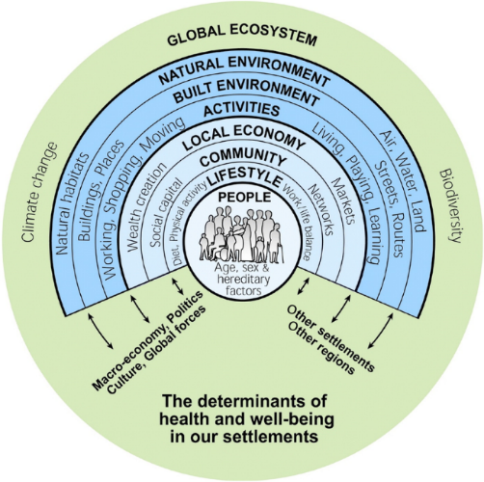

Health and Wellbeing
- Planning policies and decisions should make sufficient provision for facilities such as health infrastructure and should aim to achieve healthy, inclusive, and safe places that support healthy lifestyles, especially where they address identified local health and well-being needs. Ongoing engagement between Sandwell Council and relevant organisations will help ensure that the SLP supports both these aims.
- Sandwell’s unique circumstances give rise to several challenges to health and well-being, which are reflected in its related strategies. Providing an environment that contributes to people’s health and wellbeing is a key objective of the Council and its partners in the health, voluntary and related sectors.
- Sandwell has lower rates of both life expectancy and healthy life expectancy than the rest of England, meaning people not only die earlier but live more of their life with ill health, which has implications for their ability to be productive and for how they use the built and natural environment. According to a Local Authority Health Profile for the borough published in 2019 by Public Health England, Sandwell is one of the 20% most deprived districts / unitary authorities in England and about 25.5% (18,495) of its child population live in low-income families.
- Life expectancy is 8.6 years lower for men and 8.0 years lower for women in the most deprived areas of Sandwell compared to the least deprived areas. In Year 6, 28.3% (1,343) of children are classified as obese, which is higher than the average for England. The rate for alcohol-specific hospital admissions among those under 18 is 25. This represents 20 admissions per year. Levels of teenage pregnancy, GCSE attainment (average attainment 8 score) and breastfeeding are worse than the England average. Estimated levels of excess weight in adults (aged 18+) and physically active adults (aged 19+) are worse than the England average.
- Previously, the four Black Country Councils and their public health partners worked together on the Black Country Plan to ensure it was aligned with the plans of the area’s Sustainability and Transformation Partnership (STP), as well as with each borough’s Health and Wellbeing Strategies. The STP recognised that reducing health inequalities would help reduce financial burdens on the NHS. It also recognised that residents of the Black Country, on average, suffer from poorer health outcomes than people in the rest of England.
- The STP identified several key drivers that play a significant role in the development of future illness in the Black Country, and which directly link to demand for health provision. These are education, employment, wealth, housing, nutrition, family life, transport and social isolation. They are all influenced by the built and natural environment. The Black Country's Health and Wellbeing Strategies identified the following as key priorities for tackling health and wellbeing:
    - healthy lifestyles including physical activity, healthy eating, and addressing tobacco and alcohol consumption and obesity;
    - access to employment, education, and training;
    - quality, affordable homes that people can afford to heat;
    - mental health and wellbeing, including having social connections and feeling lonely or isolated;
    - air quality and the wider environment.
- There is therefore a need for the Sandwell Local Plan to continue to support those initiatives aimed at encouraging healthier lifestyle choices and mental wellbeing and addressing socio-economic and environmental issues that contribute to poor health and inequalities.

Health and Wellbeing
- This policy provides a context for how health and wellbeing are influenced by planning decisions, and signposts other relevant policies in the SLP. Sandwell Council intends to create an environment that protects and improves the physical, social and mental health and wellbeing of its residents, employees and visitors, including children, other young people and vulnerable adults, and which reduces health inequalities.

Policy SHW1– Health Impacts
- Sandwell Council will require the following forms of development to provide an assessment of its potential impacts on the health and wellbeing of adjacent communities, residents and businesses, and to mitigate any potential negative impacts, maximise potential positive impacts and help reduce health inequalities;
- housing developments of over ten dwellings;
- non-residential developments of 1,000m² or more floorspace.
- major new waste handling / processing development;
- any development that would have an adverse impact on locations with currently poor air quality;
- any other development that the Council considers has the potential to impact on public health.
- Such development will only be permitted where it is demonstrated that it will not, in isolation or in conjunction with other planned, committed or completed development, contribute to a negative impact on the health of the borough’s population.
- To ensure that new developments have a positive impact on the health and wellbeing of new and existing residents the Council will require an HIA of development proposals to a level of detail appropriate to its scale and nature and addressing the relevant elements of healthy design set out in paragraph 6.14;
- For developments of 100 or more dwellings, or non-residential development that extends to 5,000m² or more in area, a full Health Impact Assessment will be required;
- For developments of between 20 to 100 dwellings or non-residential development that extends from 1,000 - 5,000m² in area, the Health Impact Assessment will take the form of an extended screening or rapid Health Impact Assessment;
- For developments of 10 – 19 dwellings, or other developments that the Council considers may have a potential impact on public health, either a Design and Access Statement, Planning Statement or an extended screening or rapid Health Impact Assessment should be provided.
- Sandwell Council will support vibrant centres and local facilities, which offer services and retail outlets that promote choice, and which enable and encourage healthy choices. This will include managing the location, concentration of and operation (including opening hours) of businesses that contain uses potentially in conflict with these aims, including:
  - hot food takeaways (sui generis), or hybrid uses incorporating such uses (Policy SDM6);
  - betting shops and amusement arcades (Policy SDM8);
  - shisha cafes / lounges, where the balance of uses is such that the use of the premises is predominantly for shisha smoking.

Justification
- Proposals for major development, or other proposals with the potential to generate negative effects on the mental and physical health and wellbeing of communities, should provide an assessment of their potential impacts through the use of health impact assessments, as set out in the policy. For the purposes of the assessment process, a waste facility is considered "major" if it accepts more than 75,000 tonnes of non-hazardous waste or 100,000 tonnes of hazardous waste per year. Supporting information should be provided in accordance with guidance set out in Policy SWA4.
- Criterion 1 of the policy provides broad parameters on what forms of development will need to be assessed. Criterion 3 relates to those developments identified under criterion 1 and sets out what level of health assessment will be required.
- Such an assessment should address, where relevant, how the proposed development:
- is inclusive, safe, and attractive, with a strong sense of place, encourages social interaction and provides for all age groups and abilities;
- is designed to enable active and healthy lives through prioritising access by inclusive, active, and environmentally sustainable forms of travel, and through promoting road safety and managing the negative effects of road traffic, as set out in Policies STR5, STR6 and STR9;
- will provide a range of housing types and tenures that meet the needs of all sectors of the population, including older people and those with disabilities requiring varying degrees of care; extended families; low-income households; and those seeking to self-build as set out in Policies SHO3, SHO4 and SHO5;
- is energy-efficient and achieves affordable warmth; provides good standards of indoor air quality and ventilation; is low carbon; mitigates and / or is adapted to the effects of climate change as set out in Policy SDS2 and Policies SCC1 – SCC6;
- is designed and located to minimise or exclude adverse impacts on residential amenity, health and wellbeing arising from: noise; ground and water contamination; flood risk; vibration; and poor indoor and outdoor air quality as set out in Policies SCC5, SHW3, SCO1 – SCO3, SDM1;
- will provide employment opportunities for all skillsets and abilities along with education and training opportunities and facilities that will enable residents to fulfil their potential; support initiatives to promote local employment and procurement during construction as set out in Policies SHO8 and SEC5;
- will protect and include social infrastructure such as social care, health, leisure, sport and recreation, retail and education facilities close to where people live, which are accessible by means of inclusive, active and environmentally sustainable forms of travel as set out in Policy SHW2, SHW4;
- will protect, enhance, and provide new green and blue infrastructure, sports facilities, play and recreation opportunities to support access for all and meet identified needs as set out in Policies SNE6, SDS8, SHW4 and SHW5;
- will protect, enhance, and provide allotments and gardens for physical activity, mental wellbeing, recreation and for healthy locally produced food as set out in Policy SHW6;
- will provide high-quality broadband and other digital services to homes, educational facilities, employers, and social infrastructure, to support digital inclusion and the application of new technology to improved healthcare, as set out in Policy SID1.
- Sandwell experiences significantly higher-than-average levels of poor health among its population. Issues include obesity and related illnesses, diseases related to smoking and the effects of alcohol. The Council and its partners are concerned about the health of children, other young people and vulnerable adults, both in terms of immediate term safeguarding and the potential long-term consequences that aspects of their lifestyles will have for their health.
- The Council and its partners are engaged in a range of long-term actions to address these issues, as well as to encourage people to take greater responsibility for the choices they make themselves. Planning is one aspect of these actions. In some instances, a proposed development may have a direct impact on people’s health that will need to be mitigated. In other cases, it may be that the planning process can contribute to improving health by supporting individuals to make healthy choices, through encouraging a suitable range and mix of shops, outlets and activities.
- Making it easier for people to make these healthy choices will increase the likelihood that they will do so, and this change in behaviour will improve health outcomes over time. Policy SHW1 sets out an approach to assessing development to help influence these issues.
- Proposals for hot food takeaways will be assessed in relation to a range of policies, including Policy SDM6. Betting shops, amusement arcades and similar uses will be considered in line with Policy SDM7.

Healthcare Infrastructure
- This policy sets out the requirements for the provision of health infrastructure to serve the residents of new developments, in support of Policy SHW1.

Policy SHW2 – Healthcare Infrastructure
- New healthcare facilities should be:
  - well-designed and complement and enhance neighbourhood services and amenities;
  - well-served by public transport infrastructure, walking and cycling facilities and directed to a town centre appropriate in role and scale to the proposed development, and its intended catchment area, in accordance with Policies SCE3 and SCE4. Proposals located outside centres must be justified in terms of relevant policies such as Policy SCE6, where applicable;
  - wherever possible, located to address accessibility gaps in terms of the standards set out in Policy SHO3, particularly where a significant amount of new housing is proposed; and
  - where possible, co-located with a mix of compatible community services on a single site.
- Existing primary and secondary healthcare infrastructure and services will be protected, unless it has been demonstrated that the loss or partial loss of a facility or site arises from a wider public service transformation plan that requires investment in modern, fit for purpose infrastructure and facilities. New or improved healthcare facilities, infrastructure and services will be provided in accordance with requirements agreed between Sandwell Council and local health organisations.
- Proposals for major residential developments of ten units or more must be assessed against the capacity of existing healthcare facilities, infrastructure and / or services. Where the demand generated by the residents of the new development would have unacceptable impacts upon the capacity of these facilities, services and / or infrastructure, developers will be required to contribute to the provision or improvement of them.
- Where it is not possible to address such provision through planning conditions, a planning agreement or planning obligation may be required.
- In the first instance, infrastructure contributions will be sought to deal with relevant issues on the site or in its immediate vicinity. Where this is not possible, however, any contribution will be used to support offsite provision of healthcare infrastructure and / or related services.

Justification
- Meeting Sandwell’s future housing needs will have an impact on existing healthcare infrastructure and will generate demand for both extended and new facilities across the Plan area. in addition, it will impact upon service delivery as population growth results in additional medical interventions in the populace. Such facilities need to be in locations that reinforce the wider aims of supporting centres and ensuring accessibility by a range of sustainable and inclusive forms of transport.
- Health services in Sandwell are currently experiencing limitations on their physical and operational capacity, which inhibit their ability to respond to the area’s health needs.
- Sandwell Council and its partners, including other healthcare infrastructure providers, have a critical role to play in delivering high-quality services and ensuring essential healthcare infrastructure amenities and facilities are maintained, improved and, where necessary, expanded. Healthcare infrastructure planning is inevitably an ongoing process, and the Council will continue to work closely with these partners and the development industry to assess and meet existing and emerging healthcare infrastructure needs.
- As Sandwell grows and changes, social and community facilities must be developed that meet the changing needs of the area’s diverse community. This will in turn mean that new, improved and expanded healthcare facilities will be required. It is proposed to support and work with the NHS and other health organisations to ensure the provision of health facilities takes place where they are needed in areas subject to new development. Where appropriate, these will be included in supplementary plans and masterplans. It is also proposed to explore opportunities for the co-location of health and other facilities, such as community centres, libraries and sport and recreation amenities.
- Funding for many healthcare infrastructure projects will be delivered from mainstream NHS sources, but for some types of infrastructure, funding may also include contributions from developers. This could relate to the provision of physical infrastructure, such as premises, or social infrastructure, such as the delivery of additional services. These contributions will be secured through planning agreements or planning obligations, in line with the relevant regulations in operation at the time; these are currently the Community Infrastructure Levy (CIL) Regulations 2010 (as amended). For larger sites that generate the need for new physical infrastructure, delivery will initially be sought on-site or in the site’s immediate vicinity. Where this is not possible, or where the contributions will be required to support additional healthcare infrastructure at existing or permissioned new facilities, such provision will be in alternative locations that are accessible to the site. Any new facilities will need to be provided at locations that meet the wider aims of the policy of supporting centres and of ensuring accessibility by a range of sustainable and inclusive forms of transport.
- In establishing the need for / level of developer contributions, residential developments will be assessed against the ability of nearby primary, secondary and community healthcare providers to deliver their services without being compromised by demand from additional residents. Assessment of the capacity of existing healthcare facilities to meet the demand generated by the residents of new development uses an established method adopted by the Group Integrated Care System (ICS). Applicants should consult the ICS in advance of the submission of a planning application where a significant amount of housing is to be provided. For current strategic sites, an application of this methodology has identified no requirement for on-site provision for new health facilities. Where there is a requirement for off-site provision this is set out in details of site allocations and the Infrastructure Delivery Plan.
- The formula used for calculating contributions for healthcare provision will be as follows:
Primary Care:
- Number of projected residents per development / number of patients per consulting room = number of consulting rooms required.
- Number of consulting rooms required x build costs per consulting room = developer contribution.
Secondary Care:
- Number of projected residents per development x cost per head of population = developer contribution.
Build costs will be updated on an annual basis and the formula will be reviewed when required by changes in NHS practice or significant changes in build or operational costs.
- The Viability and Delivery Study provides evidence that greenfield sites and most brownfield sites can sustain the full range of planning obligations required. However, the Viability and Delivery Study also indicates that, depending on the extent of other planning obligations required, such contributions may not be viable on some sites. Where it can be proved that it is not viable for a housing development to fund all its own healthcare needs, alternative funding sources will be sought.

Air Quality
- Promoting healthy living is a key element of the Sandwell Local Plan. Reducing exposure to poor air quality will help improve the health and quality of life of the population and support the Plan’s aims and objectives. The need to address climate change and its associated impacts will include the need to tackle pollution and poor air quality, especially where it has impacts on both human and environmental health.
- Given Sandwell’s location, high levels of previous and extant industrial activity and the presence of significant infrastructure (in particular the M5 and M6 motorways), the whole borough is an Air Quality Management Area (AQMA).
- The WHO published data on the impacts of ambient and household air pollution on human health for the European High-Level Conference on Non-Communicable Diseases held in April 2019. The paper stated that more than 550,000 deaths in the WHO European region were attributable to the joint effects of household and ambient air pollution in 2016, with over 500,000 being due to ambient air pollution and more than 50,000 to household air pollution.
- According to the 2019 Clean Air Strategy published by DEFRA,
Air pollution is the top environmental risk to human health in the UK, and the fourth greatest threat to public health after cancer, heart disease and obesity. It makes us more susceptible to respiratory infections and other illnesses, and we estimate that the actions outlined in this document could cut the costs of air pollution to society by £1.7 billion every year by 2020, rising to £5.3 billion every year from 2030.
- Paragraph 4.1 of the same publication outlines the impacts of air quality on economic growth. Cleaner air helps to reduce the likelihood of workplace absences through ill-health; the strategy identifies that particulate matter; nitrogen dioxide and ozone were estimated to be responsible for total productivity losses of up to £2.7 billion in 2012. Clean air also helps to create and sustain a pleasant and attractive living and working environment, which is more likely to encourage growth and investment in an area.
- Following adoption of the Black Country Core Strategy in 2011, further guidance and advice was provided in the Black Country Air Quality Supplementary Planning Document, adopted in 2016. This built on work undertaken on the West Midlands Low Emissions Towns and Cities Programme, including the West Midlands Good Practice Air Quality Planning Guidance (2014). The planning guidance offered further advice on issues around ambient and indoor air quality and model conditions for use by the local planning authorities.
- The approach to air quality set out in the joint document will need to be revisited, considering new national legislation, regulations and targets, and regional and sub-regional developments regarding air quality, and in light of the abolition of supplementary planning guidance and documents.

Policy SHW3 – Air Quality
Strategic Approach
- The SLP will support a diverse approach to addressing the issue of poor air quality across the borough, including:
    - requiring development and other land use proposals to promote the integration of cycling, walking, public transport and electric charging points as part of their transport provision;
    - promoting and supporting (including through continued joint working with adjacent Black Country authorities and others) a modal shift from private motorised vehicles to the use of clean, fast and accessible public transport alternatives such as rail, the Metro and bus transport networks, cycling and walking;
    - including a range of measures relating to energy generation at developments as set out in the hierarchy identified in Policy SCC1 - Energy Infrastructure, such as the installation of renewables-based systems;
    - requiring the provision and protection of green open spaces and significant additional tree cover (Policies SDS8 and SNE3);
    - ensuring the sustainable location of new residential and employment development to minimise commute times; and
    - as part of an integrated zero-emission public transport system, promoting and requiring the use of sustainable technologies, zero-emission vehicles, design and materials and providing new or extended bus services to meet demand when development of a strategic nature is planned and constructed.
- New development must demonstrate how its occupiers and users would be affected by air quality and how the development itself affects air quality. Planning permission for new development or changes of use will be refused where data assessment indicates that development will:
    - lead to deterioration of existing poor air quality;
    - create any new areas that exceed air quality objectives; or
    - delay compliance being achieved in areas that are currently in exceedance of legal limits unless sufficient mitigation can be achieved.
Improving air quality
- Residential or other sensitive development such as schools, hospitals / health care and care facilities should be sited in areas where air quality already meets national objectives, or where compliance with those objectives can be achieved with suitable mitigation proposed as part of the development proposal and verified as being achieved before occupation of the development.
- Developments that will have a moderate air quality impact, and which can be dealt with through standard mitigation measures, will not require an air quality assessment.
- Whenever development is proposed in locations where air quality does not or will not meet national objectives, or where significant air quality impacts are likely to be generated onsite or elsewhere by the development itself or its subsequent use / activities, an appropriate Air Quality Assessment will be required to demonstrate that the proposed development will improve air quality to meet relevant objectives once the development is completed and occupied / operational:
    - the assessment must take into consideration the potential cumulative impact on air quality of all extant planning permissions in the locality, for both large / strategic and small schemes;
    - the impact of point source emissions of pollutants to air on the scheme must also be addressed;
    - the assessment must take into consideration the types of pollutant emissions likely to be generated by the development and its future use / associated activities that will have an impact on human health;
    - where assessments show that a development is likely to result in exposure to pollutant concentrations that exceed national objectives, a mitigation plan will be required to determine that the development will improve air quality, in order that it will meet air quality objectives once it is complete and occupied / operational; and
    - adequate and satisfactory mitigation measures that are capable of implementation, including the planting of additional and replacement trees in appropriate locations, must be identified, submitted as part of an application, and made subject to appropriate conditions before planning permission is granted.
- Developments should not include materials or be positioned or ventilated in a way that would result in poor indoor air quality. Guidance will be provided to detail how such issues should be addressed.
Emissions from Construction Sites
- For all types of development, the control of emissions from construction sites will be agreed with the local authority.

Justification
- National planning guidance identifies the need for local planning authorities to address the problems created by pollution, in terms of poor air quality and its impacts on human and environmental health. Major air pollutants that impact on human health include particulate matter (PM10 and PM2.5 and fine / very fine particulates) and nitrogen oxides (NOx). These gases may also combine to create ozone, a greenhouse gas that impacts on the atmosphere.
- The main cause of poor air quality across the Black Country is related to vehicular transport. Locations have been identified that do not comply with current national objectives and that will result in relevant exposures; there are several air quality hotspots where on-going monitoring is required. Sandwell Council is working to reduce pollutant concentrations and to minimise exposure to air quality that does not meet with national objectives. Like the other Black Country Councils, it has declared an Air Quality Management Area to try to address the issue of poor air quality and provide protection for human health.
- As part of this, an Air Quality Action Plan has been produced and updated, which sets out how the Council are monitoring and addressing air quality issues around vehicles, industrial emissions and smoke control. In general, monitoring over recent years has demonstrated that the levels of air pollution across the borough have fallen, in line with wider national trends. If this continues, the Sandwell-wide Air Quality Management Area may be lifted during the lifetime of this plan.
- It is important that development likely to have a negative impact on air quality is fully assessed and measures taken to make it acceptable, particularly in parts of the Black Country where air quality is currently, or is likely to become, a concern. Most developments will have a moderate air quality impact, which can be dealt with through standard mitigation measures, without the need for an Air Quality Assessment (AQA). These standard mitigation measures are designed to deal with the cumulative impact of many moderate impact developments over time and over a wide area. The West Midlands Combined Authority is responsible for producing further air quality planning guidance and where appropriate this may provide further advice and guidance. This will effectively replace the previous Black Country Air Quality SPD.
- AQAs should be proportionate to the type and scale of development proposed, in accordance with relevant national standards for air quality and local guidance as appropriate. National planning policy guidance on air quality offers several examples of what might usefully be incorporated in such assessments, including baseline conditions, specific concerns, the assessment methods to be adopted, the basis for assessing impact and determining the significance of an impact and mitigation.
- For some developments a basic screening assessment of air quality is all that will be required, whereas for other developments a full AQA will need to be carried out, using advanced dispersion modelling software. An appropriate methodology informed by national and where appropriate regional guidance should be agreed with the relevant planning officer on a case-by-case basis.
- Where a potentially adverse impact on air quality is identified, mitigation measures may include:
    - increasing the distance between the development and the pollution source;
    - using green infrastructure, particularly trees, to help absorb dust and other pollutants (see Policy SNE3 – care must be taken to ensure the type and location of such trees do not exacerbate air pollution by trapping it close to the street);
    - using ventilation systems to draw cleaner air into buildings;
    - improving public transport access to all development;
    - implementing travel plans to reduce the number of trips generated;
    - implementing low emission strategies;
    - controlling dust and emissions from construction, demolition and working projects.

Open Spaces and Recreation
- The principles of national planning policy on open space and informal recreation need to be applied in a Sandwell context to support the vision for urban renaissance and environmental transformation and to deliver opportunities for safe, attractive, functional, linked and accessible green spaces for people to relax and exercise in and enjoy. This resource also promotes the enhancement of the natural environment to support greater biodiversity, maximises benefits for health and well-being, helps to mitigate and adapt to climate change and promotes economic regeneration.
- All open spaces and informal recreation provision in Sandwell, both existing and proposed, are subject to the policies and requirements of national planning guidance as well as more detailed local policies. The National Planning Policy Framework sets out national policy for the protection of existing open space and informal recreational buildings and land, which should be read alongside Policy SHW4. The policy will also apply to any areas of open space that may not have been identified on the Policies Map or that fall below the 0.2ha cut-off utilised in the most recent open space audit (2024).
- It should be noted that Policy SHW4 relates to the strategic approach to open space and recreation, whereas Policy SHW5 relates specifically to playing fields and built sports facilities.
- Up-to-date local need assessments are central to the implementation of national policy. Local standards for different types of open space and recreation facilities have been developed for Sandwell, based on robust audits and needs assessments. These standards will form the basis for the application of national planning guidance.
- To promote healthy living, it is important that open space, opportunities for informal recreation, and places that people visit every day such as shops and schools, are located and designed so that people are encouraged to walk or cycle to them from their homes. This can be achieved through:
      - location of key facilities in the most accessible locations;
      - meeting open space quantity, quality and access standards;
      - setting of accessibility standards for new housing developments;
      - co-location of key facilities and the promotion of community use, such as the use of school facilities by local people;
      - on and off-site measures such as signage and cycle storage;
      - encouraging implementation of the Sport England Active Design policy.

Policy SHW4 – Open Space and Recreation
- All residential developments of ten homes or more should contribute towards the provision of unrestricted open space, in line with the standards set out in Table 3 of Appendix H. Where such provision on-site would make the development unviable or where there is no physical capacity to include it, the Council will accept a commuted sum for nearby off-site provision in lieu, or for the improvement of existing facilities within walking distance.
- On new housing sites of 2ha or over, Sandwell Council will seek the provision of new unrestricted open space at a minimum ratio of 3.235 hectares of space per 1,000 population. This open space will be provided on site.
- The Council will seek to ensure that at least one hectare of unrestricted open space is provided within walking distance (0.4 km) of all the Borough’s residents and proposals that help it meet this aim will be welcomed.
- Sandwell Council will support proposals that:
  - deliver against up-to-date local open space and recreation standards for the borough, and address any shortfalls in provision, in terms of quantity, quality and access;
  - address the ecological and environmental priorities set out in the Sandwell Local Nature Recovery Strategy or subsequent West Midlands LNRS as appropriate;
  - make more efficient use of open spaces in the urban area by:
    - creating more multifunctional open spaces;
    - protecting the existing open space network for recreation and biodiversity and taking opportunities to strengthen and expand it;
    - significantly expanding community use of open space and recreation facilities provided at places of education;
    - making creative use of land exchanges and disposing of surplus assets to generate resources for investment;
    - increasing access to open space and recreation facilities for all, including people with disabilities and other target groups with limited access at present; and
    - where a place, site or facility has a cross-boundary catchment, identifying the most appropriate location to maximise community access and use of new facilities.
- Aspects of development proposals that would increase the overall value of the open space and recreation network in Sandwell will be supported, especially in areas of proven deficiency against adopted quantity, quality and accessibility standards.
- Proposals should maintain and / or enhance the quantity, quality and accessibility of open space and help address any shortfalls in provision, when measured against adopted local standards. Where practicable, new open space should be provided on-site and relate well to other green infrastructure features.
- Applications for planning permission that would result in the loss of land allocated as open space on the SLP Policies Map will be refused unless it can be demonstrated that there is a robust and overriding matter of public interest at stake; and
  - the loss resulting from the proposed development would be replaced by equivalent or better provision in terms of quantity, quality and accessibility in a nearby location; or
  - an assessment has been undertaken which has clearly shown the open space or land to be surplus to requirements, meaning that:
    - following the loss of the open space, the amount of unrestricted open space at ward level would exceed 3.235 hectares per 1,000 population; and
    - following the loss of the open space, the quantity and accessibility of all types of open space would not fall below the standards set out at Table 3 of Appendix H at ward level, or if already below the standards that the quantity and accessibility of each type of open space would not become worse; or
  - the development is for alternative recreational provision, the benefits of which clearly outweigh the loss of the current or former use.
- Development proposals should focus on supporting / delivering the following functions of open space in Sandwell:
  - improving the image and environmental quality of the borough;
  - protecting and enhancing the significance of heritage assets and their settings;
  - enhancing visual amenity;
  - providing buffer zones between incompatible uses;
  - increasing surveillance and enhancing public perceptions of safety;
  - mitigating the effects of climate change, e.g., through flood risk betterment, installing SuDS, reducing potential urban heat island effects and providing opportunities for additional landscaping and tree planting;
  - preserving and enhancing environmental and habitat diversity and preventing the fragmentation of ecological networks;
  - extending, increasing access to and enhancing the ecological value of multifunctional green spaces and networks;
  - supporting informal physical activity, including through footpath and cycle network infrastructure, and providing areas for informal recreation and children’s play;
  - providing opportunities for people to grow their own food on allotments and encouraging urban horticulture.

Justification
- Being in green spaces boosts various aspects of thinking, including attention, memory and creativity, in people both with and without depression, as well as producing positive improvements in physical and mental wellbeing. All features of the outdoor environment contribute to environmental infrastructure, including natural and semi-natural habitats, parks and other open spaces, formal and informal recreation, historic buildings and landscapes, the public realm of spaces and streets, rivers, canals and drainage systems.
- Sandwell’s previous local plan identified an open space hierarchy in Sandwell, intended to -
“… analyse existing provision of green /open space, to identify strengths and weaknesses in the provision, and to guide decisions about improvements, new and replacement provision, and development proposals which impact on the provision.”
- The hierarchy identified types of open space, ranging from regional / sub regional spaces, such as Sandwell Valley and strategic open spaces such as the Rowley Hills down to local formal and informal areas of open space, such as gardens, playgrounds and landscaped public spaces. The hierarchy is set out in Appendix H.
- The provision of high-quality open space to serve new residential developments and the improvement of existing open spaces is critical to the overall aims of urban renaissance and environmental transformation. Policy SHW4 therefore identifies the functions of open space that are of importance to Sandwell, in addition to those set out in national guidance.
- Greenways are defined as linear features of mostly open character, including paths through green spaces, canal corridors and disused railway lines (although some of these could be brought back into rail use in the future), which act as wildlife corridors and provide attractive and safe off-road links for pedestrians and cyclists. They form an important network throughout the Black Country but in some cases are of poor quality or are severed by other infrastructure or barriers. The restoration of towpaths, bridges, public rights of way and the creation of cycle and pedestrian links to enhance the greenway network will be sought through planning conditions and obligations, transportation funding, and the support of other organisations such as the Canal and River Trust. Blue infrastructure features such as rivers and streams also provide opportunities for physical activity.
- Open space, play standards and requirements are set out in Appendix H and will be subject to review as evidence is updated over the Plan period. Where a commuted sum or improvements are made towards nearby off-site provision in lieu, prioritisation will be given to existing open space facilities within a 400m walking distance. Where facilities do not exist within walking distance or insufficient improvement works are identified to make the contribution acceptable, priority will be given to open space not within walking distance following the Open Space Hierarchy presented at Table 1 of Appendix H. Priority will be given to the closest local open spaces in the first instance, then neighbourhood, town and finally borough open spaces.
- Some common themes regarding open space and recreation have emerged through audits and needs assessments. Communities greatly value local open spaces. However, quantity and accessibility for each type of open space and facility varies considerably from area to area, and an increasing population in certain areas of Sandwell over the Plan period will further affect these imbalances. In general terms, prosperous areas have low levels of provision but of a higher quality, whereas deprived areas may have sufficient quantities of open space but of limited quality and function.
- The policy uses quantity and accessibility of open space as a proxy for determining whether open space is surplus to requirements, and whether it is appropriate for the open space to be lost to development. Consideration as to whether there is a robust and overriding matter of public interest at stake that outweighs the loss should account for the multifunctional role of open space including the role it may play in nature recovery. Open space that is determined to be of low quality and / or has a low value score will not be automatically considered suitable for release and must accord with the policy requirement above.
- The Natural England Green Infrastructure Standards (2023) recommends a quantity standard of one hectare of Local Nature Reserve (LNR) per 1,000 population. Sandwell currently has 0.839 hectares of designated LNR per 1000 population. An additional 55.38 hectares of LNR is required to meet the Natural England Standard at current population levels. Sandwell Council and its partners will look to identify new LNR sites within the borough during the plan period subject to the resolution of viability and deliverability issues.

Sports and playing pitches
- Playing pitch strategies for the four Black Country authorities were updated during 2021-22 and this evidence has informed the SLP. The Sandwell strategy will be updated as appropriate during the Plan period and new priorities may therefore emerge over time.
- The Black Country-wide Playing Pitch and Outdoor Sports Strategy commissioned by the four councils has provided action plans for each of the individual authorities and this in turn has been used to identify the quantitative and qualitative situation for sports pitch and playing field provision in Sandwell.
- The current Sandwell Playing Pitch and Outdoor Sports Strategy (PPOSS) action plan identifying the quantitative situation for playing field provision was produced in October 2022. The PPOSS is updated approximately every five years and therefore will be revised during the plan period. Where appropriate, developers will need to demonstrate that they have taken account of the findings of the most recent version of the Sandwell PPOSS in their schemes; this will be the version that will be used by the Council when a decision is made on planning proposals.

Policy SHW5 – Playing Fields and Sports Facilities
  - Existing playing fields and built sports facilities must be retained unless:
    - an assessment has been undertaken that has clearly shown the playing fields or built sports facilities to be surplus to requirements (for existing or alternative sports provision) at the local and sub-regional level; or
    - the loss resulting from the proposed development would be replaced by equivalent or better provision in terms of quantity and quality in a suitable and accessible location; or
    - the development is for alternative sports provision, the benefits of which clearly outweigh the loss of the current or former use; or
    - The proposed development affects only land incapable of forming part of a playing pitch and would not prejudice the use of any playing pitch or remaining areas of playing field on the site.
  - New build sports facilities should be:
    - in accordance with local needs identified in the current Playing Pitch and Outdoor Sports Strategy, to ensure provision of appropriate facilities in a suitable location to meet that need;
    - well-designed, including through the provision of high-quality landscaping and public realm enhancements, and well-related to neighbourhood services and amenities; and
    - well-linked to public transport infrastructure and footpath and cycleway networks and directed to a centre appropriate in role and scale to the proposed development and its intended catchment area. Proposals located outside centres must be justified in terms of relevant national policy.
  - Where assessments demonstrate that major housing development would increase the need for playing pitches or built sports facilities to a level where significant new or improved facilities are required to meet demand, proportionate planning obligations or Community Infrastructure Levy will be used to acquire or create sufficient provision, where it is financially viable and appropriate to do so, and long-term management arrangements can be secured and funded. Smaller co-located sites, which when taken together could effectively form part of a major development, will also need to take this policy into account.
  - Where land is provided for a new built sports facility as part of a housing development, the financial contribution made by that development towards built sports facilities will be reduced accordingly.
  - The wider community use of school playing fields, other school facilities, such as sports halls, and private facilities will be encouraged, especially in areas where public provision is deficient. Where appropriate, this will be secured through agreement to a suitably worded community use agreement.

Justification
- Publicly accessible urban open space, play and sports facilities all have a vital role to play in helping to promote healthy lifestyles. As sports participation rates in the Black Country are below the national average, needs assessments for sports facilities will consider the need to increase sports participation and improve health as well as meet existing needs. Existing and potential cross-boundary effects will also be considered when developing proposals that would affect sports facility provision. Cross-boundary issues particularly affect facilities with large catchment areas, such as swimming pools.
- An issue in Sandwell is the low quality of playing pitch sites, which would benefit from improved changing facilities and a shift towards more small pitches. Increasing community access to school sports facilities would also help to address shortfalls in some areas.
- This policy recognises that, in some circumstances where there is a significant gap in provision of natural turf playing pitches or built sports facilities such as courts and swimming pools, it may be necessary for housing developments to contribute towards improvements to such facilities over and above general open space and recreation contributions. In such cases, the Sport England Playing Pitch and Sports Facilities Calculator tools will be used to determine an appropriate level of contribution. The high capital and revenue costs of such facilities and the challenges of securing appropriate, long-term management and maintenance for them are recognised. Contributions will be considered alongside requirements for other infrastructure in the context of scheme viability.
- From a quantitative perspective and as set out in the Sandwell Playing Pitch and Outdoor Sports Strategy Action Plan, the existing position for each sport is either that demand is being met or that there is a shortfall in provision. An estimated future position (based on anticipated future housing provision in Sandwell) shows the development of new shortfalls for some pitch types and in some areas where demand is currently being met, as well as the exacerbation of existing shortfalls. There are current shortfalls of adult, youth 11v11, youth 9v9 and mini 7v7 football pitches as well as 3G pitches, cricket squares and rugby union pitches, all of which will be exacerbated when addressing future demand driven by new housing provision.
- Where demand is currently being met, this does not necessarily mean that there is a surplus of provision; any spare capacity is effectively taken up in overcoming current or future shortfalls. There is a need to protect all existing outdoor sport provision until demand is met, or a requirement to replace provision in accordance with the NPPF and Sport England’s Playing Fields Policy.
- The Action Plan and Strategy identified that contributions from housing developments could be pooled together to improve key sites and listed those high-priority locations that would provide the most benefit from additional investment:
- Barnford Park
- Birmingham County FA Headquarters
- Britannia Park
- Cakemore Playing Field
- Charlemont Playing Fields
- Hadley Stadium
- Hydes Road Playing Fields
- Lion Farm Playing Fields
- Sandwell Academy
- Tipton Sports Academy
- Warley Rugby Club
- West Bromwich Dartmouth Cricket Club
- West Smethwick Park
- However, if high priority sites in the local area of the development cannot be identified for investment, contributions should be pooled to fund the creation of new provision, particularly for cricket, in consultation with Sport England and the relevant NGB, to ensure the potential provision would be utilised and sustainable.
- There are other solutions available to help meet existing shortfalls, including by better utilising current provision, such as through:
- improving quality;
- re-configuration;
- installing additional floodlighting;
- improving ancillary facilities;
- enabling access to existing unused provision, such as at unavailable school sites.
- However, there remains a shortfall of 3G pitches that can only be met through increased provision. With resources to improve the quality of grass pitches being limited, particularly at sites managed by the Council, an increase in 3G provision could also help reduce grass pitch shortfalls through the transfer of play, which in turn can reduce overplay and aid pitch quality improvements.
- The proposed reallocation of Lion Farm to deliver housing and employment development will result in the loss of several extant playing pitches currently in use at the site. These will be replaced and where required the remaining pitches and facilities on site upgraded, prior to the commencement of any development on site.
- The locations that have been identified as having capacity to provide potential replacement pitches are:
Location | Potential capacity - June 2024
Lightwoods Park | 2 x full size pitches
Balls Hill Open Space, Chester Road Surrey Crescent Site | 1 pitch
Black Patch Park | 2 x junior pitches
Hill Top Park Site | 2x full size and 1 x junior pitch
Brooklands Open Space, Brooklands Site | 2 x full size and 1 x junior pitch
Marl Hole Park, Hambletts Road Site | 1 x full size pitch
Ratcliffe Park, Ebenezer Street Site | 1 x junior pitch
Playing Field, Bilston Road Site | 1 x full size pitch or 2 x junior pitches

Allotments
- The Small Holdings and Allotments Act 1908 placed a duty on local authorities to provide sufficient allotments according to local demand. It also made provision for local authorities to compulsorily purchase land to provide allotments.
- The National Model Design Code states that as part of open space design for large developments consideration should be given to the provision of land for allotments and community growing projects for food production, learning and community engagement.
- Sandwell currently contains 34 allotment sites that in turn provide around 1,336 plots; it encourages the continued use of allotments and will support the use of green space for local food growing, including community farming, gardening and orchards.

Policy SHW6 - Allotments
- The provision and promotion of allotments and community gardens in Sandwell will be supported by the Council. This will be achieved by:
- retaining existing allotments and resisting their loss unless in accordance with allocations identified in this plan;
- working with partners and local communities to identify sites with potential for local food growing; and
- supporting projects that promote community gardening, farming and orchards.
- If allotments are to be redeveloped, compensatory measures will be required for the loss, either through provision of new allotments on an open space of equivalent value nearby, or through a commensurate contribution to the enhancement of existing allotment provision in the vicinity.
- Proposals for community agriculture will be supported where appropriate.
- Development proposals that are located next to, or which may have an impact on, existing allotments will be expected to avoid or mitigate adverse impacts on them by employing the agent of change principle.

Justification
- Allotments and community agriculture are important to local communities, and they have a unique place in Britain’s heritage.
- Allotments have nature conservation and open space value alongside their primary use for food growing. Allotment sites will be strongly protected unless it can be clearly demonstrated that their use is no longer required.
- A study carried out in 2016 identified that allotment gardening can result in significant improvements in self-esteem and mood via reductions in tension, depression, anger and confusion. These findings are supported by previous research demonstrating the health and well-being benefits of participating in green exercise activities.
- Further evidence on the social, physical and mental benefits of allotment gardening demonstrates that:
- it provides various environmental benefits, including the support and regulation of ecosystem services;
- it results in more sustainably produced food, promotes healthy eating and acts as an educational resource;
- it improves general health, aids recovery from stress, increases life satisfaction, promotes social contact and provides opportunities for low to moderate–high intensity physical activity, all of which promote mental wellbeing;
- people who grow their own food are happier than those who do not;
- compared with an indoor exercise class, allotment gardening results in significantly lower levels of stress.
- Allotment gardening may also play a key role in promoting health and wellbeing in the more vulnerable groups in society, through the opportunities they provide for the development of social support and cohesion.

Sandwell’s Housing

Introduction
- The policies in this chapter will help to create a network of cohesive, healthy and prosperous communities across Sandwell. This is a fundamental element of the Plan’s Vision and objectives and will help deliver its strategic priorities. The policies will also ensure the provision of a balanced range of housing in terms of type, tenure, wheelchair accessibility and affordability, and specialist provision for Gypsies, Travellers and Travelling Showpeople and for those who wish to undertake self-build or custom build. New housing is expected to be of a high build quality and will need to be well-designed, including meeting national space and water efficiency standards and delivering high levels of energy efficiency and adaptation to climate change. In addition, maximising sustainable transport access to key residential services and focusing high-density housing in areas of greatest accessibility is at the heart of the Spatial Strategy, helping to deliver Strategic Objectives 6, 7 and 15.
- Providing a balanced network of well-designed and education facilities is a further key part of this approach. Creating fit-for-purpose and modern learning environments that enable pupils to concentrate on their studies in welcoming and safe environments will in turn support ongoing and future economic prosperity.

Sustainable Housing Growth
- A key role of the SLP is to set out realistic targets for the delivery of sustainable housing growth over the plan period up to 2041.

Policy SHO1 - Delivering Sustainable Housing Growth
- Sufficient land will be provided to deliver at least 11,901 net new homes over the period 2024 - 2041. As set out in the NPPF (para 76b), Sandwell Council is seeking to confirm through the SLP the existence of a 5-year housing land supply from the year of adoption (2026). For this purpose, a 20% buffer has been applied to housing supply, in line with the most recent Housing Delivery Test results (2023).
- The key sources of housing land supply are summarised in Table 7. Strategic housing allocations are set out in Chapter 16 and non-strategic housing allocations are set out in Chapter 17.

Table 7 - Housing Land Supply - Sources
Source of Supply | Type of Supply | 2024-2041
Current Supply | Site under construction | 566
Current Supply | Sites with Planning Permission or Prior Approval | 929
Current Supply | Site with Other Commitments (as set out in 2024 SHLAA) | 70
Allocated | Sites without planning permission | 6237
Allocated | Sites with Planning Permission | 1328
Allocated | Sites under construction | 322
Total Identified Sites |  | 9452
Total Windfall Allowance | Small sites (<10 homes / 0.25ha) (2028-2041) | 1547
Total Identified Sites and windfall allowance |  | 10,999
Additional floorspace in centres | West Bromwich | 5
Additional floorspace in centres | Town Centres | 70
Additional floorspace in centres | District and Local Centres | 95
Total additional floorspace in centres |  | 170
Additional supply in Wednesbury Master Plan |  | 117
Total Supply |  | 11,286
Net completions |  | 615
Total supply and net completions |  | 11,901

- Most of the requirement will be met through sites with existing planning permission and sites allocated for housing by this Plan. Additional housing supply will also be secured on windfall sites throughout the urban area.
- The development of sites for housing should be delivered through a comprehensive approach. Incremental development of an allocated site will only be allowed where it would not prejudice the remaining parts of the site coming forward for development or the delivery of infrastructure.
- All new developments should be supported by the necessary on and off-site infrastructure to serve its needs, mitigate its impacts on the environment and the local community, and ensure that it is sustainable and contributes to the proper planning of the wider area.
- Ancillary uses appropriate for residential areas, such as health facilities, community facilities and local shops, may be acceptable where there is a gap in service provision and where they can be integrated successfully into the residential environment.

Justification
- The council has identified sufficient land to provide 11,901 additional homes by 2041. The NPPF requires the Council to maintain a five-year supply of housing sites. On adoption of the plan (2026), based on the projected completions in the trajectory (see Appendix G), there is a 5.10-year supply (with a 20% buffer). 97% of the supply is on brownfield land and 3% is on undeveloped sites. The Sandwell Policies Map illustrates the distribution of housing sites across the borough. A balanced range of sites has been provided, in terms of size, location and market attractiveness, which will help to maximise housing delivery over the Plan period. Across the borough, 10% of identified supply in the Plan and in the most recent Brownfield Register is on sites no larger than 1ha, which is in accordance with the requirement set out in the NPPF at paragraph 070.
- The details of proposed housing allocations are provided in Chapters 16 and 17 and sites are shown on the Policies Map. Housing capacity has been identified in accordance with the Spatial Strategy and is based on the following information:
- Strategic Housing Land Availability Assessments (SHLAAs) and the Black Country Employment Area Review (BEAR);
- an estimate of the likely scale of housing renewal up to 2041;
- an estimate of likely windfall development on small sites up to 2041;
- an assessment of the capacity of West Bromwich strategic centre above existing supply, drawing on the West Bromwich Master Plan and Interim Planning Statement;
- an estimate of the likely capacity of vacant floorspace in town, district and local centres;
- application of a density uplift to existing allocations likely to gain permission after 2025, in line with Policy SHO3;
- an estimate of the additional ‘aspirational’ growth that will be delivered in the regeneration areas and on sites identified in masterplans and other supplementary guidance;
- a comprehensive land review and site assessment process.

- Allowances for structural change, as detailed in the Urban Capacity Review (2024), are made up of two sources - potential sites and surplus floorspace within West Bromwich Strategic Centre (drawing on the West Bromwich Master Plan and Interim Planning Statement) and for Tiers Two and Three centres (as defined in Policies SCE4 and SCE5). The structural change allowances are over and above the small windfall site allowance. The latter represents a continuation of historic rates, whereas the former represents a structural change in the factors giving rise to new housing sites which is predicted will generate additional supply over the Plan period. These include changes to shopping patterns, permitted development rights and work patterns arising from COVID impacts.
- Table 7 details the housing land supply for the plan period. An indicative annualised delivery timeline is set out in the trajectory in Appendix G. The trajectory demonstrates a steady supply of housing completions over the Plan period. As set out in the NPPF (paragraph 76), the Council is seeking to confirm through the SLP the existence of a five - year housing land supply from the year of adoption (2026). For this purpose, the buffer applied to housing supply (as set out in the housing trajectory) will be 20%, in line with the most recent Housing Delivery Test results (2023).

Windfall Development
- A robust small windfall site allowance has been included in the supply, which reflects historic completion rates for sites of less than ten homes. Windfall sites are subject to policy, sustainability, and detailed site considerations.

Policy SHO2 – Windfall developments
  - Proposals for residential development on sites not specifically allocated for residential use (windfall developments) will be permitted where development on the site is in accordance with other local plan policies.

  - Proposals for residential development will only be considered where

  - the development of the site will bring an under-used piece of land back into use and will not harm the environmental or ecological value of the site and the wider area, in accordance with other relevant policies in the SLP, or cause harm to the significance of heritage assets, including their setting.
  - All new development should be supported by the necessary on and off-site infrastructure to serve its needs, mitigate its impacts on the environment and the local community, and ensure that it is sustainable and contributes to the proper planning of the wider area.

Justification
- In addition to the sites allocated for residential development within the Plan, it is recognised that other sites will become available for development during the Plan period as it is impossible to identify all potential redevelopment proposals that may arise within an urban area such as Sandwell. These sites are likely to include surplus public land, small non-conforming employment uses and some residential intensification sites where appropriate.

Housing Density, Type and Accessibility
- It is important that the new homes delivered over the plan period:
- are provided in places with good sustainable transport access to key residential services;
- can provide a mix of types and densities that are appropriate to their location; and
- can help to meet local needs.

Policy SHO3 - Housing Density, Type and Accessibility
- Except where provided for in a site allocations policy, the density and type of new housing provided on any housing site should be informed by:
  - the need for a range of types and sizes of accommodation to meet identified local needs;
  - the level of accessibility by sustainable transport to residential services, including any improvements to be secured through development, as set out in Table 8; and
  - the need to achieve high-quality design, to mitigate and adapt to climate change. and minimise amenity impacts, considering the characteristics and mix of uses in the area where the proposal is located.
- The council will aim to provide an overall mix of house types over the plan period, tailored to best meet local needs and will support development that creates mixed, sustainable and inclusive communities. Developments of ten homes or more should provide a range of house types and sizes that will meet the accommodation needs of both existing and future residents, in line with the most recently available information.
- All developments of ten homes or more should achieve the minimum net density, on the net developable area, set out below:
  - 100 dwellings per hectare where Table 8 accessibility standards for very high-density housing are met and the site is:
- located within a Strategic or Town Centre detailed at Table 12; or
- identified for very high-density housing within a masterplan and / or design brief agreed with the council; or
- considered suitable for very high-density housing in accordance with guidance in the council’s Design Code.
  - 45 dwellings per hectare where Table 8 accessibility standards for high density housing are met;
  - 40 dwellings per hectare where Table 8 accessibility standards for moderate density housing are met.
- Table 8 provides details of the appropriate density and, where appropriate, house type mix, to be sought on each housing allocation site and any windfall site, in accordance with the requirements set out in this Policy. Further details of design requirements for housing developments will be set out in Sandwell’s Design Codes.
Table 8 - Minimum Housing Densities and Accessibility
Density (homes per hectare net) | Very High: 100+ | High: 45 + | Moderate: 40 +
Indicative proportion of flats | 100% | >15% | 0 – 15%
Indicative amount of housing suited to families | low | medium | high
Accessibility (by either walking or public transport, unless stated)
Employment - Strategic Centre or other employment area | 20 mins | 20 mins | 30 mins
Health – Primary Care e.g., GP Surgery or Health Centre | 10 mins | 10 mins | 15 mins
Fresh Food - Centre or food store | n/a | 10 mins | 15 mins
Education - Primary School (walking distance only) | n/a | 15 mins | 10 mins
Education - Secondary School | n/a | 25 mins | 20 mins
- Any development that fails to make efficient use of land, by proposing developments where more than half of the proposed homes would have 4+ bedrooms will be refused in accordance with the requirements of this policy.

Justification
- Achieving an appropriate density and mix of house types is crucial both to the success of each new housing development and the overall sustainability of the Spatial Strategy. It is important that every major development of ten homes or more contributes to providing the mix and density that best aligns with current local needs. Achieving this will also help to protect and improve residents’ physical, social and mental health, as outlined in the Health and Wellbeing section.
- The accessibility of housing developments to a range of residential services by walking, cycling or public transport is key to achieving sustainable communities. As higher density developments will accommodate more people, they should generally be delivered in those areas with good access to services, to encourage use of sustainable transport modes. The highest densities of 100 homes per hectare or more should be in areas with the best access to public transport and services, but also where a high proportion of flats will provide design solutions that best reflect historic character and local distinctiveness. Therefore, such densities will only be acceptable within West Bromwich Strategic Centre, the Town Centres or other appropriate locations identified by Policy SHO3 where accessibility standards are met.
- Conversely, lower density developments, accommodating more families, should enjoy high levels of accessibility to schools. Not all developments with good sustainable access to services will be suited to the highest densities – in some cases a lower density will be more appropriate, for example in areas of historic character, to reflect the density of adjacent uses or to meet the need for a mix of housing types.
- Table 8 provides access standards for differing house type mixes / densities, in relation to four priority residential services: employment, health, fresh food and education. Proxies have been selected for each service. Employment is represented by West Bromwich Strategic Centre and retained employment areas. The proxy used for fresh food is a centre, or an existing food store outside a centre, that currently provides a range and choice of fresh food. The access standards have been developed based on survey evidence regarding the distance people are prepared to travel to each service by foot and public transport and are designed to help create well-connected and walkable neighbourhoods. Although open space does not form one of the priority residential services for the purposes of establishing the appropriate density and type of housing, Policy SHW4, taken together with local standards and policies, will ensure that a sufficient quantity and quality of different types of open space is available close to where people live.
- Housing developments of ten homes or more will be expected to meet the accessibility standards set out in Table 8, which vary according to density and likely house type mix. The priority is for the service needs of future communities to be served by the existing network of centres, to ensure their future vitality and viability, and to secure future regeneration. Any on-site service provision potential required to meet accessibility standards is identified in the housing allocations. Where there is an identified gap in service provision against one or more of these standards, investment will be sought to improve either service provision or access to existing services sufficient to ensure standards are met.
- New service provision, including for centre uses, should be located and justified in accordance with Policies SCE3 and SCE4.
- Current accessibility to residential services by sustainable transport modes across Sandwell has been modelled. This modelling shows the high levels of accessibility achieved by the Spatial Strategy. However, there are some gaps in provision that will need to be addressed through service or access improvements. The model will be updated on a regular basis to reflect changes in service provision and public transport services. Local circumstances, such as planned changes to service provision, will be considered when assessing accessibility on a site-by-site basis.
- The Sandwell Housing Market Assessment (HMA) 2024 demonstrates that new households generated by 2041 will need the following mix of home tenures and types:
Table 9 - New housing types and tenures in Sandwell
Size of home | Market Housing | First Homes | Shared Ownership | Social / affordable rented | Total
1 bedroom | 18% | 15% | 25% | 26% | 19%
2 bedrooms | 28% | 23% | 32% | 20% | 26%
3 bedrooms | 27% | 25% | 27% | 20% | 26%
4+ bedroom | 27% | 37% | 16% | 34% | 29%
It is important that housing provision reflects the needs of these new households, allowing for at least one bedroom per person.
- Land supply is limited, and this has an impact on the number of homes that can be delivered; therefore, it is essential that any new development makes the most efficient use of the land. On sites where homes are proposed to be delivered, the Council will be looking for housing sizes that improve the choice in an area; the Council will also expect smaller family housing to be included in the overall mix of housing. Furthermore, new developments need to provide a range of typologies / mix of homes to complement the existing / surrounding housing context; a consistent run of overly large units on a site can be at odds with neighbouring sites in terms of street or plot context. Therefore, developments that fail to make the most efficient use of land by proposing schemes where more than half of the proposed homes would have 4+ bedrooms will be refused in accordance with the requirements of this policy and Policy SHO1.

Affordable Housing
- To meet local needs, a sufficient proportion of new homes provided over the plan period should be affordable.

Policy SHO4 - Affordable Housing
- Developments of ten homes or more should, where financially viable, provide a range of tenures that will meet the accommodation needs of both existing and future residents, in line with the most recently available information.
- All developments of ten homes or more should provide a proportion of affordable housing on site where this is financially viable. Only in exceptional circumstances would a commuted sum be acceptable instead of on-site provision. Smaller sites, which could reasonably be expected to form part of a major development in the future, will also need to take this policy into account. The minimum proportion of affordable housing that should be provided, subject to financial viability, is:
- On all sites in lower and brownfield sites in medium value zones – 10% affordable housing;

- On all sites in higher value zones – 25% affordable housing.
- First Homes will be provided in accordance with national policy.
- Beyond the tenure requirements set out in Parts 2 and 3 of this policy, the tenure and type of affordable homes sought will be determined on a site-by-site basis, based on national planning policy and best available information regarding local housing needs, site surroundings and viability considerations.
- Where providing the applicable percentage of affordable homes (as set out in Part 2) cannot be achieved, the maximum proportion of affordable housing will be required that does not undermine the development's viability (Policy SID1).

Justification
- Rising house prices and low average incomes over a long period have made market housing increasingly unaffordable for many Sandwell households. The Sandwell HMA (2024) identifies a requirement for 17.5% of new homes to be made available for affordable or social rent, 7.8% to be shared ownership and 8.3% to be First Homes. To meet this level of need over the Plan period, 33.6% of new housing would have to be affordable. Sandwell aspires to provide this level of affordable housing, through a range of schemes delivering up to 100% affordable housing funded through grant and other financial sources and supported by developer contributions where viable.
- The Viability and Delivery study demonstrates that viability varies greatly according to local housing values. The affordable housing value zones are shown in Figure 5. This approach should ensure that viability appraisals are not required at planning application stage for many sites. However, viability issues can vary significantly from site to site and are often caused by poor ground conditions, the extent of which cannot be accurately assessed until planning application stage. Therefore, to maximise delivery of affordable housing over the Plan period, it is important that affordable housing is sought on all eligible sites, that viability is assessed on a site-by-site basis where required, and that a flexible approach is employed wherever possible to allow for changing market conditions.
- The onus will be on the applicant to demonstrate that the provision of the required affordable housing would adversely affect the financial viability of the development proposals. Policy SID1 details steps that need to be taken to demonstrate viability issues.
- The Council recognises that exceptional circumstances may sometimes occur where the combined costs of development, including abnormal site conditions, infrastructure, or other planning obligations, would render a scheme unviable if the full affordable housing requirement were applied. In such cases, the applicant will be required to submit a site-specific Financial Viability Assessment (FVA) in accordance with current national guidance. The FVA must provide transparent and robust evidence of all relevant costs, values, and assumptions, including land value, build costs, profit levels, and sales values, and must be supported by appropriate market evidence.
- The Council will arrange for any submitted FVA to be independently reviewed, with the cost of the review met by the applicant. The assessment and its findings will be made publicly available, subject to the protection of any genuinely commercially sensitive information. The Council will seek to secure the maximum proportion of affordable housing on a case-by-case basis.
- Where appropriate, review mechanisms will be used to reassess viability at agreed stages of delivery, ensuring that additional affordable housing contributions can be secured if market conditions improve. This approach ensures that flexibility is applied transparently, maintains confidence in the planning process, and delivers the greatest possible contribution to meeting Sandwell’s affordable housing needs.
- The current affordable housing value zones are based on the current ward boundaries. Should the ward boundaries change then the value zones will be realigned to the new boundaries and viability within the affected ward(s) will be reassessed.
Figure 5 - Sandwell Affordable Housing Value Zones
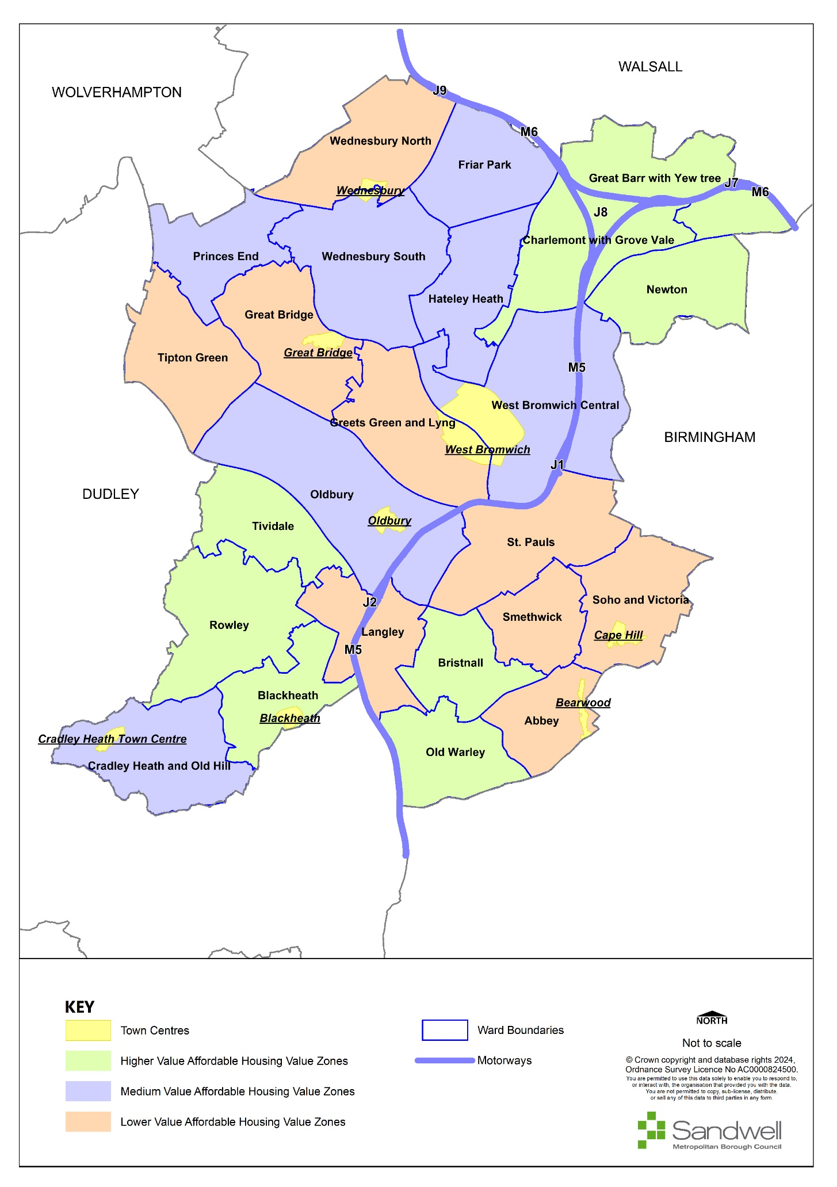
- Provision of affordable housing is through on-site provision; commuted sums in lieu of on-site provision will only be accepted in exceptional circumstances where all other avenues have been explored and found to be unsuitable. Commuted sums will be calculated using the following method:
- The amount payable per dwelling will be a sum equal to the difference between the appropriate RP purchase price and the market valuation of an equivalent dwelling in the locality (with a distinction between rented units and shared ownership units).
- Typically, a RSL would pay 50% of the market value for a social rented unit, 55% for an affordable rented unit and 70% for a shared ownership property.
- Example:
Market Valuation = £150, 000
For a social rented unit this would be:
- purchase price (social rented unit) at 50% of market value = £75,000
- commuted sum = £150,000 - £75,000 = £75,000
For an affordable rented unit this would be:
- purchase price (affordable rented units) at 55% of market value
- commuted sum = £150,000 - £82,500 = £67,500
For a shared ownership unit this would be:
- purchase price (shared ownership) at 70% of market value = £105,000
- commuted sum = £150,000 – £105,000 = £45,000
- Any costs associated with negotiating a commuted sum, including the cost of site/property valuations, will be met by the developer directly.
- The timing of the payment of commuted sum will be in accordance with a payment schedule agreed with the Council.

- Beyond national requirements, the tenure and type of affordable housing required over the Plan period will vary according to local housing need and market conditions. In general, a mix of tenures will be sought on all sites of ten homes or more, to help create mixed communities across the borough. However, there may be circumstances where this goal is better achieved through the provision of 100% affordable housing development to boost affordable housing provision, or through delivery of 100% market housing development with off-site provision of the affordable housing requirement.

Delivering Accessible and Self-build and Custom Housing
- To meet local needs, a sufficient proportion of new homes provided over the plan period should be accessible, and enough plots should be provided to meet local demand for self-build and custom build housing.

Policy SHO5 - Delivering Accessible and Self / Custom Build Housing
National Accessibility Standards
- All new homes will be required to meet M4(2) (Category 2: Accessible and adaptable dwellings) requirement in Building Regulations except where site specific factors such as vulnerability to flooding, site topography, and other circumstances may make a specific site less suitable for M4(2).
Self-Build, Custom Build and Community-led / Co-operative Housing Schemes
- On developments of 100 homes or more, where there is currently a demand for self-build and custom build plots (defined as the number of entries added to the self-build and custom build register in the most recent base period for the ward where the site is located), at least 5% of plots should be made available for self-build or custom build, or sufficient to match demand if lower.
- All plots set aside for self-build or custom build housing (secured via a legal agreement or planning condition) must include:
- legal access onto a public highway;
- water, foul drainage, broadband connection, and electricity supply available at the plot boundary;
- sufficient space to build without compromising neighbouring properties and their amenity and the amenity of future occupiers; and
- an agreed design code or plot passport for the plots.
- If a plot remains unsold after six months, after a thorough and proportionate marketing exercise that includes making details available to people on the custom and self-build register, the requirement to make the plot available for self-build or custom build will fall away.
- Where appropriate, Sandwell Council will support the delivery of community-led / co-operative housing proposals, particularly where they can help provide social / affordable housing options that meet the specific requirements of local residents.

Justification

Accessible and adaptable homes
- Sandwell Council will work with partners to meet identified needs to accommodate older people, people with disabilities and those with other special needs. The Sandwell HMA (2024) concludes that an additional 6,510 accessible and adaptable homes will be required by Sandwell households in 2041 due to disability or old age.
- There is a need for these types of home across all tenures. This implies that a significant uplift will be required to the number of homes that meet these standards currently. Although some improvements to existing homes funded through Disabled Facilities Grants may contribute towards this uplift, the provision of new homes meeting the standards would reduce the need for adaptations to be retrofitted and make the housing stock more responsive to the evolving needs of the local population.
- People’s housing needs change as they get older, and homes designed in a way that makes them more easily accessible and adaptable allow people to stay in their own homes for longer. With public health and social care strategies placing more emphasis on supporting people in their own homes rather than moving to residential care, it is important that more adaptable and accessible homes are provided. Studies have shown that older properties are generally less accessible, and harder to adapt.
- In line with new Building Regulations all new homes must meet the M4(2) (Category 2: Accessible and adaptable dwellings) requirement. Accessible and adaptable homes that meet the M4(2) Building Regulations are designed and built to a standard that meets the requirements of occupants with differing needs, including some older or disabled people, and are only slightly more expensive to build than standard housing. They must also allow adaptation to meet the changing needs of occupants over time. Homes built to this standard are more flexible and readily adaptable as people’s needs change, for example if they have children and require easy access for pushchairs, if they have a temporary or permanent disability or health issue, or as they gradually age and their mobility decreases.
- The standards will be applied through planning conditions or section 106 agreements, which will require an agreed number of units to be constructed to the specified Building Regulations requirements.
- Policy SHO5 allows for an element of flexibility in recognition of the practicalities of delivering these standards, given the challenges that may arise around the topography of some sites, where access within the gradients specified in the Building Regulations Approved Document may not be achievable. Where step-free access to dwellings cannot feasibly be achieved due to site specific factors, the optional standard will not be required for the homes affected. Where multi-storey flats or apartments are being developed without lift provision, homes on the first floor or above will not be required to meet the M4(2) standards. Ground floor flats in multi-storey developments will still be required to meet the optional standard. Where lifts are provided the standards will be applied in accordance with the Policy.

Self and Custom Build Housing and community-led / co-operative schemes
- National guidance requires local authorities to permit sufficient serviced plots of land to meet the demand for self-build and custom housebuilding in their area, defined as the number of entries to the authority’s self-build and custom housebuilding register in the most recent base period (12 months running from 31 October to 30 October). The current demand for the base period of 31 October 2023 to 30 October 2024 is 11.
- Where there is identified demand in the borough this will be assessed on a ward basis and by the number of people registered on the self-build and custom build register in the ward where development is proposed. When an application is submitted developers of larger sites (sites of 100 homes or more) will be expected to make available a small proportion of the development as serviced self-build and custom build plots, as defined in national guidance and legislation and that meet the criteria set out in Policy SHO5 parts 5a-d. Appropriate marketing of these plots, for example through specialist plot-finding services, residential property websites and local estate agents, will be required for a period of at least six months. These plots will not form part of the affordable housing requirement for the development. Detailed guidance for the plots, for example on design, will be provided where appropriate. Where there is no evidence of demand, i.e. the Sandwell self and custom build register does not have any names registered for the ward in which the development is proposed, then the applicant will not have to provide self-build / custom build plots in the proposed development.
- Self-build projects should conform to all relevant policies in the SLP, including SCC1 on climate change adaptation and mitigation.
- Community-led housing schemes include co-operative housing and co-housing. A housing co-operative traditionally means that members of the co-operative own the house(s) and all members have an equal say in the management of it, regardless of their financial share in the property. Co-housing communities are intentional communities, created and run by their residents. Each household has a self-contained, private home as well as shared community space. Residents can choose to come together to manage their community, share activities, or regularly eat together, for example. They can be established through the re-use of empty homes, or through new builds.

Protecting Family Housing
- There is sufficient demand in Sandwell for family accommodation that the Council believes it is appropriate to include a policy requiring the retention of family houses except where identified circumstances apply.

Policy SHO6 - Protecting Family Housing (Use Class C3)
- To address the shortage of homes that are suitable and attractive to families throughout the borough, and to encourage the provision of sustainable, inclusive and mixed communities, there will be a presumption against the loss of dwelling houses (Use Class C3) for family occupation through either sub-division, conversion to Use Class C4, conversion to other non-residential uses or demolition and redevelopment, unless:
  - the property / properties is / are located within a site allocation and the corresponding development principles indicate that an alternative use or mix of housing will be more appropriate;
  - the proposed development fulfils other regeneration aspirations of the Council;
  - evidence of local housing need and demand indicates that an alternative mix of housing is appropriate;
  - alternative provision will help meet other housing priorities of the Council, such as provision for elderly persons (including bungalows); or
  - an applicant can demonstrate that the property / properties will no longer be suitable for family occupation, in which case, replacement with a new Class C3 dwelling house(s), suitable for family occupation will be the preferred approach, unless one of the criteria set out above can be satisfied.

Justification
- The Sandwell Housing Market Assessment (2024) demonstrates a need for homes with one bedroom (19%), two bedrooms (26%), three bedrooms (26%) and four bedrooms (29%). Sandwell’s waiting list register also demonstrates that more people are waiting for one- and two- (42% and 32%) bedroom homes, with three- bedroom homes seeing the third highest level of demand (17.5%).
- Sandwell is limited in its capacity to identify areas of land for housing to meet the borough’s needs, and many family homes have been lost through conversion into separate flats and Houses in Multiple Occupation. Therefore, existing family homes should be retained unless there are circumstances identified where it may not be appropriate to do so.
- Such circumstances may arise where the property or properties form part of a site allocation within this Plan, and the accompanying development principles for that site state that an alternative use for the property has been identified; or where an alternative type of housing is more appropriate.
- Another example would be where an alternative form of development would fulfil regeneration aspirations identified by the Council, or where alternative provision would help to meet other housing priorities of the Council, as set out in the Housing Strategy.
- Where applicants feel that a property or properties are no longer suitable for family occupation, a robust justification will be required for their conversion or replacement. Factors that will be taken into consideration will include:
- location of the property;
- compatibility of neighbouring uses;
- provision of private outdoor amenity space;
- car parking;
- outlook; and
- adaptability of internal layout.

Housing in Multiple Occupation
- Over the last few years, the issue of the number and location of Houses in Multiple Occupation (HMOs) in Sandwell has risen in importance. A combination of changes to permitted development rights and the need to provide affordable accommodation for people on low incomes has led to an increase in the number of HMOs and in the numbers of related planning applications being determined by Sandwell’s Planning Committee.
- HMOs provide an additional and valuable source of lower-cost accommodation for sections of the community who cannot afford to purchase their own property or who do not qualify for other forms of social housing. They also provide for the needs of students and people commuting from elsewhere in the country to work in Sandwell.
- There is a perception however that HMOs lead to increases in anti-social behaviour, increased activity, parking problems, noise nuisance and more transient occupiers leading to a weakening of community coherence.

Policy SHO7 - Houses in Multiple Occupation
- Proposals for the creation of a House in Multiple Occupation (HMO), including the conversion of buildings or sub-division of dwellings, will only be permitted if this would not result in over 10% of the number of residential properties within a 100-metre radius of the application site, measured from the address point of the property (referred to in this policy as the “relevant area”) operating as HMOs and if the proposals would meet the additional criteria set out in this policy.
- The methodology for establishing the quantum of HMOs in a relevant area is set out in the table below:
Table 10 - Methodology for calculating concentration of HMOs within a relevant area.
Methodology / Evidence:
The Council will calculate the number of HMOs in the relevant area for each individual planning application by using the following approach:
- Identifying the current distribution of residential properties in the relevant area -
For the purposes of assessing applications for HMO development, dwelling houses and HMOs that are located within blocks of flats or subdivided properties are counted as one property. Residential institutions, care homes, hostels and purpose-built student accommodation and other specialist housing types are also counted as one property per block. This will ensure that calculations of HMO concentration are not skewed.
- Calculating the number of HMOs in the relevant area -
Current HMO numbers will be identified from the following sources:
  - Properties licensed as a HMO
  - Properties with C4 or Sui Generis HMO planning consent or issued with a Certificate of Lawful Development
  - Council tax records – student exemptions for council tax excluding purpose-built student accommodation and private flats
- Calculating the concentration of HMOs in the relevant area -
The concentration of HMOs surrounding the application site is calculated as a percentage of the total estimated number of existing HMO units against the total number of residential properties. It is accepted that although the HMO sources listed above provide the most robust approach to identifying the numbers and locations of HMOs in an area, it will not identify all HMOs.
- Once the current level of HMO provision has been established in a relevant area, the following criteria will be applied to a new proposal:
- the development would not:
    - result in the loss of C3 family-sized dwellings in areas where there is a proven demand for such accommodation (Policy SHO6);
    - result in a C3 family dwelling house being sandwiched between two HMOs or other non-family residential uses;
    - lead to a continuous frontage of three or more HMOs or non-family residential uses.
- the development is unlikely to be detrimental to the amenities of the occupiers of adjoining or neighbouring properties by way of noise, overlooking, general disturbance, or impact on visual amenity;
- the development would not have a significant adverse impact on the character or appearance of the area, or of the historic or natural environment;
- the development would not give rise to unacceptable adverse cumulative impacts on amenity, character, appearance, security, crime, anti-social behaviour or the fear of crime;
- in areas at risk of a 1 in 100-year plus flood event, finished ground floor levels are at least 60cm above the 1 in 100-year plus flood level;
- provisions for off- and on-street car and cycle parking are sufficient and appropriately incorporated, and would not have an adverse impact on the surrounding area by way of increased on-street parking, impaired highway safety or impeding proper access to the area;
- the site is in an area that has good access by walking and public transport to residential services, as set out in Policy SHO3; and
- the development provides a satisfactory standard of living accommodation, and the internal layout is shown to be suitable for the number of units proposed in terms of daylight, outlook and the juxtaposition of living rooms and bedrooms.
- The construction or conversion of the building / dwelling intended to form the HMO should be undertaken to provide adequate personal living space and residential facilities, including:
  - bedrooms of at least 7.5m² (single) and 11.5m² (double);
  - communal living space comprising lounge, kitchen and dining space either as distinct rooms or in an open plan format;
  - washing facilities;
  - adequate provision for the storage and disposal of refuse and recycling; and
  - outdoor amenity space for sitting out, play and drying clothes and external storage space, including cycle storage.
- Where an HMO has been established in breach of the need for planning permission, retrospective consent will only be granted in exceptional circumstances.
- Proposals for the intensification or expansion of an existing HMO should comply with the criteria above, having regard to the size and character of the property.
- All HMOs must be able to satisfy the licensing requirements of Sandwell Council before planning permission will be granted.

Justification
- Houses in Multiple Occupation (HMOs) are defined as homes accommodating three or more unrelated households who typically share kitchens, lounges, and bathrooms. If an Article 4 direction is put in place, which means that the council has removed "permitted development rights,” planning permission will be required for small HMOs (3 – 6 people) in specific areas.
- HMOs are an increasingly popular part of the housing market in parts of the Black Country. As rooms can be rented individually, they provide additional affordable accommodation options, used primarily by students, young people, and those on lower incomes.
- Whilst the area’s stock of HMOs contributes to meeting housing needs, increased numbers of properties in multiple occupancy have the potential to create harmful impacts. Concentrations of HMOs within neighbourhoods can lead to imbalanced and unsustainable communities and harm the social mix and fabric of the area by increasing the proportion of short-term households. They can damage the residential amenity and character of surrounding areas, as the level of activity associated with a HMO is significantly greater than a typical family house, thus increasing the potential for noise and disturbance.
- Harmful impacts associated with high numbers of HMOs can include:
- reduced social cohesion resulting from demographic imbalance and unsustainable communities;
- reduced housing choice resulting from housing type / tenure imbalance (e.g., a shift from permanent family housing to more transient accommodation and a growth in the private sector at the expense of owner-occupation);
- reduced community engagement from residents resulting from an increase in the transient population of an area;
- noise and disturbance resulting from intensification of the residential use and / or the lifestyle of occupants;
- detriment to the visual amenity and character of the area resulting from poor or accumulative external alterations to properties and / or poor waste management;
- reduced community facilities resulting from a shift in the character of shops and businesses;
- increased anti-social behaviour and fear of crime resulting from the lifestyles of some HMO occupants, the transient nature of the accommodation and inadequately designed / maintained properties;
- highway safety concerns resulting from congested on-street parking.
- Whilst this type of accommodation can address certain housing needs, HMOs tend to be grouped together in parts of the urban area, becoming the dominant type of housing, which can lead to social and environmental problems for local communities. Alongside this, an over-concentration of HMO properties can lead to a loss of family-sized units. This in turn can lead to a consequential increase in the overall number of units unsuited to family occupation. This can pose a serious issue for maintaining a mixed sustainable housing offer across the Black Country.
- The Sandwell HMA (2024) signalled that the greatest demand in the future will be for homes of three bedrooms or more. It is important, therefore, that an approach is taken to the creation of HMOs and the sub-division of existing properties that only allows those proposals that do not impact upon the overall supply of family-sized homes to be supported. In applying this policy, ‘family-sized dwellings’ means houses with three or more bedrooms.
- In determining the concentration of HMOs surrounding the application site, it will be calculated as a percentage of the total number of residential properties. HMOs should not form over 10% of the number of residential properties within a 100-metre radius. Any application that would result in a higher figure, e.g., 10.04%, would be refused.
- Planning permission will not be granted where the introduction of a new HMO would result in an existing C3 dwelling being ‘sandwiched’ between adjoining HMOs or non-family residential uses on both sides. In the context of the policy, this is defined as:
- Up to three single residential properties in a street located between two individual HMO properties;
- Individual HMO properties in any two of the following locations: adjacent, opposite or to the rear of a single residential property;
- A residential flat in a building where most of the other flats are proposed for use as HMOs;
- A residential flat within a building located between two other sub-divided buildings with at least one HMO flat in each of the other building;
- A residential flat located between HMOs above and below or between HMO flats on either side.
- This would not apply where the properties are separated by an intersecting road or where properties have a back-to-back relationship in different streets. Planning permission would also not be granted where it would result in a continuous frontage of three or more HMOs or non-family residential uses.
- In situations where properties are not traditional houses situated along a street frontage, the policy can be applied flexibly depending on the individual circumstances of the proposal.

Exceptional circumstances
- In some areas, the concentration of HMOs will already be at such a high level that the introduction of an additional HMO use would be difficult to refuse. In these circumstances, the retention of a property as a family dwelling is very likely to have no noticeable or meaningful effect on the balance and mix of households in an area already characterised by a high density of extant HMOs. On this basis, therefore, the conversion of a remaining building to an HMO could not harm the character of the surrounding area any further.

Education Facilities
- A variety of services are required to meet the needs of new residents, including education facilities. It is important that these facilities can be easily accessed by sustainable forms of transport and meet the variety of needs for different age groups and educational needs.

Policy SHO8 – Education Facilities
- New nursery, school and further and higher education facilities should be:
  - well-designed, to the relevant local / national standards / guidance in place, and should complement and enhance neighbourhood services and amenities;
  - well-served by public transport infrastructure, walking, and cycling facilities, particularly in centres, and located to minimise the number and length of journeys needed in relation to the home to school travel distances; and
  - wherever possible, located to address accessibility gaps in terms of the standards set out in Policy SHO3, particularly where a significant amount of new housing is proposed.
- New and improved education facilities will be secured through a range of funding measures:
  - Where a housing development of ten or more homes would increase the need for education facilities to the extent that new or improved facilities would be required to meet this need, planning obligations or Community Infrastructure Levy will be secured sufficient to meet the need in a timely manner, where this is financially viable.
  - Contributions will be secured retrospectively where forward funding of improvements is necessary to meet immediate needs.
  - For sites where there is likely to be a requirement for on-site provision of new schools, this is set out in Chapters 16 and 17.
- Where land is provided for a new school as part of a housing development, the financial contribution made by that development towards education facilities will be reduced accordingly.
- On sites where the education facility requirement is proven not to be viable, the maximum proportion of funding will be sought that will not undermine the viability of the development, subject to securing other planning obligations necessary for the development to gain planning permission. A financial viability assessment will be required to be submitted, meeting the requirements set out in Policy SID1.
- New and redeveloped education facilities should include provision for wider community use of sports and other facilities where this would be in accordance with evidence of need, secured through a suitably worded community use agreement.
- The existing network of education facilities will be protected and proposals that seek to enhance this network will be supported. The physical enhancement and expansion of higher and further educational facilities and related business and research will be supported where it helps to realise the educational, training and research potential of Sandwell.
- Proposals involving the loss, in part or the whole of an education facility will be permitted only where adequate alternative provision is available to meet the needs of the community served by the facility.

Justification
- Rising demand for school places in recent years (due to a combination of high birth rates, inward migration, retention levels and housing growth) has resulted in the expansion of a significant number of existing schools and an increased need for new schools across the wider Black Country. This investment has largely been funded by Local Education Authorities. Housing sites within the Sandwell area do not demonstrate sufficient viability to provide for their own educational needs.
- Housing growth over the Plan period is likely to generate the need for further investment in education provision for all age groups, including nursery and further and higher education. National guidance sets out the presumption that housing developments will fund the provision of education facilities sufficient to meet their own needs, including the provision of land for the construction of new buildings where necessary. However, the Viability and Delivery Study indicates that depending on the extent of other planning obligations required, this may not be viable on some sites. Where it can be proved that it is not viable for a housing development to fund all its own education facility needs, the developer should work with the Local Education Authority to investigate available options and ensure that these needs can and will be met.
- Improvements to existing educational provision should be explored to help address low educational attainment. It is important that any investment in educational services is focussed to support centres, address accessibility gaps, generate maximum service improvements and secure community benefits. Increasing community use of school sports facilities would make a major contribution towards meeting open space, sport and recreation standards and improving health through increased sports participation.
- The preferred location for major education facilities, which generate many trips, is within the network of identified centres. However, there may be cases where a development is isolated from a centre, or provision within a centre may not be possible. In such cases, the priority when selecting a location should be to address accessibility gaps in accordance with access standards set out in Policy SHO3, to maximise sustainable access to the facility.
- Locally based Academy Trusts and higher and further education institutions play a major role in the Sandwell economy and also have a key role in helping deliver economic and social transformation. Attracting and retaining graduates within Sandwell is also key to securing the maintenance and growth of a knowledge-based economy. The Higher and Further Education sector is a major driver of economic, social, and cultural regeneration and ongoing investment in the existing network of this sector is supported. Initiatives that strengthen linkages between the sector and the wider economy will also be supported.

Accommodation for Gypsies and Travellers and Travelling Showpeople
- Sandwell has a small, settled community of Gypsies and Travellers, and Travelling Showpeople, and has also experienced unauthorised encampments in the past. In accordance with national guidance, the SLP aims to provide sufficient, appropriately designed and integrated sites to accommodate the needs of these communities over the plan period.

Policy SHO9 – Accommodation for Gypsies, Travellers and Travelling Showpeople
Safeguarding Existing Supply
- Existing Gypsy and Traveller and Travelling Showpeople sites (shown on the Policies Map – SG2) will be protected unless it can be demonstrated that they are no longer required or suitable alternative provision can be made.
Meeting Future Need
- Table 11 sets out the need for new Gypsy and Traveller permanent pitches, in accordance with the Black Country Gypsy and Traveller Accommodation Assessment (GTAA) 2022.
Table 11 - Need and Supply of Gypsy and Traveller Permanent Pitches and Travelling Showpeople Plots
Type of Supply | Proposed supply (allocations) | Need to 2031 | Need 2031 - 2041 | Total need | Shortfall
Gypsy and Travellers (pitches) | 10 | 12 | 6 | 18 | 8
Travelling Showpeople (plots) | 0 | 24 | 8 | 32 | 32
- Accommodation needs for Gypsies and Travellers and Travelling Showpeople over the Plan period will be met through sites with outstanding planning permission, allocated sites and other sites granted planning permission during the Plan period in accordance with the criteria set out below. The council will pursue funding and / or management arrangements for new sites, where necessary.
- Proposals for permanent Gypsy and Traveller pitches and Travelling Showpeople plots will be assessed against the following criteria:
  - the site should be suitable as a place to live, particularly regarding health and safety, and the development should be designed to provide adequate levels of privacy and amenity for both occupants and neighbouring uses;
  - the site should meet moderate standards of access to residential services as set out in Policy SHO3, Table 8;
  - the site should be located and designed to facilitate integration with neighbouring communities;
  - the site should be suitable to allow for the planned number of pitches, an amenity block, a play area, access roads, parking and an area set aside for work purposes where appropriate, including, in the case of Travelling Showpeople, sufficient level space for outdoor storage and maintenance of equipment;
  - the site should be served or be capable of being served by adequate on-site services for water supply, power, drainage, sewage and waste disposal (storage and collection);

  - the site should not be at risk of flooding and proposals must not increase flood risk for others, in accordance with Policy SCC5.
- The location, design and facilities provided on new sites will be determined in consultation with local Gypsies and Travellers and Travelling Showpeople and will also consider / reflect any available national guidance.
- Proposals should be well designed and laid out in accordance with Secured by Design principles and as set out in Policy SDM1. It is recommended that pre-application advice is sought from the West Midlands Police Design Out Crime Officers.

Justification
- A Gypsy and Traveller Accommodation Assessment (GTAA) for the Black Country was completed in 2022, in accordance with national guidance, and identified the likely future local need for Gypsy and Traveller and Travelling Showpeople accommodation. Table 9 demonstrates that the Council cannot provide a 5-year supply for Gypsy and Traveller pitches. Small windfalls within the urban area are expected to meet remaining need over the Plan period. Chapter 17 provides details of sites allocated in the SLP for gypsy and traveller pitches. Planning permission will also be granted for additional sites that meet the criteria set out in Policy SHO9, where appropriate.
- Permanent Gypsy and Traveller pitches, and Travelling Showpeople plots, have fixed infrastructure with all the normal residential amenities, and are used as a base to travel from. They are intended to allow Gypsies and Travellers to obtain good access to education, health, and other services. It is important that pitches and plots are well designed in line with Secured by Design principles, and it is recommended that advice is sought from West Midlands Police Design Out Crime Officers.
- The GTAA identified that Gypsies and Travellers prefer small, family-sized sites with approximately 10 - 15 pitches but will accept larger sites if they have been carefully planned and designed in consultation with the Gypsy community. Local authorities may assist Gypsies and Travellers living on their own land without planning permission to obtain retrospective planning permission where this is deemed appropriate.
- Where evidence of demand can be demonstrated, the Council will also explore opportunities to locate transit pitches along traditional travelling routes through Sandwell, reflecting cultural and historic preferences.

Gypsy and Traveller Permanent Pitches
- The SLP aims to meet the needs of existing families that meet the Planning Policy for Travellers Sites 2024 (PPTS) identified in the GTAA as ‘ethnic identity’, by continuing to deliver privately and publicly owned sites and pitches. The total need identified is for 12 pitches up to 2031, and an additional six pitches from 2031 to 2041, totalling 18 pitches across the plan period. The Plan has allocated one site with ten pitches, so has a shortfall of eight pitches across the plan period.
- The evidence supports the following approach towards meeting need up to 2031:
- safeguard existing Gypsy and Traveller pitches;
- allocate existing temporary or unauthorised sites for permanent use (subject to other planning considerations);
- intensify and extend existing sites, where appropriate;
- carry forward existing pitch allocations from adopted Plans;
- allocate new pitches on sites which have emerged since adopted Plans.

- It is not possible to identify and allocate further sites to meet the remaining need for eight pitches up to 2041, as no deliverable site options were put forward through the Sandwell Local Plan preparation process, which included a “call for sites” opportunity and an assessment of Council-owned land. Therefore, this remaining need will be met within the borough through the planning application process, with proposals considered against the criteria set out in Policy SHO9 and any other relevant local plan policies. This is consistent with past trends, where small windfall sites have come forward within the urban area and have been approved where they were in accordance with other planning policies.

Travelling Showpeople Plots
- The GTAA identifies a need for 32 Travelling Showpeople plots over the Plan period. It is not possible to identify and allocate sites to meet this need, as no deliverable site options have been put forward through the Sandwell Local Plan preparation process, which included one “call for sites” opportunity. Therefore, this need will be met within the borough, through the planning application process, with proposals considered against the criteria set out in Policy SHO9 and any other relevant Local Plan policies. This is consistent with past trends, where small windfall sites have come forward within the urban area and have been approved where they were in accordance with other planning policies.
- Travelling Showpeople have different accommodation requirements to those of Gypsies and Travellers, and form part of a different community. They require large plots capable of accommodating lorries and equipment, which will be more suited to mixed use areas.

Housing for people with specific requirements
- Sandwell Council will work with partners to meet the identified needs of all sections of the community, including older people, people with disabilities and other people with special needs.

Policy SHO10 - Housing for people with specific requirements
- Proposals for specific forms of housing including children’s homes, care homes, nursing homes, extra care facilities, housing for older people, or any other identified need, will be considered in relation to the following criteria:
  - the type of specialist accommodation proposed meets identified needs;
  - compatibility with adjacent uses;
  - the suitability of the site and building;
  - the potential for undue noise and general disturbance to surrounding residents;
  - the character and quality of the resulting environment;
  - the impact on parking provision and highway safety;
  - accessibility by a choice of means of transport; and
  - proximity to facilities;
  - the proposal meets the accessibility requirements set out in Policy SHO5.
- Supporting information will be required in the form of a planning statement that, as a minimum, must set out the day-to-day activities associated with the use, staffing numbers and visitor numbers. Additional information such as a transport statement or noise statement may be required depending on circumstances.

Justification
- To plan effectively for people with specific needs, the Council will develop a series of strategies to help meet these needs, which will be implemented over the Plan period. The Strategic Housing Market Assessment 2024 identified a requirement for 1,708 additional units of sheltered housing for older people / retirement housing and 378 additional extra care units / supported living housing in Sandwell over the plan period.
- However, it is also considered that accommodation for people with specific needs is best located in areas that are close to local facilities and amenities and accessible by public transport, whilst not having a negative impact on the surrounding area. Therefore, when identifying sites for these facilities, the Council will use the above criteria as well as the accessibility criteria set out in Policy SHO3.

Sandwell’s Economy

Introduction
- The policies in this chapter are concerned with promoting and supporting employment in manufacturing, research and development (Use Class E(g)(ii), E(g)(iii) and B2), warehousing (Use Class B8) and other uses that are appropriately located in industrial employment areas.
- Offices (Use Class E(g)(i)) are not classed as an employment use for the purposes of these policies; they are covered by Policies SCE1 - SCE7, which relate to uses that are more appropriately located in town centres.
- The evidence base for the employment land policies primarily consists of a two-stage Economic Development Needs Assessment (EDNA), and the Sandwell Employment Area Review (SEAR) formerly the Black Country Employment Area Review (BEAR). The EDNA provides an objective assessment of the employment land requirement for Sandwell to 2041, based upon an independent assessment of the area’s economic development needs.
- In terms of Sandwell’s specific employment land needs, the evidence contained within the latest Black Country Economic Development Needs Assessment (EDNA) 2024 provides an overall target figure for the Black Country area of 634.7 hectares (30.21 hectares per annum) from 2020 to 2041 with the target figure for Sandwell being 203.5 hectares or 9.69 hectares per annum, based on past completions data, between 2020 - 2041. This target figure has been evidenced through past employment land completions between 2001-2020 and is based upon the high rate of past completions scenario.
- The target figure for Sandwell was based on forecasts. As such, an indicative split between different uses (manufacturing uses, logistics / storage and distribution) was not given in the EDNA. It is estimated that 65 hectares is required for manufacturing uses and 138.5 hectares is required for storage and distribution uses (based on 32% manufacturing and 68% distribution and logistics).
- Within the EDNA, the overall employment land need figure for the Black Country is stated to increase from 470 hectares to 634.7 hectares, to include the employment land lost because of planned redevelopment to alternative uses. In Sandwell, that total target figure of 203.5 hectares is increased to 229.5 hectares through the addition of 26 hectares associated with those sites comprising existing operational employment land that are allocated for housing and other land uses. The need for the replacement of losses will be monitored as the Plan is implemented.
- The key conclusions of the EDNA studies were:
    - Sandwell forms part of the Black Country Functional Economic Area (FEMA) and is a clearly defined geographical unit. It has strong employment and labour market links to a hinterland that includes southern Staffordshire, north Worcestershire, Birmingham, and Solihull;
    - Sandwell has an employment land shortfall, which will be met through the Black Country FEMA and the Duty to Co-operate with those neighbouring Local Authority Areas identified as having a strong or moderate relationship with the Black Country FEMA and other areas with an evidenced functional relationship.
    - Sandwell has been hit hard by the COVID19 recession but is expected to recover strongly and has the capacity to deliver significant growth, given the diversity, resilience and concentration of key national sectors located in the area;
    - even pre-COVID19, recent growth was achieved against a backdrop of a weak local skills base, low business start-up rates and low GVA per head in comparison with the West Midlands and UK averages;
    - economic development strategies including the Strategic Economic Plan (SEP) and Local Industrial Strategy seek to address these challenges to accelerate the growth of the local economy;
    - Sandwell’s employment land supply in 2020 was largely that inherited from the Black Country Core Strategy and the suite of Tier 2 Plans that supported it. This land supply is dominated by small sites in the urban area. The plan will allocate 1,193 ha of occupied employment land for strategic, local or other employment provision;
    - going forward, attracting high-growth knowledge-based industries in line with SEP ambitions will require the provision of more prestigious sites, high-quality space with easy access to key transport hubs and good connectivity;
    - the Plan also needs to ensure Sandwell can accommodate a variety of business needs, including start-ups and smaller businesses. This means that a mixed portfolio of sites will need to be made available, including larger and smaller sites and spaces, and areas of both higher and lower quality;
    - it is imperative to protect the existing supply of land to meet future needs that will arise from a high growth-driven economy;
    - there is a significant gap between the employment land supply, inherited from the Core Strategy and subsequent Tier 2 Plans, and forecast future needs.
- To address these issues, the strategy that underpins the SLP policies contains the following objectives:
    - to facilitate the growth and diversification of the economy, the Plan allocates land for new development within Sandwell to accommodate jobs and output growth (Policy SDS1);
    - to accommodate a variety of business needs including high technology manufacturing and logistics sectors, the Plan provides for a balanced portfolio of sites (Policy SEC1);
    - to protect and enhance land and premises within existing employment areas where this provides for the needs of jobs and businesses (Policies SEC2, SEC3 and SEC4);
    - to recognise that some sites will become unsuitable for continued employment uses and to facilitate their redevelopment to alternative uses including housing (Policy SEC4). However, the number of such sites is expected to be considerably less than was envisaged by the Black Country Core Strategy adopted in 2011;
    - to enable local communities to share the benefits of economic growth (Policy SEC5).
- In relation to employment land, the Spatial Strategy’s intention is to focus new development on sites within the Regeneration Areas, as set out in Policy SDS3. This will be achieved through the development of currently vacant sites allocated for development in the Plan, and the redevelopment and ‘intensification’ of existing premises. The great majority of existing employment areas which accommodate most of the Sandwell’s existing manufacturing and logistics jobs and businesses are also located within the Regeneration Area.

Providing for Economic Growth and Jobs
- Policy SEC1 seeks to ensure a sufficient quantum of development opportunities are provided to meet the demand for economic growth and support the diversification of Sandwell’s economy. This policy supports Strategic Objectives 2, 8 and 9.

Policy SEC1 – Providing for Economic Growth and Jobs
- The Sandwell Local Plan will seek to maintain the existing provision of around 1,221 hectares of employment land across the borough.
- The borough is subject to a demand for 229.5 hectares of new employment land (based on the past trends forecast of 203.5 hectares and accounting for the loss of employment land of 26 hectares to non-employment uses), between 2020 and 2041. This will be delivered through:
- The development of employment development sites allocated in the Plan, equal to 44.5 hectares (this figure includes past completions since 2020).
- Additional land will be brought forward through the redevelopment, intensification, conversion and enhancement of existing employment sites allocated under Policies SEC2, SEC3 and SEC4.
- Through the Duty to Co-operate process: the development of employment sites outside the borough (Black Country FEMA and those local authorities with an evidenced functional economic link to Sandwell).
- The Plan will deliver a portfolio of employment development sites of various sizes and quality to meet a range of business needs. The employment development sites, in addition to those sites currently occupied for employment uses under Policies SEC2, SEC3 and SEC4, will be safeguarded for uses under Use Classes E(g)(ii), E(g)(iii), B2, and B8.
- Within the existing employment areas subject to Policies SEC2, SEC3 and SEC4, the Council will support, with public intervention as necessary, the regeneration and renewal of such areas, including their environmental enhancement, the protection and enhancement of heritage significance where it occurs and the incorporation of sustainable measures to mitigate climate change impacts. Industrial developments will need to demonstrate how they have been designed to maximise resistance and resilience to climate change, as set out in Policy SDS2.
- To enable Sandwell’s employment areas to remain competitive and fit-for-purpose in the long term, and to aid in the economic recovery and rejuvenation of the borough’s industrial economy, new and resident companies should be encouraged to adopt a circular economy approach and related infrastructure.

Justification
- Building a strong, responsive, and competitive economy is one of the three overarching objectives of the NPPF. This should be achieved by ensuring that sufficient land of the right type is available in the right place and at the right time to support growth, innovation and improved productivity, and by identifying and co-ordinating the provision of infrastructure.
- To support the ongoing growth of the distribution sector and a strong resurgence in manufacturing, the EDNA recommends that the SLP should provide for a minimum of 229.5ha of land (this includes 26 ha of employment land lost to other uses) for employment development, for the period up to 2041. This is based on an average provision of 10.92ha per annum and allows for the replacement of some poorer quality employment land and premises redeveloped for non-industrial uses. The employment land supply baseline figures also include completions between 2020 and 2022.
- The SLP allocates 28ha of vacant employment land for development for the period between 2020 – 2041; further employment development will come forward through the redevelopment of existing employment land and premises. Further land is provided on other sites that have planning permission for employment development.
- 201ha of the employment land need arising in Sandwell cannot be met solely within the Borough. Land to address this unmet need will be sought in the first instance across the Black Country Functional Economic Market Area (FEMA). It will also be exported, as far as possible, to authorities that have a strong existing or potential functional economic relationship with Sandwell; for example, in terms of migration patterns, commuting links and / or connectivity through physical infrastructure such as rail and motorway.
- The work to export unmet need is ongoing, through the Duty to Cooperate process, and evidenced through relevant Statements of Common Ground. However, given that South Staffordshire District is an area of strong economic transaction with the Black Country, and that authority has been generally able to demonstrate a surplus of employment land to meet its needs, the siting of the West Midlands (Strategic Rail Freight) Interchange (WMSRFI) near J12 of the M6 and within that district, has been the subject of an assessment by (consultants) Stantec (2021 report). This work was undertaken to determine how much demand for employment land could be exported to those neighbouring authorities with strong functional economic ties to South Staffordshire.
- The Stantec Report stated that 67 hectares could be apportioned to the Black Country; out of this total, 18ha can be directly apportioned to Sandwell to help meet its needs. Given the robustness of this evidence, the figure of 18ha can be considered as a commitment towards contributing to Sandwell’s employment land supply. Given the offer of WMSFRI as Europe’s largest new logistics development site, this can be directly attributed towards Sandwell’s logistics need total.

Strategic Employment Areas
- Policy SEC2 provides for a sufficient stock of strategic employment land suitable for a growing and diversified economy. This policy supports Strategic Objectives 2 and 8.

Policy SEC2 – Strategic Employment Areas
- The Strategic Employment Areas are shown on the Policies Map. They are characterised by excellent accessibility, high-quality environments and clusters of high technology growth sector businesses. These areas will be safeguarded for manufacturing and logistics uses within Use Classes E(g)(ii), E(g)(iii), B2 and B8.
- Within Strategic Employment Areas, high-quality development or redevelopment of sites and premises will be required, and planning applications that prejudice or dilute the delivery of appropriate employment activity, or deter investment in such uses, will be refused.
- Strategic Employment Areas will be safeguarded from redevelopment for other non-manufacturing / logistics uses.
- Some ancillary employment-generating non-Class E(g)(ii), E(g)(iii), and Class-B2 and B8 uses, such as childcare facilities and small-scale food and drink outlets, may also be permitted in Strategic Employment Areas, where they can be shown to strongly support, maintain or enhance the business and employment function and attractiveness of the area, and meet sequential and other national or local policy tests relating to appropriate uses as necessary.

Justification
- Strategic Employment Areas (SEAs) are high-quality employment areas that are considered essential to the long-term success of Sandwell’s economy. They correspond to areas of the strongest occupier and market demand and are of high environmental quality, with excellent links to the Strategic Highway Network. They should be protected from non-employment uses that could impact upon their viability as employment locations. These areas contain, or have the potential to attract, those knowledge-based growth sector businesses whose success will be critical to the delivery of Sandwell’s economic ambitions.
- Policy SEC2 is based on the approach set out in the 2011 Core Strategy, which distinguished between Strategic High-Quality Employment Areas and Local Employment Areas. The EDNA recommended that the approach set out in the Black Country Core Strategy has served the Black Country well. Subject to some refinement, this approach has been carried forward into the SLP. Consequently, the Strategic Employment Areas identified in the SLP are the equivalent of the Strategic High-Quality Employment Areas in the former Core Strategy.
- The characteristics and extent of the Strategic Employment Areas reflect the findings of the Sandwell Employment Area Review (SEAR). The SEAR re-examined the totality of Sandwell’s employment areas against a set of criteria based on those set out in the Core Strategy and the recommendations of the EDNA.
- The key characteristics of Strategic Employment Areas are as follows:
    - to be highly accessible to the Strategic Highway Network, preferably well- located in relation to the motorway network, to provide good accessibility to international, national, and regional markets and supply chains;
    - to have good public transport accessibility;
    - to maintain a critical mass of active industrial and logistics sites and premises that are well suited to the needs of modern industry;
    - to maintain an existing (or develop a potential) high-quality environment, including suitable landscaping and greenspace and an attractive and functional built environment;
    - to be attractive to national and / or international investment.
- The majority of the defined strategic employment areas satisfy all these characteristics or are considered capable of acquiring them. The SEAR has found that it is not always necessary for an area to display all these characteristics to attract high-quality development.
- The broad extent of the strategic employment areas is shown on the Policies Map.
- The Plan seeks to safeguard land and premises within strategic employment areas for industrial and logistics activity and supports proposals that involve the improvement and renewal of land and premises within them. This process of redevelopment, intensification and enhancement of existing Local Employment Areas will provide a significant source of land to meet future growth needs.
- Some small-scale ancillary uses will be supported in strategic employment areas where this meets the day-to-day needs of employees of businesses within the SEA. Such uses include food and drink or childcare facilities. They should be of a scale, nature, and location to serve the needs of the employment area, where existing facilities are inadequate and where such needs cannot be met in adjacent town centres. While Policy SEC2 considers development for uses that are not within an industrial employment use class, these will only be supported in exceptional circumstances as it is the intention to safeguard strategic employment areas from non-manufacturing / logistics uses (B Use Classes).

Local Employment Areas
- To achieve the appropriate balance of employment uses and successfully underpin the local economy, it is essential to make provision for those types of industrial, logistics and commercial activities that do not need to be situated in strategic employment areas and are not appropriate for town centres or residential locations. This policy supports Strategic Objectives 2 and 8.

Policy SEC3 – Local Employment Areas
- Local Employment Areas are shown on the Policies Map. They are characterised by a critical mass of industrial, warehousing and service activity with good access to local markets and employees.
- These areas will provide for the needs of locally based investment and will be safeguarded for the following uses;
- industry and warehousing;
- motor trade activities, including car showrooms and vehicle repair;
- haulage and transfer depots;
- trade, wholesale retailing and builders’ merchants;
- scrap metal, timber and construction premises and yards;
- waste collection, transfer and recycling uses.
- Some ancillary employment-generating non-Class E(g)(ii), E(g)(iii)) and B uses such as childcare facilities and food and drink outlets may also be permitted in Local Employment Areas where they can:
  - be shown to strongly support, maintain or enhance the business and employment function of the area; and
  - meet sequential and other national or local policy tests (particularly Policies SCE5 and SCE6) relating to appropriate uses, as necessary.

Justification
- Local Employment Areas (LEAs) are particularly prevalent in Sandwell and play an important role in the local economy. They offer a valuable source of mainly low-cost industrial units that are vital in providing local jobs and a balanced portfolio of sites of different sizes and quality, including for small or new businesses that do not require higher-quality or large-scale premises and land.
- Policy SEC3 is based on the approach set out in the 2011 Black Country Core Strategy, which distinguished between Strategic High-Quality Employment Areas and Local Quality Employment Areas. The EDNA recommended that the approach set out in the Core Strategy has served the Sandwell well and, subject to some refinement, should be continued. The Local Employment Areas in the Sandwell Local Plan are the equivalent of the Local Quality Employment Areas in the Core Strategy.
- The characteristics and extent of the Local Employment Areas reflects the findings of the SEAR. The SEAR re-examined all of Sandwell’s employment areas against a set of criteria based on those in the Core Strategy and having regard to the recommendations of the EDNA.
- The key characteristics of Local Employment Areas are as follows;
- a critical mass of active industrial and service uses and premises that are fit for purpose;
- good access to local markets, suppliers, and employees;
- the existing or potential use and / or the traffic generated by the use does not have an unacceptable impact on the amenity of surrounding land uses or on the highway network;
- good public transport accessibility.
- The Local Employment Areas are shown on the Sandwell Local Plan Policies Map.
- The SLP seeks to safeguard Local Employment Areas as locations for industrial and logistics activity and uses that share the characteristics of Classes E(g)(ii), E(g)(iii)) and B2 and B8 uses, which are typically located within industrial areas.
- The Plan also supports proposals that involve the improvement and renewal of land and premises within them, particularly where this involves older or outdated industrial premises that are no longer fit for purpose. This process of redevelopment, intensification and enhancement of existing Local Employment Areas will help deliver a significant source of land to meet future growth needs.
- Local Employment Areas are often vulnerable to pressure for redevelopment to other uses such as housing. However, the loss of local employment land will compromise the successful delivery of Sandwell’s employment strategy. It would inhibit economic development, endanger the viability of businesses and affect the balance of jobs and workers. People working for companies in Local Employment Areas that are displaced by new forms of development would have to travel increased distances to work and the viability and sustainability of those firms would be put at risk. These areas will therefore be primarily safeguarded from non-employment uses.
- Sites within Local Employment Areas may also be appropriate for uses that serve the needs of businesses and employees working in the area. Such uses may include small-scale food and drink provision or childcare facilities. They should be of a scale, nature, and location to serve the needs of an employment area where existing facilities are inadequate or where such needs cannot be met in adjacent centres.

Other Employment Sites
- The Council recognises that there are several older employment areas across Sandwell that are not of the quality of Strategic or Local Employment Areas. Sites and premises within these areas may be suitable for redevelopment for continued employment use, or for alternative uses such as housing. Policy SEC4 provides a flexible policy framework to guide development proposals in these areas. This policy supports Strategic Objectives 2 and 8.

Policy SEC4 – Other Employment Sites
- In employment areas that are not designated as either Strategic Employment Areas or Local Employment Areas on the Policies Map, but which comprise land / sites that are currently in use (or if currently vacant, were last used) for employment purposes, development will be supported for:
- new industrial employment uses or extensions to existing industrial employment uses, or
- housing or other non-ancillary, non-industrial employment uses.
- Development or uses under part 1(b) will only be supported where there is robust evidence that:
  - if the site is vacant, that it has been marketed for employment use for a period of at least 12 months, including by site notice and through the internet or as may be agreed by the local planning authority;
  - if the site is occupied or part-occupied, that successful engagement has been undertaken with the occupiers to secure their relocation and the site has been genuinely marketed for employment use for a period of at least 12 months;
  - if the site forms part of a larger area occupied or last occupied for employment, that residential or any other use will not be adversely affected by the continuing operation of employment uses in the remainder of the area;
  - the site could be brought forward for housing in a comprehensive manner and would not lead to piecemeal development;
  - residential development would not adversely affect the ongoing operation of existing or proposed employment uses on the site or nearby; and
  - the site is suitable for housing or other non-ancillary non-employment uses in accordance with local or national policies relating to these uses.

Justification
- There are various existing employment locations in Sandwell that are not currently designated as either Strategic or Local Employment Areas. They tend to be older, less marketable employment sites close to or within residential areas, which may be in poor physical condition. They are however important to the employment land supply in Sandwell, as they provide smaller-scale and inexpensive sites and premises, suitable for use by companies who do not need, or cannot afford, larger and more modern premises.
- Proposals for redevelopment to other uses could give rise to significant regeneration benefits in some cases on those sites that, when assessed, do not meet the thresholds for being allocated as local employment areas. Larger sites (over 0.4ha) subject to this policy are shown on the Policies Map; smaller sites and areas are not included on it.
- Whilst Sandwell will continue to support these existing businesses, it is also necessary for the SLP to allow flexibility for them to be considered for alternative forms of appropriate development.
- The circumstances where such redevelopment will be permitted are set out in sections 2a – f of the policy. In addressing criteria a and b, applicants will be required to submit an Economic and Market appraisal that demonstrates that the site is unsuitable for continued employment use. The sustainability of the location (including its accessibility by a choice of modes of transport) will be a matter that should be considered in this context.
- In assessing the potential of attracting continued employment use, the Economic and Market Assessment must consider whether the costs of the necessary remediation works would make the reuse or redevelopment for employment uses unviable. The Economic and Market Assessment should also include evidence that the site is vacant (unless it can be demonstrated that occupiers are to be relocated) and has been marketed over a reasonable period and at realistic rental and capital values.

Improving Access to the Labour Market
- Restructuring Sandwell’s economy is one of the key principles of the Plan’s Vision, but the provision of land and premises alone will not deliver the necessary economic transformation without new skills and training in the workforce to help it meet the challenges of changing work requirements and patterns. This policy supports Strategic Objectives 8 and 9.

Policy SEC5 – Improving Access to the Labour Market
- Planning applications for new major (over 1000m²) job-creating development will be required to demonstrate how job opportunities arising from the proposed development will be made available to the residents of Sandwell, particularly those in the most deprived areas of the borough and other priority groups.
- Planning conditions or obligations will be negotiated with applicants and applied as appropriate to secure initiatives and /or contributions to a range of measures to benefit the local community, including the potential for working with local colleges and universities, with focuses specifically on training and recruitment with all new developments where possible, to ensure:
    - the provision of training opportunities to assist residents in accessing employment opportunities;
    - the provision of support to residents in applying for jobs arising from the development;
    - enhancement of the accessibility of the development to residents by a choice of means of transport, including walking, cycling and public transport (see Policy STR1);
    - child-care provision which enables residents to access employment opportunities;
    - measures to assist those who are disadvantaged and vulnerable, with physical and / or mental health disabilities, to access employment opportunities.
- In respect of planning applications for new employment-generating development Sandwell will negotiate with applicants on financial or other contributions, to be secured through planning obligations or the CIL Charging Schedule.

Justification
- The Plan plays a key role in ensuring that people who suffer from social exclusion and disadvantage can contribute fully to the regeneration of Sandwell. It is therefore important that jobs created through new developments across the borough are accessible to as many of Sandwell’s residents as possible, especially those in the most deprived areas or who belong to priority groups. In its role as Corporate Parent, the Council is also keen to make sure that care leavers continue to be supported to access suitable training and job opportunities and will respond positively where opportunities become available to ensure this.
- There are several aspects to increasing the accessibility of job opportunities to residents. Firstly, it may be necessary for improvements to public transport infrastructure and services to be funded, and better facilities for pedestrians and cyclists to be provided, to ensure that residents are able to travel to and from their places of employment within reasonable timescales.
- Support may also need to be provided to assist residents, particularly those from disadvantaged groups or areas, in applying for new jobs and to receive training that will assist them in accessing employment opportunities. Childcare provision may also help in enhancing access to employment and individuals with mental or physical health difficulties may also require additional support to enable them to access jobs.
- There are existing support structures and facilities in place across the sub-region to help ensure that local people can access and receive appropriate training to develop the necessary skills to compete successfully for jobs.
- To assist with this, where major new employment-creating development is proposed, the Council’s Social Value Team will implement a social value delivery plan and negotiate with companies to devise suitable bespoke training and recruitment programmes that can benefit local people, educational and community organisations.
- Attracting graduates to, and retaining them within, Sandwell will also be key to securing the growth of a knowledge-based economy. The higher and further education sector is a major driver of economic, social and cultural regeneration and ongoing investment in this sector is supported. The Council will also support initiatives that strengthen linkages between the education sector and the wider economy.

Relationship between Industry and Sensitive Uses
- As Sandwell is a predominantly urban area, there are parts of the Borough where industrial sites and premises are situated adjacent to sensitive uses such as residential, which can lead to adverse effects on neighbouring uses.

Policy SEC6 – Relationship between Industry and Sensitive Uses
- Proposals for new industrial development that is likely to have an adverse effect on neighbouring uses will not be permitted, unless the adverse effects can be reduced to an acceptable level, by means of a buffer or other robust mitigation measures.
- Equally, new proposals that may adversely affect, or be adversely affected by, existing industry operating in appropriate locations will not be permitted unless the adverse effects can be reduced to an acceptable level. Where this is to be achieved by means of a buffer, the new development will be required to provide and maintain the buffer.
- Where existing industry operates within residential areas the Council will seek to ensure that any harmful effects are mitigated. If necessary, the Council will consider the enforcement of appropriate regulations or other means to reduce the problem.

Justification
- As Sandwell is an urban borough with a thriving industrial and manufacturing based economy, there are areas within it where employment land is situated adjacent to sensitive uses. There is the potential for housing to be adversely affected by the businesses operating in these areas.
- In this context, it is recognized that some existing industrial or commercial uses may cause significant nuisance or harm to neighbouring residential areas. While the complete removal of these ‘bad neighbours’ may not always be feasible or desirable due to economic and employment considerations, the Council would support proposals that seek to replace them with less harmful neighbours - businesses or uses that have a reduced impact on adjacent sensitive uses such as housing. This approach aims to balance the protection of residents from harmful impacts with the need to maintain a viable local economy, ultimately fostering a more sustainable coexistence between employment land and sensitive residential areas.
- Equally, given pressure on older and underused industrial areas to be redeveloped for housing, the existing businesses operating in these areas should not have unreasonable restrictions placed on them because of development permitted after they were established. Where the operation of an existing business could have an adverse effect on new development (including change of use) in its vicinity, the applicant for the incoming development will be required to provide suitable mitigation measures before the development is completed.
- This is dealt with in the NPPF as the “agents of change” principle. This places the responsibility for mitigating impacts from existing noise-generating activities or uses on the proposed new noise-sensitive development; effectively, the person or business responsible for creating the conditions causing the change must also be responsible for managing the impact of it on the new / potential occupants.

Sandwell’s Centres

Introduction
- The purpose of Sandwell's centres policies is to help secure the investment, jobs and regeneration needed to create a mature, balanced and functional network of centres where residents can shop, work, live and spend their leisure time.
- Concentrating development in centres that are highly accessible by a variety of sustainable means of transport will contribute towards meeting SLP priorities, such as improvements to health and wellbeing and addressing climate change.
- Delivering a vital and viable network of centres will also contribute significantly towards meeting the current and future service needs of Sandwell's residents, particularly in serving future housing and employment growth, as well as providing a unique opportunity to improve people’s experience of the built environment.
- Centres are crucial to the delivery of Strategic Objective 15.

Sandwell’s Centres
- Sandwell's centres are evolving and are subject to ongoing challenges as the focus shifts from their primary retail function to the provision of other opportunities, including leisure, commercial and residential developments, community and civic services and local facilities.
- It is a priority for the Council to maintain and enhance centres in a way that is appropriate to their scale, position and function. This will enable them to continue their vital role in contributing to the economic growth, character and identity of the Borough.
- West Bromwich is Sandwell’s strategic centre and provides the focus for higher-order and sub-regional retail, office, leisure, cultural and service activities. This strategic function is supported and balanced by the network of town, district and local centres, which offer complementary uses including meeting the day-to-day needs of local communities, particularly for convenience (food) shopping.
- The repurposing and / or diversification of centres will be supported where necessary and appropriate, to ensure they retain their vitality and viability and also to help secure their regeneration where it is required. Policy SCE1 sets out the overall priorities and strategy for Sandwell’s centres. It defines the hierarchy of centres and where proposals are subject to planning control, it sets out appropriate uses, conditions and links to other relevant policies.
- This policy establishes that the strategic approach to future growth identified in Policy SDS1, the specific levels of housing and employment growth identified in Policies SHO1 and SEC1, and the allocations identified on the Policies Map (site allocations), should have their needs met in the first instance by the existing network of centres. It also emphasises a flexible approach to site format and scale, to maximise the use of town centre or edge-of-centre sites.

Policy SCE1 - Sandwell's Centres
- The priority for Sandwell's centres is to ensure they remain focused on serving the needs of their communities, through delivering a well-balanced diversity of commercial, business and service functions. This includes retail provision and an increasing mix of leisure, office, residential and other appropriate, complementary uses that are accessible by a variety of sustainable means of transport. This will enable centres to:
- make a key contribution to regeneration,
- tackle climate change,
- foster healthy communities, and
- create pleasant, safe public spaces to increase social interaction and cohesion.
- Sandwell's centres comprise a hierarchy, set out in Table 10. This hierarchy will be supported and protected by ensuring that development in centres is facilitated in a manner that reflects their scale, role, and function, and resisting proposals that would undermine this strategy.
- Proposals for centre uses that are in-centre are subject to specific policy requirements, as set out in Table 10, Policies SCE4 and SCE5, centre insets and Policies SWB1 and SWB2 (West Bromwich).
- Proposals for centre uses that are not in-centre must meet the sequential test and other relevant requirements, such as impact tests (as set out in Table 10 and Policy SCE6).
- Future growth and allocations in Sandwell, particularly housing and employment development identified in Policies SDS1, SHO1 and SEC1, should have their service needs met by, and contribute to the regeneration of, the existing network of centres.
- A land use approach will be adopted to encourage regeneration and to meet the challenges facing Sandwell's centres, particularly as little retail capacity has been identified to support additional floorspace, through supporting:
  - diversifying and repurposing of centres enhanced by appropriate complementary uses, particularly residential, education, health and community uses and supporting the evening economy;
  - the consolidation and reconfiguration of vacant floorspace into a mix of uses, especially the residential use of upper floors where appropriate, and / or extensions to existing floorspace, with any new development being well-integrated with existing provision;
  - enhancing the vitality, accessibility and sustainability of centres, including maximising public realm, open space, provision of suitably located and accessible pedestrian and cycle networks, and provision of green infrastructure and vehicle charging points;
  - a variety of facilities, appealing to a wide range of age and social groups, provided in a way that ensures a safe, accessible and inclusive environment and discourages antisocial behaviour, for example through management, improved lighting and CCTV coverage where appropriate.
- Proposals should recognise, protect and make use of heritage assets so that they can contribute to environmental, economic and community regeneration consistent with their status, securing their long-term viability through sensitive repair, restoration, and adaptive reuse. Proposals will be supported where they protect and enhance heritage significance, contribute to town centre vitality, and deliver public benefits that outweigh any potential harm.

Justification
- The challenges facing consumers, businesses and town centres continue to intensify and the scale of the post-pandemic rebound is uncertain given inflationary pressures. Households are faced with rapidly rising inflation, energy price increases, higher interest and mortgage rates and the prevailing global economic situation.
- A “cost of living crisis” has emerged, which will have significant adverse impacts on the least affluent households. This is likely to spark recessionary behaviours such as weaker spending and softer confidence. Rising prices are eroding the real value of wages and reducing living standards.
- Forecasts are for a ‘flatlining’ of convenience spend up to 2040, and a modest growth in comparison spend over the same period of 2.9% per annum, significantly reduced from the long-term trend of 5.1% (Black Country Centres Study 2021).
- These challenging economic conditions and the growth in online sales continues to have a significant and permanent impact on consumer shopping and spending behaviour. This is seen against a backdrop of weakened demand for retail property, high vacancy levels and a significant fall in new retail-led development in centres across the UK.
- There has been a significant move towards hybrid working. This impacts on the demand for office floorspace, resulting in increased levels of vacancies for offices in centres. There are related adverse effects for the service-led element of centres provision who rely in part on trade from office-based workers.
- With close to one-fifth of shopping centre units standing vacant, there is an oversupply of retail space in many UK locations; the consensus is that somewhere between 20 - 40% of UK retail space may ultimately need to be redeveloped or repurposed.
- Changes to permitted development rights (PDRs) and the Use Classes Order also have potentially significant implications for the planning, management and development of centres.
- There is therefore a need to consider the repurposing of existing vacant and under-utilised commercial floorspace in Sandwell, especially in retail and office provision, with the aim of generating a wider mix of uses in town centres and making up for the loss of economic activity caused by the fall in demand in those markets.
- Residential development will form a significant part of this new approach, which will bolster the vitality and viability of the remaining retail units. This is especially relevant in Sandwell, where there is a significant shortage of residential land. Other uses in centres such as education, health and community use will also be able to exploit their excellent sustainable transport links.
- Uses with intergenerational provision, green space and a variety of leisure activities will play a key part in the path to recovery and in attracting footfall back to centres and high streets. Centres in the future will require curation to enable them to continue to thrive and accommodate inclusive social and spatial interaction.
- Due to the more limited retail spending power available to centres, it is necessary to direct suitable uses to the existing network of centres as they will be well-placed to serve future development, consistent with national guidance. It is also important to protect centres from edge-of-centre development that would reduce their financial capacity beyond already constrained limits, to safeguard their vitality and viability.
- Therefore, a locally set threshold for requiring an impact test has been identified. An impact test is needed to assess whether a proposed shop or retail outlet would have a negative impact on the vitality and viability of an existing centre; for example, where edge-of-centre or out-of-centre supermarkets are proposed. An impact test will be required for any premises at the edge of, or outside, a current centre where the new development would be for more than 280m², or where extensions to an existing shop in that type of location is proposed, where the total development would then be over 280m².
- Strong justification will be needed for out-of-centre or edge-of-centre provision, with most centre-type development being rearrangements of existing floorspace, redevelopment of existing sites and extensions to existing provision.
Table 12 – Sandwell’s Hierarchy of Centres
 | Relevant policies to apply to locations:
 | In Centre | Edge of Centre | Out of Centre
West Bromwich Strategic Centre (tier-one)
West Bromwich | Policy SWB1, SWB2 - West Bromwich  Policies SCE1, SCE2 - Sandwell’s Centres | Policy SCE5  Policy SCE6 - Edge of Centre and Out of Centre Development  (If floorspace uplift / unit size less than 280m² see paragraph 9.49)  needs sequential test. | Policy SCE6 - Edge of Centre and Out of Centre Development  (If floorspace uplift/ unit size less than 280m² see paragraph 9.49)  needs sequential test.
West Bromwich |  | if total floorspace more than 280m² see paragraphs 9.20 – 9.21)  needs sequential test, needs impact test. | if total floorspace more than 280m² see paragraphs 9.20 – 9.21)  needs sequential test, needs impact test.
Town Centres (Tier-Two)
Bearwood  Blackheath  Cape Hill  Cradley Heath  Great Bridge  Oldbury  Wednesbury | Policies SCE1, SCE2 - Sandwell’s Centres  Policy SCE3 - Town Centres | Policy SCE3 - Town Centres  Policy SCE6 - Edge of Centre and Out of Centre Development  If floorspace uplift/ unit size less than 280m² see paragraph 9.49  needs sequential test.  If total floorspace more than 280m² see paragraph 9.21 (Edge of Centre)  needs sequential test, needs impact test. | Policy SCE3 - Town Centres  Policy SCE6 - Edge of Centre and Out of Centre Development  If floorspace uplift/ unit size less than 280m² see paragraph 9.49  needs sequential test.  If total floorspace more than 280m² see paragraph 9.21  needs sequential test, needs impact test.
District and Local Centres (Tier-Three)
Local Centres:  Abbey Road (Bearwood) Brandhall  Bristnall  Carters Green  Causeway Green  Charlemont  Crankhall Lane  Dudley Port  Hagley Road West (Hollybush)  Hamstead  Hill Top  Langley  Lion Farm  Old Hill  Park Lane  Poplar Rise  Princes End  Queens Head  Rood End  Smethwick High Street (Lower)  St. Marks Road  Tividale  Vicarage Road  West Cross  Whiteheath Gate  Yew Tree  District Centres:  Owen Street  Quinton  Scott Arms  Smethwick High Street  Stone Cross | Policies SCE1, SCE2 - Sandwell’s Centres  Policy SCE4 - District & Local Centres | Policy SCE4 - District & Local Centres  Policy SCE6 - Edge of Centre and Out of Centre Development  If floorspace uplift / unit size less than 280m² see paragraph 9.49  needs sequential test.  If total floorspace more than 280m² see paragraph 9.21  needs sequential test, needs impact tests. | Policy SCE4 - District & Local Centres  Policy SCE6 - Edge of Centre and Out of Centre Development  If floorspace uplift / unit size less than 280m² see paragraph 9.49  needs sequential test.  If total floorspace more than 280 m² see para 9.21  needs sequential test, needs impact tests.

Non-E Class Uses in Town Centres
- Changes to the Use Classes Order and to permitted development rights will see centres fundamentally change from having a primarily retail focus to providing for a wider mix of uses. This policy seeks to restrict non-E Class developments in town centres where they would have a deleterious effect.

Policy SCE2 - Non-E Class Uses in Town Centres
Primary Shopping Areas and Retail Frontages
- The Primary Shopping Areas within the centres of Sandwell are defined on the Policies Map.
- To ensure that uses defined by Use Class E (commercial, business and services) remain the predominant uses within the defined primary shopping areas, new development, including that with residential use above ground floor, will be permitted where:
- the proposal is for commercial Class E use at ground floor level (or ground floor plus higher storeys); or
- the proposal is for other town centre uses falling outside of Class E that would support the overall vitality and viability of the centre and fall within sui generis uses, to include the following:
    - public houses, wine bars, or drinking establishments;
    - hot food takeaways (subject to the provisions of the relevant SLP policies);
    - live music venues.
- Changes of use of ground floor premises that require planning consent in Primary Shopping Areas will be assessed on whether the proposed use:
- retains an active frontage and maintains or enhances the vitality, attractiveness, and viability of the primary shopping frontage and the wider commercial area;
- is complementary to the shopping / commercial function of the area and provides a direct service to the public;
- is for a temporary period to occupy temporarily vacant units such as for occupiers testing new business concepts, a pop-up store, or for use for events which would support the vitality and viability of the town centre;
- does not result in an over-concentration of sui generis uses within one area, and contributes to an appropriate mix and diverse offer:
- does not conflict with other Sandwell Local Plan policy objectives and requirements (e.g., Policy SDM6, Policy SDM8).
Other Shopping Areas and Retail Frontages
- In centres with no defined primary shopping area, proposals for non- ‘E’ Class uses that require planning consent will be resisted where they do not contribute to the vitality and viability of the centre, or where they would undermine its primary commercial, business and services functions.
- In all areas of town centres, it is important that a variety of facilities, appealing to a wide range of age and social groups, are offered and that these are provided in such a way to ensure a safe, accessible and inclusive environment and any anti-social behaviour is discouraged, for example through management, improved lighting and CCTV coverage where appropriate.

Justification
- The Black Country Centres Study and addenda show that centres will need to function as much more than a retail destination, providing a large range of services, facilities, employment and experiences for residents in an accessible location.
- Changes to the NPPF, the Use Classes Order, and to permitted development rights mean centres will be much more dynamic places, reacting faster than before to market forces, fulfilling different functions in the same building and potentially performing different roles throughout the day.
- Additional dwellings along high streets, supporting the economy and enabling sustainable travel, will be one positive outcome of the changes and will contribute towards the rejuvenation of central areas. At the same time, control over development in centres should recognise the need to retain both active frontages where possible and the significant retail function of centres throughout any proposed mix of uses. Therefore, control over certain classes of development in centres is required i.e., to prevent unacceptable or unbalanced clusters of non-retail activity.
- In the future, centres are likely to require curation to enable them to continue to thrive and to accommodate inclusive social and spatial interactions (Black Country Centres Study 2021 paragraph 2.48).

Town Centres (Tier-Two centres)
- Sandwell’s Tier-Two centres, as identified in Table 12, are Bearwood, Blackheath, Cape Hill, Cradley Heath, Great Bridge, Oldbury and Wednesbury.
- They are a distinctive and valued part of Sandwell’s character and will help to meet local and wider needs in the most accessible and sustainable way. This policy supports the important local function provided by Tier-Two centres, particularly convenience retail provision, and their future diversification and regeneration of town centres.

Policy SCE3 - Town Centres (Tier-Two centres)
- Proposals for appropriate uses will be supported within Tier-Two town centres (in-centre locations defined in Policy SCE1(3) and (4)), particularly where they contribute towards providing a diverse mix of uses, such as retail, office, leisure, residential, community, health, education and cultural facilities, and where they are of a scale that reflects the size, role and function of those centres and the catchments the centres serve.
- It is a priority for town centres to serve the needs of development identified in the SLP, particularly for residential and employment allocations (Policy SCE1).
- Convenience retail development is encouraged, and proposals to extend or refurbish existing stores where they are well-integrated with the centre will be supported.
- In the assessment and determination of planning proposals, the distinctive offer, unique character, and special roles played by individual town centres will be recognised and will be given appropriate weight when decisions are taken on applications that may affect the characteristics of the area.
- Proposals in edge-of-centre and / or out-of-centre locations (Policy SCE1 parts 3 and 4) must meet the relevant requirements set out in Policy SCE6 - such as accessibility, impact and sequential tests and flexibility.
- In determining planning applications for new development or changes of use in Tier Two centres, the Council will consider any issues concerning community safety, crime, and disorder and will, where necessary, seek advice from the police and other safety organisations.

Justification
- Sandwell’s network of town centres (Tier-Two centres) performs an important role. The food (convenience) shopping function will be protected and supported, especially as these uses help anchor the retail offer of the wider centres and encourage linked trips and thereby help ensure the vitality and viability of centres.
- The Black Country Centres Study health check identified little capacity for these centres to support additional retail floorspace. The priority is for future housing and employment growth in Sandwell to be served by the existing network of centres; in turn, this new development will provide additional support to the network of Tier-Two centres (as set out in Table 12).
- There is, therefore, a need for strategic interventions to enable centres to diversify further to ensure their future vitality and viability.
- Projects should reflect the distinctiveness of town centres, for example the heritage focus of Wednesbury, the civic function of Oldbury, or the specialist retail role of Cape Hill. These can inform funding initiatives such as the Future High Street Fund, Levelling Up Fund, or similar initiatives.
- Edge and / or out-of-centre proposals (as defined in Policy SCE6) must meet all relevant requirements to protect centres from the impacts of any inappropriate proposals and ensure their continued vitality and viability.
- Whilst most new shop units and changes of use will operate without problems, in some cases they can attract gatherings of people and can become a focus for anti-social behaviour, especially at night, including excessive noise, vehicle movements and litter. This will be considered when a decision is being made on such planning applications.
- Where there are concerns over nuisance and anti-social behaviour in the area in which the proposal is to be located, the applicant may be asked to contribute towards or install safety and security measures, such as CCTV systems.
- The provision of new or additional shops should not create or exacerbate road safety problems such as dangerous on-street parking or vehicle movements, or increase risks associated with pedestrians crossing busy roads to reach the business.

District and Local Centres (Tier-Three centres)
- This policy protects and supports the large network of centres that provide day-to-day convenience shopping and local service needs.

Policy SCE4 - District and Local Centres (Tier-Three centres)
- Proposals for appropriate uses (paragraph 9.68 – 9.71) will be supported within Tier-Three centres (in-centre locations being defined in paragraph 9.67a) particularly commercial, business and service uses that meet day-to-day needs and serve local communities within the catchment area of those centres. In addition, the residential reuse of upper floors will be considered positively where appropriate.
- It is a priority for Tier-Three centres to serve the day-to-day shopping and service needs of development identified in the Plan, particularly residential and employment allocations (Policy SCE1). Convenience retail development is encouraged and proposals to extend or refurbish existing food stores where they are well-integrated with the centre will be supported.
- Proposals in edge-of-centre (directly adjoining a centre boundary) and / or out-of-centre locations must meet the relevant requirements as set out in Policies SCE1 Table 12, SCE5 and SCE6.
- In determining planning applications for new development or changes of use in Tier Three centres, the Council will consider any issues concerning community safety, crime, and disorder and will, where necessary, seek advice from the police and other safety organisations.

Justification
- The network of district and local centres is crucial to serving the local needs of Sandwell’s communities in the most sustainable way. Existing centres are dependent on smaller supermarkets and / or convenience stores to anchor their retail offer.
- The priority is for housing and employment allocations to be served by the existing network of centres, providing the opportunity to support the network of Tier-Three centres (Policy SCE1, Table 12). Edge-of-centre and out-of-centre proposals must meet the relevant requirements of Policy SCE6 to protect centres from the impacts of any inappropriate edge- or out-of-centre proposals and ensure their vitality and viability.
- The Local Plan has adjusted local centre boundaries, designated new local centres, and removed local centres from the network and hierarchy. New local centres identified in this way become part of the network of Tier-Three centres in the hierarchy (SCE1, Table 12) and are subject to relevant policies.

- Whilst most new shop units and changes of use will operate without problems, in some cases they can attract gatherings of people and can become a focus for anti-social behaviour, especially at night, including excessive noise, vehicle movements and litter. This will be considered when a decision is being made on such planning applications.
- Where there are concerns over nuisance and anti-social behaviour in the area in which the proposal is to be located, the applicant may be asked to contribute towards or install safety and security measures, such as CCTV systems.
- The provision of new or additional shops should not create or exacerbate road safety problems such as dangerous on-street parking or vehicle movements, or increase risks associated with pedestrians crossing busy roads to reach the business.

Provision of Small-Scale Local Facilities not in Centres
- The priority is for local service needs, including those generated from the residential and employment allocations in the SLP, to be met in the existing network of centres; this will help to ensure their vitality and viability. However, some small-scale provision may be justified in certain circumstances to meet local community needs.
- This policy relates to proposals for small-scale local facilities for units of up to 280m² (gross) of floorspace and extensions (including internal floorspace increases such as the provision of mezzanine floors) where the proposed uplift in floorspace is up to 280m² (gross).

Policy SCE5 - Provision of Small-Scale Local Facilities not in Centres
- Small-scale (up to 280m² gross) proposals for centre uses and complementary uses that are subject to planning control will only be permitted if all the following requirements are met:
  - the proposal does not unduly impact on the health and wellbeing of the community it is intended to serve;
  - the proposal is of an appropriate scale and nature to meet the specific day-to-day needs of a population within convenient, safe walking distance for new or improved facilities;
  - local provision could not be better met by investment in a nearby centre;
  - existing facilities that meet day-to-day needs will not be undermined;
  - access to the proposal by means other than by car can be demonstrated - this will be evidenced by the proposal being within convenient, safe walking distance of the community it will serve.
- Development involving the loss of a local facility, particularly a convenience shop, pharmacy, community facility or post office, will be resisted where this would result in an increase in the number of people living more than a convenient, safe walking distance from alternative provision.
- Where planning consents are granted, effective planning conditions and / or planning obligations will be required to support the regeneration strategy and minimise impacts (Policy SDS3).
- Proposals where total floorspace exceeds 280m² (gross) will also have to meet the requirements of Policy SCE6.
- In determining planning applications for new development or changes of use in local centres, the Council will consider any issues concerning community safety, crime, and disorder and will, where necessary, seek advice from the police and other safety organisations.

Justification
- The existing network of centres plays a crucial role in serving the local needs of the Borough. Centres are dependent on smaller units, such as express supermarkets and convenience stores, to anchor their retail and service offer. It is therefore a priority to protect and support this approach. Local facilities are also provided in existing stand-alone locations and in small parades of shops. It is recognised that stand-alone provision can play a positive role in serving local communities, particularly where it offers social infrastructure.
- It applies to new development, changes of use and variations of conditions, including:
- proposals related to petrol filling stations and drive-through facilities;
- proposals for ancillary uses under Policy SEC3;
- where the potential for an element of on-site provision of new local facilities is identified, or in exceptional circumstances where such proposals are brought forward through speculative planning applications, (whereby the requirements of Policy SHO2 also must be met, particularly with respect to demonstrating high levels of accessibility by sustainable modes of transport).
- For the purposes of applying the criteria, nearby centres include those centres whose catchment areas overlap with the catchment area of the proposal, with 400m being a safe, convenient walking distance.
- For the purposes of applying the Impact Assessment, proposals that have unit sizes under 280m² (gross) but comprise several units where the total floorspace of the proposal exceeds 280m² (gross), and / or where the proposed uplift in floorspace of unit size(s) is under 280m² but would create unit(s) over 280m² (gross), will also have to meet the requirements of Policy SCE6. Proposals whose unit size(s) are over 280m² (gross) will have to meet the requirements of Policy SCE6.
- 280m² (gross) is the locally set threshold for undertaking impact tests on retail and leisure proposals as set out in national guidance in edge and out-of-centre locations. This threshold applies to:
- new development,
- changes of use,
- variations of conditions,
- extensions or increases to the floorspace of existing unit(s) (e.g., through increasing sales areas, mezzanine floors) that would create outlets with floorspace over 280m² (gross),
- and / or proposals whose unit sizes are under 280m² but the total floorspace of the proposal is over 280m² (gross).
- This policy can contribute to achieving priorities such as promoting the health and well-being of local communities. In making planning decisions, further guidance is set out in other Plan policies, such as those relating to hot food takeaways.
- Where planning permission is granted, effective planning conditions and /or planning obligations will be required to support the regeneration strategy and minimise impacts. Conditions should include defining as specifically as possible:
- the types and (sub)categories of uses that are acceptable;
- the types of goods and service to be sold;
- unit sizes and sales areas, including relating to mezzanine floors;
- any proposed future sub-division of units; and
- opening hours.
- Whilst most new shop units and changes of use will operate without problems, in some cases they can attract gatherings of people and can become a focus for anti-social behaviour, especially at night, including excessive noise, vehicle movements and litter. This will be considered when a decision is being made on such planning applications.
- Where there are concerns over nuisance and anti-social behaviour in the area in which the proposal is to be located, the applicant may be asked to contribute towards or install safety and security measures, such as CCTV systems.
- The provision of new or additional shops should not create or exacerbate road safety problems such as dangerous on-street parking or vehicle movements, or increase risks associated with pedestrians crossing busy roads to reach the business.

Edge of Centre and Out of Centre Development
- The SLP strategy requires most new development and investment to be focussed on centres. Therefore, robust justification will be required for any edge-of-centre or out-of-centre schemes that could otherwise undermine the strategy for the regeneration of the Borough and adversely affect the vitality of existing centres.
- This policy applies to those proposals not in a centre (in edge-of and / or out-of-centre locations), which have a proposed floorspace of over 280m² (gross), as set out in Policy SCE1 and Table 10.
- The approach is intended to focus appropriate uses within the existing network of centres. Very limited existing and future capacity means that any growth not in centres can cause adverse impacts on them. This policy sets out robust requirements that will ensure that investment in centres is maximised and significant adverse impacts are prevented. The policy notes that certain existing local facilities that are not in a centre provide an important service to a local area and will wherever possible be protected.

Policy SCE6 - Edge of Centre and Out of Centre Development
- There is a clear presumption in favour of focusing appropriate uses in centres.
Sequential Test
- All edge-of-centre and out-of-centre proposals for centre uses should meet the requirements of the sequential test set out in the latest national guidance.
- Edge- and out-of-centre proposals should be assessed for accessibility by a choice of modes of transport, in particular public transport, walking and cycling, and should demonstrate that they will support both social inclusion and cohesion and the need to sustain strategic transport links.
- Edge-of-centre proposals will need to demonstrate that they will be well-integrated with existing in-centre provision, for example through the availability of safe and well-located pedestrian access across major roads that would otherwise bisect a centre.
- When assessing sequentially preferable locations, proposals will need to demonstrate flexibility in their operational requirements, particularly in terms of their format and the types of goods being sold.
Impact Tests
- The locally-set floorspace thresholds for edge and out-of-centre retail and leisure proposals to meet the requirements of the Impact Assessment as set out in the latest national guidance is 280m² (gross) (Policy SCE1, Table 12).
- Impact tests should be proportionate to the nature and scale of proposals.
- Proposals should be informed by the latest available robust evidence.
- Where planning permissions are granted, effective planning conditions and / or planning obligations will be required to support the regeneration strategy and minimise adverse impacts (Policy SDS3).
- Proposals that include unit sizes under 280m² (gross) will also have to meet the requirements of Policy SCE5.

Justification
- The intention of Policy SCE6 is to ensure that investment is focused on centres, with the priority for the existing network of centres being to serve the Borough’s needs, particularly with future growth identified in housing and employment allocations (Policy SCE1). Strong justification is therefore required for edge-of-centre and out-of-centre schemes that could otherwise undermine the strategy for the regeneration of Sandwell.
- The Centres Study and its updates identifies little capacity to support additional retail floorspace, which means that proposals that lie outside centres are likely to adversely impact upon their vitality and viability. The regeneration strategy for centres is focussed on bringing vacant floorspace back into use, and a consolidated retail and leisure offer is essential to facilitate diversification, e.g., through encouraging linked trips. Centres are also dependent on units such as supermarkets and convenience stores to anchor their retail and service offer. It is therefore a priority to protect and support this approach.
- Consequently, the impact of proposals for centre uses not located in centres are a cause for concern. There is a need for an appropriately robust policy approach to ensure all potential options to focus development within centres are thoroughly explored, and that those proposals are tested for their potentially significant adverse impacts on existing centres. This is particularly the case for large-scale out-of-centre speculative retail and / or leisure proposals.
- Flexibility should be demonstrated when assessing potential in-centre locations, including in terms of specific types of goods and services and elements of the business models of proposals, such as ‘drive through’ facilities not necessarily needing to be outside a centre solely for vehicular access and circulation reasons.
- It is important to ensure edge-of-centre proposals do not cause significant adverse impacts, particularly as they share catchment areas with in-centre provision. Edge-of-centre proposals should support regeneration through being well-integrated, particularly through direct pedestrian linkages complementing and enhancing adjacent in-centre provision.
- Impact tests should be proportionate to the nature and scale of proposals; to assist with the determination of proposals they should include as a minimum the estimated turnover and trade draw from relevant centres of the proposal.
- Where planning permission is granted, effective planning conditions and /or planning obligations will be required to support the regeneration strategy and minimise impacts. Conditions should include defining as specifically as possible:
- the types and (sub)categories of uses that are acceptable;
- the types of goods and service to be sold;
- unit sizes and sales areas, including relating to mezzanine floors;
- any proposed future sub-division of units; and
- opening hours.

Definitions of in, edge and out-of-centre locations and town centre uses
- To assist with applying relevant policies and national tests, the specific locations that are defined as being either in, edge-of or out-of-centre for various uses are defined as follows:
- In-centre locations for appropriate uses are those defined in centres, such as Primary Shopping Areas and centre boundaries and are subject to Policies SCE3 and SCE4.
- Edge-of-centre locations for tier-one and tier-two centres are those locations defined by national guidance (currently within 300m of in-centre locations):
    - For retail purposes, this is a location that is well-connected to, and up to 300 metres from, the primary shopping area.
    - For all other main town centre uses, this will be a location within 300 metres of a town centre boundary.
    - For office development, this includes locations outside the centre but within 500 metres of a public transport interchange.
- Locations immediately adjoining the boundaries of tier-three centres are defined as edge-of-centre.
- Out-of-centre locations are those locations neither in nor on the edge of a centre.
- Proposals in edge and out-of-centre locations need to meet the requirements of Policy SCE6.
- Main town centre uses are those uses and “sui generis” designations that should be directed to defined centres in the first instance and are subject to requirements set out in national guidance, such as:
- the sequential test and impact assessments;
- local policy (particularly Policies SCE1 - SCE6);
- floorspace thresholds for undertaking the impact assessments set out in national guidance;
- and relevant Local Plan policies (such as frontage policies).
- Main town centre uses are set out in NPPF Annex 2:
- retail development (including warehouse clubs and factory outlet centres);
- leisure, entertainment and more intensive sport and recreation uses (including cinemas, restaurants, drive-through restaurants, bars and pubs, nightclubs, casinos, health and fitness centres, indoor bowling centres and bingo halls);
- offices; and
- arts, culture and tourism development (including theatres, museums, galleries and concert halls, hotels and conference facilities).
- Additional uses are those uses that are highly compatible with main centre uses, such as banks, cafes and hot food takeaways.
- Complementary uses are those uses well-placed to be provided in centres and where proposals for such uses to serve centres will be supported, such as residential and social infrastructure, i.e., health, education and community uses.

Town Centre Profiles
- The following section sets out a series of appraisals of the main Tier Two town centres in Sandwell. Each profile briefly identifies:
- the background, residential and economic demographic of the centre;
- its perceived strengths and weaknesses; and
- any aspirations, proposals or potential improvements.
- Where appropriate, policies designed to address issues of local concern or importance have been included. These are to be considered alongside the other policies in the SLP that will continue to apply in all parts of Sandwell.
- Any sites identified through the site allocation process that fall within the centre boundaries, and their likely capacities, have been identified.
- References to town centre health checks in the following profiles relate to the Black Country Centres Study 2020: Volume 2 – Health Checks document produced for the Black Country Plan.
- Consultants were commissioned by Sandwell Council in 2020 to develop a Local Cycling and Walking Infrastructure Plan (LCWIP). The Sandwell LCWIP (SCWIP) builds on work already completed at a regional level as part of the West Midlands LCWIP.
- The SCWIP is a Sandwell-wide review of the cycle network and walking routes across Sandwell. It incorporates:
- the four strategically relevant cycling corridors put forward as part of the West Midlands LCWIP;
- the Black Country cycling and walking vision and strategy as well as Cradley Heath railway station as a core walking zone;
- the Cycling Supplementary Planning Document (SPD); and
- the Sandwell Rights of Way Improvement Plan (ROWIP)
as well as identifying gaps in the network.

Bearwood
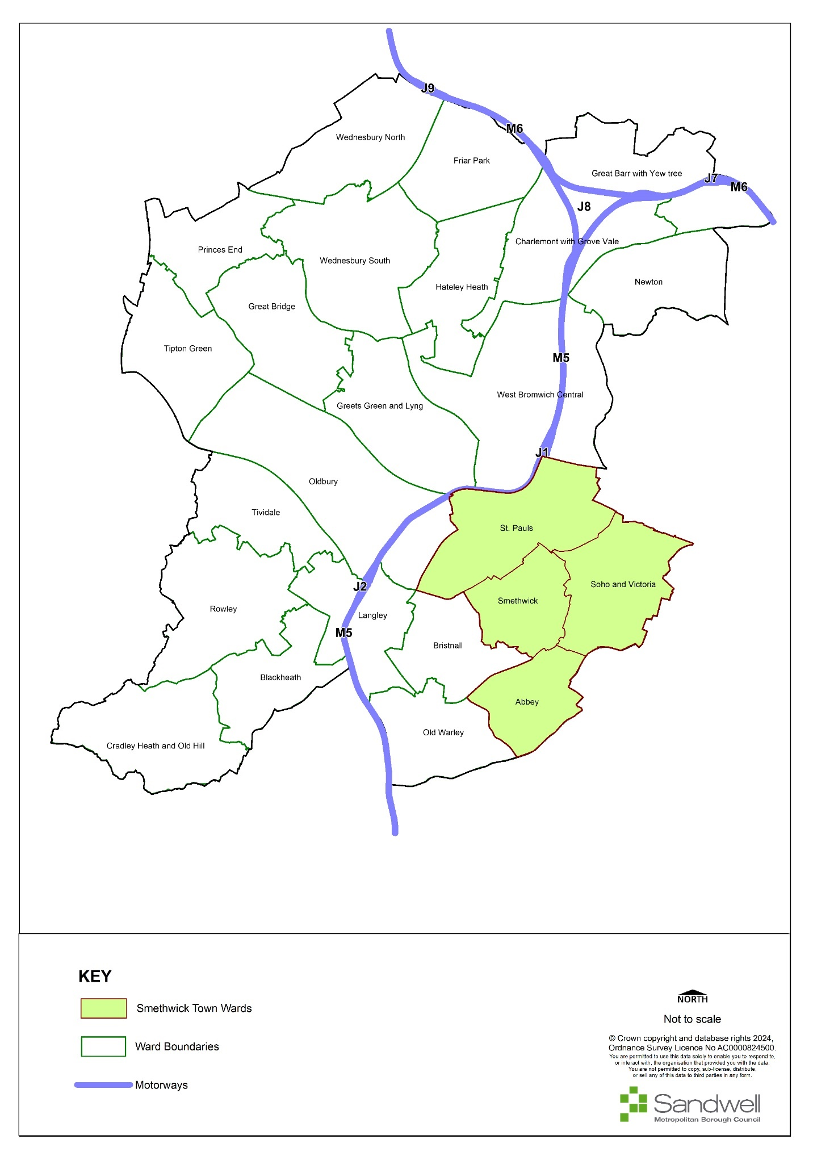

Background
- The town of Bearwood lies within Abbey Ward.
- The population of Abbey Ward, according to the 2021 Census was 12,186, a rise of 3.7% since 2011. Abbey ward has the third smallest population in the borough. Abbey ward has a smaller proportion of under-16s than average (20.2% compared with 25.1% for the town) but a larger proportion of those aged 25 - 49 (39.3% compared with 37%).
- Abbey Ward has a high proportion of residents in full time employment (39.3%); this is the highest of all Sandwell wards.
Boundary Changes
- Boundary changes are suggested for the northern end of Bearwood Road, with the proposed new boundary ending at the junction of Linden Road and Bearwood Road.
- Several reasons inform this decision. Past this point, the retail units on the eastern side of Bearwood Road are set back from the street and cause a break in the high street line that is not reformed. Additionally, the dominance of residential properties on the western side and lack of continuous commercial units in general separate this area distinctly from the rest of the Town Centre.
- It has been suggested that the southern section of the centre should also exclude the units on Hagley Road.
- Further suggestions are for the inclusion of the shops at the junction of Abbey Road and Wigorn Road within the centre boundary. The issue here would be the significant increase in the extent of the town centre boundary. It would also include many non-retail, residential uses at ground floor level. It is therefore proposed that the shops at Abbey Road / Wigorn Road should form a new Local Centre, due to the number of shops and facilities on offer.
Figure 6 - Bearwood Town Centre
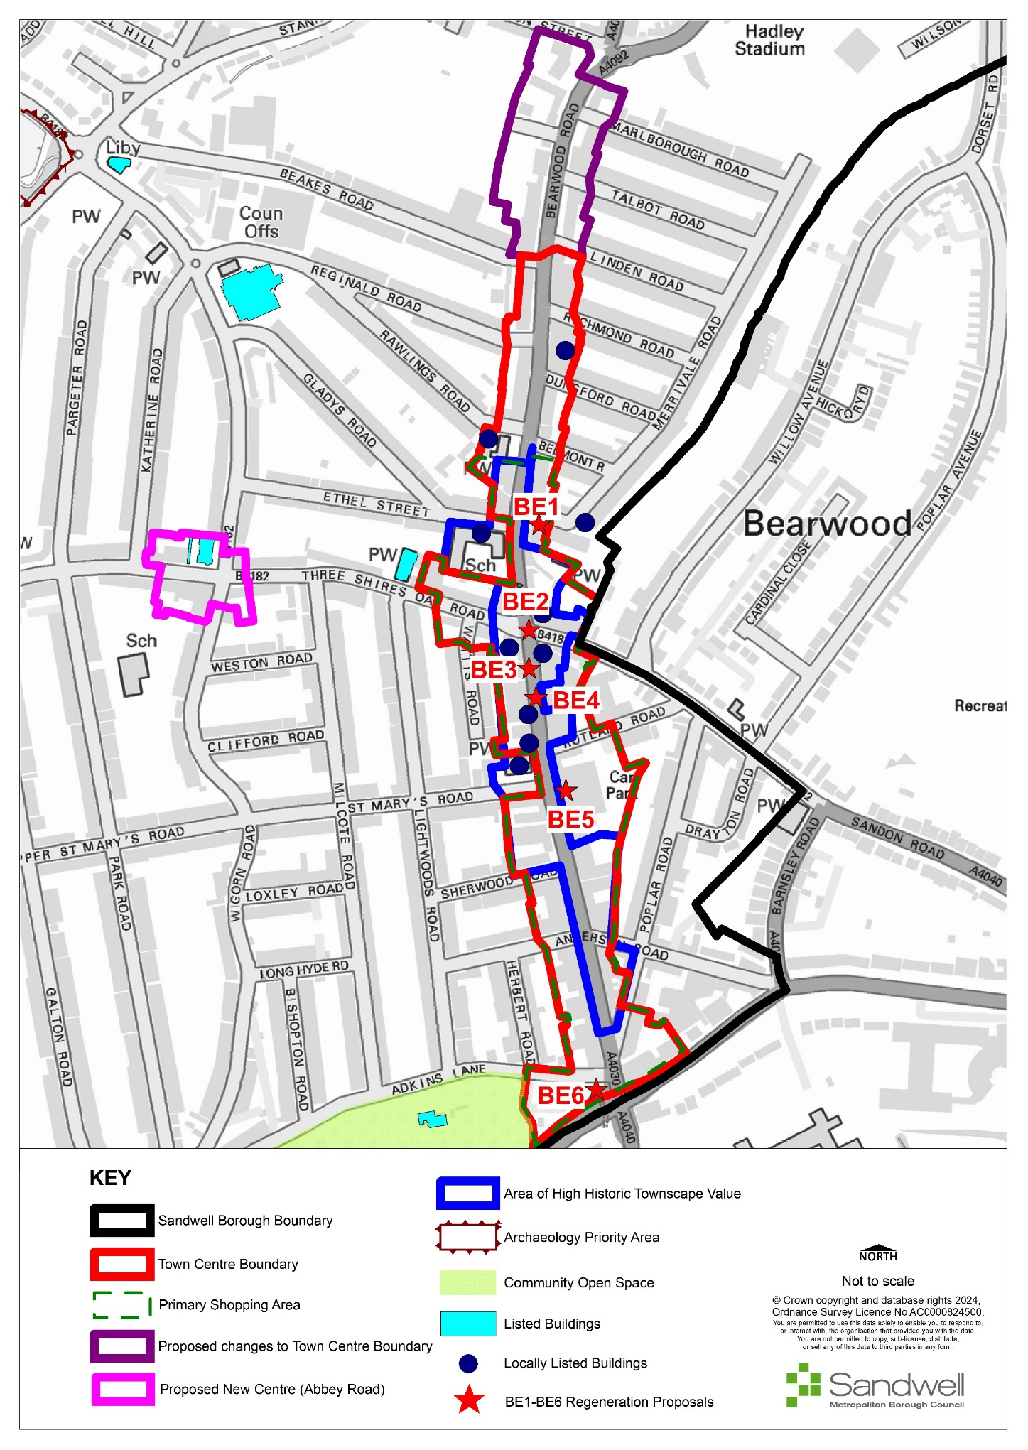

Retail and Town Centre Uses
- Bearwood Town Centre runs along Bearwood Road (c.700m), from Waterloo Road in the north to Hagley Road in the south in a traditional linear high street form. The centre also includes sections of several smaller roads off Bearwood Road, such as Three Shires Oak Road and Sandon Road.
- Bearwood contains a primary shopping area that begins south of Belmont Road and continues to the centre’s boundary with Hagley Road.
- Bearwood has shown a slight decline in function. It is over-represented in convenience style goods shopping and under-represented in comparison goods. Although Bearwood maintains a good level of national multiples, there has also been a reduction in the number of national multiples outlets since the Health Check study took place in 2020 in terms of service area.
- The service industry has increased in Bearwood since 2009 and as such has improved the evening economy, with the introduction of at least six new pubs, restaurants and cafes.
- According to 2019 data and recent trends, Bearwood has 253 total commercial units, which is 12 fewer than it had in 2009. The number of comparison goods units makes up 22% of the centre’s total commercial units, 14% below the UK national average. This under-representation is also reflected in the level of comparison goods floorspace available, which stands at 25.2% of the total commercial floorspace, compared to the national average of 32%. Since 2009, the number of comparison goods units has decreased by 21, with the floorspace decreasing by 1,365m² (a 28% decrease in the number of units).
- Convenience goods fall slightly below the national average for number of units at 13% compared to 15%. This is in contrast to the floorspace figures, which show that convenience goods are overrepresented, making up 18% of the total commercial floorspace compared to the national average of 9%. The small number of convenience goods units and large amount of floorspace is predominantly made up of Aldi, followed by Iceland, the Market, and the Co-Operative, which collectively make up 52% of Bearwood’s convenience goods floorspace. Aldi alone consists of 1,390m²; it stands in a prominent central location and acts as an anchor for the area. There has been a minimal change to the number of units and floorspace of convenience goods since 2009, with four additional units adding 141m².
- The levels of floorspace for retail services align closely to national averages; in terms of number of units Bearwood is 13% higher at 20% compared to 7%. This shows that there is a high volume of small floorplate retail service units, typical for this type of centre. Leisure services are comparable to national averages in both number of units and floorspace. Service industry representation has increased by eight units / 955m² since 2009.
- A vacancy rate of 10% (27 units vacant in 2019) is comparable to the national average of 9% and is 3% lower in terms of floorspace. Since 2009 the area of vacant commercial units has decreased from 3,995m² in 2009 to 3,370m² in 2019, which reflects the loss of two units.
- The large floorplate convenience stores are located towards the centre of Bearwood Road at the shopping centre, with vacant units appearing to be focussed on the southern end of Bearwood Road. Apart from this there is generally an even distribution of commercial uses around the Town Centre.
- Bearwood includes a reasonable number of national multiples. It also includes two leading supermarket chains and many other retail and service units. This provides the centre with a strong retail and service foundation that helps to support its role as a town centre and the high number of smaller local shops.
- It is noted however that several multiples have left the centre, including HSBC, NatWest, Barclays and Lloyds.
- Bearwood is currently under the limit for hot food takeaways (HFT) (Policy SDM6).
Facilities provision:
- The centre is supported by a range of community facilities including five churches, two schools and various dental and medical services.
Accessibility
- Due to the centre’s location along a linear A-road, it benefits from a high number of bus services, with numerous stops along the length of Bearwood Road and surrounding streets. These stops provide frequent services across the Black Country, including to Birmingham, Dudley, West Bromwich and Oldbury. A small bus interchange is also present on Adkins Lane at the end of Bearwood Road.
- Eight pedestrian crossing points are present across Bearwood Road, providing safe routes for pedestrians across the heavily congested road. The wide pavements feature bollards and barriers, which provide some separation between pedestrians and vehicular traffic; these are specifically focused on junctions and around the Bearwood Shopping Centre.
- There is a high volume of traffic along Bearwood Road.
Accessibility – provision for cyclists
- The Active Travel Fund-funded route from Thimblemill Baths to Hadley Stadium via High Street and Beaks Road (20 mph) has just been completed. This will connect to SCWIP cycle route 5, Oldbury Town Centre to Bearwood via the Aquatic Centre. As of 2023, cycle route 5 does not have funding.
- Cycle parking provision on Bearwood High Street is limited, with a small number of cycle stands provided outside Aldi and Argos.
- Due to the linear nature of the High Street and pavement widths, it would be difficult to provide additional parking stands on the main road frontages.
Environmental Quality
- The character and period style of Bearwood’s buildings vary considerably and range from the late 19th Century to the present day. This creates a contrasting environment that works well in many places, such as with the blending of terracotta buildings around Bearwood Shopping Centre. However, it is less successful in other areas, such as the sudden change in building height and style with the unit formerly occupied by The Co-operative (510 - 513 Bearwood Road) and its surroundings.
- Despite it including several attractive buildings and terraces, Bearwood contains various shop frontages in poor condition, which may adversely affect its attractiveness to potential new occupiers or for new development / investments. This includes units for both local retailing and some national multiple outlets. Dated and excessive numbers of advertisements also detract from the character and quality of the area.
- There is a clear lack of street furniture and investment in the public realm, such as benches, planting and other landscaping schemes. Though the linear nature of the centre does limit the amount of space for such investment, there are areas that would benefit.
- Heavy vehicular traffic has a clear and obvious negative impact on the environmental quality of the area. Though this is unavoidable given the key network function of the route, investment could be used to make the pedestrian environments as safe and appealing as possible. Areas of additional planting could increase the environmental quality of the centre and break up the adverse visual impact of large areas of hardstanding.
- Although there are no opportunities within Bearwood town centre itself for biodiversity net gain sites, there is a possibility within nearby and adjacent parks at Warley Woods and Lightwoods Park.
Historic Environment Allocations
- There is no conservation area in the centre, though both the Bearwood War Memorial outside St Mary’s Church, and St Gregory’s Church itself are Grade II listed. Additionally, there are several attractive historic buildings in the area, including the Bear Tavern with its clock tower.
SWOT
- The Centres Study Health checks noted the following characteristics for Bearwood:
Strengths  - Very accessible by bus;  - Strong convenience anchor with Aldi;  - Several attractive buildings;  - Strong commuting links to Birmingham City Centre. | Weaknesses  - Some poor-quality frontages;  - Lack of street furniture and investment in public realm;  - Lack of landscaping and public open space in centre.
Opportunities  - Undertake a parking assessment to determine if the level of parking for Bearwood is sufficient;  - Encourage refurbishment of poor shop frontages;  - Street furniture, public realm improvements and urban greening should be sought where possible, to improve the character and appearance of the centre. | Threats  - Continued decrease of comparison goods;  - Over-saturation of small-scale retail services.
Aspirations:
- The repurposing of listed buildings could improve the perception of Bearwood, and it can also make use of attractive architecture to encourage improvement in the vicinity.
- Opportunities for funding to spruce up shop front improvement / townscape quality and upgrade general frontages within Bearwood could be sought as they are currently quite poor. Dated and excessive advertisements also detract from the character and quality of the area. This should also be addressed through Policy SDM5.
- There is a clear lack of street furniture and general investment in the public realm, such as benches, planting or other landscaping schemes. Though the linear nature of the centre does limit the amount of space for such investment, there are areas that would benefit.
- Consideration should be given to improvements designed to mitigate issues related to road traffic, such as poor pedestrian accessibility and high levels of air pollution, which is a dominant feature of the centre.
- Due to lack of opportunity for public spaces within Bearwood, links to Lightwoods Park should be made more obvious.
- At the southern end of the town centre, at the junction of Adkins Lane, Bearwood Road, and Hagley Road, there is an area of public space / realm that was redeveloped at some point in the last five years prior to 2023. The redeveloped area features paving and a clock; however, it is let down by having a small number of benches that are awkwardly located. Furthermore, the adjacent roads are heavily congested, noisy and subject to higher levels of pollution through vehicle fumes and emissions. This is an example of an area that could be improved to encourage use of the space. The introduction of green space, a pocket parklet and / or landscaping would be beneficial.
- The following changes would be welcomed, to help make the centre more user-friendly:
- An increase in comparison shops would help to offer a wider range of goods and services.
- If the centre was reduced in size, an effective focal point could be created, with an attempt to try and consolidate core uses of the centre into a smaller area.
Proposals
- The following locations offer opportunities for future improvements and additions to the public realm and character of the area.
Ref | Location | Indicative Land Use
BE1 | Land at Bearwood Road opposite Ethel Street (between Merrivale Road and Bearwood Chapel) | The pedestrian area here is wider than elsewhere along Bearwood Road and there is an element of greenery and planting as well as two benches. Opportunities exist here to create a focal point and to make this area greener by connecting all the planted areas to form one garden area. This will include the removal of the advertisement sign as this adds to the street clutter.
BE2 | The junction of Bearwood Road (A4040) and Three Shires Oak Road (B4182) | At present, pedestrians must cross at the junction twice in some instances to get to their destination. A diagonal crossing at this junction could aid in permeability of the centre.
BE3 | Pavements along Bearwood Road | At various points along Bearwood Road there is vegetation growing from the base of the buildings. Opportunities will be explored to remove such vegetation which will aid in improving the appearance of the centre.
BE4 | Throughout the Town Centre core | Opportunities will be explored to introduce more cycle parking stands where space allows.
BE5 | Area outside of Aldi | As the pedestrian area is wider in this location, there is opportunity to add benches.
BE6 | Adkins Road / Hagley Road – outside Dixons Estate Agents | The large area of paving here is stark and unattractive. Opportunities exist to make the area greener and more inviting through planting and adding benches.
 | Changes to town centre boundary | See Figure 5 and paragraphs 9.84 to 9.87.

Blackheath
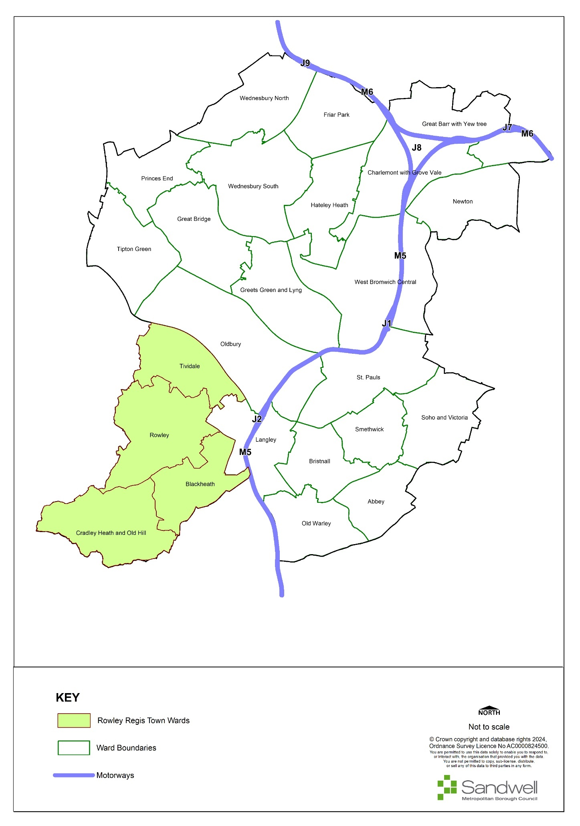
- Blackheath is a town centre in the Rowley Town area of Sandwell, which comprises Tividale, Blackheath, Rowley and Cradley Heath and Old Hill wards. It is the principal town centre in Rowley Regis. Blackheath has seen a fall in population of about 2% in the latest census data over a 10-year period, compared to an increase across Sandwell of 11% over the same period.
- 22.5 % of Blackheath’s residents are from ethnic minority backgrounds, compared to 48% of residents across Sandwell as a whole.
- Latest census data shows a proportionally older age profile than Sandwell, but a younger age profile than England. Blackheath ward has the highest proportion of residents who are retired (22.5%).
- Rowley town has the second highest proportion of residents who are economically active (59.7%) and the proportion of those who are unemployed is lower than the average for Sandwell as a whole.

Figure 7 - Blackheath Town Centre
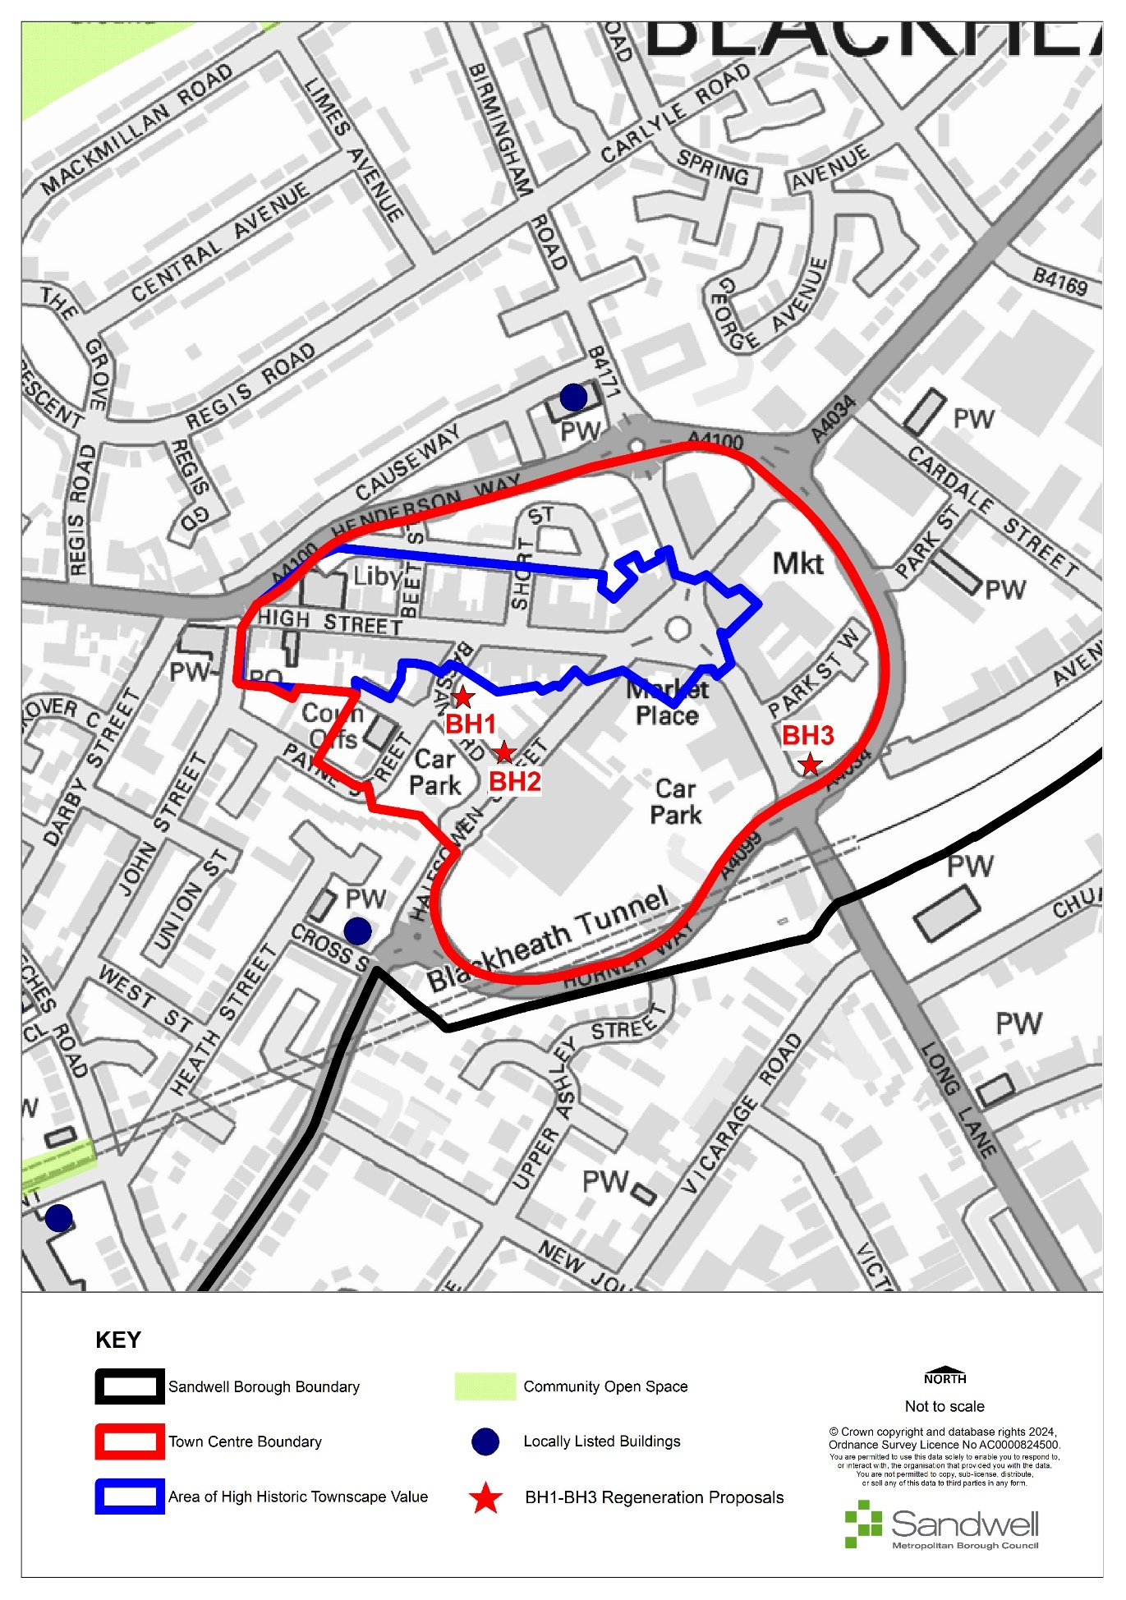

Retail and Town Centre Uses
- Blackheath Town Centre is focussed on the Market Place, where five routes to surrounding towns converge, and has a High Street extending westwards from Market Place. A by-pass was constructed in stages around the town centre during the 1980s /1990s, but due to an absence of parallel traffic restraint measures in the town centre, the central streets and Market Place remain congested with through traffic.
- The town offers a good mix of retail and non-retail uses. It is anchored by a medium-sized Sainsburys food store, which opened in 1997, and a more recent Lidl store just beyond the eastern edge of the town centre, at Oldbury Road / Archer Way. The centre has a range of retail shops, covering national brands (Poundland, Iceland) and local independent traders. It has a thriving indoor market off Market Place, with over 60 market stalls, which trades three days a week and is fully let. The centre is noticeably busier on market days (Monday, Friday, Saturday) than at other times and the market has a wide draw. There are a range of non-retail uses and a reasonable evening economy, with cafes, restaurants, traditional pubs and a microbar all represented. Towards the western end of High Street there is a modern purpose-built library, which functions as a busy and popular community hub and warm space in the town.
- The Centres Study and its addenda show the town is stable, with no great increase in vacancies or extra floorspace from previous studies. Blackheath appears to have weathered the pandemic and benefited from increased local demand as travelling was discouraged. The town has relatively few vacancies and a good mix of uses. It is a vital and viable town centre.
- The quality of the public realm, and that of shopfronts varies through the town. Retail is forecast to decline in relative terms, meaning there is likely to be an increased role for social and community functions in Blackheath, building on its improved access. The Centres Study noted a lack of appropriate street furniture such as benches and planting in the town, which would assist public and personal interactions if provided.
- Britannia Park, although around 500 metres outside the town centre, is Blackheath’s main public park. It is benefiting from Towns Fund investment. This includes the provision of new changing rooms, play facilities, skate park, parking and access improvements, with improved links to the town centre for cyclists and pedestrians provided through the complementary Rowley Connected project – a walking, cycling and wayfinding Towns Fund project.
- The Centres Study shows that Blackheath, like other towns in Sandwell, demonstrates no capacity for additional comparison retail - and limited capacity for convenience retail - as far ahead as can be forecast. To protect the centre’s vitality and viability, new out-of-centre and edge-of-centre town centre uses should be robustly tested via impact and sequential tests, with any new retail proposals being focused on the redevelopment and reconfiguration /extension of existing capacity within the centre.

Historic Environment
- Blackheath has no listed buildings, Conservation Areas or Areas of Potential Archaeological Importance.
Primary Shopping Area
- No Primary Shopping Area (PSA) has been identified; the current Town Centre boundary acts as an appropriate PSA.
Hot Food Takeaways
- Blackheath has nine takeaways according to the 2022 centres survey; this is close to but still under the 7% limit under the HFT threshold.
Accessibility
- Blackheath is sustainably located, with many existing bus services available and a railway station outside the centre. It is an important hub for local bus services to a variety of destinations, with over 35 departures on ten different routes in a typical weekday off-peak hour. Rowley Regis railway station has frequent direct trains to Birmingham city centre, Stourbridge, Kidderminster and Worcester. It is located around 500 metres east of the town centre and the route between it and the town centre, was improved in 2021 using funding from the Government’s Towns Fund initiative. Bus services will benefit from the Towns Fund-supported new bus interchange at Market Place, along with an improved public realm and pedestrian space at the heart of the town centre, again in Market Place. These works, which are currently undergoing design refinements, are scheduled to be implemented by 2025.
- Rowley Regis Connected (also a Towns Fund project) will improve access for pedestrians and cyclists to bus and rail and employment nodes in Blackheath and wider Rowley Regis.
SWOT
- The Centres Study Health checks noted the following characteristics for Blackheath:
Strengths  - Good bus service links;  - Good range of uses, good national multiple representation. | Weaknesses  - Tired frontages of some commercial units;  - Lack of continuity in paving and landscaping.
Opportunities  - Improve store frontages;  - Consider improving street furniture such as benches and planting schemes. | Threats  - Further decline in environmental quality could deter visitors.

Proposals
- Development opportunities are limited in the centre. However, a few small sites have been identified as potential development locations and are identified in the table below, together with other possible improvements to local amenity and character.
Site | Location | Proposal
BH1 | Bassano Road | There is a long-established taxi operation in the centre at Bassano Road. Although this is an acceptable use, it comprises a portacabin within a large plot and does not make the best use of a central site. This could be better developed for residential use in this sustainable location and thus bolster the existing retail and commercial functions of the centre. This will depend on relocating the existing business, perhaps to a vacant unit within the centre, that is adjacent to a car park.
BH2 | Bassano Road / Halesowen Street | This site is currently grassed with an area of dilapidated seating. The Centres Study identified a lack of outside seating in Blackheath. To aid in non-transactional interactions opportunities will be sought to expand replace and expand the seating.
BH3 | Archer Way / Long Lane | This site was allocated in the previous plan. It would be suitable for a limited amount of a centre type use, with residential above. It could also function as a pocket park, as lack of seating in the town was noted by The Centres Study. These would complement seating proposed within Market Place as part of the bus interchange scheme
- BH2 and BH3 are small sites left after road improvements.

Cape Hill
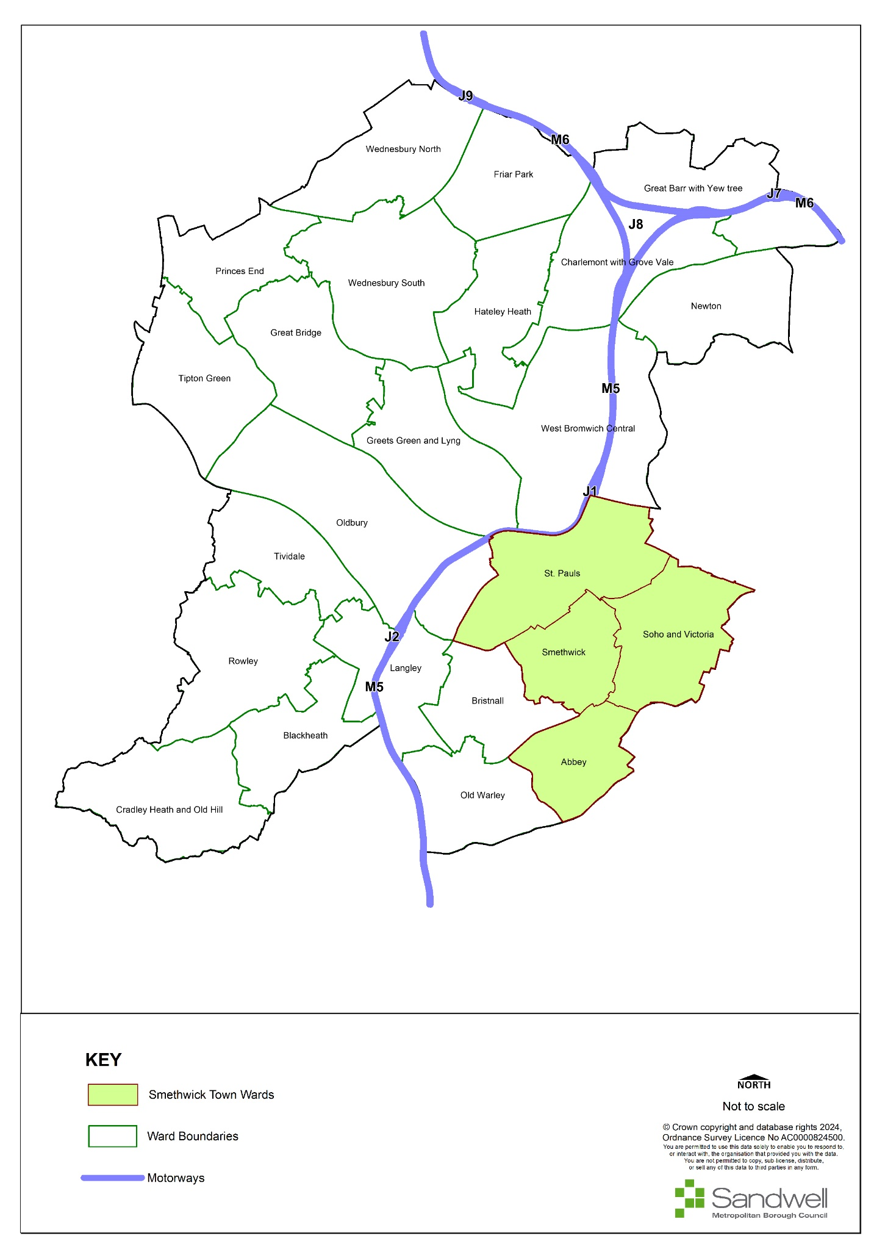
- The town of Cape Hill lies within the ward of Soho and Victoria.
- The population of Soho and Victoria Ward is 19,629 according to the 2021 census. This is an increase of 30.5% since the 2011 Census, which is the largest growth in population in Sandwell. Soho and Victoria is now the most populous ward in Sandwell.
- Soho and Victoria ward has seen a particularly large population increase in younger age groups, with a 10% increase in the proportion aged under 20, and a 20% increase in the number of people aged between 20 - 64 (the largest increase of all of Sandwell wards for both age groups). There has also been a slight rise in those aged 65 and over.
- In Soho and Victoria Ward, 90.2% of residents are from groups other than White British; it has the highest proportion of people from the Pakistani, Chinese and Asian Other, Black African and Black Other groups in Sandwell.
- Regarding employment levels, 48.5% of residents are economically active and in employment; this is lower than the England average. Soho and Victoria Ward has the highest rate of unemployment of all Sandwell wards (6.2% of those aged 16+).

Figure 8 - Cape Hill Town Centre
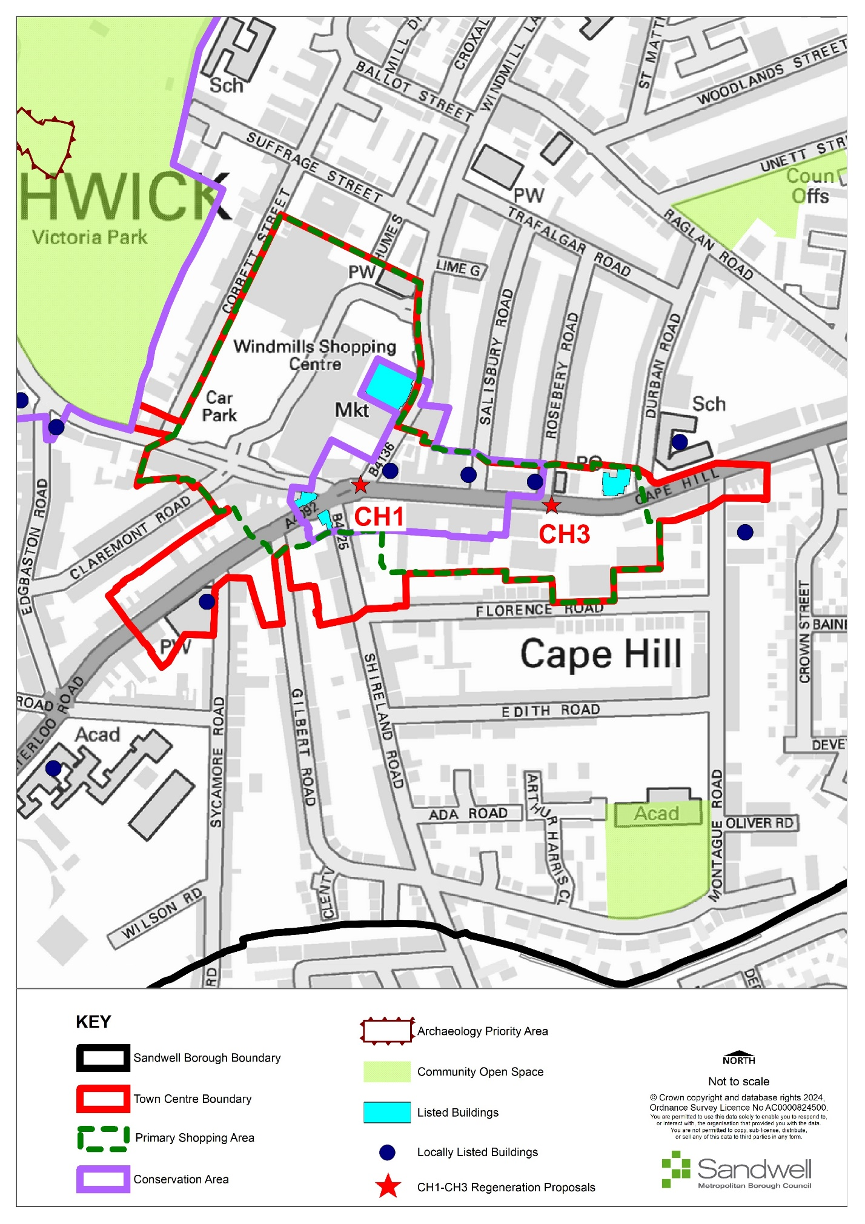

Retail and Town Centre Uses
- Cape Hill is one of the main town centres within Smethwick. The Town Centre primarily consists of the Windmill Shopping Centre, Cape Hill Road, and sections of surrounding roads: Waterloo Road, High Street, Shireland Road, and Windmill Lane.
- Cape Hill contains a primary shopping area, which includes most of the centre. The spurs of retail activity off Waterloo Road, Shireland Road and the east side of Cape Hill from its junction at Durban Road are not included within the primary shopping area as they lie further away from the main retail hub of the centre and have a lower footfall.
- The Windmill Shopping Centre creates a greater draw while the rest of the centre acts more as a local centre serving a more immediate local need.
- From the 2019 Black Country Centres Study, Cape Hill demonstrated a small increase in the number of occupied commercial units within the centre. The centre tends to be busy with vehicular traffic but is not particularly busy with pedestrians, though there is a consistent amount of people throughout most of the area. The busiest area is the entrance to the Windmill Shopping Centre from Cape Hill, with many pedestrians moving between the shopping centre and eastwards down Cape Hill Road. The study also concluded that Shireland Road and Waterloo Road were equally busy.
- Cape Hill had a total of 207 commercial units with a total floorspace of 38,455m² as of 2019 compared to 198 units and 36,585m² in 2009, suggesting a degree of overall growth in the centre in the last ten years.
- Comparison goods units make up 28% of the centre’s uses by number of units, 7% below the UK national average of 36%. When comparing floorspace, comparison goods make up 32% of the centre’s total, exactly aligning with the national average. For a town centre this is a healthy position, although this sector has declined by 11 units and 2,056m² floorspace since. The presence of the Windmill Shopping Centre directly within the Town Centre has a positive impact on the floorspace of comparison goods when compared to nearby Town Centres.
- Convenience goods account for 20% of Cape Hill’s commercial units, which is 5% above the national average; the floorspace of these units makes up 37% of the centre’s total, which is 28% above average. This over-representation of convenience goods floorspace can be mostly attributed to the large (6,320m²) Asda store, which represents 44% of all convenience floorspace in the centre. The second and third largest convenience stores include Windmills Market (1,510m²) and PAK Supermarkets (1,290m²). Convenience goods have increased in both number of units and floorspace (13 units and 2,908m²) since 2009. This shows that convenience retail plays a major role in the centre.
- The floorspace levels of retail services, at 9%, are below the national average of 14%; however, the number of units providing retail services is higher than average at 23% compared to the national average of 7%. This shows that there is a high volume of small floorplate retail service units, which is typical for this type of centre.
- Leisure services are under-represented in terms of both number of units and floorspace, falling 10% and 14% below the national average of 24% and 25% respectively. What leisure services there are, are heavily focused towards takeaways, which make up 65% of the sector. Financial and business services align to the national average for number of units at 7%, but fall 6% below average for floorspace at 10%, again highlighting the prevalence of small units. Collectively the service industry has increased by 21 units and 346m² since 2009, which is a positive sign.
- Cape Hill has a below-average level of vacancies in terms of both number of units (13 vacant) and floorspace (2,986m²), which stand at 6% and 8% respectively, both 3% below the national average. This compares well to other centres in the borough, which are experiencing above average vacancy rates. It has also improved considerably since 2009, when the vacancy rate was 14%.
- Spatially, Cape Hill contains several high-density parades of small units along its main roads, with significantly larger units at the Windmill Shopping Centre and medium-sized units at the Cape Hill Retail Centre at the eastern end of Cape Hill. There is little pattern in the distribution of uses, though there is a higher proportion of comparison goods units towards the western end of Cape Hill Road. Several national multiples are also present, most of which are located within the Windmill Centre, with the remainder situated along Cape Hill Road and the retail centre.
- Cape Hill has exceeded the threshold for HFTs (Policy SDM6).
Facilities provision
- There are several community facilities, including several religious institutions, two primary schools and a health centre. Cape Hill also benefits from its proximity to a large green space at Victoria Park.
Accessibility
- Due to the presence of multiple busy roads, the centre is well-connected for vehicles and is served by at least six different bus services to various destinations including Birmingham, Smethwick, and West Bromwich. These include the 80, 82, 897, 89, 54, and 54A.
- There are a high proportion of pedestrian crossings at The Windmill Centre and the main junction on Cape Hill Road; this contrasts with the rest of the centre in which there is a clear lack of such crossings.
- A lack of crossing points negatively impacts pedestrian flows and makes it difficult to cross busy roads without heading towards The Windmill Centre.
Accessibility – Provision for cyclists
- Cape Hill forms part of the A457 corridor from Oldbury to Cape Hill, which includes SCWIP cycle route (CR) 11.
- Smethwick Connected is a connectivity project promoting walking and cycling improvements between Smethwick High Street and the Midland Metropolitan University Hospital. This includes walking improvements within the Windmill Eye estate, although it does not affect the High Street to any great extent. Towns Fund money is being used to deliver new cycle and pedestrian facilities along the A457 in incremental phases from Smethwick Galton Bridge Station to Cape Hill. The scheme is being delivered in different phases as follows:
- Phase 1: A two-way segregated cycle way on the south side of the A457 from Galton Station to Rolfe Street junction.
- Phase 2: A two-way segregated cycle way from Rolfe Street to Cross Street on both sides of A457. The carriageway was realigned to allow the construction of a new footway and cycleway from High Street junction to Lynton Avenue, with a link for both onto Lynton Avenue. A new traffic signal crossing was installed on the A457 adjacent to Cross Street junction. This Phase was completed in June 2023.
- Phase 3: Lynton Avenue to Metropolitan Hospital Walking Route; new and upgraded pedestrian facilities such as dropped crossing and tactile paving.
- Phase 4: A two-way segregated cycleway along the A457 from Lynton Avenue to Soho Street junction. This Phase will connect onto the end of Phase 2. This Phase is due to start in Autumn 2023, with completion expected by Spring 2024.
- Phase 5: in development as of 2023 and will be delivered by the Canal and River Trust. It includes the construction of a towpath from the canal to the path at the side of Heath Trading Park. This will then be connected to the cycle routes on Winson Street; completion is expected by November 2023
- SCWIP CR11 already partially exists but it requires updating to the standards identified in the Local Transport Note 1/20 (LNT1/20). There is a £19 million budget available from the City Region Sustainable Transport Settlements (CRYSTS) funding to improve access to the hospital, which will be split between Sandwell and Birmingham and will be used to create a cycle route from the A457 to the National Cycle Network via route 5 along the Birmingham canals (NCN5), borough boundary links with Birmingham and SCWIP 11 upgrades.
- There are several cycle stands provided within the Windmill Shopping centre, but these are spaced too closely together, which renders half of them effectively unusable. The current Sandwell Cycling supplementary planning guidance suggests that cycle stands should be spaced one metre apart. Every other cycle stand in the row should therefore be removed and relocated elsewhere within the vicinity.
- There is a lack of provision elsewhere in the centre due to the narrow widths of the pavements.
Accessibility - Transport Proposals:
- Although there are no new transport proposes for Cape Hill itself, it will be impacted by the Smethwick Connected Project, which includes walking improvements within the Windmill Eye estate.
Environmental Quality
- Beyond the Windmill Centre, the environmental quality of the area is generally poor, with most of the shop frontages being in need of significant maintenance and modernisation. Despite having a proportionately lower-than-average number of vacant units, suggesting it is relatively successful, the low quality of the occupied properties does not support a positive perception of the centre.
- The centre is dominated by rows of two to three storey terraced properties of varying styles and appearances, though generally constructed of red brick. The type and quality of paving varies across the centre; Shireland Road and Waterloo Road feature mostly red and grey bricked paving, whilst Cape Hill Road comprises a mixture of concrete and dark brick. The centre would benefit from a consistent paving scheme of higher quality.
- Though constrained by pavement sizes and main roads, there is a lack of any significant street furniture or decorative finishes such as a planting scheme, which would help to raise the visual amenity of the area.
Historic Environment Allocations
- There is a conservation area within Cape Hill town centre, designated in August 2012. The conservation area comprises the heart of Cape Hill and is focused on the junction of Cape Hill with Waterloo Road and Shireland Road; it runs east along Cape Hill to the junction with Rosebery Road
- There are four listed buildings within the centre, including the Grade II* Waterloo Hotel. Unfortunately, these listed buildings are not being utilised to their potential and their architectural quality is let down by their vacancy (they are all vacant as of July 2023), their poor physical quality and the generally poor appearance of neighbouring units, which adversely affects their setting.
SWOT
- The Centres Study Health checks noted the following characteristics for Cape Hill:
Strengths  - Very accessible by bus;  - Strong comparison goods offer compared to nearby centres;  - Windmill Centre provides a very strong anchor;  - Low level of vacancies. | Weaknesses  - Mostly poor-quality frontages;  - Lack of street furniture and investment in public realm.
Opportunities  - Develop / repurpose listed buildings to capitalise on their attractive architecture;  - Encourage refurbishment of poor shop frontages;  - Invest in street furniture and public realm. | Threats  - Loss of the pub or any of the restaurants, further decreasing evening generating activity;  - Poor environmental quality begins to impact occupancy of units.

Aspirations
- The health checks identified that there is limited evening activity due to the lack of relevant facilities around Cape Hill, including those meeting the strict definition of leisure as well as restaurants or cafes. There is just one pub and 11 restaurants, although a number of these also act as hot food takeaways.
- There may be opportunities to provide improved public and active transport links from Cape Hill and other surrounding centres to the new Aquatics Centre in Smethwick.
- Opportunities for funding to improve shop fronts and townscape quality should be investigated. Generally, frontages within Cape Hill are in a poor condition, which may adversely affect its attractiveness to potential new occupiers or for new development / investment.
- There is council housing under construction (2023) to the rear of the High Street on Church Hill Street.
- An increase in the number of banks and / or the introduction of a post office would ensure that certain groups of the community are not excluded, and people can continue to have a physical facility to deal with financial cash transactions.
Proposals
- The following locations offer opportunities for future improvements and additions to the public realm and character of the area.
Site | Location | Indicative Land Use
CH1 | The wider area outside the Windmill centre. | The environmental quality of the area is generally very poor, with most of the shop frontages in need of significant maintenance and modernisation. Opportunities will be sought to secure funding to improve the appearance of shop frontages and general environmental quality of the area.
CH2 | - Former Lloyds Bank (Sampson Lloyd), Cape Hill  - Waterloo Hotel, Shireland Road  - Mecca Bingo Club, Windmill Lane  - Cape House, Cape Hill / Durban Road | There are four listed buildings within the centre, including the Grade II* Waterloo Hotel building. Unfortunately, these listed buildings are not being utilised to their potential and their architectural quality is let down by their vacancy (all vacant - 2023). Opportunities will be sought to assist developers with the upkeep of the Listed Building when planning permission is sought.
CH3 | The wider area outside the Windmill centre. | The type and quality of paving varies across the centre; Shireland Road and Waterloo Road feature mostly red and grey bricked paving, whilst Cape Hill Road comprises a mixture of concrete and dark brick. The centre would benefit from a consistent paving scheme of higher quality.

Cradley Heath
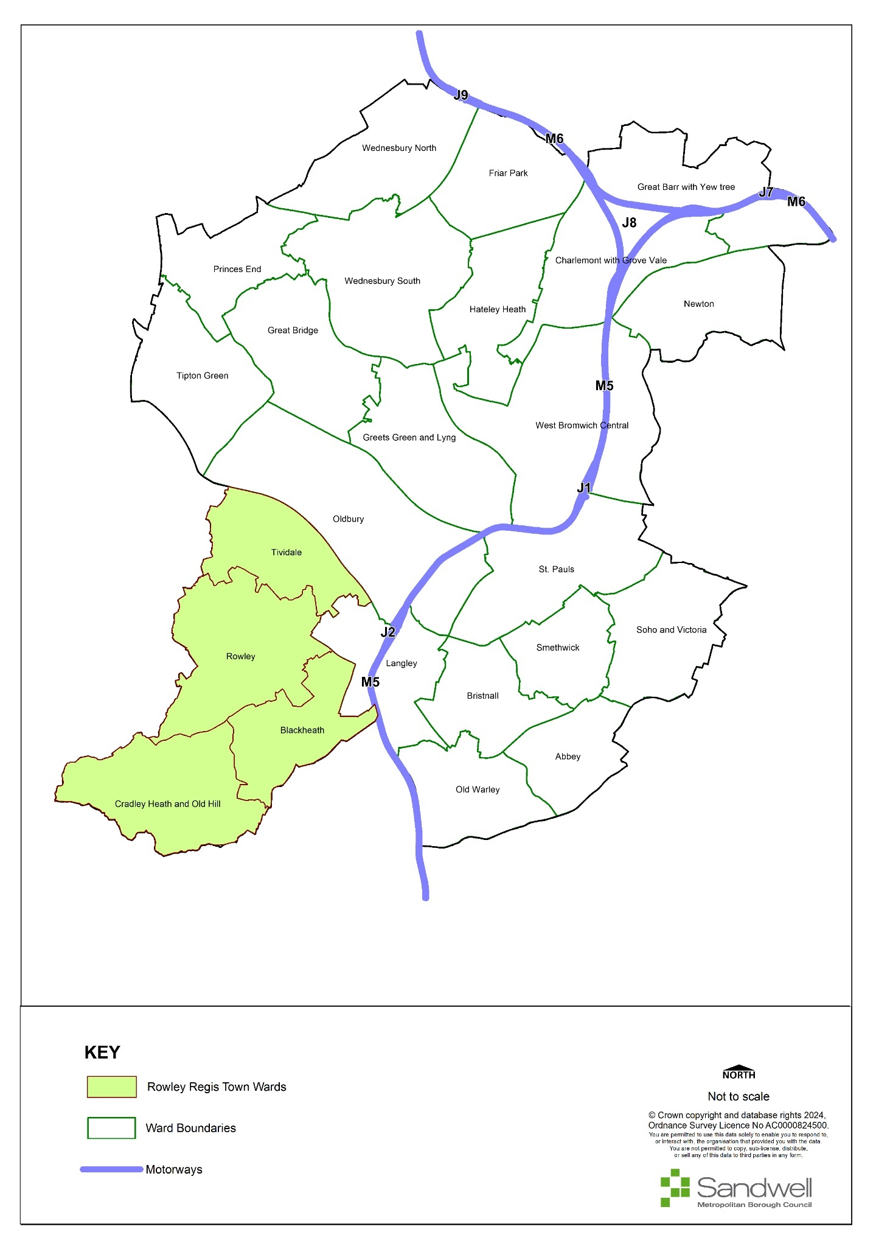
- Cradley Heath is a linear town in the Rowley Town area, one of Sandwell’s six historic centres, and lies in the southwest corner of the borough. Cradley Heath is in the Cradley Heath and Old Hill Ward.
- It is the largest ward in Rowley with 14,961 residents, which represents an increase of around 10.3% since the 2011 census. This echoes changes in Sandwell as a whole, which has experienced an 11% rise in population.
- Cradley Heath and Old Hill is the ninth most populous ward in Sandwell. It has a high prevalence of single person households (non-pensioners). At 20.7% this compares with a town average for Rowley of 16.9%.
- Cradley Heath’s population is 77.6% white British / white Other, 4.4% Mixed, 11% Asian or Asian British and 4.2% Black or Black British groups: Sandwell’s population overall is 57.3% white British / white other.
- 19.5% of the residents of Cradley Heath and Old Hill are retired. The proportion of residents who are long-term sick or disabled in Rowley is highest in Cradley Heath and Old Hill ward (6.1%).
- Cradley Heath and Old Hill has a lower level of owner-occupation than the borough average. It has the highest proportion of social and private renting and shared ownership in the town. The proportion of households renting from a private landlord or letting agency has increased from 12.5% in 2011 to 17.8% in 2021.
- 53.4% of the population of Cradley Heath and Old Hill ward are economically active and the proportion of those who are unemployed is lower than the average for Sandwell as a whole (4.2% compared to 4.5%).
Figure 9 - Cradley Heath Town Centre
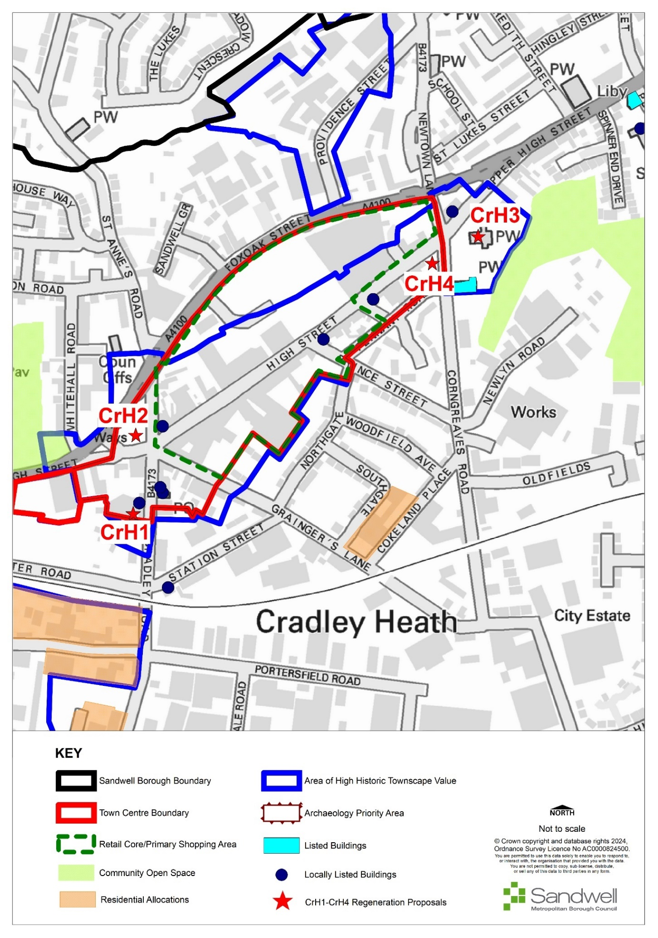

Retail and Town Centre Uses
- The centre has a large ‘Tesco Extra’ store, which acts as an ‘anchor’ and generates many pedestrian and vehicle trips to the town. However, away from this immediate area, activity drops off significantly. The environment near to the superstore has good quality public realm with opportunities for visitors to sit and interact. Away from this immediate area the townscape is less welcoming, and parts of the town have poor-quality and aging shop fronts, with several shuttered and vacant units and little opportunity for public interaction.
- In other towns the arrival of a major food retailer has complemented and boosted trade in independent stores throughout the centre. In Cradley Heath, however, this does not seem to be the case. Here, the size of the Tesco store and the pre-existing fragility of the town’s traditional retail offer means that Tesco offers a one-stop retail destination that has drawn activity away from the rest of the town.
- Vacancies have been rising in the centre, particularly in the Market Square, indicating a period of decline. This centre, like many others, needs to move away from being principally concerned with retailing and towards fostering non-transactional interactions and providing more residential opportunities on unoccupied sites and upper floors. The vacant commercial premises and sites in the town, if redeveloped for residential use, will bolster the remaining retail and commercial functions.
- Cradley Heath, along with other towns in Sandwell and the Black Country, shows no capacity for additional comparison retail and limited convenience retail as far as can be forecast. To protect the centre’s remaining vitality and viability, out-of-centre and edge-of-centre town centre uses should be robustly tested through impact and sequential tests before permission is granted, with retail development focused on redevelopment and reconfiguration / extension of existing capacity in the centre.
SWOT
- The Centres Study identified the following characteristics for Cradley Heath:
Strengths  - Within walking distance from a transport interchange with rail and bus facilities.  - Significant levels of free parking at Tesco.  - Very strong anchor with Tesco Extra. | Weaknesses  - Declining uses by number of units and floorspace.  - Increasing vacancy floorspace.
Opportunities  - Promote refurbishment and modernisation of frontages.  - Improve street furniture and other aesthetic elements. | Threats  - Continued decrease of all uses.  - Complete decline of centre.

Aspirations
- An increase in street furniture and other decorative schemes such as planting would make the area both more attractive and more functional.
- The centre’s frontages need refurbishment and modernisation to improve their current tired and neglected appearance.
- Rowley Regis Towns Fund includes an improved scheme called “Rowley Connected”, aimed at promoting improvements to walking and cycling across Rowley. A committed element of this scheme involves a project to create safe cycle linkages along Cradley Heath High Street, continuing via Lower High Street and as far as Cradley Heath interchange. This work is scheduled for completion in 2024.
- As part of the “Rowley Connected” scheme, there are plans under consideration to upgrade and resurface an informal footpath connecting St Luke’s Church with the open space at Bearmore playing fields, and for this ultimately to be extended to provide a low-traffic route between Cradley Heath and Old Hill centres for walkers and cyclists.
- Rowley Regis Satellite Education Hub has funding from the Towns Fund and will provide education and training facilities for young people and adults. Although just outside the current Centre boundary, immediately beyond LIDL and opposite Mary Macarthur Gardens on Lower High Street, it will add to the vitality and viability of Cradley Heath by promoting economic growth, rectifying skills shortages and contributing to a suitably skilled workforce. It will also strengthen the formation of a nascent growth hub centred around Cradley Heath interchange.
Opportunities for improvement
- The Centres Study Health Check noted that frontages in the centre appear dated and tired-looking. Obtaining funding to upgrade frontages, the general streetscape and street scene improvements would all make the centre appear more welcoming, improve dwell times and reinforce the non-transactional interactions the centre needs to improve its vitality and viability and benefit from its excellent connectivity.
- The Centres Study suggested the southern town centre boundary be amended; that Lidl (Lower High Street) be added, the area of St Anne’s Road removed due to a lack of any commercial units; and that the boundary should end at the post office on Cradley Road again due to a lack of occupied commercial units.
Proposals
- The following table identifies locations that offer opportunities for future improvements and additions to the public realm and character of the area, as well as smaller-scale development opportunities.
Ref | Location | Indicative Land Use
CrH1 | A substantial development opportunity on the site of the former Majestic Cinema and its car park at Cradley Road.  These sites are a high priority for development for two reasons:  - they have lain vacant, derelict and overgrown for some time and have been the subject of numerous complaints, and contribute to an air of neglect and decline in this part of the centre;  - new development will link to recent and proposed residential growth zones southwest of the town centre between Chester Road and Woods Lane. These sites are in the process of delivering a total of around 250 homes and will transform a former industrial area into an aspirational residential neighbourhood in a sustainable location that will help to support the viability of the town centre. | This is suitable for residential development, with an indicative capacity of up to 50 dwellings, dependant on house type and design.  A mix of uses may be possible, with limited commercial opportunities on the ground floor due to the limited capacity in the centre, and residential above as is found in adjacent sites.
CrH2 | At the western entrance to the centre a used car lot and hand car wash operation occupy land at High Street / St Anne’s Road / Lower High Street. These currently have a low-quality visual appearance and do not contribute positively to the character and amenity of the centre. | An opportunity exists to redevelop this gateway site, possibly for residential use, or to improve and maintain the visual quality of the existing uses.  Funding opportunities will be sought to this end.
CrH3 | St Luke’s church closed in 2014 and was demolished due to rising repair costs. The site is a tranquil green location and contains mature trees in the northern part of the town. The Council will explore with the Church Commissioners how to sympathetically improve the site and maintain public access as an asset for the community. | Any proposals must respect the site’s sensitive former use, as well as the status of the adjoining graveyard. The aim is to create an informal quiet area of nature and contemplation for the northern end of Cradley Heath. This will form a counterpoint to Mary MacArthur Gardens in the south of Cradley Heath. External funding mechanisms will be explored.  As part of the approved Rowley Regis Towns Fund “Rowley Connected” scheme, there are plans under consideration to upgrade and resurface an informal footpath that connects St Luke’s Church with the open space at Bearmore playing fields. The intention is for this ultimately be extended to provide a low-traffic route between Cradley Heath and Old Hill centres for walkers and cyclists.
CrH4 | At the northern entrance to the town adjacent to No1 High Street, a site currently set out as grass with anti-vehicle trespass mounding. | Suitable for residential development of high-quality design and materials to reflect its gateway location. Alternatively, development as a ‘pocket park’ would augment the currently very limited other opportunities in the centre for non-transactional socialising / amenity use.  If the site is developed for commercial use, this aspect should be limited to reflect the lack of retail capacity in the centre. Encouragement will be given to using upper floors for residential use to bolster the centre and make best use of its sustainably located position.

Great Bridge
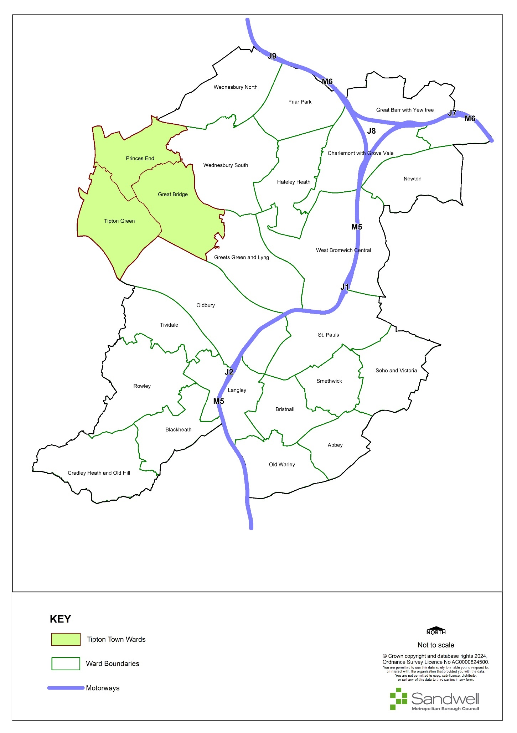
- Great Bridge is the main town centre in Tipton and makes up one of its three wards. The population of Tipton in 2021 was 44,125, providing 12.9% of Sandwell’s total population. Of this total, 19% of Tipton’s population are from ethnic minority backgrounds.
- The population profile of the town in terms of age structure is very similar to that of Sandwell overall. The main difference is a slightly larger proportion of residents aged under 16. Tipton also has the lowest number of people aged 65 and over of any area in Sandwell.
- Tipton’s Income Deprivation Affecting Children Index and Income Deprivation Affecting Older People Index Scores put it in the 20% most deprived areas in England for both indices.
- Healthy life expectancy was statistically and significantly lower than the average for England in all three wards in Tipton. Healthy life expectancy for both women and men was lower than the present state pension age (66) in all three wards and when compared to the average in England; this suggests that people may not necessarily be healthy enough to work until the state pension age.
Figure 10 - Great Bridge Town Centre
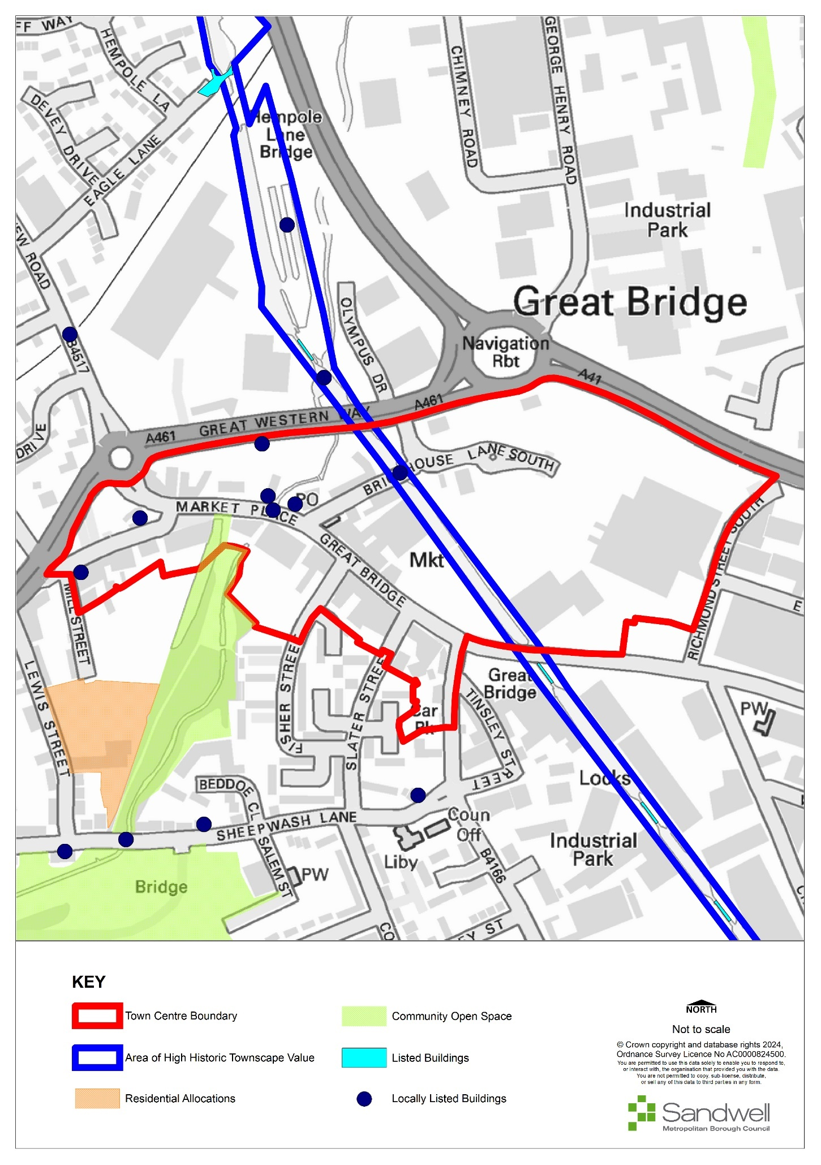

Retail and Town Centre Uses
- The centre is currently designated as a town centre in the Sandwell Local Plan. The current boundary of the centre accurately reflects the extent of the retail area and does not require consolidation.
- The town centre designation includes Great Bridge Retail Park. Whilst the retail park and the main centre operate independently, there appears to be little benefit in amending the Town Centre boundary to exclude the retail park. However, better integration between the two elements is required for the retail centre to form a robust part of the town centre.
- There is no Primary Shopping Area boundary currently defined, and it is not recommended that one is needed, as the role of the centre is primarily in retail use across all areas.
- Great Bridge currently has 86 commercial units with a total floorspace of 13,850m². 2009 data appears to include Great Bridge Retail Park as well, which is not included within the 2019 GOAD data. As such, a comparison of the number of units and their floorspace over the past ten years is not directly available. However, the 2009 study recorded 90 units; it is likely that this comprised 86 units in the traditional centre and four in the Retail Park, meaning that the traditional centre has remained the same size. Two drive-through restaurants have been added to the retail park in the interim (these were not mentioned in the 2009 report). In 2009 there were four vacant units and there are now five vacant units. Therefore, the centre has remained generally consistent in size and stability in terms of the level of vacancies over the last ten years.
- The various commercial uses in Great Bridge are evenly spaced through the centre with no clear patterns or grouping. The units themselves are typically small (<160m²) and are grouped in terraces, occasionally broken by larger stores, lanes, or empty areas. There are very few community facilities within or near to the centre, with only a library and medical centre in evidence. There are seven main national multiples (excluding the Retail Park), which are evenly distributed around the centre (these include a Lidl store and various bookmakers).
- Comparison goods retailers occupy 20% of the centre’s units, well below the UK national average of 36%. When comparing floorspace, comparison goods make up 32% of the centre’s total, which is the same as the national average. This level of comparison goods is above average when compared to nearby town centres, suggesting a stronger market presence. Convenience goods account for 15% of Great Bridge’s commercial units, which aligns with the national average; however, the floorspace of these units makes up 21% of the centre’s total, which is 12% above the national average. This over-representation of convenience goods can mostly be attributed to the relatively large 1,380m² Lidl store, which represents 48% of all convenience floorspace in the centre. Again, this high level of convenience floorspace is typical for such town centres, which tend to have one or several large floorplate supermarkets.
- The floorspace levels of retail services are below the national average, at 11% compared to 14%. However, in terms of number of units, levels of retail services are higher than average at 22% compared to 7% nationally. This shows that there is a high volume of small floorplate retail service units, a trend throughout most local town centres. 11 of these 18 units are hairdressers.
- Leisure services closely align with the national average, with the number of units making up 28% of the centre’s total (3% above average), and the floorspace totalling 21% of the centre’s total (3% below average). These levels are above average when Great Bridge is compared to other town centres and suggest a comparably healthier leisure market. However, it is worth noting that 50% of these leisure services are takeaways; this limits the evening economy-generating uses to the three restaurants in the centre.
- In accordance with Policy SDM6 - Hot Food Takeaways, the threshold for Great Bridge Town Centre is 7% and as of 2023 there are seven hot food takeaways in the centre, representing 7.69% of the total number of units. Therefore, Great Bridge is over the threshold for the number of hot food takeaways in the town centre.
Facilities Provision
- There are very few community facilities within or near to the centre, with only a library and medical centre in evidence.
Accessibility
- Although there are no new transport proposes for Great Bridge itself, the centre will benefit from the Wednesbury to Brierley Hill Metro line.
- The centre is dominated by road traffic, to the significant detriment of pedestrian movement. Pavements vary from being wide (i.e., outside Lidl) to narrow (around Market Place) and sometimes pedestrians must contend with cars parked on the pavement. The roads, in addition to being busy with traffic, are also relatively narrow and there is no cycle infrastructure, making the centre difficult to access for cyclists.
- Crossing the road is only possible at signalled pedestrian crossings, which are relatively far apart (there are four within the centre). They are generally well-located; one aligns with the footbridge to the retail park, and one with the market, although the crossing to Lidl is more difficult, being a staggered one.
- This level of inconsistency and lack of provision makes the centre particularly difficult to access for those with disabilities. The footbridge provides a direct, though unappealing, link to the retail park, though this is DDA accessible.
- Dudley Port Rail Station is 0.6 miles west of the town centre and the nearby Black Country Route provides access to both the M5 and M6 motorways.
Accessibility – Provision for cyclists
- There are several proposed SCWIP routes - CR 3, CR 14 and a West Midlands LCWIP route from Burnt Tree to West Bromwich via Great Bridge and Carters Green.
Environmental Quality
9.17 The environmental quality of the town centre is generally poor, with most of the shop frontages in need of significant maintenance and modernisation. Despite having a proportionately lower-than-average number of vacant units, suggesting it is relatively successful, the low quality of the occupied properties does not support a positive perception of the centre.
SWOT
- The Centres Study Health checks noted the following characteristics for Great Bridge:
Strengths  - Low vacancy rate.  - Anchored by Lidl and outdoor market.  - Healthy diversity of uses.  - Ample car parking. | Weaknesses  - Centre is dominated by heavy through traffic.  - Poor public realm.  - Poor physical environment.  - Poor quality pedestrian link to the retail park.  - Offer is limited to cheaper goods and services (e.g., only a discount supermarket, leisure).  - sector dominated by takeaways; markets focus on cheap goods.  - General lack of community facilities.
Opportunities  - The Outdoor Market site could be physically improved.  - The public realm and built form could be improved throughout.  - A better pedestrian environment and pedestrian prioritisation would be welcomed, alongside better cycle and DDA provision.  - Large cleared site at eastern edge of centre – has planning permission for 48 apartments. | Threats  - Great Bridge Retail Park draws trade away from the traditional centre and is reliant on private car use.
Aspirations
- The health checks identified that there is limited evening activity due to the lack of leisure facilities around Great Bridge, including the strict definition of leisure as well as restaurants.
- Opportunities for funding to improve shop fronts and townscape quality should be investigated. Generally, frontages within Great Bridge are in a poor condition, which may adversely affect its attractiveness to potential new occupiers or for new development / investment.
- Opportunities should be sought to improve public and active transport provision by enhancing pedestrian and cycle connections between the town centre and the new tram stop off New Road.
- Opportunities to improve the relationship to Walsall Canal should be considered, by opening the Canal to the town centre and providing new connections.

Oldbury
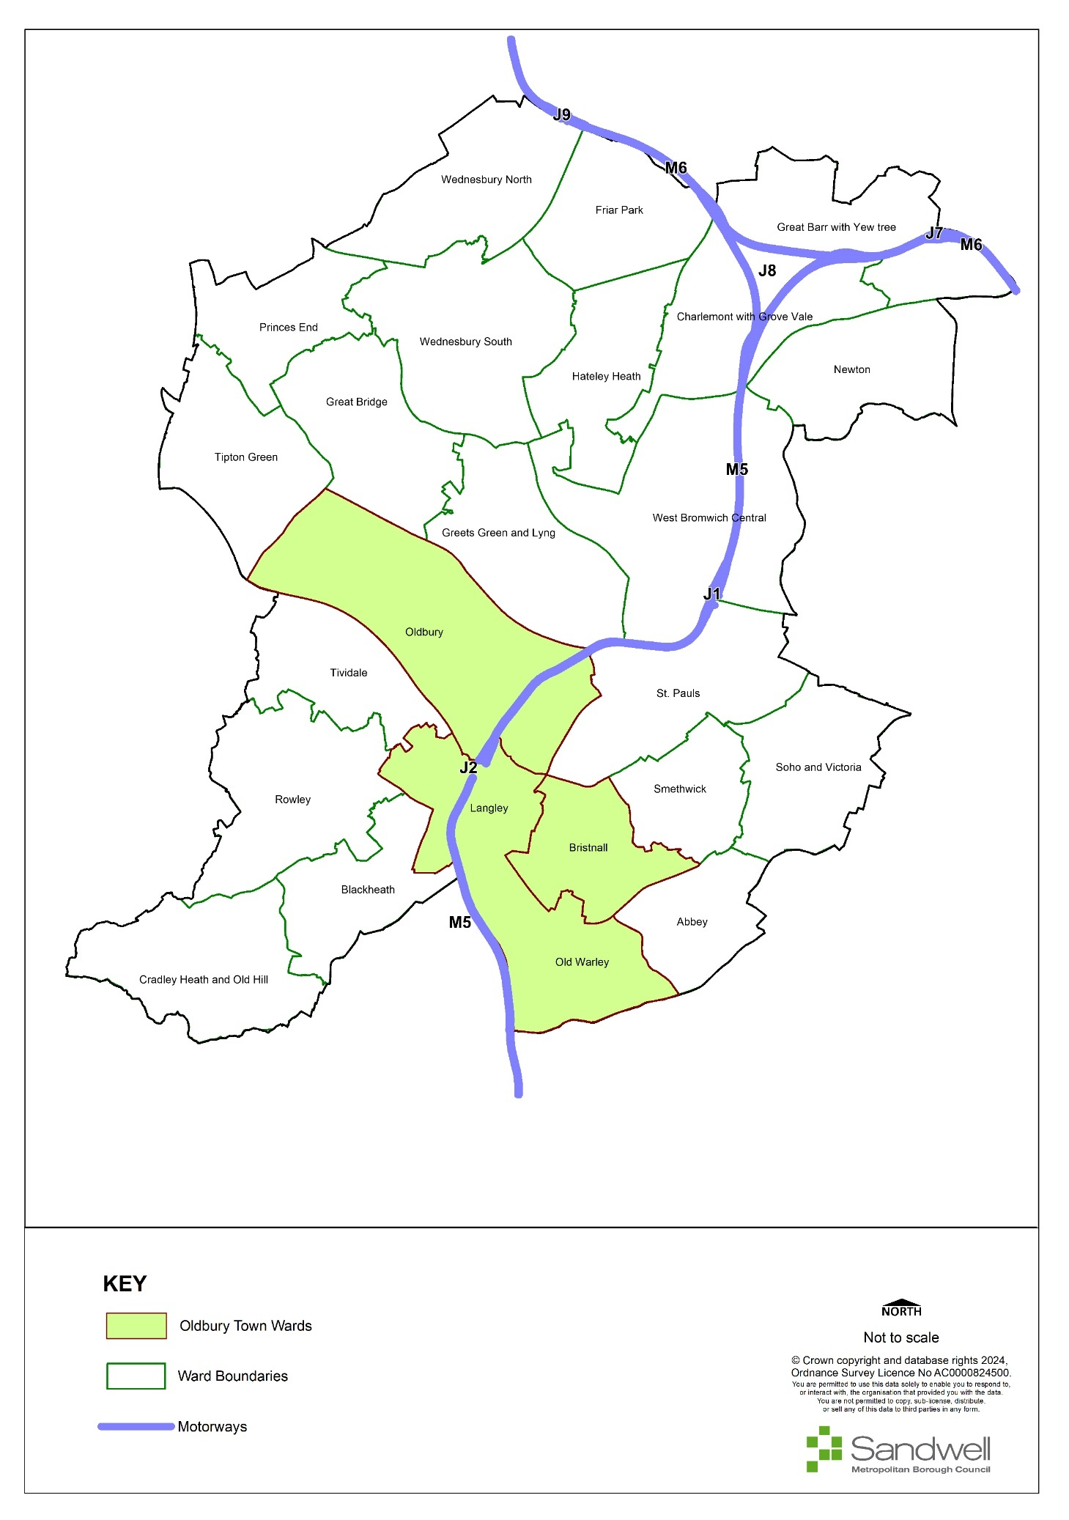
- Oldbury Town is centrally located and is the administrative centre for Sandwell. It contains the wards of Bristnall, Oldbury, Langley and Old Warley. It borders Birmingham and Dudley to the south and southwest.
- The population of Oldbury town in mid-2020 was estimated to be 53,707. Oldbury town has seen an increase in all age groups between 2011 and 2021, but the rise in those aged 65 and over is smaller (+2.6% and +5.3% for under 20s and 20-64s, but only 0.5% for those aged 65 and over.
- Oldbury Ward has the largest population, with 15,607 residents.
- 41.5% of Oldbury town’s population are from ethnic minorities; this is lower than the borough’s average of 48% and higher than the 26% for England and Wales.
- 90% of the Lower Layer Super Output Areas (LSOAs) in Oldbury are in the 50% most deprived LSOA in England (Sandwell - 86.0%).
- Of the six main towns, Oldbury town has the greatest proportion of residents who are economically active (60.3%) and the second highest proportion of residents in full-time employment (34.8%).
- Oldbury town has the highest level of owner-occupation of the six towns in the Borough. The proportion of households in privately rented accommodation has increased to 18.5%, which is similar to Sandwell as a whole. It has the lowest proportion of social rented housing of the six towns.
Figure 11 - Oldbury Town Centre
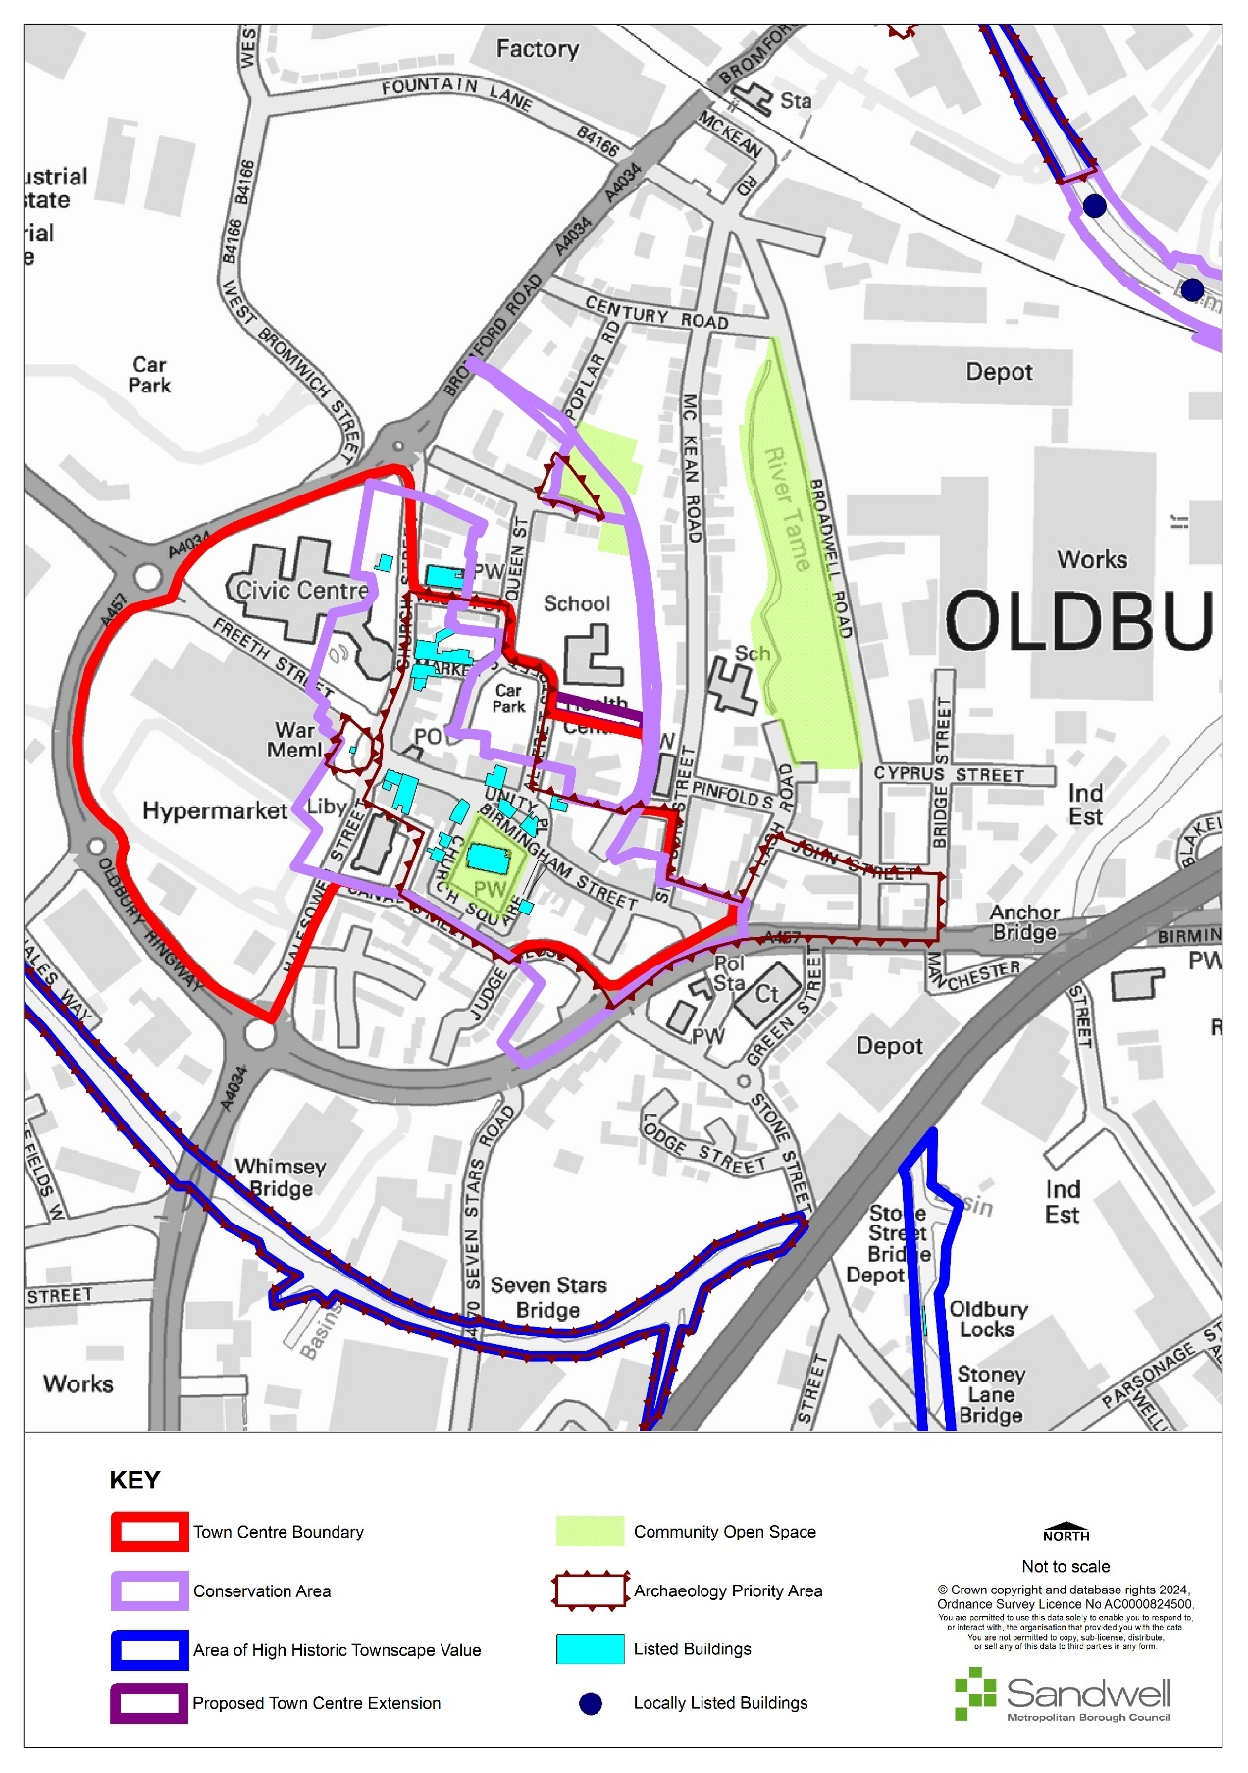
Existing Centres Boundary
- The centre is designated as a town centre in the Black Country Core Strategy centres hierarchy, and it is proposed to continue with this designation.
- The town centre boundary is well-contained to the west by the Oldbury Ring Road. To the east the boundary follows the length of Birmingham Street to its junction on Birmingham Road. The Centres Study identified that the boundary could be altered to include the whole health centre rather than the boundary intersecting it currently.
Primary Shopping Area
- Oldbury Town Centre does not have an existing primary shopping area. Due to the nature of Oldbury’s primary role as a service-driven town centre, a primary shopping areais not considered necessary.

Retail and Town Centre Uses
- Oldbury is the only town centre in the four Oldbury wards. It is comprised mainly of the Sainsbury’s supermarket / parking, the Sandwell Council offices and a variety of commercial units along Halesowen Street, Church Street and Birmingham Street.
- Latest available information demonstrates that in total the centre currently has 95 outlets with a combined floorspace of approximately 25,500 sqm. Since 2016 there has been an increase of eight outlets and some 2,350 sqm in terms of floorspace. The increase in floorspace is seen across all goods categories except for leisure services. The centre currently has 14 vacant outlets, compared to the nine reported in 2016.
- The Black Country Centres Study 2020 identified that units selling comparison goods comprised 7% of Oldbury’s total number of commercial premises, 8% below the national average. Convenience goods comprised 47% of the centre’s total commercial floorspace, compared to 9% nationally. Sainsbury’s represents 97% of the convenience goods floorspace, accounting for the small number of units but high volume of floorspace.
- Financial and business services and retail services provide a higher-than-average number of units (12% and 17% above the average respectively) but provide floorspace figures comparable to the average, suggesting a high volume of small floorplate stores. Leisure services are under-represented both in terms of number of units and their floorspace.
- In accordance with Policy SDM6, the hot food takeaway (HFT) threshold for Oldbury town centre is 7%; in 2022 the percentage of HFT in the centre was 5.7%.

Facilities Provision
- The centre is supported by a small range of community facilities including five churches, two schools, a library, health centre and Sandwell Council’s main offices.

Accessibility
- Oldbury Town centre is close to a major motorway junction (M5, Junction 2). It is served by Sandwell and Dudley railway station, which lies on the edge of the town centre, offering direct inter-city trains to Birmingham International Airport, London and the north-west.
- Oldbury bus interchange is situated in the middle of the town and is well-connected to the wider area, with excellent links to Walsall, West Bromwich and Birmingham.
- There are two core walking zones around Sandwell and Dudley and Langley Railway Stations.

Accessibility – Provision for Cyclists
- Oldbury Town Centre is served by the National Cycle Network Route No.81.
- Proposed SCWIP route 4 A4034, from Oldbury Town Centre to Blackheath Town Centre via Birchley Island, will see a major junction improvement. The cycle route is at preliminary design stage and will be delivered incrementally.
- Another West Midlands LCWIP cycle route runs from Sandwell and Dudley Railway Station to Cradley Heath via Langley and Blackheath. This route connects to proposed SCWIP cycle route 5 from Oldbury Town Centre to Bearwood via the Sandwell Aquatic Centre
- SCWIP Cycle Route 6 A457 (Air Quality Hot Spot) Oldbury Town Centre to Smethwick Galton Bridge Railway Station is currently at Strategic Outline Business Case stage; the section from Smethwick Galton Bridge to Rolfe Street Railway Station was delivered under Towns Fund (accelerated fund). Further phases to the junction of Grove Lane and Cranford Street are being delivered via Towns Fund over the next three financial years. The route will connect with West Midlands Metropolitan University Hospital and Birmingham Cycle Network
- SCWIP cycle route 3 is proposed from Great Bridge Town Centre to Roebuck Lane (National Cycle Route 5) via Brandon Way, Kelvin Way and Kenrick Way

Accessibility – Transport Proposals
- The A4123 is subject to a proposed multimodal corridor improvement project that intersects with the A4034 at Birchley Island. Phase one has been delivered, from Tipton Road to Burnt Tree junction, and Phase 2 (Burnt Tree junction to Lower City Road) is under development. This route will be delivered incrementally up to Hagley Road
- There are bus priority measures proposed from Dudley Road, through the junction of Oldbury Ringway / Freeth Street.
- The Birchley Island / M5 Junction 2 link project lies at the intersection of the M5, A4123 and A4034 in Sandwell. These routes connect Birmingham, Blackheath, Dudley, Oldbury, Walsall, West Bromwich and Wolverhampton to each other as well as linking much of the southern part of the Black Country to the national motorway network.
- Works to improve the junction and its accessibility were scheduled to start in 2023 but this has now been pushed back to 2024 / 2025. Several upgrades will be made to this junction, including the addition of a fourth lane for all traffic; extending the length of Lane 3; creating segregated cycle tracks / footways; installing controlled crossings; and road widening. These works will address ongoing issues at the junction and improve road user experience.
- The junction improvement is a crucial part of the Black Country transport network and is of importance to both commuters and businesses.

Environmental Quality
- Existing green space designations are supported and the valuable contribution that they make is recognised.
- There is important established green planting and tree coverage that contributes to the setting of areas and public spaces in Oldbury. This includes areas around Sainsburys and the council offices and a variety of public spaces, and they provide valuable areas for people to stop in.
- Other areas on Birmingham Road could benefit from public realm and shop front improvements, which could make the centre more attractive, helping to attract new businesses to the area and reduce the number of vacant commercial units.

Historic Environment Allocations
- Oldbury Conservation Area was formally designated in March 1974 and reassessed in 2008. Currently the Oldbury Conservation Area centres on Church Square and Unity Place, which is the focal point of the core town centre. The area was substantially built before 1857, at a time when Oldbury was a nationally important industrial centre. This is reflected in the quality of the buildings, many of which, by virtue of their individual character and their relationship to the surrounding spaces and buildings, make a positive contribution to the quality of the environment.
- The Town Centre features 19 Grade II and one Grade II* listed buildings, with most of them falling within the conservation area. Many of the listed buildings and others present attractive early to mid-19th Century styles that provide the centre with a distinct character.
SWOT
- The Centres Study Health checks noted the following characteristics for Oldbury:
Strengths  - Generally high-quality environment;  - Historic buildings give character to the centre. | Weaknesses  - Lack of comparison goods stores;  - Heavily reliant on Sainsbury’s as an anchor;  - Poor links to the Retail Park.
Opportunities  - Create better pedestrian links to Oldbury Green Retail Park;  - Encourage more comparison goods retailers;  - Enhance shop frontages along Birmingham Street. | Threats  - Retail Park continues to impact centre and reduce comparison offering;  - Complete withdrawal of comparison goods and other traditional high street uses.

Aspirations
- The large number of bus services and levels of parking make Oldbury very accessible; however, consideration should be given to better integrating the Town Centre with Oldbury Green retail park.
- The upgrade of building stock within Oldbury Town Centre to encourage businesses to grow and create new jobs, considering the Conservation Area designation, will be supported.
- Opportunities to provide improved public and active transport, to provide more cycle lanes should be investigated.
- Encouraging active uses towards the eastern end of Birmingham Road would help to increase the sense of safety. Improving the environment on Birmingham Road may also help to attract businesses.
- Residential use on the upper floors in Oldbury Town Centre is considered an appropriate use.
- Opportunities will be sought to secure funding to improve the appearance of shop frontages and the general environmental quality of the area.
- The Council have secured funding from UK Shared Prosperity funding to create a work business hub at Jack Judge House.
Proposals
Ref | Location | Indicative Land Use
OL1 | Town Centre | An amended boundary is proposed, as shown in Figure 10, to include the whole health centre on Birmingham Street.

Wednesbury Town
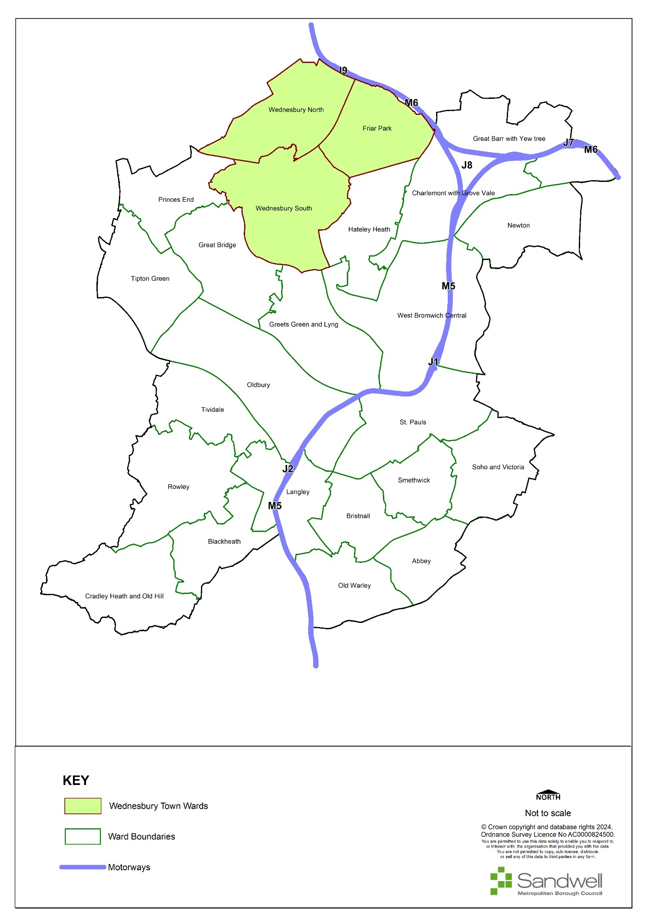
- Wednesbury is a market town in the West Midlands, located approximately ten miles northwest of Birmingham and six miles southeast of Wolverhampton. Wednesbury is one of the six main towns of Sandwell, and is in the north of the borough, approximately three miles north of West Bromwich. The town contains the wards of Friar Park, Wednesbury North and Wednesbury South.
- The population of Wednesbury in mid-2020 was estimated to be 39,491 with 19,503 males (49.4%), and 19,988 females (50.6%). Wednesbury has the smallest population of the six main towns in Sandwell. 18.6% of population are from ethnic minority backgrounds. Wednesbury has a proportionally older age profile than Sandwell, but a younger age profile than England on average.
- Overall, Wednesbury is more deprived than England and also when compared to the rest of Sandwell, and its deprivation score would put it in the 20% most deprived areas in England. 26% of its residents are living in income deprived households and 13% are claiming job seekers’ allowance.
- Female and male healthy life expectancy were statistically significantly lower than the average for England in all three wards in Wednesbury. Healthy life expectancy for both females and males was lower than the present state pension age (66) for all three wards and compared to the rest of England; this indicates that people may not necessarily be healthy enough to work until the state pension age.
Figure 12 - Wednesbury Town Centre
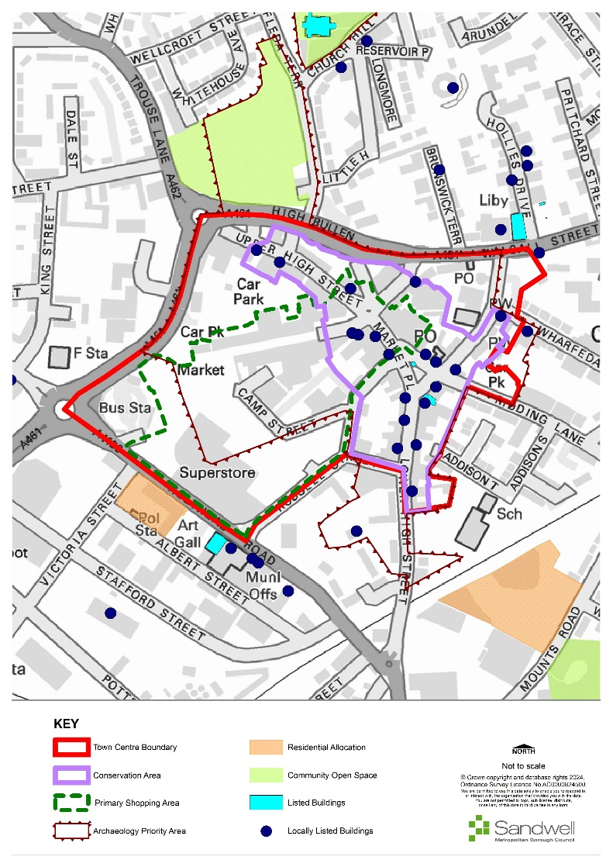

Retail and Town Centre Uses
- Wednesbury has a total of 176 commercial units (2023), with a total floorspace of 34,720m²; this compares to 183 units and 29,154m² in 2009, revealing a relatively large increase in floorspace but a small decrease in overall units in the last ten years. Comparison goods sales occupy 28% of the centre’s units, compared to the UK national average of 36%. When comparing floorspace, comparison goods make up 25% of the centre’s total, which is 7% below the national average. A small level of comparison goods is expected in this type of centre. This sector has declined by nine units but has maintained its share of floorspace since 2009.
- Convenience goods occupy 11% of Wednesbury’s commercial units, which is 4% below national average. However, the floorspace of these units makes up 32% of the centre’s total, which is 23% above average. This over-representation of convenience goods can mostly be attributed to the large 7,020 sq. m. Morrisons store, which represents 64% of all convenience floorspace in the centre. Large floorplate anchor convenience stores are very typical in these types of town centre. Convenience goods outlets have decreased by four units, but floorspace has increased significantly by 5,211m² since 2009.
- The floorspace proportion of other retail services stands at 10%, which is below the national average of 14%; however, in terms of the number of units in such uses, retail services occupy 20% compared to a national average occupancy rate of 7%. This shows that there is a high volume of small floorplate retail service units, typical for this type of town centre. These are mostly hairdressers and beauty salons.
- Leisure services are under-represented in terms of both number of units and floorspace, falling 8% and 7% below the national average respectively. Over a third (11) of leisure services are takeaways, with only one restaurant. However, this restaurant and the five pubs / bars that are evenly distributed in the centre could help to generate an evening economy. Collectively the service industry has lost four units and 1,767m² since 2009.
- Vacancies have increased from 18 units in 2009 to 28 in 2019, or in floorspace terms from 1,914m² in 2009 to 4,040m² in 2019. This currently represents 15% of units, which is above the national average of 9%. This level of vacancy is concerning, especially given its significant increase since 2009. In terms of floorspace though, it represents 12% which is very similar to the national average of 11%.
- Retail, leisure and business and financial services are evenly distributed around the centre with no specific areas where these are grouped. Contrasting this, comparison and convenience goods are concentrated towards Union Street although they are also present throughout the centre. Whilst Union Street has been a focus for comparison goods, this is also experiencing a higher number of vacant units. The centre features a diverse range of community uses, including an art gallery, leisure centre, library and primary school. National multiples are well represented and include several high street banks and supermarkets.
- Wednesbury has an attractive environment and retains its market town role and related identity. Market Place and the buildings around it provide the historic focus for this and represent a distinctive presence, with its historic triangular space and street frontages.
- In accordance with Policy SDM6, the hot food takeaway threshold for Wednesbury Town Centre is 7% and as of 2023 there are 12 hot food takeaways in the centre, representing 6% of the total number of units.

Facilities Provision
- There are several community facilities, including several religious institutions within the centre. Adjacent to the town centre boundary there is Wednesbury Town Hall and Museum to the south, to the north is Wednesbury Library and to the west is Wednesbury Leisure Centre.
Accessibility
- The town centre is well connected by road, with the A461 providing access to Junction 9 of the M6 Motorway and the A41 providing access to Junction 1 of the M5 Motorway.
- The centre is well-served by regular bus services, with on-street stops and a large bus station at the end of Union Street. To the south of the town centre is the Wednesbury Great Western Street Metro stop. Regular services run from the stop to Birmingham and Wolverhampton; in the future, services will also run to Dudley.
- The centre is easily accessible by road via Walsall Street. Parking is generally sufficient for current levels of use. Options comprise:
- High Bullen: 137 spaces
- Morrisons: 390 spaces
- Ridding Lane: 48 spaces
- Spring Head: 62 spaces
- The quality of the pedestrian environment is mixed. Union Street offers an easy pedestrian experience on a traffic-free street. On other streets, pavements are relatively narrow and cluttered with highway signage. The junction at Market Place / High Bullen is dominated by highways infrastructure and is difficult for pedestrians to cross.
Accessibility – Provision for cyclists
- There is an existing cycle route that links the town centre with the Tamebridge Rail station.
Accessibility - Transport Proposals:
- The Wednesbury to Brierley Hill Metro Line is currently under construction (2024).
Centre Boundary
- The centre is designated as a town centre and its boundary is formed by the Walsall Road dual carriageway to the north and west. At the eastern and southern edges, it may be necessary to consider whether the boundary should be consolidated.
Primary Shopping Area
- Wednesbury has an identified primary shopping area, which has not changed recently.
Wednesbury Conservation Area
- Wednesbury Market Place was designated as a conservation area in 1980 because of its special architectural and historic interest; it covers an area of c.3 hectares.
- Wednesbury Market Place conservation area is of special interest for its largely late-medieval street pattern and its concentration of 18th and 19th century buildings around a triangular marketplace. Although it may potentially have even earlier origins, related to an earlier fortified settlement or ‘burh’ to the north of the town, the modern settlement developed between two key communication routes that led to important crossing points over the River Tame. These were in use from at least the 13th century onwards.
- The survival of the historic layout of the town, and the retention and adaptation of the buildings and their plot structure, provides further special interest through their potential to provide information about the development of the town and the form and use of the buildings over time. The relationship with the roads and the tight-knit 18th, 19th and early 20th century retail frontages documents the evolution of commerce in the town. The marketplace also has historic and communal significance as a site of commercial and civic interaction over hundreds of years.
Area of Potential for Archaeological Importance
- The town centre is situated in a wider Area of Potential Archaeological Importance.
SWOT
- The Centres Study Health checks noted the following characteristics for Wednesbury:
Strengths  - Some strong townscape features (e.g., Market Place);  - Significant historic building mix throughout the town;  - Strong market function retained;  - Large Morrison’s store anchors the centre;  - Very accessible by public transport with bus station;  - Pedestrianised street offers ease of pedestrian movement;  - Good provision of community facilities. | Weaknesses  - Central junction is dominated by highways and is a weak pedestrian environment;  - Union Street / outdoor market / bus station forms poor environment;  - Need for a higher quality leisure sector.
Opportunities  - Opportunities to make more of the sense of place, e.g., at Market Square;  - Surplus parking may offer development opportunities. | Threats  - Growing vacancies on Union Street as comparison goods sector declines;  - Centre is somewhat over-reliant on Morrison’s as the only supermarket present.

Aspirations
- The health checks identified that there is limited evening activity due to the lack of leisure facilities around Wednesbury, including the strict definition of leisure as well as restaurants.
- There may also be an opportunity to provide improved public and active transport, and to provide more cycle lanes.
- Generally, frontages within Wednesbury are in a poor condition, which may adversely affect its attractiveness to potential new occupiers or for new development / investment. There is the opportunity to celebrate, respect and enhance the town’s heritage. Opportunities for funding to improve shop fronts and townscape quality have been investigated. In partnership with Historic England, the Council has identified a Heritage Action Zone within Wednesbury’s town centre. Various proposals offer opportunities for future improvements and additions to the public realm and character of the area and are set out below.
Wednesbury High Street Heritage Action Zone
- As part of Sandwell Council's commitment to support struggling high streets, and to highlight the historic significance of the area, it partnered with Historic England to deliver a c.£3.6m heritage regeneration scheme within Wednesbury itself. This provided both funding for physical improvements to the buildings in the identified zone and opportunities for shop owners, residents, organisations and visitors to Wednesbury town to enjoy an improved and richer experience when in the centre.
- The project involved three main approaches:
- Improvements to shop fronts and buildings within the town’s conservation area, to help revitalise the town centre; the possible introduction of more homes through first floor conversions; and the creation of a more enjoyable experience for residents and visitors.
- Public realm improvements, including repaving footpaths and streets with high-quality materials, planting trees and replacing street furniture, to help create a safer space for pedestrians and shoppers.
- The delivery of cultural activities designed to engage the community within and around the high street.
- As part of the regeneration of the historic town centre, funding is available for the renovation of shop frontages, with up to 80% of the cost being met by the scheme. Shop owners can use this non-repayable grant to replace shop fronts and signage and reinstate the historic features of their building.
- Shop front renovations will need to reflect the heritage of the town and guidance will be given to those who wish to take up the grant offer. A shop front design guide outlining the types of works that can be funded has been produced to provide this advice.
Wednesbury Town Centre Masterplan
- The Wednesbury Town Centre Masterplan has been prepared to guide investment and future regeneration within and adjacent to the town centre boundary over the period to 2034. The Masterplan sets out six aims to revitalise the town centre through investment in public spaces, diversification of the town centre offer, and by encouraging more people to live and work in the town:
- A welcoming and inclusive town centre with attractive points of arrival, an improved sense of safety, high quality wayfinding, and a distinctive character that draws on the identity and heritage of Wednesbury.
- A well-connected place that is easy to walk and cycle to and around, has better links to the Metro, is well integrated with surrounding areas to support sustainable patterns of travel, and is easy to get to by a range of modes.
- A transformed environment with enhanced public realm, repaired townscape, more green infrastructure, better integration with surrounding open space and resilience to climate change.
- A consolidated and strengthened retail offer with a diversified range of shops, more independent businesses and an expanded evening, cultural, community and leisure offers which attract families and children.
- A diversified mix of land uses, including higher density residential development, places for enterprise and employment and facilities that support these uses, tackling vacant sites and buildings.
- An active and vibrant place in the daytime and evening with high footfall in key retail streets, active ground floor uses and spill out, and animation of the public realm through events, markets, pop-ups and meanwhile uses.
- The Masterplan is being delivered in part from £20 million funding secured through the Wednesbury Levelling Up Partnership.

West Bromwich
West Bromwich
- West Bromwich, as designated on the Policies Map and shown on Figure 13, is the third largest centre in the Black Country. It is the focus for a wide range of civic, retail, cultural and leisure functions. The centre is organised around a strongly linear high street form. The high street itself runs north-west to south-east with a focus on retail activity along the Princess Parade / Duchess Parade section, which is enclosed by the West Bromwich Ringway. It is in a highly accessible location via a range of public transport options including rail, metro and bus services; users of the Metro can reach Birmingham city centre in 15 minutes and buses run between West Bromwich and the other towns in Sandwell on a regular basis.
- The SLP supports the diversification, repurposing and rejuvenation of the strategic centre, with it being the focus for a well-balanced mix of residential, leisure, commercial, business and service uses. Changing shopping patterns and challenges to the high street will be addressed through increased flexibility and facilitating the consolidation of the shopping core (particularly to reduce vacancy rates), complemented by surrounding mixed uses, and supported by maximising residential provision in all locations (including the use of upper floors).
- The West Bromwich Masterplan states the aspirations for the centre of the town as,
A mixed-use centre with central market square at its heart and comprising food and beverage and leisure blocks to the North / West, office blocks and residential to the South and education and multi-storey car park to the East of central courtyard.
- The future of the centre, as with most strategic centres across the Black Country, is dependent on reducing reliance on retail to generate footfall and generating alternative uses (potentially mixed uses) that function both during the day and into the evening.
Background
- West Bromwich is the largest town, by population size and by area, in the borough, giving it the lowest population density. It includes the main commercial and retail centre of Sandwell. Its housing markets include older terraced housing in the town centre, extensive council-built neighbourhoods to the north and the more affluent suburban Great Barr area. The town also has one of the most successful new residential developments in the Midlands at the Lyng – the Urban 180 / Eastern Gateway area is an award winning social housing scheme. West Bromwich has the second oldest age profile in Sandwell with 16.6% of its population aged over 65. It has the second highest number of jobs at 36,400 and has experienced 6% employment growth since 2012. Its 2,430 businesses have experienced similar growth.
- West Bromwich is also the strategic centre for Sandwell and as such is the focus for major investment opportunities for retail, commercial, leisure and educational uses. The town centre has excellent accessibility to the motorway network with Junction 1 M5 within 1.5km providing access to the M6. Within the town, sustainable travel options are provided by a bus station, the Midland Metro providing access in 15 minutes to both Wolverhampton and Birmingham via five stops within the regeneration area boundary and excellent pedestrian and cycle links to and through the area.
- Traditionally the High Street was at the core of the town. However, there has been a shift towards increased activity within the New Square development, built ten years ago. With anchor stores Tesco Extra and Primark, a selection of food and beverage offers and a cinema, this became the more popular shopping and leisure destination. This led to a decline in the quality and quantity of shops in the High Street. Further relocations away from Queens Square, one of the town’s key precincts, have also contributed to the overall perception of decline. Conversely, Kings Square continues to trade well.
- Education provision in the town continues to grow. Sandwell College and Central Sixth have been resident for some years and moving into the town has resulted in some of the vibrancy, lost in previous years, being regained with the additional student footfall. Furthermore, Shireland University Technical College and the Central St Michaels Sandwell Science, Engineering & Manufacturing Centre will continue to add to this offer.
- The Central St Michaels Sandwell Science, Engineering & Manufacturing Centre lies on West Bromwich’s High Street and opened in September 2023. It is a new technical campus for Sandwell College and is delivering opportunities in engineering, advanced manufacturing, civil engineering, construction and hybrid electric vehicles for adults and young people. The new facility will provide programmes for the unemployed as well as reskilling the workforce through Apprenticeships Standards and other technical and professional qualifications.
- Recent years have seen a change in shopping habits. Even prior to the COVID pandemic, retail centres were struggling with increasing rents and business rates, competition from out-of-town retail complexes and an increase in online shopping with the loss of comparison retail (i.e., clothes, shoes, electrical goods) to the internet. The pandemic only served to exacerbate the situation, with many of the high street names switching to online shopping only, removing their presence from the High Street.
- National permitted development rights have also changed considerably, allowing for offices to be converted to residential uses without needing planning permission. Changes in technology have allowed for more people to work from home or adopt flexible working patterns (especially during the pandemic). This has led to reduced demand for offices in centres, with levels of demand remaining below pre-pandemic levels (as of 2024).
- A side effect of the above has been the adverse impact on service sectors dependent on high footfall in West Bromwich and elsewhere and supported in part by office-based workers, such as food and drink sales, convenience retailing and smaller service industries.
West Bromwich Town Centre
- To aid regeneration of the centre and stimulate post-pandemic recovery, a masterplan and Interim Planning Statement were produced for West Bromwich. The masterplan is a catalyst for ongoing and new regeneration schemes – unlocking further investment and opportunities to boost the town’s future economic growth, and fostering, promoting and supporting strong urban design principles throughout those interventions. The interim planning statement was designed to provide updated planning advice for development following changes to national planning legislation over time. The guidance offered in the statement has now been incorporated into these policies. An extract from the Masterplan showing the main locations for new development can be found in Appendix B.
- The Masterplan and Interim Planning Statement were approved by Cabinet in February 2022 and set out an ambitious programme of development opportunities to reinvigorate the town, helping to deliver new jobs, a more resilient centre and reinventing its function as the strategic centre.
- To support these proposals, £25m was awarded from the national Towns Fund to progress various projects within the town including retail diversification, cultural, educational and urban greening schemes.

Policy SWB1 - West Bromwich Town Centre
- The strategic priorities for West Bromwich are:
  - to reinvigorate the town centre;
  - to unlock land to aid regeneration;
  - to support good quality jobs;
  - to stimulate COVID19 recovery;
  - to promote the highest standards of sustainable urban design.
- This will be achieved by:
- delivering a significant number of new homes in and around the centre (Policy SWB2) to support the creation of a vibrant, active and sustainable town centre;
- creating a Metro gateway and new town square and promoting a step change in the quality of local places / the public realm;
- delivering mixed use, leisure, commercial and ancillary office growth in sustainable core locations;
- repurposing vacant premises and sites in the centre to deliver community, education and healthcare provision;
- undertaking site assembly and redevelopment to provide land suitable for new markets, education facilities and high-quality housing;
- regenerating the Town Hall Quarter to establish a fully restored cultural and evening / night-time offer in the town centre;
- creating sustainable travel networks across the centre and into surrounding locations;
- providing a green link from the Metro through the heart of the town centre to connect the town centre to Dartmouth Park and Sandwell Valley, including cycling and walking routes across the town centre through to Sandwell Valley;
- providing landscaping, green links, squares, parks and parklets, sustainable travel networks and additional green infrastructure throughout the centre;
- conserving and enhancing the historic environment (Policies SHE1 – SHE4).
- Opportunities for future development in and around West Bromwich will be supported where they help deliver the aims and objectives set out above.
- Areas such as The Lyng may be suitable for high quality, well-designed mixed-use development and investment. Should such sites become available through land assembly or allocation during the timescale of the SLP, the Council will support the production of masterplans that demonstrate how sustainable new development could be brought forward in those areas.

Justification
- The transformational change proposed for West Bromwich will see the redevelopment of some existing uses and the relocation of the indoor market to a new unit providing links directly to the High Street. The main reconfiguration will involve legacy retail and vacant sites and is intended to create a mix of high-quality leisure uses, encouraging people to alight from the Metro and move into the centre of the town and onto New Square.
- New homes will be introduced to increase sustainable town centre living and increase natural surveillance throughout the day and evening. Opportunities to promote more leisure and night-time uses will be available for selected sites and the town will continue to support further educational uses where there is a demand. This mix of uses will help to create a vibrant, sustainable and inclusive community that is accessible to, and provides for, all age groups.
- A network of green spaces, new connections and improved public realm will connect the old with the new, linked to the cultural quarter near the Town Hall, through the High Street and through to Dartmouth Park. Cycle routes are to be extended east to west and north to south to further strengthen connectivity and access across the town centre and beyond.
- The Strategic Centre benefited from an Area Action Plan (AAP) that was adopted in 2011. Until the local plan review is completed, all AAP policies remain relevant to proposals within the boundary of West Bromwich Strategic Centre.
- The masterplan is intended to act as a catalyst for on-going and new regeneration schemes for West Bromwich – unlocking further investment and opportunities to boost the town’s future economic growth. The masterplan strengthens the links between the town centre and adjoining areas such as the Cultural Quarter and Dartmouth Park / Sandwell Valley by creating strategically connected functional and active zones with playful street furniture, public art and art trails connecting spaces along the routes. The masterplan builds on the Towns Investment Plan for West Bromwich, which successfully bid for £25 million to reinvigorate the town, underpinned by strong urban design principles.
- The housing capacity for West Bromwich is based on existing permissions, but also includes an estimated uplift based on more recent evidence, including the Black Country Centres study and estimated capacity identified in the West Bromwich Interim Planning Statement and Master Plan.

Delivering the Strategy
- This strategy will be delivered by the allocation of sites and implementation of policies in this Plan across the administrative area to accommodate housing and employment development.
Figure 13 - West Bromwich Town Centre
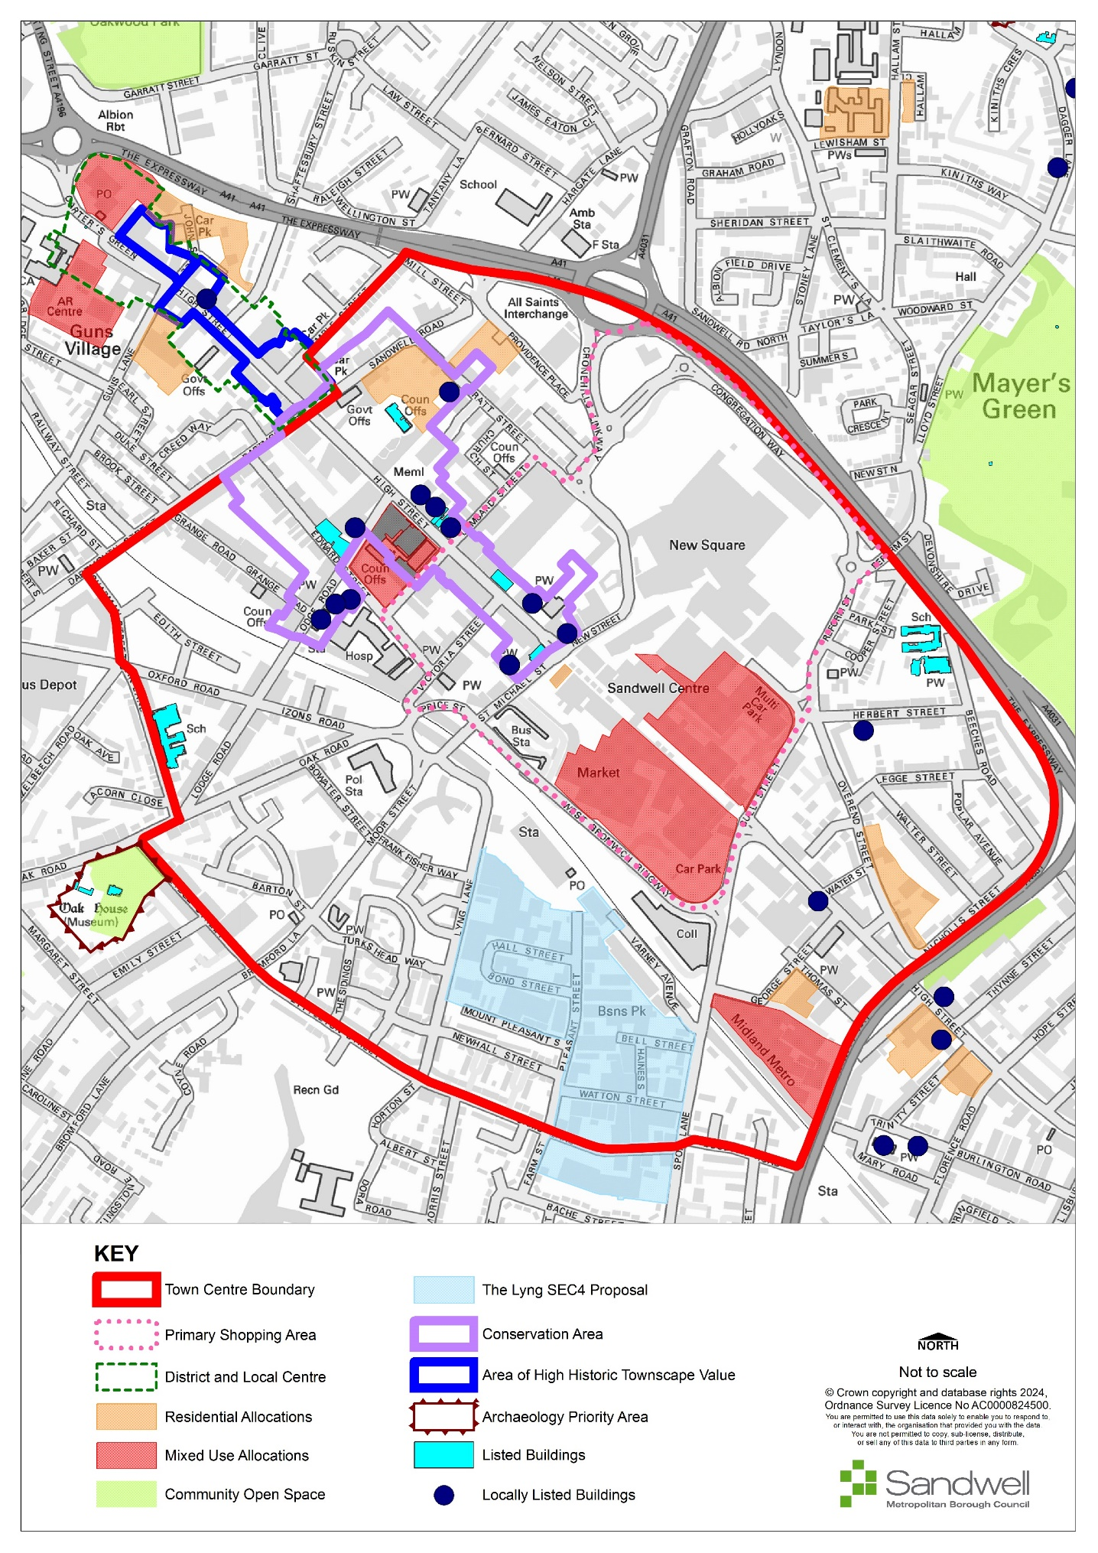

Regeneration in West Bromwich
- The re-energising and repurposing of West Bromwich is of fundamental importance to the regeneration of Sandwell and the wider Black Country. It is one of the main drivers of the Black Country’s economy and supports one of the main hubs of the sub-regional transport network. It is a sustainable location and is well-placed to provide the community with easy access to comparison shopping, leisure, entertainment and cultural facilities and office-based employment.
- Table 11 sets out a list of projects and proposals designed to support the ongoing regeneration of West Bromwich that were identified in the Masterplan.
Table 13 - West Bromwich Masterplan Projects
Zone | Location | Indicative land use
1 | West Bromwich Central Mixed-Use Centre  A new multi-purpose town centre and a square at the centre of enhanced linkages and green public realm, with an emphasis on high quality public space and surrounding amenities and encouraging interaction and entertainment. This will include a mixed-use centre with central market square, comprising food and beverage outlets and leisure uses to the north / west, office blocks and residential to the south and education and a multi-storey car park to the east of the central courtyard. | Retail - 4,502m²,  Offices - 5,032 m²  Residential – 343 homes  Education - 5,060 m²  Food and beverage - 11,840 m²  Community / leisure - 9,862m²  Health - 5,205m²  Parking – 625 parking spaces
2 | Queens Square Living  A centrally located high-density residential community set within a green park with external parking spaces, office and gym / amenities space at ground level of the northern residential block. Retail blocks with town houses above to the north and east of the square create a well-defined edge with active market streets to the High Street and Queens Street. | Retail – 7,447m²,  Offices - 8,55m²,  Residential – 396 homes  Community / leisure - 1395m²  Car parking – 206 parking spaces
3 | Cultural Quarter  Main block along High Street adjacent to the Town Hall provides scope for cultural / community spaces with restaurant / food and beverage uses helping to create an active street. This is likely to be brought forward as a Social Housing residential scheme as a social housing provider has acquired this site.  The building to the rear facing Edward Street and Lodge Road is proposed as aged living accommodation, set beside a cultural offer. It could also provide a site for a Youth Building / Hub. | Residential – 52 homes  Food and beverage - 1,054 m²  Community / leisure - 2,000 m²  Parking – ten parking spaces
4 | Urban Pocket Park  A new park / route that connects St. Michael Street, the Astle Retail centre and the High Street. Work with key stakeholders and landowners to bring forward future connections and management of spaces. | Food and beverage - 260m²  Community / leisure - 1,350m²  Parking – five parking spaces
5 | George Street Living  A high-density residential community comprising a series of 3 - 8 storey blocks with landscaped courtyards and amenities. The site is ideally positioned close to Trinity Way Metro and accommodates on-site parking and amenities. | Residential – 327 homes  Community / leisure - 1,150m²  Parking – 79 parking spaces
The Lyng | The Lyng falls under Policy SEC4 (Employment Use). This protects the area from piecemeal development that would prejudice the long-term planning of the area while allowing comprehensive redevelopment of the area for a variety of types of use should viability and relocation issues be resolved. | New industrial or employment uses, housing or other non-ancillary, non-industrial employment uses (criteria apply).
- In addition to those proposals identified in the Masterplan, there are several sites that also remain a priority in terms of their value to the ongoing revitalisation of the strategic centre:
Location | Indicative land use
George Street  Community use - currently laid out as a car park, this is expected to form part of an extended Temple / community facility. | Gurdwara (Temple) extension
Providence Place  This site is a possible council land disposal. It is in a comparatively tranquil, well-connected location, suitable for residential use.  The site is adjacent to a listed building (Highfields) and lies in a Conservation Area. For these reasons the attractive treescape within the site must be preserved, which will constrain the amount of development possible on this site. The site is also suitable for offices, or as a potential expansion site for the existing CBSO School. Its location behind the High Street on a no through road and behind the Expressway makes it a comparatively tranquil well-connected location, also suitable for residential use. | On this 0.73ha site approximately 0.4ha could be developed, providing capacity for up to 40 apartments.
Overend Street  Contains an active builders’ merchants and is becoming an incompatible use within the wider residential-led regeneration of the area. Its relocation would free up a well-connected, accessible site suitable for next generation eco homes, building on the established ‘Eastern Gateway’ scheme. It is considered a priority site. | Residential - this 0.70ha site could support up to 70 dwellings in a highly accessible location in the Strategic Centre.
Environment and climate change
- In line with the Council’s Climate Change Strategy, a local heat network for West Bromwich is at commercialisation stage. This is part of the strategy towards achieving carbon neutrality for Sandwell Council buildings and operations by 2030 and for the borough by 2041.
- Other heat networks are being explored, albeit these are currently at an initial stage. General ‘greening’ of the centre, via landscaping and other environmental enhancements is proposed, with improved links to Dartmouth Park and Sandwell Valley.
- As part of the above, the central area will have more meet-and-greet areas to foster non-transactional interactions and drive footfall, thus bolstering a reduced but viable amount of retail and other centre uses.
Sandwell Valley
- The Council will investigate opportunities for utilising Sandwell Valley for leisure and tourism through the Cultural Strategy, whilst respecting its green belt status and the other nature conservation allocations it contains.
Development in West Bromwich
- The Centres Study undertaken for the BCP, and its addendums, were informed by a Household Survey that identified changes in shopping patterns, especially the continued growth of online shopping. The health checks recognised that West Bromwich is facing several challenges – particularly in relation to relatively high vacancy rates.
- The commercial market across all sectors, but particularly affecting the traditional High Street, has materially evolved and changed.

Policy SWB2 – Development in West Bromwich
- It is a priority for West Bromwich to serve identified housing and employment growth aspirations (Policy SDS1, Policy SDS3). The diversification of West Bromwich to provide a re-purposed, well-balanced mix of appropriate uses will be supported (Policy SCE1), in particular:
- Residential provision will be maximised, to increase and strengthen communities, with indicative housing capacity identified by the West Bromwich Masterplan, providing a minimum of 1,536 new homes in the strategic centre by 2041.
- Most new homes will be built at very high densities (Policy SHO3, Table 5) and as part of mixed-use developments where suitable, with additional residential use helping to attract investment and promoting the vitality of the centre.
- Complementary uses, particularly community, leisure, health and education use (Policy SDS5, Policy SDM9).
- Large-scale proposals to serve wider catchment areas should be focussed on West Bromwich to maximise linked trips, promote the use of sustainable modes of transport and support regeneration.
Retail
- Existing convenience and comparison retail provision will be protected and appropriate new development for these uses supported, to meet both local shopping needs and large-scale provision serving the wider catchment; this should be focused on re-purposing vacant floorspace and re-using existing sites within the centre in the first instance (Policy SCE1).
Leisure
- Leisure uses, especially large-scale public and commercial facilities such as cinemas, hotels, and a wide range of high-quality family venues and activities, will be supported where they help to diversify the centre, encourage linked trips and enhance the evening economy and visitor experience (SDS5).
Office
- Office provision will be supported, as West Bromwich is an important location for such employment. Future demand will be market-led; suitable sites are identified in the Masterplan.
- Proposals in edge-of-centre and / or out-of-centre locations must meet the relevant requirements set out in Policy SCE6.
Sustainability
- West Bromwich is a highly sustainable focus for service provision; it is a priority to ensure high quality public realm and standards of design are delivered and supported through environmental policies to deliver the aims and objectives in the Masterplan.
Accessibility
- Proposals for commercial and business development that involve more than 500m² (gross) of floorspace within the primary shopping areas of the centre and well-linked edge-of-centre locations should provide a travel plan.

Justification
- A more pragmatic and flexible approach needs to be undertaken in addressing the future growth of West Bromwich, which does not necessarily place sole emphasis on the retail sector. Rather, this approach allows for greater emphasis on services, communal or civic uses, and incorporates qualitative enhancements to the existing provision. It also supports a mix of uses in relation to new development, including consideration for different types including the concurrent, meanwhile and co-operative uses of units. This means it is essential to provide appropriate flexibility to enable the centre to diversify and be re-purposed to ensure its future vitality and viability is maintained and enhanced. This includes prioritising high-quality public realm including the provision of high-quality open spaces, green infrastructure, pedestrian and cycle networks and electric vehicle charging points.
- Current evidence shows there is no capacity to support additional retail and office floorspace; it would not therefore be appropriate to include specific formal targets for different uses in policy except where indicated by the West Bromwich Masterplan.
- Planning decisions should be informed by the latest available evidence, and the Council will seek to remodel capacity, particularly for retail, periodically in the future. The emphasis therefore is on the consolidation of core areas, as opposed to expansion or identifying larger comprehensive development at in-centre or edge-of-centre sites, with any future potential for new floorspace likely to be met through infill development, reuse / reconfiguration of vacant units, change of use applications and / or extensions to existing stores.
- It is important that any new large-scale commercial and public leisure provision is focussed on West Bromwich, to encourage linked trips, enhance the evening economy and diversify the experiential nature of the centre.
- Changing working patterns, including an increase in agile and flexible working, means that future office environments are likely to be configured differently. Future office provision is likely to be predominantly market-led. West Bromwich remains an important place of work, with office workers making a positive contribution towards ensuring vitality and viability.
- The Masterplan and West Bromwich inset plan identify potential office sites, particularly as part of mixed-use development. This will ensure sites are available for office development when demand re-emerges whilst ensuring other appropriate uses can also come forward.
- City living and residential development in centres is likely to be a growth area over the plan period and will make a positive contribution to regeneration, particularly as a part of mixed-use development and upper floor living. Residential provision should therefore be maximised to facilitate the centre as an important place to live, supporting a resident population and local service provision. Planning decisions will be informed by the indicative residential locations in the Masterplan and inset allocations; the principles of good urban design must be applied to all schemes.
- Housing and employment allocations will be served by the existing network of centres. The fragility of centres and the challenges in ensuring their vitality and viability mean it is important to have robust tests for new proposals within 300m of a relevant boundary, as set out in Policy SCE6.
- West Bromwich is accessible by a variety of means of transport, particularly walking, cycling, the Metro and buses. Relevant in-centre and edge-of-centre development will contribute to sustainability and encourage a modal shift in transport towards public transport, cycling and walking and reduce the need to travel.
- The strategic centre boundary and primary shopping area are identified on the Policies Map and shown at Figure 13. They are used for determining what is in and out-of-scope in terms of proposals.

Transport

Introduction
- The Local Transport Authority for the West Midlands metropolitan area, including Sandwell, is the West Midlands Combined Authority through its transport arm, Transport for West Midlands (TfWM). TfWM has strategic oversight of the whole network including public transport and major highways, other than the national strategic road network (SRN). The region’s transport strategy, along with the policies and programmes that support it, is set out in the West Midlands Local Transport Plan (LTP). LTP4 - Movement for Growth (2016) is in the process of being replaced by LTP5. The first element, the Core Strategy, has been approved, and subsequent elements are expected to be by the anticipated adoption date of this Local Plan. Where appropriate, Sandwell transport policies reflect the approach being taken through the emerging LTP5.
- The delivery of an improved and integrated transport network both within Sandwell and in links to regional and national networks is fundamental to achieving the Vision and in helping to transform the borough, deliver housing growth and improve economic performance, and thus in achieving SLP Strategic Objective 10. The development of transport networks in the West Midlands is focused on a step change in public transport provision serving and linking centres, improving sustainable transport facilities and services across the area, improving connectivity to national networks and improving the efficiency of strategic highway routes. The improvements needed to deliver the transport strategy are shown on the Transport Improvements Plan (Figure 15).
- To help address the climate change crisis, strategic and local transport policies, plans and programmes must emphasise the delivery of a modernised and sustainable transport network. Specific objectives include reducing pollution and road congestion through improvements to public transport, promoting walking and cycling networks and reducing the need to travel. National policy also focuses on the need for the transport network to support sustainable economic growth.
- Additionally, the West Midlands LTP has a key role to play in reducing carbon emissions and the impact on the natural environment. The Sandwell Local Plan will therefore need to focus on promoting the appropriate design, location and layout of development, increasing investment in infrastructure, improving the quality, equality and accessibility of public transport, supporting walking and cycling, enhancing road safety and reducing the amount of emissions produced by transportation.

Figure 14 – Existing Transport Network
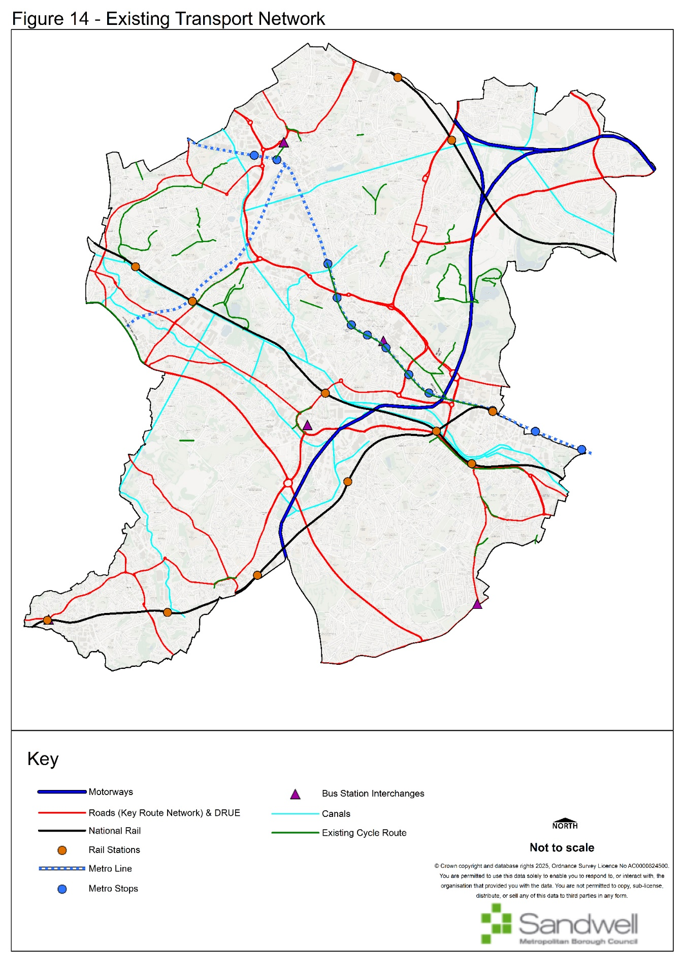

Priorities for the Development of the Transport Network
- It is acknowledged that the COVID19 pandemic and its aftermath, and the resultant shift towards homeworking has impacted on the way in which transport is used. In particular, there has been a significant impact on public transport patronage levels, which may take many years to recover to pre-pandemic levels.
- However, high-quality public transport combined with the provision of an extensive safe and convenient active travel (walking and cycling) network remains at the heart of the West Midlands transport strategy. The development of the transport network is focused on a step change in public transport provision through serving and linking centres, improving sustainable transport facilities and services across the area, improving connectivity to national networks and improving the efficiency of strategic highway routes.
- Additionally, transport strategy in Sandwell, and the wider West Midlands, has a key role to play in reducing carbon emissions and the impact on the natural environment. The Sandwell Local Plan will therefore need to focus on promoting the appropriate design, location and layout of development, increasing investment in infrastructure, improving the quality, equality and accessibility of public transport, supporting walking and cycling, enhancing road safety and reducing the amount of emissions produced by transportation.

Policy STR1 – Priorities for the Development of the Transport Network
- Land needed for the implementation of priority transport projects will be safeguarded to allow for their future delivery.
- All new developments must provide adequate access for all modes of travel, prioritising walking, cycling and public transport to influence travel choices. Residential development will be expected to meet the accessibility standards set out elsewhere in this Plan.
- Key transport corridors will be prioritised through the delivery of infrastructure to support active travel (walking, cycling), public transport improvements, traffic management (including localised junction improvements) and road safety.
- Key transport priorities identified for delivery during the lifetime of the SLP currently include the following:
- Motorways:
    - M5 Improvements (Junctions 1 and 2)
- Rail:
    - Midlands Rail Hub
- Rapid Transit:
    - Wednesbury – Brierley Hill
    - A34 Walsall Road Sprint Corridor
    - Walsall – Stourbridge corridor tram-train extensions
- Key road corridors including the following (but not limited to):
    - A4123 Corridor Upgrade
    - A461 Black Country Corridor
    - A457 / B4135 Oldbury, Smethwick to Birmingham Corridor
    - A4034 Blackheath and Oldbury Corridor
    - West Midlands Core Bus Network corridors
- Interchanges:
    - Dudley Port Integrated Transport Hub

Justification
- Good connectivity to the wider regional national transport networks and Birmingham International Airport for both passengers and freight has been identified as being necessary to support the regeneration of Sandwell. The economic growth will be supported by improved access to major global economies.
- Movement for Growth sought to enable all residents being able to access at least three strategic centres within 45 minutes (AM peak). This has been carried forward into LTP5 as the “45 Minute Region” concept that envisages this being achieved through a combination of frequent rapid transit services and high quality “turn up and go” bus services.
- A strategic public transport “spine” comprising high quality, reliable, fast and high-capacity rapid transit between the strategic centres - Brierley Hill, Walsall, West Bromwich, Wolverhampton and Birmingham remains a crucial element of the Black Country’s and Sandwell’s transport strategy. It is necessary to support the role of these centres as a focus for employment, shopping and leisure, and increasingly housing.
- Currently Metro line 1 provides the required standard of link between Wolverhampton, West Bromwich and Birmingham but it is important that the public transport modes of rail, metro and bus are better integrated to ensure that people can use them to travel where and when they need to. The combination of the Wednesbury to Brierley Hill metro extension and the proposed Dudley Port Integrated Transport Hub have now added Dudley to the rapid transit network which will eventually also include Brierley Hill through the completion of the extension.
- The Black Country Rapid Transit study of 2016 concluded that full delivery of the Public Transport Spine would best be achieved by completing the Stourbridge to Walsall corridor as a tram-based facility (subject to the adoption of Tram-Train technology) whilst the Walsall to Birmingham link should be catered for through bus rapid transit. This is the A34 SPRINT project, Phase 2 of which is currently being delivered.
- The completion of feasibility studies into the provision of the Stourbridge to Brierley Hill and Wednesbury to Walsall rapid transit proposals will be an early requirement for taking the strategy forward, with the latter providing improved connectivity for residents in Tipton and Wednesbury in particular.
- It is vital that new development has access to high quality public transport facilities and services from the outset as this will ensure that people travelling to and from these areas do not establish unsustainable travel patterns due to the initial absence of good public transport.
- The Sandwell Local Plan supports the delivery of an enhanced transport network for the borough, to ensure a seamless integration of land-use and transport planning and to demonstrate the strong interdependency of future land-use decisions and adequate servicing by a variety of travel modes. The exact mode of public transport should reflect existing demand and take account of potential future economic or housing growth points to ensure an integrated approach to sustainable development and travel patterns. This is essential to support the scale of growth proposed for the core regeneration areas and strategic centres and to create an effective transportation system to support sustainable communities. This transport network will provide communities with access to employment, leisure, education and health care and will facilitate improved access to employment sites.
- In this regard the re-opening of rail corridors such as Walsall to Aldridge, the delivery of an upgraded Wolverhampton to Shrewsbury line and the Midland Rail Hub (developed through Midlands Connect) will support housing growth both within Sandwell and in those areas meeting housing and employment need beyond the borough’s boundaries.
- The operation of the highway network needs to be improved to support the growth and long-term viability of Sandwell’s economy whilst limiting the environmental effect of transport usage. The emerging LTP5 sets out a strategy to help achieve the West Midlands target for net zero carbon emissions by 2041 by making the best use of the existing highway network in a coordinated way through a programme of Key Route Network (KRN) corridor-based multi-modal improvements.
- New highway building within Sandwell will be mainly in support of regeneration, but some key junctions on the DfT’s Major Road Network and the West Midlands Key Route Network such as important links for public transport and to the motorway network for freight will be improved by major construction schemes. Highway improvements, especially those located on the West Midlands Metropolitan Cycle Network or the Core Bus Network (see Figure 16), will be expected to address the needs of all users, especially pedestrians and cyclists, and to cater for bus priority in line with current Government guidance.
- The Council will investigate road space reallocation to facilitate public transport and active travel wherever physical constraints permit it. However, due regard will be given to the Council’s obligations as Local Traffic Authority under the Network Management Duty contained in the Traffic Management Act 2004.
- Strategic Employment Areas are defined in terms of good access standards to the motorway network. As no new motorways are planned within the lifetime of this plan the M6, M5 and M54 motorways will remain vital transport links for Sandwell business and freight.
- Buses will continue to dominate local public transport provision in Sandwell throughout the plan period. 85% of all passenger miles were catered for by bus prior to the COVID19 pandemic and bus services have recovered at a faster rate than either rail or metro. The National Bus Strategy (2021) requires bus priority to be an integral part of all highway improvements. Therefore, work on the key corridors identified in the West Midlands Bus Service Improvement Plan (BSIP) will play a significant role in delivering this requirement, through a partnership of TfWM, Local Highway Authorities and operators. Specific local measures to help buses will be delivered in other locations where appropriate, along with the upgrading of bus stations in strategic and other centres where demand resulting from the concentration of new developments requires it. Coaches also have a role to play in providing affordable long-distance connectivity and access facilities to and from major Black Country destinations and will be encouraged.
- While improvement of accessibility to bus services will be a priority, some people will have little choice but to make the first part of their journey by car. The success of Park and Ride in contributing to a sustainable travel pattern will depend on minimising the distance driven before transferring to public transport. Well-located Park and Ride facilities can provide a realistic alternative for many car drivers; they can contribute to environmental improvement by reducing congestion on radial routes into centres at peak times and by improving public transport patronage. However, new Park and Ride sites will only be developed in accordance with the adopted West Midlands Park & Ride strategy.
- As transport projects reach the design stage, there will be a need to safeguard land needed for the implementation of those schemes. Where projects are sufficiently advanced, improvement lines will be imposed and land will be safeguarded through the SLP and the Policies Map.
- During the development of new transport schemes, the Council and its partners will exercise due diligence in preventing harm to the historic environment. Where appropriate, due to the size or nature of the scheme, an historic impact assessment will be undertaken.
- Appendix J provides further details on the proposals that make up the transport priorities set out above. The main interventions are also identified on Figure 15 – Transport Improvements Plan.

Figure 15 - Transport Improvements Plan
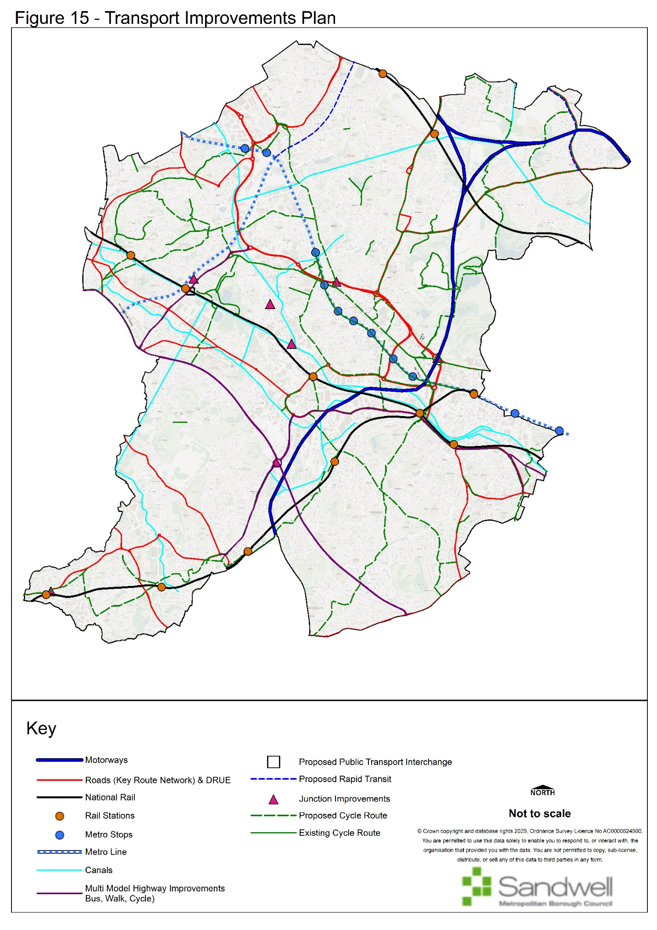

Figure 16 - Core Bus Network Plan
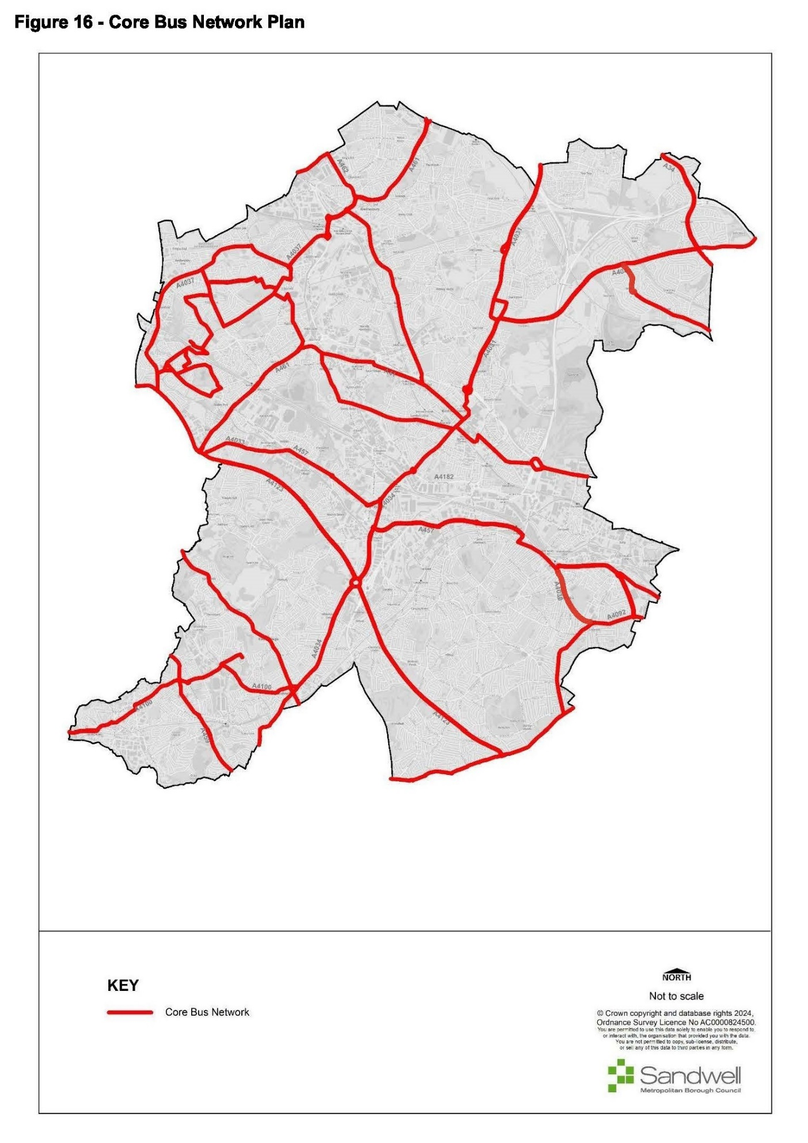

Safeguarding the Development of the Key Route Network (KRN)
- The West Midlands Key Route Network (KRN) (Figure 14) caters for the main strategic demand flows of people and freight across the metropolitan area whilst providing connections to the national strategic road network (SRN). Highway capacity will be used to effectively cater for movement by rapid transit and core bus routes, the Metropolitan Cycle Network, lorries, vans and private cars. This will involve the reallocation of road space where appropriate to provide reliable, high volume public transport and segregated active travel provision. There will be an enhanced role for traffic management using new technology via the West Midlands Regional Transport Coordination Centre (RTCC).

Policy STR2 – Safeguarding the Development of the Key Route Network (KRN)
- Sandwell will, in conjunction with Transport for West Midlands and other neighbouring local highway authorities, identify capital improvements and management strategies to ensure the KRN meets its strategic functions.
- Land needed for the implementation of improvements to the KRN will be safeguarded to assist in their future delivery.
- Where new development is expected to result in adverse impacts on the KRN, appropriate mitigation measures will need to be identified through transport assessments and provided through planning obligations.
- When working with neighbouring authorities, sub-national transport bodies, infrastructure providers and statutory bodies, there will be a focus on reducing the impact of private car use on the KRN and delivering a net-zero transport system.

Justification
- The West Midlands Key Route Network not only serves the main strategic demand flows of people and freight across the metropolitan area and provides connections to the national strategic road network. It also serves large local flows that use main roads and will need to provide good access for businesses reliant on road-based transport. The network will use highway capacity effectively to cater for movement by rapid transit and core bus routes (the West Midlands Core Bus Network as shown on Figure 16 or as amended from time to time), the Metropolitan Cycle Network, lorries, vans and private cars. This will involve the reallocation of road space where appropriate to provide reliable, high volume public transport and enhanced cycling facilities. However, the Council's duties under the Traffic Management Act 2004 will be taken into consideration when developing proposals.
- The Key Route Network has been defined on the basis of a West Midlands Combined Authority definition agreed with the seven highway authorities, in consultation with neighbouring highway authorities. Since 2025, the power to alter the KRN has been devolved to the WMCA Mayor. All policies relating to the KRN will apply to the network as amended from time to time. The KRN features agreed performance specifications drawn up for different types of links in the network in accordance with their role for movement (“link”), and their role as a destination in its own right e.g., a suburban / town centre high street (“place”).
- Improvements will be implemented to meet the agreed performance specification for the links and junctions involved to support road based rapid transit proposals such as SPRINT (Bus Rapid Transit) and Metro. Improvements will take into account guidance contained in the National Bus Strategy and the West Midlands Vision for Bus. Where routes also form part of the Metropolitan Cycle Network, the standards contained in Local Transport Note 1/20 will be applied.
- Capital scheme improvements will be identified where appropriate, but it also is vital that this network is managed efficiently through the collaboration of all four Black Country authorities and Birmingham City Council in their role as Local Highway Authorities, along with National Highways.

Managing Transport Impacts of New Development
- To ensure that the transport elements of the Sandwell Local Plan are deliverable, it is essential that both new developments and existing facilities identify travel and transportation impacts and proposals for mitigation. It is important that accessibility by a choice of sustainable modes of transport is maximised. Transport Assessments and Travel Plans produced by developers, employers, schools and facility operators are essential to bring about sustainable travel solutions and help deliver Strategic Objectives 2 and 16.

Policy STR3 – Managing Transport Impacts of New Development
- Planning permission will not be granted for any proposals that are likely to have significant transport implications, unless accompanied by mitigation schemes that demonstrate an acceptable level of accessibility and safety can be achieved using all modes of transport to, from and through the development. Mitigation schemes must in particular address access by walking, cycling, public transport and shared transport, for example by facilitating car clubs.
- These proposals should be in accordance with an agreed Transport Assessment, where deemed necessary by the Local Highway Authority, and include the implementation of measures to promote and improve such sustainable transport infrastructure and facilities through agreed Travel Plans and similar measures.
- Sustainable transport modes must be made more convenient than car usage for the majority of journeys in order to promote genuine modal shift. They should be supported by the necessary management and regulatory measures if deemed necessary by the Local Highway Authority. Planning conditions and /or legal agreements may be required to ensure the implementation of agreed measures.

Justification
- All developments will be assessed both in terms of their impact on the transport network and the opportunities that could be available to ensure that the site is accessible by sustainable modes of transport. The supporting documentation will either take the form of a full Transport Assessment (TA) or a less detailed Transport Statement (TS) and will generally be determined by the size and scale of development or land use. This will be based on guidance from individual authorities with a TA sometimes being required instead of a TS based on reasons other than spatial thresholds; road safety concerns, existing congestion problems, air quality problems, concerns over community severance or likelihood of off-site parking being generated.
- TfWM’s guide for developers should be routinely consulted for larger developments.
- Where a development is considered to have a potential significant effect on the Strategic Road Network (SRN), National Highways will be consulted. In addition, National Highways should be consulted on developments considered to have a significant impact on the Strategic Road Network Designated Routes for Unplanned Events (DRUE). The SRN and DRUE are shown on Figure 15.

The Efficient Movement of Freight and Logistics
- New freight railways and rail sidings will present an economic opportunity for Sandwell’s businesses. Improved journey times on the Key Route Network will support economic prosperity and switching traffic to rail or inland waterways will relieve the highway network of traffic, thereby reducing congestion, improving air quality and the environment and reducing carbon emissions. The siting of key employment proposals will be steered towards locations with good access to the KRN to assist with reducing environmental impact, improve air quality and reduce carbon emissions. Improvements to the freight network are fundamental to achieving the Vision for sustainable communities, environmental transformation and economic prosperity and to delivering Strategic Objectives 2, 8 and 16.

Policy STR4 – The Efficient Movement of Freight and Logistics
- The movement of freight by sustainable modes of transport such as rail and waterways will be encouraged. Road-based freight will be encouraged to use the Key Route Network whenever practicable.
- The use of low emission vehicles, e-cargo bikes and other micro-mobility solutions will be encouraged, especially for 'last-mile' journeys.
- Junction improvements and routeing strategies will be focussed on those parts of the highway network evidenced as being of particular importance for freight access to employment sites and the motorway network.
- Proposals that generate significant freight movements will be directed to sites with satisfactory access to the Key Route Network.
- Existing and disused railway lines and sidings, and any that become disused in the future, will be safeguarded for rail-related uses.
- Sites with existing and potential access to the rail network for freight will be safeguarded for rail-related uses.
- Depots and train stabling facilities will be safeguarded.
- Consideration will be given to the movement of freight, goods and other courier services on Sandwell’s roads when determining location of new development.

Justification
- The level of motor traffic on Sandwell’s roads has increased, partly driven by the growing number of trucks, vans, mopeds, and bikes delivering groceries, parcels, and food takeaway services to online shoppers’ homes. There is a need to reduce the strain placed by e-commerce deliveries on Sandwell’s roads by, for example, identifying sites for parcel lockers, incentivise more “Click and Collect” options to reduce the volume of home delivery vehicles on the roads, catering for the use of e-cargo bikes, low emission vehicles and the use of micromobility to transport goods.
- Within the wider Black Country, freight traffic has always been particularly important, reflecting the area’s past level of manufacturing, and it remains significant today with industry, distribution and logistics giving rise to much freight traffic. This is reflected in both the M5 and M6 motorways, where the proportion of heavy goods vehicles can be 30% of total traffic, and the local road network where the traffic on many main routes has an exceptionally high percentage of heavy goods vehicles.
- Heavy Goods Vehicles account for 21% of all transport emissions, with Light Duty Vehicles accounting for 13%, meaning the road freight sector contributes 34% of transport emissions, despite freight representing just 19% of all vehicle miles undertaken in the UK. Making the most efficient use of the highway network whilst providing facilities to transfer freight from road to rail and inland waterways will play a major part in achieving the region’s climate change targets.
- The design and layout of much of the KRN in Sandwell dates from a period when goods vehicles were significantly smaller and lighter than those currently in use and this gives rise to problems of reliability and with deliveries and servicing. In many cases upgrading of these routes is neither economically viable nor environmentally desirable.
- Sandwell is a member of the West Midlands Freight Quality Partnership, as are freight operators and their national representative bodies. The Regional Freight Strategy sets a context for planning for freight within the Black Country sub-region. Removal of freight from the road to rail or canal will reduce congestion, and support investment in rail and canals.
- The railway network serving Sandwell and the wider Black Country suffers from capacity problems during the day when there is high demand for passenger services, and this has shifted much freight traffic to night-time operation. Of the disused lines the most important is Stourbridge-Walsall-Lichfield, which has been identified in the Regional Freight Strategy as being an important link for freight moving between the southwest and northeast regions. Locally, four sites have been identified as being suitable for rail connection if rail freight services are reinstated. Within the West Midlands conurbation, the Stourbridge to Lichfield link would act as a bypass for the rail network around Birmingham which has severe capacity constraints. The capacity released by the reopening of Stourbridge-Walsall-Lichfield, as well as benefiting the freight network, would allow extra passenger services to operate to and through Birmingham to the benefit of the wider West Midlands.
- The Regional Freight Strategy notes a shortage of private sidings in the West Midlands region. Sites with existing or potential rail access along current and proposed freight routes, particularly the Stourbridge - Walsall – Lichfield corridor, will be protected for rail-related uses.
- The Freight Strategy notes the need to address the increased importance of ‘last mile’ logistics and the role that transport innovation can play in this, e.g., through provision of parcel hubs, EV charging for delivery vehicles, etc. Where appropriate, locations for infrastructure to facilitate this will be identified through site allocations and in the SLP Infrastructure Delivery Plan.

Cycling and Walking Networks
- The development of sustainable modes of travel and encouraging people out of their cars, particularly for shorter and commuter journeys, is an important element of Strategic Objectives 1, 2, 8, 9, 10, 11, 16 and 18. Places need to be well-connected with attractive, convenient, direct and safe routes available to non-car users, thus providing real choice.
- The cycle network in the West Midlands consists of three tiers:
  - The National Cycle Network (NCN) – identified and developed by Sustrans in partnership with local authorities and shown on the Transport Key Diagram. This network provides long distance routes across the country linking major destinations. NCN Routes 5 (Reading to Holyhead via Birmingham) and 81 (Birmingham to Aberystwyth via Wolverhampton and Telford) both pass through Sandwell.
  - The Metropolitan Network (known as the Starley Network) – identified by WMCA in the Local Transport Plan and developed through the West Midlands Cycling & Walking Infrastructure Plan (WM LCWIP). These routes link strategic locations in the West Midlands and are also shown on the Transport Improvements Plan (Figure 15).
  - Local Networks – these are identified through individual authorities’ LCWIPs and are identified on the Transport Improvements Plan (Figure 15).
- The emerging Black Country Cycling Strategy will provide greater detail on those sections of the Starley network and the most important links in the local network.

Policy STR5 – Creating Coherent Networks for Cycling and Walking
- By working in partnership with Transport for West Midlands and neighbouring local authorities, Sandwell will ensure that it can create and maintain a comprehensive cycle network based on the four tiers of the West Midlands cycle network, including the use of common cycle infrastructure design standards such as LTN1/20 and Manual for Streets 2 or such future relevant guidance as may be appropriate.
- Creating an environment that encourages active travel requires new developments to link to existing walking and cycling networks. The links should be coherent, safe, direct, comfortable, attractive, and not impeded by other infrastructure including that provided for other forms of transport and digital / communication infrastructure.
- Where possible, existing links including the canal network should be enhanced and the networks extended to serve new developments.
- New developments should have good walking and cycling links to public transport nodes and interchanges.
- Where possible, a compact and legible urban realm with easy to reach destinations on foot and by cycle should be delivered, including appropriate signage and wayfinding.
- Cycle parking facilities should be provided at all new developments and should be in convenient locations with good natural surveillance, e.g., near to main front entrances for short stay visitors or under shelter for long stay visitors.
- The number of cycle parking spaces required in new developments and in public realm schemes should be determined using the guidance and standards set out in Appendix I.
- Sandwell Council will work with Transport for West Midlands and neighbouring local authorities on expanding the West Midlands Cycle Hire scheme and location and provision of cycle hire infrastructure will be integral when determining new development.
- The design of cycle infrastructure should be in accordance with the principles and standards contained in the Department for Transport’s Local Transport Note 1/20 (LTN1/20): Cycle Infrastructure Design.
- Where feasible, to improve the local environment for pedestrians and cyclists, measures to manage traffic should be considered, which may include measures such as modal filters, reducing traffic speeds, road space reallocation, and implementing parking management policies.

Justification
- It is essential that the development of walking and cycling facilities are an integral part of the transport system both on the highway network, canal corridors, Public Rights of Way and on other paths. Comprehensive cycle and walking networks within Sandwell will enable communities to access employment, public transport interchanges, services and facilities in a sustainable way.
- A transport network that facilitates car use and disadvantages walking and cycling can adversely affect the health and well-being of its communities. Identifying and overcoming barriers to walking and cycling during development processes will encourage a renaissance of walking and cycling within the borough and help improve the health and well-being of local communities by reducing the incidence of obesity, coronary heart disease, strokes and diabetes.
- Both walking and cycling are active modes of travel with clear health benefits. The implementation recognises the specific requirements of each with dedicated, segregated cycling provision being the default objective along with a comprehensive network of walking opportunities available both on highway and off road.
- Walking and cycling strategies are incorporated within the West Midlands Local Transport Plan. Their over-arching framework is the West Midlands Local Cycling & Walking Infrastructure Plan. The four Black Country local authorities are jointly preparing a Cycling Strategy for the sub-region, and each will develop their own local cycling and walking infrastructure plans during the lifetime of the SLP.
- All new cycle facilities will be designed in accordance with guidance set out in Local Transport Note 1/20 and TfWM’s Cycle Design Guidance. Where cycle routes and associated facilities are located in areas of heritage, archaeological or ecological sensitivity, their design should take this into account.

Influencing the Demand for Travel and Travel Choices
- The management of the demand for road space and car parking, together with influencing travel choices, is fundamental to achieving the Vision for sustainable communities, environmental transformation and economic prosperity and to delivering Spatial Objectives 1, 2, 8, 16 and 18.

Policy STR6 – Influencing the Demand for Travel and Travel Choices
- Sandwell is committed to considering all aspects of traffic management in the centres and wider area in accordance with the Traffic Management Act 2004. The priorities for traffic management in Sandwell are:
- identifying appropriate strategic park and ride sites on current public transport routes to ease traffic flows into centres;
- working together with the rest of the region to manage region-wide traffic flows through the West Midlands Regional Traffic Control Centre and further joint working;
- implementing demand management measures to restrain car usage and managing car parking demand, thereby encouraging behaviour change and increasing travel by sustainable modes of transport;
- providing better accessibility to shared transport services such as demand responsive transport services, mobility hubs and ‘car clubs’, reducing the need to travel long distances by car or helping people to travel by more sustainable modes of transport;
- providing better transport planning advice and information in partnership with TfWM’s Behaviour Change Hub;
- maximising access to high-speed broadband / digital infrastructure will be required to enable smarter working for those that are able to do so, thus further reducing the need to travel.

Justification
- The SLP Spatial Strategy aims to make the network of town and city centres as attractive and accessible as possible, to encourage use of the most sustainable modes of travel.
- An important aspect of demand management is the prioritisation and allocation of road space. Using schemes such as traffic calming measures and full or time limited pedestrianisation will help in encouraging sustainable methods of travel such as walking, cycling and buses, by making these modes more attractive to people visiting the centres.
- Other important elements include the promotion and marketing of sustainable transport through travel plans (Policy STR3), planning conditions / obligations and other associated sustainable mobility initiatives, including the promotion of schemes and opportunities for walking, cycling, micro-mobility (such as e-scooters), public transport and car sharing. These policies will reduce road traffic congestion and pollution, improve road safety, promote social inclusion and accessibility, therefore encouraging consumers to access the four strategic centres using sustainable transport.
- It is recognised that there will always be instances where the use of a car is necessary. However, this can still be achieved without the need to own a car. Where appropriate, the introduction of car clubs, which provide access to vehicles on an ‘as-and-when required’ basis, will be encouraged.

Network Management
- Sandwell Council is committed to making the best use of its budgets and advocates an asset management approach for the maintenance of its highway network, to help deliver the best long-term outcomes for local communities.

Policy STR7 – Network Management
- Depending on the location of new development, the deployment of advanced and smart technologies that allow the public to plan their journeys more effectively may be appropriate; for example, by providing real time travel information and satellite navigation systems, Variable Message Signs (VMS) along congested parts of the network and digital sensors / cameras to monitor traffic and collect data on traffic patterns for future planning.
- All new developments that impact the existing highway network, or which result in a new asset to be adopted by the Local Highway Authority, may be subject to fees and obligations for the maintenance of the highway network as part of a relevant legal agreement

Justification
- Much of the highway network in Sandwell is constrained by its urban fabric, resulting in narrow roads and footways. In many cases the overall highway width is such that there is limited scope to accommodate infrastructure dedicated to specific modes or groups of vehicles. Therefore, the use of advanced technology to help manage the use of road space will be vital to ensuring that maximum benefit can be derived from the asset.
- However, where development includes the provision of new infrastructure, including dedicated infrastructure for cyclists, buses etc., there will be a need to provide for its ongoing maintenance to mitigate the impact on future highway authority budgets.

Parking Management
- The management of car parking is fundamental to achieving the Vision for sustainable communities, environmental transformation and economic prosperity. It also has a key role in reducing the impact of vehicle trips on air quality and carbon emissions.

Policy STR8 – Parking Management
- The priorities for traffic management in Sandwell include the sustainable delivery and management of parking in centres and beyond, through use of some or all the following measures as appropriate:
  - The management and control of parking - ensuring that it is not used as a tool for competition between centres;
  - The type of parking – ensuring that where appropriate long-stay parking is removed from town centres, to support parking for leisure and retail customers and to encourage commuters to use more sustainable means and reduce peak hour traffic flows;
  - Maximum parking standards – ensuring that a consistent approach to maximum parking standards is enforced in new developments as set out in the guidance and standards contained at Appendix I;
  - The location of parking – by reviewing the location of town centre car parks through the “Network Management Duty”, to ensure that the flow of traffic around town centres is as efficient as possible;
  - Providing more convenient, secure and accessible cycle parking will be a critical part of increasing cycling in Sandwell and making it a natural first choice for journeys. Considering different users and types of cycle parking will be an essential part of this and new developments should consider this in accordance with guidance set out in Appendix I.

Justification
- The correct balance needs to be found between managing and pricing of parking to maximise the use of sustainable travel means to enter town and city centres, whilst avoiding restricting parking to the extent that consumers are dissuaded from using town centres and deterring new development.
- The control and management of parking in centres will require a variety of approaches, recognising that not all publicly available car parking is in local authority control or management. The use of planning conditions to ensure that new public parking is managed appropriately will therefore be an important aspect of this policy.
- The continued adoption of maximum parking standards for all but residential development is an important tool in managing demand for single-occupancy vehicle trips to centres and major employment destinations, leisure and other facilities.
- Reduced levels of long-stay car parking in centres will enable more efficient use of land.
- Where new development that includes parking controls and management to encourage alternative modes for staff and visitors has the potential to impact on adjacent residential areas, post-occupation monitoring may indicate a need for the introduction of residents parking schemes and other traffic management measures. Agreements to secure this will be sought as part of the Development Management process.
- Additional parking enforcement may be required because of new development. Should this require additional resources and thus increase the cost of enforcement for the Council, the developer may be required to contribute to the increased cost of undertaking parking enforcement activities as part of any planning obligations agreement.

Planning for Low Emission Vehicles
- The UK government plans to ban the sale of petrol and diesel cars by 2035, having previously committed to do so by 2030. The resultant societal shift from petrol and diesel internal combustion engine (ICE) vehicles to ULEVs will require widespread support from local authorities as well as the provision of infrastructure by the private sector. It is projected that there will an addition 42,500 ULEVs within the Black Country by 2025. The Black Country ULEV strategy sets out a framework for how the authorities can support this transition.

Policy STR9 – Planning for Low Emission Vehicles
- Proposals for low emission vehicles will be supported by:
  - Ensuring that new developments include provision for charging infrastructure in accordance with current legislative and regulatory guidelines;
  - Measures to encourage LEV use through travel plans and other initiatives;
  - Where appropriate the Council will facilitate the introduction of charging points in public locations;
  - Working with partners to explore support for alternative low emission vehicle technologies, such as hydrogen fuel cells, across a range of modes; private cars, buses and / or small passenger and fleet vehicles.

Justification
- In July 2019, the West Midlands Combined Authority committed to setting a ‘net zero’ emissions target by 2041, with a climate action plan being approved by the WMCA board in January 2020. The WMCA Board further approved a regional ULEV strategy in February 2020. The Black Country ULEV strategy sits under this regional document. Whilst the WMCA ULEV Strategy focusses on sharing best practice, co-ordination and possible joint delivery of a large-scale network of rapid charging ‘hubs’, the Black Country ULEV strategy takes a more granular approach, focussing on the specifics of each authority and offering a framework for the delivery on infrastructure on the ground.
- The study found that the Black Country lags behind the rest of the country when it comes to adoption of ULEVs. This is reflected in the availability of charging infrastructure across the four authorities, with around 80% of the sub-region further than one km from the nearest publicly available charge point. However, relative to median wage, Sandwell sits on or above the trend for ULEV adoption, indicating higher uptake than might be expected given the average wage across each of the four authorities.
- It is acknowledged that a straight one-for-one replacement of ICE vehicles with ULEVs, particularly electric cars, will continue to have implications for air quality; EVs are generally heavier and produce higher levels of PM2.5 than ICE cars, whilst the large size of many EVs means that they require more space to park. Therefore, the adoption of ULEVs should not reduce the overall objective of increasing the take-up of public transport usage and active travel modes to reduce reliance on the use of the car.

Transport Innovation & Digital Connectivity
- The historic relationship between the West Midlands’ economic success and mobility goes beyond increasing travel. The West Midlands is a key UK centre of automotive manufacturing and production. It is also part of the UK’s so called “Golden Triangle”, within a four-hour drive to all major UK ports and 90% of the UK’s population. As such, Sandwell is the location of choice for some of the UK’s major industries and largest distribution centres. Freight and logistics, a key sector for Sandwell and the wider West Midlands, supports almost every other economic sector, employing thousands of people and contributing extensively to Inclusive Growth. There are also those employed in public transport services in the region, including many who work for Mobico (formerly National Express Group), a leading public transport operator with bus, coach and rail services across the world, and headquartered in the West Midlands.
- An ever-evolving transport technology sector will represent great challenges and opportunities to industry, both in terms of products and services created in and exported from Sandwell, and those created in the borough and used by local residents. For example, the freight and logistics sector faces a great challenge in phasing out internal combustion engines, but also in reducing vehicle miles through consolidation of deliveries and minimising the impacts of delivery vehicles in places with high pedestrian footfall. However, there are also plenty of opportunities for new industrial activity in the provision of transport products and services that better support Inclusive Growth, given that significant demand for transport will remain.

Policy STR10 – Transport Innovation and Digital Connectivity
- Opportunities for integrating 5G connectivity within the transport network should be explored when development proposals, masterplanning and major housing and employment schemes are being promoted, to improve transport services and ensure there is 5G connectivity throughout Sandwell. This should include the provision of 5G connectivity as part of new development proposals, which will encourage more people to connect remotely, reducing the need to travel (see Policy SID2).
- Sandwell will ensure the integration of ‘smart infrastructure’ where possible as part of new development proposals. In transport terms, examples of smart infrastructure include:
  - smart parking sensors, which provide live parking capacity data;
  - traffic signals that can respond to levels of congestion and prioritise sustainable transport modes; and
  - transport volume monitoring sensors, which can provide information on the use of different modes, journey time or tracking data.
- Working in partnership with Transport for West Midlands and neighbouring Local Authorities, Sandwell will facilitate Mobility as a Service and will ensure this is integrated into any new infrastructure where applicable.

Justification
- The West Midlands currently leads on the Industrial Strategy’s ‘Future of Mobility’ grand challenge, building on its existing strengths in automotive innovation (e.g., the UK Battery Industrialisation Centre), and connected supply chains in rail, automotive and aerospace as well as digital communications with the West Midlands 5G testbed. The region is piloting and leading on a broad spectrum of transport innovations and technologies including micromobility (such as e-scooters), Mobility as a Service (MaaS), connected autonomous vehicles (CAV) and mobility credit trials. The region has also developed a UK first proposal for a transport regulatory ‘sandbox’ to help test and develop new solutions to transport challenges. The West Midlands already has well-developed infrastructure and energy plans to support the shift to zero carbon. Therefore, cementing its position as a UK industry leader in mobility sectors will attract new investment, create and sustain highly skilled jobs, accelerate clustering and catalyse innovation - boosting the international competitiveness of the region.
- Technological advances in the management and operation of traffic signals, and the further expansion of the use of urban traffic control (UTC) systems on Sandwell’s network has the potential to improve the efficiency of the network without wholesale changes to highway geometry. Investment in upgraded signal equipment and improved control technology at Junction 1 of the M5 during 2023 resulted in an approximate 10% increase in junction capacity with no physical changes to the junction’s layout.

Infrastructure and Delivery

Introduction
  - A key role of the SLP is to plan for the growth required for a sustainable and prosperous Sandwell. The Borough is planning to accommodate 11,901 new houses and provide for 1,221ha of employment land (of which 28ha is currently vacant) up to 2041. Ensuring effective delivery of this amount of development will require strong collaborative working with public, private and third sector partners, involving a robust process of infrastructure planning and delivery.

Infrastructure Provision
  - The provision of appropriate infrastructure in a timely manner underpins the transformational and regeneration strategy of the SLP and these policies are intended to ensure the delivery of all spatial priorities.
  - Physical and social infrastructure is necessary to enable and support the growth required over the Plan period. New housing and economic development will put pressure on existing services and utilities but may also create opportunities to provide robust and innovative infrastructure solutions.
  - The SLP is supported by an Infrastructure Delivery Plan (IDP), which draws upon a range of evidence including transport modelling, a Utilities Infrastructure Capacity Study, a Water Cycle Study, and a Viability and Delivery Study. This evidence underpins the SLP by identifying infrastructure investment required to support development, potential constraints to delivery and the key delivery mechanisms and partners.
  - The SLP adopts a brownfield-first approach to maximise delivery of development within the urban area; however, poor ground conditions that are a legacy of Sandwell’s mining and industrial past are a substantial constraint, in both physical and financial terms. Therefore, tackling significant and structural delivery constraints are a priority for interventions, as they affect much of the development land supply in the urban area. The Council is working in partnership with the West Midlands Combined Authority to ensure that brownfield land is prioritised for development opportunities and funding intervention.
  - Where valuable mineral resources are present, and it is viable to extract them as part of a remediation scheme, this may also help offset costs.
  - Parts of Sandwell’s existing highway infrastructure suffers from congestion. The transport modelling evidence is available to view alongside the SLP and updated transport modelling work is ongoing, to inform the Plan as it progresses. Assuming that proposals for improved public transport, walking and cycling are delivered, it is not anticipated that the development of new housing and employment land will have a significant additional impact on the strategic highways network.
  - Most new housing development in the urban area will enjoy good accessibility, including to sustainable modes of transport, centres of employment, schools, shops, health facilities and other residential services. This should help to reduce the requirement for additional travel and will also help mitigate the impact of development.
  - Infrastructure investment will be required to support development, including:
- public open space
- transport provision
- school places
- health facilities
- affordable housing
- sustainable drainage systems
- wastewater treatment
- waste management

Transport and Access to Residential Services
  - Changes may be required to the way that Sandwell is powered over the Plan period, together with an increasing reliance on digital solutions. Where gaps in service provision exist, service providers are aware of them and will work to address them.
  - As identified in the Economic Development Needs Assessment (EDNA), the Black Country comprises a clearly defined functional economic market area (FEMA) with strong employment and labour market links to a hinterland with Birmingham and South Staffordshire districts. It is a fast-growing functional economy and has the capacity to deliver significant growth, given the diversity, resilience and concentration of key national sectors located in the area. However, skills challenges are holding it back.
  - Economic development strategies (including the Strategic Economic Plan (SEP) and Local Industrial Strategy) have sought to address these challenges and to accelerate the growth of the local economy, and there are major investment plans in the Black Country – including for transport infrastructure, which is crucial to meeting the ambitions identified at a regional level.
  - Considerable investment is taking place in the Black Country, including the delivery of projects within Sandwell through working with the West Midlands Combined Authority. Some key projects that will take place over the life of the SLP include the regeneration of West Bromwich and other town centres, and many of these projects are, and will, benefit from funds such as:
- Devolved Housing Deal;
- Levelling Up Funds;
- Towns Fund;
- Future High Streets;
- Transport settlements including City Regions Sustainable Transport Settlement (CRSTS).
Other infrastructure likely to be delivered before and during the plan period are:
- The rollout of a fast-charging network for electric vehicles, ensuring that drivers will never be further than 30 miles from a rapid charging station;
- Updated digital infrastructure rollout.

Planning Obligations
  - Planning obligations currently deliver local infrastructure improvements necessary to mitigate the impact of development on the local area. Examples include affordable housing provision, access improvements, open space and residential services.
  - Financial viability has always impacted on the extent of planning obligations that can be secured in in Sandwell, particularly in areas suffering from poor ground conditions. The SLP will be introducing requirements for sustainable design and for development to adapt to and mitigate against climate change. As informed by the Viability and Delivery Study, viability impacts will vary according to the size, type (i.e., greenfield or brownfield) and location (e.g., whether the site is within a low or high value area) of the sites involved. It is likely that interventions may be necessary to bring forward development on some of the more constrained sites within lower value areas.
  - The Community Infrastructure Levy (CIL) provides opportunities for local authorities to generate contributions for local and sub-regional infrastructure through a levy on a wide range of developments. This can present opportunities to provide a range of infrastructure currently beyond the scope of planning obligations. The Council has an adopted CIL charging regime, which has been endorsed by the Viability and Delivery Study. The Viability and Delivery Study has confirmed that the CIL charges should not increase from their current rates.

Policy SID1 – Infrastructure Provision and Viability Assessments
- All new developments should be supported by the necessary on and off-site infrastructure to serve its needs, mitigate its impacts, and ensure that it is sustainable and contributes to the proper planning of the wider area.
- Unless material circumstances or considerations indicate otherwise, development proposals will only be permitted if all necessary infrastructure improvements, mitigation measures and sustainable design requirements and proposals are provided and /or can be phased to support the requirements of the proposed development. These will be secured through planning obligations, the Community Infrastructure Levy / Infrastructure Funding Statements, planning conditions or other relevant means or mechanisms as necessary, to an appropriate timetable that is prioritised, resourced, managed, delivered and co-ordinated.
- A planning application that complies with up-to-date policies within this plan will be assumed to be viable and should provide any relevant planning contributions necessary to make it acceptable in planning terms.
- Where an applicant submits a planning application that seeks to make a reduced planning contribution on viability grounds, financial viability assessments conforming to national guidance will be required to be submitted prior to determination and, where necessary, independently appraised by an appropriate professional appointed by the local planning authority at the cost of the applicant. The onus will be on the applicant to demonstrate that the provision of planning contributions would adversely affect the financial viability of the development proposals.
- Any viability assessment should be prepared on the basis that it will be made publicly available.
- On sites where applying the relevant planning contributions, affordable housing or accessibility requirements set out in Policies SHO4 and SHO5 can be demonstrated to make the development unviable, the maximum proportion of such housing will be sought that will not undermine the viability of the development, subject to achieving optimum tenure mix and securing other planning obligations necessary for the development to gain planning permission.
- Sandwell Council will set out in an Infrastructure Delivery Plan (to be reviewed annually):
  - The infrastructure that is to be provided or supported.
  - The prioritisation of and resources for infrastructure provision
  - The scale and form of obligation or levy to be applied to each type of infrastructure.

Justification
  - The scale of growth proposed in the SLP will have impacts on the local environment and the capacity of a range of infrastructure and facilities. It is important that the appropriate investment takes place to ensure, future development is sustainable. The definition of infrastructure in this context, for which overall targets and standards are set in the SLP and national planning policy, is wide, including:
  - affordable housing;
  - renewable energy;
  - publicly accessible open space;
  - sustainable drainage;
  - sport and recreational facilities;
  - biodiversity net gain;
  - transport, including active travel;
  - air quality mitigation measures;
  - residential services; and
  - public services including emergency facilities.
  - These requirements are set out in more detail within the appropriate sections of the SLP, with related policies and guidance contained in Supplementary Plans. Policy requirements set out in the SLP have been subject to a proportionate assessment of viability to ensure that those requirements are realistic, and the cost of meeting the needs of relevant policies will not undermine the deliverability of the Plan. Each development proposal must address its own impacts through on-site and offsite provision or enhancements, secured through planning obligations or other relevant means.
  - Analysis suggests that education infrastructure needs arising from the proposed SLP growth are likely to be accommodated via expansions to the current school estate as opposed to the creation of a new school(s). However, due to the SLP plan period extending beyond current education forecasts, this analysis would be ongoing, and contributions may subsequently be required.
  - Like education provision, analysis suggests that additional GP consulting rooms may be required in certain parts of the borough, depending on the scale and nature of proposed developments. Consultation with key infrastructure providers will be conducted throughout the planning process to determine if contributions are required on a site-by-site basis.
  - Where the combined impact of several developments creates the need for infrastructure in an area, it may be necessary for developer contributions to be pooled to allow the infrastructure to be secured in a fair and equitable way. Pooling may take place both between developments, and between Sandwell and other local authorities where there is a cross-boundary impact.
  - Viability issues can vary significantly from site to site and are often caused by poor ground conditions, the extent of which cannot be accurately assessed until the planning application stage. Therefore, to maximise delivery of affordable housing over the plan period, it is important that affordable housing is sought on all eligible sites and that viability will be assessed on a site-by-site basis where required.
  - Planning obligations currently deliver local infrastructure improvements necessary to mitigate the impact of development on the local area. Examples include affordable housing provision, access improvements, open space and residential services.
  - Financial viability has always impacted on the extent of planning obligations that can be secured in in Sandwell, particularly in areas suffering from poor ground conditions. The SLP will be introducing requirements for sustainable design and for development to adapt to and mitigate against climate change. As informed by the Viability and Delivery Study, viability impacts will vary according to the size, type (i.e., greenfield or brownfield) and location (e.g., whether the site is within a low or high value area) of the sites involved. It is likely that interventions may be necessary to bring forward development on some of the more constrained sites within lower value areas.
  - The Community Infrastructure Levy (CIL) provides opportunities for local authorities to generate contributions for local and sub-regional infrastructure through a levy on a wide range of developments. This can present opportunities to provide a range of infrastructure currently beyond the scope of planning obligations. The Council has an adopted CIL charging regime, which has been endorsed by the Viability and Delivery Study. The Viability and Delivery Study has confirmed that the CIL charges should not increase from their current rates.

Digital Infrastructure
  - Planning policy can play an important role in helping to address the key digital connectivity infrastructure needs of Sandwell. Fast and reliable digital connectivity is now a standard utility requirement for all new developments, to the point where Part R of the Building Regulations were amended to introduce gigabit broadband infrastructure and connectivity requirements for the construction of new homes in England.
  - Sandwell Council is also looking to help close the “digital divide” through initiatives designed to provide people who do not currently have sufficient access to digital services and technology with second-hand PCs, laptops and tablets. This will enhance their digital skills and create opportunities for personal growth and development. By extending the benefits of technology to underserved groups, Sandwell Digital Donations is playing a pivotal role in creating a more inclusive and connected society.

Policy SID2 – Digital Infrastructure
- All major development proposals should be supported by a statement that details what digital infrastructure will be provided to serve the development and confirms that it will be available at first occupation.
5G, 6G and Future Digital Networks
- Any proposals for infrastructure to support the delivery of 5G and future, more advanced, digital networks will be supported in principle, subject to meeting the following criteria and the requirements of other local policies and national guidance:
- Proposals should be sensitively sited and designed to minimise impacts on the environment, amenity, and character of the surrounding area.
- Proposals should not have an adverse impact on areas of ecological interest or areas of landscape importance, and should protect and, where possible, enhance the significance of heritage assets and their setting (Policies SNE2 and SHE2).
- Proposals should demonstrate that proper regard has been given to location and landscaping requirements, including the potential for innovative solutions complementary to the immediate surroundings.
- The potential to use canal towpaths to accommodate digital infrastructure and cabling should be explored, where this would not adversely affect areas of ecological or historic interest (Policy SNE6).
- Operators proposing 5G and future, more advanced, digital network infrastructure are strongly recommended to enter early discussions with the Council.

Justification
  - Full fibre broadband is the future of connectivity and increases speeds from the 30MB available for “fibre to the cabinet” broadband to 1000MB (1GB). Currently, full fibre coverage stands at 57.2% in Sandwell - compared to 62.4% across England (February 2024). Full fibre provision is required to meet future demands for connectivity, as highlighted by a 50% increase in demand each year, and to enable the wider economic, health and service delivery benefits it will support.
  - At the local level, the availability, reliability and speed of broadband provision is a key consideration for house buyers and many view it to be as essential as more traditional utilities. Wider adoption will help reduce the need to travel, thereby improving highway safety and mitigating the transport impacts of new development, as reflected in the Key Route Network’s ‘Connecting Communities’ programme. Similarly, it is also a key concern in the public health and business sectors. However, despite the obvious benefits to developers and end-users, full fibre is not always provided in new residential and commercial properties.
  - Planning policy can play a role in helping to achieve the necessary transformation in broadband connectivity. The NPPF clearly recognises this and supports the delivery of advanced, high-quality communications infrastructure and the expansion of highspeed broadband where possible.
Infrastructure
  - Sandwell is working together with other authorities and the West Midlands Combined Authority as part of the WM5G Digital Forum to support the rollout of future proofed digital infrastructure. The WMCA is spearheading the digital agenda in the region through projects such as the West Midlands Digital Roadmap 2024 – 2027.
  - Currently most properties in the Black Country are connected to superfast broadband (fibre to the cabinet and copper to the premises with speeds up to 30MB) but future provision will be full fibre (fibre to the premises with speeds up to 1GB). Fibre to the premises (FTTP) is recognised by the Government as a Next Generation Access (NGA) technology and as a priority for investment. While superfast speeds can be achieved on current generation copper networks, it is widely accepted that NGA technologies should be prioritised.
  - The Government committed to gigabit-capable broadband by 2025 and it is Sandwell’s aspiration to support the rollout of full fibre across the borough as soon as possible. By supporting next-generation digital infrastructure provision, Sandwell is aiming to provide a futureproof solution for broadband delivery. Adopting this approach will prevent the need for fibre retrofitting programmes in the future, which have significant cost implications and can cause considerable disruption through road works. In Sandwell and elsewhere in the Black Country, canal and waterway corridors (especially towpaths) can provide alternative opportunities to provide digital communications infrastructure. According to recent evidence, Sandwell benefits from superfast broadband (over 30Mbps) to 99.8% of premises, and gigabit (over 900 Mbps as fibre to the premises or DOCSIS 3.1) to 96.5%.
  - To help deliver this aspiration, Policy SID2 requires developers to confirm that suitable digital infrastructure is available at every new property on all major developments.
  - In exceptional cases, where FTTP is not practical, consideration will be given to:
- non-Next Generation Access technologies that can provide speeds in excess of 30MB per second (or the latest requirement if higher) as an alternative;
- an affordable 1GB/s- capable connection being made available to all end users.
  - The intention of Policy SID2 is not to require developers to deliver FTTP solutions themselves. Instead, it focuses on the need to conduct early dialogue with telecom providers to best understand what their infrastructure specifications are and how these can be accommodated as part of the new development. The involvement of multiple telecoms providers at build stage will minimise the impact later.
  - To facilitate this, any application for a qualifying development should be supported by an “FTTP Statement”, which provides details of:
- dialogue with the telecom operators;
- how FTTP will be provided to serve the development;
- confirms that this process will be completed upon occupation of the first property on the development;
- that sufficient ducting space for future digital full fibre connectivity infrastructure is provided to all end users within that development.
  - Conditions will be applied to any subsequent permission to ensure that FTTP will be secured as envisaged by the statement. For outline applications, the statement may be more limited on specific details relating to the imminent implementation of FTTP and provide a commitment to supply these details later, including how and when the telecom operators will be consulted.

5G Network Infrastructure
  - 5G is mobile internet that is as fast as fibre, with speeds up to 1GB – five to ten times faster than current home broadband connectivity. 5G benefits include huge capacity, with the ability to connect thousands of users and devices at the same time at consistently ultrafast speeds. They are ultra-reliable and secure with low latency, which will be transformational for industry. The demand for mobile data in the UK is growing rapidly, and as households and businesses become increasingly reliant on mobile connectivity, the infrastructure must be in place to ensure supply does not become a constraint on future demand.
  - The Government wants the UK to be a world leader in 5G, and for communities to benefit from investment in such new technology. The NPPF expects planning policies and decisions to support the expansion of next generation mobile technology such as 5G. The West Midlands was selected as the UK’s first multi-city 5G test bed, paving the way for the future rollout of 5G across the UK and making the region the first in the UK ready to trial new 5G applications and services at scale.
  - To deploy 5G and improve coverage in partial “not-spots” (a place where wireless internet, especially broadband, services are not available), mobile network operators will need to strengthen existing sites to accommodate additional equipment. To extend coverage into total not-spots or to add capacity in areas of high demand, mobile network operators will also need to identify and develop new sites. Masts will need to be higher than at present to accommodate 5G, which may impact on local amenity and character in some areas.
  - Mobile Network Operators are encouraged to have early discussions with planning authorities and to communicate and consult with local communities, especially in the case of new sites. This will help to ensure that the best sites are selected for 5G infrastructure, and that equipment is sympathetically designed and camouflaged where appropriate, in line with principles set out in the NPPF and relevant local planning policies.
  - Where larger developments are planned, developers can consider the incorporation of potential sites for telecoms equipment to ensure 5G coverage.

Policy SID3 – 5G Network Infrastructure
- To ensure that the installation of masts is in full compliance with the requirements of the radio frequency (RF) public exposure guidelines of the International Commission on Non-Ionizing Radiation Protection (ICNIRP) applications for all prior approval and full planning applications must:
  - provide self-certification to the effect that a mobile phone base station when operational will meet the ICNRP guidelines; and
  - provide a statement for each site indicating its location, the height of the antenna, the frequency and modulation characteristics and details of power output and where a mobile phone base station is added to an external mast or site, confirmation that the cumulative exposure will not exceed the ICNRP guidelines.
- Infrastructure should be located where it will have the least adverse impact on local landscapes, biodiversity and heritage assets wherever possible. Where unavoidable impacts arise in sensitive locations, they should be considered fully and avoided or mitigated accordingly.

Justification
  - The ICNIRP guidelines are a set of radiation levels proposed by an international body. These are used as the maximum recommended levels of radiation for base stations.
  - To ensure that the proposed mobile phone base station will be within the levels set out by ICNRP, with every application, the operators must provide a certificate of compliance with these radiation levels. Without this certificate, the application will not be determined.

Policy SID4 - Communications Infrastructure / Equipment
- The siting and design (including materials) of digital infrastructure / equipment, which includes (but is not limited to) telephone kiosks and digital interactive finger posts, will be carefully controlled to ensure:
- they do not detract from the visual amenities of the street scene;
- they avoid harmful impacts on public amenity or unacceptable street clutter in the public realm;
- they avoid harm to the significance of heritage assets or their settings and support local distinctiveness.

Justification
  - High quality design and the protection of amenities within the borough will be encouraged through the use of appropriate designs for telecommunications equipment and digital infrastructure. It will also be important to ensure that digital infrastructure installations do not harm the significance of heritage assets when situated close to historic buildings or places.

Waste and Minerals

Waste - Introduction
- Sandwell Council is the waste collection, disposal and planning authority for Sandwell.
- The key objective for the management of waste across the borough is to minimise its generation across all sectors and increase the re-use, recycling and recovery rates of waste material.
- The following policy aims are likely to be important for Sandwell going forward:
    - the proposed introduction of a requirement to segregate certain municipal wastes for collection, which implies a need for a review and the revision of collection regimes for the Local Authority and businesses producing commercial waste;
    - continued focus on measures to encourage waste prevention including, in line with national policy, the introduction of produce responsibility obligations for packaging wastes and reduction of single use plastics; and
    - continued focus on the protection of the environment and human health and tackling waste disposal crime.

Waste Infrastructure – Future Requirements
- This policy sets out the overall strategy and principles for waste management in Sandwell and the types of waste development that will support this. It also identifies how much new waste management capacity Sandwell is likely to need to support planned levels of housing and growth over the plan period, and to help deliver the strategic priority of meeting Sandwell’s resource and infrastructure needs.

Policy SWA1 – Waste Infrastructure Future Requirements
- Proposals for major development shall evidence how its operation will minimise waste production, especially through construction, as well as facilitating the re-use and recovery of waste materials including, for example, through recycling, composting and energy from waste.
- Proposals for waste management facilities will be supported based upon the following principles;
  - managing waste through the waste hierarchy in sequential order. Sites for the disposal of waste will only be permitted where it meets a need which cannot be met by treatment higher in the waste hierarchy;
  - promoting the opportunities for on-site management of waste where it arises and encouraging the co-location of waste developments that can use each other’s waste materials;
  - ensuring that sufficient capacity is located within Sandwell to accommodate the waste capacity requirements during the plan period and reducing the reliance on other authority areas;
  - enabling the development of recycling facilities across Sandwell, including civic amenity sites, and ensuring that there is enough capacity and access for the deposit of municipal waste for re-reuse, recycling, and disposal;
  - waste must be disposed of, or be recovered in, one of the nearest appropriate facilities, by means of the most appropriate methods and technologies, to ensure a high level of protection for the environment and public health;
  - ensuring new waste management facilities are located and designed to avoid unacceptable adverse impacts on the townscape and landscape, human health and well-being, nature conservation and heritage assets and amenity;
  - working collaboratively with neighbouring authorities with responsibilities for waste who import waste into, or export waste out of, Sandwell, to ensure a co-operative cross boundary approach to waste management is maintained.

Justification
- There have been significant policy changes in the management of waste over the last 20 years, primarily due to the implementation of the waste hierarchy and the need to reuse and recycle waste before disposing of it. In addition, the management of waste should be considered alongside other spatial planning matters, including economic development, regeneration and the national obligation to reduce greenhouse gas emissions. The National Planning Policy for Waste requires that areas and / or sites for the location of waste management facilities are identified in local plans. The SLP identifies several preferred areas for the location of new waste facilities.
- In line with national waste planning guidance, the Plan will, where necessary, make provision for the suitable management of non-hazardous waste; Local Authority Collected Waste (LACW) and Commercial and Industrial Waste (C&I); construction, demolition and excavation waste (CD&E); hazardous waste such as asbestos or batteries, low-level radioactive waste, agricultural waste and wastewater produced from water treatment.
- Findings from the Black Country Waste Study (BCWS) (2020) show that the waste industry has grown quickly over the past twenty years and makes a significant contribution to the national economy. The past two decades have seen a growth of around 55% in employment and incomes in the sector.
- The waste sector is of importance to Sandwell, where it makes a far more significant contribution to the economy (0.88% of total local jobs) when compared with national figures (0.55% of jobs nationally). It is expected that this sector’s contribution to GVA will grow by nearly 250% by 2030. To deliver these environmental and economic benefits, the Plan will have an important role in providing supportive land use policies.
- Housing and employment land are projected to increase in Sandwell as the regeneration of the urban area progresses, to help meet strategic housing and employment targets. The needs of new waste infrastructure will need to be balanced with those of housing and employment on suitable sites. In seeking to identify development sites for waste infrastructure, priority shall be given to the safeguarding of existing and allocated sites for their continued use and the retention of the local employment areas in which they occur.
- Waste reduction and resource efficiency improvements will have a significant influence on future waste growth. Waste per household decreased from a peak of 1,056 kilograms per household per year (kg/ hh/ yr) in 2002 - 03 to 983 kg/ hh/ yr in 2017 - 18 (a reduction of over 7.5%). This has been driven by a range of factors, including household income, increased resource efficiency (such as lightweighting) and changes in consumer behaviours. Similar factors are also thought to be driving reductions in C&I waste.
- In addition, the transition towards a circular economy, the approach to economic development designed to benefit businesses, society and the environment, is expected to significantly change the way waste will be managed in future. In particular, the quantities of waste reused, recycled, and composted are expected to increase substantially.
- Transitioning towards the circular economy will involve a significant reduction in the amount of waste produced by households and businesses, because avoidable waste will be ‘designed out’ of products at the manufacturing stage. It will also mean a significant shift away from methods of managing unavoidable waste at the bottom of the ‘waste hierarchy’ (waste disposal and energy recovery) and towards those at the top of the hierarchy, which can ‘close the loop’ (re-use and recycling).
- As waste facilities are an essential part of the infrastructure of an area, it is not only important that they are appropriately located, but also that policy protection is applied to areas suitable for waste uses, to help achieve the objectives of moving waste up the hierarchy.
- A different set of assumptions have been applied to the CD&E stream, based on the construction waste targets set under the Waste Framework Directive (2009/98/EC), the management of current CD&E arisings and the likely targets to be set in the future.
- Total waste management capacity in Sandwell is driven by decreasing disposal capacity as existing landfill and other disposal sites run out of void space. The capacities include both internal and external capacity for recycling and transfer, based on exports of waste from the Black Country; the capacities of these site categories are not anticipated to increase or decrease significantly over the plan period.
- To account for likely changes in operational capacity at the waste management sites, internal capacity is based on five-year average (mean) tonnages of ‘waste received’ at permitted sites and operational incinerators by site category, 2013-2017. Material legislative and collection approach changes have been minimal over this period, so a five-year average is a more reliable figure than using the longer ten-year average. It should be noted that external capacity is based on 2017 input tonnages of ‘waste received’ at permitted sites and operational incinerators, by site category.
- There is currently one operational non-hazardous landfill site in Sandwell; the former Edwin Richards Quarry, which at the end of 2021 had remaining void space of 4.8 mt. Depending on the annual inputs, the site may still have some operational void space at the end of the plan period, with the permitted end date being 2042.

Expected Changes – Waste Management
- Under current projections, the quantity of waste Sandwell is projected to manage increases from 1.75 million tonnes (mt) in 2021 to 2.1 mt in 2040 – 41, equating to an increase of 23% or 1.1% per annum. An ongoing emphasis on waste reduction has seen a 7.5% reduction in waste per household since 2006 - 07 and this trend could have a significant influence on future waste growth. However, there are emerging changes in the need for different types of waste management capacity.
- The waste projections have also considered a range of waste management scenarios based on the recycling rates that may be achieved, and these are summarised in Table 12 below. The BCWS considers that Waste Management Scenario 2 (WMS2) is the most likely scenario for Sandwell.
- WMS2 (Circular Economy) assumes that the targets for reuse and recycling of municipal waste will be achieved for household and C&I waste over the plan period (i.e., 65% of waste from these streams will be recycled by 2035). A different set of assumptions has been applied to the CD&E waste stream, based on existing CD&E waste management rates in the Black Country and potential future recycling targets suggested in the ‘Circular Economy Package’ proposals.
- Taking into account known future developments or closures, total waste management capacity projections are projected to decrease from 6.1mt in 2021 to 1.7mt in 2041, which is driven by decreasing landfill space with recycling, recovery and transfer capacity not anticipated to change significantly.
- Sandwell has sufficient disposal capacity for most of the plan period, but by the end of it, and dependent upon the extent to which diversion from landfill can be achieved, there will be a need for additional disposal capacity and the contractual arrangements for these exports will be an important focus going forward.
- To achieve ‘net self-sufficiency’ Sandwell would be expected to provide for extra waste capacity. If self-sufficiency is to be maintained then an additional 159,000 to 472,000 tonnes of recycling capacity will be required by the end of the plan period to support planned housing and employment growth and compensate for the types of waste capacity it cannot accommodate because of being a built-up area (e.g., composting, anaerobic digestion, hazardous landfill).
- There is a surplus of recovery capacity in Sandwell from 2025 onwards under all waste management scenarios, due to planned infrastructure bringing extra capacity online.
Table 14 - Black Country Waste Study – Waste Management Scenarios
Scenarios | Household Waste | C&I Waste | CD&E Waste
Waste Management Scenario 1 (WMS1): no change in recycling performance | No change in household waste recycling | No change in C&I waste recycling | No change in CD&E waste recycling
Waste Management Scenario 2 (WMS2): meet indicative EU Circular Economy targets | 65% household waste reuse, recycling and composting by 2035 | 65% C&I waste reuse recycling and composting by 2035 | c.85% CD&E waste recycling or recovery by 2030
Waste Management Scenario 3 (WMS3): progress towards EU Circular Economy targets | 60% household waste reuse, recycling and composting by 2035 | 55% C&I waste reuse, recycling and composting by 2035 | c. 80% CD&E waste recycling or recovery by 2030
Source: BCWS, Table 4.7

Waste Imports and Exports
- The BCWS waste projections also considered net waste imports. Around 1.35 million tonnes of waste were received at permitted waste sites (including landfill sites) and operational incinerators in Sandwell in 2021 (BCWS Table 2.10). The total imports into Sandwell originating from the West Midlands region was 746,000 tonnes, representing 68% of the total waste received.
- More than 80% of the waste received at permitted waste facilities in Sandwell (excluding incinerators) in 2021 by tonnage originated within the former West Midlands Metropolitan area (BCWS Appendix J, Table J4). However, the originating authority of 29.5% of this waste is not known. 15% of the waste is recorded as originating from within the Black Country, and 15% from Birmingham.
- Similarly, more than 80% of the waste received at permitted sites in England that was recorded as having originated in Sandwell in 2021 (by tonnage) did not travel beyond the former West Midlands Metropolitan area.
- In 2021 nearly 608kt of waste originating in Sandwell were exported to permitted sites in England and Wales.

Waste Growth Projections
- The waste projections for Sandwell are a function of waste growth projections and waste management scenarios. These have been informed by the Resources and Waste Strategy and incorporate differences in waste growth and recycling and recovery performance which may vary over the plan period.

‘Capacity Gaps’ and Need for New Waste Infrastructure 2018 – 2041
- Housing and employment land demand are projected to increase as Sandwell’s regeneration of the urban area progresses. The needs of new waste infrastructure need to be balanced with those of housing and employment for suitable development sites. The Council will look to identify development sites for waste infrastructure, with priority placed upon the safeguarding of existing and allocated sites for continued use.
- In addition, the way waste will be managed in future is expected to change significantly as the UK transitions towards a circular economy. The quantities of waste reused, recycled and composted are expected to increase significantly.
- Based on the assumption that the circular economy recycling targets identified in Table 14 above will either be met (WMS2) or partially met (WMS3), the BCWS (Table 3.9) predicts that the following additional waste management capacity will need to be delivered in the Black Country between 2021 and 2041 to maintain net self-sufficiency:
- re-use / recycling (non-hazardous municipal waste) – 813 kt to 1.4mt
- energy recovery (residual municipal waste) – 335 to 663 kt
(Source - BCWS, paragraphs 3.5.1 – 3.5.29, Table 3.9)
- Most of the new capacity requirements identified in the policy are expected to be delivered by the waste industry rather than by the local authority. Delivery will therefore depend on whether new projects are financially viable and attractive to investors. This will in turn depend on demand from waste producers, the effectiveness of government initiatives to incentivise re-use and recycling of waste in preference to energy recovery and disposal to landfill, and the availability of suitable sites where the new facilities can be built (Policy W3).

Waste Sites
- Policy SWA2 relates to the protection of sites identified for or currently in use as waste treatment facilities and seeks to manage the interactions between such sites and surrounding uses.

Policy SWA2 – Waste Sites
Protecting Waste Sites
- Sandwell will safeguard all existing strategic and other waste management facilities from incompatible development, to maintain maximum levels of waste management capacity and meet Strategic Objective 17, unless it can be demonstrated that:
  - there is no longer a need for the facility; and
  - capacity can be met elsewhere; or
  - appropriate compensatory provision is made in appropriate locations elsewhere in the Black Country.
This policy will also apply to all new waste management sites that are implemented within the lifetime of the plan.
New development near existing waste facilities
- Proposals for housing and other potentially sensitive uses will not be permitted near to or adjacent to an existing waste management site where there is potential for conflict between the uses,
  - unless a temporary permission for a waste use has expired, or the waste management use has otherwise ceased, and the site or infrastructure is considered unsuitable for a subsequent waste use;
  - or redevelopment of the waste site or loss of waste infrastructure would form part of a strategy or scheme that has wider environmental, social and / or economic benefits that outweigh the retention of the site or infrastructure for the waste use and alternative provision is made for the displaced waste use;
  - or a suitable replacement site or infrastructure has otherwise been identified and permitted.
- Waste Site Impact Assessments will be expected to demonstrate that at least one of the above criteria applies. Applications should also identify any ‘legacy’ issues arising from existing or former waste uses, and how these will be addressed through the design of the development and the construction process.

Justification
Waste Sites
- The existing pattern of waste management infrastructure is illustrated in the Black Country Waste Study, which shows the location of all known waste management facilities in Sandwell.
- They have been identified through a detailed analysis of all known licenced and exempt facilities in each authority area and include waste treatment, waste transfer, waste to energy and landfill facilities.
- The definition of a strategic waste management site includes:
    - all facilities that form a vital part of Sandwell’s municipal waste management infrastructure, e.g., energy from waste plants, waste transfer facilities and HWRCs, depots;
    - all commercial waste management facilities that fulfil more than one local role, e.g., they are part of a nationwide or regional operation linked to other facilities elsewhere and take in waste from all over the Black Country and / or beyond;
    - all commercial facilities specialising in a particular waste stream or waste management technology, of which there are no or very few others of the same type operating elsewhere in Sandwell;
    - all facilities likely to make a significant contribution towards existing waste management capacity;
    - a site with sufficient capacity to recover, treat or dispose of at least 20,000 tonnes of waste per annum;
    - a facility forming part of the UK’s network of installations for waste disposal, such as landfill sites;
    - a hazardous waste recovery facility of sufficient size to qualify as a Nationally Significant Infrastructure Project (NSIP).

Safeguarding Existing and Planned Waste Sites
- Sandwell is planning for significant housing and employment land growth between now and 2041. However, the need for new housing and employment development has to be balanced against the need to retain the infrastructure needed to support local households, businesses, and the construction industry. This includes the infrastructure required to manage the waste new development generates. Waste Planning authorities must therefore ensure that the impact of non-waste development on existing and planned waste facilities is acceptable, and “does not prejudice the implementation of the waste hierarchy and/ or the efficient operation of such facilities” (NPPW, para. 8).
- The BCWS therefore recommends a safeguarding policy for existing strategic and other waste sites and preferred industrial areas, identified for the development of new waste infrastructure (BCWS, 5.6.1 – 5.6.5 and 6.2.1). However, it also recognises that the redevelopment of existing or former waste management sites with new housing, employment or other land uses is sometimes justified and the policy reflects this. For example, redevelopment is likely to be acceptable where the waste facility has already closed, or the operator is proposing to close it or relocate the operations to another site.
- Another important material consideration will be whether the waste operations are lawful, i.e., whether they have planning permission or a lawful development certificate. For example, if the waste operations are unauthorised and unsuitable for the location, the Council will normally consider taking enforcement action to stop them.

Potential Losses of Waste Management Capacity
- When determining applications for non-waste development within a short distance of or adjacent to an existing waste management facility, regard will be had to any potential adverse impacts the proposed development might have on the future of the site as a location for the continuation of waste management activities in accordance with the ‘agent of change’ principle. If a development is likely to have an unacceptable impact on the future of the site as a location for waste management, it will be refused.

Waste Site Impact Assessments
- Taking on board the BCWS recommendations, the policy requires applications for non-waste development, which could be sensitive to the operation of a waste management site, on or near to an existing or planned waste site to include a Waste Site Impact Assessment. This should:
    - identify the waste site potentially affected;
    - explain the spatial relationship between the application site and the waste site;
    - provide a brief description of the waste site, which should include:
        - its operational status and any proposed changes;
        - the facility type;
        - whether the site is a strategic waste site;
        - the type(s) of waste managed;
        - the waste operations permitted on the site.
    - summarise the main effects of the waste operations;
    - identify any effects that could be harmful to the health, wellbeing, and amenity of the occupiers of the new development;
    - consider how the occupiers of the new development could be affected;
    - consider how the waste site could be affected by the development;
    - demonstrate how the development complies with the policy and the measures proposed to ensure that the waste site and the proposed development can co-exist without compromising each other.

Preferred Areas for New Waste Facilities
- The identification and delivery of new waste management facilities will make a significant contribution towards meeting new capacity requirements set out above and will meet the aims and objectives of the Plan.

Policy SWA3 – Preferred Areas for New Waste Facilities
- The preferred locations for waste management facilities are the Local Employment Areas shown on the Sandwell Local Plan Policies Map.
- All proposals for new waste management facilities should demonstrate how they will contribute to Strategic Objective 17 and the strategic objectives of Policy SWA1, such as the contribution they will make to landfill diversion, delivery of new waste management capacity and diversification of the range of facilities currently available.
- All applications for waste development will be expected to comply with the requirements in Policy SWA4.

Justification
- The Sandwell Local Plan is a strategic plan and therefore it focuses on safeguarding strategic waste sites. The quantity of waste Sandwell is projected to manage (included imported waste) is predicted to increase from 1.75 million tonnes (mt) in 2021 to 2.1mt in 2040-41, equating to an increase of 23% or 1.1% per annum. The SLP will also need to give appropriate protection to other waste sites.
- Waste facilities are an essential part of the infrastructure of an area; hence provision must be made in the Local Plan to deliver facilities and enable the objectives of moving waste up the hierarchy.
- Certain forms of waste infrastructure are relatively specialised or of strategic scale or are in other ways particularly important in terms of the contribution they make to the overall network. However, and in combination, all facilities can contribute to delivering these objectives.
- National Planning Policy for Waste (NPPW) requires the Waste Management Authorities to identify suitable sites and areas for waste management in Local Plan documents. Several specific locations were identified in the Black Country Waste Study 2020, where new waste management facilities could be located.
- When deciding which areas should be allocated, waste planning authorities should assess their suitability against a range of criteria:
    - the extent to which the site or area will support the other policies set out in the NPPW;
    - physical and environmental constraints on development, including existing and proposed neighbouring land uses;
    - the capacity of the existing and potential transport infrastructure to support the sustainable movement of waste and products arising from resource recovery, seeking when practicable and beneficial to use modes other than road transport, and;
    - the cumulative impact of existing and proposed waste disposal facilities on the well-being of local community, including any significant adverse impacts on environmental quality, social cohesion and inclusion or economic potential.
- The NPPW advises that when identifying suitable sites and areas for waste, waste planning authorities should consider opportunities for on-site management of waste where it arises. This is addressed in Policy SWA1.
- The NPPW also recommends looking at a broad range of locations for the development of new waste infrastructure, including industrial sites (particularly where there are opportunities to co-locate waste management facilities together). Priority should be given to the re-use of previously developed land, sites allocated for employment use and redundant agricultural buildings (NPPW, paragraph 4).
- As the strategy for sustainable waste management involves broadening the range of waste management facilities available in the Black Country, it is necessary to identify a range of opportunities that can accommodate different types of operation and technology. Many waste operations are similar to industrial processes and can be accommodated in Local Employment Areas.

Identification of Preferred Sites
- It is not proposed to allocate specific sites for waste in the Local Plan because no new sites likely to be deliverable within the plan period have been identified, apart from sites that already have planning permission (NPPF, 16, 35, Annex 2). To have sufficient confidence to allocate a site, it would need to be actively promoted for a waste management use by the Council, a landowner and / or a commercial waste operator.

Identification of Preferred Areas
- Several employment areas have been identified in the BCWS as being most suited to the development of new waste recovery, treatment, and transfer infrastructure. These sites were identified through a three-stage screening process followed by an assessment of employment locations and selected sites promoted through the ‘call for sites’ that fell outside of the excluded areas.
- Waste site options within the resulting ‘refined study area’ were then identified in consultation with the Council. These were then subjected to two further rounds of assessment:
    - Stage 4: Positive Local Factors - using criteria similar to Stage 1 to identify characteristics likely to be attractive to waste operators and to encourage delivery of new waste infrastructure; and
    - Stage 5: Detailed Non-Spatial Assessment – focusing on site constraints, potential land use conflicts and transport / access constraints likely to be a potential barrier to delivery of new waste infrastructure.
- The results of the assessments are presented in Appendix M of the BCWS and are summarised in Table 5.10 of the main report. These areas are considered least likely to give rise to land use conflicts, and in several cases, there is already co-location of existing waste facilities to which new sites would contribute.
Table 15 - Preferred Areas for new waste facilities in Sandwell
Site Ref | Address | Potentially Suitable Waste Use | Area (ha)
M.4 | Cornwall Road and Parkrose Industrial Estates, Soho | Energy from waste treatment, in-vessel composting, anaerobic digestion, transfer, recycling | 60.1
M.5 | Tat Bank, Langley | Energy from waste treatment, in-vessel composting, anaerobic digestion, transfer, recycling | 53.1
M.6 | Charles Street Enterprise Park, Queens Court Trading Estate, Swan Village | Treatment, in-vessel composting, anaerobic digestion, transfer, recycling | 42.7
M.7 | Hill Top and Bilport Lane Industrial Estates, Wednesbury | Treatment, in-vessel composting, anaerobic digestion, transfer, recycling | 19.9
M.8 | Powke Lane and Waterfall Lane Trading Estates, Rowley Regis | Treatment, in-vessel composting, anaerobic digestion, transfer, recycling | 46.1
M.9 | Dartmouth Road | Treatment, in-vessel composting, anaerobic digestion, transfer, recycling | 26.2
M10 | Bloomfield Road, Tipton | Treatment, in-vessel composting, anaerobic digestion, transfer, recycling | 16.8
- While most types of waste facilities are likely to be acceptable in all Local Employment Areas, the list of facilities acceptable on Strategic Employment Areas is much shorter. They will normally be restricted to fully enclosed operations that fall within Use Classes B1 (c) or B2 and are already classified as employment uses, or sui generis operations that would be compatible with a Strategic Employment Area location and would not compromise existing or potential future employment uses falling within Use Classes E(g)(ii), E(g)(iii), B2 or B8.
- Certain waste operations may be acceptable on employment land not identified as strategic or local employment areas for long-term retention in employment land use. However, given the status of these sites and the potential that they will be developed for a non-employment use, the Council is only likely to grant a temporary permission for waste development in these types of location.
- The policy recognises that some types of waste operation involve the processing of waste in the open air and are therefore unlikely to be suitable on employment sites; for example, the disposal of inert waste onto or into land.

Locational Considerations for New Waste Facilities
- The Black Country Waste Study has been undertaken to review the existing operating capacity of waste infrastructure across the Black Country and to assess future requirements over the Plan period.
- Steering waste management facilities towards the most suitable locations where they are likely to generate maximum benefits in terms of co-location, provide supporting infrastructure for other uses and minimise potential harmful effects on the environment and local communities, will support the strategic priorities of the Plan.

Policy SWA4 – Locational Considerations for New Waste Facilities
Key Locational Considerations for All Waste Management Proposals
- Proposals should demonstrate how they will contribute to Strategic Objective 17 and the strategic objectives of Policy SWA1, such as the contribution they will make towards landfill diversion, delivery of new waste management capacity and diversification of the range of facilities currently available.
- Development for new-build waste management facilities should be focused in local employment areas and will be required to meet the following criteria:
  - evidence the need for the facility;
  - all waste processes and operations must be contained, processed and managed within buildings unless there are acceptable operational reasons why these processes cannot be contained in buildings;
  - proposals must accord with other relevant Plan policies in relation to the protection of the environment and public amenity, or demonstrate that other material considerations outweigh any policy conflicts;
  - consideration will be given to the potential impacts of waste management proposals on:
      - minimising adverse visual impacts;
      - potential detrimental effects on the environment and public health;
      - generation of odours, litter, light, dust, and other infestation;
      - noise, excessive traffic and vibration;
      - risk of serious fires through combustion of accumulated wastes;
      - harm to water quality and resources and flood risk management;
      - land instability;
      - land use conflict; proposals should demonstrate compatibility with the uses already present within / adjacent to the area;
      - where necessary mitigation measures should be identified to reduce any adverse effects to an acceptable level.
      - whether the proposal would provide opportunities for co-location of related uses and / or generate other benefits (for example; produce a range of waste types or streams, produce high quality aggregates or other useful raw materials, or supply heat and power or other forms of energy to adjacent uses).

Justification
- National policy guidance requires authorities to identify suitable areas for waste management in development plan documents. When deciding which ones should be chosen, their suitability should be assessed against a range of criteria, including physical and environmental constraints, cumulative impacts, and transport effects.
- Several broad locations suitable for the development of new waste management facilities in Sandwell have been identified in Table 13 of Policy SWA3.
- There are a number of spatial issues common to all waste management proposals that should be addressed in all cases. The relationship of a proposal to the strategy for waste, as set out in Strategic Objective 17 and Policy SWA1, is of paramount importance and all proposals should demonstrate how they will contribute towards this. They should also address other locational issues such as proximity to the source of waste, relationships to adjoining / neighbouring uses, visual impacts and other potential effects on the surrounding area. Potentially harmful environmental / amenity impacts will be minimised where operations are contained within a building or enclosure, so facilities should always be enclosed where feasible.
- As the strategy for sustainable waste management involves broadening the range of waste management facilities available in the area, it is necessary to identify a range of opportunities that can accommodate different types of operation and technology.
- Many of the waste management facilities have operations that are similar to industrial processes and therefore may be located in retained employment areas. Operators seeking a location for new waste management facilities should focus their search on areas to be retained as employment land and should avoid those areas proposed to change to housing. The Waste Study identifies several areas across the Black Country that are considered suitable for locating new waste management facilities.
- There are certain types of waste management facilities that require an open site (e.g., open window composting facilities) and will therefore be difficult to accommodate within the urban areas of Sandwell due to the lack of suitable sites. These types of facility are subject to strict regulation by the Environment Agency and must be located at least 250m away from sensitive receptors.
- The last part of the policy sets out the criteria against which new waste management proposals will be assessed.

Waste Applications – Supporting Information
- All waste applications should be accompanied by a supporting statement that provides a general description of the development. There are a number of other issues common to all waste developments that should be addressed in all cases. For example, the relationship of the proposal to the strategy for waste and resources as set out in Strategic Objective 17 and in the general principles and preferred methods of managing waste in Policy SWA1 is of paramount importance, and all applications should explain how the proposed development is aligned with these principles.
- Applicants will be required to provide a certain amount of information about their proposed development on the planning application form, including information about the waste streams to be managed and the maximum annual throughput in tonnes and / or void space in cubic metres. However, as the space available on the form is limited, a more comprehensive description of the proposed waste operations should be provided in the main supporting statement.
- To assist applicants, the policy sets out the key pieces of information they should provide to enable the Council to understand the types of operation proposed and the potential effects of the development on the environment and on the health, wellbeing and amenity of people living or working near the site..
- The most appropriate place to set out, describe in detail and assess such a proposal against relevant planning policies is within a Planning Statement. In addition, if the development requires an Environmental Impact Assessment (as it represents Schedule 1 or 2 development), details should be included in an Environmental Statement. The following information should also be included in the supporting statement and / or on the planning application form:
- the type of waste facility or facilities proposed;
- the waste streams and types of waste to be managed;
- the types of operation to be carried out on the site;
- whether waste would be sourced locally, regionally or nationally;
- the maximum operational throughput in tonnes per annum;
- for waste disposal, the total void space to be infilled in cubic metres;
- the outputs from the operations, including waste residues;
- the expected fate and destination of the outputs;
- the number of associated vehicular movements;
- the number of jobs created.

Resource Management and New Development
- Managing material resources – including waste - in a responsible way is an important element of sustainable development and will support Strategic Objective 17 of the Plan.

Policy SWA5 – Resource Management and New Development
Waste Management in new developments
- All new developments should;
  - address waste as a resource;
  - minimise waste as far as possible;
  - design sites with resource and waste management in mind;
  - manage unavoidable waste in a sustainable and responsible manner; and
  - maximise use of materials with low environmental impacts.
- Where a proposal includes uses likely to generate significant amounts of waste, these should be managed either on-site or in as close a proximity as possible to the source of the waste.
- Resource and waste management requirements should be reflected in the design and layout of new development schemes. Wherever possible building, engineering and landscaping projects should use alternatives to primary aggregates, such as secondary and recycled materials, renewable and locally sourced products and materials with low environmental impacts. Consideration should also be given to how waste will be managed within the development once it is in use.
- Where redevelopment of existing buildings or structures and / or remediation of derelict land is proposed, construction, demolition and excavation wastes should be managed on-site where feasible and as much material as possible should be recovered and re-used for engineering or building either on-site or elsewhere.

Justification
- The management of material resources including waste in a responsible way is an important element of sustainable development. This policy sets out general principles on waste management and resource efficiency to be addressed by new developments, including requirements to manage large amounts of waste on site or nearby, recycle and re-use products as far as possible.
- The waste hierarchy ranks waste management options according to what is best for the environment. It gives top priority to preventing waste arising in the first place. When waste is created, it gives priority to preparing it for re-use, then recycling, then recovery, and finally disposal (e.g., landfill).
- Achieving zero waste growth and driving waste up the waste hierarchy are important objectives of national policy guidance and the strategy for waste management in Sandwell. Managing waste on-site and making better use of waste generated through development are critical to the delivery of these objectives.
- The scale of development across Sandwell presents a major opportunity to influence decisions over how resources are managed and to develop a more integrated and holistic approach towards this at a local level. This policy sets out the minimum requirements for planning applications for all developments to demonstrate how they have addressed waste and resource issues.
- Residential developments should include adequate storage for recyclable and non-recyclable waste pending collection, including storage for recyclable wastes and access for waste collection vehicles.
- The resources and waste management requirements of businesses will be an important consideration in development projects to improve employment areas, town, and district centres. Where feasible, regeneration schemes should include provision for on-site waste management.
- Where organisations are generating significant amounts of a particular type of waste, which is not currently managed in Sandwell, consideration should be given towards waste being disposed of or being recovered at the nearest appropriate facility(s).
- Opportunities for symbiosis – matching waste producers with organisations who might have a use for the waste produced - should be explored.

MINERALS
- Local plans are expected to make sufficient provision for all forms of development, including for minerals. The policies for minerals in this section also support the overall Vision, Objectives and Priorities by ensuring that in 2041, Sandwell will:
  - Use mineral resources responsibly, including maximising the use of alternatives to maintain a supply of minerals and mineral products to support the local economy and growth;
  - Ensure that other development does not needlessly prevent mineral resources from being worked in the future if it is feasible and economically viable to do so; and
  - Manage and use mineral products in ways that avoids significantly harming the environment and the health and wellbeing of local communities.
- Planning policies for minerals should provide for the extraction of minerals of “local and national importance” (NPPF paragraph 210). While sand and gravel, brick clay and fireclay occur naturally in Sandwell, it does not produce any primary minerals. For minerals planning purposes, past trends and future provision is planned at the West Midlands Metropolitan Area (WMMA) level.
- Despite not producing any minerals itself, it is possible that in some parts of Sandwell there remain mineral resources that are effectively sterilised by their location in an urban area, hence the need for minerals policies in the SLP. As with all unitary authorities, Sandwell is also the minerals planning authority for the borough.
- Mineral Planning Authorities are expected to maintain a landbank of at least seven years of permitted reserves of sand and gravel (NPPF paragraph 213) to ensure a steady and adequate supply of aggregates for the construction industry. This means that sites with planning permission for sand and gravel extraction need to have enough minerals left in them to sustain the expected demand over the whole of the plan period plus seven years beyond that.
Construction Aggregates - Expected Demand over the Plan Period
- Current national policy guidance on minerals identifies past sales as an indicator of current demand for aggregate minerals (NPPF paragraph 207), but as it is not necessarily a reliable indicator of future demand, “other relevant local information” should also be considered when planning for future supplies.
- Data on historic sales of aggregates within the WMMA is contained in the West Midlands Aggregates Working Party (AWP) annual monitoring reports, as informed by the annual aggregates monitoring survey. The latest information available relates to the 2021 calendar year. Sales data for the ten years from 2011 - 2021 and average (mean) sales over the ten-year period are shown in Table 14, compared to the indicative ‘apportionment’ for the WMMA and the annual requirement from the WMMA LAA 2015. Production of data for specific sites is regarded as commercially confidential, so in line with what has been agreed by the AWP, figures are provided only for total annual production in the WMMA rather than for individual Mineral Planning Authorities.
- The economic recession has clearly had a significant effect on sales of sand and gravel in the WMMA and wider West Midlands region over the ten years up to 2017, which was the latest information available at the time the 2020 Black Country Minerals Study was prepared.
Table 16 - Ten-year rolling average annual sand and gravel sales in the WMMA 2011 - 2021 (million tonnes)
Year | 2011 | 2012 | 2013 | 2014 | 2015 | 2016 |  | 2017 | 2018 | 2019 | 2020 | 2021
Annual Sales | 0.401 | 0.46 | 0.49 | 0.5 | 0.53 | 0.58 |  | 0.48 | 0.36 | 0.26 | 0.39 | 0.51
Apportionment | 0.55 | 0.55 | 0.55 | 0.55 | 0.44 | 0.44 |  | 0.44 | 0.44 | 0.44 | 0.44 | 0.44
Deviation (+/-) | -0.15 | -0.09 | -0.06 | -0.05 | +0.09 | +0.14 |  | +0.04 | -0.08 | -0.18 | -0.05 | +0.07
10 Year Period | Total 10 Year Sales (MT) |  |  |  |  |  | 10 Year Average (mean) Sales (MT)
2011 – 2021 | 4.56 |  |  |  |  |  | 0.456
Source: WMMA LAA 2023
- Based on the last ten-year average sales figure, the WMMA would need to identify nearly 13 million tonnes of permitted sand and gravel reserves and other potential sand and gravel resources to provide a ‘rolling’ landbank over the Black Country Plan period. Table 16 below shows how this has been calculated.
- Another indicator of current demand for construction aggregates in the WMMA is provided by the national aggregate minerals surveys, which record consumption of construction aggregates by region and sub-region. The last survey to have been carried out in 2014 found that the WMMA consumed around 1.9 million tonnes of sand and gravel and around one million tonnes of crushed rock in that year.
Table 17 - Sand and Gravel – WMMA Landbank Requirement December 2017
Sand and Gravel Landbank Requirement in West Midlands | Million tonnes
Ten-year average sales 2011 – 2021 | 0.46
20-year requirement to the end of the BCP Period in 2041 (ten-year average sales x 20 years) | 9.20
Requirement for Landbank (ten-year average sales x seven years) | 3.22
Total Landbank Requirement (20 years + 7 Years) | 12.44
Source: WMMA LAA 2023
- Reliable consumption figures for the pre-recession period are not available for the WMMA. However, data from the 2005 national survey indicates that Birmingham and the Black Country alone consumed at least one million tonnes of sand and gravel and at least 1.7 million tonnes of crushed rock.
- The planned housing and employment growth in Sandwell over the plan period will increase the demand for minerals and will impact on mineral consumption. However, as established in the 2020 Black Country Minerals Study, it is difficult to quantify what the projected housing and employment growth mean in terms of the amount of minerals that needs to be planned for, specifically construction aggregates. The minerals provision in this plan will therefore be continually monitored in conjunction with continued liaison with those Minerals Planning Authorities who form the wider West Midlands region.
- Notwithstanding the above, the requirement to maintain a ‘rolling’ landbank over Sandwell’s Local Plan period of nearly 13 million tonnes for sand and gravel (as set out in Table 15) remains unaffected.

Sand and Gravel Supply
- Solihull is the only authority in the sub-region with workable sand and gravel resources.
- At the end of 2017, Solihull had nearly four million tonnes of permitted sand and gravel reserves. However, a high proportion of these reserves are expected to be sterilised by HS2, and this has already led to the closure of one site (Stonebrook Quarry). It is therefore unlikely that Solihull will be able to sustain the same rates of sand and gravel sales seen over the last ten years, at least in the short-term until new sites come forward. The latest information available shows that Staffordshire is by far the largest producer of sand and gravel in the West Midlands region and is the main source of imports to the West Midlands Metropolitan Area.
Crushed Rock Supply
- The last quarry in the Black Country to produce crushed rock (dolerite), Edwin Richards in Sandwell, closed in 2008. As detailed in the 2020 Black Country Minerals Study, there are no winnable crushed rock resources remaining anywhere in the Black Country, therefore no provision is identified for this mineral.
- Coating plants and construction projects in Sandwell are expected to continue to rely on imports of crushed rock from outside the area. The latest information available suggests that most of the crushed rock imported into the West Midlands Metropolitan Area is imported from Leicestershire, Shropshire, and Derbyshire.
Supply of Secondary and Recycled Aggregates
- Secondary and recycled aggregate sites expected to continue in production up to the end of the plan period will be safeguarded (Policy SMI1). Due regard should also be had to the relevant Sandwell Local Plan waste policies (Policy SWA5).

Mineral Safeguarding
- This policy sets out how mineral resources in Sandwell, and sites that are expected to be producing, processing or transporting minerals and mineral products, will be protected from other types of development that could compromise their continued operation over the plan period.

Policy SMI1 - Minerals Safeguarding
- Mineral deposits that are identified as being, or may become of, economic importance will be safeguarded from unnecessary sterilisation.
- Where development is proposed, encouragement will be given to the extraction of the mineral resource prior to or in conjunction with, development, where this would not have unacceptable impacts on neighbouring uses. Developments over five hectares should be accompanied by supporting information (as set out in the Justification) demonstrating that mineral resources will not be needlessly sterilised.
Secondary and Recycled Aggregates
- At the end of 2017 Sandwell was estimated to be producing around 330,000 tonnes of secondary and recycled aggregates per annum at permitted production sites. As a minimum, Sandwell will aim to maintain this level of production throughout the plan period. In support of this, permitted secondary and recycled aggregate sites expected to continue in production up to 2041 will be safeguarded.
- The location of all permitted mineral infrastructure sites in Sandwell, are identified on the Policies Map and these sites are also listed below. Applications for development within a 150m buffer zone of these sites will need to demonstrate they will not have any unacceptable impacts on these sites that would prevent them from continuing to operate.

Justification
- To prevent the unnecessary sterilisation of minerals resources the prior extraction of these resources is encouraged where non-mineral development is proposed (except for conversions / changes of use that do not involve any new building or excavation works).
- Mineral sterilisation issues will only generally come into play when larger development sites are concerned, i.e., those generally above five hectares, and such developments should be accompanied by supporting information demonstrating that mineral resources will not be needlessly sterilised. The supporting information should include details of a prior extraction scheme or, where this is not considered feasible, evidence that:
    - mineral resources are either not present, are of no economic value or have already been extracted as a result of a previous site reclamation scheme or other development; or
    - extraction of minerals is not feasible, for example due to significant overburden or because mineral extraction would lead to or exacerbate ground instability; or
    - prior extraction of minerals would result in abnormal costs and / or delays which would jeopardise the viability of the development; or
    - there is an overriding need for the development which outweighs the need to safeguard the mineral resources present; or
    - extraction of minerals would have unacceptable impacts on neighbouring uses, the amenity of local communities or other important environmental assets.
- Where prior extraction is proposed, conditions will be imposed on any grant of permission requiring applicants to provide details of the types and tonnages of minerals extracted once the scheme has been completed.
Mineral Processing Infrastructure in Sandwell
- As mineral infrastructure facilities are an essential part of the total infrastructure of the area, it is not only important that they are appropriately located but also there is policy protection applied to these sites to help maintain an adequate and steady supply of minerals.
Table 18 - Key Mineral Infrastructure
Site Ref | Site | Location | Type
MIS1 | Anytime Concrete | West Bromwich | Concrete batching plant
MIS2 | Bescot LDC Depot | Wednesbury | Rail-related aggregates depot
MIS2 | Bescot LDC Depot and Rail Ballast Facility | Bescot, Wednesbury | Aggregates recycling
MIS3 | Breedon Oldbury Concrete Plant | Oldbury | Concrete batching plant
MIS4 | CEMEX Concrete Batching Plant | Oldbury | Concrete batching plant
MIS5 | Former Hanson Site (West Bromwich) | West Bromwich | Aggregates recycling
MIS6 | Hanson Ready Mixed Concrete Plant | Oldbury | Concrete batching plant
MIS7 | Wednesbury Asphalt Plant | Wednesbury | Coating plant
MIS8 | Cradley Special Brick | Cradley Heath | Brickworks
MIS9 | Oldfields | Cradley Heath | Aggregates recycling
MIS10 | Metamix | Tipton | Concrete batching plant

Managing the Effects of Mineral Development
- This policy sets out the requirements that planning applications for potential mineral working and minerals infrastructure will be expected to address. The policy identifies some general requirements that any potential mineral development proposals will need to satisfy, and then lists several additional criteria against which such proposals will be further assessed. The policy applies to both proposals at existing sites and those at new ones.

Policy SMI2 - Managing the Effects of Mineral Development
General Requirements for Minerals Developments
- When working ceases, all plant and equipment should be removed, and sites should be restored as soon as possible.
- The working, processing or recycling of minerals must accord with all other policies in relation to the protection of the environment, public amenity and health, and surrounding land uses as set out in this plan or in any other adopted development plan – or otherwise demonstrate that other material considerations outweigh any policy conflict.
- Subject to other policies within the Plan, planning permission will be granted for built development within the Limestone Consideration Zones around Coneygre Mine and Blackham Mine, where the applicant is able to demonstrate that a collapse in the mine would not prejudice public safety or compromise the structural integrity of the proposed structures.
- Proposals should address the impact of transporting minerals and mineral products on the highway network and should be accompanied by a Transport Assessment if generating a significant number of vehicle movements.
Additional Assessment Criteria for Minerals Developments
- In addition to the general requirements set out above, proposals for mineral working or mineral-related infrastructure at both new and existing sites will be further assessed in terms of:
  - minimising any adverse visual impacts;
  - effects on natural, built, and historic (including archaeological) environments and on public health;
  - generation of noise, dust, vibration, lighting, and excessive vehicle movements;
  - compatibility with neighbouring uses – taking into account the nature of the operations, hours of working, the timing and duration of operations and any cumulative effects;
  - harm to water quality and resources and flood risk management;
  - ground conditions and land stability;
  - land use conflict – proposals should demonstrate compatibility with the uses already present within the surrounding area;
  - impacts on the highway, transport, and drainage network;
  - where necessary, mitigation measures should be identified to reduce any adverse effects to an acceptable level.

Justification

General Requirements for Mineral Developments
- This policy sets out the general requirements that will apply to all proposals involving the development of mineral infrastructure and mineral working.
- Mineral infrastructure proposals are defined as storage, handling, and processing facilities (such as depots and recycling facilities) and transportation facilities (such as rail sidings, rail heads and canal wharves). Mineral working proposals (of which there are currently none in Sandwell) include activities such as prior extraction in advance of a redevelopment scheme, extensions to existing quarries, new quarries, borrow pits, stockpiles, and exploitation of coal bed methane.
- Mineral developments differ and early discussion with the Council is recommended to clarify the scope and detail of information that will be required. It will be important that the applicant demonstrates the proposal to be consistent with national policy guidance and the overall Spatial Strategy.
Environment and Amenity
- Impacts need to be carefully managed, to maintain the environmental quality and amenity of neighbouring uses. For example, proposals should consider the potential for:
    - impacts on air quality arising from the transportation of material or dust and particles from excavation and processing;
    - impacts on important environmental assets such as sites designated for their importance for biodiversity / geodiversity, historic buildings, conservation areas, and important archaeological remains;
    - visual impacts on the local landscape, particularly on prominent and highly visible sites;
    - impacts on local communities (including their health) near to mineral handling or production sites.
Cumulative Impacts
- The cumulative impact on the amenity of local communities already affected by quarrying is also an important issue. One of the main sources of complaint is noise and dust from heavy goods vehicles, so haulage routes should minimise these impacts where possible. Without proper management and mitigation, a concentration of quarries and related activities may make particular areas less attractive to live in.
Transportation
- There is little scope for the transportation of minerals by modes other than road in the Black Country, as the rail network does not reach the main mineral resource areas, and the canal network is generally not considered suitable for transporting minerals other than on a short-term temporary basis. Nevertheless, and in the interests of moving towards more sustainable transport, proposals should consider the potential for moving mineral products by rail or inland waterways where feasible.

Development Constraints and Industrial Legacy
- Within Sandwell there are a range of areas that contain constraints that could affect development.

Hazardous Installations and Substances
- Major accidents at sites storing hazardous substances are rare, but when they do occur the effects on people living nearby can be devastating. The planning system seeks to manage the prevention and limitation of major accidents from hazardous installations and substances through three processes.
Hazardous substances consent
- The storage or use of hazardous substances at or above defined limits requires hazardous substances consent. Applications for hazardous substances consent should be made to the relevant hazardous substances authority. This is Sandwell Council, as the local planning authority.
The plan-making process
- Sandwell Council is required to have regard to the prevention of major accidents and limiting their consequences when preparing the Local Plan. The Council must also consider the long-term need for appropriate distances between hazardous establishments and population or environmentally sensitive areas. The Council must also consider whether additional measures for existing establishments are required so that risks to people in the area are not increased.
The determination of planning applications
- When considering development proposals around hazardous installations, Sandwell Council will seek technical advice from the Health and Safety Executive and Environment Agency on the risks presented by major accident hazards affecting people in the surrounding area and the wider environment. Those risks will be given appropriate weight and will be balanced against other relevant planning considerations when applications for planning permission are determined.

Policy SCO1 - Hazardous Installations and Substances
- The Council will seek the reduction or removal of the hazardous component of notified installations. Where any existing or proposed industrial development presents a significant potential hazard to the health and safety of employees, or to people living and working in the surrounding area, the Council will seek either a reduction in the risk or its elimination.
- The Council will use its powers under the Planning (Hazardous Substances) Act 1990 (or any subsequent legislative powers that supersede this Act) to revoke or modify a hazardous substances consent where either the consent has not been relied upon for five years or where all potential claimants for compensation indicate that they will not seek compensation.
- The Council will oppose the expansion of existing hazardous installations unless it can be demonstrated that consent will not:
  - increase the population at risk or the level of risk itself; or
  - adversely impact on the potential for development and / or redevelopment of adjoining land.
- The Council will consult the Health and Safety Executive, the Environment Agency and other relevant bodies on all applications for hazardous substances consent and planning permission in the consultation zones around hazardous premises as may be notified from time to time to the Council by the Health and Safety Executive.
- The Council will not grant either planning permission or hazardous substances consent for new development that when operational will:
- result in a significant increase to the risk or consequences of a major incident; and / or
- adversely impact on the potential for development / redevelopment of adjoining land.

Justification
- The Planning (Hazardous Substances) Act 1990 requires consent to be granted for the storage and use of certain toxic, explosive, inflammable, highly reactive and hazardous substances. The Planning (Hazardous Substances) Regulations 2015 sets out which hazardous substances require consent and identifies their controlled quantities (the maximum amount of any one substance that can be stored at a site). Nevertheless, the application of these regulations cannot guarantee that there will be no residual risk to people in the vicinity, meaning that the risk remains unavoidable despite all legally required measures being taken to prevent and mitigate the impacts of a major accident.
- To address this, the Council will exercise a degree of control over the presence of hazardous substances through the development control system, where these substances are directly associated with a proposed development. However, there are situations where hazardous substances may be introduced onto a site, or used in a different way within it, without there being any associated development requiring planning permission. The provisions address this gap in planning regulations by enabling specific control to be exercised over the presence of hazardous substances whether associated development is involved or not. The Council must decide if, in the light of the residual risk and having regard to the existing and prospective uses of a site and its surroundings, the proposed presence of a hazardous substance is an appropriate land use for that site.
- Where planning permission is required in addition because the proposed storage or use of a hazardous substance is associated with a development proposal, two separate applications and approvals will be necessary. The Council will wish to ensure that related applications for hazardous substances consent and for planning permission are dealt with together.
- The Health and Safety Executive (HSE) must be consulted on every application for hazardous substances consent and will assess the risks arising to persons in the vicinity from the presence of a hazardous substance. However, the decision on whether those risks are tolerable in the context of existing and potential uses of neighbouring land is made by the local planning authority. Hence, the Act confers responsibility for determining applications for hazardous substances consent, for vetting claims for deemed consent and for enforcing the controls onto the local planning authority. The HSE is responsible for notifying local planning authorities of the relevant consultation zones around sites where certain hazardous substances are present. Applicants can use the Health and Safety Executive Planning Advice web app to determine whether a proposal is within a consultation zone.
- The types of development within a relevant zone on which HSE should be consulted include:
- all residential development;
- retail, office and industrial development above a specified floor area; and
- any development likely to result in a material increase in the number of persons working within or visiting the notified area.
- Sandwell Council is concerned with stabilising and reducing the number of residents who may be vulnerable to hazardous substances. Consequently, it will oppose applications that would increase the number of people exposed to them, or that would put vulnerable groups at risk, and will seek the reduction or removal of the hazardous component of notified installations.
- As with planning permission, hazardous substance consent provides an entitlement that runs with the land; as a general principle, it is considered that compensation should normally be payable when loss or damage results from a revocation or modification of such permission. However, it may be undesirable for a hazardous substances consent to continue to have an effect when it has fallen into disuse, as it could restrict unnecessarily the uses to which neighbouring land can be put or continue to impose onerous requirements on those who benefit from the consent. Consequently, the Council will use its powers under Section 14 to revoke consent, when appropriate, and when compensation is not payable.

Pollution Control
- Sandwell Council aims to protect current and future residents of the borough and the environment from the effects of pollution, both from existing sources and from any impacts originating from new development. Controlling pollution appropriately can contribute to the achievement of sustainable development by fulfilling both the environmental objective of minimising pollution and the social objective of supporting healthy communities.

Policy SCO2 - Pollution Control
- Development proposals that are likely to cause or increase pollution or expose their occupants, users or adjacent residents to new or increased pollution will only be permitted where it can be demonstrated that sufficient mitigation measures are available and will be used to minimise harmful impacts to a level that protects the health and amenity of people and the environment. Measures that seek to eliminate existing pollution sources or reduce existing levels of pollution will be supported.
- Development proposals must not, either individually or cumulatively, contribute to or produce poor air quality, odour nuisance and / or unacceptable levels of emissions from commercial and industrial premises that could cause detriment to local amenity. Proposals should be designed to reduce the exposure of occupants and users of the development to poor air quality and mitigate the effects of all relevant pollution sources. The Council will seek to improve air quality across the borough (Policy SHW3). Proposals that include measures to improve air quality will be supported.
- Development proposals that incorporate artificial lighting must have regard to the siting, design and luminance of external lighting sources, and the relationship between light spill and the design of the scheme, to avoid adversely affecting local amenity and nature conservation. Measures should be employed to ensure external lighting is only used when required.
- Development proposals must not give rise to noise and vibration at such levels that they are likely to adversely impact health and quality of life, both during the construction of development and following its completion.
- Development proposals that are sensitive to noise should not be located within an area of existing high levels of noise unless it has been demonstrated that noise impacts can be satisfactorily mitigated by the design and layout of the scheme, and / or the incorporation of insulation, including acoustic glazing.
- The ‘agent of change’ principle set out in the National Planning Policy Framework will be applied when determining applications for planning permission.

Justification
- The NPPF requires planning policies to prevent new and existing development from contributing to, being put at unacceptable risk from, or being adversely affected by, unacceptable levels of air, water or noise pollution.
- The whole of Sandwell Borough was declared an Air Quality Management Area (AQMA) in July 2005 due to likely exceedances of the Air Quality Objective for Nitrogen Dioxide of 40 micrograms per cubic metre (ug/m³) . The borough has historically had poor air quality due to industrial emissions; however, air quality has improved due to cleaner technology and the closure of many traditional heavy industry-related premises. The main concern now is traffic-related pollution, caused by high volumes of traffic and the presence of the busy M5 and M6 motorway networks.
- National planning guidance states that odour can be a planning concern because of its effect on local amenity. The Institute of Air Quality Management’s guidance on the assessment of odour for planning (revised in 2018) explains that there must be odour exposure before an adverse effect can occur. Odour exposure requires the presence of all three links in the source-pathway-receptor chain. Removing a link within the chain can prevent odour exposure.
- National planning guidance also explains that light pollution can be a source of annoyance to people, can be harmful to wildlife and can undermine enjoyment of the countryside or the night sky. It states that the planning system can ensure that external lighting arrangements are deemed appropriate from the outset. Applications for planning permission that introduce new external lighting sources may need to supply sufficient information for the local planning authority to assess the impact of the lighting proposals. The Council may require the incorporation of lighting shields and baffles into the design of new external lighting proposals to mitigate against any negative impacts.
- Potential receptors of light pollution impact include residential properties, areas of ecological value and the canal network. Light pollution in the environment can include (but not be limited to):
- light trespass / encroachment on domestic properties from adjacent activities or buildings;
- glare caused by poorly designed and installed lighting, which can adversely affect pedestrians, cyclists and drivers;
- sky glow, where poorly located and directed light shines upwards and prevents views of the dark night sky.
- Among the impacts of these forms of pollution are reductions in privacy, poor quality sleep, hazards to road and site users and adverse impacts on the natural environment and wildlife. While it might be difficult to eliminate entirely some of these impacts, especially in an urban area such as Sandwell, it is possible to design lighting schemes to mitigate and minimise them, especially in areas where lower light levels contribute to social and environmental benefits.
- Sandwell Council will seek to safeguard the health and quality of life of its residents by refusing applications for planning permission that would give rise to unacceptable levels of noise and vibration, both during construction and following the completion of development. There is increasing evidence of the harmful effects of noise on human health, for example on the cardiovascular system and mental health. The Council’s validation checklist for planning applications sets out the situations in which an application for planning permission should be accompanied by a noise impact assessment. Such assessments should be carried out and reported in accordance with current authoritative guidance, British Standard and best practice by a competent person. Appropriate mitigation and / or remedial measures should be identified and secured through planning conditions and / or obligations.
- The Council will apply the ‘agent of change’ principle set out in the National Planning Policy Framework to ensure that new development does not place unreasonable restrictions on the functioning of existing businesses and community facilities.

Land contamination and instability
- Much of the land within Sandwell has been impacted by historic heavy industry, contaminating uses and the extensive mining of mineral resources using small open pits and underground pits. This has left a legacy of poor quality and unstable land, with ground conditions varying greatly across relatively short distances within the borough.
- The presence of contamination or ground instability can affect the use of land; however, development can help address these issues and bring the land back into beneficial use.

Policy SCO3 - Land contamination and instability
- Planning permission will be granted for development on:
  - land that is unstable;
  - land that is contaminated or suspected of being contaminated due to its historic use or geology; or
  - land that will potentially become contaminated as a result of the development;
subject to the submission of satisfactory information relating to ground conditions and the presence of ground gas, and full details of the assessment and remedial measures that will be used to deal with instability and contaminants.
- The assessment must demonstrate that:
  - there will be no significant harm, or any risk of significant harm, to the health and wellbeing of people and the environment;
  - there will be no current likelihood, or future risk, that watercourses and groundwater will become contaminated; and
  - any necessary remedial action is undertaken to safeguard users of the land or neighbouring land both during the construction of development and following occupation.
- The Council will support the reclamation and remediation of derelict, despoiled, degraded and contaminated land as part of the ongoing regeneration of the borough.

Justification
- The NPPF requires planning policies to prevent new and existing development from contributing to, being put at unacceptable risk from, or being adversely affected by, land instability. Planning policies should also enhance the environment by supporting the remediation and mitigation of despoiled, degraded, derelict, contaminated and unstable land, where appropriate.
- Most applications for planning permission will be expected to provide a desk-based study of ground conditions as a minimum requirement. Applicants should refer to the Council’s validation checklist and seek advice from officers to determine the need for and scope of a desk-based study and / or intrusive site investigation. Regard should be had to the potential for migrating contaminants, and the possible presence of ground gas from historic landfill and mining sites. A land stability or slope stability risk assessment may be required where unstable ground is known or suspected.
- Sandwell Council will consult the Coal Authority on applications for planning permission within a Development High Risk Area unless the application is an exempt one. Applications for planning permission within a Development High Risk Area will need to be accompanied by a Coal Mining Risk Assessment, again unless the proposed development is exempted.
- The Council will impose conditions and / or obligations on the grant of planning consent to ensure satisfactory information is provided in relation to ground conditions, and that agreed remedial action is completed prior to the occupation of development.

Development Management
  - The following section contains policies designed to provide guidance for householders, business owners and others wanting to undertake development in Sandwell.

Design Quality
  - High-quality design is an essential element both in placemaking and in reflecting the distinctive character of the area and will help deliver the Strategic Objectives by setting challenging but appropriate standards. Achieving sustainable development is fundamental to the Vision for transforming Sandwell environmentally, socially and economically. Each part of the borough is distinct and successful place-making will depend on understanding and responding to these unique identities through sensitive design proposals. Development proposals will be expected to deliver urban regeneration and expansion through the implementation of design schemes that also provide economic, social and environmental benefits.
  - Innovative modern design will also have an important part to play in mitigating and adapting to climate change. This will be achieved by ensuring that buildings and landscaping are designed to offer comfortable and attractive living environments reflecting local traditional design qualities and features, while also addressing issues around climate change through the inclusion of green energy technologies, a reduction in carbon generation and the efficient and effective use of water, planting and materials.

Policy SDM1 – Design Quality
- Developments must be designed to high standards and should create a strong sense of place and reflect Sandwell’s unique character. They must address as appropriate:
  - the topography, townscapes and landscapes of Sandwell;
  - the need to maintain strategic gaps and views, including to and from the Rowley Hills;
  - the built and natural settings of development;
  - the need to ensure that domestic extensions should generally be subservient and proportionate to the existing dwelling and should be in keeping with their surroundings by virtue of their scale, architecture and materials.
  - the treatment of ‘gateway’ opportunities where they occur in key locations;
  - Sandwell’s industrial and domestic architecture;
  - the need to ensure development has no harmful impacts on key environmental and heritage assets, townscapes and locations and that wherever possible it contributes to the conservation and enhancement of environmental and heritage assets and their settings;
  - the presence of canals in Sandwell’s urban environments and the opportunities they offer for design, accessibility, the environment and technology;
  - the matter of land instability where this is an issue in relation to specific development proposals;
  - the need to mitigate and adapt to the impacts of climate change in accordance with the relevant policies in the plan.
- Development proposals must demonstrate that the following guidance has been considered and where appropriate used to inform design and access statements and site-specific design codes (where agreed with the Council) that reflect their Sandwell-specific context:
  - the ten characteristics of the National Design Guide, to provide a high-quality network of streets, buildings and spaces;
  - the principles of Manual for Streets, to ensure urban streets and spaces provide a high-quality public realm and an attractive, safe and permeable movement network;
  - use of the Building for a Healthy Life criteria (or subsequent iterations) and compliance with Sandwell’s Design Code, masterplans and guidance for new housing developments, to achieve high design standards, good place-making and sustainable development;
  - compliance with crime prevention measures, such as Secured by Design and / or Park Mark principles;
  - the agent of change principle, in relation to existing uses adjacent to proposed development sites.
- Major development proposals should demonstrate that the following opportunities have been considered and where appropriate been used to inform the design:
  - including urban greening as a fundamental element of site and building design;
  - incorporating measures such as high-quality landscaping and tree planting, other soft landscaping, green roofs, green walls and sustainable drainage and conserving existing green spaces and natural resources;
  - optimising the use of multi-functional green infrastructure (including water features, green roofs and planting) for urban cooling, local flood risk management and to provide access to outdoor space and shading.
- Development must not cause an adverse impact on the living environment of occupiers of existing residential properties, or unacceptable living conditions for future occupiers of new residential properties, in terms of:
  - privacy and overlooking
  - access to sunlight and daylight;
  - artificial lighting;
  - vibration;
  - dust and fumes;
  - smell;
  - noise;
  - crime and safety; and / or
  - wind, where the proposals involve the development of tall buildings.
- To improve the quality and perception of the public realm in Sandwell, the Council will encourage the promotion of public art, subject to appropriate public consultation and in accordance with other relevant policies. Where new development changes or creates public spaces, the Council will welcome the provision of public art as part of the proposal.

Justification
  - Urban areas, settlements, towns and villages in the Black Country all possess their own distinct character. Successful place-making will depend on understanding and responding to these unique localities and supporting the delivery of high-quality design proposals that are complementary to local character and vernacular.
  - High-quality design will help to stimulate economic, social and environmental benefits, including ensuring that new homes and other buildings are designed and built to help to mitigate and minimise climate change impacts. Ensuring good design is embedded across Sandwell will help support regeneration and the delivery of an inclusive and robust economy, attracting people and businesses to both relocate to and remain in the area.
  - The Government published an updated National Design Guide in January 2021 that set out a series of aims and objectives for achieving well-designed places. The document identified the key themes of good design and goes on to set out a list of ten characteristics that drive it. Paragraph 36 of the Guide was clear that the ten characteristics reflect the Government’s priorities and so provide a common overarching framework within which issues around good design should be considered:
36. ‘Well-designed places have individual characteristics which work together to create its physical Character. The ten characteristics help to nurture and sustain a sense of Community. They work to positively address environmental issues affecting Climate. They all contribute towards the cross-cutting themes for good design set out in the National Planning Policy Framework.’
  - The National Planning Policy Framework (2021) addresses the issue of good design throughout, including in paragraph 130, which states that permission should be refused for development of poor design that fails to take the opportunities available for improving the character and quality of an area and the way it functions.
  - Locally, the West Midlands Combined Authority (WMCA) have published a West Midlands Design Charter. The Charter was produced in collaboration with the various public bodies that make up the WMCA and was tested with developers, designers and investors from the private sector.
  - The Charter represents a regional commitment to good place-making and will be used to support applications for WMCA funding for new development (including residential, commercial and mixed use). Its key themes include:
      - character;
      - connectivity and mobility;
      - future readiness;
      - health and wellbeing;
      - engagement;
      - stewardship and delivery;
which in turn encompass 12 further principles of good placemaking.
  - Sandwell Council will support urban regeneration by ensuring all new developments demonstrate high-quality design. An attractive environment is also an essential prerequisite for economic competitiveness and housing choice. A Sandwell Design Code is being prepared and will be adopted once it has been through the appropriate consultation and examination process; this will provide the primary guidance resource for anyone wishing to undertake development in the borough.
  - Opportunities exist to transform areas in Sandwell into places people actively choose to live, work and invest in. This will involve, in some cases, the reinforcement or reinvention of a sense of place and local identity within Sandwell and a commitment to high-quality design if it is to maximise the benefits from the opportunities offered by transformation on this scale.
  - At the same time, Sandwell has a strong tradition of housing existing immediately alongside industrial and employment uses. This aspect of its character should be protected by consideration of the agent of change principle, in relation to existing uses adjacent to proposed development sites, which can be found in Paragraph 192 of the NPPF (2023).
  - This policy seeks to integrate key design principles with an approach that interprets and reflects both local distinctiveness and the overall character of Sandwell. Good design relates to buildings, architecture, the spaces within which buildings sit, the quality of the public realm reflected in its streets and spaces and the relationship between the development and the surrounding area.
  - To ensure that development proposals accord with policy requirements, the Design and Access Statements accompanying planning applications should follow the Government’s guidance, “Making an Application” (2014) (updated 2021).
  - The following table sets out a list of policies that are cross-referenced against criteria a to j of part 1 of the policy. This is intended to provide a useful starting point for members of the public and developers who want to understand what policies might apply to schemes that are being proposed. This is not a closed list, and other SLP policies will also apply where appropriate.
Policy section | Other policies in SLP
a. the topography, townscapes and landscapes of Sandwell; | SDS5, SDS8, SNE1 – SNE6, SHE1 – SHE4, SHW4
b. the need to maintain strategic gaps and views, including to and from the Rowley Hills; | SDS5, SDS7, SDS8, SNE5, SHW4
c. the built and natural settings of development; | SDS8, SNE1 – SNE6, SHE1 - SHE4
d. the need to ensure that domestic extensions should generally be subservient and proportionate to the existing dwelling and should be in keeping with their surroundings by virtue of their scale, architecture and materials. | SDS5, SHE1 – SHE4 (where relevant), SHO7, SHO10, SDM2
e. the treatment of ‘gateway’ opportunities where they occur in key locations; | SDS5, SDS8, SNE3,
f. Sandwell’s industrial and domestic architecture; | SDM2, SDM3
g. the need to ensure development has no harmful impacts on key environmental and heritage assets, townscapes and locations and that wherever possible it contributes to the conservation and enhancement of environmental and heritage assets and their settings; | SDS2, SDS8, SNE1 – SNE6, SHE1 – SHE4, SDM3 - SDM5
h. the presence of canals in Sandwell’s urban environments and the opportunities they offer for design, accessibility, the environment and technology | SDS8, SNE6, SHW4, STR5, SID2
i. the matter of land instability where this is an issue in relation to specific development proposals; | SCO3
j. the need to mitigate and adapt to the impacts of climate change in accordance with the relevant policies in the plan. | SDS2, SDS8, SCC1 – SCC6, SDM2
  - Not all the guidance listed in Part 2 of the policy may be applicable to a scheme, as some designs may not warrant it. Developers should however include in their design and access statements an indication that they have considered and incorporated relevant aspects of national and local guidance where it will help deliver a positive outcome for the design of the scheme, the wider environment and for the mental and physical wellbeing of new residents and local communities. Where such guidance has not been used to inform new schemes, for example where it is not felt to be necessary or other relevant guidance has been employed instead, an explanation should be provided as part of the proposal’s supporting information.
  - The Sandwell Design Code provides locally specific advice for everyone submitting a planning application on what standards and details the Council will be expecting from all new buildings in the borough. It sets out both primary requirements and additional guidance for all development proposals in Sandwell. If a situation arises where it is felt the code does not address a particular issue on a site that may be relevant to matters of design, proposals will be expected to reflect and evidence the most relevant and up-to-date national design guidance available, including the contents of the extant National Model Design Code, on how their proposals have addressed this issue.
  - As set out in Policy SDS5, schemes that do not use / comply with the Sandwell Design Code will be refused unless specific and convincing reasons can be provided for not doing so.
  - Where a developer wishes to utilise their own design code, their code must be agreed with the Council. Their approach must still accord with local design principles set out in the Sandwell Design Code and follow the process as set out in the National Model Design Code as appropriate, which includes the need to conduct evidenced community engagement prior to the code being agreed with the Council.
  - Part 3 of the policy states that major developments will be expected to consider and address matters relating to green infrastructure and landscaping as part of their approach to site development. This is entirely in accordance with the SLP’s identified spatial strategy, the suite of policies set out in the plan and the drive towards a greener and healthier borough. Again, the Council recognises that in some cases, site conditions may mean it will not be possible to achieve everything that is requested in Part 3 – in some instances, certain elements may not be appropriate, deliverable or required on a particular site. In such cases, developers should provide a clear and evidenced explanation for the omission of these key elements, which will be weighed against other relevant policies in the SLP and taken into consideration when a decision is taken on a scheme.
  - The protection and enhancement of Sandwell’s canal network and natural waterways will be sought to the extent possible through the design and layout of appropriately located housing and employment development. The integration of waterways into canal-adjacent site proposals will help to create attractive waterside development. Canals and their environs will also act as a unifying characteristic within the wider Black Country’s urban structure and landscape.
  - Sandwell recognises the potential of public art to enhance the design of development and the amenity of local areas, and to generate a sense of local pride and ownership. Public art can be free-standing or incorporated within the overall design of buildings, layouts and landscaping and should involve engagement with local artists where possible. The Council will welcome the inclusion of public art in schemes across Sandwell.
  - A key objective for new developments should be that they create safe and accessible environments where crime, the fear of crime and anti-social behaviour do not undermine people’s quality of life, health or wider community cohesion. Good design, layout and spatial relationships (including the use of sensitively designed and located landscaping that reduces opportunities for anti-social behaviours) can make a positive contribution towards improving community safety in an area. It is the intention of Sandwell Council to work with the police towards the reduction of crime, the fear of crime and anti-social behaviour across Sandwell. This will be a material consideration in all planning proposals. Developers are also encouraged to engage with the West Midlands Police Design Out Crime initiative and to use Secured by Design and Park Mark guidance as appropriate.
  - Sport England’s Active Design guidance promotes public health and community activity through building an infrastructure that creates opportunities for all types of physical activity, and the Council welcomes its use in designing schemes and housing layouts.
  - The fifth principle of the West Midlands Design Charter refers to the need to address climate change through good design;
Principle 5 – Climate Resilience
Developments should incorporate climate adaptation measures that respond to the short and long-term impacts of climate change and address the environmental impact of the proposal across its lifecycle.
  - Climate change mitigation and adaptation measures will be addressed through the specific climate change policies in the SLP and the renewable energy and BREEAM requirement for new development, which are set out in Policy SDS2 and Policies SCC1 – SCC6.

Development and Design Standards
  - There are three optional national technical standards for housing, which can be adopted through planning policy. Policy SDM2 adopts two of these standards for new housing in Sandwell, covering internal space standards and water efficiency. The policy should also be read in conjunction with Policy SCC1.

Policy SDM2 – Development and Design Standards
Nationally Described Space Standards
- New residential development (including the conversion of buildings) will be required to meet the Nationally Described Space Standards (NDSS), except where it can be clearly evidenced that the implementation of the NDSS would cause harm to the significance of a heritage asset, or the development proposes an innovative design for the construction of, or a change of use to, a small dwelling. Any other proposed departures from the NDSS standards, including for the conversion of former non-residential buildings such as from office blocks to apartments, will require robust and convincing justification to be demonstrated before a scheme will be approved.
- Where NDSS are not used, development should reflect National Design Guide principle H1 in delivering functional, healthy and sustainable homes and buildings, particularly in relation to creating healthy, comfortable and safe internal and external environments.
Water efficiency in new dwellings
- New residential development (including conversions from non-residential properties) and houses in multiple occupation will be required to meet the water efficiency standard of 110 litres per person per day, as set out in Part G2 of current Building Regulations. Developers are encouraged to implement higher water efficiency standards where possible.

Justification
  - The Council believes that everyone has the right to a good standard of residential accommodation, with sufficient space to meet their needs. To address this, Policy SDM2 adopts the optional national space standards covering internal floor area and dimensions for key parts of the home.
  - The standard is modest and is generally met in most new build housing across the borough; however, in a minority of cases adoption of the standard would help to achieve better living conditions. The requirement for a minimum space standard can also add to the attractiveness of a development and increase the marketability of properties.
  - The standard will apply to all tenures except where national planning guidance suggests otherwise.
  - Evidence provided by the Sandwell Viability and Delivery Study (2021) suggests that introduction of this standard is very unlikely to impact on development viability, given the relatively modest increases in room sizes.
  - All new-build dwellings will be expected to meet the NDSS, including apartments, as will the conversion of commercial, industrial or similar non-domestic buildings to provide residential accommodation. The policy identifies limited exceptions to this, allowing for an element of flexibility in certain circumstances:
  - The successful conversion of a heritage asset to a dwelling will be dictated in some instances by the form the building takes, including through the retention of the structure as it was first constructed. This may in turn preclude the imposition of the NDSS in the interests of maintaining its significance.
- There may also be situations where a proposal for a purpose-built small house (often referred to as a tiny or micro home and typically having a floor area of 50m² or less) would not deliver room sizes to match the NDSS. This offers flexibility in considering innovative designs that may come forward from individuals interested in developing such a property.
  - Introduction of the higher water efficiency standard for all new homes is justified by evidence provided in the Water Cycle Study (2020) and more recently (July 2021) by the Secretary of State’s determination that Severn Trent Water’s catchment is now considered to be an area of serious water stress for the purposes of water resources planning (except in the Chester area). This change in water stress classification adds further weight to the need for a tighter water efficiency limit to be adopted; this will be enforced through the building regulations system. Where new water efficiency standards emerge during the plan period, they will be used in place of the one set out in the policy. Both Severn Trent and South Staffordshire Water currently offer incentives, overseen by Ofwat, that provide financial payments to developers who build homes that achieve lower water consumption levels such as 100 litres per person per day or less.

Tall Buildings and Gateway Sites
  - Tall buildings can help to accommodate new development as well as communicating ambition, energy and innovation. They make efficient use of land to deliver jobs, homes and mixed communities. Tall buildings in the right locations and with the right design have the potential to enhance the appearance and character of areas and to deliver regeneration. In all cases the design of tall buildings should incorporate a high-quality environment both for its immediate users and for surrounding development and the public realm.
  - Tall buildings can also generate impacts related to their height, massing and prominence. Design principles for high density development also apply to tall buildings, including liveability considerations for residential development.
  - Gateway sites in Sandwell may be marked by tall buildings but do not have to be. The important feature of gateway sites will be their overall design quality and distinctiveness, as they will act as signals of Sandwell’s ambitions for growth.

Policy SDM3 – Tall Buildings and Gateway Sites
Tall buildings
- The proposed heights for buildings should reflect other design and policy requirements, including the need to have regard to the existing or emerging character and context of the area and should also take account of the requirements of the historic environment policies (SHE1 – SHE4) as appropriate.
- The height and location of tall buildings in relation to other existing and proposed buildings / structures should be clearly identified in masterplans and / or design and access statements, which should also set out a clear rationale for the development of tall buildings.
- Landscape and Visual Impact Assessments will be necessary to enable the visual impact of tall buildings to be assessed from near and distant viewpoints. Accurate visual representations of the submitted scheme should be provided from key viewpoints agreed with Sandwell Council. Information on local microclimate impacts should also be submitted, as a separate assessment or as part of the Design and Access Statement.
- For development proposals that include taller buildings, applicants must demonstrate that consideration has been given to alternative design options that explore whether similar densities can be achieved using more traditional and human- scaled typologies including terraced housing, maisonettes, and courtyard apartments.
- The planning application and its supporting information must demonstrate that:
- there is sufficient access to public transport for occupants / users of the building;
- there is access to local services and facilities, depending on the number and type of residents expected;
- the proposal will not have an unacceptable adverse impact on local character, and / or heritage assets, including the canal network;
- the design considers topography;
- the proposal will not create unacceptable adverse environmental impacts, including flood risk, creation of a wind tunnel, loss or lack of daylight / sunlight;
- the design is of high architectural quality.

Gateway Sites
- When assessing proposals and applications for planning permission on gateway sites the Council will apply the following principles:
- Key extant landmark buildings, structures and features will be preserved and improved; views of them and their settings will be protected as necessary;
- the topography of the area will be emphasised in the design and location of new buildings or features;
- new development should be of architectural merit and use high-grade materials;
- proposals should include hard and soft landscaping, including trees, water and public art;
- where possible and appropriate, redundant street furniture, associated clutter and advertisements should be removed.

Justification
  - This policy does not aim to hide tall buildings, but to ensure that they are located and designed to create a positive feature in the urban environment from all viewpoints.
  - It is important to understand what is meant by tall or taller buildings in a Sandwell-specific context. Most of the buildings in Sandwell are residential in nature and appearance, so in the wider borough there are relatively few examples of taller or tall buildings, except in certain locations. Some industrial, office and leisure buildings and telecommunication structures are key landmarks on the borough’s skyline, however.
  - Based on information from the emerging Sandwell Design Code:
- In most of Sandwell, building heights tend to be between one to three storeys, with the majority of residential properties being two storeys.
- In the regeneration areas identified in the SLP (Dudley Port and Tipton, Smethwick, Wednesbury and West Bromwich), there are concentrations of taller buildings of between three to four storeys.
- Some taller buildings (between three to four storeys) also stand close to the Metro and along other public transport corridors.
- In West Bromwich there are several buildings above five storeys in height, for example in Charlemont and Newton.
- There are other examples of residential towers exceeding eight storeys in height in various parts of the borough, including at Windmill Lane (Smethwick), Whiteheath Gate (Oldbury), and Wallace Road (Tividale).
  - For the purposes of this policy, therefore, a taller building would be dependent on local context and location but is likely to be one or more storeys taller than the prevailing building height in the area. A tall building would be one located within West Bromwich, or in other town centre locations where appropriate, and may be over five storeys in height depending on its context and the adjacent morphology. Proposed buildings of this scale should:
- be designed to respond to their local setting and character,
- consider and address any potential impacts on areas or buildings of heritage significance, and
- be accompanied by a site-specific analysis, visual impact analysis and /or site design code, where agreed by the Council.
  - In designing tall buildings, emphasis should be given to the appearance of its roof form, to recognising the building’s impact on the skyline, and to the relationship of the base section of the building with its immediate environment. This last consideration is intended to ensure there is enough activity and interest at ground level to counter the potentially dominating impact of the building’s greater height. It may also be appropriate to set taller elements of the building back from the street frontage. Tall buildings will need to integrate into their surroundings at all points, particularly at street level and skyline. Should such a proposal potentially obscure parts of a skyline already containing landmark features / buildings, this will be taken into consideration when a decision is made.
  - Proposals for tall buildings should be accompanied by sufficient information on which to assess their impact. Tall buildings will not be permitted where the required information has not been provided.
  - Gateway sites are prominent development opportunities around the existing strategic town centre of West Bromwich and the other main town centres in Sandwell, as well as similar opportunities that occur along major transportation networks including railways and public transport interchanges. These development sites will, if managed and designed appropriately, assist in welcoming visitors to a centre and signifying its functional importance, as well as acting as signifiers of Sandwell’s growth ambitions.
  - Gateways may be marked by appropriately designed tall buildings but not always; the expectation of this policy is that gateway sites would be marked by development of exceptionally high quality, which relies for its distinctiveness on design aspects other than just size and height.

Advertisements
  - As set out in The Town and Country Planning (Control of Advertisements) (England) Regulations 2007, the Council may exercise its powers over the control of advertisements in the interest of amenity and public safety. This policy sets out criteria against which an advertisement’s relationship to amenity and safety will be assessed.

Policy SDM4 - Advertisements
- Proposals for advertisements will not be given consent where they would have an unacceptable impact on amenity or public safety.
- An advertisement will be considered to have an unacceptable impact on amenity where it would:
  - create or reinforce a negative visual impact in its immediate neighbourhood;
  - detract from the character or setting of any feature of historic, architectural or cultural interest;
  - generate a negative impact on the living conditions of nearby residents by reason of its siting or illumination.
- Advertisement proposals of all types will be considered harmful to public and road safety where they would:
  - obscure views into an area, reducing natural surveillance;
  - create an unwelcoming sense of enclosure;
  - obscure safety cameras;
  - unsafely reduce natural or street lighting;
  - create visual distraction that would be harmful to the attention of drivers or the ready interpretation of road signs, traffic signals and / or visibility at junctions (see parts 6 – 8 below for details).
Poster Panels and Hoardings
- Applications for poster panels will be considered in light of local amenity and public safety. Regard should be given to the scale of buildings and the character of the location in which they are to be sited, together with any potential impact on highway safety.
- In general, advertisement hoardings will not be appropriate in wholly residential areas. Poster advertising may be appropriate in predominantly shopping and business parts of Conservation Areas and Areas of Townscape Value, though care will be needed in how they are accommodated.
Illuminated and Moving Advertisements
- The intensity of the illumination of an advertising unit and display should be set at a suitable level of luminance at night for its size and location and the panel must be fitted with a light sensor designed to adjust the brightness when changes in ambient light levels occur.
- For moving / electronic advertising, the minimum display time for each advertisement shall be ten seconds. There must be no moving images, animation, video or full motion images or any images that resemble road signs, traffic lights or traffic signs of any kind before, during or after the display of any advertisement.
- The interval between the display of each moving advertisement shall be 0.1 seconds or less and the complete display screen shall change without visual effects (including fading, swiping or other animated transition methods) between each advertisement.

Justification
  - The policy aims to prevent proposals that would be harmful to local character and amenity in any part of the borough. A perceived lower level of visual amenity in a particular area will not be allowed to justify further harmful proposals, including the permitting of increased numbers of advertisements causing visual clutter.
  - The use of digital advertisements has increased in recent years. The illumination and movement associated with such advertisements can increase their capacity to adversely impact the amenities of an area and to affect public safety. Digital and illuminated advertisements should have regard to the Institute of Lighting Professionals’ guidance note PLG05 The Brightness of Illuminated Advertisements. Such advertisements should be able to ensure they will not have harmful impacts associated with their luminance though:
  - restricted operation hours;
  - maximum luminance levels;
  - the provision of ambient lighting sensors;
  - the provision of a default black screen.
  - In conservation areas, advertising proposals will also be expected to demonstrate how they would conserve or enhance the character and appearance of the area, as required under Section 72 of the Planning (Listed Building and Conservation Areas) Act 1990 (see Policies SHE1 – SHE 4 for further guidance on proposals in the historic environment).

Design and Installation of Shop Fronts and Roller Shutters
  - It is considered that the quality and appearance of the borough’s town centres are vital to their sustainability. The quality of shop fronts plays a significant role in this. The policy ensures they are designed and delivered to a standard that makes a positive contribution to the character and visual amenity of their location.

Policy SDM5 - Shop Fronts and Roller Shutters
Roller Shutters
- Planning permission is required for the installation of all permanent roller shutters. All applications for the installation of roller shutters will be assessed using the following criteria:
- encouragement will be given to the integration of roller shutters as part of development proposals for new shop fronts, through the planning application process and pre-application discussion;
- the applicant must satisfy the local planning authority that the type of security shutter they are proposing is the most appropriate;
- roller shutters should, wherever possible, not project across the pilasters of the shop front, or obscure any architectural detail. The submitted plans should indicate this;
- roller shutter boxes should, wherever possible, be hidden within the structure of the building or behind shop fascias, so as not to affect the character and architecture of the building;
- metal roller shutters should be perforated and be colour powder coated or painted;
- details of materials should be submitted with the planning application.
- no more than 50% of the shutters should be solid;
- roller shutters that are totally solid will not be acceptable.
Shop Front Design
- All planning applications for the installation of shop fronts will be assessed against the following criteria:
- all shop fronts should be designed to fit in with the scale and architectural character of the building in which they are to be contained;
- all shop fronts should remain within their existing structural openings and be fully framed with fascia signs. Shop fronts and fascias must also be recessed behind pilasters;
- adjacent shop fronts should be separated by a pilaster, matching the building; original pilasters should be retained where they exist;
- original features, such as iron columns, ornamental brackets or carved stonework, should be preserved or restored;
- canopies should be retractable and sited below the fascia;
- to ensure a high standard of shop front design, all applications for planning permission will require the submission of a detailed elevation of the proposed shop front in relation to the building within which it is to be contained, as well as adjacent shop fronts;
- retention of facades above shop fronts that are of good quality, or which have special, architectural or historic interest, should be encouraged;
- whilst the appearance of a building should not be compromised, consideration should be given to natural surveillance, safety and security when designing new shop fronts.
- Where development proposals involve works to shopfronts or the installation of roller shutters affecting heritage assets, including Conservation Areas and Listed Buildings, the design and materials must conserve or enhance the asset’s significance and setting. Proposals should follow the guidance set out in Policies SHE1 - SHE4 and avoid visually intrusive or unsympathetic alterations that would harm the building’s architectural or historic character or that of the historic environment it lies within.

Justification
  - New or replacement shop fronts should be of good quality and should involve the use of high-grade materials appropriate to their setting. In addition to this, they should be designed to reflect the character and context of an area. Care should be taken to ensure the sympathetic design of shop fronts and security measures where buildings are located in sensitive areas such as conservation areas, or where they form part of a listed building.
  - The design of new or replacement shop fronts should incorporate security measures at an early stage of the design process, to prevent the need for shutter boxes to be added later. Their design should also pay due regard to excluding features that may hinder community safety or contribute to criminal activity. The location of window openings and the types of materials used should be to a standard that will help to prevent unauthorised intrusion. Display windows should incorporate stall risers and avoid floor to ceiling designs.
  - Additional security, such as grilles and lights, should be provided to safeguard shop premises and their customers where necessary. Consideration needs to be given to the design of roller shutters.
  - Galvanised shutters will be unacceptable as they have a detrimental effect upon the street scene, creating dead frontages and intimidating environments. The introduction of perforated shutters that are illuminated from the interior provide additional lighting to the street scene, adding to the perception of public safety and amenity. They also prevent dead frontages in addition to creating natural surveillance into the shop as well as allowing the goods on display to be viewed. Well-designed roller shutters such as this will prevent the creation of a solid, unwelcoming appearance especially at night when most businesses are closed.
  - Heritage assets are an irreplaceable resource and should be conserved in a manner appropriate to their significance. Alterations to shopfronts and the installation of security features such as roller shutters can have a pronounced impact on the character and appearance of historic buildings and areas. Listed Building Consent will be required even for minor works, including the installation of internal or external roller blinds or shutters, where they affect the special architectural or historic interest of a listed building.

Hot Food Takeaways
  - Hot food takeaways are common within retail centres. They complement the retail function of a centre, contributing to its vitality and viability and ensuring a mix of day and evening activity can be supported. However, an over-concentration of hot food takeaway uses can also undermine the role and function of retail centres. It is also recognised that hot food takeaways have a greater potential than other retail uses to have a detrimental impact on residential amenity, environmental quality and the health of the local population.
  - The Government has set out a plan to halve childhood obesity by 2030 and have noted that planning authorities can restrict numbers of hot food takeaways around schools and areas where there is already an over-concentration.

Policy SDM6 - Hot Food Takeaways
I: In principle considerations
Vitality and Viability
- A percentage limit for the appropriate number of hot food takeaways in centres (strategic, town, district and local), including hot food takeaway permissions, and vacant units with a hot food takeaway as their lawful use is as follows:
- in centres with 40 retail units or more – no more than 7% of frontages should be occupied by hot food takeaways;
- in centres with less than 40 retail units – no more than 12% of the frontages should be occupied by hot food takeaways.
Clustering of hot food takeaways in centres.
- No more than two hot food takeaway outlets should be located next to each other. Any application for a further hot food takeaway use that would exceed this limit will not be permitted.
- Where two hot food takeaways are located next to each other, they should be separated from any new hot food takeaway unit by at least two non- hot food takeaway units.
Exclusion zones
- An exclusion zone will be implemented near to secondary schools and higher education establishments; no new hot food takeaway developments will be permitted where they are within 400 metres of a secondary school or college site (as measured in a straight line from the school entrance(s) used by pupils / students).
II: Detailed Matters
- Where the above requirements have been satisfied and the Hot Food Takeaway is acceptable in principle the following additional measures to protect the amenity of surrounding residential occupiers will apply:
Amenity
- No new hot food takeaways will be permitted where they are directly adjacent to residential property at ground floor level. This does not apply to first / second floor flats above or diagonally above a proposed hot food takeaway.
- Where there is an existing residential unit above a proposed hot food takeaway, which is not connected with its operation, private residential amenity should not be prejudiced. Specific attention will need to be given to odour extraction, noise insulation, private accessibility and public convenience. Appropriate mitigation measures will include control over hours of opening hours.
- Where appropriate provisions cannot be included then such uses will not be supported, even within designated centres.
Local environmental issues
- All hot food takeaways will require appropriate fume extraction equipment to be installed, retained and maintained to reduce / remove potential nuisance from odours. Extraction systems should be effective in dispersing odours from hot food takeaways, whilst satisfying the council’s design policies, especially in areas of historic character.
- Such systems should be insulated to a level sufficient to prevent any noise they make from creating adverse impacts for adjacent residents.
Disposal of waste products and litter
- Appropriate fat traps / interceptors must be installed on sinks and drains to prevent fat / oil from reaching the wastewater system, to avoid blockages and the subsequent flooding of property.
- Appropriate storage areas must be specified for food waste bins and packaging waste and be included in any new proposal.
- The bins to be provided must be a suitable size and should be stored in a location that will not cause a nuisance to neighbouring residential or commercial properties, including regarding odours and accessibility.
- Commercial bin stores must be contained within the site. Where this is not possible, secure storage structures should be provided, designed to prevent vermin infestation and reduce odours.
Management of Associated Impacts
- Proposals for new hot food takeaways will only be granted permission subject to planning conditions addressing matters such as (but not limited to):
- opening hours;
- parking restrictions;
- highway safety;
- where it is considered necessary, the installation of or contributions towards monitoring technology such as CCTV.
In some cases, approval may be limited to a personal permission and / or a temporary consent.
- In determining any planning applications for hot food takeaways, the Council will consider any issues concerning community safety, crime, and disorder and will, where necessary, seek advice from the police and other safety organisations.

Justification
  - The Council has pledged to improve its population’s health and wellbeing and to reduce health inequalities. One of the challenges the Council faces in promoting healthy eating is the unrestricted availability of foods high in fat, salt and sugar in local neighbourhoods, often associated with hot food takeaways. Controls over the prevalence of hot food takeaways are set out in this and the following policy, which will be used within retail centres and beyond to limit the availability of such foods in specific circumstances, whilst still permitting personal choice.
  - The council strongly encourages hot food takeaway operators to adopt healthy eating measures. Such measures may include (but are not limited to):
- demonstrating a commitment to reducing the levels of saturated fat, salt and sugar in the food sold in their premises, and to make smaller portions available on request;
- offering healthy alternatives on the menu;
- making small changes to the way they cook and serve food.
Obesity
  - The Joint Strategic Needs Assessment (JSNA) for Sandwell identifies that the general health of people in Sandwell is improving, but not as fast as the England average.
  - Sandwell has higher levels of obesity than the national average, both amongst children and adults. Reducing the levels of obesity in Sandwell will be a big step towards achieving the Council’s 2030 ambition of Sandwell being a ‘place where we live healthy lives and live them for longer’.
  - In 2024 - 25, 25% of reception-aged children in Sandwell were overweight or obese, compared to an average of 24% for England. This rose to 46% of Year 6 children in Sandwell, compared to 36% nationally. Over-18s also fared badly, with 71.6% of adults in Sandwell being overweight or obese, compared to 64.5% in England in 2023 - 24.
  - Obesity contributes to the onset of many diseases and premature mortality and is the sixth most important risk factor contributing to the overall burden of disease worldwide. Moderate obesity (BMI 30-35 kg/m²) can reduce life expectancy by an average of three years, while morbid obesity (BMI 40-50 kg/m²) reduces life expectancy by eight to ten years. This eight to ten-year loss of life is equivalent to the effects of lifelong smoking.
  - Significant health problems related to obesity start to develop at primary school age and behaviours established in early life have been shown to track into adulthood. This hot food takeaway policy relates to schools covering the age range for secondary schools and academies but not to primary schools, where children cannot leave the premises without adult supervision.
Relationship to sensitive uses
  - Research has indicated that children attending schools near fast food outlets are more likely to be obese than those in schools where such outlets are inaccessible; therefore, new hot food takeaway units should not be located where they would increase the exposure of school children / young adults to these opportunities.
  - This approach will not be applied in local, district or strategic centres where they overlap the 400m buffer zone. In these areas percentage policies will take precedence.
  - On average, there are more fast-food outlets in deprived areas than in more affluent areas, and research shows a strong correlation between hot food takeaways per 100,000 population and levels of deprivation.
Town and local centres
  - Hot food takeaways are classed as additional retail uses, as they are compatible with town centre locations. They will be discouraged outside defined centres, as they often attract considerable customer numbers and are associated with issues such as litter, waste disposal, noise, odour and additional traffic movements. For these reasons, they will normally only be supported in areas where residential amenity is less likely to be an issue.
  - Limitations on hot food takeaway units exist to ensure that the vitality and viability of Sandwell’s centres and parades are maintained. This policy is intended to mitigate the over-concentration of such uses to a point where they will not affect the viability of centres to deliver services to members of the public. In doing so, this will also help to address some of the related health and social impacts associated with over-consumption of fast food. A survey covering Sandwell’s centres is undertaken every year to monitor the levels of hot food takeaways in centres.
  - It is recognised that hot food takeaway establishments provide convenience as part of a wider food offer, particularly in town centres. However, compared to other retail uses, they are more likely to have a detrimental impact on amenity and on the retail character and function of shopping centres. Such harmful impacts tend to reduce town centre viability and increase the incidence of litter, smells, anti-social behaviour, noise and general disturbance, parking and traffic problems.
  - In recent years several retail units in the borough have been converted to hot food takeaways. Even with the introduction of planning guidance on hot food takeaways, implemented in 2012 and amended in 2016 that imposed a limit on the number of hot food takeaway units permitted within a retail centre, there has still been a net increase of 29 hot food takeaway units within the borough between 2015 and 2022. In seven out of 38 centres in Sandwell, there has been a reduction in the number of hot food takeaway units, but only of one unit in each. Of these seven centres, all but one is already in breach of the threshold or will be in breach should another hot food takeaway receive consent.
Vacant Hot Food Takeaway Units
  - Vacant lawful hot food takeaway uses will be included as part of the relevant hot food takeaway threshold calculation. The policy will reduce the possibility of an excessive number of hot food takeaways being operational in a centre and thereby exceeding the identified thresholds. It will also encourage the re-use of vacant hot food takeaway premises in the immediate area, which may in turn help prevent long-term vacancies and offer a degree of viability and vitality to the immediate area.
Clustering of Uses
  - The clustering of hot food takeaway outlets can create areas in centres that are effectively dominated by one use. These types of outlets are only open and active in the evening and often shuttered during the day, leading to dead frontages. By reducing the clustering of these types of outlets, the variety of different types of shop fronts in an area will increase. This in turn will improve the appearance and vitality of the centre.

Management of Hot Food Takeaways
  - In addition to Policy SDM6, Policy SDM7 offers guidance on the requirements for the provision of hot food takeaways. Applicants wishing to provide or alter a hot food takeaway unit should ensure they address the issues raised in the policy, which is designed to manage adverse impacts on adjacent residents and properties.

Environmental and residential amenity issues
  - Many hot food takeaways produce odours during opening times. The potential impact of odours will be taken into account by the Council when a hot food takeaway planning application is being determined. Some types of food preparation and cooking practices will produce more odours than others and therefore may require a higher specification and control to remove odour, grease and smoke particles.
Disposal of waste and litter
  - Where possible, bins and bin stores must be located where they will be:
- shaded from hot summer sunshine;
- screened;
- emptied and cleaned regularly.
This will contribute toward preventing odours and flies. The bin stores should also be appropriately located to maintain clear and convenient access for refuse collection services and be accessible at all times to those working at the premises.
Additional local impacts
  - It should be noted that the fear of crime can be a material consideration in determining planning applications.
  - Whilst most hot food takeaways will operate without problems, in some cases they can attract gatherings of people and can become a focus for anti-social behaviour, especially at night, including excessive noise, vehicle movements and litter. This will be considered when a decision is being made on such planning applications.
  - Where there are concerns over nuisance and anti-social behaviour in the area in which the proposal is to be located, the applicant may be asked to contribute towards or install safety and security measures, such as CCTV systems.
  - The provision of hot food takeaways should not create or exacerbate road safety problems such as dangerous on-street parking or vehicle movements, or increase risks associated with pedestrians crossing busy roads to reach the business.

Gambling Activities and Alternative Financial Services
  - Sandwell Council wishes to minimise any negative impacts related to licensed gambling. Operators are expected to take account of Sandwell’s Gambling Objectives as set out in its Gambling Statement of Principles to safeguard those who participate in gambling activities.
  - A proliferation of gambling uses, payday loan shops and pawnbrokers are not considered compatible with the positive outcomes sought through town centre regeneration.

Policy SDM7 - Gambling Activities and Alternative Financial Services
- Planning permission for a payday loan shop, pawnbrokers’, amusement arcade or betting shop within a retail centre will not be granted if to do so would cause an unacceptable grouping of uses that would have a negative impact on the character and vitality of the centre.
- A negative impact on the character of the centre is likely to occur when the following thresholds are exceeded:
  - Within a town centre: more than 5% of the number of ground floor units being in a gambling or arcade use.
  - Within a district or local centre, or local shopping centre / parade: more than 10% of the number of ground floor units being a gambling or arcade use.
  - In all locations: two or more uses immediately adjacent to each other.
  - In all locations: less than two units in other uses between gambling or arcade uses.
- In calculating the existing or proposed percentage of units, payday loan shops, pawnbrokers, betting shops and arcade uses will be counted together.
- When applying the thresholds set out above:
- only ground floor units will be counted; and
- when rounding percentages, they will be rounded down.
- Proposals will be considered against the potential detrimental impact on the amenity of neighbouring uses, through increased noise and disturbance. They will also be required to provide an active frontage, through a permanent shop front and window display.
- In determining any planning application for all pay day loan shops, pawnbrokers, and gambling uses the Council will consider any issues concerning community safety, crime, and disorder and will, where necessary, seek advice from the police and other safety organisations.

Justification
  - This policy should be read in conjunction with the SLP’s town centre policies.
  - To ensure that designated retail centres are diverse and balanced, applications for pay day loan shops, pawnbrokers and gambling uses will be assessed for their cumulative impact using the thresholds in Part 2 of the policy. Planning permission will normally be refused where these thresholds are exceeded.
  - An oversupply of gambling uses displaces other potential high street activities and has the potential to impact on the vitality of retail centres within the borough. The proliferation and grouping of these uses within centres may also have social, economic and health implications for both centres and surrounding communities.
  - Inactive frontages are detrimental to the character and vitality of the Borough’s centres as they lack visual interest when compared to typical retail displays. It is important that the Borough’s retail centres provide a vibrant and attractive proposition to customers and inactive frontages create a negative perception of these retail centres.

Community Facilities
  - The employment land policies contained in the SLP set out the types of employment uses that would be permitted in those areas / sites allocated as strategic or local employment land. These sites are safeguarded for.
- light industrial employment uses (the research and development of products or processes or any industrial process that could be carried out in a residential area without causing detriment to the amenity of the area);
- general industry; and
- storage and warehousing.
  - Local employment sites are those areas where development is supported primarily for new or smaller-scale employment activity. In the past, local employment land in Sandwell has come under pressure from non-employment proposals, such as churches / mosques, banqueting suites and other community-related uses. This has caused problems in some cases where the new uses have been proposed on sites adjacent to uses occupied by general employment uses.
  - In addition, given the demand for employment land that exists in Sandwell, the Council is seeking to retain as much existing employment land as possible to help meet the needs of current and incoming employers. As a result, it will be necessary for any applicants who wish to use employment land and premises for alternative or non-employment uses to be able to demonstrate very clearly why the site or buildings are no longer needed for employment and what steps will be taken to minimise adverse impacts on adjacent uses.
  - Given the number of vacant units in town centres and the likelihood of vacancies in such areas increasing over time, the Council considers that most community facilities would be best located in town centres, where they will be accessible by different means of transport and where other facilities and services will be more readily available to support them.

Policy SDM8 - Community Facilities
- In considering proposals for new community facilities, examples of which include (but are not limited to):
- banqueting suites and entertainment venues;
- places of worship and / or religious instruction;
- leisure and recreational activities;
- larger-scale non-employment uses e.g., nurseries, wholesale catering, animal day care;
- community centres;
or the conversion or extension of existing community facilities, the following criteria will be considered:
  - Any proposal for a community facility or use that involves the loss of premises and sites identified as falling within either strategic or local employment areas will be refused.
  - Proposals for new community facilities on land or premises identified under Policy SEC4, which are either currently or formerly in employment use, will be resisted; applicants wishing to reuse such buildings or sites will need to meet the criteria set out in that policy and be able to demonstrate why the site is no longer suitable for employment use now or in the future.
  - Encouragement will be given to locating community facilities and uses on sites with main road frontages at the fringes of commercial areas, and particularly in town, district or local centres.
  - If the building(s) to be used shares a party wall with any sensitive use (particularly residential) it is unlikely that planning permission will be granted. Exceptions to this are likely to occur only when there is clear evidence submitted to the Council that the use will not adversely affect the occupiers of adjoining properties.
- Where noise from the proposed new activities is likely to affect neighbouring properties, consideration will be given to attaching conditions to any planning permission granted, which would reduce or eliminate such problems. These may include:
  - installation and retention of suitable sound insulation;
  - restricting the use of parts of the building, or the type of uses proposed;
  - restricting the hours of use of all or parts of the building.
- Developments will need to make provision for car parking in line with the requirements set out in Appendix I. Consideration will be given to lower levels of car parking contingent on a robust Transport Assessment or Transport Statement being provided, which includes an assessment of:
  - the proximity and availability of public transport facilities;
  - whether most people walk to a place of worship or religious instruction;
  - the use of the centre for wider community purposes and for special events drawing large numbers of participants;
  - the availability of other car parking in the vicinity;
  - the adverse effects of on-street parking on adjacent occupiers, the environment of the neighbourhood, and whether it would create potential hazards to pedestrians and other road users.
- Where a change of use is proposed, consideration may also be given to the granting of planning permission for a limited period where concerns relating to an application are insufficient to warrant refusal.
- The provision of additional community facilities will be encouraged, including those serving cultural and other social needs.
- Any proposal that would result in the loss of a public house will be resisted unless there is an alternative venue that can meet similar needs within walking distance, or evidence is provided that the venue is no longer viable. Lack of viability will need to be demonstrated through the submission of robust evidence. As set out elsewhere in this plan (Policy SDS6), prior to considering any application for its change of use or redevelopment the Council will require robust evidence to be submitted that demonstrates the owners / occupiers have sought to retain the premises in its current or a very similar use. This must include evidence that the facility has been actively and genuinely marketed for 6 – 12 months for its current use (dependant on the nature or complexity of that use or the building itself) and that there has been no interest in either the freehold or leasehold.
- The loss of a building identified as providing for local social, community, leisure or similar uses will be resisted unless it can be robustly demonstrated to the satisfaction of the Council that:
- All reasonable efforts have been made to retain the facility in its current use, including robust active and positive marketing over a minimum six-month period;
- It is no longer required for that specific use, and no alternative community use can be found for it;
- it is being replaced with a community facility of equivalent or better quality / capacity in the local area; or
- it is no longer viable or practical to retain the building and it cannot be adapted or improved to suit.
This requirement applies equally to community venues that are either still open or that have been closed within the past five years.
- As part of the design of new community developments likely to attract large numbers of people, or the change of use of existing premises to accommodate community-related activity, the promoters of the scheme should undertake an assessment to demonstrate and document how potential security and crime-related vulnerabilities have been identified, assessed and where necessary, addressed in a manner that is appropriate and proportionate.

Justification
  - Having non-employment uses near heavy industry can cause problems for both sets of occupiers; the “agents of change” principle in the NPPF requires incoming users to ensure that their activities do not adversely impact on adjacent established uses. As an example, incoming industrial users on appropriate and allocated industrial sites adjacent to community or leisure activities would have to use additional resources to ensure their activities did not impact on places used for social events. This in turn could mean potential industrial and employment-generating uses avoiding such sites, especially if impact mitigation would adversely affect the new scheme’s viability.
  - Public houses and community centres across Sandwell provide opportunities for social interaction as well as offering locations for the delivery of cultural events and activities. They are publicly accessible community venues and where possible should be retained and supported in their role as part of the social character of the borough. In accordance with NPPF paragraph 97, the loss of existing public houses, community facilities and services will only be permitted in exceptional circumstances, supported by robust evidence to justify the loss in accordance with the criteria set out above. This will help to ensure that all residents continue to have good access to the facilities and services they rely on. Public houses are a notable aspect of the urban and industrial fabric of the borough and are often of significant heritage and architectural merit, as well as serving a community function.
  - Community facilities, such as places of worship and banqueting suites, often create parking problems associated with their use, particularly in residential areas. High levels of on street or inappropriate parking is frequently encountered at particular times of day, or on particular days of the week. Special events, when larger numbers of user are experienced, can exacerbate this situation.
  - Therefore, car parking will be required in accordance with the guidance set out in Appendix I. Subject to robust evidence on predicted levels of generated non-car trips being provided through either a Transport Assessment or Transport Statement as appropriate, lower levels of car parking will be considered in sustainable locations such as near public transport hubs, railway stations and metro stops. Lower levels will also be considered in town centres where sufficient public car parking is available at suitable times without adverse impact on other existing uses.
  - In some locations large-scale commercial entertainment and community activities may be appropriate, assuming sufficient parking is made available, and events are held during evenings and weekends when employment areas are likely to be less busy. However, these types of activities will generally be more properly located in town and local centres, with good accessibility by public transport; they would be subject to a robust sequential test if they are being proposed outside centres.
  - In addition, there are other larger-scale activities that are not classed as employment uses (although in some cases they may employ significant numbers of people), but which require large premises away from housing areas or other more sensitive uses. These might include wholesale catering, larger indoor recreational and leisure uses and dog day-care for example.

Telecommunications
  - The ongoing growth of and reliance on digital communications means that there remains a need for guidance on the provision of associated infrastructure.

Policy SDM9 - Telecommunications
- In considering proposals for telecommunication development for which planning permission is required, or to which the prior approval procedure is applicable, the following criteria will apply:
- the siting and external appearance of apparatus including any location or landscaping requirements have been designed to minimise the impact of such apparatus on amenity, while respecting operational efficiency;
- antennae have, so far as is practicable, been sited either to minimise the effect on, or to complement or beneficially add to the external appearance of the building on which they are installed;
- applicants must demonstrate that they have explored all possibilities for sharing masts, or for siting masts on existing buildings or structures;
- the development would not impact on scheduled highway improvement works.
- Microcell installations will be expected where agreements exist with the relevant highway authority to utilise existing street furniture and should not clutter of the street scene, impede pedestrian flows or contribute to highway safety issues.

Justification
  - Since April 2022, new ground-based mobile masts up to 30 metres in height in unprotected areas, and up to 25 metres in protected areas, are considered permitted development in England.
  - A full application for planning permission is required for any telecoms infrastructure that is not covered by permitted development rights. Prior to deciding a planning application, Sandwell Council will seek views from the local community on the proposed project.
  - Some telecoms infrastructure, such as new ground-based mobile masts, are considered permitted development but require “prior approval” from the local planning authority regarding siting and appearance. The Council will also inform residents of this type of application.
  - All telecommunications proposals should be designed to minimise visual impact and intrusion. The decision to propose ground-based or building-based masts, antennae and cabins will depend on the respective impact that the proposal will have on visual amenity, local character, skyline and neighbouring uses.

Strategic Site Allocations

Introduction
  - This chapter identifies strategic housing, employment and mixed-use allocations across the plan period, to provide a clear and deliverable framework for growth in Sandwell. This ensures that the spatial strategy for growth is delivered in a coordinated, sustainable, and infrastructure-led manner.
  - The selection of sites was informed by a comprehensive site assessment methodology, which applied a consistent and transparent framework to assess the suitability, availability, and achievability of potential housing, employment and mixed-use sites. This process considered a range of planning and environmental factors, including whether the land was previously developed, access to services and sustainable transport, the capacity of existing and planned infrastructure, flood risk, and potential effects on biodiversity and geodiversity, The assessment drew upon a robust evidence base, including the Sandwell Housing Market Assessment, Black Country Economic Development Needs Assessment, Black Country Employment Area Review, Sustainability Appraisal, and Strategic Flood Risk Assessment, as well as engagement with infrastructure providers and key stakeholders. Sites were also assessed for their potential impacts on heritage assets, which were taken into account when a decision was taken on their allocation.
  - The delivery of the allocations will be monitored through the Council’s Annual Monitoring Report and housing trajectory to try to ensure that planned growth is achieved in a timely and sustainable manner. Where necessary, the Council will work proactively with developers, infrastructure providers, and delivery partners to overcome barriers to delivery and to ensure that housing provision remains aligned with the overall vision and objectives of the Local Plan.
  - The inclusion of a site as a strategic allocation does not remove the need for planning permission. A planning application should be in accordance with the site-specific allocation policy as well as all other relevant development plan policies.
Strategic Housing Allocations
  - Strategic housing sites are defined as individual housing sites or masterplan areas capable of delivering over 500 dwellings. These sites represent a significant proportion of the planned housing growth in the borough and are critical to achieving housing requirement of the Local Plan.
Policy SSH1 – Edwin Richards Quarry
  - The site lies within Rowley Regis in the southwestern part of the borough. It is bordered to the north by Turners Hill and Dudley Golf Course, to the east by Portway Road, to the south by the B4171 Dudley Road, with horse paddocks and extensive areas of housing to the southeast, and by further housing to the southwest. The site in its entirety is brownfield land and comprises an extensive former dolerite quarry, part of which has been infilled with municipal, commercial and industrial waste.
Policy SSH1 – Edwin Richards Quarry
Location | Edwin Richards Quarry, Portway Road, Rowley Regis
Gross Site Area (Ha) | 52
Indicative Net Developable Area (Ha) | 15
Indicative Capacity (and Completion Year) | 628 homes (2027-2041) and an additional 150 homes post plan period
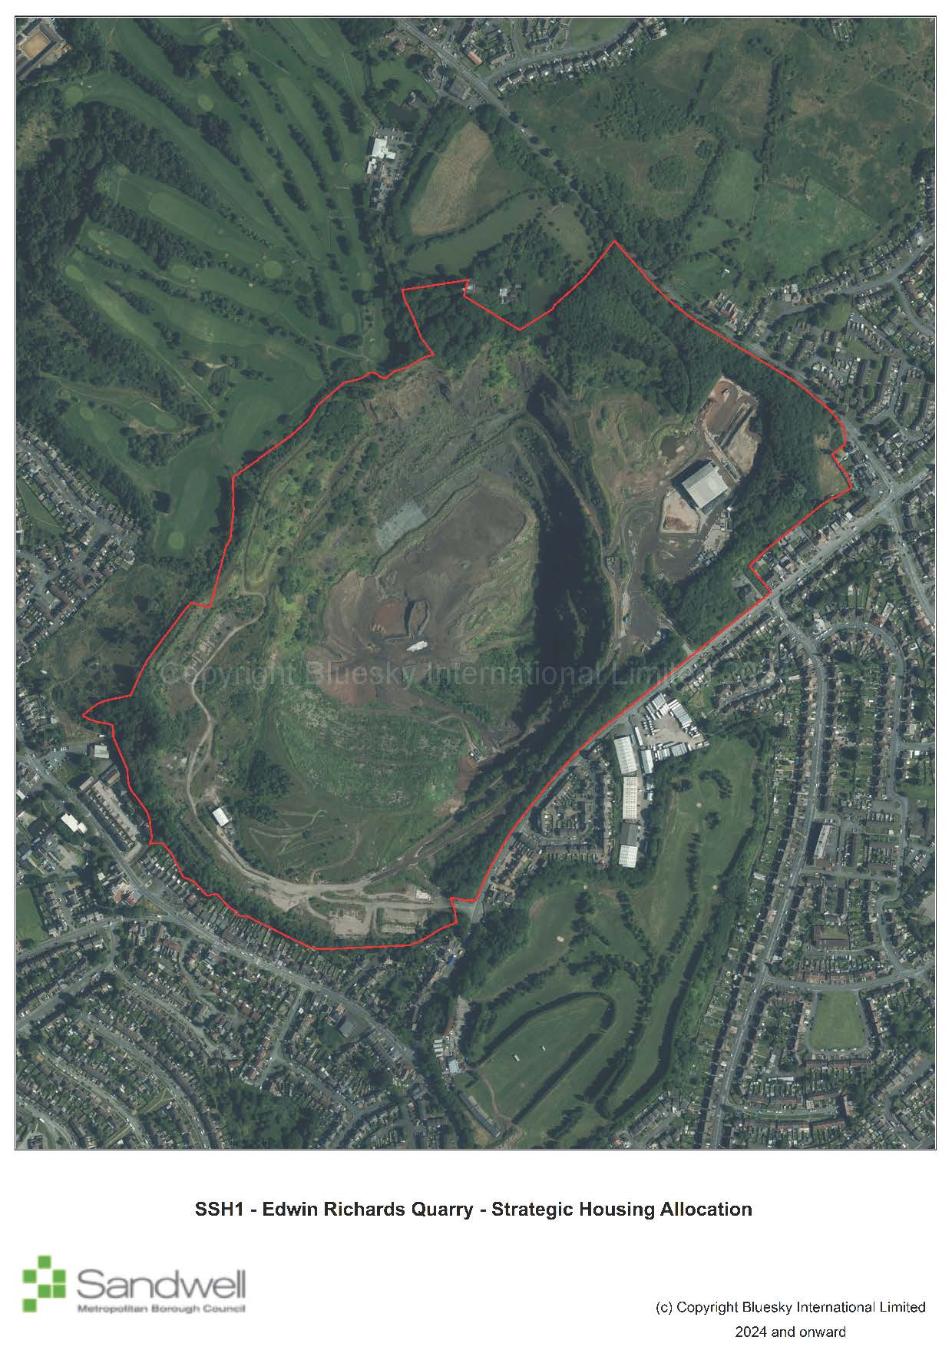
Site constraints
- The site comprises an extensive former dolerite quarry, part of which has been infilled with non-hazardous municipal, commercial and industrial waste. Landfill operations remain active and are likely to continue in some form until their expiry date in February 2042.
- The northeastern part of the site is heavily covered with trees.
- The ground has been engineered, creating a series of man-made plateaus.
- A small proportion of the site along the southern boundary falls within a Site of Local Importance for Nature Conservation (SLINC). The southwestern corner is designated as a wildlife corridor and as strategic open space.
Successful development of the site will require:
- the preparation of a comprehensive masterplan in consultation with the Council, which responds to the Council’s design code (Policy SDS5);
- The protection and enhancement of nature conservation sites (Policy SNE1);
- the waste disposal operational capacity of Edwin Richards Landfill to be maintained unless criteria in Policy SWA2 are met; and
- proposals for housing and other potentially sensitive uses not to conflict with waste disposal operations at Edwin Richards Landfill (Policy SWA2).

Policy SSH2 – Friar Park
  - The site is located in the north of Sandwell close to the borough boundary with Walsall. It comprises a former sewage farm, together with former farmland that has mostly been restored as open space. The site has had previous land uses; however, it now has the character of a greenfield site.
  - To the south and west of the site is Friar Park, a large residential estate with associated facilities, and football facility. Bescot Local Distribution Centre (railway sidings) and the Birmingham to Wolverhampton railway line are located to the north and northeast, beyond which is the River Tame and the elevated M6 motorway. To the east is Sandy Lane, beyond which is the A4031 (Walsall Road) and Tame Bridge Parkway railway station.
Policy SSH2 – Friar Park
Location | Friar Park Urban Village, Friar Park Road, Wednesbury
Gross Site Area (Ha) | 26.62
Indicative Net Developable Area (Ha) | 15.75
Indicative Capacity (and Completion Year) | 614 homes (2028-2036)
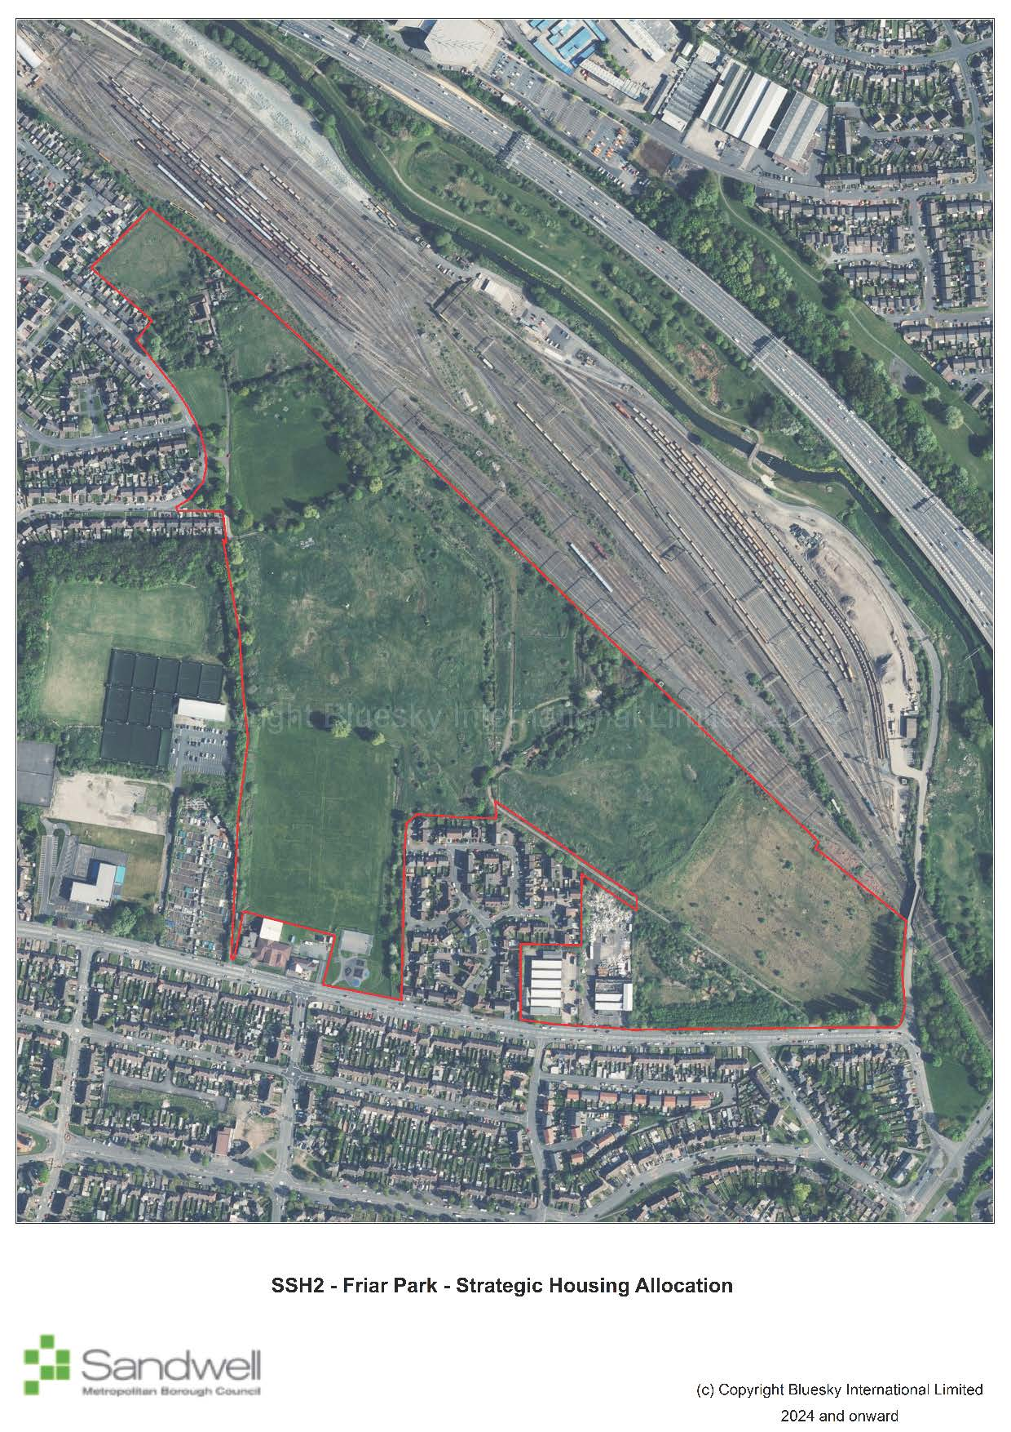
Site constraints
- Five sports pitches (four youth 11v11 football pitches and one adult football pitch) are located on the site, all of which are recorded as lapsed in the Playing Pitch and Outdoor Sports Strategy (2022).
- Over half the site area is designated as a Site of Local Importance for Nature Conservation (SLINC).
- A small proportion of the northeastern corner of the sites lies within Flood Zone 2.
- Previous uses at the site mean that contaminated land and made ground is present, particularly in the area of the former sewage works.
- Bescot Local Distribution Centre (railway sidings) to the north and northwest of the site is a train stabling depot and aggregates logistics site.
Successful development of the site will require:
- general conformity with Friar Park Urban Village Masterplan (2023);
- that existing playing fields are not built on unless a mitigation package is agreed in accordance with NPPF paragraph 103 (Policy SHW5);
- an appropriate remediation strategy to be agreed and implemented with relevant stakeholders to address contamination issues (Policy SCO3); and
- damage to the designated SLINC to be minimised, and full mitigation secured to address any remaining impact on the SLINC (Policy SNE1).

Policy SSH3 - Rattlechain and land between Addington Way and River Tame
  - This strategic allocation comprises land north of Temple Way and land between Addington Way and River Tame, which lies approximately 1.8km northwest of Oldbury Town Centre. To the south of the site is the large Temple Way residential estate. To the west is a variety of industrial and employment uses including metal fabricators and cleared land used for open storage and vehicle parking. To the north is the Birmingham Main Line Canal with the Birmingham to Wolverhampton railway line running parallel, beyond which is Sheepwash Nature Reserve. To the east is the River Tame and an area of open space that accommodates areas of woodland. The Gower Branch Canal lies further to the east.
  - The site has a complex history, including having been used previously for coal mining, as a brick works and clay pit, a tip for fuel ash and commercial waste, and as a deposit for phosphorous waste. Presently the western third of the site comprises a lagoon, which is formed of a main body of water and a smaller ancillary body of water adjacent to the west. The lagoon is approximately 20 metres deep and accommodates the deposits of phosphorous waste, which is monitored through a Waste Management Licence.
  - The remainder of the allocation accommodates deposits of fuel ash and commercial waste and outwardly comprises a variety of scrubland, grassland and small patches of woodland. The land is undulating, and in the main is higher in elevation than the residential estate to the south, with steep drops particularly down to the River Tame along the eastern boundary.
  - Despite accommodating previous land uses, the site appears predominantly as greenfield land; due to previous restoration efforts it does not meet the NPPF definition of previously developed land. In addition, at present the site does not meet the definition of ‘contaminated land’ under Part IIA Environmental Protection Act 1990.
Policy SSH3 – Rattlechain and Land between Addington Way and River Tame
Location | Land to the north of Temple Way & Land between Addington Way and River Tame – Tividale
Gross Site Area (Ha) | 15.72
Indicative Net Developable Area (Ha) | 15.72
Indicative Capacity (and Completion Year) | 554 homes (2034-2041)
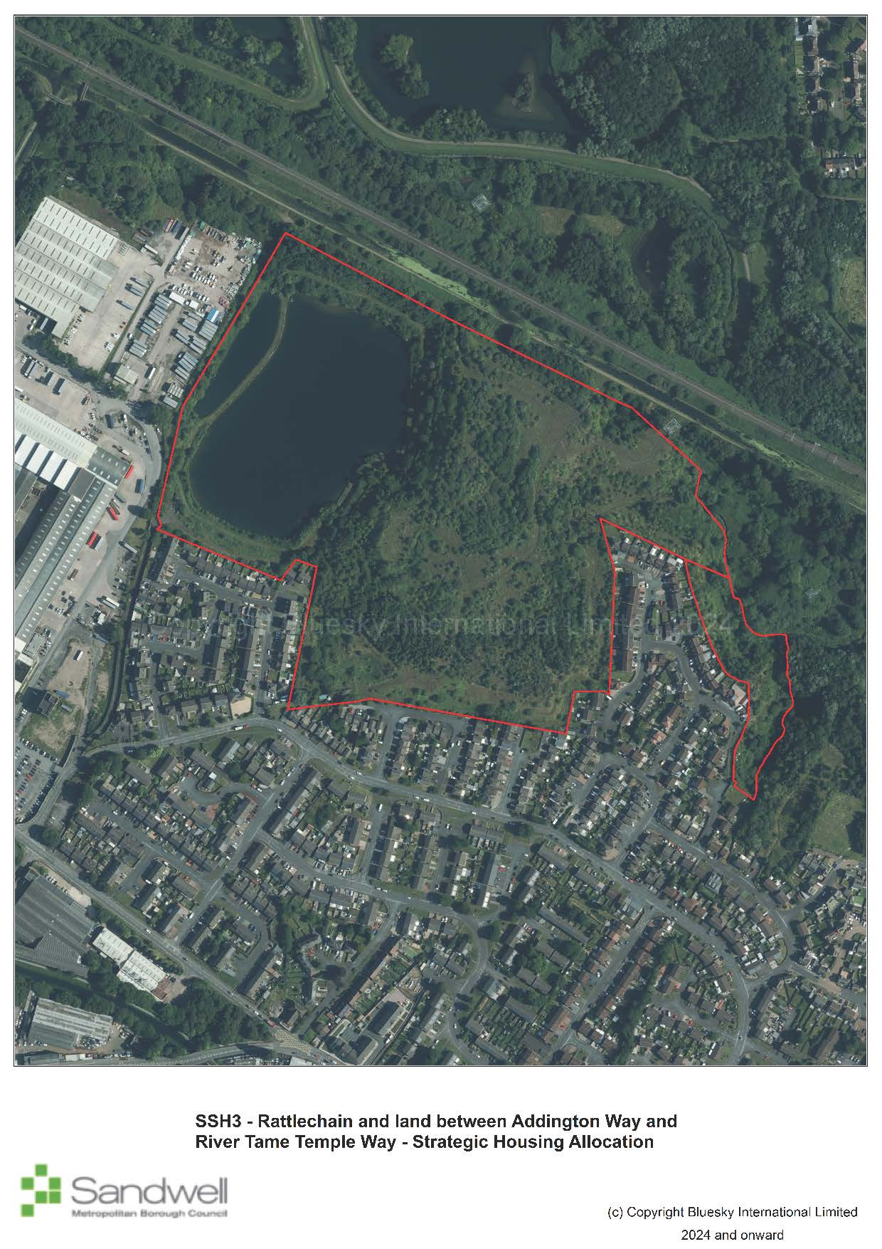
Site constraints
- Although majority of the site is within Flood Zone 1 and at low risk of flooding, land around the River Tame in the east of the site is within Flood Zone 2 and 3.
- The topography of the site falls sharply down to the river, which is within a steep valley.
- Several canal towpath bridges close to the site are listed at Grade II, including at the junction with the Gower Branch Canal (300 metres to the east), and at the Dudley Port Junction (750 metres to the west).
- Ground contamination and stability issues, including resulting from previous uses of the site for coal mining, as a brick works and clay pit, a tip for fuel ash and commercial waste, and as a deposit for phosphorous waste.
- A small proportion of the site is designated as a Site of Local Importance for Nature Conservation (SLINC).
- There are several mature trees within the site.
- National grid gas mains and overhead electric pylons are present on site.
Successful development of the site will require:
- the preparation of a comprehensive masterplan in consultation with the Council, which responds to the Sandwell Design Code (Policy SDS5);
- the Exception Test to be passed if all built development is not steered to areas of Flood Zone 1 (Policy SCC5).
- an appropriate remediation strategy to be agreed and implemented with relevant stakeholders to address contamination issues (Policy SCO3);
- damage to the designated SLINC to be minimised, and full mitigation secured to address any remaining impact on the SLINC (Policy SNE1);
- ensuring development protects and enhances the significance of heritage assets and their settings (Policy SHE1).
- provision of acceptable vehicular access routes and integration with the surrounding sustainable transport network for vehicles, cyclists and pedestrians (Policy STR5).
- a strategy for responding to the NGET overhead transmission lines and any underground cables present within the site which demonstrates how the NGET Design Guide and Principles have been applied at the master planning stage and how the impact of the assets has been reduced through good design; and
- development to protect and enhance the character, nature conservation value, water quality, structural stability and recreational usage of the canal network (Policy SNE6).

Policy SSH4 - North Smethwick Canalside
  - The site is one of the key regeneration sites identified within the Smethwick to Birmingham Corridor Framework. It is a brownfield site and is situated to the south of the Birmingham Canal on either side of Rolfe Street. To the south lies the Birmingham to Wolverhampton railway line and the A457 (Tollhouse Way). The area consists of several industrial buildings offering a range of uses including motor repairs, window manufacture, building materials, a hostel, a banqueting suite and vacant buildings. Smethwick Rolfe Street railway station lies to the west of the site and offers regular train services between Wolverhampton and Birmingham New Street. There is an approved Rolfe Street Masterplan in place that will guide future development in the area.
Policy SSH4 – North Smethwick Canalside
Location | North Smethwick Canalside, Smethwick
Gross Site Area (Ha) | 8.77
Indicative Net Developable Area (Ha) | 6.57
Indicative Capacity (and Completion Year) | 500 homes (2029-2038)
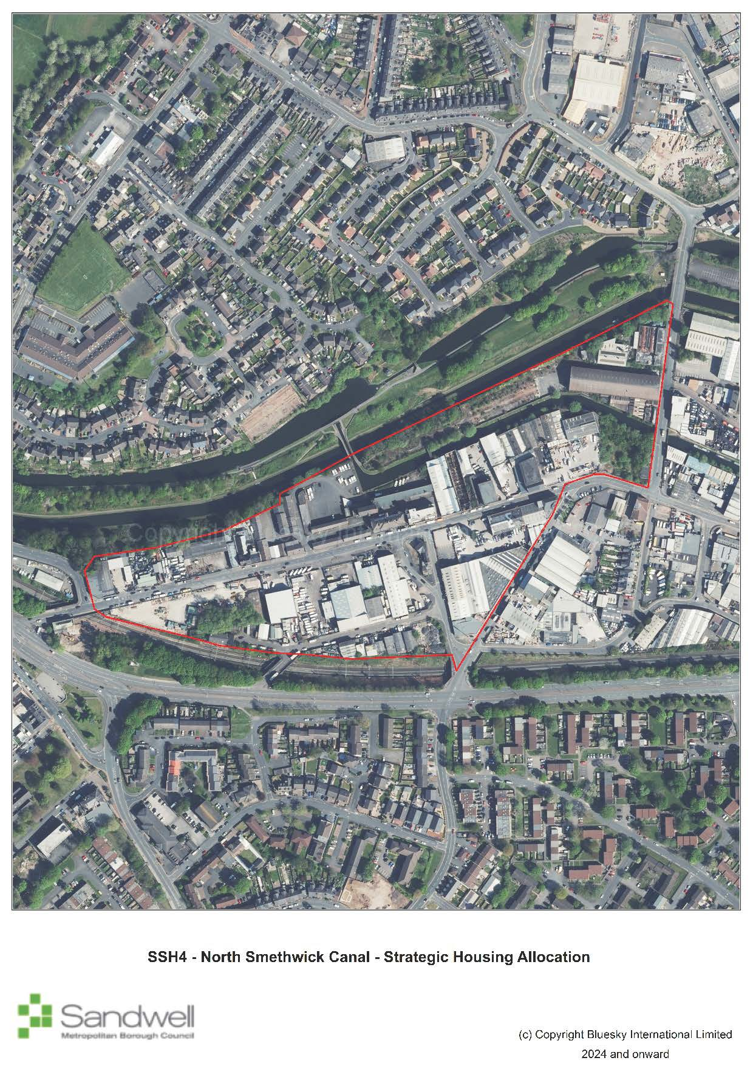
Site constraints
- The site is adjacent to the Birmingham to Wolverhampton railway line.
- The site is adjacent to the Birmingham Mainline canal.
- The site lies partly within the Smethwick Summit Galton Bridge Conservation Area; there are listed structures within and adjacent to the site including a Grade II listed wall and the Grade II* Engine Arm Aqueduct, which is also a scheduled ancient monument.
- There is a possibility of structures buried underground, including water wells at the site of the former Rolfe Street Baths.
- The site contains existing industrial, employment and other uses.
Successful development of the site will require:
- general conformity with the Urban Design Framework and Character and Design information set out in the Rolfe Street Masterplan (2023);
- investigating, and where appropriate, the protecting of important archaeological assets (Policy SHE4);
- safeguarding the amenity of future residents from the possible impact of noise, particularly from the adjacent railway line (Policy SCO2);
- ensuring development protects and enhances the significance of heritage assets and their settings (Policy SHE1);
- development to protect and enhance the character, nature conservation value, water quality, structural stability and recreational usage of the canal network (Policy SNE6).

Grove Lane Masterplan Sites
  - The Grove Lane Masterplan includes six sites that will deliver a substantive amount of housing and will collectively provide strategic benefits. Such benefits include the regeneration of key areas within Smethwick, and contributions to the creation of sustainable communities that support the wider spatial vision for the borough. These are brownfield sites within the Smethwick Regeneration Area, which seek to redevelop existing low quality employment land to residential uses and complement the recent significant investment by Sandwell and West Birmingham NHS Trust in the new Midland Metropolitan University Hospital and associated Learning Campus. The area forms part of the Smethwick to Birmingham Corridor, which follows the route of the Birmingham Main Line Canal.
  - The Grove Lane Masterplan proposes the development of a new two-form entry primary school as part of the development of the Grove Lane Area. However, the Infrastructure Development Plan that was produced for the Sandwell Local Plan subsequently did not identify any need for additional mainstream schools within the borough across the plan period. Any requirement for a new school should be revisited and fully assessed as proposals progress.
Policy SSH5 – Abberley Street
  - The site lies to the south of Cranford Street, with Winson Street to the east, Abberley Street to the south and the Cape Arm site to the west. The site is divided into two distinct areas with an existing brick-built building on the northern portion. The building has been sub-divided into smaller units with small scale employment uses operating from the majority of them. To the south fronting Abberley Street, the site includes derelict and dilapidated former industrial units with some vacant land.
Policy SSH5 – Abberley Street
Location | Abberley Street, Smethwick
Gross Site Area (Ha) | 2.48
Indicative Net Developable Area (Ha) | 1.86
Indicative Capacity (and Completion Year) | 140 homes (2028-2033)
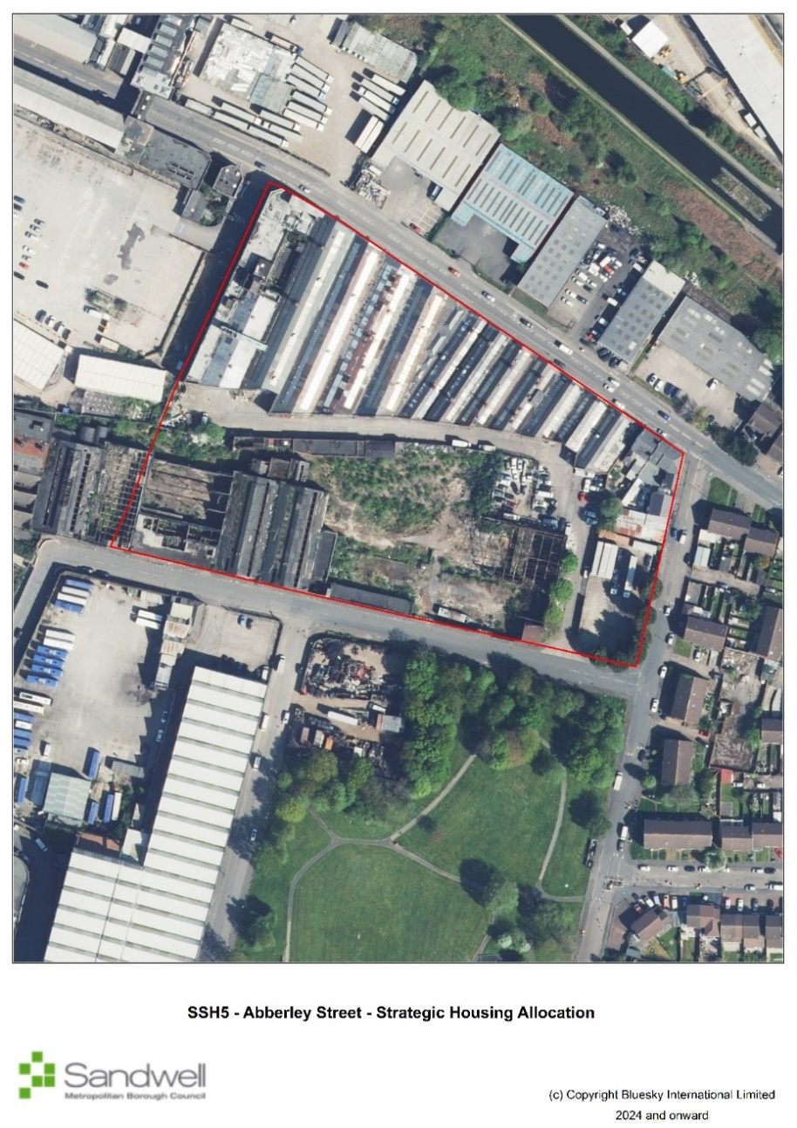
Site constraints
- Possible contamination issues due to past industrial activity
- A canal arm previously passed through the western part of the site and its former route is designated as a Wildlife Corridor
- The site comprises active industrial and employment uses as well as derelict and dilapidated former industrial units.
Successful development of the site will require:
- general conformity with the Key Principles set out in the Grove Lane Masterplan (Character Area 6).
- the movement of wildlife to be protected and enhanced (Policy SNE1).

Policy SSH6 – Cape Arm Cranford Street
  - The site is bounded by Cranford Street to the north and Cape Arm canal to the south. It comprises a vacant site, covered with a concrete slab that was used as a car park / compound for the construction of the new Midland Metropolitan University Hospital. Derelict buildings front Cranford Street and Abberley Street.
Policy SSH6 – Cape Arm Cranford Street
Location | Cape Arm, Cranford Street, Smethwick
Gross Site Area (Ha) | 2.42
Indicative Net Developable Area (Ha) | 2.13
Indicative Capacity (and Completion Year) | 120 homes
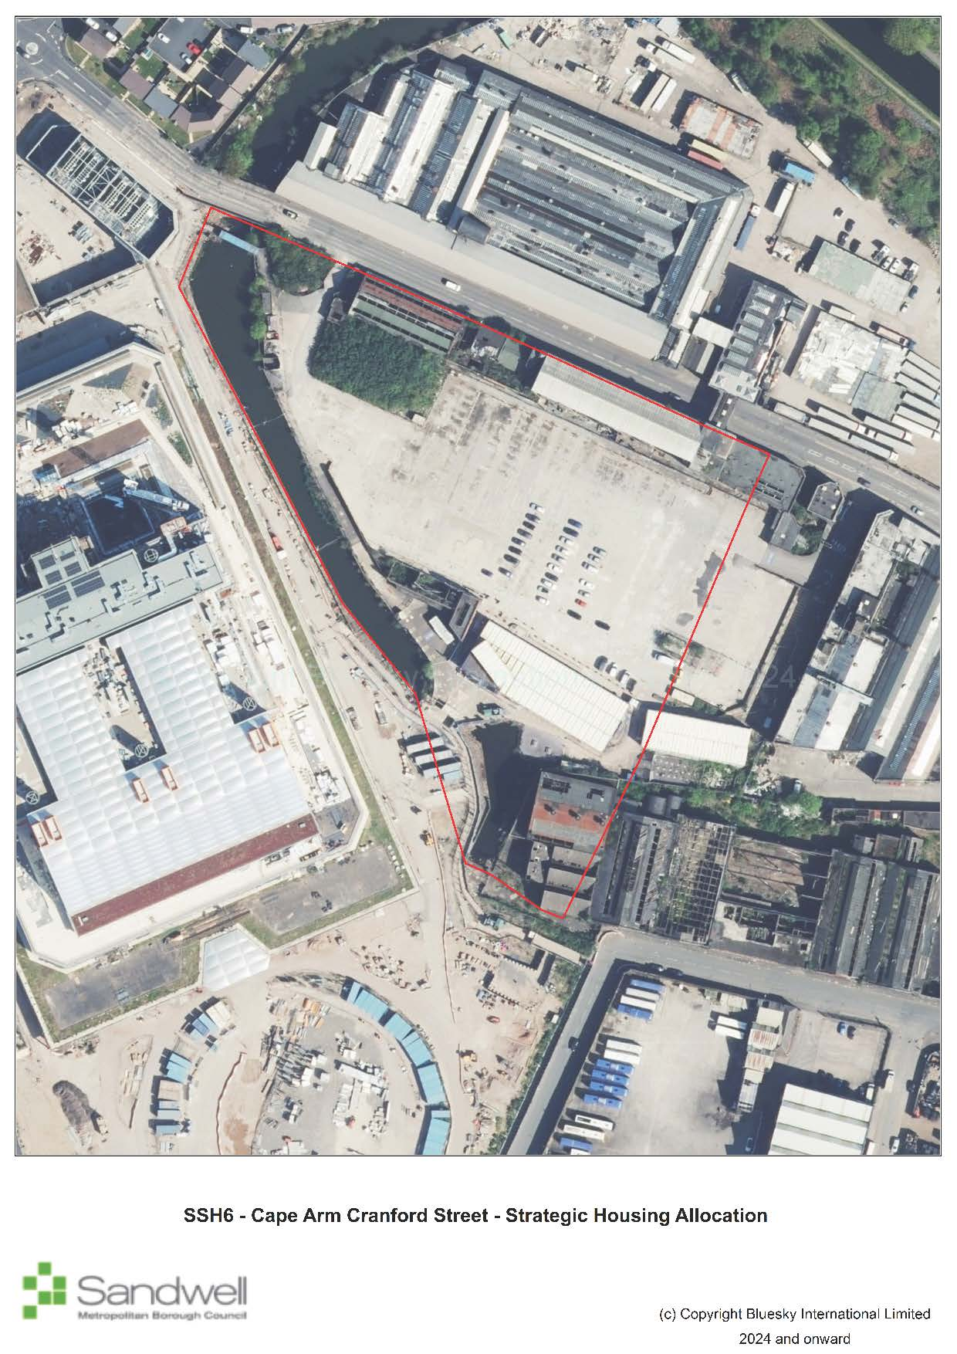
Site constraints
- Possible contamination issues due to past industrial activity
- The canal passes through the western and southern edge of the site.
- A proportion of the site is designated as a wildlife corridor.
- There are existing buildings on site.
Successful development of the site will require:
- general conformity with the Key Principles set out in the Grove Lane Masterplan (Character Area 2).
- development to protect and enhance the character, nature conservation value, water quality, structural stability and recreational usage of the canal network (Policy SNE6); the movement of wildlife to be protected and enhanced (Policy SNE1); and
- support for the creation of a green link and active travel route from the Midland Metropolitan University Hospital to Cranford Street (Policy STR5).

Policy SSH7 – Cranford Street / Heath Street / Canal
  - The site lies to the north of Cranford Street with the Cape Arm canal to the west and the Birmingham Main Line Canal to the immediate north. The borough boundary with Birmingham lies to the east of the site. Currently most of the site is occupied by older industrial buildings, in use as a factory distribution centre. The remainder of the site accommodates newer, smaller individual industrial units for a range of uses including food distribution, home improvements and motor repairs and testing centre. A cycle route leading from the canal towpath through to Cranford Street has recently been created.
Policy SSH7 – Cranford Street / Heath Street / Canal
Location | Cranford Street / Heath Street / Canal, Smethwick
Gross Site Area (Ha) | 3.00
Indicative Net Developable Area (Ha) | 2.88
Indicative Capacity (and Completion Year) | 115 homes (2028-2031)
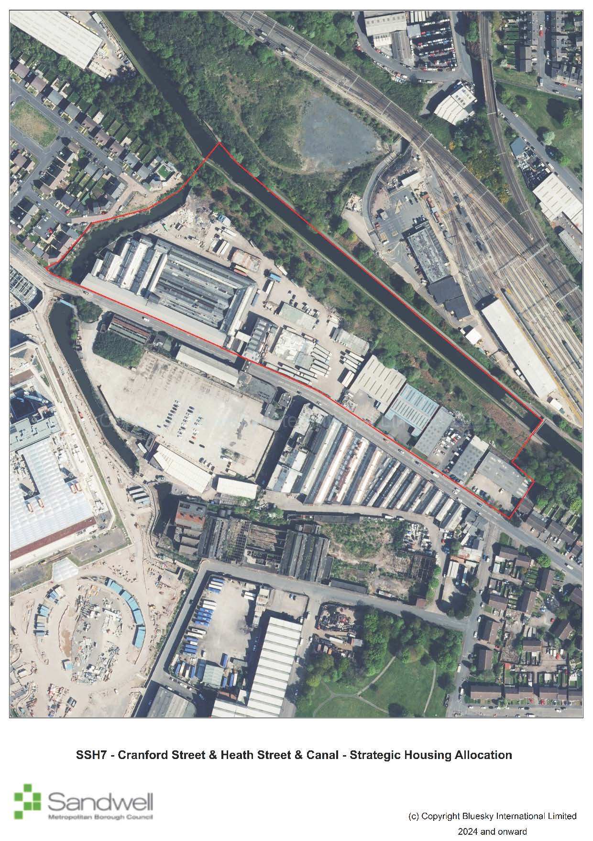
Site constraints
- The northern part of the site along the canal is within the Smethwick Summit Galton Valley Conservation Area.
- The Birmingham Main Line Canal and Cape Arm are designated as a Wildlife Corridor.
- Parts of the canal basin are within Flood Zone 2 and 3. Parts of the wider site are at risk of surface water flooding.
- Possible contamination issues could be present due to past industrial activity.
- The site comprises occupied industrial buildings and a car park.
Successful development of the site will require:
- general conformity with the Key Principles set out in the Grove Lane Masterplan (Character Area 1).
- development to protect and enhance the character, nature conservation value, water quality, structural stability and recreational usage of the canal network (Policy SNE6); the movement of wildlife to be protected and enhanced (Policy SNE1).
- ensuring development protects and enhances the significance of heritage assets and their settings (Policy SHE1).
- development to reduce the risk of surface water flooding (Policies SCC5 and SCC6)

Policy SSH8 – Grove Lane / Cranford Street / London Street
  - The site is triangular in shape and bounded by Cranford Street to the north, Grove Lane to the south and London Street to the east. There are multiple land uses within this area including light industrial, motor repairs, van hire, petrol station and vacant buildings. Many of the structures are older industrial premises although there are more recent additions / extensions to some buildings. This site lies adjacent to the new Midland Metropolitan University Hospital.
Policy SSH8 – Grove Lane / Cranford Street / London Street
Location | Grove Lane / Cranford Street / London Street, Smethwick
Gross Site Area (Ha) | 2.04
Indicative Net Developable Area (Ha) | 2.04
Indicative Capacity (and Completion Year) | 500 homes (2026-2032)
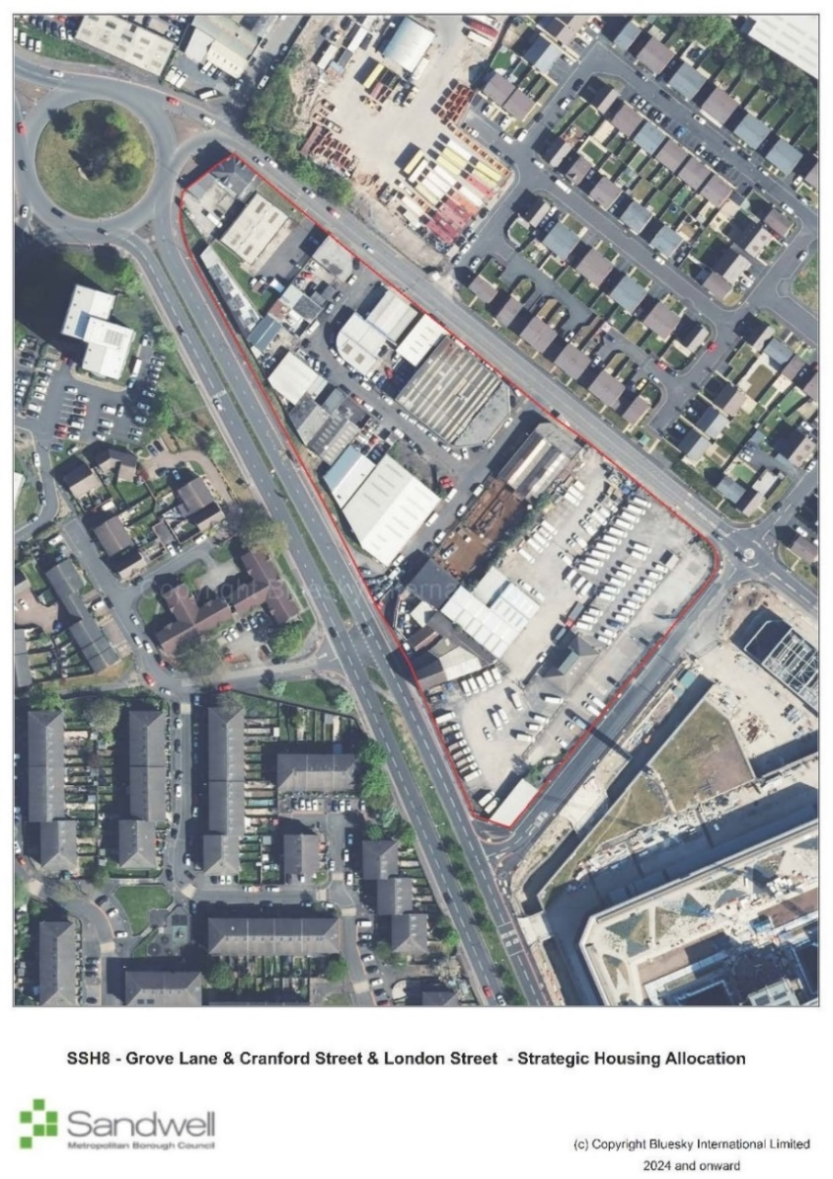
Site constraints
- Possible contamination issues due to past industrial activity.
- The site comprises occupied industrial buildings and premises.
Successful development of the site will require:
- general conformity with the Key Principles set out in the Grove Lane Masterplan (Character Area 7).

Policy SSH9 – Grove Street / MMUH
  - The site is bordered by Grove Street to the west, Dudley Road to the south, Halberton Street and Dugdale Streets to the east and Abberley Street to the north. Comprising mainly older industrial premises in poor condition, the buildings accommodate a range of uses including car repairs, sales, offices, a coach company and a mosque. The new Midland Metropolitan University Hospital lies immediately to the west of this site.
Policy SSH9 – Grove Street / MMUH
Location | Grove Street, Smethwick
Gross Site Area (Ha) | 2.18
Indicative Net Developable Area (Ha) | 2.18
Indicative Capacity (and Completion Year) | 85 homes and a two-form entry primary school (2029-2031)
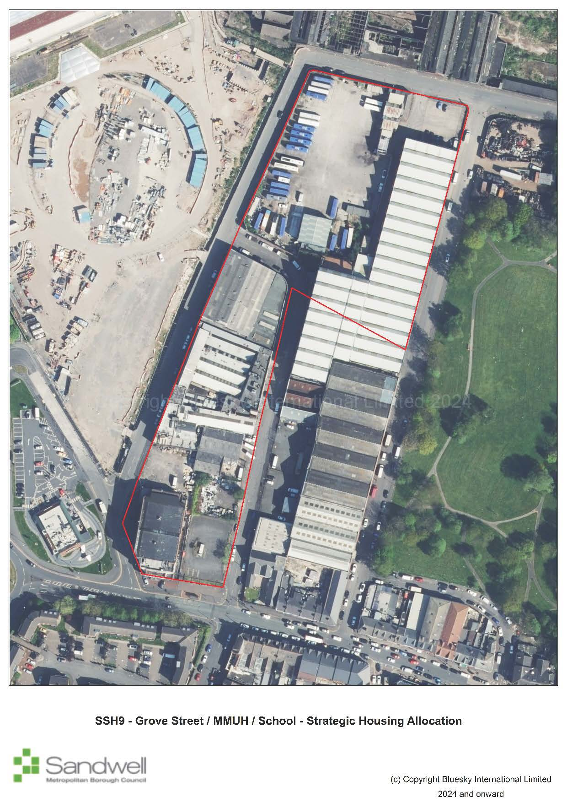
Site constraints
- Possible contamination issues due to past industrial activity.
- The site comprises occupied industrial buildings and premises.
Successful development of the site will require:
- general conformity with the Key Principles set out in the Grove Lane Masterplan (Character Area 4); and
- the requirement for a new school as part of the delivery of the Grove Lane Masterplan to be revisited and fully assessed; and
- taking account of possible future redevelopment of Moilliett Street Park in Birmingham as envisaged by the Smethwick to Birmingham Corridor Framework.

Policy SSH10 – Moilliett Street Park
  - The site is partially in Sandwell but also includes Moilliett Park, which is located within Birmingham City. The site lies to the north of Dudley Road, which is an established retail centre in Birmingham, with Halberton Street to the west, Winson Street to the east and lying to the south of Abberley Street. The site currently comprises old industrial buildings and Moilliett Park. The part of the site within Sandwell is allocated as SSH10.
Policy SSH10 – Moilliett Street Park
Location | Moilliett Street Park, Smethwick
Gross Site Area (Ha) | 0.77
Indicative Net Developable Area (Ha) | 0.77
Indicative Capacity (and Completion Year) | 35 homes (2029-2030)
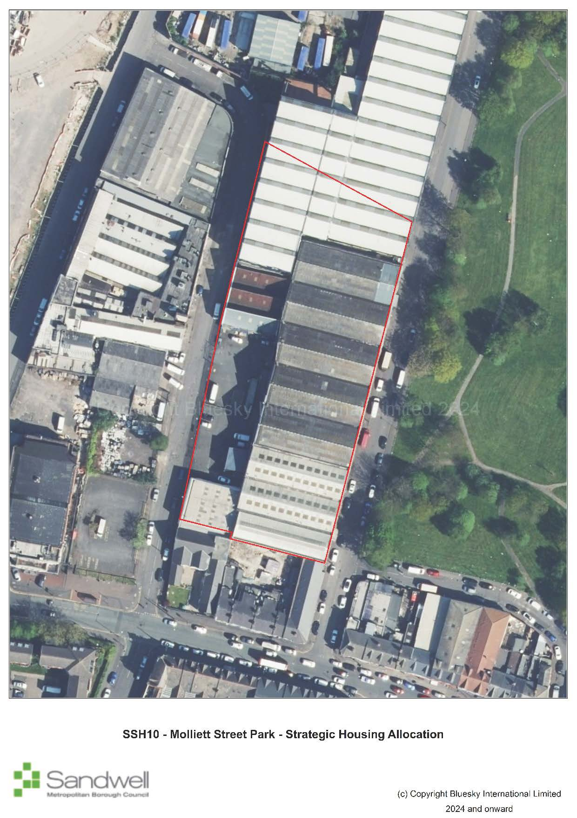
Site constraints
- Possible contamination and ground issues due to past industrial activity.
- The site comprises occupied industrial buildings.
Successful development of the site will require:
- general conformity with the Key Principles set out in the Grove Lane Masterplan (Character Area 5); and
- taking account of possible future redevelopment of Moilliett Street Park in Birmingham as envisaged by the Smethwick to Birmingham Corridor Framework.

Strategic Mixed Used Allocations
  - These are mixed used allocations capable of delivering substantive number of dwellings as well as employment development and other development uses and includes sites identified in the West Bromwich Masterplan.
Policy SSM1 – Lion Farm
  - The site is located approximately 1km southwest of Oldbury town centre and 400 metres west of Junction 2 of the M5 motorway. The site comprises 11 adult sized football pitches, which are underused, associated dilapidated changing facilities and car parking in the west, with general open space, a disused social club, areas of woodland and allotments in the north. High voltage power cables cross the site running north to southeast, with two transmission towers located within the site boundary.
  - To the east of the site is Birchley Industrial Estate, which is occupied by various large office and retail units. Beyond this is Birchley Island, a key road interchange that connects the A4034 and A4123 (Wolverhampton Road) with Junction 2 of the M5. A modern residential estate lies to the northeast of the site. The north of the site is bound by Newbury Lane, beyond which is a residential area. To the west are more residential areas, as well as Lion Farm local centre and St James Church of England Primary School. To the south are residential dwellings and the A4034 (Birchfield Lane), beyond which is Titford Canal and Pool.
  - Although the site has been developed previously, it now predominantly comprises playing pitches and has the character of a greenfield site.
Policy SSM1 – Lion Farm
Location | Lion Farm Playing Fields, Newbury Lane, Oldbury
Gross Site Area (Ha) | 20.92
Indicative Net Developable Area (Ha) | 4.5
Indicative Capacity (and Completion Year) | 200 residential dwellings, 2.3 hectares of employment land, playing fields and associated facilities, and green space (2033-2037)
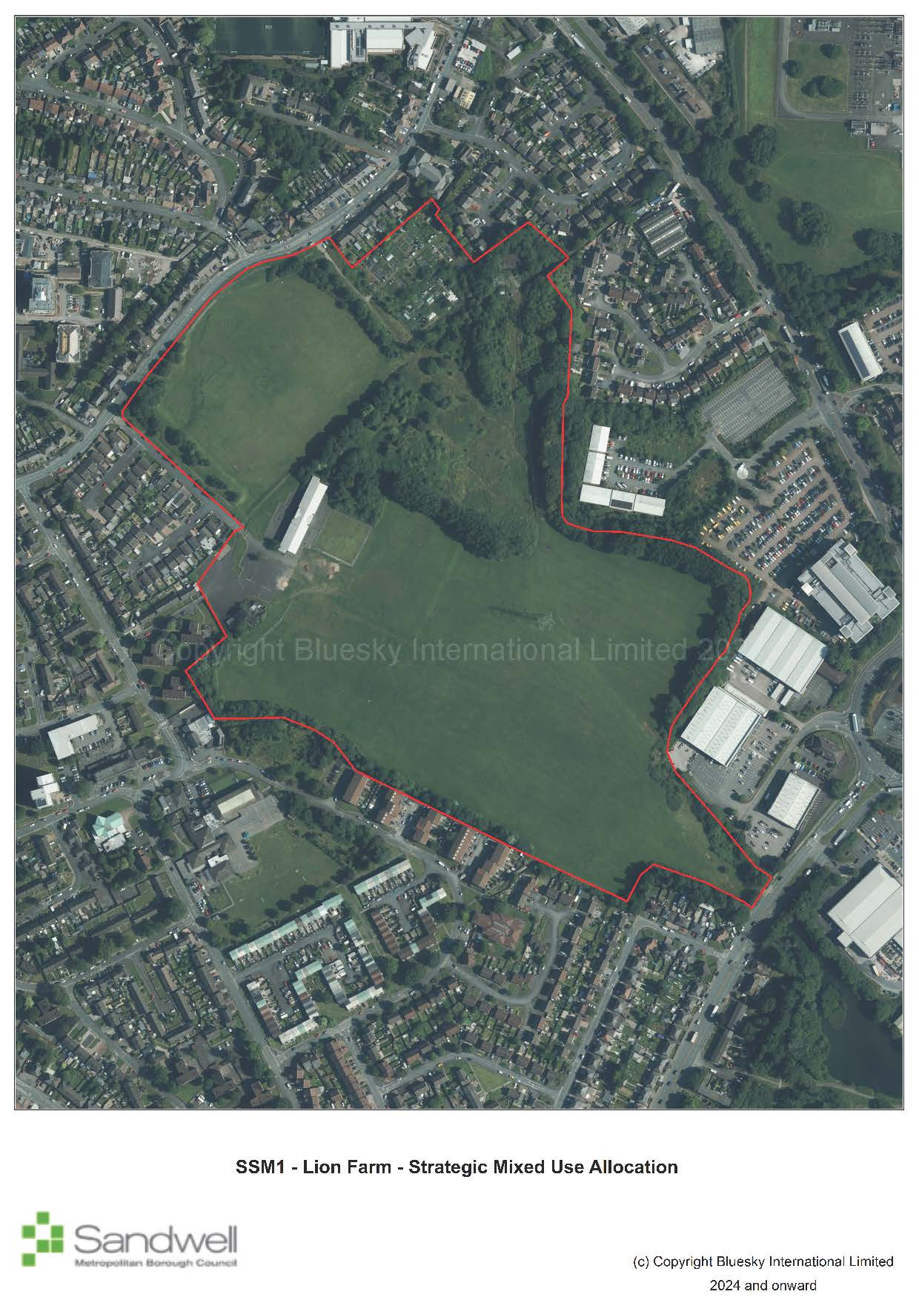
Site constraints
- The site comprises 11 adult-size football pitches
- NGET overhead transmission lines and underground cables are present within the site (YJ ROUTE: 275Kv Overhead Transmission Line route: KITWELL - OCKER HILL 275Kv Underground Cable route: KITWELL 275KV S/S)
- A canal spur and various canal basins crossed the site historically, providing waterway access to a former brickworks and various coal shafts. Made ground, subterranean structures and untreated mine shafts may be present.
- The central part of the site is in Flood Zone 2 and Flood Zone 3, comprising approximately 9% of the total site area.
Successful development of the site will require:
- that existing playing fields are not built on unless a mitigation package consistent with NPPF paragraph 103 is agreed (Policy SHW5);
- a strategy for responding to the NGET overhead transmission lines and underground cables present within the site which demonstrates how the NGET Design Guide and Principles have been applied at the master planning stage and how the impact of the assets has been reduced through good design;
- development to be located in areas of lowest flood risk (Policy SCC5);
- investigating, and where appropriate protecting important archaeological assets (Policy SHE4);
- preparation of a masterplan that identifies parts of the site for very high-density housing (Policy SHO3); and
- new employment development within Use Classes E(g)(ii), E(g)(iii), B2 or B8 (Policy SEC1).

West Bromwich Masterplan Sites
  - Four sites in the West Bromwich Masterplan have been identified to deliver mixed uses and together provide strategic benefits.
Policy SSM2 – Cultural Quarter
  - The allocation is located within West Bromwich Strategic Centre approximately 150 metres northeast of Lodge Road metro station. The allocation contains several of the town’s main civic buildings. The eastern corner of the site was cleared around eight years ago and there is an apartment block currently under construction on it. The southern half of the site comprises the Edward Street surface level public car park.
  - To the east of the site is a cluster of banks and the retail core of West Bromwich. To the north are other Victorian buildings, some Grade II listed, which mostly comprise offices and residential conversions. To the west are other attractive Victorian buildings including the Grade II listed Ryland Memorial School of Art, currently in use as a school, and residential buildings. To the south is a Masonic Hall and the Edward Street Hospital, which has recently undergone a partial redevelopment.
Policy SSM2 – Cultural Quarter
Location | Cultural Quarter, High Street, West Bromwich
Gross Site Area (Ha) | 1.09
Indicative Net Developable Area (Ha) | 1.09
Indicative Capacity (and Completion Year) | 52 residential dwellings, 1,054sqm food and beverage, 2,000sqm  community/leisure and 10 car parking spaces (2025-2031)
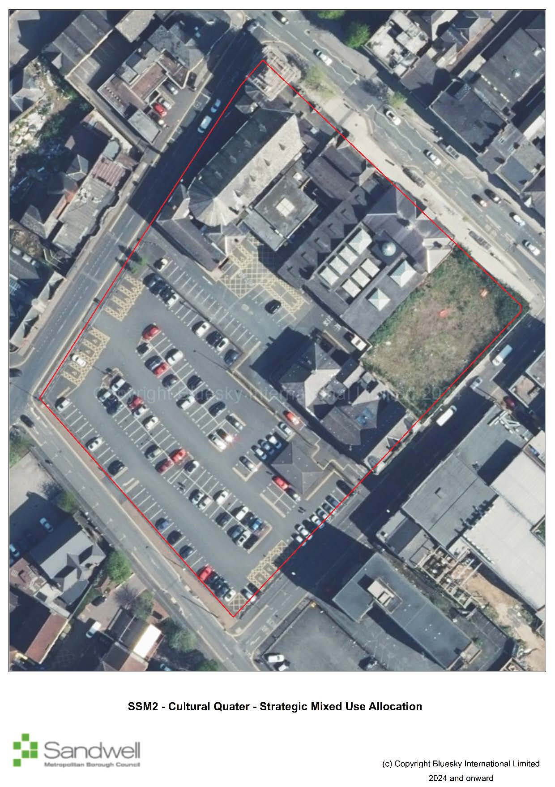
Site constraints
- Designated heritage assets present within and adjacent to the site including the West Bromwich High Street Conservation Area, Grade II Central Public Library, Grade II Town Hall, and Grade II Law Courts.
- The site includes an existing public car park.
Successful development of the site will require:
- the protection of the significance of heritage assets and the conservation and enhancement of local character and those aspects of heritage assets and their settings that are recognised as being of special quality (Policies SHE1 and SHE2);
- regenerating the Town Hall Quarter to establish a fully restored cultural and evening / night-time offer in the town centre (Policy SWB1);
- delivery of a mixed-use development including new homes (Policy SWB2); and
- general conformity with the Key Information set out in the West Bromwich Masterplan (Zone 3).

Policy SSM3 – George Street Living
  - George Street Living is located on the edge of West Bromwich Strategic Centre on a prominent site adjacent to the A4031 Trinity Way and the Birmingham to Wolverhampton metro line. The allocation currently accommodates a range of light industrial and storage uses as well as ancillary office and retail uses. The former Spring Works site was cleared around ten years ago, resulting in around two thirds of the allocation containing no buildings or fixed structures. The cleared area is currently used for open storage.
  - To the east of the allocation is the A4031 Trinity Way, a busy dual carriageway that is frequently used by HGVs; beyond is a residential area comprising mostly terraced housing. To the south is the Birmingham to Wolverhampton metro line, beyond which lie further residential properties. A large surface level car park lies to the west. Beyond this is the large Sandwell College building and industrial units on the Lyng Industrial Estate. To the north is George Street and Thomas Street, beyond which are a collection of light industrial uses, community venues and places of worship, and the rear of retail units and other main town centre uses facing the High Street.
Policy SSM3 – George Street Living
Location | George Street Living, Trinity Way, West Bromwich
Gross Site Area (Ha) | 2.36
Indicative Net Developable Area (Ha) | 1.77
Indicative Capacity (and Completion Year) | 327 residential units, 1,150sqm community/leisure, 79 parking spaces (2035-2040)
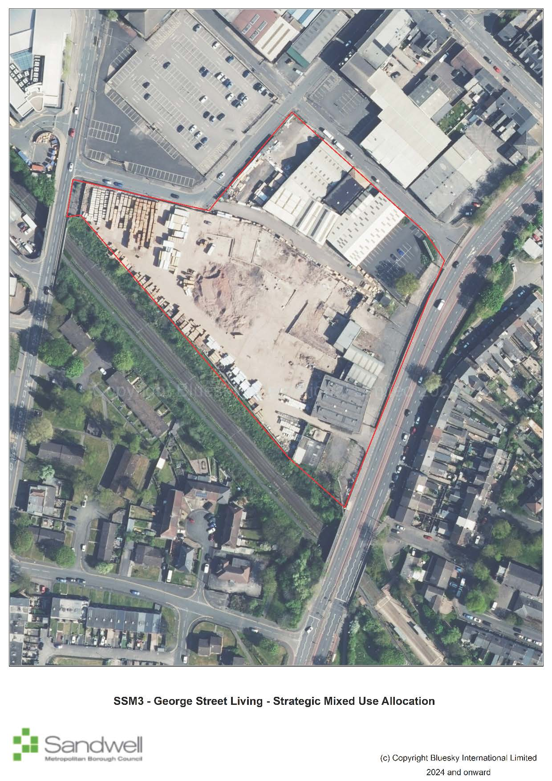
Site constraints
- The site comprises light industrial and storage uses as well as ancillary office and retail uses. A former industrial site (Spring Works) has been cleared. Made ground and subterranean structures may be present.
- Safeguarding the amenity of future residents from the impacts of surrounding land uses including industrial uses to the north and the dualled A4031 Trinty Way to the east
Successful development of the site will require:
- delivery of residential-led development including new homes built at very high densities (Policies SWB2 and SHO3); and
- general conformity with the Key Information set out in the West Bromwich Masterplan (Zone 5).

Policy SSM4 – Queens Square
  - Queen’s Square Living is located in the heart of West Bromwich Strategic Centre. The site takes in a variety of properties including some of Queens Square Shopping Centre and associated servicing area, a row of retail units fronting High Street, and the cleared sites of the former Bull Street Multi Storey Car Park and the former Marks and Spencer.
  - The southwest of the allocation is bound by the pedestrianised High Street, beyond which is the West Bromwich Central allocation which currently accommodates a variety of retail and town centre uses. To the northwest is the remainder of Queens Square Shopping Centre and other retail units fronting the High Street. To the north and northeast is the modern New Square retail / leisure development, including the access road to one of the servicing areas for New Square. To the southeast is Bull Street, beyond which are a variety of residential and main town centre uses.
Policy SSM4 – Queens Square
Location | Queens Square Living, High Street, West Bromwich
Gross Site Area (Ha) | 2.84
Indicative Net Developable Area (Ha) | 2.13
Indicative Capacity (and Completion Year) | 396 residential units, 7,447sqm retail, 855sqm offices, 1,395sqm  community/leisure, 206 car parking spaces (2038-2041)
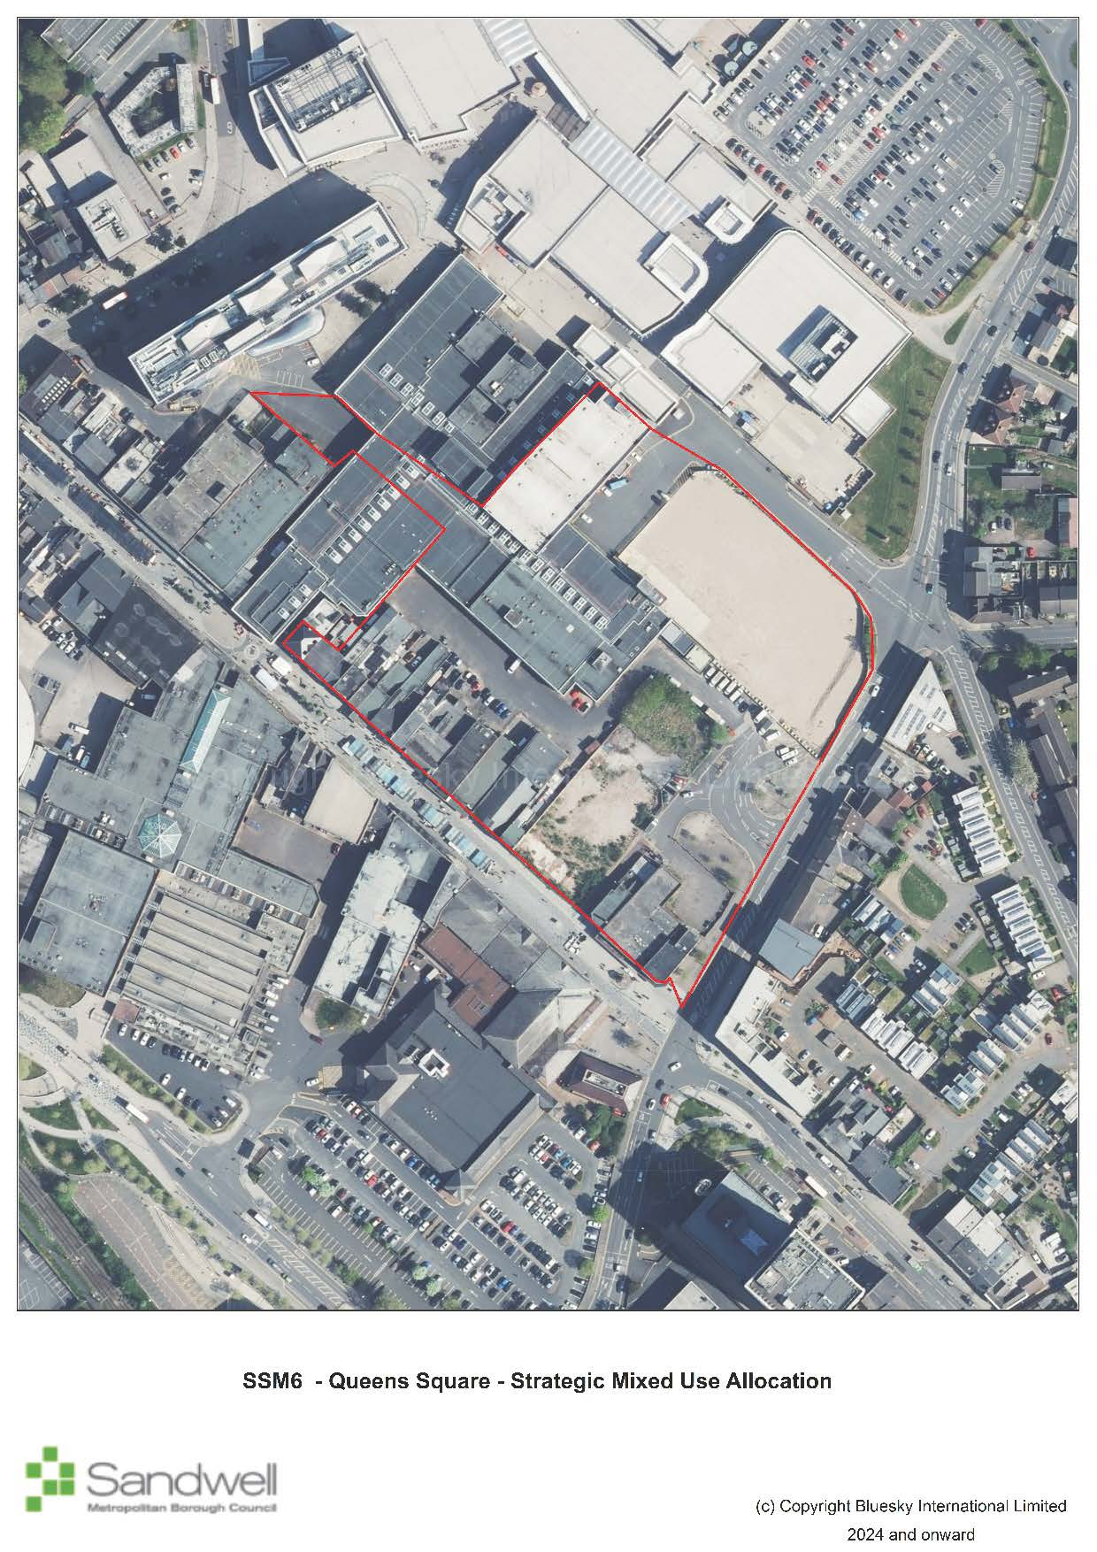
Site constraints
- The site comprises existing retail units and other main town centre uses.
Successful development of the site will require:
- delivery of mixed-use development including new homes built at very high densities (Policies SWB2 and SHO3); and
- general conformity with the Key Information set out in the West Bromwich Masterplan (Zone 2).

Policy SSM5 - West Bromwich Central
  - West Bromwich Central is located at the gateway to West Bromwich Strategic Centre adjacent to the bus and metro stations. The site takes in a variety of town centre premises including Kings Square Shopping Centre and associated servicing yard, several retail units facing the High Street, the former Kings Cinema, the former Indoor Markets, the former Morrisons supermarket (currently occupied by JD Gyms) and a large surface level car park.
  - To the southwest of the allocation is West Bromwich Ringway, a traffic-calmed boulevard, beyond which is the large Sandwell College building and the Birmingham to Wolverhampton metro line. To the northwest is West Bromwich bus station and the continuation of retail units facing the High Street. To the northeast is the pedestrianised High Street itself, beyond which is the retail heart of the town anchored by Queens Square Shopping Centre and the modern New Square retail / leisure development. To the southeast is Bull Street, beyond which are a variety of uses including offices, retail, small storage and light industrial units, and surface level car parking.

Policy SSM5 – West Bromwich Central
Location | West Bromwich Central, High Street, West Bromwich
Gross Site Area (Ha) | 3.84
Indicative Net Developable Area (Ha) | 2.85
Indicative Capacity (and Completion Year) | 343 residential units, 2,302sqm retail, 5,032sqm offices, 5,060sqm  education, 11,840sqm food and beverage, 9,862sqm community/leisure, 5,205sqm health and 625 parking spaces (2029-2035)
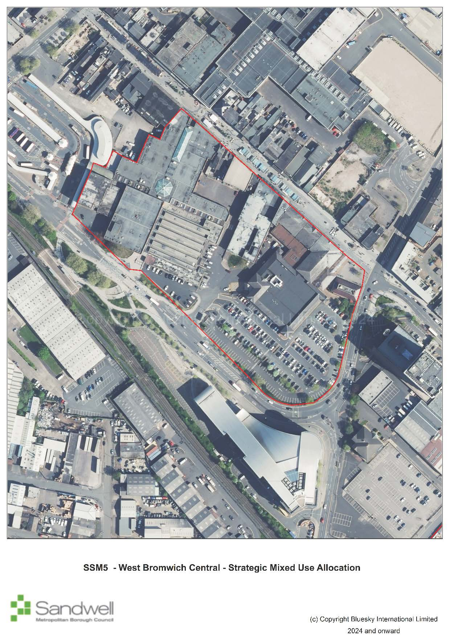
Site constraints
- The site comprises existing retail units, other main town centre uses and a privately owned publicly accessible car park.
Successful development of the site will require:
- the creation of a metro gateway, a new town square and a green link through to the heart of the town centre from the metro stop (Policy SWB1).
- delivery of mixed-use development including new homes built at very high densities (Policies SWB2 and SHO3); and
- general conformity with the Key Information set out in the West Bromwich Masterplan (Zone 1).

Strategic Employment Allocations
  - These are defined as vacant employment sites of over seven hectares, identified and assessed in the Black Country Economic Development Needs Assessment or Black Country Employment Area Review as important to the delivery of strategic economic growth.
  - Only one site meets these criteria.
Policy SSE1 - Coneygree Business Park (open land)
  - The site is a vacant site that has remained undeveloped since it formed part of the Coneygree Colliery. It is approximately 1.8km northeast of Dudley town centre, 8.2km southeast of Wolverhampton city centre and 12km northwest of Birmingham city centre.
  - Access to the site is gained from Coneygree Road, Tipton, which is linked to the A4123 Birmingham New Road.
  - The site in a predominately mixed used area and was formerly known as Coneygre Mine. The mine has not been in use since the foundry closed in the 1980s. There are no built structures present on the site, although there are an abundance of trees and vegetation and a covering of foundry sand remaining from previous operations.

Policy SSE1 - Coneygree Business Park (open land)
Location | Coneygree Business Park (Open Land)
Gross Site Area (Ha) | 7.22
Indicative Net Developable Area (Ha) | 7.22
Indicative Capacity | 7.22 hectares of employment uses (E(g)(ii), E(g)(iii), B2, and B8 uses)
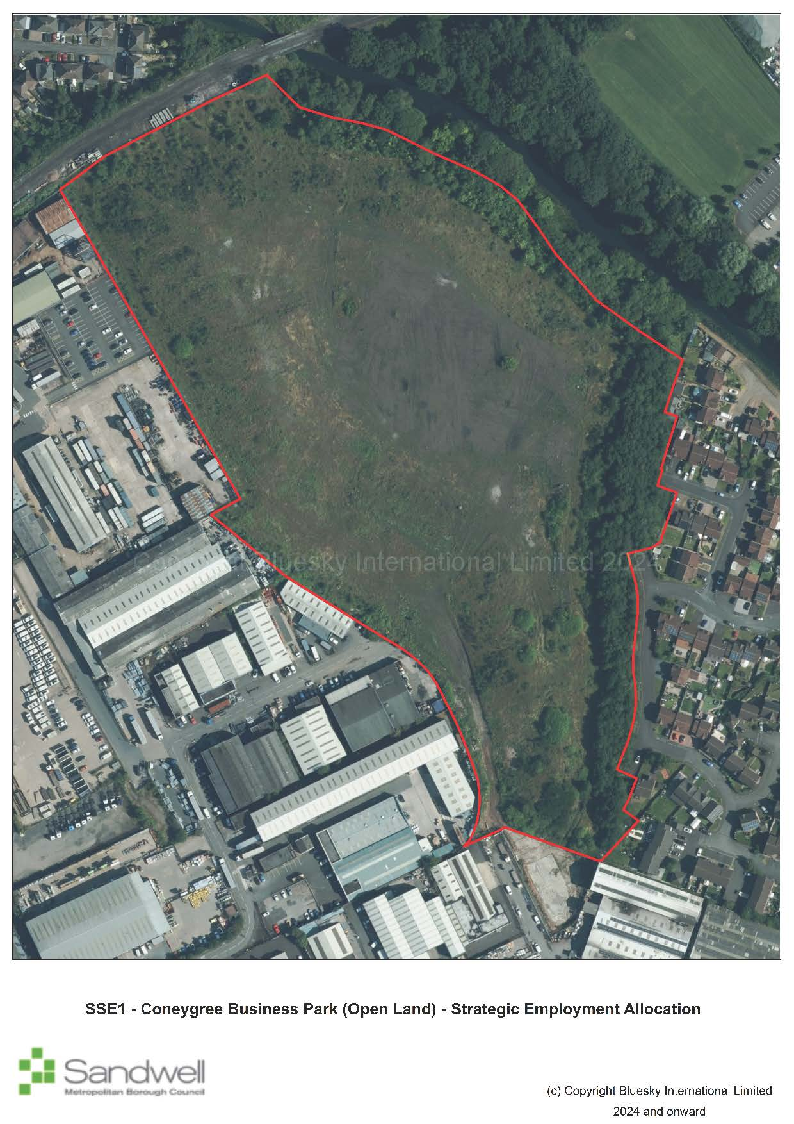
Site constraints
- Coal mining legacy identified at the site and several existing mineshafts spread across the site.
- It is situated in a Limestone Consideration Zone.
- The land undulates in several areas, with a differential of up to 18 metres from the highest to the lowest points.
- A culverted watercourse runs through the middle of the site from the southwest to northeast.
- Adjacent to a canal and contains four filled historical canal arms / basins in the northern section of the site.
Successful development of the site will require:
- an appropriate remediation strategy to be agreed with relevant stakeholders to address contamination issues (Policy SCO3);
- investigation, and where appropriate protection of important archaeological assets (Policy SHE4);
- development to protect and enhance the character, nature conservation value, water quality, structural stability and recreational usage of the canal network (Policy SNE6); and
- assessing the feasibility of opening up and naturalising any underground culverts. Should this prove impractical, no development over culverted watercourse and allowing a suitable distance from the outside edge of the culvert (Policy SCC5).

Non-Strategic Site Allocations
17.1 Non-strategic sites are housing, employment, mixed use and gypsy and traveller sites allocations that do not meet the threshold to be considered strategic allocations. They are distributed across the borough and provide a balanced and flexible supply of housing and employment land. These sites make an important contribution to meeting local housing and employment needs and ensuring a diversity of development opportunities throughout the plan period.
17.2 This approach ensures that delivery is aligned with infrastructure provision, responds to local needs, and supports the creation of sustainable, inclusive, and well-connected communities consistent with the principles of the NPPF.
17.3 The inclusion of a site as a non-strategic allocation does not remove the need for planning permission to be obtained.

Non-Strategic Housing Allocations
Site ref | Site name and address | Ward | Town | Indicative capacity | Gross site area (ha)  Land type (brownfield or greenfield) | Indicative net developable area (ha) | Net density (dph) | Anticipated delivery timescale (completion year) | Further information
SH1 | Brown Lion Street | Tipton Green | Tipton | 28 | 0.46  Brownfield | 0.46 | 59 | 2026-2027 | Granted consent for 27 dwellings - DC/23/67972
SH2 | Land adjacent to Asda, Wolverhampton Road, Oldbury | Langley | Oldbury | 60 | 1.6  Greenfield | 1.6 | 41 | 2028-2029 | Access issue will need to be overcome.  Siting of houses should safeguard existing residential amenity and the asset of the watercourse.
SH4 | Lower High Street (Station Hotel and Dunns site). | Cradley Heath and Old Hill | Rowley Regis | 20 | 0.28  Brownfield | 0.28 | 71 | 2032-2033 | N/A
SH5 | Mill Street, Great Bridge | Great Bridge | Tipton | 40 | 0.86  Brownfield | 0.86 | 45 | 2028-2029 | Applications on part of site.  DC/22/67019 -Land at Mill Street Tipton Proposed 20 no. dwellings with associated parking.  DC/22/67018 - 8 homes pending consent.  Within Wednesbury Regeneration Area
SH6 | Swan Lane, north of A41 West Bromwich | Greets Green and Lyng | West Bromwich | 147 | 3.78  Brownfield | 2.42 | 61 | 2026-2029 | Application - DC/22/66532: Proposed 147 dwelling houses (65 houses and 82 apartments)
SH7 | The Boat Gauging House and adjoining land, Factory Road, Tipton | Tipton Green | Tipton | 50 | 0.57  Brownfield | 0.57 | 88 | 2028-2030 | Application - DC/21/65872 – Proposed residential development comprising of 46 no. 1 and 2 bed apartments, and conversion of boat house to 4 no. 2 bed residential units.  Within Tipton and Dudley Port Regeneration Area.  Development proposals should have regard to the heritage assets on site in scale, form and impact on character.
SH8 | Alma Street, Wednesbury | Friar Park | Wednesbury | 23 | 0.52  Brownfield | 0.52 | 44 | 2030-2031 | N/A
SH9 | The Phoenix Collegiate, Friar Park Road, Wednesbury | West Bromwich Central | West Bromwich | 105 | 4.80  Brownfield | 2.35 | 30 | 2026-2028 | Application - DC/20/63911: Proposed residential development of up to 84 No. dwellings, associated public open space and infrastructure (outline application for access).  Playing field loss mitigation may be required as per SHW5
SH10 | Tipton Conservative and Unionist Club, 64 Union Street, Tipton | Tipton Green | Tipton | 15 | 0.19  Brownfield | 0.19 | 74 | 2029-2030 | Application - DC/19/62733: Proposed change of use to residential, to include 7 No. 1 bed properties and 7 No. 2 bed properties. Application has now expired.  Within Tipton and Dudley Port Regeneration Area
SH11 | Sandwell District and General Hospital, West Bromwich | West Bromwich  Central | West Bromwich | 121 | 0.82  Brownfield | 0.82 | 148 | 2030-2032 | Application - DC/20/64894: Demolition of existing building and proposed mixed use development comprising of 12 No. houses and 109 No. apartments for key workers. Application has now expired.
SH13 | Silverthorne Lane / Forge Lane, Cradley Heath | Cradley Heath and Old Hill | Rowley Regis | 81 | 2.41  Brownfield | 1.81 | 45 | 2035-2038 | N/A
SH14 | Langley Maltings, Western Road, Langley | Oldbury | Oldbury | 71 | 2.72  Brownfield | 2.04 | 35 | 2040-2041 | Density reflects that this the site contains a Grade II listed building.  Development proposals should have full regard to adjacent heritage assets in scheme layout, design and appearance
SH15 | Macarthur Road Industrial Estate, Cradley Heath | Cradley Heath and Old Hill | Rowley Regis | 13 | 0.3  Brownfield | 0.3 | 43 | 2035-2036 | N/A
SH16 | Cradley Heath Factory Centre, Woods Lane, Cradley | Cradley Heath and Old Hill | Rowley Regis | 170 | 4.85  Brownfield | 3.64 | 45 | 2030-2035 | Part of site has application - DC/21/66444: Proposed demolition of existing industrial buildings and development of 34 No. dwellings. Part of the site with planning permission is developed.
SH17 | Land adjacent Droicon Estate, Portway Road, Rowley Regis | Rowley | Rowley Regis | 28 | 0.7  Brownfield | 0.7 | 40 | 2030-2031 | N/A
SH19 | Land at Horseley Heath, Alexandra Road and Lower Church Lane, Tipton | Great Bridge | Tipton | 77 | 2.26  Brownfield | 1.7 | 40 | 2040-2041 | SLINC SA028 – Alexandra Road to the north of the site. SLINC SA103:1  Dixons Branch Canal to the south of the site  Development proposals where adjacent to the canal should have full regard to the nature conservation needs of the SLINC
SH20 | Elbow Street, Old Hill | Cradley Heath and Old Hill | Rowley Regis | 33 | 0.77  Brownfield | 0.77 | 43 | 2032-2033 | N/A
SH21 | Dudley Road East | Oldbury | Oldbury | 90 | 2.65  Brownfield | 2.00 | 45 | 2035-2038 | Adjacent to a SINC SA038 – Gower Branch Canal.  Within Tipton and Dudley Port Regeneration Area.  Development proposals where adjacent to the canal should have full regard to the nature conservation needs of the adjacent SINC.
SH22 | Tatbank Road, Oldbury | St Pauls | Smethwick | 52 | 1.15  Brownfield | 1.15 | 45 | 2040-2041 | N/A
SH23 | 28-64 High Street, West Bromwich | West Bromwich Central | West Bromwich | 53 | 0.60  Brownfield | 0.60 | 88 | 2031-2033 | N/A
SH24 | Cokeland Place/ Graingers Lane, Cradley Heath | Cradley Heath and Old Hill | Rowley Regis | 16 | 0.36  Brownfield | 0.36 | 44 | 2035-2036 | N/A
SH25 | Bradleys Lane/ High Street, Tipton | Prince’s End | Tipton | 189 | 5.60  Brownfield | 4.20 | 45 | 2038-2041 | An appropriate remediation strategy to be agreed and implemented with relevant stakeholders to address contamination issues (Policy SCO3)  Adjacent to Brierley Lane Open Space, which is also a SLINC SA011- Dudley to Priestfield Disused Railway. Appropriate mitigation will be required.
SH26 | Lower City Road, Oldbury | Oldbury | Oldbury | 73 | 1.83  Brownfield | 1.83 | 40 | 2035-2038 | An appropriate remediation strategy to be agreed and implemented with relevant stakeholders to address contamination issues (Policy SCO3)  Development proposals should have full regard for the canal side location.  Within Tipton and Dudley Port Regeneration Area.
SH27 | Site surrounding former Post office and Telephone Exchange, Horseley Heath | Great Bridge | Tipton | 52 | 1.16  Brownfield | 1.16 | 45 | 2034-2036 | N/A
SH28 | Friar Street, Wednesbury | Friar Park | Wednesbury | 45 | 1.01  Brownfield | 1.01 | 45 | 2040-2041 | Adjacent to SLINC SA002 Woden Road South.  Development proposals should have full regard to the nature conservation needs of the adjacent SINC.
SH29 | Used car sales site, corner of Lower Church Lane and Horseley Heath, Tipton | Tipton Green | Tipton | 23 | 0.56  Brownfield | 0.56 | 41 | 2040-2041 | N/A
SH30 | Land to east of Black Lake, West Bromwich | Hateley Heath | West Bromwich | 83 | 2.45  Brownfield | 1.83 | 45 | 2040-2041 | Site adjacent to SINC SA034 Ridgeacre Branch Canal.  Development proposals where adjacent to the canal should have full regard to the nature conservation needs of the adjacent SINC.
SH31 | Summerton Road, Oldbury | Oldbury | Oldbury | 36 | 0.89  Brownfield | 0.89 | 40 | 2035-2037 | Development proposals should have full regard for the canal side location.
SH32 | Bank Street (West), Hateley Heath | Hateley Heath | West Bromwich | 43 | 0.85  Brownfield | 0.85 | 51 | 2030-2032 | N/A
SH33 | Wellington Road, Tipton | Tipton Green | Tipton | 40 | 0.91  Brownfield | 0.91 | 44 | 2040-2041 | Within Tipton and Dudley Port Regeneration Area
SH34 | Brandhall Golf Course | Old Warley | Oldbury | 190 | 5.18  Greenfield | 3.88 | 48 | 2026-2031 | Application - DC/23/68540: Proposed demolition of existing buildings and erection of 1 No. primary school, 190 No. dwellings, public open space, landscaping and associated works (outline application with all matters reserved)  Golf course loss mitigation as per SHW5
SH38 | Brades Road, Oldbury | Oldbury | Oldbury | 51 | 1.16  Brownfield | 1.16 | 45 | 2030-31 | Gas pipeline possibly running along line of canal could constrain the site and reduce development capacity. Appropriate mitigation should be considered.
SH40 | Langley Swimming Centre, Vicarage Road, Oldbury | Langley | Oldbury | 20 | 0.49  Brownfield | 0.49 | 41 | 2026-2027 | N/A
SH42 | Forge Tavern, Franchise Street, Wednesbury | Wednesbury North | Wednesbury | 10 | 0.14  Brownfield | 0.14 | 71 | 2031-2032 | N/A
SH43 | Land off Tanhouse Avenue, Great Barr | Newton | West Bromwich | 46 | 1.66  Greenfield | 1.15 | 40 | 2040-2041 | SLINC SA045:20 Tanhouse Avenue will need to be mitigated. Adjacent to SINC SA045 Forge Mill.  Any proposal will need to allow for access to the adjacent playing field.  Playing field loss mitigation may be required as per SHW5
SH44 | Wyndmill Crescent, West Bromwich | Charlemont | West Bromwich | 11 | 0.19  Brownfield | 0.19 | 58 | 2033-2034 | N/A
SH45 | Site of 30-144 Mounts Road, Wednesbury | Wednesbury South | Wednesbury | 45 | 1.07  Brownfield | 1.07 | 42 | 2025-2026 | DC/22/67797 - Proposed residential development comprising of 45 dwellings, landscaping and car parking. Site under construction
SH47 | Site of former Stone Cross Neighbourhood Office | Charlemont with Grove Vale | West Bromwich | 14 | 0.32  Brownfield | 0.32 | 47 | 2029-2030 | Application DC/18/61923 – Proposed erection of dwellings. New planning application submitted DC/23/6896
SH49 | Johns Street, Carters Green | West Bromwich  Central | West Bromwich | 33 | 0.82  Brownfield | 0.82 | 40 | 2032-2033 | Within Carters Green Regeneration Area
SH50 | Tentec, Guns Lane | West Bromwich Central | West Bromwich | 129 | 0.6  Brownfield | 0.6 | 210 | 2030-2033 | Application DC/22/67454 – Proposed new build development of 129 apartments with amenities, 69 onsite parking spaces and associated landscaping – pending decision.  Within Carters Green Regeneration Area
SH51 | Providence Place / Bratt Street, West Bromwich | West Bromwich Central | West Bromwich | 40 | 0.74  Brownfield | 0.74 | 100 | 2037-2038 | Part of West Bromwich Masterplan  Within West Bromwich Regeneration Area  Applicants will need to assess impact on heritage including the Grade II Listed Highfields buildings and demonstrate acceptability of the proposal.
SH52 | Overend Street, West Bromwich | West Bromwich Central | West Bromwich | 70 | 0.71  Brownfield | 0.71 | 99 | 2039-2041 | Remaining element of Eastern Gateway.  Within West Bromwich Regeneration Area.
SH59 | Beever Road | Great Bridge | Tipton | 18 | 0.83  Brownfield | 0.83 | 22 | 2025-2026 | Application - DC/21/65582: Proposed 10 No. bungalows and 8 No. flats. Site under construction in 2024
SH61 | Thandi Coach Station, Alma Street, West Bromwich | Soho and Victoria | Smethwick | 58 | 0.71  Brownfield | 0.71 | 82 | 2029-2030 | Application - DC/17/60747: Proposed residential development of 54 No apartments and 4 No. houses – made a start on site.  Within Smethwick Regeneration Area
SH62 | Star and Garter, 252 Duchess Parade, West Bromwich | West Bromwich Central | West Bromwich | 60 | 0.05  Brownfield | 0.05 | 200 | 2031-2032 | Application - DC/21/65798: Proposed nine storey mixed use development comprising of 1 No. retail unit at ground floor and 60 No. apartments above.  Within West Bromwich Regeneration Area.
SH63 | 192 – 200 Dudley Road, Oldbury, B69 3DS | Oldbury | Oldbury | 24 | 0.58  Brownfield | 0.58 | 41 | 2031-2032 | N/A
SH64 | Windmill House, Windmill Lane, Smethwick | Soho and Victoria | Smethwick | 10 | 0.21  Brownfield | 0.21 | 47 | 2030-2031 | N/A
SH65 | Smethwick Police Station, Piddock Road, Smethwick B66 3BL | Soho and Victoria | Smethwick | 10 | 0.22  Brownfield | 0.22 | 45 | 2030-2031 | The site is entirely within the Smethwick High Street and Crocketts Lane Conservation Area and is home to Locally Listed buildings that stand within the setting of heritage assets including a statutory Listed Building. Proposals will be required to demonstrate acceptability in terms of material planning considerations including impacts on heritage.
SH66 | Wednesbury Police Station, Albert Street, Wednesbury | Wednesbury South | Wednesbury | 15 | 0.33  Brownfield | 0.33 | 45 | 2030-2031 | Proposals will need to take account of impact upon the setting of the nearby listed Richards Art Gallery and adjacent locally listed buildings. Heritage is a component of the Council’s strategic vision for Wednesbury as set out the in Wednesbury Town Centre Masterplan.
SH67 | Land at Tippity Green (golf course) Rowley Regis | Rowley | Rowley Regis | 250 | 10.30  Greenfield and brownfield | 6.25 | 40 | 2028-2031 | Part of the site is within Alsopp’s Hill which is designated as a SLINC. Appropriate mitigation will be required.  Part of the site is a historic landfill site. As such, appropriate remediation is required to address the potential environmental risk to groundwater, surface waters and human health.  Golf course loss mitigation as per SHW5

Non-strategic mixed-use allocations
Site Ref | Site Name and Address | Ward | Town | Appropriate Uses and Capacities | Gross Site Area (Ha)  Land Type (Brownfield or Greenfield) | Anticipated delivery Timescale (Completion Year) | Further Information
SM1 | Chances Glass Works, land west of Spon Lane, north of Palace Drive | St Pauls | West Bromwich | Housing – 276 units  Workspace – 7,208m²  Heritage centre – 779m²  Open space – 1ha  New highways access onto Spon Lane | 0.64  Brownfield | 2040-2041 | Heritage-led regeneration appropriate programme given the identified heritage assets within the sites (Grade II Listed Building, Scheduled Ancient Monument, Galton Valley Conservation Area).  The site is a key industrial heritage site. Consequently, proposals for regeneration should have particular regard to the heritage assets in all respects.
SM3 | Evans Halshaw car showroom, Carters Green | West Bromwich Central | West Bromwich | Housing – 140 units  Ancillary commercial – 7 units (approx. 2,000m² total) | 0.89  Brownfield | 2030-2033 | Within West Bromwich Regeneration Area  Given its prominent location, there is potential for impact on the street scene. This, together with impacts on nearby heritage assets, will be material in determination of any application.
SM4 | Army Reserve, Carters Green | West Bromwich Central | West Bromwich | Housing – 63 units  Ancillary commercial – 4 units  (approx. 1,000m² total) | 1.17  Brownfield | 2035-2037 | Within West Bromwich Regeneration Area  Given its prominent location, there is potential for impact on the street scene. This, together with impacts on nearby heritage assets, will be material in determination of any application.

Non-strategic employment allocations on vacant land
Site Ref | Site Name and Address | Ward | Town | Gross Site Area (Ha) | Further Information
SEC1-1 | Whitehall Road, Tipton | Great Bridge | Tipton | 5.3 | N/A
SEC1-2 | British Gas, Land off Dudley Road, Oldbury | Oldbury | Oldbury | 1.05 | N/A
SEC1-3 | Junction Two, Oldbury | Oldbury | Oldbury | 1.12 | N/A
SEC1-5 | Site off Bilport Lane, Wednesbury | Wednesbury South | Wednesbury | 5.29 | The development will be developed with the following site-specific criteria:  VT ROUTE TWR (001A - 016): 400Kv - A strategy for responding to the NGET overhead transmission lines present within the site that demonstrates how the NGET Design Guide and Principles have been applied at the masterplanning stage and how the impact of the assets has been reduced through good design
SEC1-6 | Brandon Way / Albion Road | Greets Green and Lyng | West Bromwich | 1.54 | N/A
SEC1-7 | Legacy 43, Ryder Street, West Bromwich | Great Bridge | West Bromwich | 0.88 | N/A
SEC1-8 | Roway Lane, Oldbury | Oldbury | Oldbury | 3.65 | The development will be developed with the following site-specific criteria:  VT ROUTE TWR (019 - 036): 400Kv Overhead Transmission Line route: KITWELL - OCKER HILL - A strategy for responding to the NGET overhead transmission lines present within the site that demonstrates how the NGET Design Guide and Principles have been applied at the master planning stage and how the impact of the assets has been reduced through good design.

Gypsy and Traveller site allocations
Site Ref | Site Name and Address | Ward | Town | Gross Site Area (Ha) | Indicative Net Developable Area (Ha) | Indicative Capacity | Anticipated delivery Timescale (Completion Year) | Further Information
SG1 | Brierley Lane | Princess End | Tipton | 0.73 | 0.73 | 10 pitches | 2030-2031 | Extension to caravan site – funding required
SG2 | Brierley Lane | Princess End | Tipton | 0.75 | 0.73 | 16 pitches | N/A | Allocation to safeguard existing use as gypsy and traveller site

Delivery, Monitoring, and Implementation

Monitoring and Review
  - Sandwell Council is committed to ensuring that robust monitoring of the implementation of the Sandwell Local Plan is carried out. The aim is to ensure that the Strategic Objectives of the SLP are delivered successfully so that the Vision of the borough for 2041 can be realised.
  - Monitoring indicators for each chapter of the Plan are set out below. Performance against the indicators will provide the Council and interested stakeholders with important data about development and land-use change within Sandwell. It will show whether the policies are performing effectively and if the Council should commence an early review of the Plan.
  - Notwithstanding this, the Council is required under the transitionary arrangements set out in paragraph 236 of the 2024 version of the NPPF to begin work on a new local plan under the revised plan-making system provided for under the Levelling Up and Regeneration Act 2023, as soon as the relevant provisions are brought into force. The preparation of the new plan will run concurrently with the preparation of a Spatial Development Strategy, which is expected to include the authorities that are constituent members of the West Midlands Combined Authority, including Sandwell.

Development Strategy
Policies | Target | Timescale
Policy SDS1 – Development Strategy
Policy SDS2 - Increasing Efficiency and Resilience
Policy SDS3 – Regeneration in Sandwell
Policy SDS4 – Towns and Local Areas
Policy SDS5 - Achieving Well-designed Places
Policy SDS6 - Cultural Facilities and the Visitor Economy
Policy SDS7 – Sandwell’s Green Belt
Policy SDS8 - Green and Blue Infrastructure in Sandwell
Monitoring Indicator | Target | Timescale
SDSa – Deliver new housing and maintain provision of employment land | Minimum of 11,901 houses  Minimum of 1,221ha employment land | Annually
SDSb - Deliver new housing and maintain provision of employment land within Regeneration Areas (including West Bromwich) | Minimum of 3,296 houses  Minimum 584ha employment land | Annually
SDSc - Deliver new housing and maintain provision of employment land within town and local communities outside West Bromwich and the Regeneration Areas | Minimum 474 new homes  Minimum 637ha of employment land | Annually
SDSd - Delivery of Sandwell Design Code | Adopt and implement a Design Code | by 2027
SDSe - Retention and enhancement of cultural, tourist and leisure facilities within Sandwell | No loss of cultural, tourist or leisure facilities within the borough | Annually
SDSf - Area of green belt lost to inappropriate development | 0% | Annually
SDSg - Prepare, adopt and implement a Green Infrastructure Strategy | Provision of a Green Infrastructure Strategy | By 2027

Sandwell’s Natural and Historic Environment
Policies | Target | Timescale
Policy SNE1 – Nature Conservation
Policy SNE2 – Protection and Enhancement of Wildlife Habitats
Policy SNE3 – Provision, retention and protection of trees, woodlands and hedgerows
Policy SNE4 - Geodiversity and the Black Country UNESCO Global Geopark
Policy SNE5 - The Rowley Hills
Policy SNE6 – Canals
Policy SHE1 – Listed Buildings and Conservation Areas
Policy SHE2 – Development in the Historic Environment
Policy SHE3 – Locally Listed Buildings
Policy SHE4 - Archaeology
Monitoring Indicator | Target | Timescale
SNEa - Changes in areas of biodiversity importance | No reduction in designated nature conservation sites through development (SINCs, LNRs) | Annually
SNEa - Changes in areas of biodiversity importance | No net reduction in designated nature conservation sites through development (SLINCs) | Annually
SNEb - The number of development sites achieving at least 10% Biodiversity Net Gain | All qualifying developments with planning permission delivering 10%+ BNG on- or off- site | Annually
SNEc - Number of Biodiversity Net Gain units secured through the development management process | No target | Annually
SNEd - Increase in tree canopy cover across Sandwell | 6% increase | by 2030
SNEe - Number of development sites achieving a ratio of 3:1 replacement trees on sites where felling has taken place | 85% of permissioned development involving the felling of trees on site | Annually
SNEf - Area of ancient woodland / number of veteran trees lost | No areas of ancient woodland / no veteran trees lost in Sandwell | Annually
SNEg - Net loss of sites with recognised geological value to development without appropriate mitigation / recording having taken place | 0% | Annually
SNEh - Number of planning applications / appeals granted permission for development within the Rowley Hills SOS that are in contravention of the policy | 0 | Annually
SHEa - Proportion of planning permissions granted in accordance with Historic Environment Adviser recommendations | 100% | Annually
SHEb - Demolition of statutorily listed buildings | 0 | Annually
SHEc - Number of planning permissions granted with outstanding objection from Conservation Officer | 0% | Annually
SHEd - Number of locally listed buildings lost without an historical record being made | 0 | Annually
SHEe - All requests to developers to commission further archaeological information are complied with | 100% | Annually

Climate Change
Policies | Target | Timescale
Policy SCC1 – Energy Infrastructure
Policy SCC2 – Reducing operational carbon in new build non-residential development
Policy SCC3 – Climate-adapted Design and Construction
Policy SCC4 - Embodied carbon and waste
Policy SCC5 – Flood Risk
Policy SCC6 - Sustainable drainage
Monitoring Indicator | Target | Timescale
SCCa - Proportion of qualifying development proposals that incorporate decentralised energy provision. | 100% | Annually
SCCb - Progress towards net zero carbon dioxide emissions borough wide | Net zero | Annually
SCCc - Proportion of new housing and other development built within areas identified as being at risk of flooding | 0% | Annually
SCCd - Proportion of new housing and other development proposals including sustainable drainage provision | 100% | Annually
SCCe - Proportion of qualifying developments meeting BREEAM New Construction standards | 100% | Annually
SCCf - Average in-use Energy Use Intensity of new buildings | Annual decrease
SCCg - Percentage of qualifying developments securing 39% on-site renewable energy generation relating to regulated energy | 100%
SCCh - Percentage of households in the borough with installed solar PV | Annual increase
SCCi - MW capacity of installed renewable electricity projects over 150kW borough wide | Annual increase
SCCj - Average annual CO2 emissions of new build development (split into regulated and unregulated) and %TER reduction for the regulated portion | Annual decrease
SCCk - Average %TER reduction delivered through energy efficiency measures | Greater reduction annually
SCCl - Percentage of households in the borough with installed heat pump | Annual increase

Health and Wellbeing in Sandwell
Policies | Target | Timescale
Policy SHW1– Health Impact Assessments
Policy SHW2 – Healthcare Infrastructure
Policy SHW3 – Air Quality
Policy SHW4– Open Space and Recreation
Policy SHW5 – Playing Fields and Sports Facilities
Policy SHW6 - Allotments
Monitoring Indicator | Target | Timescale
SHWa - Proportion of qualifying development proposals that provide health impact assessments. | 100% | Annually
SHWb - Number of planning permissions granted with outstanding objections from the Environmental Health Team | 0 | Annually
SHWc - Maintain or increase amount of unrestricted open space per 1,000 population | At least 3.258 ha per 1,000 population | Annually
SHWd - Net loss of playing fields / sports facilities across Sandwell | 0% | Annually
SHWe - Net increase in pitch provision for football / cricket / rugby to meet shortfalls set out in policy SHW5 and related appendix | No appropriate development refused | Annually
SHWf - Net loss of allotments in Sandwell | 0% | Annually

Sandwell’s Housing
Policies | Target | Timescale
Policy SHO1 - Delivering Sustainable Housing Growth
Policy SHO2 – Windfall developments
Policy SHO3 - Housing Density, Type and Accessibility
Policy SHO4 - Affordable Housing
Policy SHO5 - Delivering Accessible and Self / Custom Build Housing
Policy SHO6 - Protecting Family Housing (Use Class C3)
Policy SHO7 - Houses in Multiple Occupation
Policy SHO8 – Education Facilities
Policy SHO9 – Accommodation for Gypsies, Travellers and Travelling Showpeople
Policy SHO10 - Housing for people with specific needs
Monitoring Indicator | Target | Timescale
SHOa - Sandwell housing land supply | Maintain or exceed a Five-Year Housing Land Supply throughout plan period | Annually
SHOb - Annual Sandwell net housing completions | Meet or exceed delivery of housing requirement | Annually  Monitor completions against annualised requirement and review trajectory annually (Appendix G)
SHOc- Net affordable units completed | In accordance with stepped requirement (10-25%) detailed at policy SHO4 | Annually
SHOd - Proportion of new homes permitted on brownfield land | 95% of new homes permitted on brownfield land | Annually
SHOe - Net additional pitches & plots for gypsies and travellers | 10 new gypsy and traveller pitches | Annually
SHOf - Number of applications for Houses in Multiple Occupation permitted that conflict with requirements of SHO7 | 0 | Annually
SHOg- Number of school places exceeds demand | Increase | Annually

Sandwell’s Economy
Policies | Target | Timescale
Policy SEC1 – Providing for Economic Growth and Jobs
Policy SEC2 – Strategic Employment Areas
Policy SEC3 – Local Employment Areas
Policy SEC4 – Other Employment Sites
Policy SEC5 – Improving Access to the Labour Market
Policy SEC6 – Relationship between Industry and Sensitive Uses
Monitoring Indicator | Target | Timescale
SECa - Employment land completions on sites allocated through Policy SEC1 | 44.5ha | 2020-2041
SECb - Redevelopment of employment land and premises (ha) in Strategic Employment Areas to non-employment uses. | 0ha | Annually
SECc - Employment development on land outside of Strategic and Local Employment Areas (ha) | No target | Annually
SECd - Net change in employment floorspace (sqm) | No target | Annually
SECe - Proportion of major planning permissions making provision for targeted recruitment or training secured through s106 Agreements, planning conditions or other mechanisms. | 50% (Based on SLP target) | Annually

Sandwell’s Centres
Policies | Target | Timescale
Policy SCE1 - Sandwell's Centres
Policy SCE2 - Non-E Class Uses in Town Centres
Policy SCE3 - Town Centres (tier-two centres)
Policy SCE4 - District and Local Centres (tier-three centres)
Policy SCE5 - Provision of Small-Scale Local Facilities not in centres
Policy SCE6 - Edge of Centre and Out of Centre Development
Monitoring Indicator | Target | Timescale
SCEa - Number / amount of floorspace of applications for main town centres that are consented and completed | All planning permissions to meet policy requirements | Annually
SCEb - Number of retail / leisure applications for edge-of-centre and out-of-centre locations submitting sequential tests | 100% | Annually
SCEc - Number of retail / leisure applications for edge-of-centre and out-of-centre locations over 280m² submitting impact test | 100% | Annually
SCEd - Amount of floorspace permitted in out-of-centre locations and in conflict with SCE5 (small-scale local facilities) | 0 | Annually

West Bromwich
Policies | Target | Timescale
Policy SWB1 - West Bromwich Town Centre
Policy SWB2 – Development in West Bromwich
Monitoring Indicator | Target | Timescale
SWBa - All planning permissions for leisure uses of 1000m² and over to be located in West Bromwich | 100% | Annually
SWBb - Delivery of new homes within West Bromwich | 1,162 new homes (policy SWB2) | Annually

Transport
Policies | Target | Timescale
Policy STR1 – Priorities for the Development of the Transport Network
Policy STR2 – Safeguarding the Development of the Key Route Network (KRN)
Policy STR3 – Managing Transport Impacts of New Development
Policy STR4 – The Efficient Movement of Freight & Logistics
Policy STR5 – Creating Coherent Networks for Cycling and Walking
Policy STR6 – Influencing the Demand for Travel and Travel Choices
Policy STR7 – Network Management
Policy STR8– Parking Management
Policy STR9 – Planning for Low Emission Vehicles
Policy STR10 – Transport Innovation & Digital Connectivity
Monitoring Indicator | Target | Timescale
STRa - Delivery of key transport priority projects set out at STR1 | Delivery | Annually
STRb - Average number of cyclists recorded by cycle counters within the borough | Annual increase | Annually
STRc - Number of electric vehicle charging points | No target | Annually

Infrastructure and Delivery
Policies | Target | Timescale
Policy SID1 – Infrastructure Provision and Viability Assessments
Policy SID2 – Digital Infrastructure
Policy SID3 – 5G Network Infrastructure
Policy SID4 - Communications Infrastructure / Equipment
Monitoring Indicator | Target | Timescale
SIDa - Full fibre broadband coverage across the borough | The same or better than national coverage | Annually
SIDb - 5G coverage across the borough | The same or better than national coverage | Annually

Waste and Minerals
Policies | Target | Timescale
Policy SWA1 – Waste Infrastructure Future Requirements
Policy SWA2 – Waste Sites
Policy SWA3 – Preferred Areas for New Waste Facilities
Policy SWA4 – Locational Considerations for New Waste Facilities
Policy SWA5 – Resource Management and New Development
Policy SMI1 - Minerals Safeguarding
Policy SMI2 - Managing the Effects of Mineral Development
Monitoring Indicator | Target | Timescale
SWAa - Waste generation from different sources | Annual decrease | Annually
SWAb - Waste management measured as % of LACW recycled / recovered per annum (DEFRA LACW Statistics) | 60% of municipal waste to be recycled.  65% of municipal waste to be recycled | by 2030  by 2035
SWAc - Number of planning applications for housing development near to a Strategic Waste Site / % of proposals compliant with policy | 100% of housing developments near to a strategic Waste Site to include effective measures to manage land use conflicts | Annually
SWAd - Total number of planning applications for waste development approved; number of applications approved within the preferred areas or other retained employment areas | 100% of planning permissions for waste development (excluding landfill sites) to be in preferred areas or other retained employment areas | Annually
SWAe - Net change in waste capacity (split by management method) – significant losses in capacity / significant gains from development of new infrastructure | 100% of indicative waste capacity requirements in Policy SWA3 delivered | Annually

Development Constraints and Industrial Legacy
Policies | Target | Timescale
Policy SCO1 - Hazardous Installations and Substances
Policy SCO2 - Pollution Control
Policy SCO3 - Land contamination and instability
Monitoring Indicator | Target | Timescale
SCOa - Number of applications granted despite HSE objection relating to hazardous installations. | 0 | Annually

Development Management
Policies | Target | Timescale
Policy SDM1 – Design Quality
Policy SDM2 – Development and Design Standards
Policy SDM3 – Tall Buildings and Gateway Sites
Policy SDM4 - Advertisements
Policy SDM5 - Shop Fronts and Roller Shutters
Policy SDM6 - Hot Food Takeaways

Policy SDM7 - Gambling activities and alternative financial services
Policy SDM8 - Community Facilities
Policy SDM9 - Telecommunications
Monitoring Indicator | Target | Timescale
SDMa - Number of external roller grilles or shutters permitted within conservation areas, on listed or locally listed buildings or affecting the appearance or setting of a Heritage Asset | 0 | Annually
SDMb - Centres with planning permission for Hot Food Takeaways that exceed the required threshold for their location | 0 | Annually
SDMc - Centres with planning permission for gambling and related activities that exceed the required threshold for their location | 0 | Annually
SDMd - Loss of land or premises identified as falling under Policies SEC2 and SEC3 to community or other alternative uses | 0 | Annually

Strategic Site Allocations
Policies | Target | Timescale
Policy SSH1 – Edwin Richards Quarry
Policy SSH2 – Friar Park
Policy SSH3 – Rattlechain and land between Addington Way and River Tame
Policy SSH4 – North Smethwick Canalside
Policy SSH5 – Abberley Street
Policy SSH6 – Cape Arm Cranford Street
Policy SSH7 – Cranford Street / Heath Street / Canal
Policy SSH8 – Grove Lane / Cranford Street / London Street
Policy SSH9 – Grove Street / MMUH
Policy SSH10 – Moilliett Street Park
Policy SSM1 – Lion Farm
Policy SSM2 – Cultural Quarter
Policy SSM3 – George Street Living
Policy SSM4 – Queens Square
Policy SSM5 – West Bromwich Central
Policy SSE1 – Coneygree Business Park (open land)
Monitoring Indicators | Target | Timescale
SSHa - Annual Sandwell net strategic housing allocations completions | Meet or exceed delivery of strategic housing requirement | Annually  Monitor completions against annualised requirement and review trajectory annually (Appendix G)
SSMa - Annual Sandwell net strategic mixed-use allocations completions | Meet or exceed delivery of strategic mixed-use requirement | Annually  Monitor completions against annualised requirement and review trajectory annually (Appendix G) as well as annually monitor other complementary development proposals.
SSEa - Sandwell net strategic employment allocations completions | 7.22 ha | 2024 - 2041

Paragraphs 20 – 23, 28 of the NPPF (December 2023)
The SLP was prepared under the terms of the then current NPPF, from December 2023
https://www.wmca.org.uk/documents/strategies/plan-for-growth/west-midlands-plan-for-growth/
https://www.wmca.org.uk/what-we-do/
https://www.gov.uk/government/publications/west-midlands-local-industrial-strategy
Information in this chapter taken from Sandwell Trends, based on the 2021 census, unless otherwise stated.
https://www.ons.gov.uk/visualisations/censusareachanges/E08000028/
Public Health England - https://fingertips.phe.org.uk/profile/health-profiles/data#page/1/gid/1938132696/ati/402/iid/90366/age/1/sex/1/cat/-1/ctp/-1/yrr/3/cid/4/tbm/1
Public Health England - https://fingertips.phe.org.uk/static-reports/health-profiles/2019/e08000028.html?area-name=sandwell (2019)
Information taken from LG Inform
The West Midlands showed the largest negative growth in GDP in Quarter 2 2020 when compared with the same quarter a year earlier, at 24.7%; Source: ONS https://www.ons.gov.uk/economy/grossdomesticproductgdp/bulletins/gdpukregionsandcountries/apriltojune2020
Sandwell Authority Monitoring Report 2021 - 22 - https://www.sandwell.gov.uk/downloads/file/1513/sandwell-amr-2022
NOMIS – Business Counts 2023 https://www.nomisweb.co.uk/reports/lmp/lad/1778385150/subreports/idbr_time_series/report.aspx?
A business with average annualised growth greater than 20% per annum over a three-year period is considered a high-growth enterprise. Growth can be measured by the number of employees or by turnover (Eurostat − OECD Manual on Business Demography Statistics). https://www.theeiu.org/reports/60/business-demography-2022/
Census 2021
NOMIS (Employment and unemployment figures for Jan - Dec 2023)
NOMIS - Economic inactivity (Jan - Dec 2023) https://www.nomisweb.co.uk/reports/lmp/lad/1778385150/subreports/einact_time_series/report.aspx?
NOMIS – Employment and unemployment (Jan – Dec 2023)
NOMIS - Workless Households (Jan-Dec 2022)
https://www.theeiu.org/reports/73/black-country-state-of-the-sub-region-2023/
NOMIS – Qualification Jan – Dec 2023
Source – ONS Business Register and Employment Survey, October 2022 via https://www.nomisweb.co.uk/reports/lmp/la/1946157189/printable.aspx
https://regeneratingsandwell.co.uk/downloads/download/14/sandwell-regeneration-strategy
ONS jobs density, 2022
2021 Census
Dept. for Transport Road Traffic Statistics 2022
Data from Historic England website (June 2024)
Paragraph 3.3, Draft Green Spaces Strategy Implementation and Business Plan 22/23 – 25/26 – Sandwell MBC Green Spaces
https://www.sandwell.gov.uk/downloads/file/3236/sandwell-open-space-assessment-september-2024-
https://storymaps.arcgis.com/stories/8657602fefdc4e2f87c07e668aa47810
https://labs.thinkbroadband.com/local/sandwell-district,E08000028
https://www.sandwell.gov.uk/Vision2030
Paragraph: 003 reference ID: 6-003-20140612
https://worldgbc.org/advancing-net-zero/embodied-carbon/
https://www.gov.uk/government/statistics/uk-waste-data/uk-statistics-on-waste#recovery-rate-from-non-hazardous-construction-and-demolition-cd-waste
https://www.constructionleadershipcouncil.co.uk/wp-content/uploads/2021/07/ZAW-Interactive-Routemap-FINAL.pdf
https://regeneratingsandwell.co.uk/downloads/download/14/sandwell-regeneration-strategy
Please also see Appendix B
Please also see Appendix B
Please also see Appendix B and https://regeneratingsandwell.co.uk/heritage-regeneration-1/wednesbury-high-street-heritage-action-zone
See Appendix B
https://en.wikipedia.org/wiki/Soho_Foundry
https://regeneratingsandwell.co.uk/sustainability-health-1/midland-metropolitan-university-hospital
Please see Appendix B for summaries and layout plans of each one.
https://www.sandwell.gov.uk/news/article/272/more-regeneration-and-opportunities-on-the-way-in-sandwell
Please also see Appendix B
https://regeneratingsandwell.co.uk/
Submission of a site under the Call for Sites procedure does not indicate / guarantee its suitability for allocation.
See Policy SDM1 for further guidance on design in Sandwell.
https://www.gov.uk/government/publications/national-design-guide and https://www.gov.uk/government/publications/national-model-design-code
This will include the provision of hotels and other accommodation with strong links to key destinations and associated facilities.
Paragraph 187 of the NPPF (2023) states that both planning policies and decisions should ensure that new development can be integrated effectively with existing businesses and community facilities (e.g., places of worship, pubs, music venues and sports clubs). Unreasonable restrictions should not be placed on existing businesses because of development permitted after they were established.
https://www.artscouncil.org.uk/creative-matters/news/story-east-meets-west-midlands
The boundary of the Sandwell Green Belt is shown on the Policies Map.
Paragraph 154b (or any subsequent update) of the NPPF (January 2024).
https://designatedsites.naturalengland.org.uk/GreenInfrastructure/Home.aspx
Comment by Black Country Geological Society – paragraph 6.1 of the Black Country Core Strategy
Accessible Natural Greenspace Standard; effectively updated by the Green Infrastructure Standards for England (2023) https://designatedsites.naturalengland.org.uk/GreenInfrastructure/downloads/Green%20Infrastructure%20Standards%20for%20England%20Summary%20v1.1.pdf
https://www.gov.uk/government/publications/statutory-biodiversity-metric-tools-and-guides
https://www.gov.uk/government/publications/nature-recovery-network
Subject to exemptions set out in national guidance
BNG is measured using the current (or any subsequent updated) version of the Biodiversity Metric Calculation Tool. Natural England has published detailed guidance on how to use the metric.
See also Paragraph: 008 Reference ID: 74-008-20240214 of the national Biodiversity Net Gain guidance
Note: further sites may be identified in due course that may also be equally acceptable.
https://www.wmca.org.uk/what-we-do/environment-energy/west-midlands-local-nature-recovery-strategy/
This can be after the grant of planning permission but must be before work starts on site.
Examples of indicators include (but may not be restricted to) the total number and type of biodiversity units created, the number of developments achieving biodiversity net gains and a record of on-site and off-site contributions.
https://www.wmca.org.uk/what-we-do/environment-energy/west-midlands-local-nature-recovery-strategy/
Tree Strategy and Implementation Plan 2023 – 2028 - https://sandwell.moderngov.co.uk/documents/s13367/Appendix%20A%20-%20Tree%20Strategy%20and%20Implementation%20Plan%202023%20-%202028.pdf
Sandwell Tree Strategy and Implementation Plan 2023 - 2028
See also the Woodland Trust’s Emergency Tree Plan 2020 - https://www.woodlandtrust.org.uk/trees-woods-and-wildlife/british-trees/how-trees-fight-climate-change/
This will be in the context of the requirements outlined in policies elsewhere in this plan on the role of trees in mitigating climate change and providing appropriate levels of shade and cooling.
Where possible and in most cases, replacement trees should be UK and Ireland sourced and grown, to help limit the spread of tree pests and diseases, while supporting regional nurseries when acquiring them.
Emergency Tree Plan for the UK – The Woodland Trust 2020
Taking into account the requirements of points 6 and 7 of this policy.
The area of ground covered by trees when seen from above.
Health and status as assessed in a report produced by an accredited arboriculturist.
National planning guidance identifies trees worthy of retention on amenity grounds (through use of a TPO) as those that are visible in part or whole from a public place and / or those with individual, collective and wider impact (in terms of size, form, future potential, rarity, cultural / historic value, landscape contribution and / or contribution to a conservation area). Other factors such as value for nature conservation and climate change may also be considered.
An arboricultural survey, carried out to the appropriate standard BS5837:2012 (BS5837:2012 - Trees in relation to Design, Demolition and Construction, BSI: London) should be undertaken and used to inform a proposal's layout at the beginning of the design process.
To allow for an appropriate volume of soil in which to develop a viable root system and to prevent future stress that might affect the trees’ long-term health and lifespan.
Black Country Natural Capital Valuation, i-Tree (Treeconomics, Birmingham Tree People, Forest Research), 2022 https://sandwell.moderngov.co.uk/documents/s13084/Appendix%20B%20-%20iTree%20Sandwell%20Report.pdf
Urban Trees and Human Health: A Scoping Review - Published: 18 June 2020 https://www.mdpi.com/1660-4601/17/12/4371
A term for the benefits humans receive from natural processes occurring in ecosystems, such as providing clean drinking water and decomposition of waste. In 2004 the UN grouped services into four categories: provisioning - e.g., water supply; regulating - e.g., influence on climate; supporting - e.g., crop pollination; cultural - e.g., outdoor activities.
http://publications.naturalengland.org.uk/publication/6416203718590464
http://publications.naturalengland.org.uk/publication/4973580642418688
Health Benefits of Street Trees - Vadims Sarajevs, The Research Agency of the Forestry Commission, 2011 https://cdn.forestresearch.gov.uk/2022/02/health_benefits_of_street_trees_29june2011-1.pdf
i.e., The installation of buried services, drainage systems (such as swales and storage crates for SuDS), the installation of both temporary and permanent means of access, etc.
The tree is a clearly identified and immediate threat to human safety; disease is significantly impacting the tree’s longevity and safety; the tree is causing clearly evidenced structural damage to property where remedial works cannot be undertaken to alleviate the problem; the tree is creating a clearly identified danger or causing significant damage to the adopted highway / footpath network.
https://www.gov.uk/guidance/ancient-woodland-and-veteran-trees-protection-surveys-licences - national guidance on ancient woodland and veteran trees
Many of which are identified as Sites of Local Importance for Nature Conservation (SLINCs) or Sites of Importance for Nature Conservation (SINCs), and / or lie within areas of significant historic value, such as conservation areas, registered parks and gardens or other parts of the Black Country’s historic landscape.
Statutory designations and sites of local importance such as SINCs and SLINCs with a geological component
Paragraph 5.4.42
https://www.unesco.org.uk/geoparks/
See Appendix F
See Appendix F
The Structure Plan was adopted in June 1978, reviewed in 1982 and amended in 1986. The Rowley Hills were identified as an area of linear open space under policy SPP6.
Potential Sites of Importance (PSIs) in Birmingham and the Black Country are possible ecological designation sites that have not yet been assessed against the Local Wildlife and Geological Sites selection criteria but may potentially support species of note, areas of important semi-natural habitat or valuable geological features.
Further advice on canal-adjacent or related development can be obtained from the Canal and River Trust - https://canalrivertrust.org.uk/specialist-teams/planning-and-design/our-statutory-consultee-role/what-were-interested-in/pre-application-advice
Including (but not limited to) waterway walls, embankments, cuttings, locks, culverts, weirs, aqueducts, tunnels and bridges.
https://canalrivertrust.org.uk/about-us
The identified Canal and River Trust (CRT) and non-Trust residential mooring sites may not remain in existence for the duration of the SLP (until 2041); up-to-date details for CRT moorings are available from them on request.
https://blackcountryplan.dudley.gov.uk/media/13895/comp_black-country-hlc-final-report-30-10-2019-lr_redacted.pdf
https://historicengland.org.uk/content/docs/research/assessment-ca-value-pdf/
See also Policies SDS6 and SDM1
NPPF Annex 2 - Significance: The value of a heritage asset to this and future generations because of its heritage interest. The interest may be archaeological, architectural, artistic, or historic. Significance derives not only from a heritage asset’s physical presence, but also from its setting.
https://blackcountryplan.dudley.gov.uk/media/13895/comp_black-country-hlc-final-report-30-10-2019-lr_redacted.pdf
See Appendix K for the location of designations.
https://www.sandwell.gov.uk/downloads/download/630/locally-listed-buildings
https://www.metoffice.gov.uk/binaries/content/assets/metofficegovuk/pdf/research/ukcp/ukcp18-infographic-headline-findings-land.pdf
All results are for the 10th - 90th percentile range for the 2060 - 2079 period relative to 1981-2000
https://tcpa.org.uk/resources/the-climate-crisis-a-guide-for-local-authorities-on-planning-for-climate-change/
https://ec.europa.eu/clima/policies/adaptation_en
https://www.sandwell.gov.uk/downloads/file/1574/black-country-utilities-infrastructure-capacity-study-2019-
https://www.thescorecard.org.uk/
Energy that is generated close to where it will be used, rather than at an industrial plant and sent through the national grid, including micro-renewables, heating and cooling. It can refer to energy from waste plants, communal or district heating and cooling, as well as geothermal, biomass or solar energy. Decentralised heat or power networks can serve a single building or a whole community, even being built out across entire cities.
A system that distributes heat or hot water from a central source to a group of residential or commercial buildings through a network of underground pipes carrying hot water. Heat networks can be supplied by a range of sources including energy-from-waste (EfW) facilities, combined heat and power (CHP) plants and heat pumps. The advantages include cost savings, higher efficiencies and carbon emission reductions.
Building Research Establishment Domestic Energy Model
Microgeneration Certification Scheme – the standards organisation for certifying low-carbon products and installations used to produce electricity and heat from renewable sources
Exceptional circumstances where the renewable electricity target (as 39% of regulated energy use) is not achieved may only be found acceptable in some cases, for example with taller flatted buildings (four storeys or above) or where overshadowing significantly impacts solar PV output, or where grid capacity or connection can be demonstrated to be unfeasible.
https://www.gov.uk/government/statistics/solar-pv-cost-data
https://www.gov.uk/government/statistics/solar-pv-cost-data
https://www.bsria.com/uk/consultancy/project-improvement/soft-landings/
https://kb.goodhomes.org.uk/tool/assured-performance-process/
https://building-performance.network/advocacy/british-standard-bs40101-launch
Target Emission Rate
TM54 is a Technical Memorandum published by CIBSE and addresses the growing awareness that buildings in operation do not always perform as the designers predicted. This can apply to both energy cost and emissions.
‘Simplified Building Energy Model’ is a government approved methodology that calculates the energy required to heat, cool, ventilate and light a non-dwelling.
Exceptional circumstances where an on-site net zero energy balance is not achieved may only be found acceptable in some cases, for example with taller flatted buildings (four storeys or above) or where overshadowing significantly impacts solar PV output.
https://www.gov.uk/government/statistics/solar-pv-cost-data
See appendix to climate change report and evidence base
Energy modelling evidence cited in the climate change report and evidence base has shown that up to 100% has been found feasible in other nearby local areas
https://www.cibse.org/policy-insight/news/nabers-uk-partners-with-cibse-as-new-uk-scheme-administrator
'Thermal mass' is a material's capacity to absorb, store and release heat.
Architectural feature that reduces heat gain within a building by deflecting sunlight
https://www.manchester.ac.uk/discover/news/canals-can-help-the-uk/#:~:text=Research%20published%20by%20The%20University,wide%20corridor%20along%20the%20waterway
https://committees.parliament.uk/publications/30124/documents/174271/default/
Paragraph 159, NPPF December 2023
Source Protection Zones are designed to control activities close to water supplies intended for human consumption. These water sources include wells, boreholes and springs, all of which are used for public drinking. Zone 1, defined as the inner zone, is the most sensitive part of an area within a zone.
Staffordshire County Council, February 2017 - https://www.staffordshire.gov.uk/Environment/Flood-Risk-Management/Documents/SuDS-Handbook.pdf , excluding Appendix E
Source Protection Zones are designed to control activities close to water supplies intended for human consumption. These water sources include wells, boreholes and springs, all of which are used for public drinking. Zone 1, defined as the inner zone, is the most sensitive part of an area within a zone.
NPPF (December 2023) paragraph 175 or later iteration
https://fingertips.phe.org.uk/static-reports/health-profiles/2019/E08000028.html?area-name=Sandwell
Rate per 100,000 population (PHE Local Authority Health Profile 2019; link above)
https://fingertips.phe.org.uk/static-reports/health-profiles/2019/E08000028.html?area-name=Sandwell
See also Table 3 of the SLP, which identifies relationships between the plan’s objectives and the policies in the plan that will help deliver them.
The infrastructure strategies of these partner organisations have helped inform this policy.
https://uk-air.defra.gov.uk/assets/documents/reports/cat09/2006240802_Impacts_of_Net_Zero_pathways_on_future_air_quality_in_the_UK.pdf
https://www.who.int/europe/publications/i/item/WHO-EURO-2019-3641-43400-60937
https://www.gov.uk/government/publications/clean-air-strategy-2019
Pollution that originates from one place
NPPG, Paragraph: 007 Reference ID: 32-007-20140306
https://www.nice.org.uk/guidance/ng70
As identified in The Town and Country Planning (General Development Procedure) (Amendment) Order 1996
A purpose-built structure or venue designed and constructed to accommodate sporting and physical recreation activities. Examples may include, but are not limited to, sports halls, gymnasiums, swimming pools or indoor courts, and their ancillary spaces.
Based on the off-site contribution costs set out at Appendix H
Involving both current activities and facilities and where there are plans for new open spaces and recreation sites / uses.
See SLP Appendix H
This requirement applies only when considering changes to areas of informal open space and recreation – formal playing pitches and sports provision are addressed in detail in Policy SHW5
https://www.mentalhealth.org.uk/our-work/research/nature-how-connecting-nature-benefits-our-mental-health
Sandwell Open Space Assessment 2024
https://www.sandwell.gov.uk/downloads/download/489/sandwell-local-plan-playing-pitch-strategy-and-open-space-evidence
https://academic.oup.com/jpubhealth/article/38/3/e336/2239844
https://www.nsalg.org.uk/wp-content/uploads/2012/05/health-and-well-being-allotments.pdf https://thenas.org.uk/benefits-of-allotments
Market housing includes both owner-occupied and private rented.
First Homes figures represent potential demand rather than a requirement. These figures represent the distribution of housing that should be delivered.
Refer to Figure 5 for affordable housing value zones.
Or any subsequent national equivalent standard
As set out in Annex 2 of the NPPF (December 2023)
As of July 2023
A planned residential community designed to have a high degree of social cohesion and teamwork, with shared responsibilities and resources - https://cohousing.org.uk/faqs/ .
Family housing is a self-contained dwelling that is intended for one family or household and has two or more bedrooms.
Or subsequent / equivalent iterations
https://www.gov.uk/private-renting/houses-in-multiple-occupation
See paragraph 7.56.
The location of an address point is recorded on the Local Land and Property Gazetteer (LLPG) which is managed by Sandwell Council.
See justification for more detailed explanation.
For the purposes of this policy a non-family residential use is defined as a HMO, student accommodation, residential accommodation within C1 and C2 Use and self-contained flats.
It is recommended that pre-application and planning application advice is sought for HMO proposals from the West Midlands Police Design Out Crime Offices
Some national planning guidance is available, covering licensing and mandatory minimum room sizes https://assets.publishing.service.gov.uk/government/uploads/system/uploads/attachment_data/file/925269/HMOs_and_residential_property_licensing_reforms_guidance.pdf .
This would normally be calculated to match the same amenity provision for an apartment block (10m² per person)
Sandwell Housing Strategy 2023-2028 https://www.sandwell.gov.uk/housing/housing-strategy-2023-2028
Prepared by Warwick Economics & Development Limited (WECD)
Led by the Black Country Local Planning Authorities
National Planning Practice Guidance states that economic needs should be assessed in relation to relevant Functional Economic Market Areas (FEMAs), that is, the spatial level at which local economies and markets actually operate.
Of which 28ha is currently vacant, while 1,193ha is existing occupied employment land (2023)
The circular economy is a model of production and consumption, which involves sharing, leasing, reusing, repairing, refurbishing and recycling existing materials and products as long as possible (https://www.europarl.europa.eu/news/en/headlines/economy/20151201STO05603/circular-economy-definition-importance-and-benefits#:~:text=The%20circular%20economy%20is%20a,products%20as%20long%20as%20possible).
Classes E(g)(ii), E(g)(iii), B2 and B8 uses.
https://sandwellbusinessgrowth.com/run-your-business/responsible-business/csr-and-social-value/
E.g., excessive traffic, pollution (air, noise, fumes, water, soil), disturbance, visual amenity etc.
An appropriate buffer may take a variety of forms such as open space, a landscaped area, a wall or other physical barrier.
Paragraph 193 (NPPF, December 2023)
Within the relevant boundaries or Primary Shopping Areas of defined centres
Not within the relevant boundaries or Primary Shopping Areas of a defined centre but are in edge-of-centre or out-of-centre locations.
Convenience shopping includes food, newspapers etc., while comparison shopping includes white goods, clothing, shoes etc.
LSH and REVO Research (April 2022) - How Can We Deliver the Recovery & Renaissance of Our Towns, High Streets and Shopping Centres?
Where proposals are subject to the requirement for planning permission
https://www.planningportal.co.uk/permission/common-projects/change-of-use/use-classes
https://www.sandwell.gov.uk/downloads/download/401/sandwell-local-plan-centres-evidence
As defined in paragraph 9.67
Paragraph 9.69
“Appropriate uses” include business, commercial, service and community use.
https://blackcountryplan.dudley.gov.uk/media/18592/black-country-centres-study-2020-vol-2-healthchecks.pdf
Policy SNE2
Taken from Sandwell Trends, source: 2021 Census.
Source: 2021 Census (Sandwell Trends)
Transport for West Midlands - https://www.tfwm.org.uk/media/h5rdx1tt/sandwell-dudley-area-map-20250105.pdf www.tfwm.org.uk
Sandwell Trends – https://www.sandwelltrends.info/ethnicity-religion-country-of-birth/ (In 2021, 57.3% (195,620) of usual residents in Sandwell identified their ethnic group within the high-level "White" category, compared with 81.7% in England & Wales.)
Experian’s GOAD plans show the fascia name, retail category, floor space and exact location of all retail outlets and vacant premises. Key location factors such as pedestrian zones, road crossings, bus stops and car parks are also featured.
Disability Discrimination Act 1995
Sandwell Trends - https://www.sandwelltrends.info/oldbury/
Sandwell Trends – Census Sandwell Profile - https://www.sandwelltrends.info/wp-content/uploads/sites/5/2023/04/Sandwell-Census-Profile-2021.pdf
Sandwell Trends - https://www.sandwelltrends.info/wp-content/uploads/sites/5/2022/09/Oldbury-Town-Profile-September-2022.pdf
Black Country Centres Study 2020, Volume 2: Healthchecks
Experian Goad data for Oldbury (March 2022)
Black Country Centres Study 2020, Volume 2: Healthchecks
https://www.blackcountrytransport.org.uk/projects/birchley-Island-a4123-phase-1.html
https://historicengland.org.uk/advice/heritage-action-zones/
https://regeneratingsandwell.co.uk/heritage-regeneration-1/wednesbury-high-street-heritage-action-zone
https://regeneratingsandwell.co.uk/about-1/funding-programmes/4 .
Best Social or Affordable New Housing Development - LABC Awards 2014 (Winner); Best New Affordable Housing Scheme- Housing Excellence Awards 2017 (Shortlisted)
https://www.sandwell.gov.uk/vision2030
See also Appendix B
Concurrent uses - a building may be in several different uses concurrently or be used for different uses at different times of the day.
Meanwhile uses - a site is utilised for a duration of time before it is turned into a more permanent end state, taking advantage of a short window of opportunity.
As of April 2024
Digital transport service platforms that enable users to access, pay for, and get real-time information on, a range of public and private transport options.
To be delivered through the reasonable use of planning conditions or S106/CIL obligations
Next Generation Access Networks: ‘wired access networks that consist wholly or in part of optical elements, and which are capable of delivering broadband access services with enhanced characteristics (such as higher throughput) as compared to those provided over already existing copper networks.’ Commission Recommendation 2010/572/EU of 20 September 2010 on regulated access to Next Generation Access Networks technology.
https://labs.thinkbroadband.com/local/sandwell-district,E08000028
Lightweighting is a concept that originated in the vehicle industry around manufacturing vehicles that are physically lighter, to achieve better fuel efficiency and reduce raw material use and costs. The term has also been used to describe the process of making packaging lighter or replacing it with lighter weight alternatives.
It is estimated that the recycling and recovery rate achieved for CD&E waste in the Black Country in 2017 was around 33% (see BCWS, Table 3.10). This suggests that the Black Country is currently not meeting the existing Waste Framework Directive (2009/98/EC) target to recycle or recover 70% of non-hazardous C&D waste by 2020. The likely reasons for this are identified above.
See Appendix C
BCWS (2020), paragraphs 5.2.3 – 5.2.15, tables 5.1 – 5.4 and figures 5.1 – 5.3
Waste development covers the use of any land or buildings for the storage, treatment, processing, transfer, bulking-up, recycling, recovery, or final deposit of any substance classified as 'waste'.
The West Midlands Metropolitan Area (WMMA) comprises the seven unitary authorities of Birmingham, Coventry, Dudley, Sandwell, Solihull, Walsall, and Wolverhampton and for minerals planning purposes, past trends and future provision is planned at the WMMA level.
Trends in annual sales and landbank supplies of construction aggregates are monitored by calendar year (1 January – 31 December) rather than by the usual monitoring years (1 April – 31 March), therefore the sand and gravel requirement for the plan period runs from the 2019 calendar year to the 2039 calendar year.
CLG (2007), Collation of the results of the 2005 Aggregate Minerals Survey for England and Wales, Table 11. This does not include any apportionment of the sales assigned to the West Midlands only, some of which must have been consumed in Birmingham and the Black Country.
https://www.hse.gov.uk/landuseplanning/planning-advice-web-app.htm
Planning (Hazardous Substances) Act 1990
Further guidance in relation to air quality is provided by Policy SHW3
See also Policy SNE2 and SNE6.2 b
NPPF (2023) paragraph 180, section (e)
https://uk-air.defra.gov.uk/aqma/local-authorities?la_id=222
https://www.sandwell.gov.uk/info/200274/pollution/485/air_quality
https://www.gov.uk/guidance/air-quality--3
http://www.iaqm.co.uk/text/guidance/odour-guidance-2014.pdf
The source of pollution is the activity that leads to the pollutants being released. The pathway is the part of the environment that a pollutant travels along on its journey towards the receptor. The receptor is the thing that is being harmed by the source, e.g., humans, trees, wildlife and non-living items such as a monument or building.
https://www.gov.uk/guidance/light-pollution
https://committees.parliament.uk/publications/40937/documents/199438/default/
NPPF (2023) paragraph 180, section (e)
NPPF (2023) paragraph 180, section (f
https://www.gov.uk/guidance/land-stability
https://datamine-cauk.hub.arcgis.com/
https://www.gov.uk/government/publications/national-design-guide
Current and future iterations - https://www.ciht.org.uk/knowledge-resource-centre/resources/revising-manual-for-streets/
https://www.designforhomes.org/project/building-for-a-healthy-life/
See Policy SDS5 for more details on the Design Code and its proposed use. Until it is adopted, the extant Residential Design Guide Supplementary Planning Document can continue to be used.
Paragraph 187 of the NPPF (2021) states that both planning policies and decisions should ensure that new development can be integrated effectively with existing businesses and community facilities (e.g., places of worship, pubs, music venues and sports clubs). Unreasonable restrictions should not be placed on existing businesses because of development permitted after they were established.
e.g., landscaping, provision of formal / informal open space, habitat creation and improvement, tree planting, certain forms of infrastructure such as types of SuDS etc. in urban locations.
Including street trees where appropriate and in accordance with other policies of the SLP.
Context; Identity; Built form; Movement; Nature; Public spaces; Uses; Homes and buildings; Resources; Lifespan.
https://www.wmca.org.uk/media/3647/wmdesigncharter.pdf
Regional Ambition; Local Distinctiveness; Regional Network; Modal Shift; Climate Resilience; Delivering Low Carbon Development; Technological Resilience; Building Active Communities; Promoting Wellbeing; Engagement; Stewardship; Securing Social Value.
https://www.sportengland.org/guidance-and-support/facilities-and-planning/design-and-cost-guidance/active-design
https://www.gov.uk/guidance/housing-optional-technical-standards#internal-space-standards
More specialised types of housing provision will be required to meet the relevant space standards for their typology.
Excluding prior notification / permitted development where new dwellings are being created – NDSS will apply in all such cases.
Or any succeeding guidance or legislation on design standards.
Sites and other development opportunities that stand at major road- or rail-linked points of access into Sandwell, or on the outskirts of West Bromwich and other main town centres.
2023 or subsequent iterations
https://www.gov.uk/government/news/new-measures-announced-to-halve-childhood-obesity-by-2030
https://assets.publishing.service.gov.uk/government/uploads/system/uploads/attachment_data/file/296248/Obesity_and_environment_March2014.pdf
https://www.sandwelltrends.info/wp-content/uploads/sites/5/2023/12/JSNA-Chapter1-Dec-23.pdf
https://www.ons.gov.uk/peoplepopulationandcommunity/wellbeing/articles/subnationalindicatorsexplorer/2022-01-06#E08000028
https://www.gov.uk/government/statistics/health-of-the-region-data-explorer - select West Midlands from the “select region” drop down list and Sandwell from the local authority one; then go to page 18
https://www.gov.uk/government/statistics/health-of-the-region-data-explorer - select West Midlands from the “select region” drop down list and Sandwell from the local authority one; then go to page 19
Information in paragraph taken from Office of Health Improvement & Disparities: https://fingertips.phe.org.uk/search/obes#page/4/gid/1/pat/6/par/E12000005/ati/402/are/E08000028/iid/90323/age/201/sex/4/cat/-1/ctp/-1/yrr/1/cid/4/tbm/1/page-options/tre-do-1_tre-ao-0
https://www.ox.ac.uk/news/2009-03-18-moderate-obesity-takes-years-life-expectancy
Craigie, A. M., A. A. Lake, et al. (2011) Tracking of obesity-related behaviours from childhood to adulthood: A systematic review. Maturitas 70(3): 266-284
Engler-Stringer, R., Ha, L., Gerrard, A. and Muhajarine, N. (2014) The community and consumer food environment and children’s diet: a systematic review. BMC Public Health. 14 (522)
https://www.sandwell.gov.uk/info/200367/licensing/4923/gambling_and_lottery_policy
Taken from the Knowsley Town Centre Uses SPD 2022
Policies SEC2 and SEC3
As identified in the NPPF (December 2023), paragraph 97a (local shops, meeting places, sports venues, open space, cultural buildings, public houses, and places of worship)

