Work is underway to roll out CCTV and concierge services to blocks that currently do not receive them.
This includes the installation of CCTV cameras monitored and recorded at our Roway Lane control room, and upgrades to door entry systems, which will also be networked to the control room to provide you with a 24-hour concierge service.
These elements will be brought together by summer next year, at which point the systems will be connected and activated.
Blocks will be notified when work begins that may directly impact tenants and residents, and you will also be informed in advance of services going live.
We anticipate the full upgrade across all blocks will be completed by September 2026.
Sandwell Council’s CCTV and Concierge service is part of a wider partnership approach that helps make Sandwell a safer and more welcoming place at any time of the day or night.
You can find out more about these services that you will soon receive on the Council’s webpage.
https://www.sandwell.gov.uk/community-safety/cctv-sandwell
Sandwell Council have appointed a company called Total Integrated Solutions [TIS] to carry out this work. You may see TIS operatives carrying out various tasks during these periods. Images of their logo and vans are below for familiarisation purposes.

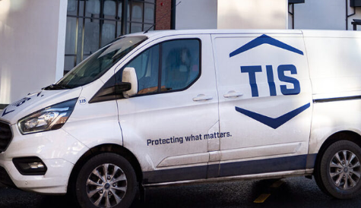

Works will affect the blocks listed below in the order specified.

Service Charges
When the work has been completed in your block, a weekly service charge will be added to your rent account. The new charge is in addition to your current rent.
The service charges for the period 7 April 2025 to 5 April 2026 will be £10.96 per week.
In addition, service charges are reviewed annually and subject to approval from Cabinet before the start of each financial year in April. Where there is a further change to your services charges, we will give you 28 days written notice before the changes come into effect.
If you currently pay a service charge for door entry, the door entry charge will be ended on your rent account the day before the new security charge is applied.
For Sandwell Council Leaseholders, a pro-rata charge will be raised on your account until the end of the financial year. You will receive your annual bill for 2026/27 as normal in April/ May 2026 which will include the new charges.
What do I need to do?
If you are claiming Universal Credit housing costs:
- You will need to sign into your online Universal Credit account https://www.universal-credit.service.gov.uk/sign-in
- Click on menu and select ‘report a change’
- Find ‘where you live and what it costs’
- Follow the prompts to enter your new service charge
- Keep this letter somewhere safe - you will need it to update the Department for Work and Pensions when the new charges are applied to your rent account.

If you are currently in receipt of housing benefit your benefits will be recalculated by the Revenues and Benefits Department and your rent account will be updated.
If you pay by monthly Direct Debit, the amount you pay will be re-calculated automatically.
Where do I get help, I can’t afford this increase?
We know that this is a difficult time for many of our customers and we want to ensure support is available.
Our Welfare Rights Team can give you free independent and impartial advice and support of all welfare benefits. If you need any advice, please contact 0121 569 3158.
For more information, please visit https://www.sandwell.gov.uk/welfarerights or https://www.sandwell.gov.uk/resilientresidents.
We are committed to helping you sustain your tenancy. If you are experiencing difficulties paying your rent, please don’t delay contacting us - early contact gives us the best chance to support you. Contact the Rents Team on 0121 737 5148.
For more information on the support available to help you manage your rent account, please visit www.sandwell.gov.uk/rentfirst or scan the QR code below using your mobile device.

To help our customers budget and to give you peace of mind that your rent is paid on time, we ask customers to pay their rent by direct debit. You can set up a direct debit online at: www.sandwell.gov.uk/payingyourrent or by calling 0121 368 1166.

Yours sincerely

CCTV and Concierge
Sandwell Council


