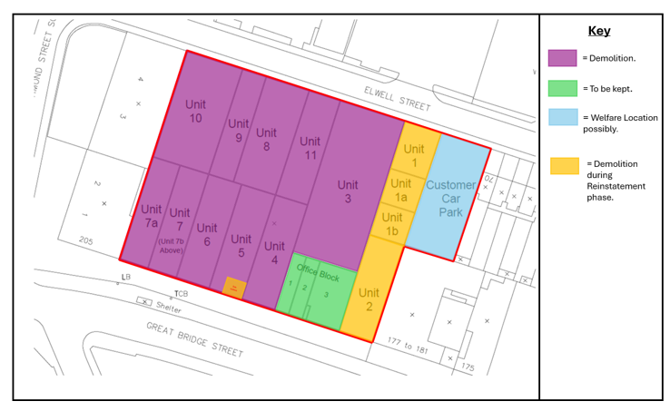
NOT TO SCALE – HOARDING SHOWN WITH BLUE LINE

