SANDWELL

Resident Newsletter
Charge Your EV Locally with Wenea’s New Public Chargers
Sandwell Council, working with Wenea, has brought new electric vehicle charge points to the community. They’re easy to use, reliable, and help reduce emissions in our borough.
🔌 Where to find them
- Park Road – 2 chargers (7.4 kW)
- Long Hyde Road – 2 chargers (7.4 kW)
- Heath Street – 2 chargers (7.4 kW)
- Gladys Road – 2 chargers (7.4 kW)
- Reginald Road – 2 chargers (7.4 kW)
- Merrivale Road – 4 chargers (7.4 kW)
- Vince Street – 2 chargers (7.4 kW)
- Capethorn Road – 2 chargers (7.4 kW)
- The Uplands – 2 chargers (7.4 kW)
- Clifton Road – 2 chargers (7.4 kW)
- Green Street – 2 chargers (7.4 kW)
- Sandwell Road North – 2 chargers (7.4 kW)
- Terrace Street – 2 chargers (7.4 kW)
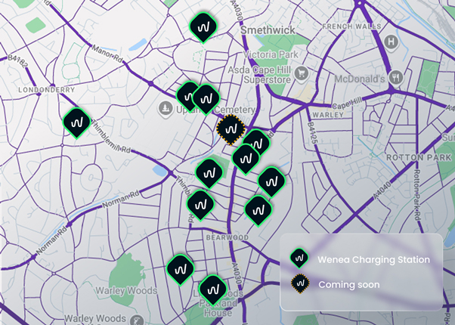
📱 To start charging, download the Wenea app. Every charge helps build a cleaner, greener Sandwell.

This project supports Sandwell Council’s vision for a cleaner, greener borough and gives residents greater access to sustainable travel options.

