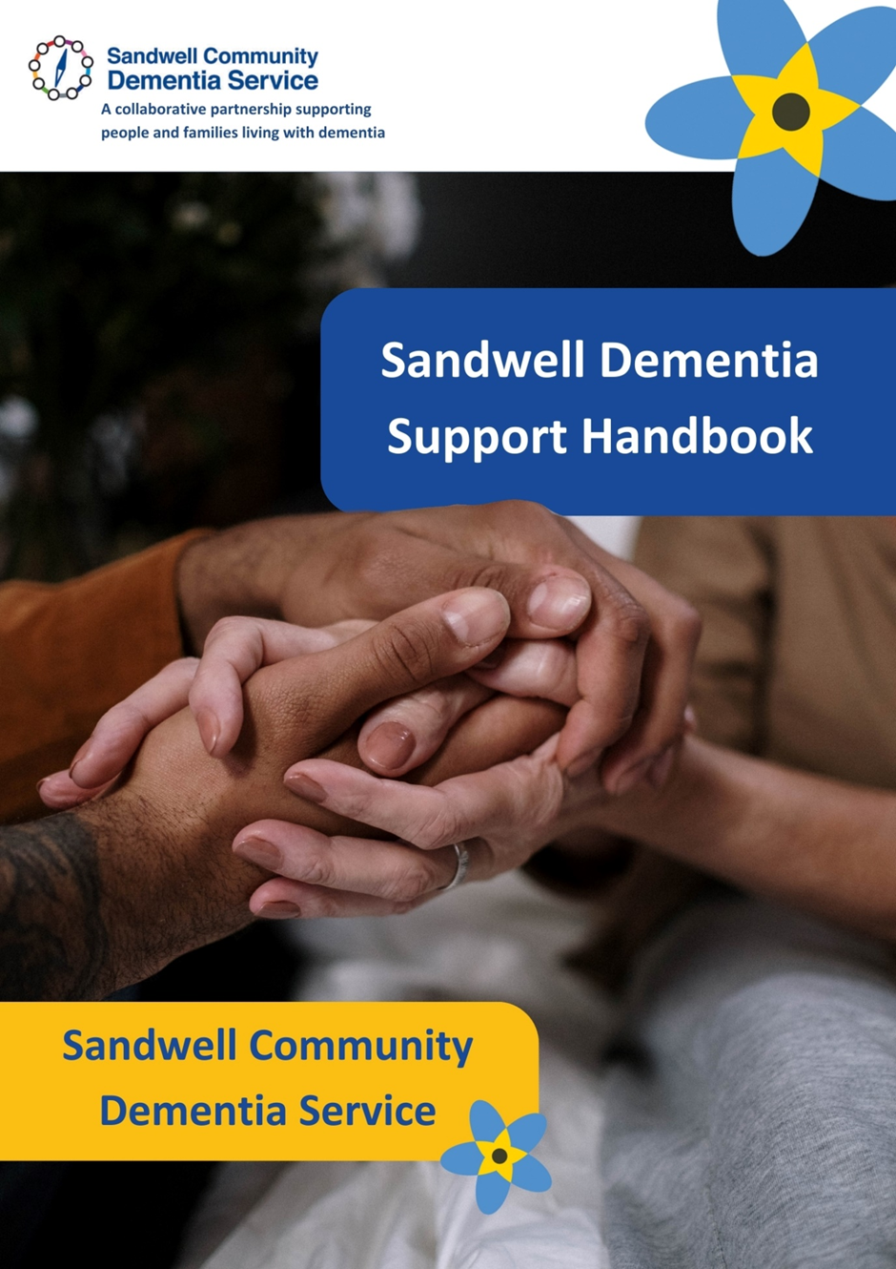

Contents
Section 1 Information Page 4 – Page 30
- Page 5 - Introduction
- Page 6 – Dementia Research, Making Your Home Dementia Friendly
- Page 7 – Housing Options,
- Page 8 - Staying Healthy, Keeping Active
- Page 9 – Driving, Keeping Warm, Incontinence
- Page 10 – Incontinence, Sleep, Alcohol
- Page 11 – Alcohol, Type of Care
- Page 12 - Financial Planning, Financial Support
- Page 13 - Financial Support, Behaviour
- Page 14 - Behaviour, Pain
- Page 15 – Memory, Future Planning, Support Plan, Lasting Power of Attorney
- Page 16 - Lasting Power of Attorney, Deputyship, Organ Donation,
- Page 17 – Advance Statement
- Page 18-22 – Advance Decision to Refuse Treatment (ADRT)
- Page 23-26 – The ReSPECT Process
- Page 27 – Do Not Attempt Resuscitation (DNAR), Wills
- Page 28 – Wills, Will Aid
- Page 29 – Role of an Executor, Inheritance Tax, Digital Legacy
- Page 30 – Digital Legacy, Life Insurance
- Page 31-32 – Funeral Plans

Section 2 – Living Well / About Me Page 33 – Page 48
- Page 34 – Calling Card, Getting to Know You
- Page 35 – Next of Kin, Main Carer, Lasting Power of Attorney
- Page 36-37 – Family and Friends Contacts
- Page 38 – Professional Contacts
- Page 39-45 – Living Well / About Me
- Page 46-48 – Making the Most of Life
Section 3 – Emergency Care Planning Page 49 – Page 71
- Page 48-54 – Emergency Care Planning
- Page 55-65 – Daily Routine Outline
Section 4 – My Goals Page 72 – Page 83
- Page 67-70 – My Goals
Section 5 - My Appointments Page 84 – Page 124
- Page 72-88 – Appointment Planners

Section 1
Information

The Dementia Support Handbook has been designed for people living with dementia to think about and record their preferences, wishes and plans.
If something happens to you and you cannot make decisions about your health or care, for example if you have dementia or a stroke, then your family do not have the legal right to make decisions for you.
It is recommended this document is reviewed on a regular basis (suggested every 6 months unless any changes are made in between).
Additional information can be found in Sandwell Dementia Care and Support Planning Toolkit - https://www.sandwell.gov.uk/downloads/file/3178/sandwell-dementia-planning-toolkit-for-web
Planning for the Future
What matters most to you, what are your priorities and thing you would like to action?
What are your thoughts about your future:
• is it something you have thought about?
• what would you like to see happen?
Practicalities
It is never too early to start to think about and plan ahead for future support and for after death too.
Date the handbook was started:

Handbook completed by:

Date the handbook was updated:

Handbook updated by:

Date the handbook was updated:

Handbook updated by:

Date the handbook was updated:

Handbook updated by:

Dementia Research
Researchers from around the world are working hard to find a cure for dementia and better ways to support those living with a dementia diagnosis and their families.
Research into dementia would not be possible without the help of people living with the condition. This help takes many forms including being involved in a clinical trial to test a new treatment, giving blood for use in genetic research or by giving your views on the quality of healthcare and support services.
If you would like to take part in research, there are several ways you can do this:
- Ask GP
- Ask at memory service
- Register interest online at www.joindementiaresearch.nihr.ac.uk

Making your Home Dementia Friendly
Sometimes you only need to make small changes to help you stay physically active, safe and remain independent. It is a good idea to make the necessary changes as soon as possible to make your home a supportive place and help you to feel comfortable.
- Remove any trip hazards such as loose rugs
- Remove any clutter and unused items
- Ensure there is good lighting
- Install smoke alarms and carbon monoxide detectors, if you don’t already have them
- At night use night lights or consider leaving a light on to help you get around and find things
- Ask for a free home safety visit form your local fire service
- Use colour and contrast to help things stand out – plain brightly coloured bed and table linen to contrast with the walls
- Use colour and contrast for eating and drinking items such as plates, cups and cutlery
- Use technology in different ways to make your home dementia friendly
- Keep a list of important telephone numbers and who to contact in an emergency by the phone
- Installing hand and grab rails
Further information available - https://www.alzheimers.org.uk/get-support/publications-factsheets/making-your-home-dementia-friendly
https://www.nhs.uk/conditions/dementia/living-with-dementia/home-environment/
https://www.dementiauk.org/information-and-support/living-with-dementia/making-the-home-safe-and-comfortable-for-a-person-with-dementia/
https://www.ageuk.org.uk/information-advice/health-wellbeing/conditions-illnesses/dementia/a-dementia-friendly-home/

Housing Options
Staying in your own home – There are things you can do to make your home suitable for you to continue to live there. You GP or healthcare professional can refer you to an occupational therapist who will have the expertise to advise you on appropriate modifications.
Moving to a more suitable property – whether you own your own home or rent, it may be worth considering moving to a more suitable property which may be easier to manage, closer to family and friends, closer to shops or public transport routes.
Living with family – not an option that will suit all families but where there is, this can benefit as each generation of the family can support the other.
Assisted Living / Extra Care Housing – you still have your own front door, but staff are usually available 24 hours per day to provide personal care and support services.
Sheltered / Retirement Housing – Usually available to people aged 55 or above. The self-contained flats usually have a warden / manager onsite, an alarm system, communal areas and may also offer social activities.
Shared Lives Schemes – Support adults with needs that make it harder for them to live on their own. Through the scheme a person who needs care is matched with an approved carer. The carer shares their family and community life, and provides care and support for the person with the care needs. Some Carers are regular daytime visitors whilst others may move in with the person needing care.
Further information available - https://www.ageuk.org.uk/information-advice/care/housing-options/assisted-living-and-extra-care-housing/
https://www.alzheimers.org.uk/get-support/help-dementia-care/care-homes-decision#:~:text=Assisted%20living,-This%20is%20housing&text=It%20is%20also%20known%20as%20supported%20living%20or%20extra%20care,like%20shopping%20or%20laundry%20services

Staying Healthy
If you have dementia, it doesn’t mean you should feel ill, anxious or depressed. It is important to see the GP of you are feeling ill to rule out any other illnesses or infections. Other illnesses and infections can make your dementia present worse.
Ways to stay healthy:
- Try to drink plenty of fluids and eat balanced meals
- Take regular exercise
- Get enough sleep
- Ensure you stay warm enough
- If you smoke, try to stop. There are services that help with stopping smoking – your GP will be able to tell you of the services in your area. Smoking increases the risk of vascular dementia, and toxins in cigarettes increase inflammation causing Alzheimer’s.
- If you enjoy the occasional alcoholic drink, speak with the GP to ensure this won’t cause a problem with any medication you are taking
- Have regular eye tests, if you wear glasses ensure they are clean and the correct ones for your prescription
- Have regular hearing tests. If you have a hearing aid, ensure you wear it, check the batteries and ensure it is kept clean
- Ensure you are up to date with your vaccines, such as flu, coronavirus, pneumonia (for over 65s) and shingles (for overs 70s)
- Ensure shoes and slippers fit well to prevent falls
- Keep up regular visits to the dentist and keep your teeth and mouth healthy.
- Feeling low or depressed may be a sign of depression. Your GP can advise of treatments for anxiety and depression, if your symptoms continue or get worse
Further information available - https://www.dementiauk.org/information-and-support/health-advice/staying-healthy/

Keeping Active
Having dementia doesn’t mean you have to stop doing the things you enjoy. Being active can help you remain independent and in touch with other people, and can improve your quality of life.
There are lots of different activities to keep you active, some suggestions are below:
- Playing games or cards
- Completing puzzles such as wordsearch, crosswords, sudoku or jigsaw puzzles
- Exercise such as walking, swimming or cycling
- Creative activities such as drawing, painting, crafts, knitting, crochet
- Visiting places of interest such as theatre, museums
- Listening to music, podcasts or audio books
- Reading
- Going on day trips or holidays
- Seeing family and friends
- Gardening
- Spending time with a pet
Further information available - https://www.alzheimers.org.uk/get-support/staying-independent/keeping-active-dementia-practical-tips
https://www.nhs.uk/conditions/dementia/living-with-dementia/activities/
https://www.alzheimersresearchuk.org/dementia-information/dementia-risk/physical-activity-and-dementia-risk/

Driving
It is important for the person to follow medical advice when it comes to driving. If the person is still driving when they receive a diagnosis of Dementia, they must notify the Driver and Vehicle Licensing Agency (DVLA) in they are living in England or Wales, or the Driver and Vehicle Agency (DVA) if living in Northern Ireland. They also need to inform their insurance company.
Further information available - https://www.alzheimers.org.uk/get-support/staying-independent/driving-dementia
https://www.dementiauk.org/information-and-support/living-with-dementia/driving-and-dementia/
https://www.gov.uk/dementia-and-driving

Keeping Warm
Someone with dementia may not realise they are cold or may be unable to tell someone.
Tips to keep warm:
- Stay active when indoors – avoid sitting for too long
- Heat your home to at least 18C (65F)
- Wear several layers of thin clothing to trap warmth
- Check heating and cooking appliances are safe
Further information available - https://fis.sandwell.gov.uk/kb5/sandwell/directory/service.page?id=LM0IwuFMtP0&familychannel=0

Incontinence
It is common for people to have more difficulties using the toilet as they get older, particularly if they have dementia. Accidents and incontinence can cause problems which can be upsetting for the person with dementia and difficult for the person supporting them.
Try to encourage the person with dementia to drink the recommended 6-8 glasses of liquids each day, more if the person is constipated as not drinking enough liquids can cause constipation. The person should be encouraged to eat a balanced diet with plenty of fruit and vegetables, and fibre (cereals, brown rice, wholemeal bread, potatoes) to help with regular bowel movements. If able, the person with dementia should be encouraged to keep active, perhaps with a daily walk as this will help with regular bowel movements. Try to build going to the toilet into the person’s routine, ensuring you allow enough time for the person to empty their bowels.
Further information available - https://www.nhs.uk/conditions/urinary-incontinence/10-ways-to-stop-leaks/
https://www.alzheimers.org.uk/get-support/daily-living/toilet-problems-continence
https://www.dementiauk.org/information-and-support/health-advice/continence/

Sleep
Tips to support good sleep for people with dementia:
- Exercise during the day
- Limit daytime naps
- Ensure a range of stimulating activities – someone is less likely to doze off during the day if they are active
- Avoid caffeinated drinks such as tea and coffee (or change to decaffeinated options)
- Consider using black out curtains
- Use a clock with indicates day and night times
- Ensure the person is no thirsty, hungry or in pain
- Find relaxing ways to encourage the person to sleep (such as listening to music)
Further information available - https://www.dementiauk.org/information-and-support/living-with-dementia/dementia-and-sleep/
https://www.sleepfoundation.org/mental-health/dementia-and-sleep

Alcohol
Drinking excessive amounts of alcohol over a lengthy period of time can lead to brain damage, and may increase the risk of developing dementia. It’s important to balance the person with dementia’s right to enjoy a sociable activity such as drinking alcohol, against the risk it may pose. However:
- People with dementia can become more confused after drinking alcohol, so may need to limit the amount they have
- Alcohol doesn’t mix well with certain medicines
- People who have dementia secondary to alcohol abuse should not drink alcohol
- People with alcoholic dementia should have high thiamine diets and/or thiamine supplements.
Further information available - https://www.alzheimers.org.uk/about-dementia/types-dementia/alcohol-related-dementia
https://www.dementiauk.org/information-and-support/living-with-dementia/alcohol-and-dementia/

Type of Care
Care Homes
Care homes in England are required to be registered with the Care Quality Commission (CQC) which monitors, rates and inspects services. Care homes range in size from 4beds to over 100 and whilst a few are run by local councils, the majority tend to be run by private companies or charities.
Care Homes are generally classed under 2 types:
Residential Homes – Do not have nurses on the care team. Will provide help and assistance with personal care.
Nursing Homes – Have professional registered nurses and experienced care assistants who provide 24-hour nursing care services for people with more complex health needs as well as providing help and assistance with personal care.
Domiciliary Care – Care provided by home care agencies for you in your own home ranging from one 15 minute a week to live-in 24 hours care. Agencies are required to be registered with CQC if they provider personal care. Agencies providing shopping, laundry and similar services but no personal care do not need to be registered with CQC.
Hospice Care – Provide care for people with life-limiting conditions as they approach the end of their life. Support is also provided earlier in a person’s illness when symptoms are difficult to manage. Hospice care places a high value on dignity, respect and the wishes of a person who is ill. It aims to look after their medical, emotional, social, practical, psychological and spiritual needs, and the needs of the person’s family and carers.
Further information available - https://www.nhs.uk/conditions/dementia/care-and-support/care-homes/
https://www.dementiauk.org/information-and-support/specialist-diagnosis-and-support/considering-a-care-home-for-a-person-with-dementia/
Financial Planning
The amount you will have to pay for care will vary depending on your personal circumstances and the area that you live in. The cost of your care and how much you will have to contribute from your own resources will be calculated by your local council. If you have over £23,250 in capital you will have to pay for your own care. Speaking to a financial advisor may help you understand the options available to meet the needs of the cost of your care in the most efficient manner according to your personal circumstances.

Financial Support
There are a number of benefits and other financial support available if you are on a low income, have a disability, are a carer or have a terminal diagnosis.
- Attendance Allowance – helps with extra costs if you have a disability severe enough that you need someone to help look after you. It is paid at 2 different rates and the amount you get will depend on the level of care you need. To qualify you will be either physically or mentally disabled and of State Pension age or older and have needed help for six months or longer (unless you are terminally ill). You don’t have to have someone care for you to be able to claim. You are not entitled to Attendance Allowance of you already get Disability Living Allowance or PIP.
- Benefits for the terminally ill – If you’re living with a terminal illness and have been told by your doctor or a medical professional that you might have less than 6 months to live, you may get benefits at a higher rate or extra money and/or start getting payments quicker than usual. You will need to ask a medical professional to fill in a DS1500 form, which confirms your diagnosis and treatment plan.
- Carer’s Allowance – May be eligible if you, the person you care for and the type of care you provide meets certain criteria. You do not have to be related to, or live with the person you care for. You must be the primary carer for someone at least 35 hours per week and they need to get certain benefits.
- Carer’s Credit – You may be able to get this if you are not eligible for Carer’s Allowance. This gives you credits to help fill gaps in your National Insurance Record, so you can take on caring responsibilities without affecting your ability to qualify for the State Pension.
- Council Support – You might be eligible for your local council to pay towards the cost of your care if you have less than £23,250 in savings. The exact amount will depend on what care you need and how much you can afford to pay.
- Council Tax Support – regardless of income many people living with dementia, if considered by their doctor to have severe mental impairment will qualify for a reduction on their council tax bill.
- Housing Benefit – If you are on a low income and living in rented accommodation you may be entitled to help with your rent. If you are of working age, you will normally need to claim UC instead.
- NHS Continuing Healthcare – Some people with long-term complex health needs qualify for free social care arranged and funded solely by the NHS. To confirm eligibility, you will need to be assessed by a team of healthcare professionals (a multidisciplinary team)
- Pension Credit – Gives you extra money to help with living costs if you are on a low income and over the State Pension age. Can also help with housing costs such as ground rent or service charges. You may get extra help if you are severely disabled, a carer or responsible for a child or young person. Person Credit is separate from your State Pension. You can get Pension Credit even if you have other income, savings or your own home.
- Personal Independence Payment (PIP) – A tax-free benefit for people aged 16 and over who have not reached State Pension age. Replacing Disability Living Allowance, it can help with extra costs caused by long term ill-health or a disability.
- Universal Credit (UC) – may be able to get if you are on a low income or need help with you living costs and are below State Pension age. You can be working including self-employed or part time work or unemployed. You may get extra money if you have a health condition that affects your ability to work.
Further information available - https://www.alzheimers.org.uk/get-support/legal-financial/benefits-dementia
https://www.dementiauk.org/information-and-support/financial-and-legal-support/
https://www.ageuk.org.uk/information-advice/health-wellbeing/conditions-illnesses/dementia/getting-care-and-support/
https://www.nhs.uk/conditions/dementia/care-and-support/social-services-and-the-nhs/

Behaviour
Tips to support people who are agitated:
- Rule out or treat the underlying cause
- Uncontrolled pain
- Untreated depression
- Infection or illness
- Medication side-effects
If the person behaves in an aggressive way, try to stay calm and avoid confrontation. Call for assistance if they are not settling.
Tips to support people who are restless:
- Make sure the person has plenty to eat and drink
- Daily routine, including daily walks
- Have something to occupy their hands such as a fidget blanket, sorting puzzle or a box of meaningful items
- Accompany them on a walk
- Consider tracking devices and alarm systems
Tips to support people who repeat the same question or activity:
- Remain patient, keeping the tone in your voice level and calm
- If the behaviour is not harmful or causing a problem, accept that the person finds it comforting and reassuring and let it be
- Look at what is triggering the behaviour
- If the person keeps asking about the time or date, consider putting a calendar or clock where they can easily see it. Day clocks can be purchased and are relatively inexpensive
- If the person keeps looking for a particular item, keep it somewhere that is easy to see and access
Further information available - https://www.nhs.uk/conditions/dementia/living-with-dementia/behaviour/#:~:text=People%20with%20dementia%20often%20develop,daily%20routine%2C%20including%20daily%20walks
https://www.alzheimers.org.uk/about-dementia/symptoms-and-diagnosis/symptoms/behaviour-changes

Pain
Clinical tips to recognise when people with dementia are in pain:
- Calling out, groaning or shouting
- Changes in behaviour, such as fidgeting, restlessness, or distress during personal care
- Sleeping more or less than usual
- Body language, such as bracing or guarding, or repetitive movements
- Facial expressions, such as grimacing or frowning
- Mood, withdrawal or uncharacteristic quietness, low mood
- Increased pulse, sweating, flushing or appearing pale
- Poor appetite
Further information available - https://www.dementiauk.org/information-and-support/health-advice/pain-and-dementia/

Memory
Tips to help cope with memory loss:
- Keep a regular routine
- Use a daily / weekly timetable
- Record information in a notebook
- Plan activities for when they are most active (in the morning or evening)
- Use your brain – puzzles such as wordsearch, crosswords, sudoku, jigsaw puzzles
- Use signs and labels (example – fridge label on the fridge)
- Pill box organiser
- Consider a day clock
- Keep a list of helpful numbers
- Keep main items in an obvious place (example – keys)
- Maintain healthy lifestyle to prevent further deterioration
Further information available - https://www.alzheimers.org.uk/get-support/staying-independent/coping-with-memory-loss

Future Planning
Support Plan
It is not a legal document and not all people need or choose to have a support plan, but by creating one means you and your carers can be more involved in the decisions about your care. It can be useful if you are being supported by a variety of healthcare professionals for them to better understand your situation and what matters most to you. A support plan sets out what is important to you, your goals and the support you need to enable you to meet those goals. It also takes into account your physical and mental health as well as personal, family, social spiritual and cultural considerations. Support plans tend to be produced with you by one or more people involved in your care. If you don’t have one and think it would be helpful you can contact your GP. It should be reviewed on a regular basis as your goals and the support you need are likely to change over time and your plan should be meaningful for your current situation. You can ask your GP to ad the latest version to your notes.

Lasting Power of Attorney
People living in England and Wales may want to set up a Lasting Power of Attorney (LPA) to enable someone you trust to have the legal power to make decisions for you if you reach the stage, you are no longer able to make decisions for yourself or communicate them. There are two types:
- One covers property and financial affairs (including Bills, Bank Accounts and selling property)
- One covers health and welfare (such as day-to-day care decisions and medical treatment)
The person who makes the LPA is known as the ‘donor’ and the person given the power to make decisions is known as the ‘attorney’.
A Lasting Power of Attorney can only be drafted when you have mental capacity and can only be used, unless stated otherwise, when you lack mental capacity.
A Lasting Power of Attorney can only be used after it has been registered and sealed by the Office of the Public Guardian.
People living in Northern Ireland can set up an Enduring Power of Attorney (EPA) enabling someone else to manage their finances and property if they are unable to.
Further information available - https://www.gov.uk/power-of-attorney
https://www.nhs.uk/conditions/end-of-life-care/planning-ahead/lasting-power-of-attorney/
https://www.alzheimers.org.uk/get-support/legal-financial/lasting-power-attorney
https://www.ageuk.org.uk/information-advice/money-legal/legal-issues/power-of-attorney/

Deputyship
If you no longer have mental capacity to make decisions for yourself or understand the consequences of your decisions and do not have a LPA in place, another person (e.g, a close relative or friend) or organisation (e.g. the Council, an accountant or a solicitor) will need to apply to be your deputy.
Being a Next of Kin DOES NOT give you the legal authority to make decisions on behalf of another adult.
Further information available - https://www.alzheimers.org.uk/sites/default/files/2018-06/6485%20AS%20Factsheet%20530(web)_0.pdf

Organ Donation
Choosing to donate your organs is a generous and worthwhile decision that can save lives, it is up to you whether you donate all, some or none.
Organ donation in England has changed to an opt out system. This means that all adults agree to become organ donors when they die, unless they have made it known that they do not wish to donate.
Further information available - https://www.organdonation.nhs.uk/

Advance Statement
This document sets out what you would like to have happen as you approach the end of your life. If you become unable to communicate or make decisions for yourself. Although this is not a legal document, those caring for you are expected to follow your wishes where practicable. This is not for decisions regarding medical treatment but is more about your beliefs, values and other things that are important to you. You can also include other practical information.
In an Advance Statement you cannot:
- Choose to refuse basic care that is essential to keep you comfortable (e.g. keeping you warm, pain relief, nursing care)
- Choose to refuse the offer of food or drink by mouth
- Request anything unlawful, such as euthanasia or help to take your own life
- Demand specific treatment – Healthcare professionals do not have to give any treatment they consider clinically unnecessary, useless or inappropriate
- Refuse treatment for a mental disorder if you meet the relevant criteria to be detained until the Mental Health Act 1983.
It is advised to review the document on a regular basis and update it with any changes to your wishes and priorities. Your healthcare professional can help you understand the kind of choices you might wish to make. When completed, you should discuss it with your family and make sure it is available to them when needed.
If you are writing the advance statement on behalf of somebody (if you hold lasting power of attorney or a close family relative) it is important to reflect what they would have wanted,
Templates for Advance Statement of Preference can be found online to download and complete.
Further information available - https://www.nhs.uk/conditions/end-of-life-care/planning-ahead/advance-statement/
https://www.alzheimers.org.uk/get-support/legal-financial/dementia-advance-decisions-statements
https://www.ageuk.org.uk/siteassets/documents/factsheets/fs72_advance_decisions_advance_statements_and_living_wills_fcs.pdf

Advance Decision to Refuse Treatment (ADRT)
An Advance Decision to Refuse Treatment (also known as Living Will or Advance Directive) is for you to write down any treatments that you do not want to have in the future. It is a legally binding document if you have signed it, had your signature witnessed and have met the other considerations. It will only come into force if you lose capacity to make your own choices.
You should have an ADRT if there are certain circumstances in which you would not wish to be kept alive, an ADRT ensures that your medical team will follow your wishes, regardless of others’ opinions.
It is advisable to discuss it with a healthcare professional, who can help you complete it. You can find example templates online or your healthcare professional may be able to provide you with the form to record your wishes.
Further information available - https://www.nhs.uk/conditions/end-of-life-care/planning-ahead/advance-decision-to-refuse-treatment/
https://www.ageuk.org.uk/siteassets/documents/factsheets/fs72_advance_decisions_advance_statements_and_living_wills_fcs.pdf
https://www.alzheimers.org.uk/get-support/legal-financial/advance-decisions-dementia

The example below is from the Alzheimer’s Society.
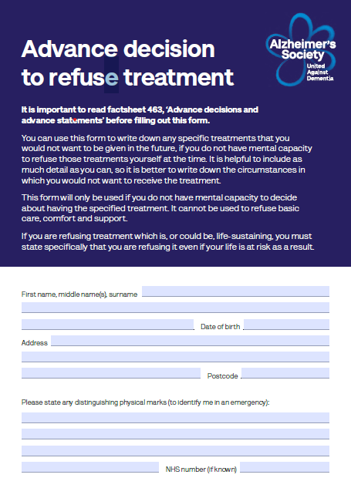

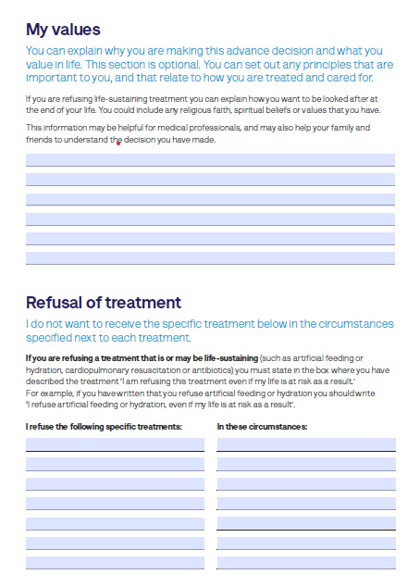

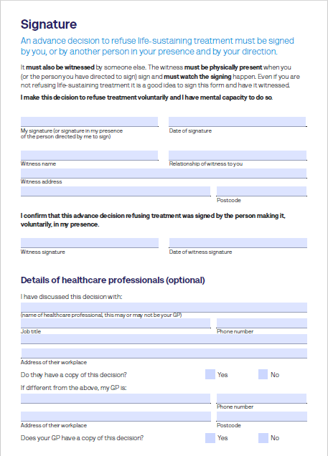

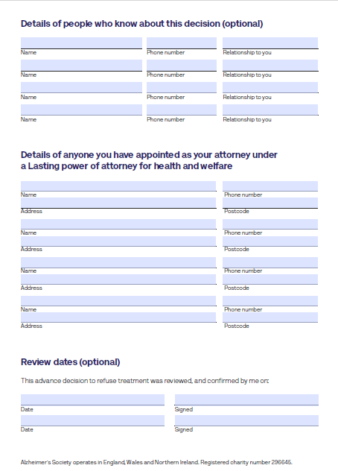

The ReSPECT Process
What does ReSPECT stand for?
Recommended Summary Plan for Emergency Care and Treatment.
What is ReSPECT?
ReSPECT is a process which creates personalised recommendations for someone’s clinical care in emergency situations only, where they are not able to make decisions or express their wishes. It will not change any other care or treatment that you may need.
It is important, as in an emergency situation, people are often unable to communicate or make decisions for themselves. Having the ReSPECT plan in place, helps to ensure that you will receive the appropriate care and treatment that has been discussed and recommended for you, including recommendations about cardiopulmonary resuscitation (CPR).
Who is it for?
As this is not used in all parts of the country, you will need to check with a healthcare professional whether ReSPECT is used in your area.
ReSPECT is for anyone who wants to record their preferences for their care and treatment, particularly if you have complex health needs, are likely to be nearing end of life, or at risk of sudden deterioration or cardiac arrest.
What does it do?
It provides health and care professionals responding to an emergency with a summary of recommendations to help them make immediate decisions about your care and treatment. It is important that you know what recommendations are recorded on the plan and that you are comfortable with them.
You should inform anyone you spend substantial time with, such as your family, friends, carers, neighbours that you have a ReSPECT plan. It is important they are aware you are with the agreed recommendations and understand what is important to you.
How does it work?
If you have an appointment with a health care professional, are admitted to hospital to have a health care professional visiting you, you need to tell them you have a plan and if it is possible, take the ReSPECT plan with you.
This allows the opportunity for the recommendations to be regularly reviewed. You can amend your plan by speaking with a health care professional if there are aspects you are no longer comfortable with.
It is recommended to keep your ReSPECT plan with you, or if this is not possible, it should be kept where it is easily accessible for people who may need to refer to it, such as ambulance personnel. If you have healthcare records or care agency records in a folder kept at home, it may be recommended to store your ReSPECT plan within these.
Further information available - https://www.resus.org.uk/respect

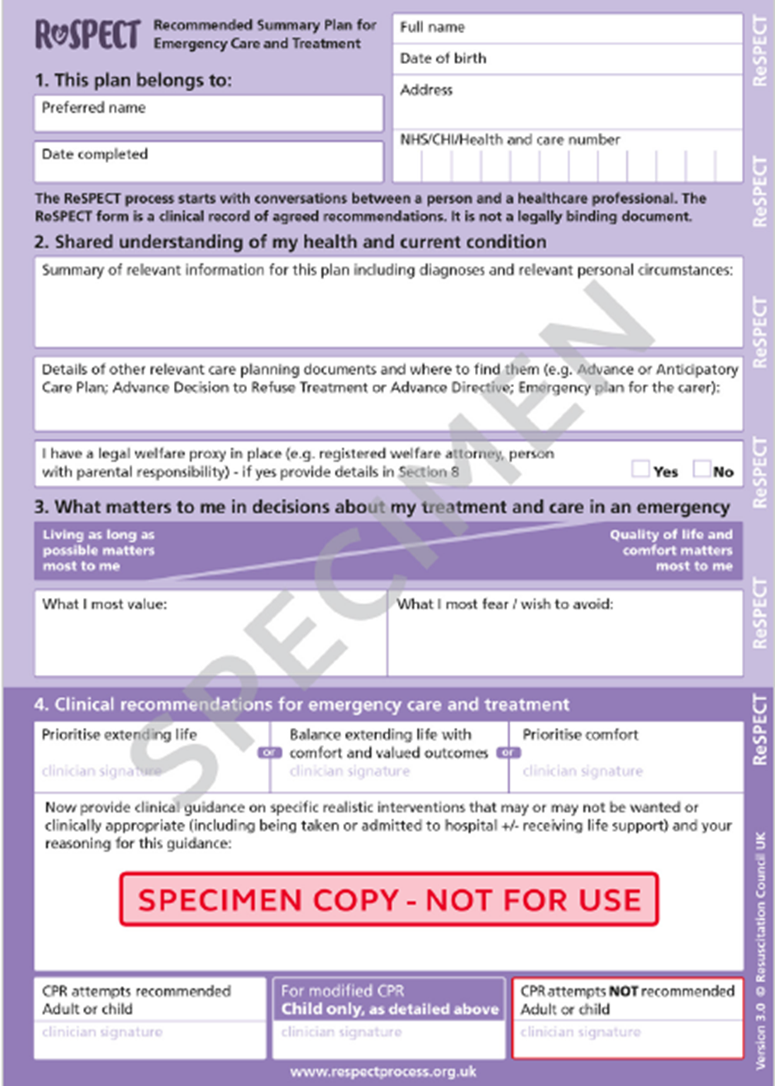
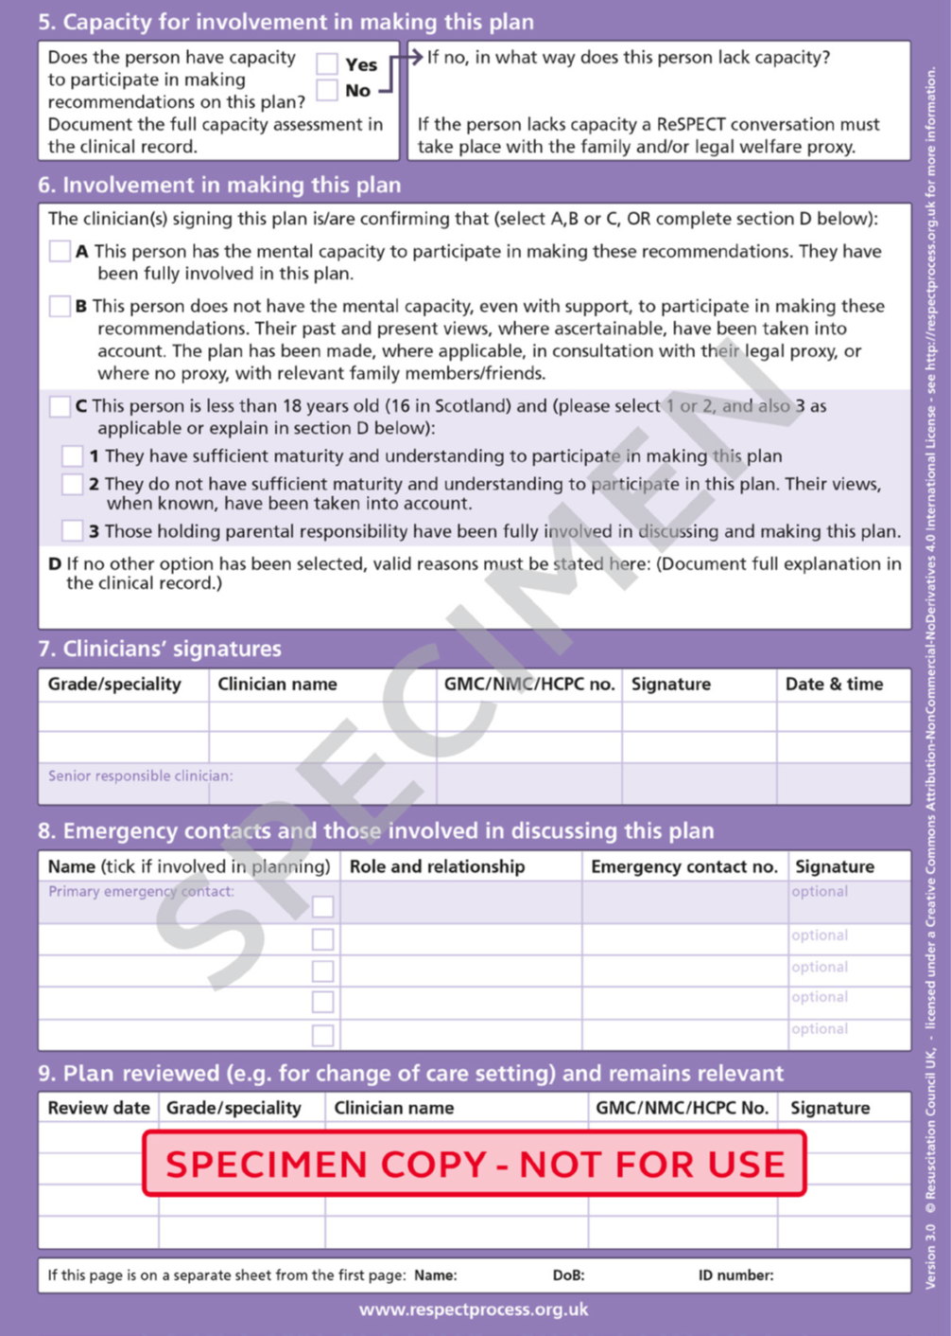
Do Not Attempt Resuscitation (DNAR, also known as DNACPR or DNR)
This is an instruction to health care professionals not to perform CPR.
CPR is when a team is trying to get the heart pumping again, after it has stopped. At the same time, they are trying to get enough oxygen into the lungs to keep other parts of the body oxygenated, to reduce damage to the brain and other organs. CPR involves rapid, repeated compression of a person’s chest, blowing air or oxygen into their lungs, if necessary, by inserting a tube into their windpipe, delivery of high-voltage electric shock through their chest and injection of drugs.
You may not want someone to do this if your heart stops as the final stage of the dying process. This may be because the person is frail, because their organs aren’t working or because they have another condition such as cancer. In these circumstances trying to restart the heart won’t help as it cannot reverse the other things that are happening and in doing so, will prolong or increase suffering. Without a recommendation not to attempt CPR in place, health care professionals including ambulance staff are required to attempt CPR.
Although a DNAR is not a legally binding document, as long as it is correctly completed and signed by a health care professional, it will be respected by those attending to your medical needs. A DNAR form only covers CPR so you will still be given all other types of treatment for your condition along with treatment to ensure you’re comfortable and pain-free.
Your next of kin or other family members do not have the right to put a DNAR in place for you. Your lasting power of attorney can at on your behalf and ask a health care professional to sign the form. If you live in a care home the manager may discuss it with you (or your family if you no longer have capacity) and your GP and create one as a decision taken in your best interests. If you are admitted to hospital, the healthcare team may put a DNAR in place, again based on a decision taken in your best interests and in consultation with your lasting power of attorney and / or your family.
Further information available - https://www.nhs.uk/conditions/do-not-attempt-cardiopulmonary-resuscitation-dnacpr-decisions/

Wills
Do you have a Will?

If you have a Will – where is it stored?

If you do not have a Will then you may want to think about making a Will.
A Will is a legal document stating what you would like to happen to your estate (money, property and possessions) after your death. If you die without a Will, the law decides who gets what!
If you have child(ren) under 18 years of age, a Will allows the appointment of a Guardian(s) for them. If you do not have a Will and both parents die, the Council or the courts will decide who should look after them.
In most cases, it is recommended that you seek legal advice to make a Will, this will ensure it is legally valid and achieves your objectives. Once completed, it should be stored in a secure place and you should let your executors know where it is.
If you die without a Will, the law decides what happens to your estate.
You don’t necessarily have to go to a solicitor to write your will. You may be able to get a simple Will wrote for free during ‘Free Wills Month’ (see below) or by choosing to leave a gift to charity. Many national charities are part of the National Free Wills network and will pay for the cost of drawing up a simple Will. There are also do-it-yourself templates available online and from certain retailers if you wish to do it yourself.
It is important not to delay the writing of your Will if you have been diagnosed with a progressive illness such as dementia. There may come a time when the question might arise as to whether you have the requisite mental capacity for making a Will. It can be time-consuming and distressing have to prove you have capacity.
Further information available - https://www.alzheimers.org.uk/get-support/publications-and-factsheets/dementia-together-magazine/can-someone-dementia-make-will

Will Aid
Every November, solicitors support charities by volunteering their time and waive their fee for writing a basic Will for individuals and invite them to make a voluntary contribution to Will Aid instead.
Further information available - https://www.willaid.org.uk/

Role of an Executor
When you make a Will, you must name an Executor (you can have up to four), who is legally responsible for carrying out the instructions in the Will for handling the estate and tasks involved:
- Registering the death
- Arranging the funeral
- Taking responsibility for property and post
- Valuing the estate
- Sorting our finances
- Dealing with estate
- Paying any inheritance tax
- Applying for probate
- Distributing the estate
You are advised to choose people who you trust and who are good with paperwork. A professional executor is advisable where there may be conflicts in a family, complicated or overseas assets to deal with or inheritance tax to pay but their costs will need to be paid out of the estate.

Further information available - https://www.ageuk.org.uk/siteassets/documents/information-guides/ageukil8_how_to_be_an_executor_inf.pdf

Inheritance Tax

In some cases, having a Will can help to reduce the amount of Inheritance Tax that needs to be paid from your estate. You can check this with your solicitor or financial advisor and how the current law affects you.

Further information available - https://www.gov.uk/inheritance-tax

Digital Legacy
As the amount of time people spend online increases, this has led to a range of benefits but has also changed the way we complete many day-to-day tasks and how we interact with others via, text, email and through social media.
Many of us are now storing photographs or videos on an electronic device(s), in the cloud or on our social media accounts. If you would like others to access (or continue to run) these after you die, you need to make sure they are informed of your wishes and left instructions for accessing these.
Do you have any online accounts (banking, shopping)? Are your loved ones aware of how to access them in the event of your death?
The Digital Legacy Association provides information about how to protect and pass on your digital assets and legacy.
Further information available - https://www.freewills.co.uk/guides/what-is-a-digital-legacy

Life Insurance
Life insurance is a policy that pays out a lump sum or regular payments to your family or loved ones on your death It gives your dependents financial support after you’ve gone. This can be used to support them for a number of years, to replace lost income, or to pay off a large debt such as a mortgage.
It's quick and easy to set up. It needn't be expensive. And it can give you welcome reassurance. You pay a monthly premium for Life Insurance. There are several factors including your age, health and lifestyle, which determine the level of cover required, as well as the type of policy you will need and how much you will need to pay. You may also be able to claim before your death if you are diagnosed with a terminal illness during the term of the policy. This will be determined by the terms of the cover you take.
The amount of money paid out will depends of the level of cover purchased.
If you intend to make an advance decision to refuse life-sustaining treatment and have a life insurance policy, check with the insurance company, as there is a risk it may affect your policy. If you have any doubts or concerns, it is advisable to take appropriate legal advice.

Funeral Plans
Funerals have changed a lot in recent years. Many funeral directors cater for non-religious ceremonies where there tends to be more of a focus on celebrating someone’s life as opposed to mourning their departure. Ceremonies are becoming increasingly personalised with some families opting to lead the ceremony. You may also have specific wishes for your funeral so informing your loved ones can ensure they fulfil your wishes wherever practical.
You may want to think about the following
Do you want to be buried or Cremated?

If cremated, what would you like to be done with your ashes (eg. kept or scattered)

If buried, where would you like to be buried?

What type of ceremony would you like (religious, non-religious, humanist)

Do you have a location in mind?

What music would you like played?

What hymns would you like?

Are there any poems, prayers or readings you would like?

Are there people you would like to read the poems, prayers or readings?

Do you have a list of people you’d like notified?

Type of ceremony (large, small, family only)

Would you like flowers (particular type of flower/s)

Would you like donations made to a particular cause instead of flowers?

How will your funeral be paid for?

The cost of a funeral depends on the choices you make, on one end of the scale, you can pay for horses, fancy coffins, marble headstones or whatever you can imagine, or you could just have a direct cremation and arrange the funeral yourself.
A pre-paid funeral plan allow you to pay upfront or in instalments for a funeral. This may help to relieve the financial burden on family and protect them against rising funeral costs.
The Financial Conduct Authority started to regulate pre-paid funeral plans from 29th July 2022.
Further information available - https://www.gov.uk/after-a-death/arrange-the-funeral
https://www.ageuk.org.uk/siteassets/documents/factsheets/fs27_planning_for_your_funeral_fcs.pdf
https://www.hospiceuk.org/information-and-support/your-guide-hospice-and-end-life-care/planning-ahead/how-plan-your-own-funeral

Section 2

Living well
About Me

Name of Sandwell Community Dementia Service Team Member:
___________________________________________________________________________

Title: ______________________________________________________________________

Contact Number: ___________________________________________________________

Attach Photo of SCDS Team Member

Getting To Know You

Full Name: Preferred name:

Gender:

Date of Birth:

Address:

Telephone:

Email:

NHS Number:

Hospital Number:

Next of Kin

Name:

Relationship:

Telephone:

Email:

Main Contact / Carer

Name:

Relationship:

Telephone:

Email:

Lasting Power of Attorney – Financial Affairs
Name:

Relationship:

Telephone:

Email:

Lasting Power of Attorney – Health and Welfare
Name:

Relationship:

Telephone:

Email:

Other family / friends contacts
Name:

Relationship:

Telephone:

Email:

Name:

Relationship:

Telephone:

Email:

Name:

Relationship:

Telephone:

Email:

Name:

Relationship:

Telephone:

Email:

Name:

Relationship:

Telephone:

Email:
Name:

Relationship:

Telephone:

Email:

Name:

Relationship:

Telephone:

Email:

Name:

Relationship:

Telephone:

Email:

Name:

Relationship:

Telephone:

Email:

Name:

Relationship:

Telephone:

Email:

Name and contact details for other people supporting you including care workers, social workers, GP’s, nurses and other professionals
Name:

Organisation / Job Title:

Telephone:

Email:

Name:

Organisation / Job Title:

Telephone:

Email:

Name:

Organisation / Job Title:

Telephone:

Email:

Name:

Organisation / Job Title:

Telephone:

Email:

Living Well
About Me
Important People in my Life

Important Dates and Why They are Important

Hobbies and Interests

Favourite Music

Favourite Television Programmes

My previous or current occupation(s)

My Culture, Faith or Religious Beliefs

My Pets / Favourite Animals / Animals I don’t Like

Favourite Foods / Foods I Dislike or Can’t Eat

Favourite Places I have Lived or Visited

Eyesight (Do I wear glasses)

Hearing (Do I wear hearing aids or hear better on one side, what language I speak, Do I need an interpreter, may I need you to repeat words, speak slowly, speak up, write things down for me)

What aids I use to get around indoors and outdoors.

Do I need assistance with moving and handling?

Physical Health and Co-existing Conditions

My Medication

Allergies (or bad reactions to medicines)

Do I have support with nursing tasks – E.g. injections, wound care, etc

Things I like to do myself

Things I may want help with

Things that make me worry or upset

Things that make me feel better if I am upset, worried or anxious

How I like to sleep and my preferred routine

My preferred bathing routine

Are there any recent adaptions made to your home to ensure a dementia friendly home / environment?

What will stop you living where you live now?

Where would you like to be cared for if you are no longer to live where you currently live

Other information about me

Making the Most of Life
What Matters Most to Me?

What may matter to me when I am less well or dying?

What makes me feel most at peace?

What are my networks of support and how can they be supported so that we all remain resilient and well cared for?

Care Preferences
When I am less well, where do I want to be cared for and by whom?

Is there a point at which I would not want admission to a healthcare facility for further treatment which aims to preserve or extend life?

Where might I prefer to be cared for when I am dying?

Who do I want to make decisions for me if I am no longer able to make them for myself?

Do I wish to make a will?

Do I or my family have preferences for what happens after death?

Section 3

Emergency Care Planning

As carers we like to think that we will always be there when needed but sometimes this isn’t always possible. An emergency care plan is to ensure the person you are caring for is supported at the earliest opportunity and that you have peace of mind that there is something in place, if for whatever reason, you cannot provide the care.
It is important that others are aware of the plan, should it need to be implemented. If you have family or friends who have agreed to help out in an emergency it is important their contact details are on the plan and they sign to confirm they understand they may be called and agree to their information to be shared with other professionals, this would usually be on needs to know basis only.
If for some reason you are unable to communicate, it is important to make sure others can take action.
You should:
- Ensure this section is completed within this handbook or complete another Emergency Care Plan.
- Carry a card in your purse or wallet stating you are a carer.
- Inform your GP that you are a carer and give them a copy of you emergency care plan.
- Give a copy to a trusted person, this could be someone identified as an emergency Contact.
- Keep the plan updated.
- Keep the plan secure.
- Tell people you trust where to locate the plan.

General Details

Date updated:

Name of Carer:

The name of the person I care for:

They like to be called:

Their address is:

Their date of birth is:

They can be contacted by:

If you need to gain access to the property where the person I care for lives, a key is held by:

Name:

Address:

Contact telephone number:

Emergency Contact Details
If I am not able to provide care, because of an emergency, please contact one of the following, who are listed in order of preference:

Contact 1

Name:

Address

Contact Telephone Numbers:

Relationship to the cared for person:

I agree to be contacted in an emergency to provide support and that my details can be shared on a need-to-know basis with other professionals.

Signature:

Do they have keys to your house?

Contact 2

Name:

Address

Contact Telephone Numbers:

Relationship to the cared for person:

I agree to be contacted in an emergency to provide support and that my details can be shared on a need-to-know basis with other professionals.

Signature:

Do they have keys to your house?

Contact 3

Name:

Address

Contact Telephone Numbers:

Relationship to the cared for person:

I agree to be contacted in an emergency to provide support and that my details can be shared on a need-to-know basis with other professionals.

Signature:

Do they have keys to your house?

Details of Dependent Children or Young Carers in the Household
Name:

Date of birth:

Is a Dependent:

Helps out with caring:

Name:

Date of birth:

Is a Dependent:

Helps out with caring:

Name:

Date of birth:

Is a Dependent:

Helps out with caring:

Name:

Date of birth:

Is a Dependent:

Helps out with caring:

Safety During the Day and Night
During the day, how long (if at all) can the cared person be left on their own:

Provide details:

During the night, how long (if at all) can the cared person be left on their own:

Provide details:

Additional Emergency Planning Information
Lasting Power of Attorney – Refer to Section 2

GP / Carers or Other Health Professionals involved on Care – Refer to Section 2

Medical Details – Refer to Section 2

Communication – Refer to Section 2

Assisted Health Tasks - Refer to Section 2

Moving and Handling - Refer to Section 2

Equipment - Refer to Section 2

Behavioural Issues - Refer to Section 2

What do you do for the person you care for?
Please tick to select the relevant box | Day | Night | Additional Information
Personal care (e.g. wash, dress, toilet, feeding)

Health needs (e.g. dressings, injections)

Moving and handling (e.g helping in/out of bed, helping in/out of chair, walking)

Safety during the day

Safety during the night

Life planning / management (e.g. dealing with letters / services, managing finances)
Emotional support (e.g. company, dealing with crises)

Day to day activities (e.g. shopping, laundry, washing, transportation to appointments)
Daily Routine Outline
This routine happens daily / or on

Time | Activity

Daily Routine Outline
This routine happens daily / or on

Time | Activity

Daily Routine Outline
This routine happens daily / or on

Time | Activity

Daily Routine Outline
This routine happens daily / or on

Time | Activity

Daily Routine Outline
This routine happens daily / or on

Time | Activity

Daily Routine Outline
This routine happens daily / or on

Time | Activity

Daily Routine Outline
This routine happens daily / or on

Time | Activity

Daily Routine Outline
This routine happens daily / or on

Time | Activity

Daily Routine Outline
This routine happens daily / or on

Time | Activity

Daily Routine Outline
This routine happens daily / or on

Time | Activity

Daily Routine Outline
This routine happens daily / or on

Time | Activity

Daily Routine Outline
This routine happens daily / or on

Time | Activity

Daily Routine Outline
This routine happens daily / or on

Time | Activity

Daily Routine Outline
This routine happens daily / or on

Time | Activity

Daily Routine Outline
This routine happens daily / or on

Time | Activity

Section 4
My Goals

My Goals
These can be split into short, medium and long term goals. They are your goals but examples may include to maintain independence, daily walks, exercise more, lose weight, gain weight, stop smoking.
My Goal

My Goal

My Goal

My Goal

My Goal

My Goal

My Goal

My Goal

My Goal

My Goal

My Goal

My Goal

My Goal

My Goal

My Goal

My Goal

My Goal

My Goal

My Goal

My Goal

My Goal

My Goal

My Goal

My Goal

My Goal

My Goal

My Goal

My Goal

My Goal

My Goal

My Goal

My Goal

My Goal

Section 5
My Appointments

My Appointments
This section can be used for planning your appointments, knowing who you are seeing, when and where you are going. Making a note if you have any questions you want answering at the appointment, recording what happened during the appointment and any actions following the appointment and recording your next appointment date and time.
Appointment Details

Date of Appointment: Time of Appointment:

What is the appointment for:

Where is the appointment:

Name of who I and seeing and their job title:

Their contact number:

Questions I have:

Appointment Notes:

Actions or next Appointment:

Appointment Details

Date of Appointment: Time of Appointment:

What is the appointment for:

Where is the appointment:

Name of who I and seeing and their job title:

Their contact number:

Questions I have:

Appointment Notes:

Actions or next Appointment:

Appointment Details

Date of Appointment: Time of Appointment:

What is the appointment for:

Where is the appointment:

Name of who I and seeing and their job title:

Their contact number:

Questions I have:

Appointment Notes:

Actions or next Appointment:

Appointment Details

Date of Appointment: Time of Appointment:

What is the appointment for:

Where is the appointment:

Name of who I and seeing and their job title:

Their contact number:

Questions I have:

Appointment Notes:

Actions or next Appointment:

Appointment Details

Date of Appointment: Time of Appointment:

What is the appointment for:

Where is the appointment:

Name of who I and seeing and their job title:

Their contact number:

Questions I have:

Appointment Notes:

Actions or next Appointment:

Appointment Details

Date of Appointment: Time of Appointment:

What is the appointment for:

Where is the appointment:

Name of who I and seeing and their job title:

Their contact number:

Questions I have:

Appointment Notes:

Actions or next Appointment:

Appointment Details

Date of Appointment: Time of Appointment:

What is the appointment for:

Where is the appointment:

Name of who I and seeing and their job title:

Their contact number:

Questions I have:

Appointment Notes:

Actions or next Appointment:

Appointment Details

Date of Appointment: Time of Appointment:

What is the appointment for:

Where is the appointment:

Name of who I and seeing and their job title:

Their contact number:

Questions I have:

Appointment Notes:

Actions or next Appointment:

Appointment Details

Date of Appointment: Time of Appointment:

What is the appointment for:

Where is the appointment:

Name of who I and seeing and their job title:

Their contact number:

Questions I have:

Appointment Notes:

Actions or next Appointment:

Appointment Details

Date of Appointment: Time of Appointment:

What is the appointment for:

Where is the appointment:

Name of who I and seeing and their job title:

Their contact number:

Questions I have:

Appointment Notes:

Actions or next Appointment:

Appointment Details

Date of Appointment: Time of Appointment:

What is the appointment for:

Where is the appointment:

Name of who I and seeing and their job title:

Their contact number:

Questions I have:

Appointment Notes:

Actions or next Appointment:

Appointment Details

Date of Appointment: Time of Appointment:

What is the appointment for:

Where is the appointment:

Name of who I and seeing and their job title:

Their contact number:

Questions I have:

Appointment Notes:

Actions or next Appointment:

Appointment Details

Date of Appointment: Time of Appointment:

What is the appointment for:

Where is the appointment:

Name of who I and seeing and their job title:

Their contact number:

Questions I have:

Appointment Notes:

Actions or next Appointment:

Appointment Details

Date of Appointment: Time of Appointment:

What is the appointment for:

Where is the appointment:

Name of who I and seeing and their job title:

Their contact number:

Questions I have:

Appointment Notes:

Actions or next Appointment:

Appointment Details

Date of Appointment: Time of Appointment:

What is the appointment for:

Where is the appointment:

Name of who I and seeing and their job title:

Their contact number:

Questions I have:

Appointment Notes:

Actions or next Appointment:

Appointment Details

Date of Appointment: Time of Appointment:

What is the appointment for:

Where is the appointment:

Name of who I and seeing and their job title:

Their contact number:

Questions I have:

Appointment Notes:

Actions or next Appointment:

Appointment Details

Date of Appointment: Time of Appointment:

What is the appointment for:

Where is the appointment:

Name of who I and seeing and their job title:

Their contact number:

Questions I have:

Appointment Notes:

Actions or next Appointment:

Appointment Details

Date of Appointment: Time of Appointment:

What is the appointment for:

Where is the appointment:

Name of who I and seeing and their job title:

Their contact number:

Questions I have:

Appointment Notes:

Actions or next Appointment:

Appointment Details

Date of Appointment: Time of Appointment:

What is the appointment for:

Where is the appointment:

Name of who I and seeing and their job title:

Their contact number:

Questions I have:

Appointment Notes:

Actions or next Appointment:

Appointment Details

Date of Appointment: Time of Appointment:

What is the appointment for:

Where is the appointment:

Name of who I and seeing and their job title:

Their contact number:

Questions I have:

Appointment Notes:

Actions or next Appointment:

Appointment Details

Date of Appointment: Time of Appointment:

What is the appointment for:

Where is the appointment:

Name of who I and seeing and their job title:

Their contact number:

Questions I have:

Appointment Notes:

Actions or next Appointment:

Appointment Details

Date of Appointment: Time of Appointment:

What is the appointment for:

Where is the appointment:

Name of who I and seeing and their job title:

Their contact number:

Questions I have:

Appointment Notes:

Actions or next Appointment:

Appointment Details

Date of Appointment: Time of Appointment:

What is the appointment for:

Where is the appointment:

Name of who I and seeing and their job title:

Their contact number:

Questions I have:

Appointment Notes:

Actions or next Appointment:

Appointment Details

Date of Appointment: Time of Appointment:

What is the appointment for:

Where is the appointment:

Name of who I and seeing and their job title:

Their contact number:

Questions I have:

Appointment Notes:

Actions or next Appointment:

Appointment Details

Date of Appointment: Time of Appointment:

What is the appointment for:

Where is the appointment:

Name of who I and seeing and their job title:

Their contact number:

Questions I have:

Appointment Notes:

Actions or next Appointment:

Appointment Details

Date of Appointment: Time of Appointment:

What is the appointment for:

Where is the appointment:

Name of who I and seeing and their job title:

Their contact number:

Questions I have:

Appointment Notes:

Actions or next Appointment:

Appointment Details

Date of Appointment: Time of Appointment:

What is the appointment for:

Where is the appointment:

Name of who I and seeing and their job title:

Their contact number:

Questions I have:

Appointment Notes:

Actions or next Appointment:

Appointment Details

Date of Appointment: Time of Appointment:

What is the appointment for:

Where is the appointment:

Name of who I and seeing and their job title:

Their contact number:

Questions I have:

Appointment Notes:

Actions or next Appointment:

Appointment Details

Date of Appointment: Time of Appointment:

What is the appointment for:

Where is the appointment:

Name of who I and seeing and their job title:

Their contact number:

Questions I have:

Appointment Notes:

Actions or next Appointment:

Appointment Details

Date of Appointment: Time of Appointment:

What is the appointment for:

Where is the appointment:

Name of who I and seeing and their job title:

Their contact number:

Questions I have:

Appointment Notes:

Actions or next Appointment:

Appointment Details

Date of Appointment: Time of Appointment:

What is the appointment for:

Where is the appointment:

Name of who I and seeing and their job title:

Their contact number:

Questions I have:

Appointment Notes:

Actions or next Appointment:

Appointment Details

Date of Appointment: Time of Appointment:

What is the appointment for:

Where is the appointment:

Name of who I and seeing and their job title:

Their contact number:

Questions I have:

Appointment Notes:

Actions or next Appointment:

Appointment Details

Date of Appointment: Time of Appointment:

What is the appointment for:

Where is the appointment:

Name of who I and seeing and their job title:

Their contact number:

Questions I have:

Appointment Notes:

Actions or next Appointment:

Appointment Details

Date of Appointment: Time of Appointment:

What is the appointment for:

Where is the appointment:

Name of who I and seeing and their job title:

Their contact number:

Questions I have:

Appointment Notes:

Actions or next Appointment:

Appointment Details

Date of Appointment: Time of Appointment:

What is the appointment for:

Where is the appointment:

Name of who I and seeing and their job title:

Their contact number:

Questions I have:

Appointment Notes:

Actions or next Appointment:

Appointment Details

Date of Appointment: Time of Appointment:

What is the appointment for:

Where is the appointment:

Name of who I and seeing and their job title:

Their contact number:

Questions I have:

Appointment Notes:

Actions or next Appointment:

Appointment Details

Date of Appointment: Time of Appointment:

What is the appointment for:

Where is the appointment:

Name of who I and seeing and their job title:

Their contact number:

Questions I have:

Appointment Notes:

Actions or next Appointment:

Appointment Details

Date of Appointment: Time of Appointment:

What is the appointment for:

Where is the appointment:

Name of who I and seeing and their job title:

Their contact number:

Questions I have:

Appointment Notes:

Actions or next Appointment:

Appointment Details

Date of Appointment: Time of Appointment:

What is the appointment for:

Where is the appointment:

Name of who I and seeing and their job title:

Their contact number:

Questions I have:

Appointment Notes:

Actions or next Appointment:

Appointment Details

Date of Appointment: Time of Appointment:

What is the appointment for:

Where is the appointment:

Name of who I and seeing and their job title:

Their contact number:

Questions I have:

Appointment Notes:

Actions or next Appointment:

