
2024 Air Quality Annual Status Report (ASR)
In fulfilment of Part IV of the Environment Act 1995 Local Air Quality Management, as amended by the Environment Act 2021
Date: 18 June 2024

Information | Sandwell MBC Details
Local Authority Officer | Elizabeth Stephens and Sophie Morris
Department | Pollution Control Team, Public Health
Address | Sandwell Council House, Freeth Street, Oldbury, B69 3DE
Telephone | 0121 569 2200
E-mail | pollution_control@sandwell.gov.uk
Report Reference Number | Sandwell ASR 2024
Date | 18 June 2024

Executive Summary: Air Quality in Our Area
Breathing in polluted air affects our health and costs the NHS and our society billions of pounds each year. Since clean air is essential for all of us to breathe, it's crucial for everyone to be aware of how poor air quality impacts health and the actions required to reduce both sources and our personal exposure.
Air pollution is recognised as a contributing factor in the onset of heart disease and cancer and can cause a vast range of health impacts, including effects on lung function, exacerbation of asthma, increases in hospital admissions and mortality. In the UK, it is estimated that the reduction in healthy life expectancy caused by air pollution is equivalent to 29,000 to 43,000 deaths a year.
We know that air pollution particularly affects the most vulnerable in society including children, the elderly, and those with existing heart and lung conditions. Additionally, people living in less affluent areas are most exposed to dangerous levels of air pollution.
Table ES 1 provides a brief explanation of the key pollutants relevant to Local Air Quality Management and the kind of activities they might arise from.
Table ES 1 - Description of Key Pollutants
Pollutant | Description
Nitrogen Dioxide (NO₂) | Nitrogen dioxide is a gas which is generally emitted from high-temperature combustion processes such as road transport or energy generation.
Sulphur Dioxide (SO₂) | Sulphur dioxide (SO₂) is a corrosive gas which is predominantly produced from the combustion of coal or crude oil.
Particulate Matter  (PM₁₀ and PM_{2.5}) | Particulate matter is everything in the air that is not a gas.  Particles can come from natural sources such as pollen, as well as human made sources such as smoke from fires, emissions from industry and dust from tyres and brakes.  PM₁₀ refers to particles under 10 micrometres. Fine particulate matter or PM_{2.5} are particles under 2.5 micrometres.

Air Quality in Sandwell
Sandwell Metropolitan Borough Council (SMBC) is situated in the heart of the West Midlands, within the region of the UK commonly referred to as "The Black Country". It is one of seven local authorities that are members of the West Midlands Combined Authority (WMCA), alongside Birmingham, Coventry, Dudley, Solihull, Walsall, and Wolverhampton. The area is densely populated, covering approximately 8,600 hectares and housing around 330,000 residents. The borough is characterised by well-established industry and is served by an extensive road network comprising local and major arterial roads, including the M5 and M6 Motorways.
Declaration of an Air Quality Management Area (AQMA)
In 2005 Sandwell was declared an Air Quality Management Area (AQMA) due to high concentrations of nitrogen dioxide (NO₂). Although NO2 concentrations are generally decreasing, some areas still experience high levels due to growing traffic and congestion. The annual mean NO₂ objective was exceeded in 2023 at two monitoring locations, but overall levels continue to follow a downward trend.
The reduction in NO₂ concentrations is positive but concerns over the negative health effects of fine particulate matter (PM_{2.5}) are rising. Studies confirm that long-term exposure to PM_{2.5} is linked to premature death, particularly amongst those with heart or lung disease as well but can also impact children such as permanently stunting lung growth. Whilst daily exposure to raised levels of PM_{2.5} is associated with increased hospital admissions and deaths. Although traffic is a significant contributor to PM_{2.5} emissions, domestic wood and coal burning are the main sources of PM_{2.5} in urban areas like Sandwell.
Regulation of Local Air Quality
Sandwell’s Pollution Control Team and Regulatory Services Team are responsible for overseeing air quality in residential and commercial locations. The team investigate potential statutory complaints relating to smoke emissions, including enforcing our smoke control area issuing permits for industrial activities under Environmental Permitting Regulations and consulting on planning applications.
Sandwell Council also collaborates with various organisations to improve air quality, including other local authorities, the West Midlands Combined Authority, Transport for West Midlands (TfWM), National Highways, the NHS, The University of Birmingham, Black Country Transport, the Office for Environmental Protection, Canal and River Trust and EarthSense.
Air Pollution Monitoring
In 2023, Sandwell had five continuous automatic air quality monitoring stations, all of which monitor NO₂, whilst four of the five also analyse PM₁₀ and PM_{2.5} concentrations and one of these also monitors Ozone (O₃). Nitrogen diffusion tubes are installed at 119 locations across Sandwell, with 22 of these sites having tubes in triplicate. In 2018 Sandwell had seven priority zones for air quality, see the maps in Appendix D, as well as two Hotspots. In 2023, only Zone 3 had an exceedance in annual NO2 concentrations, this was recorded on the A457 link road to the M5 see Table 1.1 below.
Table 1.1. Sandwell NO2 Key Priority Zones for 2020 to 2025 and Historical Non-Compliance with NO2 National Objectives
Zone | Historic Area No. | Description of Area | NO₂ Compliant
Zone | Historic Area No. | Description of Area | 2018 | 2019 | 2020 | 2021 | 2022 | 2023
1 | 13 | High Street / Powke Lane, Blackheath | X | X
2 | 11 | Bearwood Road, Smethwick | X | X
3 | 1 | M5 Corridor - Blakeley Hall Road, Oldbury to Birmingham Road (A41), West Bromwich | X | X |  | X | X | X
4 | 10 | Newton Road / Birmingham Road (A34), Great Barr | X | X
5 | 14 | Bromford Lane (including Kelvin Way / Brandon Way Junction),  West Bromwich | X
6 | 16 | All Saints Way / Expressway,  West Bromwich | X
7 | 15 | Trinity Way / Kenrick Way, West Bromwich | X | X
Hotspot 1 |  | Mallin Street, Smethwick | X | X
Hotspot 2 |  | Gorsty Hill, Blackheath | X

Clean Air Strategy 2018 – Delivering Nitrogen Dioxide Compliance in the Shortest Possible Time
Sandwell Council were in a ‘third wave’ of local authorities, that received a Ministerial Direction in March 2018 requiring a feasibility study to be undertaken, requiring NO₂ compliance to be expediated along two link roads to the M5, these were the A41 in West Bromwich and the A457 in Oldbury. The feasibility study identified two measures that could potentially expediate NO₂ reductions: retrofitting buses to Euro VI standard and improving traffic signalling. Both measures were completed by November 2019. To monitor the effectiveness of these measures on air quality, triplicate NO₂ diffusion tubes were located at five points along the A41 in 2019. In 2023 the results from all locations were well below the 10% national air quality objective (AQO) with annual mean concentrations ranging between 29.1µg/m³ to 32.2µg/m3.
Improvements in NO₂ concentrations have also been realised along the A457 Birmingham Road. In 2023 ten of the eleven NO₂ diffusion tubes were within the AQO. Only tube (BP) continues to exceed the AQO recording 44.0µg/m³ in 2023, where the cause of these elevated concentrations is due to vehicles breaking and accelerating up to and from a nearby roundabout, as well as the proximity of buildings to the road limiting pollution dispersion. NO₂ levels along both link roads will continue to be monitored in 2024, with quarterly reports delivered to JAQU and we await further direction.
Levels of Nitrogen Dioxide (NO₂) in Sandwell in 2023 Compared with National Trends
In 2023 Sandwell demonstrated significant decreases in annual background and roadside NO₂, with a 19.5% reduction in roadside concentrations and 20% in urban background concentrations. Sandwell is following the UK downward trend, as is shown in Figure 1.1.
Figure 1.1 – Comparison between the UK and Sandwell Annual Mean NO2 Concentrations 2019-2023

Levels of Particulate Matter in Sandwell in 2023 Compared with National Trends
PM₁₀ concentrations in Sandwell have continued to track below the average UK PM₁₀ concentrations at both our Urban Roadside monitoring locations, with levels approximately 2µg/m³ lower than recorded in 2022, see Figure 1.2.
Figure 1.2 – Comparison between the UK and Sandwell's Annual Mean PM₁₀ Concentrations at Urban Roadside Sites 2019-2023

The annual urban background PM₁₀ annual concentrations at Highfields has aligned with the UK national average since 2021 as shown in Figure 1.3. Whilst PM₁₀ concentrations at Haden Hill reduced by approximately 1µg/m³ since 2022, sitting just below the national average.
Figure 1.3 – Comparison between the UK and Sandwell's Annual Mean PM₁₀ Concentrations at Urban Background Sites 2019-2023

The Environmental Targets (Fine Particulate Matter) (England) Regulations 2023 set a maximum target of 10µg/m³ for annual PM_{2.5} concentrations in English local authorities to be met by 2040. The regulations also introduced a requirement that population exposure to PM_{2.5} was reduced by at least 35% (based on 2018 levels) by 2040 with an intermediate target of 22% by 2028. (Population exposure refers to the average concentration that someone in England is exposed to and is based on urban background measurements, as these are representative of the type of environment in which people live and work in).
Prior to the introduction of these Regulations Sandwell had expanded its PM_{2.5} monitoring capabilities in 2021, from one site (Haden Hill) to four, and now allows comparison against national trends for the last three years. Annual PM_{2.5} concentrations at the Wilderness Lane site have tracked roughly 2µg/m³ below the UK average for the last three years as shown in Figure 1.4. Whilst Birmingham Road concentrations have increased marginally so but were still 0.1 µg/m³ below the UK average in 2023.
Figure 1.4 – Comparison between the UK and Sandwell's Annual PM_{2.5} Concentrations at Urban Roadside Sites 2021-2023

PM_{2.5} has been monitored at Haden Hill since 2007, fluctuating around 6 to 8 µg/m³ over the last five years, with concentrations now tracking just below the UK levels, as can be seen in Figure 1.5. Whilst at Highfields concentrations decreased by 1.7µg/m³ in 2023, with levels now only 0.1µg/m³ above the national average.
Figure 1.5 – Comparison between the UK and Sandwell's Annual PM_{2.5} Concentrations at an Urban Background Sites 2019-2023

Although current concentrations of PM_{2.5} are currently within the legal target of the 2040 10µg/m³ annual mean, there is no safe level of exposure for health, hence the guideline levels established by the World Health Organisation which are currently at 5µg/m³. Currently no sites in Sandwell are at or below 5µg/m³.
Sandwell currently has good PM_{2.5} monitoring capability which is important for understanding long term trends. However, PM_{2.5} concentrations are influenced by many factors, including transboundary transport, weather, and agriculture, as well as complex atmospheric chemical reactions that result in the formation of secondary particulate matter. These wider influences can result in annual fluctuations at a local level that are not necessarily created from local sources but as a local authority we still need to reduce our own emissions and avoid adding to the global air pollution burden.

Actions to Improve Air Quality
Whilst air quality has improved significantly in recent decades, there are some areas where local action is needed to protect people and the environment from the effects of air pollution.
The Environmental Improvement Plan sets out actions that will drive continued improvements to air quality and to meet the new national interim and long-term targets for fine particulate matter (PM_{2.5}), the pollutant of most harmful to human health. The Air Quality Strategy provides more information on local authorities' responsibilities to work towards these new targets and reduce fine particulate matter in their areas.
The Road to Zero details the Government’s approach to reduce exhaust emissions from road transport through a number of mechanisms, in balance with the needs of the local community. This is extremely important given that cars are the most popular mode of personal travel, and the majority of Air Quality Management Areas (AQMAs) are designated due to elevated concentrations heavily influenced by transport emissions.

Faith Communities for Clean Air
In 2020 we designed a project called ‘Working with Faith Groups in Sandwell to Improve Air Quality via Behavioural Change’. This project proposal was submitted in a successful bid to Defra for an Air Quality Grant with funding received in 2021. The project started in October 2021 and was formally completed in December 2023 with a total of 16 faith centres participating over a two-year period. Each participating faith centre was provided with a ‘Zephyr’ air quality monitor that was linked to an online dashboard that provided real-time local air quality data, which was shown on a TV screen in their centre. Noticeboards were also placed in each centre to support awareness raising. Council air quality officers delivered talks and encouraged faith centre members to engage in a wide range of activities that had positive gains for local air quality. The project has been received but a formal evaluation will be provided to Defra in July 2024, that will analyse knowledge gain as well as any associated positive behaviour changes amongst participants.
Although the project has formally finished, faith centre engagement will continue as we build-on and maintain interest and awareness in air quality and will be supporting spin-off projects from these centres.

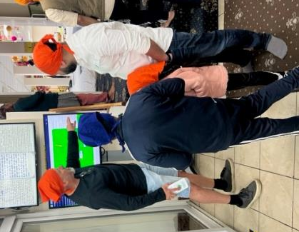
Centre members learning about air quality at the Guru Har Rai Sahib Ji West Bromwich
Air Quality Noticeboards located in the faith centres provide congregations and visitors with information and news on local air quality.


Sandwell’s Boroughwide Smoke Control Area
Sandwell revoked its 52 existing smoke control areas (that covered approximately 1/5th of the borough) in August 2023 and replaced them with a single order covering the whole of the borough. ‘The Borough of Sandwell Smoke Control Order 2022’ will come into force on 1 July 2024 and aims to improve air quality by highlighting the harm to health from domestic burning and encouraging the use of alternative heating sources or where necessary, require the burning of cleaner fuels. Domestic burning is the most significant source of PM_{2.5} emissions in the UK, even when compared to transport and industry, but due to the low-level of public awareness, domestic burning is on the increase. In the UK Emissions of PM_{2.5} and PM₁₀ from domestic wood burning increased by 56% between 2012 and 2022. In 2022 domestic burning (i.e., the burning of solid fuels such as wood, coal and fuels derived from waste such as coffee logs) was estimated to contribute to 29 per cent of total PM_{2.5} emissions.
West Midlands Combined Authority – Air Quality Framework
The WMCA were awarded a Defra Air Quality Grant in 2023, with funds allocated to support air quality awareness raising initiatives within the newly established West Midlands Air Quality Framework. Sandwell has been able to benefit from this funding through the commissioning of a local research trial to support the introduction of its smoke control area. The trial is taking place in the spring of 2024 and will evaluate how the air quality and smoke control area messages shared are received by households. By analysing our communication methods, we can tailor messaging to help maximise compliance and more importantly protect public health. The findings will be shared with other local authorities to help their future publicity and communications around domestic burning. Sandwell are also planning to recruit an Air Quality Education and Enforcement Officer in 2024, to support this education-led enforcement approach.
Active Travel
Encouraging active and sustainable travel is a key priority within Sandwell’s air quality action plan. When a journey, usually taken by car, is replaced with walking, wheeling, or cycling there are tangible benefits to both local air quality and health.
During 2023 our Active Travel Officer has worked closely with schools, businesses, and community organisations across the borough, highlights include:
- Nine new schools signed up to ModeShift STARS. This accreditation scheme recognises schools and other educational establishments that show excellence in supporting cycling, walking and other forms of active travel.

- Active Travel presentations at Faith Centres and Community Centres across the borough to engage with residents to understand and break down the barriers to active travel, including lack of awareness of quiet walking and cycling routes and safety.

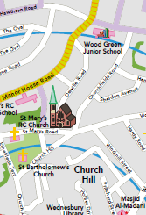
- Production of a new ‘Walking and Cycling in Wednesbury’ map and includes new cycle routes and walking times. The map will be piloted in 2024 and if successful, the intention is to produce a map for each of Sandwell’s six towns.
- Promotion of ‘Living Streets’ and associated activities including their ‘WOW Walk to School Challenge’.
- Partnership working with Sustrans to introduce a workplace wellbeing scheme to improve employees physical and mental health. A series of 5 led walks were provided at lunchtime and before/after work, along with ‘Walking & Wheeling Challenges’ to incentivise staff to take up active travel options. Edmundson Electrical were one of the participating businesses and were recipients of a Sustrans ‘Workplace Walking’ Award.
- Encouraging and supporting community groups to set up ‘Active Travel Hubs’, including Cradley Heath Community Link’s bicycle store and repair hub.
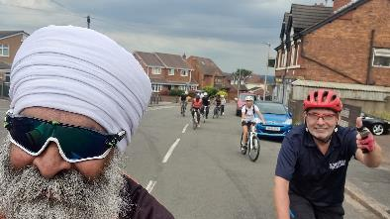
- Supporting led rides and learn to ride sessions, including arranging a ‘Bike Bus’ in collaboration with the ‘Sikh Helpline’ in West Bromwich and British Cycling in support of Clean Air Day 2023.
- Promotion of the British Triathlon Community Activator Course which upskills volunteers and allows them to confidently lead walking and learn to ride sessions.
NHS Partnership Working
We have been working in partnership with the NHS to raise awareness of the impact that poor air quality has on health and in particular children with asthma. We have been encouraging health professionals in the NHS to integrate air quality into discussions with patients and in doing so we aim to inspire both practitioners and patients to take proactive measures to protect themselves and reduce their own personal emissions. A snapshot of the work undertaken includes:
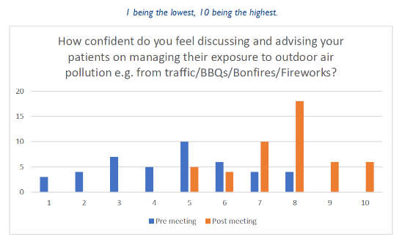
- A presentation in June 2023 on ‘Air Pollution and Asthma’ at two ‘All Things Air’ webinars, attended by over 150 health professionals, including nurses, GPs and Consultants. Feedback from the webinars was positive, as shown in the chart opposite.
- Providing air quality and health information for the 'Black Country 0-18 Healthier Together' website, as part of the NHS Healthier Futures programme. This information is designed to be inclusive and accessible to a diverse audience, including parents, carers, and health professionals, with the ability to provide instant translations into multiple languages.
- Gained permission from the North Central London ICS to adapt their leaflet on air quality and asthma for Health Professionals to distribute in the Black Country.
- Included asthma within a new children’s air pollution storybook ‘Auntie Duck’ due for publication in 2024.
- Organised joint community events with the ICB Children and Young People Asthma Transformation Team to highlight the links between air quality and asthma.
- Worked with the Greener NHS group to identify opportunities to encourage active and sustainable travel to and around NHS sites.

Conclusions and Priorities
Exceedances of National Air Quality Objectives
Sandwell recorded two exceedances of the NO₂ national air quality objective in 2023, demonstrating a compliance rate of 98.4% and remaining within close reach of full compliance at all sites. As the uptake of cleaner vehicles continues it is expected that NO₂ concentrations will continue to fall, and we will achieve compliance.
Significant Trends
Sandwell has demonstrated a continued an overall downward trend in NO₂ concentrations in 2023, with only four sites increasing at all since last year, we are generally mirroring the UK trend.
The PM₁₀ concentrations have decreased at all sites since 2022, and continue to follow a long-term decline in concentrations, although this has significantly slowed since 2021.
Establishing confidence in PM_{2.5} trends is challenging because we have only three years of data from three out of the four monitoring stations, as Haden Hill is the only site providing data for over five years. In 2023 PM_{2.5} increased marginally at all sites and like the rest of the UK is demonstrating a slight upward trend in concentrations since 2020. Although PM_{2.5} remains below the government target of 10µg/m³ our aim is to continue to adopt measures that support reductions in PM_{2.5} and are closer to the WHO guideline of 5µg/m³, given that there is no safe level of exposure to PM_{2.5}.

Sandwell’s Air Quality Priorities
As a local authority our priorities are focused on continuously reducing NO₂ and PM_{2.5} concentrations, through the identification and implementation of a range of measures across all six towns.
Sandwell MBC’s current 2020-2025 Air Quality Action Plan (AQAP) be updated by June 2025, following public consultation. In the meantime, the air quality priorities in 2024, most of which are likely to be included in the new AQAP 2025-2030, are as follows:
- Promote public transport and active travel, including walking and cycling. Engage with all schools to encourage and support participation in active travel programs such as ModeShift STARS and Living Streets.
- Reduce pollution from domestic burning through information and publicity campaigns and the adoption of an education-led approach to enforcing Sandwell’s new Boroughwide Smoke Control Area.
- Maintain a flexible approach to how we engage with our diverse communities to encourage positive behaviour change, such as the introduction of town-based walking and cycling maps and the creation of ‘Auntie Duck’, our new air pollution storybook character who advocates for cleaner air.
- Maintenance of our air quality monitoring network, including the passive NO₂ diffusion tubes at 119 sites and the 5 continuous monitoring stations. Whilst using low cost-air quality monitors such as Zephyrs, to monitor potential air pollution hotspots and air quality at a more granular level.
- Extend our collaborative approach to improving local air quality by engaging with a wide spectrum of organisations, partners and institutions such as the NHS, West Midlands Combined Authority, National Highways and The University of Birmingham.
- Support the switch to low or zero emission vehicles through the Black Country ULEV strategy as well as the upgrade of Sandwell MBC’s fleet to low and zero emission vehicles.
- Regulate emissions from commercial and industrial sources through the environmental permitting process, as well as the identification of new emission sources.
- Provide constructive and practical consultations on development proposals to mitigate against harm to local air quality.

Local Engagement and How to get Involved
Sandwell Metropolitan Borough Council aims to engage with a wide variety of departments and organisations, as well as its citizens when designing measures to improve local air quality. This takes many forms, such as public consultations, as well as community-based projects and initiatives, such as the Faith Communities for Clean Air Project.
We work closely with the Black Country’s NHS ICB and their Children and Young People Asthma Transformation Team. This bi-monthly working group is working on a variety of approaches to integrate air quality awareness into children’s asthma management.
Through our newly appointed Active Travel Officer we have increased our engagement with a range of charitable organisations including British Triathlon, British Cycling, Cycling UK, Living Streets and Sustrans to support initiatives that encourage more active lifestyles and less car dependency.
Sandwell’s Air Quality Action Plan 2020-2025 is reviewed by a quarterly steering group, bringing together a range of external stakeholders. The group regularly includes officers from Sandwell’s Transport and Road Safety, Climate Change and Planning teams, WM-Air at the University of Birmingham, Transport for West Midlands, AECOM and National Highways. These meetings provide an important opportunity for us to report on the progress of existing air quality measures and to steer future initiatives.
How You Can Help
All the options mentioned below are easily accessible via the Council’s webpage. Participation in any of these initiatives can help raise awareness of air quality and promote the reduction of harmful air pollutant emissions.
- Sandwell Council’s Interactive Cycle Map helps residents explore on and off-road cycling routes, including segregated paths, traffic-calmed routes and canal towpaths. It also highlights cycle parking infrastructure locations, cycle shops and more.
- The GoJauntly walking route planner app provides information on free walking routes around the local community, to promote safe, greener and stress-free walking routes.
- TravelWise in Sandwell is a one stop shop providing a wide range of information on planning sustainable travel, including carshares, public transport routes, cycle routes and walking journeys.
- Resilient Residents has sections with information on Going Green, Health and Wellbeing and Saving Money. The Sandwell Cycling and Walking Infrastructure Plan 2020 explains Sandwell Council’s aims to increase walking and cycling uptake, the targeting of resources and the delivery of improvements to the walking and cycling environment.
- Air Quality Sandwell offers residents the opportunity to report a pollution problem and is also where reports detailing Sandwell’s air quality history can be found.
- The Healthy Sandwell website offers health and wellbeing support to residents’, providing information and services on walking and increasing physical activity. Details of Sandwell’s Smoke Control Area are provided on this government web page, whilst further information is also available on Sandwell’s Air Quality website, including the decision to designate all of Sandwell as a smoke control area, following public consultation.
- Reporting repetitive bonfires can help reduce air pollution and help prevent them from becoming a nuisance. Guidelines are also provided on how to help minimise the impact on neighbour’s health and safety should you choose to burn any garden waste.
- Sandwell have partnered with GetComposting to reduce methane and potential emissions from garden waste being burned, this website provides information about the importance of composting and offers discounts.
- Air quality and climate change are closely linked. Sandwell’s Climate Change website provides tips on how we can all help in the fight against climate change.
- Planting and preserving trees are important in improving air quality. Sandwell’s Tree Preservation Orders and Urban Tree Policy highlight the importance of trees and new tree planning. The Woodland Trust is a woodland conservation charity, and they provide information on how to plant a tree and how to get involved with tree planting and other projects in Sandwell.
- Sandwell has committed to the Black Country Ultra Low Emission Vehicle Strategy, a programme committed to delivering a network of electric vehicle charging points and ULEV public service vehicles. Maps of planned on-street residential chargers are available to view and you can make suggestions for future locations.
- Sandwell’s LitterWatch Eco Bus is a project designed to educate children and adults about their local environment, air pollution, climate change and recycling. It is a free service available to all Sandwell schools and community groups.
- Switching to energy efficient bulbs and appliances, improving insulation, and replacing your boiler with a lower NO_{x} option can help reduce carbon emission and improve air quality. Find out if your eligible for support through the Boiler Upgrade Scheme.
- Switching energy providers to those that source energy from renewable energy sources (wind, solar and water) is also a good way to reduce the impact of our homes on air quality and climate change.
- Businesses that would like electric vehicle charge point installed can still take advantage of the Government's Workplace Charging Scheme (WGS). The WGS is a voucher-based scheme that provides a contribution towards the up-front costs of the purchase and installation of electric vehicle chargers. Employers can apply for vouchers using the Workplace Charging Scheme application.
- The walk and cycle Sandwell Facebook page is for pedestrians and cyclists that are interested in discussing their experiences (good and bad) when travelling around the borough and to help the Council identify where improvements can be made.

Local Responsibilities and Commitment
This ASR was prepared by the Pollution Control Team of Sandwell Metropolitan Borough Council with the support and agreement of the following officers and departments:
Elizabeth Stephens – Air Quality Team Manager, Senior EHO
Sophie Morris – Public Health Specialist (Air Quality and Climate Change)
This ASR has been approved by:
- Liann Brookes-Smith – Interim Director of Public Health
- Lina Martino – Public Health Consultant
- Andy Thorpe – Healthy Urban Development Officer
This ASR has been signed off by a Director of Public Health.
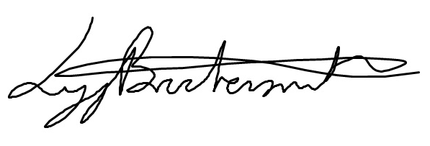

Liann Brookes-Smith, Interim Director of Public Health

If you have any comments on this ASR please send them to Elizabeth Stephens at:
Address: Public Health, Sandwell Council House, Freeth Street, Oldbury, West Midlands, B69 3DE
Or Email: pollution_control@sandwell.gov.uk

Table of Contents
Executive Summary: Air Quality in Our Area iii
Air Quality in Sandwell iv
Actions to Improve Air Quality ix
Conclusions and Priorities xiv
Local Engagement and How to get Involved xvi
Local Responsibilities and Commitment xix
1 Local Air Quality Management 1
2 Actions to Improve Air Quality 2
2.1 Air Quality Management Areas 2
2.2 Progress and Impact of Measures to address Air Quality in Sandwell 4
2.3 PM_{2.5} – Local Authority Approach to Reducing Emissions and/or Concentrations 21
3 Air Quality Monitoring Data and Comparison with Air Quality Objectives and National Compliance 24
3.1 Summary of Monitoring Undertaken 24
3.1.1 Automatic Monitoring Sites 24
3.1.2 Non-Automatic Monitoring Sites 25
3.2 Individual Pollutants 25
3.2.1 Nitrogen Dioxide (NO₂) 25
3.2.2 Particulate Matter (PM₁₀) 28
3.2.3 Particulate Matter (PM_{2.5}) 29
3.2.4 Ozone (O₃) 30
Appendix A: Monitoring Results 32
Appendix B: Full Monthly Diffusion Tube Results for 2023 70
Appendix C: Supporting Technical Information / Air Quality Monitoring Data QA/QC 79
New or Changed Sources Identified Within Sandwell MBC During 2023 79
Additional Air Quality Works Undertaken by Sandwell MBC During 2023 81
Air Quality Monitoring Network Using Low-Cost Sensors 81
All Saints Way – Speed Reduction Modelling 82
QA/QC of Diffusion Tube Monitoring 82
Diffusion Tube Annualisation 83
Diffusion Tube Bias Adjustment Factors 84
NO₂ Fall-off with Distance from the Road 85
QA/QC of Automatic Monitoring 86
Accessing Historic Data 87
Automatic Monitoring Annualisation 88
Appendix D: Map(s) of Monitoring Locations and AQMAs 89
Appendix E: Summary of Air Quality Objectives in England 102
Appendix F: Zephyr Air Quality Data Summary 2023 1
Introduction 3
Why air pollution matters 3
Zephyr® Sensors 3
Retrieval of gas concentrations 3
Retrieval of particulates 3
Summary of Zephyr Monitoring in Sandwell - 2023 4
Location of the 21 ‘Zephyr’ air quality monitors across Sandwell in 2023 6
Data Capture 2023 7
Annual Mean NO₂ Concentrations 2023 (μg/m³) 8
Annual Mean PM₁₀ Concentrations 2023 (μg/m³) 9
Annual Mean PM_{2.5} Concentrations 2023 (μg/m³) 10
Glossary of Terms 112
References 113

Figures
Figure 1.1 – Comparison between the UK and Sandwell Annual Mean NO2 Concentrations 2019-2023 vi
Figure 1.2 – Comparison between the UK and Sandwell's Annual Mean PM₁₀ Concentrations at Urban Roadside Sites 2019-2023 vii
Figure 1.3 – Comparison between the UK and Sandwell's Annual Mean PM₁₀ Concentrations at Urban Background Sites 2019-2023 vii
Figure 1.4 – Comparison between the UK and Sandwell's Annual PM_{2.5} Concentrations at Urban Roadside Sites 2021-2023 viii
Figure 1.5 – Comparison between the UK and Sandwell's Annual PM_{2.5} Concentrations at an Urban Background Sites 2019-2023 viii
Figure 2.2 – Private Hire Vehicles by Fuel Type in Sandwell 2023 8
Figure 2.1 – Trends in Private Hire Vehicle Fuel Type in Sandwell 8
Figure 2.3 – Comparison of the Fraction of Mortality Attributable to PM_{2.5} Air Pollution within the West Midlands Local Authorities 21
Figure 2.4 – Trends in the Fraction of Mortality Attributable to PM_{2.5} Air Pollution within the West Midlands Local Authorities 2018-2022 22
Figure 3.1 – Annual Mean NO₂ Concentration Trends at all Continuous Monitoring Stations in Sandwell 2019 -2023 26
Figure 3.2 – Percentage of NO₂ diffusion tube sites in Sandwell that have exceeded the National Air Quality Objective (2019-2023) 27
Figure 3.3 – Trends in Annual Mean PM₁₀ Concentrations at Continuous Monitoring Stations in Sandwell 2019 - 2023 28
Figure 3.4 – Annual Mean PM_{2.5} Concentrations in Sandwell 2021-2023 Compared with WHO Guidelines and the UK Government Target (2040) 30
Figure 3.5 – Comparison of the Monthly Mean Ozone Levels at Highfields, West Bromwich in 2022 and 2023 31

Figure A.1 – Trends in Annual Mean NO₂ Concentrations 63
Figure A.3 – Trends in Annual Mean PM₁₀ Concentrations 66
Figure A.4 – Trends in Number of 24-Hour Mean PM₁₀ Results > 50µg/m³ 68
Figure A.5 – Trends in Annual Mean PM_{2.5} Concentrations 70

Figure D.1 - Map of Continuous Automatic Monitoring Stations in Sandwell 90
Figure D 2 - Map of NO2 Diffusion Tube Monitoring Sites in Sandwell 91
Figure D 3- Map of Diffusion Tube Sites, Air Quality Monitoring Stations and Air Quality Priority Zones in Oldbury 92
Figure D 4 Map of Diffusion Tube Sites, Air Quality Monitoring Stations and Air Quality Priority Zones, Rowley Regis 93
Figure D 5 - Map of Diffusion Tube Sites and Air Quality Priority Zones in Smethwick in Smethwick, Sandwell 94
Figure D 6 - Map of Diffusion Tube Sites, Automatic Air Quality Monitoring Stations and Air Quality Priority Zones in West Bromwich 95
Figure D 7 - Map of Diffusion Tube Sites and Air Quality Priority Zone in Wednesbury, Sandwell 96
Figure D 8 - Map of Diffusion Tube Locations, Tipton 97
Figure D 9 - Maps of Air Quality Priority Zones 1 & 2 98
Figure D 10- Map of Air Quality Priority Zone 3 99
Figure D 11 - Map of Air Quality Priority Zone 4 100
Figure D 12 - Map of Air Quality Priority Zone 5 101
Figure D 13 - Maps of Air Quality Priority Zones 6 and 7 102
Tables
Table 2.1 – Declared Air Quality Management Areas 3
Table 2.2 – Progress on Measures to Improve Air Quality 13

Table A.1 – Details of Automatic Monitoring Sites 32
Table A.2 – Details of Non-Automatic Monitoring Sites 34
Table A.3 – Annual Mean NO₂ Monitoring Results: Automatic Monitoring (µg/m³) 51
Table A.4 – Annual Mean NO₂ Monitoring Results: Non-Automatic Monitoring (µg/m³) 53
Table A.5 – 1-Hour Mean NO₂ Monitoring Results, Number of 1-Hour Means > 200µg/m³ 64
Table A.6 – Annual Mean PM₁₀ Monitoring Results (µg/m³) 65
Table A.7 – 24-Hour Mean PM₁₀ Monitoring Results, Number of PM₁₀ 24-Hour Means > 50µg/m³ 67
Table A.8 – Annual Mean PM_{2.5} Monitoring Results (µg/m³) 69

Table B.1 – NO₂ 2023 Diffusion Tube Results (µg/m³) 71

Table C.1 – Annualisation Summary (concentrations presented in µg/m³) 84
Table C.2 – Bias Adjustment Factor 85
Table C.3 – Local Bias Adjustment Calculation 85
Table C.4 – Non-Automatic NO₂ Fall off With Distance Calculations (concentrations presented in µg/m³) 86

Table E.1 – Air Quality Objectives in England 103

Local Air Quality Management
This report provides an overview of air quality in Sandwell during 2023. It fulfils the requirements of Local Air Quality Management (LAQM) as set out in Part IV of the Environment Act (1995), as amended by the Environment Act (2021), and the relevant Policy and Technical Guidance documents.
The LAQM process places an obligation on all local authorities to regularly review and assess air quality in their areas, and to determine whether or not the air quality objectives are likely to be achieved. Where an exceedance is considered likely the local authority must declare an Air Quality Management Area (AQMA) and prepare an Air Quality Action Plan (AQAP) setting out the measures it intends to put in place in order to achieve and maintain the objectives and the dates by which each measure will be carried out. This Annual Status Report (ASR) is an annual requirement showing the strategies employed by Sandwell MBC to improve air quality and any progress that has been made.
The statutory air quality objectives applicable to LAQM in England are presented in Table E.1.

Actions to Improve Air Quality
  - Air Quality Management Areas
Air Quality Management Areas (AQMAs) are declared when there is an exceedance or likely exceedance of an air quality objective. After declaration, the authority should prepare an Air Quality Action Plan (AQAP) within 18 months. The AQAP should specify how air quality targets will be achieved and maintained and provide dates by which measures will be carried out.
A summary of AQMAs declared by Sandwell MBC can be found in Table 2.1. The table presents a description of the AQMA that is currently designated within Sandwell.
Appendix D: Maps of Monitoring Locations and AQMAs provides maps of the air quality monitoring locations within our boroughwide AQMA. The air quality objective pertinent to the current AQMA designation is as follows:
- NO₂ annual mean

Table 2.1 – Declared Air Quality Management Areas

AQMA Name | Date of Declaration | Pollutants and Air Quality Objectives | One Line Description | Is air quality in the AQMA influenced by roads controlled by Highways England? | Level of Exceedance: Declaration | Level of Exceedance: Current Year | Number of Years Compliant with Air Quality Objective | Name and Date of AQAP Publication | Web Link to AQAP
Sandwell Air Quality Management Area | Sandwell AQMA Order 2005 | NO2 Annual Mean | Sandwell Metropolitan Borough Council | YES | 58.51 | 44.0 | 0 | Air Quality Action Plan Sandwell MBC 2020-2025 | https://www.sandwell.gov.uk/downloads/download/2598/air_quality_action_plan_2020-2025
☒ Sandwell MBC confirm the information on UK-Air regarding their AQMA(s) is up to date.
☒ Sandwell MBC confirm that all current AQAPs have been submitted to Defra.

  - Progress and Impact of Measures to address Air Quality in Sandwell
Defra’s appraisal of last year’s ASR concluded that overall, the report was well structured, detailed and provided the information specified in the guidance. Four specific comments were provided by Defra in response to the report, these comments are printed in black with Sandwell’s response in green.
- Continue with Reference to the Public Health Outcomes Framework, following the positive work made in this submission.
The Public Health Outcomes Framework is a useful tool for comparing the mortality burden attributed to fine particulate matter in Sandwell with our neighbouring authorities, as well as the rest of England. We will continue to use this framework in future reports.
- Continue analysis of trends in the air quality data in comparison to the Air Quality Objectives.
We will maintain our analysis and presentation of air quality data against Air Quality Objectives to ensure clarity and transparency.
- Continue maintaining high standards of QA/QC procedures with sufficient supporting evidence provided, with robust analysis shown in this submission.
Ensuring that our QA/QC procedures adhere to LAQM. TG22 and are strictly adhered to is a priority. As a local authority we take pride in ensuring that the data we report is reliable and is analysed and reported accurately. We will endeavour to maintain these standards.
- Ensure subscripts are used appropriately for the next ASR submission in 2024, e.g., on page 24 should be PM_{2.5}
Additional checks will be made before submission to ensure the consistent use of subscripts throughout the report.

Sandwell’s Air Quality Measures
Sandwell MBC has taken forward a number of direct measures during the current reporting year of 2023 in pursuit of improving local air quality. Details of all measures completed, in progress or planned are set out in Table 2.2. 31 measures are included within Table 2.2, with the type of measure and the progress Sandwell MBC have made during the reporting year of 2023 presented. Where there have been, or continue to be, barriers restricting the implementation of the measure, these are also presented within Table 2.2.
More detail on these measures can be found in Sandwell’s Air Quality Action Plan 2020-2025, although additional measures have also been included since the Plan was created, including our Boroughwide Smoke Control Area, the Faith Communities Behaviour Change Project and our participation in the WMCA’s regional Air Quality Framework.
West Midlands Combined Authority (WMCA)
The Air Quality Framework, established in 2022 expands upon the initiatives previously developed by their Sustainable Travel Team under the Transport for West Midlands (TfWM) arm of the WMCA. The WMCA’s Air Quality Framework is designed to accelerate this work and complement the Air Quality Action Plans of the seven constituent local authorities.
The Framework has identified ‘options’ that are priority air quality measures and these will be progressed/delivered between 2024 and 2026. A collaborative approach is required for success, so Sandwell has been working closely with both the Environment Team at the WMCA and the University of Birmingham’s WM-Air Team who are supporting its delivery. The WMCA also received a £1million Defra Air Quality Grant in March 2023 to help fund the delivery of priority air quality measures across the region. In Sandwell this will allow funding for:
- delivery of a behaviour research trial, designed to identify how messages should be framed to maximise compliance with Sandwell’s new Smoke Control Area.
- 13 low-cost air quality sensors that will measure a range of pollutants including NO₂ and PM_{2.5}. These will be part of a network of 90 sensors across the West Midlands region. The data will be hosted on a dedicated web platform so that real-time air quality information is available to all.
- investigative air quality sampling to determine whether the new Midland Metropolitan Hospital in Smethwick is located in a PM_{2.5} hotspot as suggested by modelling data.
Black Country Transport Ultra-Low Emission Vehicle Strategy
Sandwell remains committed to the Black Country Transport – Ultra Low Emission Vehicle Strategy that was agreed in May 2020. This is a strategic transport partnership between Dudley, Sandwell, Walsall and Wolverhampton Councils to accelerate the uptake of ULEVs across the area before the planned nationwide ban on the sale of petrol and diesel vehicles in 2035. It sets out targets that Sandwell should meet to ensure that there is an EV charging infrastructure that encourages the switch to ULEV’s and meets growing demand for EVs.
Key Completed measures
The following measures as identified in our ASR 2023 were completed in 2023.
- Revocation of Sandwell’s existing 52 Smoke Control Orders and issuing of a new Boroughwide Smoke Control Order to provide equitable levels of protection for all residents. The new SCA was formally declared in February 2023 and comes into force on 1 July 2024. The new SCA creates a unique opportunity to raise awareness of the harms to health from domestic burning.
- Sandwell’s Smoke Control Area Enforcement Guide has been approved, incorporating the new enforcement provisions of the Environment Act 2021. This allows for the issuing of fixed civil financial penalty notices to individuals who repeatedly breach Sandwell’s Smoke Control Order (SCO). The fine is set at a maximum of £300, with a reduction to £175 for early payment.
- The ‘Faith Communities for Clean Air’ project, funded by a Defra air quality grant, was completed at the end of December 2023. An evaluation report on the project and our findings will be submitted to Defra by July 2024 and once agreed will be published on our website.
- The maintenance and collection of data from our network of 21 Zephyr low-cost air quality monitors, including cleaning and analysis of the data. See Appendix F.
- Further extensions to Sandwell’s cycling and pedestrianisation infrastructure including public realm improvements to Wednesbury and Rowley Regis Town Centres.
- The 40 to 30mph speed reduction modelling project on the A4031 (All Saints Way, West Bromwich) was completed. This demonstrated that there were significant potential benefits to local air quality should this measure be implemented. The results are to be shared with Sandwell’s Highway Department for a discussion on real world feasibility.
- 37 sites across Sandwell have been provided with on-street electrical vehicle chargers (with two charging points at each), funded by a £300,000 grant from the Office for Zero Emission Vehicles.
- 29 EV chargers have been installed for public/staff/fleet, including 16 at Sandwell’s Aquatic Centre.
- 20 EV chargers have been funded at Shidas Lane, Sandwell’s Waste Recycling Centre to support the conversion of SERCO’s fleet (excluding the large refuse collection vehicles).
- 9 Schools signed up to the ModeShift Stars scheme which supports and rewards schools who promote and encourage the uptake of active and sustainable travel methods.
- Monitoring of NO₂ has continued on Kelvin Way (N1A) to see if the changes made to lane marking, capacity and traffic flow on the Kelvin Way/Trinity Way roundabout in 2018 have been effective. In 2017 annual concentrations were 40.4µg/m³ in 2024 they were 30.7µg/m³.
- Quarterly NO₂ diffusion tube data results have been submitted to the Joint Air Quality Unit (JAQU) as part of the ongoing assessment of the actions taken in the ‘Third Wave’ study to reduce NO₂ along the A257 (Oldbury) and A41 (West Bromwich). As one site on the A257 (Oldbury) still exceeds 40µg/m³ we await further direction from JAQU.
- The annual review of Sandwell's licensed private vehicle fleet was conducted to identify trends in fuel profiles since 2019. (N.B. 2020 data was incomplete and therefore not included.) Figure 2.1 illustrates a significant shift towards hybrid vehicles, while the numbers of diesel and petrol vehicles have remained relatively unchanged since 2021. There has been a notable decrease in the number of fully electric vehicles, from 36 in 2021 to just 2 in 2023. Figure 2.2 provides an overview of the private hire vehicle fleet in 2023 based on fuel type. The Council is in the early stages of developing a new taxi/private hire vehicle emissions policy that will support air quality improvements by encouraging the adoption of cleaner vehicles in this sector.
Figure 2.2 – Private Hire Vehicles by Fuel Type in Sandwell 2023
Figure 2.1 – Trends in Private Hire Vehicle Fuel Type in Sandwell

Measures to be Completed in 2024
Sandwell MBC expects the following measures to be completed over the course of the next reporting year:
- Launch of the ‘Auntie Duck’ Education Programme, centred around a brand-new air pollution storybook commissioned by Sandwell’s Air Quality Team. The book is suitable for Key Stage 2 children and a free digital copy will be available on-line. Paper copies of the book will also be offered to every primary school in Sandwell, alongside 3 lesson plans and associated learning activities that meet with PSHE national curriculum requirements.
- The new Wednesbury Walking and Cycling map will be piloted with residents in the town, with the aim to produce at least one more for another town in Sandwell.
- The evaluation report on the Faith communities for Clean Air Project funded by a Defra Air Quality Grant, will be published.
- Information on air pollution and its impact on health, including how to reduce exposure, will be included on the new ‘Black Country 0-18 Healthier Together’ website. This is aimed at parents, carers and health professionals, and has the built-in capability of being translated into many different languages.
- 10 more primary schools to be enrolled on the ModeShift STARS active travel for schools’ programme, that encourages children to walk, cycle and scooter to school.
- 13 of our existing Zephyrs will be replaced by new Zephyrs that will feed into the West Midlands wide air quality dashboard, hosted by the West Midlands Combined Authority. This dashboard is part of a bigger programme of work to increase the visibility and understanding of air pollution across the region.
- Signage will be installed at nine entry points to Sandwell along the canal network to inform boaters they are entering a Smoke Control Area. These signs commissioned by Sandwell Metropolitan Borough Council (MBC), are being installed by the Canal and River Trust.
- Delivery of Sandwell’s 2024/2025 Bikeability programme, funded by a Department for Transport grant. This programme provides schoolchildren with the life skills of being able to cycle confidently and competently on today’s roads. ‘Bike Right’, on behalf of Sandwell MBC, will deliver 3078 Level 1 & 2 Combined places 148 Level 3 places and 278 Learn to Ride places, as well as SEND training as needed.
- Installation of 10 EV charging points at Sandwell’s Vehicle Depot at Roway Lane.
- Deployment of NO₂ diffusion tubes, on behalf of National Highways, at five sites close to the elevated section of the M5 between J1 and J2. This monitoring is necessary to understand the impact on local air quality following the introduction of the 60mph speed restriction on this elevated section of motorway in 2021.

Priorities for 2024
Sandwell MBC’s priorities for the coming year are as follows:
- Continued delivery of Sandwell’s Air Quality Action Plan 2020-2025, and production of a new AQAP that clearly identifies our priorities to tackle air quality issues that are within our control over the next five years.
- Focus on the reduction of domestic burning through education-led enforcement of Sandwell’s Boroughwide Smoke Control Area. An information and publicity campaign will be launched in 2024, incorporating insights from the WMCA-funded research trial to maximise compliance and reduce harmful PM_{2.5} emissions. Messaging will be shared via social media, adverts and leaflets. These will target residents, canal boaters and businesses who may be impacted by the new rules.
- Continued replacement of Sandwell’s Council fleet vehicles to EVs, delivering on net zero commitment to reduce pollutant emissions from local authority vehicles.
- Maintaining productive working relationships with key partners, including the NHS, WMCA, National Highways and local authorities within the West Midlands.
- Promoting active travel including walking and cycling and the use of sustainable transport. Prioritising our engagement with schools and proactively encouraging and supporting the uptake of school active travel programs such as ModeShift STARS and Living Streets.
- Using a flexible approach and working alongside local communities to develop resources and support that are most likely to encourage positive behaviour change, such as town-based walking and cycling maps and ‘Auntie Duck’, our new children’s air pollution storybook character, who is a passionate advocate for cleaner air!
- Maintain our air quality monitoring provision including our passive NO₂ diffusion tubes as well as our five continuous monitoring stations so we can continue to identify air pollution hotspots as well as long-term trends. Whilst using low cost-air quality monitors to further improve our understanding and response to local air quality issues.
- Regulate emissions from commercial and industrial sources through the environmental permitting process, as well as the identification of new emission sources.
- Provide constructive and practical consultations on development proposals to mitigate against harm to local air quality.
- To work as one Council in response to the climate change crisis and to identify and capitalise on the synergies between carbon reduction and improved air quality to maximise the potential benefits for our communities.
- Play an active role within the West Midlands Environmental Protection Group and use this as a platform for sharing knowledge and best practice with our neighbouring local authorities.
- Contribute to Sandwell’s new Local Plan to ensure that the air quality policy within it supports our air quality priorities including the provision of developments that promote the integration of cycling, walking, public transport, protects green spaces, increases energy efficiency and includes the use of zero or low-emission sustainable technologies.
- Supporting innovative research that increases are understanding and implementation of actions that support long-term improvements in local air quality.
Sandwell MBC worked to implement these measures in partnership with the following stakeholders during 2023:
- AECOM
- Air Quality Data Management (AQDM)
- Balaji Temple, Oldbury
- British Cycling
- British Triathlon
- Canal and River Trust
- Department for Environment Food and Rural Affairs (DEFRA)
- EarthSense
- EnviroTech
- Guru Nanak Gurdwara, Smethwick
- Horiba Ltd
- Jamia Masjid, Smethwick
- Living Streets
- ModeShift Stars
- National Highways
- NHS Black Country Integrated Care Board – Children and Young People with Asthma Transformation Team
- Office of Zero Emissions
- Pindar Creative
- St Francis of Assis Church, Wednesbury
- St Matthews Church, Tipton
- Shri Pashupatinath Mandir, Rowley Regis
- University of Birmingham
- Wesley Centre, Wednesbury
- West Midlands Combined Authority
- Yemeni Community Association, West Bromwich
Principal Challenges and Barriers
The primary challenges and barriers that Sandwell MBC expects to encounter going forward are changes in staffing and budget constraints. Additionally, some air quality measures depend heavily on third parties, including charitable and voluntary organisations, which require their goodwill and time to support air quality projects.
Measures Where Progress Has Been Slower Than Expected
Progress on Sandwell’s Boroughwide Smoke Control Area was delayed by an additional 4 months whilst we awaited approval for the revocation of the original 52 Orders from the Secretary of State. The requirement to provide an updated equality impact assessment to full Council regarding the use of civil fixed penalty notices also created further delay in the autumn of 2023. The equality impact assessment was approved in January 2024 so the enforcement date was subsequently pushed back to July 1, 2024, to allow residents more time to prepare.

Whilst the measures stated above and in Table 2.2 will help to contribute towards compliance, Sandwell MBC anticipates that further additional measures not yet prescribed will be required in subsequent years to achieve compliance and enable the revocation of Sandwell’s AQMA.

Table 2.2 – Progress on Measures to Improve Air Quality
Measure No. | Measure Title | Category | Classification | Year Measure Introduced in AQAP | Estimated / Actual Completion Date | Organisations Involved | Funding Source | Defra AQ Grant Funding | Funding Status | Estimated Cost of Measure | Measure Status | Reduction in Pollutant / Emission from Measure | Key Performance Indicator | Progress to Date | Comments / Barriers to Implementation
1 | Implementation of the new Borough of Sandwell Smoke Control Order | Public Information | Other | N/A | 2026 | Sandwell MBC Public Health and Environmental Health, WMCA | Sandwell MBC and Defra SCA Grant and Air Quality Grant (via WMCA) | YES | Partially Funded | £10k - 50k | Implementation | Reduced emissions of PM_{2.5} due to burning smokeless fuels, more efficient burning as well as discouraging the installation of new solid fuel burning stoves and use of open fireplaces. | Evaluation questionnaire as part of the behaviour research trial with WMCA | Initial survey launched in March 2024 to determine best approach to messaging around the new boroughwide SCA. Publicity and comms to be produced in Summer of 2024 leading up to the fire lighting season in autumn 2024. | Specialist education and enforcement officer still to be employed, to help lead this work
2 | Launch and implementation of the 'Auntie Duck' educational engagement programme. | Public Information | Via other mechanisms | N/A | 2040 | Sandwell MBC Public Health, Black Country NHS (Integrated Care Board) | Sandwell MBC | NO | Not Funded | < £10k | Implementation | Reduced emissions of NO2 and PM due to behaviour changes mainly relating to travel | Number of schools requesting a copy of Sandwell's new 'Auntie Duck' storybook on air pollution with associated lesson plans. Follow up evaluation after 6 months. | Auntie Duck storybook to be launched on Clean Air Day (20/06/2024) with associated and follow up evaluation planned | ‘Auntie Duck’ is being developed as Sandwell’s air quality mascot, with the intention that further activities and engagement activities will be created in future years. To build on character recognition and increase air quality awareness.
3 | Promotion of active and sustainable travel in schools, workplaces, and community organisations | Promoting Travel Alternatives | Intensive active travel campaign & infrastructure | 2020 | 2040 | Sandwell Public Health, TfWM, Living Streets, British Triathlon, British Cycling | Sandwell MBC | NO | Not Funded | < £10k | Implementation | Reduced tail pipe emissions from cars (NO2 & PM) | Number of schools with a travel plan and/or members of ModeShift STARS. Number of schools participating in the Living Streets WOW programme. Number of workplaces with travel plans | 23 schools participating in the Living Streets WOW programme. 9 schools signed up to ModeShift Stars in 2023. 16 faith centres have been involved with promoting active and sustainable travel. | ModeShift STARS funding for workplaces has been withdrawn by TfWM so other programmes such as the Living Streets Workplace Challenge will be used to sustain this work.
4 | Project working with Faith Centres across Sandwell to reduce local air pollution by encouraging behavioural change using low-cost air quality monitors and a web based AQ dashboard and AQ toolkit | Public Information | Other | 2020 | 2024 | Sandwell MBC | Defra and Sandwell MBC | YES | Funded | £100k - £500k | Completed | Reduced emissions of NO2 and PM amongst those participating due to behaviour change (<0.1%) | Behavioural change assessed through questionnaires at beginning and end of project | Grant award made by DEFRA in March 2021 - project began in August 2021. | Evaluation report due July 2024
5 | Use of real-time air pollution sensors to monitor potential air pollution hotspots | Public Information | Via the Internet | 2020 | 2027 | Sandwell MBC | Sandwell MBC | YES | Not Funded | £50k - £100k | Implementation | Reduced emissions of NO2 and PM (₁₀/_{2.5}) due to increased awareness of sources of air pollution and behaviour change. (<0.1%) | Review and analysis of data to determine pollutant trends | 13 low-cost Zephyr air quality monitors strategically located across the borough | 13 'Zephyrs' from the WMCA's air quality grant are being provided in 2024, so Sandwell’s will be decommissioned
6 | West Midlands Air Quality Framework | Policy Guidance and Development Control | Regional Groups Co-ordinating programmes to develop area wide Strategies to reduce emissions and improve air quality | 2020 | 2029 | West Midlands Combined Authority, Sandwell, Wolverhampton, Walsall, Dudley, Solihull, Coventry and Birmingham. | Defra Air Quality Grant via WMCA | YES | Funded | £500k - £1 million | Implementation | Reduced emissions of PM (₁₀/_{2.5}) through behaviour change due to increased awareness of wood and solid fuel burning as causes of air pollution (<0.1%) | Results of evaluation questionnaire as part of the behaviour research trial with WMCA. | Bid made for Air Quality Grant Funding in 2022 and approved February 2023 | Now determining measures that operate well ‘at scale’ to improve air quality. Including the monitoring of PM_{2.5} and PM₁₀ particulates to produce real-time data to enable residents to understand the need for action to address poor air quality and what that action might involve.
7 | New Wednesbury Walking and Cycling Map | Promoting travel Alternatives | Other | 2023 | 2024 | Sandwell MBC | Sandwell MBC | NO | Not Funded | <£10k | Completed | Reduced NO2 and PM tailpipe emissions due to behaviour change (<0.1%) | Results of evaluation of survey on map and views on-line | Cycling and walking map is now available on-line and paper copies have been produced to pilot with community groups in Wednesbury | If map is well received then plan is to produce maps for the 5 other towns, ideally 2 a year
8 | Maintain up-to-date air quality information on Sandwell MBC's air quality website pages | Public Information | Via the Internet | 2020 | 2040 | Sandwell MBC | Sandwell MBC | NO | Not Funded | < £10k | Implementation | Reduce emissions from bonfires, wood burners and educate on causes of air pollution, protection and how to reduce it. (<0.1%) | Number of webpage views | Council website is frequently updated to include relevant and helpful air quality information | Info on Sandwell's Air Quality can be found at https://www.sandwell.gov.uk/info/200274/pollution/485/air_quality
9 | Consult on new planning applications for impact on local air quality | Policy Guidance and Development Control | Air Quality Planning and Policy Guidance | 2010 | 2040 | Sandwell MBC | Sandwell MBC | NO | Not Funded | < £10k | Implementation | Reduced emissions of NO2 and PM by preventing or mitigating against developments that have significant potential to increase air pollution concentrations (<0.1%) | Number of consultations provided | Consultations continue to be provided to planning with reference to changes in air quality legislation, policy, and guidance | The Local Development Plan is expected to be in place by the end of 2024 and will be referred to in all pre-planning application submissions for AQ comments/advice.
10 | Provide air quality guidance to land/property developers prior to planning application submission | Policy Guidance and Development Control | Air Quality Planning and Policy Guidance | 2016 | 2040 | Sandwell MBC | Sandwell MBC | NO | Not Funded | < £10k | Implementation | Reduced emissions of NO2 and PM (₁₀/_{2.5}) by preventing or mitigating against developments with potential to increase air pollution concentrations (<0.1%) | Number of consultations provided | Consultations continue to be provided to planning with reference to changes in air quality legislation, policy and guidance | The Local Development Plan is expected to be in place by the end of 2024 and will be referred to in all pre-planning application submissions for AQ comments/advice.
11 | Black Country - ULEV Strategy - provision of electric charging infrastructure across Sandwell and other black country local authorities | Promoting Low Emission Transport | Other | 2020 | 2035 | Sandwell MBC and Black Country Authorities | Sandwell MBC and Black Country Local Authorities | NO | Partially funded | £1 million - £10 million | Implementation | By 2025 - Transport emissions reduction of 10% for NOx, and 35% for PM | Increase of Sandwell's Vehicle Parc to 4%, 90% of population within 5 minutes’ drive of a rapid charger | Strategy was adopted by Sandwell MBC Cabinet September 2021 | Central government change in policy has extended the sale of diesel and petrol vehicles till 2035 which has slowed interest and reduced pace/urgency in this work.
12 | Bikeability - provision of bicycle skills /road safety teaching with primary school aged children | Promoting Travel Alternatives | Promotion of cycling | 2020 | 2026 | Sandwell MBC and Bike Right | Department for Transport Bikeability Grant | NO | Funded | £100k - £500k | Implementation | Reduces tailpipe emissions as encourages cycling as an alternative method of getting to school (<0.1%) | Number of children participating | In financial year 2023/24 we delivered 1473 Level 1 & 2 combined places, 42 level 3 places and 202 Learn to ride places (Bikeability Plus Modules).  'Bike Right' have been contracted to deliver Bikeability in 2024-2026 | Funding is supported by DfT so not guaranteed to continue beyond 2026
13 | ‘Third wave’ Air Quality Strategy intervention to reduce NO2 concentrations on A41 and A457 | Traffic Management | Public transport improvements-interchanges stations and services | 2018 | 2024 | Sandwell MBC, DEFRA | DEFRA | Yes | Fully Funded | £50k - £100k | Implementation | Reducing emissions - site specific targets to achieve annual mean <40µgm/m3 | NO2 Diffusion tube data demonstrating annual mean <40µgm/m3 | Bus retrofit and traffic signal works completed in 2019. Continue to monitor until advised otherwise by Defra and the Joint Air Quality Unit (JAQU) | Data from 2023 demonstrates only 1 monitoring point still in exceedance of the NO2 air quality objective.
14 | Midland Metro Extension (Wednesbury to Brierley Hill) | Transport Planning and Infrastructure | Public transport improvements-interchanges stations and services | 2017 | 2025 | Sandwell MBC WMCA | WMCA, Black Country LEP and HS2 Connectivity | NO | Funded | > £10 million | Implementation | Reduction in tailpipe emissions as people use tram instead of private vehicles (<0.1%) | Numbers of people using the new metro line | Work is in progress - can be tracked at https://metroalliance.co.uk/projects/wednesbury-to-brierley-hill-extension/ | Incurred further delays - should have been completed in 2023
15 | Major highway improvement at Birchley Island (Junction 2, M5) | Traffic Management | Other | 2020 | 2026 | Sandwell MBC, WMCA | Sandwell MBC, Department of Transport | NO | Funded | > £10 million | Planning | Reduction in tailpipe emissions due to reduced traffic congestion (~1%) | Reduction in tailpipe emissions from vehicles queuing | Work expected to start in 2023 | Dedicated cycle lanes and pedestrian routes to be included
16 | Partnership working with NHS (ICB) Children and Young People with Asthma Transformation Team | Public Information | Via other mechanisms | 2022 | 2026 | Sandwell MBC, NHS Black Country (ICB) | Sandwell MBC | NO | Not Funded | < £10k | Implementation | Behaviour change resulting in lower tail pipe emissions and domestic burning (<0.1%) | Number of people engaged with, including patients, NHS staff, schools etc. 200 + health professionals engaged with Clean Air Day Webinar - links between air pollution and asthma. | Ongoing work stream - includes production and distribution of leaflets, webinars, joint engagement events, providing information and resources for inclusion on the NHS Black Country 'Healthier Together' website | Discussions are underway around a potential research study in 2024/2025 with the aim of including air pollution exposure into children's asthma management plans.
17 | Continuing upgrade of Sandwell's vehicle fleet to zero or low-emission vehicles | Promoting Low Emission Transport | Public Vehicle Procurement -Prioritising uptake of low emission vehicles | 2018 | 2030 | Sandwell MBC, SERCO | Sandwell MBC | NO | Not Funded | £500k - £1 million | Implementation | Reduced tailpipe emissions of NO2 and PM_{2.5} (<0.1%) | Reduction in tail pipe emissions from Sandwell's own vehicle fleet including refuse collection lorries. | Currently 3% of Sandwell MBC's fleet are electric vehicles. | Fleet review has been placed on the Councils list of 10 corporate Transformation Projects. Phase 1 is to review Fleet efficiency with the aim to reduce cost/size. Phase 2 will be an options appraisal to transition the efficient Fleet to ZEV. Currently at the very outset of phase 1.
18 | OZEZ provision of on street electric vehicle charging points | Promoting Low Emission Transport | Procuring alternative Refuelling infrastructure to promote Low Emission Vehicles, EV recharging, Gas fuel recharging | 2023 | 2024 | Sandwell MBC, Black Country Transport | Office for Zero Emissions | NO | Partially Funded | £100k - £500k | Completed | Reduced tailpipe emissions of NO2 and PM_{2.5} (<0.1%) | Number of vehicles using the chargers | 74 single on-street charging points installed 2023.
19 | Air Quality priorities to be incorporated in the Local Development Plan to create healthy urban communities. | Policy Guidance and Development Control | Air Quality Planning and Policy Guidance | 2020 | 2025 | Sandwell MBC | Sandwell MBC | NO | Not Funded | < £10k | Implementation | Opportunities to improve air quality or mitigate impact through traffic and travel management, and green infrastructure provision. Reduced emissions of NO2 and PM (₁₀/_{2.5}) due to sources of air pollution and behaviour change. (~1%) | Annual average NO2 value reductions | Ongoing work to co-ordinate departments across the Council | The Local Development Plan is expected to be in place by the end of 2024
20 | Promotion of walking | Promoting Travel Alternatives | Promotion of walking | 2010 | 2030 | Sandwell MBC | Sandwell MBC | NO | Funded | £50k - £100k | Implementation | Reduced tailpipe emissions of NO2 and PM_{2.5} (<0.1%) | Increase in walking for key journeys, Sandwell Travel Surveys. Downloading of the Go Jauntly App. | On-going. Sandwell’s walking strategy published in 2015. Go Jauntly App approved for a further 3 years (from April 2024) | Sandwell website links directly to https://www.gojauntly.com/sandwell. New Active Travel Office in post from December 2022
21 | Blackheath Town Centre Active Travel Interventions | Promoting Travel Alternatives | Intensive active travel campaign & infrastructure | 2020 | 2023 | Sandwell MBC, Transport for West Midlands | Department for Transport Active Travel Fund | NO | Funded | £100k - £500k | Completed | Reduced tailpipe emissions of NO2 and PM_{2.5} (<0.1%) | Use of cycle lanes, cycle parking, increased footfall in town centre | Upgrade of pedestrian crossings, traffic calming, new cycle route linking to existing cycle route on Archer Way, cycle parking, widened footpaths, and de-cluttering of footpaths.
22 | Wednesbury Town Centre Active Travel Interventions | Promoting Travel Alternatives | Intensive active travel campaign & infrastructure | 2020 | 2023 | Sandwell MBC | Department for Transport Active Travel Fund | NO | Funded | £100k - £500k | Completed | Reduced tailpipe emissions of NO2 and PM_{2.5} (<0.1%) | Use of cycle lanes, cycle parking, increased footfall in town centre | Cycling allowed on Union St, two-way cycle path, restriction of traffic on Victoria Street to make it safer to walk and cycle between the town and Great Western tram stop and sheltered bicycle parking
23 | Bearwood High Street Active Travel Interventions | Promoting Travel Alternatives | Intensive active travel campaign & infrastructure | 2020 | 2024 | Sandwell MBC | Department for Transport Active Travel Fund | NO | Funded | £100k - £500k | Planning | Reduced tailpipe emissions of NO2 and PM_{2.5} (<0.1%) | Use of cycle lanes, cycle parking, increased footfall in town centre | Plan includes new pedestrian crossings and improvement of existing. De-clutter footways, more cycle parking. A new two-way protected cycle route linking Bearwood Road at the junction with Linder Road to Hadley Stadium
24 | A4123 New Segregated Cycle Lane | Transport Planning and Infrastructure | Intensive active travel campaign & infrastructure | 2020 | 2023 | Sandwell MBC | Department for Transport Active Travel Fund | NO | Funded | £100k - £500k | Completed | Reduced tailpipe emissions of NO2 and PM_{2.5} (<0.1%) | Number of cyclists using the route | Protected cycle path between Burnt Tree and Tipton Road junctions, with excellent connectivity to the future Metro stop | There is ambition for future extensions to this route to the Wolverhampton Ring Road in the North and the Hagley Road (linking to Birmingham) in the South
25 | Smethwick Walking Route | Promoting Travel Alternatives | Promotion of walking | 2021 | 2024 | Sandwell MBC | Towns Fund | NO | Funded | £50k - £100k | Planning | Reduced tailpipe emissions of NO2 and PM_{2.5} (<0.1%) | Number of pedestrians using the walking route | Plan includes a signposted walking route from Smethwick Rolfe Street Train Station to the new Midland Metropolitan University Hospital through quiet routes including the Windmill Eye estate (1.5 miles in length) | The Midland Met University Hospital is due to open in Autumn 2024 following severe construction delays
26 | Provision and maintenance of accessible information regarding sustainable transport options | Promoting Travel Alternatives | Personalised Travel Planning | 2010 | 2030 | Sandwell MBC, Transport for West Midlands | Sandwell MBC, WMCA | NO | Partially Funded | £10k - 50k | Implementation | Reduced tailpipe emissions of NO2 and PM_{2.5} (~1%) | Increased public transport patronage | On-going promotion of public transport options remains available and up to date https://www.sandwell.gov.uk/publictransport
27 | Bus lane enforcement (cameras introduced on three bus lanes) Hagley Road West, Walsall Road and New Street | Traffic Management | Strategic highway improvements, Re-prioritising road space away from cars, including Access management, Selective vehicle priority, bus priority, high vehicle occupancy lane | 2019 | 2032 | Sandwell MBC, Nation Express West Midlands, Transport for West Midlands | Sandwell MBC | NO | Funded | £500k - £1 million | Completed | Reduction in bus idling waiting to pull out, stuck in traffic (~1%) | Increased public transport patronage | Completed - enforcement cameras in use | Improvement in bus service timetabling reliability, encourages alternative to private vehicles.
28 | Promotion of cycling | Promoting Travel Alternatives | Promotion of cycling | 2010 | 2030 | Sandwell MBC | Sandwell MBC, Transport for West Midlands | NO | Funded | £50k - £100k | Implementation | Reduced tailpipe emissions of NO2 and PM_{2.5} (<0.1%) | Increased uptake of cycling as alternative to car. Sandwell Travel Surveys and uptake of learn to ride and led ride sessions. | Local Cycling and Walking Infrastructure Plan (LCWIP) approved in 2019 and Active Travel Fund provided. Public Health appointment of a British Cycling - Cycling Activator (early 2022) and Active Travel Officer (end of 2022) | Cycling Activator and Active Travel Officer posts are temporary so future funding uncertain.
29 | Options appraisal of introducing a taxi/private hire vehicle emissions policy | Promoting Low Emission Transport | Taxi Licensing conditions | 2023 | 2026 | Sandwell MBC | Sandwell MBC | NO | Not funded | < £10k | Planning | Reduced tailpipe emissions of NO2 and PM_{2.5} (<0.1%) | Vehicles only licensed that meet minimum emissions standard | In very early stages, will be an extensive process involved to bring about any new policy, including consultation with the public and taxi drivers.
30 | Use of s.106 funds to model impact on air quality of a 40 to 30mph speed reduction on All Saints Way, West Bromwich | Traffic Management | Reduction of speed limits, 20mph zones | 2023 | 2024 | Sandwell MBC | Sandwell MBC | NO | Funded | £10k - 50k | Completed | A reduction of annual mean roadside NO2 concentrations between 0.1 and 1.6 μg/m³ could be achieved by 2027 if speed reduction was implemented. | Monitored levels of NO2 along All Saints Way | The feasibility of implementing a real-world speed reduction need to be considered by the Highways Team | Copy of the report is available at https://www.sandwell.gov.uk/downloads/file/2595/all-saints-way-a4031-modelled-impact-of-speed-reduction-on-air-quality
31 | A health-centred Systems Approach towards Net-Zero: Transforming regional climate mitigation policies (WM-NZ) | Policy Guidance and Development Control | Regional Groups Co-ordinating programmes to develop Area wide Strategies to reduce emissions and improve air quality | 2023 | 2026 | Wellcome trust, University of Birmingham, Birmingham City Council, Dudley Council, CERC, WMCA, Sandwell MBC, Coventry CC, DEFRA, University of Surrey, Solihull MBC, WSP, UK100, University of York, Clean Air Fund | Wellcome Trust | NO | Funded | >£1 million | Planning | Reduction in NO₂ and PM_{2.5} from behaviour change, including energy efficiency, reduced tail pipe emissions and active travel | Project outcomes and in-built KPIs | Planning phase of the project launched in October 2023. Participatory systems mapping being carried out in 2024 with stakeholders. | More information available at https://research.birmingham.ac.uk/en/projects/a-health-centred-systems-approach-towards-net-zero-transforming-r

  - PM_{2.5} – Local Authority Approach to Reducing Emissions and/or Concentrations
As detailed in Policy Guidance LAQM.PG22 (Chapter 8) and the Air Quality Strategy, local authorities are expected to work towards reducing emissions and/or concentrations of fine particulate matter (PM_{2.5})). There is clear evidence that PM_{2.5} (particulate matter smaller than 2.5 micrometres) has a significant impact on human health, including premature mortality, allergic reactions, and cardiovascular diseases.
The importance of PM_{2.5} is underscored by its inclusion as a key indicator of mortality in the Public Health Outcomes Framework. This is the mortality burden associated with long term exposure to particulate air pollution at current levels and is expressed as the percentage of annual deaths from all causes in those aged 30 and older.
In Sandwell the fraction of mortality attributable to particulate (PM_{2.5}) air pollution was 6.7% in 2022, compared with a mean of 5.8% for English local authorities.
Sandwell has the highest mortality fraction due to particulate (PM_{2.5}) air pollution in the West Midlands (as shown in Figure 2.3) where the average is 6.1%, and Dudley and Wolverhampton are the lowest at 5.8% (2022),
Figure 2.3 – Comparison of the Fraction of Mortality Attributable to PM_{2.5} Air Pollution within the West Midlands Local Authorities

Figure 2.4 illustrates that between 2018 and 2022, Sandwell retained the highest percentage burden of mortality attributable to PM_{2.5} within the West Midlands and has annually surpassed the English average by approximately 1%.
Figure 2.4 – Trends in the Fraction of Mortality Attributable to PM_{2.5} Air Pollution within the West Midlands Local Authorities 2018-2022

Although concentrations of PM_{2.5} in 2023 are within the legal target of 10µg/m³ (to be achieved by 2040) they are above the WHO guideline levels of 5 µg/m³. To protect public health Sandwell MBC remains committed to implementing measures that not only prevent annual levels from exceeding 10µg/m3 but also strive to reduce them to be closer to the WHO guideline of 5µg/m3.
Sandwell MBC is taking the following measures to address and reduce PM_{2.5}:
- Sandwell MBC extended its PM_{2.5} monitoring network in 2022 to provide real rather than modelled data across the borough. With four continuous monitoring stations analysing PM_{2.5} concentrations and 21 Zephyrs also providing data we are developing a much clearer picture of current levels and the longer-term trends.
- On July 1, 2024, Sandwell’s Boroughwide Smoke Control Order will take effect, replacing the 52 small smoke control areas that previously covered about one-fifth of the borough. This initiative aims to reduce PM_{2.5} emissions from domestic combustion, which, according to the latest Defra statistics, contributes significantly to air pollution by accounting for 29% of total manmade PM_{2.5} emissions. Advertising the new SCA offers a unique opportunity for a health education campaign to create more conversation and awareness of the harms to health from all types of domestic burning. We intend to employ an Air Quality Education and Enforcement officer for two years, to lead the education campaign and investigate complaints relating to domestic burning activities, including chimney smoke and bonfires, which generate over 200 complaints per year. We are also engaging in research trial funded by the WMCA's air quality grant to identify the most effective messaging to maximise compliance with the new legal requirements.
- Sandwell is prioritising active and sustainable travel, by highlighting alternatives to car use to reduce personal PM_{2.5} emissions. Our Active Travel Officer engages with schools, businesses, and community groups, promoting programs like ModeShift STARS, Living Streets WOW, Workplace Walking Challenges, and the Wednesbury Walking and Cycling Map. Continued investment in cycling infrastructure and pedestrian safety continues to be supported by Active Travel Grant Funding.
- Localism and community engagement remain key priorities for Sandwell in helping to reduce PM_{2.5} emissions. Through our "Faith Communities for Clean Air Project," we have shared crucial air quality messages and established meaningful connections that we are continuing to build upon. Officers from our air quality team will continue to engage with schools, faith centres, workplaces, and community groups to highlight the dangers to health associated with poor air quality and assist with community-led measures for improvement.
- We are prioritising our partnership with the NHS to maximise opportunities for raising awareness about the impact of PM_{2.5} emissions, especially among individuals with underlying respiratory conditions such as asthma. Our aim extends to educating NHS health professionals about the health implications of poor air quality and integrating air quality considerations into patients’ health management plans. In doing so we aim to inspire patients and practitioners to take proactive measures to reduce their own personal emissions.
- Measures to reduce traffic congestion are continually being reviewed and updated to minimise traffic idling which is an important source of PM_{2.5}. Sandwell’s Highways Team consistently reviews traffic flows and ways to keep vehicles moving. Examples include optimising traffic and pedestrian signals, enforcing speed restrictions, and maintaining strict parking regulations.
- Air quality is routinely incorporated into planning considerations for new developments and refurbishments, as we aim to minimise and mitigate against developments that could result in significant harm to local air quality. In 2023 we provided air quality consultation responses to 199 planning applications.
- Sandwell's Pollution Control team fulfils a critical role in regulating PM_{2.5} emissions from industrial processes and ensuring compliance with the Environmental Permitting regime. This is achieved through a combination of routine inspections and investigations prompted by complaints. Officer vigilance helps maintain environmental standards and safeguard public health by monitoring and enforcing adherence to the regulations.
- The quarterly steering group for the Air Quality Action Plan remains active and is now considering measures to be included in Sandwell’s next AQAP 2025-2030. This collaborative effort is crucial, as it convenes a diverse range of stakeholders with valuable expertise and experience.

Air Quality Monitoring Data and Comparison with Air Quality Objectives and National Compliance
This section sets out the monitoring undertaken within 2023 by Sandwell MBC and how it compares with the relevant air quality objectives. In addition, monitoring results are presented for a five-year period between 2019 and 2023 to allow monitoring trends to be identified and discussed.
  - Summary of Monitoring Undertaken

Automatic Monitoring Sites
Sandwell MBC undertook automatic (continuous) monitoring at five sites during 2023. Table A.1 in Appendix A shows the details of the automatic monitoring sites. Air quality monitoring results for automatic monitoring station at the Birmingham Road, Oldbury site, which is part of the AURN, along with other stations across the UK, are available through the UK-Air website.
Maps showing the location of the monitoring sites are provided in Appendix D. Further details on how the monitors are calibrated and how the data has been adjusted are included in Appendix C.

Non-Automatic Monitoring Sites
Sandwell MBC undertook non-automatic (i.e., passive) monitoring of NO₂ at 119 sites during 2023. Table A.2 in Appendix A presents the details of the non-automatic sites.
A map showing the location of the NO₂ diffusion tube monitoring sites is provided in Appendix D, Figure D.2 and a digital map is also available by clicking on this link.
Further details on Quality Assurance/Quality Control (QA/QC) for the diffusion tubes, including bias adjustments and any other adjustments applied (e.g., annualisation and/or distance correction), are included in Appendix C.
  - Individual Pollutants
The air quality monitoring results presented in this section are, where relevant, adjusted for bias, annualisation (where the annual mean data capture is below 75% and greater than 25%), and distance correction. Further details on adjustments are provided in Appendix C.

Nitrogen Dioxide (NO₂)
Table A.3 and Table A.4 in Appendix A compare the ratified and adjusted monitored NO₂ annual mean concentrations for the past five years with the air quality objective of 40µg/m³. Note that the concentration data presented represents the concentration at the location of the monitoring site, following the application of bias adjustment and annualisation, as required (i.e., the values are exclusive of any consideration to fall-off with distance adjustment).
For diffusion tubes, the full 2023 dataset of monthly mean values is provided in Appendix B. Note that the concentration data presented in Table B.1 includes distance corrected values, only where relevant.
Table A.5 in Appendix A compares the ratified continuous monitored NO₂ hourly mean concentrations for the past five years with the air quality objective of 200µg/m³, not to be exceeded more than 18 times per year.
Continuous Monitoring Sites
- Data capture was 94.5% or above for NO₂ at four of the five continuous monitoring stations, but as Haden Hill only achieved 57.8% data capture annualisation was undertaken.
- There were no exceedances of the NO₂ 1-hour mean >200µg/m³ at any of the monitoring stations in 2023 as recorded in Table A.5 in Appendix A. This is the fifth year when no exceedances have been identified.
- Annual Nitrogen dioxide levels decreased at all sites in 2023 as shown in Figure 3.1 and in Figure A1 in Appendix A.
Figure 3.1 – Annual Mean NO₂ Concentration Trends at all Continuous Monitoring Stations in Sandwell 2019 -2023

- Birmingham Road in Oldbury is a roadside monitoring station. In 2023, NO2 concentrations were 25.9 µg/m³, which is lower than concentrations recorded in 2020 and 25% lower than in 2019.
- Haden Hill in Cradley Heath is an urban background station and it has seen a reduction in NO2 concentrations of nearly 31% since 2019. The concentrations recorded in 2023 of 9.7µg/m³ are significantly lower than the levels recorded last year of 14 µg/m³ so it will be interesting to see if these concentrations are sustained in 2024.
- Wilderness Lane, Great Barr is another roadside station that has seen a marked 34% reduction in NO₂ concentrations since 2019, with concentrations 4.2µg/m³ lower than in 2022.
- Highfields, West Bromwich, another background station has seen a 1.8 µg/m³ reduction in concentrations since last year and 26% reduction from 5 years ago.
- West Bromwich Roadside recorded annual NO2 concentrations of 19.2µg/m³ in 2023, a reduction of 1.8µg/m³ since last year and a 26% reduction since 2019.
Diffusion Tubes
The NO2 diffusion tube data from 2023 demonstrates 98.4% compliance with the air quality national objective (AQO). As shown in Figure 3.2 the percentage of non-compliant sites has decreased from 9% in 2019 to less than 1.6% in 2024.
Figure 3.2 – Percentage of NO₂ diffusion tube sites in Sandwell that have exceeded the National Air Quality Objective (2019-2023)

The two sites which exceeded the AQO in 2023, were Birmingham Road, Oldbury (BP) at 44.0µg/m³, this was 47.5 µg/m³ in 2019, so although it has decreased it remains obstinately above the AQO. The second is on Grafton Road, West Bromwich (C1D) with annual concentrations increasing from 36.8 µg/m³ in 2019 to 41.4 µg/m³.
Since 2019, only 4 of the 119 sites have bucked the five-year downward UK trend in NO₂ by recording increases in annual NO₂ concentrations and of these only two remain within 10% of the national objective for NO2. These are Tube C1D, which is located by a dual carriageway with pedestrian controlled traffic lights and C7D which positioned by a heavily trafficked roundabout on the A457 Dudley Road. Both sites have significant amounts of vehicles breaking and accelerating which continues to elevate local concentrations
Overall, NO₂ concentrations continue to show a positive trend across Sandwell, with over 96% of sites demonstrating no increase in NO₂ levels since 2019 and remaining compliant with national air quality objectives. However, we are not complacent and recognise the need to further reduce NO₂ levels in a couple of persistent hotspots. It is crucial to remember that even when NO₂ levels meet national objectives, higher concentrations can still negatively impact health.

Particulate Matter (PM₁₀)
Table A.6 in Appendix A: Monitoring Results compares the ratified and adjusted monitored PM₁₀ annual mean concentrations for the past five years with the air quality objective of 40µg/m³.
- Annual data capture was 96.4% or above at the four stations that continuously monitor PM₁₀ concentrations.
- PM₁₀ annual mean concentrations remained significantly below the national air quality objective of 40µg/m³ in 2023, with the highest recorded level at Birmingham Road at 13.2µg/m³ as shown in Figure 3.3.
- Over the last five years there has been a gradual but overall decrease in PM₁₀ concentrations as can be seen in Figure 3.3. In 2023 all sites had lower concentrations of PM₁₀ than recorded last year, the biggest reduction was at Highfields, West Bromwich with a drop from 14 µg/m³ to 10.2 µg/m³.
Figure 3.3 – Trends in Annual Mean PM₁₀ Concentrations at Continuous Monitoring Stations in Sandwell 2019 - 2023

Table A.7 in Appendix A compares the ratified continuous monitored PM₁₀ daily mean concentrations for the past five years with the air quality objective of 50µg/m³, not to be exceeded more than 35 times per year.

- Typically, moderate, or high episodes of PM₁₀ occur in the spring and are mostly likely to be linked to agricultural and farming and the release of large amounts of ammonia, that reacts with pollutants from traffic and industry to form secondary PM₁₀. This year there were two moderate episodes of PM₁₀ that exceeded the daily mean allowance in the autumn. Although there were high peaks in PM₁₀ in November around fireworks night, they did not exceed a daily mean of 50µg/m³.
- There was one 24-hour exceedance of the 50µg/m³ daily mean at Birmingham Road, Oldbury on 9 September, when it was 51.1µg/m³. As there is an annual allowance of 35 days, the national objective was not exceeded.
- There was another 24-hour exceedance of the 50µg/m³ daily mean at Highfields, West Bromwich, when the daily mean was recorded as 52.6 µg/m³ on 26 October 2023, but again the national objective of no more than 35 days was not exceeded.

Particulate Matter (PM_{2.5})
Table A.8 in Appendix A presents the ratified and adjusted monitored PM_{2.5} annual mean concentrations for the past five years where available.
PM_{2.5} is the pollutant which has the most significant impact on public health and therefore is the pollutant on which the Public Health Outcomes Framework (PHOF) is based. A significant investment was made by Sandwell MBC in 2021 to update our PM_{2.5} monitoring capabilities and expand the number of monitoring locations. We now monitor PM_{2.5} at four locations with FIDAS analysers, two are urban background and two are roadside. The data gathered is providing us with a clearer picture of the distribution of PM_{2.5} across the borough. The results from the first three years of monitoring at all sites is shown in Figure 3.4
Figure 3.4 – Annual Mean PM_{2.5} Concentrations in Sandwell 2021-2023 Compared with WHO Guidelines and the UK Government Target (2040)

The highest annual mean concentration was at Birmingham Road, Oldbury at 7.6µg/m³ whilst the lowest was at Wilderness Lane, Great Barr at 6.1µg/m³. Although both are roadside stations, Birmingham Road has a much higher volume of traffic. Even so it is surprising that Wilderness Lane has lower levels than the urban background stations at Haden Hill and Highfields.
Given that we only have three years of PM_{2.5} data from our four continuous monitoring stations caution must be made against concluding that these are long-term trends. However, it is noted that mean annual concentrations were lower at all four sites in 2023 compared with 2022, with the greatest decrease of 19% at Highfields, West Bromwich falling from 9µg/m³ to 7.3µg/m³. The annual mean concentrations were all within the UK target of 10µg/m³, but all still exceed the WHO target of 5µg/m^{3.}

Ozone (O₃)
Ground level ozone formation is the result of a series of complex chemical reactions, but it typically forms where there is sunlight, VOCs and lower levels of nitrogen dioxide. Currently, there is no National Air Quality Objective for ground level ozone as it is generally viewed as a ‘transboundary’ pollutant that can drift across countries. However, surface, or ground-level ozone, can trigger a variety of health problems, particularly for children, the elderly, and anyone with lung diseases such as asthma. For this reason, the World Health Organisation have set an Ozone Air Quality Objective of 100µg/m³, where the daily maximum of the 8-hour running mean should not be exceeded more than 10 times per annum.
Ozone is only monitored at Highfields, West Bromwich in our urban background station. In 2023 data capture was 94.6%, and the annual mean was 52.5µg/m³ which was higher than the 47µg/m³ in 2022 see Figure 3.5. The highest monthly averages were recorded in April, May, June and September. The running 8-hour mean was exceeded on 19 days, which is less than 2022 when it was 23 days. The maximum concentration of the running 8-hour mean was 142.6µg/m³ on 9th September. There is an annual allowance of 10 days for exceedances, so the WHO Ozone Air Quality Objective was exceeded.

Figure 3.5 – Comparison of the Monthly Mean Ozone Levels at Highfields, West Bromwich in 2022 and 2023

Appendix A: Monitoring Results
Table A.1 – Details of Automatic Monitoring Sites
Site ID | Site Name | Site Type | X OS Grid Ref (Easting) | Y OS Grid Ref (Northing) | Pollutants Monitored | In AQMA?  Which AQMA? | Monitoring Technique | Distance to Relevant Exposure (m) ⁽¹⁾ | Distance to kerb of nearest road (m) ⁽²⁾ | Inlet Height (m)
West Bromwich | Highfields | Urban Background | 400187 | 291601 | NO2 | Sandwell | Chemiluminescence | 35 | 21 | 2.5
West Bromwich | Highfields | Urban Background | 400187 | 291601 | PM10 | Sandwell | FIDAS | 35 | 21 | 2.5
West Bromwich | Highfields | Urban Background | 400187 | 291601 | PM2.5 | Sandwell | FIDAS | 35 | 21 | 2.5
West Bromwich | Highfields | Urban Background | 400187 | 291601 | O3 | Sandwell | Chemiluminescence | 35 | 21 | 2.5
Birmingham Rd (Oldbury | Birmingham Road | Roadside | 399857 | 289392 | NO2 | Sandwell | Chemiluminescence | 8 | 5 | 2.5
Birmingham Rd (Oldbury | Birmingham Road | Roadside | 399857 | 399857 | PM10 | Sandwell | FIDAS | 8 | 5 | 2.5
Birmingham Rd (Oldbury | Birmingham Road | Roadside | 399857 | 399857 | PM2.5 | Sandwell | FIDAS | 8 | 5 | 2.5
Wilderness Lane (Great Barr) | Wilderness Lane | Roadside | 403956 | 294855 | NO2 | Sandwell | Chemiluminescence | 147 | 11 | 2.8
Wilderness Lane (Great Barr) | Wilderness Lane | Roadside | 403956 | 294855 | PM10 | Sandwell | FIDAS | 147 | 11 | 2.8
Wilderness Lane (Great Barr) | Wilderness Lane | Roadside | 403956 | 294855 | PM2.5 | Sandwell | FIDAS | 147 | 11 | 2.8
Haden Hill | Haden Hill | Urban Background | 395755 | 285493 | NO2 | Sandwell | Chemiluminescence | 105 | 119 | 2.5
Haden Hill | Haden Hill | Urban Background | 395755 | 285493 | PM10 | Sandwell | FIDAS | 105 | 119 | 2.5
Haden Hill | Haden Hill | Urban Background | 395755 | 285493 | PM2.5 | Sandwell | FIDAS | 105 | 119 | 2.5
West Bromwich Roadside | West Bromwich Roadside | Roadside | 400521 | 291541 | NO2 | Sandwell | Chemiluminescence | 11 | 7 | 1.6
Notes:
(1) 0m if the monitoring site is at a location of exposure (e.g. installed on the façade of a residential property).
(2) N/A if not applicable

Table A.2 – Details of Non-Automatic Monitoring Sites
Diffusion Tube ID | Site Name | Site Type | X OS Grid Ref (Easting) | Y OS Grid Ref (Northing) | Pollutants Monitored | In AQMA? Which AQMA? | Distance to Relevant Exposure (m) ⁽¹⁾ | Distance to kerb of nearest road (m) ⁽²⁾ | Tube Co-located with a Continuous Analyser? | Tube Height (m)
AD | Street Sign Myvod Road Wednesbury WS10 9BU | Roadside | 399639 | 296095 | NO2 | Sandwell AQMA | 10.0 | 1.5 | No | 2.8
AE | Traffic Lights Wood Green Road Wednesbury WS10 9QS | Roadside | 399680 | 296089 | NO2 | Sandwell AQMA | 11.1 | 1.7 | No | 2.7
AF | Traffic Lights corner of Myvod Road & Wood Green Road Wednesbury WS10 9QS | Roadside | 399672 | 296042 | NO2 | Sandwell AQMA | 11.1 | 1.7 | No | 2.7
B17 | Street Sign Birmingham Road Oldbury B69 4EQ (far side of road) | Roadside | 399733 | 289401 | NO2 | Sandwell AQMA | 15.0 | 1.5 | No | 2.8
BA | Lamp post corner of Blakeley Hall Road & Birmingham Road B69 4EQ (M5 viaduct) | Roadside | 399686 | 289431 | NO2 | Sandwell AQMA | 4.0 | 4.0 | No | 2.8
BD | Crossing Point Birmingham Road B69 4EH | Kerbside | 399889 | 289395 | NO2 | Sandwell AQMA | 5.8 | 1.0 | No | 2.8
BDQ | Street Sign Birmingham Road B69 4EH | Roadside | 399943 | 289377 | NO2 | Sandwell AQMA | 8.6 | 1.2 | No | 2.8
BE | Crossing Point opp. British Queen PH Birmingham Road B69 4EH | Kerbside | 399915 | 289353 | NO2 | Sandwell AQMA | 2.5 | 0.8 | No | 2.7
BF | Downpipe Birmingham Road B69 4EQ | Kerbside | 399807 | 289408 | NO2 | Sandwell AQMA | 5.8 | 0.3 | No | 2.6
BG | Downpipe Birmingham Road B69 4EQ | Kerbside | 399721 | 289429 | NO2 | Sandwell AQMA | 5.6 | 0.3 | No | 2.7
BO | Street Sign Birmingham Road B69 4EH | Kerbside | 400039 | 289366 | NO2 | Sandwell AQMA | 6.2 | 0.3 | No | 2.8
BP | Telegraph Pole Birmingham Road B69 4EH | Roadside | 400149 | 289424 | NO2 | Sandwell AQMA | 6.8 | 6.8 | No | 2.8
BR | Downpipe Birmingham Road B69 4EQ | Roadside | 399814 | 289407 | NO2 | Sandwell AQMA | 3.0 | 5.9 | No | 2.1
BS | Lamp post near AQ Monitoring Station Birmingham Road B69 4HA | Roadside | 399864 | 289427 | NO2 | Sandwell AQMA | 16.3 | 8.6 | No | 2.9
B52 | Lamp post Birmingham Road Oldbury B69 4EQ | Roadside | 399692 | 289428 | NO2 | Sandwell AQMA | 5.0 | 3.0 | No | 2.8
C10A | Crossing Point Hagley Road Smethwick B66 4AX | Kerbside | 402285 | 286062 | NO2 | Sandwell AQMA | 4.0 | 0.4 | No | 2.7
C10D | Lamp post Hagley Road Smethwick B66 4AX | Roadside | 402298 | 286073 | NO2 | Sandwell AQMA | 0.8 | 5.3 | No | 2.8
C11A | Street Sign opp Shoulder of Mutton PH Blackheath B65 9BA | Roadside | 397439 | 286416 | NO2 | Sandwell AQMA | 4.9 | 4.9 | No | 2.8
C11D | Crossing Point near Blackheath Post Office B65 0HG | Kerbside | 397428 | 286381 | NO2 | Sandwell AQMA | 1.3 | 0.5 | No | 2.7
C11E | Lamp post opp. Halesowen Street Blackheath B65 0HG | Kerbside | 397391 | 286359 | NO2 | Sandwell AQMA | 4.5 | 0.1 | No | 2.8
C12A | Downpipe Jinks Watch Shop High Street Blackheath B65 0EH | Kerbside | 396899 | 286438 | NO2 | Sandwell AQMA | 2.5 | 1.0 | No | 2.6
C12D | Crossing Point Powke Lane Blackheath B65 0AA | Kerbside | 396872 | 286454 | NO2 | Sandwell AQMA | 3.0 | 0.1 | No | 2.7
C12E | Downpipe Powke Lane Blackheath B65 0AA | Roadside | 396780 | 286465 | NO2 | Sandwell AQMA | 3.5 | 3.0 | No | 3.0
C13D | Downpipe Dudley Port Tipton DY4 7RL | Roadside | 396411 | 291471 | NO2 | Sandwell AQMA | 4.1 | 2.4 | No | 2.9
C14A | Lamp post opp. Ocker Hill Infant School Tipton DY4 0DS | Kerbside | 397355 | 293929 | NO2 | Sandwell AQMA | 16.0 | 0.6 | No | 2.9
C15A | Telegraph Pole Gorsty Hill Road Rowley Regis B65 OHA | Roadside | 396867 | 285536 | NO2 | Sandwell AQMA | 2.0 | 2.0 | No | 2.7
C1A | Lamp post Grafton Road West Bromwich B71 4EH | Kerbside | 400668 | 291726 | NO2 | Sandwell AQMA | 5.0 | 0.3 | No | 2.5
C1D | Crossing Point near JB Stores Grafton Road B71 4EB | Roadside | 400664 | 292020 | NO2 | Sandwell AQMA | 18.0 | 2.0 | No | 2.8
C2A | Street Sign opp. Churchwell Gardens West Bromwich B71 1RR | Roadside | 401050 | 292898 | NO2 | Sandwell AQMA | 9.8 | 2.0 | No | 2.8
C2E | Crossing Point All Saints Way West Bromwich B71 1RR | Kerbside | 401059 | 292966 | NO2 | Sandwell AQMA | 4.9 | 1.0 | No | 2.8
C4A | Street Sign opp. Spon Lane West Bromwich B70 6BD | Kerbside | 400619 | 290153 | NO2 | Sandwell AQMA | 9.0 | 0.3 | No | 2.8
C4D | Lamp post at Kelvin Way and Trinity Way (Traffic Island) West Bromwich B70 6BD | Kerbside | 400657 | 290090 | NO2 | Sandwell AQMA | 9.0 | 0.3 | No | 2.7
C4E | Crossing Point Trinity Way West Bromwich B70 6BB | Kerbside | 400738 | 290113 | NO2 | Sandwell AQMA | 6.0 | 0.5 | No | 2.7
C5A | Lamp post McKean Road Oldbury B69 4BY (Train Station Entrance/Exit) | Kerbside | 399267 | 290084 | NO2 | Sandwell AQMA | 2.1 | 0.2 | No | 2.8
C5D | Crossing Point Bromford Road & Broadwell Road Oldbury B69 4BD | Kerbside | 399207 | 290032 | NO2 | Sandwell AQMA | 8.3 | 0.7 | No | 2.8
C5E | Street Sign corner of Bromford Road & Century Road Oldbury B69 3DX | Roadside | 399139 | 289947 | NO2 | Sandwell AQMA | 2.9 | 1.9 | No | 2.7
C6A | Downpipe Halesowen Street Oldbury B69 2RW | Roadside | 398937 | 289322 | NO2 | Sandwell AQMA | 17.9 | 3.0 | No | 2.1
C6E | Street Sign opp Bethel Church Oldbury B69 4JG | Kerbside | 399229 | 289315 | NO2 | Sandwell AQMA | 13.8 | 0.5 | No | 2.8
C7A | Downpipe Dudley Road East Oldbury B69 3DR | Kerbside | 398283 | 290113 | NO2 | Sandwell AQMA | 1.5 | 0.6 | No | 2.8
C7D | Lamp post Brades Road & Dudley Road East (Traffic Island) Oldbury B69 3DU | Roadside | 398136 | 290226 | NO2 | Sandwell AQMA | 11.3 | 1.6 | No | 2.8
C7E | Downpipe Dudley Road East Oldbury B69 3EB | Kerbside | 398042 | 290285 | NO2 | Sandwell AQMA | 9.5 | 0.4 | No | 2.8
C7F | Crossing Point Asquith Drive Oldbury B69 3LL | Kerbside | 397493 | 290628 | NO2 | Sandwell AQMA | 4.7 | 0.3 | No | 2.8
C7H | Lamp post Dudley Road East Oldbury B69 3DR | Kerbside | 398311 | 290135 | NO2 | Sandwell AQMA | 4.4 | 0.5 | No | 2.7
C9A | Street Sign Bearwood Road Smethwick B66 4DH | Roadside | 402138 | 286650 | NO2 | Sandwell AQMA | 2.6 | 0.3 | No | 2.9
C9D | Crossing Point Bearwood Road Smethwick B66 4BL | Roadside | 402160 | 286554 | NO2 | Sandwell AQMA | 2.3 | 2.0 | No | 2.8
DA1, DA2, DA3 | Lamp post Bilhay Lane & Black Country New Road West Bromwich B70 9RP | Roadside | 399402 | 292095 | NO2 | Sandwell AQMA | 15.0 | 2.0 | No | 2.8
DB1, DB2, DB3 | Lamp post Black Country New Road West Bromwich B70 9LS | Roadside | 399508 | 292068 | NO2 | Sandwell AQMA | 30.0 | 5.0 | No | 2.9
DC1, DC2, DC3 | Lamp post corner of Temple Street & Mill Street West Bromwich B70 9TE | Roadside | 400233 | 291783 | NO2 | Sandwell AQMA | 20.0 | 1.5 | No | 2.8
DD1, DD2, DD3 | Lamp post entrance to Holiday Inn & Providence Place West Bromwich B70 8AF | Roadside | 400366 | 291781 | NO2 | Sandwell AQMA | 60.0 | 2.0 | No | 2.8
DE1, DE2, DE3 | Lamp post Congregation Way West Bromwich B71 4JA (near traffic island Tesco petrol station) | Roadside | 400728 | 291599 | NO2 | Sandwell AQMA | 80.0 | 2.0 | No | 2.9
DF1, DF2, DF3 | Lamp post Congregation Way West Bromwich B71 4AQ (near traffic island Reform St) | Roadside | 400890 | 291558 | NO2 | Sandwell AQMA | 50.0 | 2.0 | No | 2.8
DG1, DG2, DG3 | Lamp post near King George V Primary School Beeches Rd West Bromwich B70 6JA | Roadside | 401040 | 291269 | NO2 | Sandwell AQMA | 10.0 | 2.0 | No | 2.9
DH1, DH2, DH3 | Lamp Post corner of Beeches Road & Nicholls Street West Bromwich B70 6HQ | Kerbside | 401195 | 290934 | NO2 | Sandwell AQMA | 10.0 | 0.5 | No | .2.9
DEF1 | Lamp post near Penny Farm PH Oldbury B69 2AQ | Roadside | 398469 | 288673 | NO2 | Sandwell AQMA | 40.0 | 2.0 | No | 2.8
DEF2 | Lamp post Corner of Birchy Park Avenue & Wolverhampton Road Oldbury B69 2JW | Roadside | 398405 | 288722 | NO2 | Sandwell AQMA | 7.0 | 7.0 | No | 2.8
DP1 | Lamp post opp. Port 'n' Ale PH Tipton DY4 7DS | Roadside | 397324 | 292256 | NO2 | Sandwell AQMA | 3.2 | 1.3 | No | 2.8
DP4 | Lamp post Tame Road Tipton DY4 7HU | Roadside | 397344 | 292214 | NO2 | Sandwell AQMA | 7.1 | 1.5 | No | 2.8
EA | Street Sign corner of Herbert Road & Overend Street West Bromwich B70 6ER | Kerbside | 400869 | 291102 | NO2 | Sandwell AQMA | 4.8 | 0.8 | No | 2.8
EB | Lamp post Legge Street West Bromwich B70 6HD | Roadside | 400921 | 291001 | NO2 | Sandwell AQMA | 6.9 | 2.3 | No | 2.8
ED | Lamp post opp. Probation Services West Bromwich B70 7PQ | Roadside | 400555 | 291257 | NO2 | Sandwell AQMA | 4.5 | 4.0 | No | 2.8
EE | Lamp post opp. Jarnak Polish Shop Price Street West Bromwich B70 8EP | Kerbside | 400275 | 291132 | NO2 | Sandwell AQMA | 3.5 | 0.5 | No | 2.9
EF | Lamp post Bromford Lane West Bromwich B70 7HS | Roadside | 399789 | 290547 | NO2 | Sandwell AQMA | 5.5 | 5.2 | No | 2.8
FA1, FA2, FA3 | A457 Lamp Post traffic island Freeth St & Oldbury Ringway Oldbury B69 3DL | Roadside | 398756 | 289622 | NO2 | Sandwell AQMA | 272.0 | 2.0 | No | 2.8
FB1, FB2, FB3 | A457 Lamp post near entrance to Oldbury Retail Park Oldbury B69 3DD | Roadside | 398717 | 289574 | NO2 | Sandwell AQMA | 275.0 | 2.0 | No | 2.9
FC1, FC2, FC3 | A457 Lamp post Oldbury Ringway opp. Sainsburys Petrol Station Oldbury B69 4JW | Roadside | 398788 | 289451 | NO2 | Sandwell AQMA | 160.0 | 3.0 | No | 2.8
FD1, FD2, FD3 | A457 Lamp post (rear to car park) Judge Close off Oldbury Ringway Oldbury B69 4DY | Roadside | 399162 | 289413 | NO2 | Sandwell AQMA | 39.0 | 3.0 | No | 2.7
FE1, FE2, FE3 | A457 Lamp post opp. The George PH corner of Broadwell Rd & Birmingham Rd Oldbury B69 4EE | Roadside | 399375 | 289398 | NO2 | Sandwell AQMA | 52.0 | 2.5 | No | 2.9
FF1, FF2, FF3 | A457 Lamp post near Crystal Drive & Birmingham Rd Oldbury B66 1NY | Roadside | 400370 | 289532 | NO2 | Sandwell AQMA | 150.0 | 3.0 | No | 2.8
FG1, FG2, FG3 | A457 Lamp post near Redwood Trade Park (Murco Petrol Station) Birmingham Rd Oldbury B66 1NU | Roadside | 400535 | 289436 | NO2 | Sandwell AQMA | 120.0 | 3.0 | No | 2.8
GA,  GB,  GC | Co-Location AQ Monitoring Station Birmingham Road Oldbury B69 4HA | Roadside | 399858 | 289391 | NO2 | Sandwell AQMA | 8.2 | 5.4 | Yes | 2.8
HA | Crossing Point near Astle Retail Park West Bromwich B70 8NS | Kerbside | 400383 | 291307 | NO2 | Sandwell AQMA | 1.0 | 0.3 | No | 2.9
HH1 | Co-Location AQ Monitoring Station Haden Hill Park Cradley Heath B64 7HS | Kerbside | 395754 | 285492 | NO2 | Sandwell AQMA | 87.0 | 0.5 | No | 2.9
KD | Lamp post Ragley Drive Great Barr 6QB | Kerbside | 403793 | 294661 | NO2 | Sandwell AQMA | 13.0 | 0.3 | No | 2.8
KE | Lamp post entrance to Q3 Academy Wilderness La Great Barr B43 7SD | Roadside | 403925 | 294970 | NO2 | Sandwell AQMA | 1.2 | 1.2 | No | 2.9
LA,  LB,  LC | Co-Location AQ Monitoring Station Highfields West Bromwich B70 8RJ | Urban Background | 400216 | 291633 | NO2 | Sandwell AQMA | N/A | 26.1 | Yes | 2.8
MA | Downpipe 56 Mallin Street Smethwick B66 1QZ | Roadside | 400712 | 289296 | NO2 | Sandwell AQMA | 2.0 | 1.8 | No | 2.8
MC | Crossing Point adjacent Ivy Bush PH St Mallin Street Smethwick B66 1QS | Kerbside | 400748 | 289150 | NO2 | Sandwell AQMA | 1.6 | 0.7 | No | 2.1
N1A | Lamp post Bromford Lane & Brandon Way (Traffic Island) West Bromwich B70 7JW | Kerbside | 399647 | 290355 | NO2 | Sandwell AQMA |  | 0.1 | No | 2.8
N1B | Lamp post Bromford Lane & Brandon Way (Traffic Island) West Bromwich B70 7JZ | Kerbside | 399615 | 290358 | NO2 | Sandwell AQMA |  | 0.9 | No | 2.8
N2A | Street Sign corner of Oakfield Road & Soho Way Smethwick B66 3JZ | Kerbside | 403126 | 288557 | NO2 | Sandwell AQMA | 20.0 | 0.8 | No | 2.7
OA | Crossing Point Bearwood Road Smethwick B66 4BL (WBBS) | Kerbside | 402240 | 286203 | NO2 | Sandwell AQMA | 2.9 | 0.2 | No | 2.8
OB | Downpipe Bearwood Road Smethwick B66 4BS | Kerbside | 402195 | 286233 | NO2 | Sandwell AQMA | 4.0 | 1.0 | No | 2.8
OC | Street Sign Bearwood Road Smethwick B66 4BL | Kerbside | 402245 | 286150 | NO2 | Sandwell AQMA | 4.0 | 1.0 | No | 2.8
OD | Downpipe Bearwood Road Smethwick B66 4BS | Kerbside | 402222 | 286162 | NO2 | Sandwell AQMA | 5.2 | 1.0 | No | 2.9
OE | Street Sign Bearwood Road Smethwick B66 4BJ | Kerbside | 402212 | 286234 | NO2 | Sandwell AQMA | 4.0 | 1.0 | No | 2.9
OG | Crossing Point opp. (Aldi) Bearwood Road Smethwick B66 4BQ | Kerbside | 402187 | 286333 | NO2 | Sandwell AQMA | 4.0 | 0.5 | No | 2.9
OH | Crossing Point Bearwood Road Smethwick B66 4BS | Kerbside | 402192 | 286244 | NO2 | Sandwell AQMA | 4.0 | 0.5 | No | 2.9
OI | Crossing Point Bearwood Road Smethwick B66 4BJ | Kerbside | 402214 | 286253 | NO2 | Sandwell AQMA | 4.0 | 0.5 | No | 2.9
OJ | Crossing Point Bearwood Road Smethwick B66 4BS | Kerbside | 402194 | 286246 | NO2 | Sandwell AQMA | 4.0 | 0.5 | No | 2.9
OP4 | Lamp post Bearwood Road Smethwick B66 4BW | Roadside | 402229 | 286096 | NO2 | Sandwell AQMA | 0.0 | 5.5 | No | 2.9
PA1, PA2, PA3 | A41 Lamp post corner of Halfords Lane & Birmingham Rd West Bromwich (WBA Stadium) B71 4LD | Kerbside | 402461 | 290241 | NO2 | Sandwell AQMA | 41.0 | 0.8 | No | 2.9
PB1, PB2, PB3 | A41 Lamp post near Walkway Bridge Birmingham Rd West Bromwich B71 4JZ | Roadside | 402221 | 290290 | NO2 | Sandwell AQMA | 55.0 | 1.5 | No | 2.8
PC1, PC2, PC3 | A41 Lamp post near J1 M5 Birmingham Rd West Bromwich B71 4JQ | Roadside | 401950 | 290355 | NO2 | Sandwell AQMA | 25.0 | 1.5 | No | 2.9
PD1, PD2, PD3 | A41 Lamp post near Sandwell Cricket Club Birmingham Rd West Bromwich B71 4JZ | Roadside | 402111 | 290331 | NO2 | Sandwell AQMA | 75.0 | 1.0 | No | 2.8
PE1, PE2, PE3 | A41 Lamp post near Starbucks Birmingham Rd West Bromwich B71 4JZ | Roadside | 402334 | 290279 | NO2 | Sandwell AQMA | 55.0 | 1.0 | No | 2.8
PS1A | Downpipe Goose & Granite PH West Bromwich B70 7PN | Kerbside | 400504 | 291239 | NO2 | Sandwell AQMA | 6.2 | 0.1 | No | 2.9
RA | Lamp post opp. Roebuck Lane West Bromwich B70 6QX | Urban Background | 401558 | 290077 | NO2 | Sandwell AQMA | 43.0 | 43.0 | No | 2.9
SA | Co-Location AQ Monitoring Station Wilderness Lane Great Barr B43 7SD | Urban Background | 403951 | 294852 | NO2 | Sandwell AQMA | N/A | 53.0 | No | 3.1
SU | Street Sign opp Bratt Street West Bromwich B71 8SH | Roadside | 400476 | 291481 | NO2 | Sandwell AQMA | N/A | 7.8 | No | 2.8
TA | Downpipe Tividale Road Tividale B69 2LG | Roadside | 395958 | 290645 | NO2 | Sandwell AQMA | N/A | 5.4 | No | 2.1
TC | Lamp post New Birmingham Road Tividale DY4 7TD | Roadside | 395854 | 290643 | NO2 | Sandwell AQMA | 44.0 | 3.9 | No | 2.9
UA | Lamp post opp. Oldbury Road Rowley Regis B65 0PR | Roadside | 398135 | 287603 | NO2 | Sandwell AQMA | 32.0 | 2.0 | No | 2.7
UB | Street Sign Throne Road Rowley Regis B65 9JS | Roadside | 398167 | 287750 | NO2 | Sandwell AQMA | 7.4 | 1.2 | No | 2.9
UC | Street Sign Titford Lane Rowley Regis B65 0PT | Kerbside | 398170 | 287746 | NO2 | Sandwell AQMA | 7.7 | 0.2 | No | 2.9
VD | Lamp post near ABS Carpets Market Place Great Bridge DY4 7EJ | Roadside | 397628 | 292459 | NO2 | Sandwell AQMA | 5.3 | 2.0 | No | 2.8
VT | Lamp post Tipton Road Oldbury B69 3HY | Roadside | 397155 | 290867 | NO2 | Sandwell AQMA | 10.3 | 2.7 | No | 2.8
WA | Lamp post Snapdragon Drive Walsall WS5 4SX | Kerbside | 401917 | 295329 | NO2 | Sandwell AQMA | 8.0 | 0.2 | No | 2.7
WB | Lamp post Wolfsbane Drive Walsall WS5 4RT | Urban Background | 402139 | 295119 | NO2 | Sandwell AQMA | 68.0 |  | No | 2.6
WF | Lamp post Woodruff Way Walsall WS5 4RS | Kerbside | 402133 | 295234 | NO2 | Sandwell AQMA | 8.0 | 0.2 | No | 2.7
WW2 | Lamp post corner of Westmore Way & Pemberton Crescent Wednesbury WS10 0TZ | Roadside | 400564 | 296037 | NO2 | Sandwell AQMA | 202.0 |  | No | 2.9
WW3 | Lamp post Westmore Way Wednesbury WS10 0TR | Urban Background | 400598 | 296035 | NO2 | Sandwell AQMA | 195.0 |  | No | 2.9
XE | Lamp post Lochranza Croft Great Barr B43 7AA | Roadside | 404435 | 294866 | NO2 | Sandwell AQMA | 4.3 | 16.3 | No | 2.8
ZA | Garage Post Whitecrest Great Barr B43 6EP | Urban Background | 404504 | 294813 | NO2 | Sandwell AQMA | 37.0 | 33.0 | No | 1.9
ZC | Downpipe Birmingham Road Great Barr B43 6NX | Roadside | 404493 | 294532 | NO2 | Sandwell AQMA | 3.0 | 1.9 | No | 1.9
ZK | Downpipe Tabitha Home Care Birmingham Road Great Barr B43 6NW | Kerbside | 404621 | 294291 | NO2 | Sandwell AQMA | 17.2 | 0.3 | No | 1.8
ZO | Downpipe GP Surgery corner of Pages Lane & Newton Road Great Barr B43 6AA | Kerbside | 404290 | 294179 | NO2 | Sandwell AQMA | 4.0 | 0.8 | No | 2.7
ZP | Street Sign exit from Aldi Newton Road Great Barr B43 6BW | Kerbside | 404555 | 294219 | NO2 | Sandwell AQMA | 3.2 | 0.4 | No | 2.8
ZQ | Street Sign Opp Meat Centre 20 Newton Road Great Barr B43 6BN | Kerbside | 404539 | 294187 | NO2 | Sandwell AQMA | 3.5 | 0.5 | No | 2.7
ZR | Street Sign Newton Road Great Barr B43 6BW | Kerbside | 404410 | 294170 | NO2 | Sandwell AQMA | 5.9 | 0.4 | No | 2.8
Notes:
(1) 0m if the monitoring site is at a location of exposure (e.g. installed on the façade of a residential property).
(2) N/A if not applicable.
Table A.3 – Annual Mean NO₂ Monitoring Results: Automatic Monitoring (µg/m³)
Site ID | X OS Grid Ref (Easting) | Y OS Grid Ref (Northing) | Site Type | Valid Data Capture for Monitoring Period (%) ⁽¹⁾ | Valid Data Capture 2023 (%) ⁽²⁾ | 2019 | 2020 | 2021 | 2022 | 2023
Highfields West Bromwich | 400187 | 291601 | Urban Background | 94.5 | 94.5 | 21 | 15 | 18 | 19 | 17.8
Birmingham Road Oldbury | 399857 | 289392 | Roadside | 96.5 | 96.5 | 33.5 | 25.85 | 27.7 | 27.2 | 25.9
Wilderness Lane Great Barr | 403956 | 294855 | Roadside | 99.9 | 99.9 | 30 | 23 | 23 | 24 | 19.8
Haden Hill Park Cradley Heath | 395755 | 285493 | Urban Background | 57.8 | 57.8 | 14 | 11 | 13 | 14 | 9.7
West Bromwich Roadside | 400521 | 291541 | Roadside | 97.6 | 97.6 | 26 | 19 | 21 | 21 | 19.2
☒ Annualisation has been conducted where data capture is <75% and >25% in line with LAQM.TG22
☒ Reported concentrations are those at the location of the monitoring site (annualised, as required), i.e. prior to any fall-off with distance correction
☒ Where exceedances of the NO₂ annual mean objective occur at locations not representative of relevant exposure, the fall-off with distance concentration has been calculated and reported concentration provided in brackets for 2023.
Notes:
The annual mean concentrations are presented as µg/m³.
Exceedances of the NO₂ annual mean objective of 40µg/m³ are shown in bold.
All means have been “annualised” as per LAQM.TG22 if valid data capture for the full calendar year is less than 75%. See Appendix C for details.
Concentrations are those at the location of monitoring and not those following any fall-off with distance adjustment.
(1) Data capture for the monitoring period, in cases where monitoring was only carried out for part of the year.
(2) Data capture for the full calendar year (e.g. if monitoring was carried out for 6 months, the maximum data capture for the full calendar year is 50%).

Table A.4 – Annual Mean NO₂ Monitoring Results: Non-Automatic Monitoring (µg/m³)
Diffusion Tube ID | X OS Grid Ref (Easting) | Y OS Grid Ref (Northing) | Site Type | Valid Data Capture for Monitoring Period (%) ⁽¹⁾ | Valid Data Capture 2023 (%) ⁽²⁾ | 2019 | 2020 | 2021 | 2022 | 2023
AD | 399639 | 296095 | Roadside | 100.0 | 100.0 | 29.5 | 26.7 | 22.2 | 22.6 | 22.3
AE | 399680 | 296089 | Roadside | 100.0 | 100.0 | 33.1 | 28.6 | 29.6 | 30.2 | 29.0
AF | 399672 | 296042 | Roadside | 100.0 | 100.0 | 29.0 | 24.4 | 28.7 | 30.0 | 27.8
B17 | 399733 | 289401 | Roadside | 100.0 | 100.0 | 29.1 | 23.9 | 26.1 | 23.5 | 23.3
BA | 399686 | 289431 | Roadside | 100.0 | 100.0 | 33.0 | 28.1 | 31.1 | 25.8 | 26.9
BD | 399889 | 289395 | Kerbside | 90.4 | 90.4 | 37.7 | 31.6 | 34.6 | 31.3 | 30.4
BDQ | 399943 | 289377 | Roadside | 100.0 | 100.0 | 43.8 | 31.3 | 32.5 | 29.9 | 28.7
BE | 399915 | 289353 | Kerbside | 100.0 | 100.0 | 47.9 | 38.0 | 39.2 | 34.4 | 34.0
BF | 399807 | 289408 | Kerbside | 100.0 | 100.0 | 33.0 | 28.2 | 29.4 | 26.9 | 25.9
BG | 399721 | 289429 | Kerbside | 100.0 | 100.0 | 33.2 | 27.6 | 32.2 | 32.3 | 31.3
BO | 400039 | 289366 | Kerbside | 100.0 | 100.0 | 35.7 | 29.7 | 32.8 | 30.4 | 29.8
BP | 400149 | 289424 | Roadside | 100.0 | 100.0 | 34.3 | 30.3 | 36.2 | 44.5 | 44.0
BR | 399814 | 289407 | Roadside | 100.0 | 100.0 | 39.8 | 31.4 | 30.4 | 27.8 | 27.2
BS | 399864 | 289427 | Roadside | 92.3 | 92.3 | 31.3 | 26.3 | 28.1 | 25.7 | 23.9
B52 | 399692 | 289428 | Roadside | 100.0 | 100.0 | 37.5 | 31.4 | 31.5 | 29.3 | 27.6
C10A | 402285 | 286062 | Kerbside | 92.3 | 92.3 | 39.6 | 23.9 | 34.7 | 32.9 | 33.0
C10D | 402298 | 286073 | Roadside | 100.0 | 100.0 | 44.1 | 33.4 | 36.2 | 33.4 | 32.6
C11A | 397439 | 286416 | Roadside | 90.4 | 90.4 | 33.0 | 26.5 | 27.5 | 27.6 | 29.7
C11D | 397428 | 286381 | Kerbside | 100.0 | 100.0 | 28.9 | 23.7 | 25.4 | 24.9 | 26.1
C11E | 397391 | 286359 | Kerbside | 92.3 | 92.3 | 30.5 | 23.3 | 30.2 | 30.2 | 30.6
C12A | 396899 | 286438 | Kerbside | 100.0 | 100.0 | 40.7 | 34.3 | 36.9 | 34.9 | 34.1
C12D | 396872 | 286454 | Kerbside | 100.0 | 100.0 | 37.5 | 26.6 | 33.3 | 29.6 | 28.5
C12E | 396780 | 286465 | Roadside | 100.0 | 100.0 | 32.5 | 22.9 | 29.5 | 27.5 | 28.0
C13D | 396411 | 291471 | Roadside | 100.0 | 100.0 | 33.1 | 25.7 | 30.1 | 26.1 | 24.8
C14A | 397355 | 293929 | Kerbside | 100.0 | 100.0 | 30.9 | 24.9 | 29.2 | 30.2 | 27.5
C15A | 396867 | 285536 | Roadside | 100.0 | 100.0 | 32.6 | 30.2 | 33.7 | 31.1 | 29.1
C1A | 400668 | 291726 | Kerbside | 100.0 | 100.0 | 29.8 | 24.7 | 24.5 | 25.0 | 22.2
C1D | 400664 | 292020 | Roadside | 100.0 | 100.0 | 36.8 | 30.3 | 31.9 | 37.8 | 41.4
C2A | 401050 | 292898 | Roadside | 100.0 | 100.0 | 33.2 | 25.5 | 30.1 | 28.8 | 28.8
C2E | 401059 | 292966 | Kerbside | 100.0 | 100.0 | 31.1 | 25.9 | 28.3 | 27.2 | 28.5
C4A | 400619 | 290153 | Kerbside | 100.0 | 100.0 | 32.9 | 27.7 | 29.7 | 29.3 | 26.3
C4D | 400657 | 290090 | Kerbside | 100.0 | 100.0 | 40.8 | 32.5 | 35.2 | 34.6 | 32.6
C4E | 400738 | 290113 | Kerbside | 100.0 | 100.0 | 34.9 | 29.4 | 31.6 | 30.4 | 30.2
C5A | 399267 | 290084 | Kerbside | 100.0 | 100.0 | 27.5 | 22.8 | 25.6 | 24.8 | 25.2
C5D | 399207 | 290032 | Kerbside | 92.3 | 92.3 | 35.8 | 29.0 | 32.2 | 31.9 | 31.9
C5E | 399139 | 289947 | Roadside | 100.0 | 100.0 | 32.2 | 24.6 | 24.0 | 24.0 | 24.2
C6A | 398937 | 289322 | Roadside | 100.0 | 100.0 | 31.6 | 26.7 | 29.1 | 28.7 | 27.2
C6E | 399229 | 289315 | Kerbside | 100.0 | 100.0 | 30.6 | 24.9 | 26.9 | 23.7 | 24.6
C7A | 398283 | 290113 | Kerbside | 100.0 | 100.0 | 39.0 | 29.4 | 26.5 | 24.0 | 23.2
C7D | 398136 | 290226 | Roadside | 100.0 | 100.0 | 29.2 | 28.9 | 35.7 | 36.9 | 36.3
C7E | 398042 | 290285 | Kerbside | 100.0 | 100.0 | 31.3 | 23.4 | 28.0 | 26.4 | 25.4
C7F | 397493 | 290628 | Kerbside | 100.0 | 100.0 | 34.4 | 27.5 | 28.7 | 26.2 | 26.9
C7H | 398311 | 290135 | Kerbside | 100.0 | 100.0 | 21.0 | 15.7 | 16.5 | 17.3 | 16.3
C9A | 402138 | 286650 | Roadside | 100.0 | 100.0 | 29.1 | 22.1 | 25.3 | 24.4 | 22.7
C9D | 402160 | 286554 | Roadside | 100.0 | 100.0 | 39.9 | 29.1 | 34.1 | 31.7 | 31.0
DA1, DA2, DA3 | 399402 | 292095 | Roadside | 100.0 | 100.0 | 29.6 | 24.5 | 25.7 | 24.0 | 23.6
DB1, DB2, DB3 | 399508 | 292068 | Roadside | 100.0 | 100.0 | 39.9 | 35.2 | 37.4 | 35.0 | 32.4
DC1, DC2, DC3 | 400233 | 291783 | Roadside | 92.3 | 92.3 | 26.4 | 21.9 | 24.1 | 23.3 | 21.1
DD1, DD2, DD3 | 400366 | 291781 | Roadside | 92.3 | 92.3 | 29.5 | 25.2 | 28.7 | 26.7 | 24.5
DE1, DE2, DE3 | 400728 | 291599 | Roadside | 100.0 | 100.0 | 31.0 | 25.3 | 27.5 | 24.7 | 22.0
DF1, DF2, DF3 | 400890 | 291558 | Roadside | 100.0 | 100.0 | 33.0 | 27.7 | 29.8 | 29.1 | 26.5
DG1, DG2, DG3 | 401040 | 291269 | Roadside | 100.0 | 100.0 | 35.0 | 28.6 | 27.6 | 26.8 | 24.5
DH1, DH2, DH3 | 401195 | 290934 | Kerbside | 100.0 | 100.0 | 26.3 | 22.4 | 22.8 | 22.6 | 21.3
DEF1 | 398469 | 288673 | Roadside | 100.0 | 100.0 | 30.7 | 26.0 | 28.2 | 26.6 | 24.1
DEF2 | 398405 | 288722 | Roadside | 100.0 | 100.0 | 21.1 | 16.1 | 18.7 | 17.7 | 16.7
DP1 | 397324 | 292256 | Roadside | 100.0 | 100.0 | 29.3 | 27.4 | 29.1 | 28.1 | 27.1
DP4 | 397344 | 292214 | Roadside | 100.0 | 100.0 | 28.8 | 19.2 | 20.4 | 20.0 | 18.0
EA | 400869 | 291102 | Kerbside | 92.3 | 92.3 | 23.8 | 19.8 | 21.1 | 18.7 | 18.6
EB | 400921 | 291001 | Roadside | 92.3 | 92.3 | 22.6 | 20.1 | 20.8 | 19.1 | 18.8
ED | 400555 | 291257 | Roadside | 92.3 | 92.3 | 24.5 | 21.4 | 26.1 | 24.0 | 26.0
EE | 400275 | 291132 | Roadside | 100.0 | 100.0 | 26.7 | 27.1 | 30.4 | 28.6 | 29.0
EF | 399789 | 290547 | Roadside | 100.0 | 100.0 | 29.2 | 24.7 | 27.2 | 25.8 | 28.1
FA1, FA2, FA3 | 398756 | 289622 | Roadside | 100.0 | 100.0 | 37.2 | 31.4 | 34.0 | 33.1 | 30.6
FB1, FB2, FB3 | 398717 | 289574 | Roadside | 100.0 | 100.0 | 27.9 | 23.0 | 26.1 | 27.7 | 27.3
FC1, FC2, FC3 | 398788 | 289451 | Roadside | 100.0 | 100.0 | 33.8 | 28.3 | 30.8 | 31.4 | 28.3
FD1, FD2, FD3 | 399162 | 289413 | Roadside | 100.0 | 100.0 | 30.8 | 24.2 | 23.9 | 23.6 | 23.1
FE1, FE2, FE3 | 399375 | 289398 | Roadside | 100.0 | 100.0 | 35.9 | 32.1 | 34.7 | 32.9 | 31.8
FF1, FF2, FF3 | 400370 | 289532 | Roadside | 84.6 | 84.6 | 36.9 | 30.6 | 31.4 | 31.3 | 31.5
FG1, FG2, FG3 | 400535 | 289436 | Roadside | 100.0 | 100.0 | 33.7 | 30.2 | 33.0 | 30.5 | 29.5
GA, GB, GC | 399858 | 289391 | Roadside | 100.0 | 100.0 | 35.4 | 27.8 | 30.5 | 27.8 | 27.5
HA | 400383 | 291307 | Kerbside | 100.0 | 100.0 | 29.4 | 24.3 | 27.4 | 26.1 | 27.7
HH1 | 395754 | 285492 | Kerbside | 90.4 | 90.4 | 14.5 | 11.6 | 11.1 | 13.8 | 11.8
KD | 403793 | 294661 | Kerbside | 100.0 | 100.0 | 24.4 | 19.5 | 18.0 | 19.2 | 18.0
KE | 403925 | 294970 | Roadside | 100.0 | 100.0 | 22.5 | 17.7 | 18.7 | 18.0 | 16.2
LA, LB, LC | 400216 | 291633 | Urban Background | 100.0 | 100.0 | 22.3 | 17.3 | 18.5 | 18.0 | 16.9
MA | 400712 | 289296 | Roadside | 100.0 | 100.0 | 42.5 | 34.6 | 34.7 | 29.7 | 28.2
MC | 400748 | 289150 | Kerbside | 100.0 | 100.0 | 35.1 | 28.5 | 31.9 | 30.5 | 30.3
N1A | 399647 | 290355 | Kerbside | 92.3 | 92.3 | 38.5 | 30.9 | 32.2 | 32.3 | 30.7
N1B | 399615 | 290358 | Kerbside | 92.3 | 92.3 | 34.9 | 29.4 | 34.6 | 32.2 | 33.8
N2A | 403126 | 288557 | Kerbside | 90.4 | 90.4 | 25.1 | 19.5 | 26.2 | 23.5 | 21.9
OA | 402240 | 286203 | Kerbside | 100.0 | 100.0 | 31.3 | 25.3 | 29.0 | 27.9 | 26.3
OB | 402195 | 286233 | Kerbside | 92.3 | 92.3 | 36.6 | 26.6 | 30.5 | 29.6 | 29.0
OC | 402245 | 286150 | Kerbside | 100.0 | 100.0 | 33.6 | 26.6 | 29.8 | 27.8 | 26.7
OD | 402222 | 286162 | Kerbside | 100.0 | 100.0 | 35.6 | 27.4 | 30.6 | 28.3 | 27.1
OE | 402212 | 286234 | Kerbside | 100.0 | 100.0 | 32.3 | 26.8 | 30.8 | 30.2 | 28.7
OG | 402187 | 286333 | Kerbside | 100.0 | 100.0 | 32.7 | 24.2 | 29.0 | 27.4 | 24.7
OH | 402192 | 286244 | Kerbside | 100.0 | 100.0 | 38.1 | 28.8 | 31.1 | 30.6 | 29.1
OI | 402214 | 286253 | Kerbside | 100.0 | 100.0 | 29.5 | 24.3 | 28.4 | 27.6 | 26.1
OJ | 402194 | 286246 | Kerbside | 100.0 | 100.0 | 34.4 | 28.7 | 31.1 | 29.9 | 28.7
OP4 | 402229 | 286096 | Roadside | 100.0 | 100.0 | 36.7 | 28.5 | 32.4 | 31.1 | 30.0
PA1, PA2, PA3 | 402461 | 290241 | Kerbside | 100.0 | 100.0 | 35.9 | 30.4 | 34.2 | 30.8 | 31.4
PB1, PB2, PB3 | 402221 | 290290 | Urban Background | 100.0 | 100.0 | 34.9 | 29.4 | 32.7 | 29.1 | 29.1
PC1, PC2, PC3 | 401950 | 290355 | Urban Background | 92.3 | 92.3 | 44.6 | 38.1 | 44.2 | 39.6 | 34.0
PD1, PD2, PD3 | 402111 | 290331 | Urban Background | 100.0 | 100.0 | 38.8 | 31.5 | 34.8 | 32.9 | 31.3
PE1, PE2, PE3 | 402334 | 290279 | Urban Background | 100.0 | 100.0 | 39.2 | 31.9 | 35.6 | 33.0 | 32.2
PS1A | 400504 | 291239 | Roadside | 92.3 | 92.3 | 31.1 | 25.1 | 28.3 | 27.6 | 27.4
RA | 401558 | 290077 | Urban Background | 100.0 | 100.0 | 29.4 | 23.4 | 28.0 | 25.1 | 25.3
SA | 403951 | 294852 | Urban Background | 100.0 | 100.0 | 26.2 | 20.6 | 21.9 | 20.4 | 18.8
SU | 400476 | 291481 | Roadside | 100.0 | 100.0 | 25.4 | 19.4 | 22.0 | 21.1 | 19.9
TA | 395958 | 290645 | Roadside | 100.0 | 100.0 | 28.6 | 23.7 | 24.5 | 23.2 | 21.8
TC | 395854 | 290643 | Roadside | 100.0 | 100.0 | 39.8 | 34.1 | 33.3 | 30.5 | 32.4
UA | 398135 | 287603 | Roadside | 92.3 | 92.3 | 29.8 | 24.1 | 29.5 | 27.3 | 27.7
UB | 398167 | 287750 | Roadside | 100.0 | 100.0 | 33.3 | 25.2 | 27.2 | 24.4 | 22.9
UC | 398170 | 287746 | Kerbside | 100.0 | 100.0 | 32.4 | 26.9 | 28.6 | 26.1 | 25.4
VD | 397628 | 292459 | Roadside | 100.0 | 100.0 | 25.6 | 21.3 | 23.3 | 21.1 | 20.1
VT | 397155 | 290867 | Roadside | 100.0 | 100.0 | 26.3 | 21.5 | 22.1 | 21.1 | 19.7
WA | 401917 | 295329 | Kerbside | 100.0 | 100.0 | 29.1 | 22.6 | 22.9 | 25.7 | 22.4
WB | 402139 | 295119 | Urban Background | 100.0 | 100.0 | 26.5 | 20.7 | 21.7 | 21.8 | 19.7
WF | 402133 | 295234 | Kerbside | 82.7 | 82.7 | 27.7 | 20.0 | 22.5 | 22.9 | 21.9
WW2 | 400564 | 296037 | Roadside | 92.3 | 92.3 | 23.3 | 17.9 | 22.1 | 18.9 | 17.3
WW3 | 400598 | 296035 | Urban Background | 100.0 | 100.0 | 22.6 | 17.6 | 22.0 | 19.7 | 18.0
XE | 404435 | 294866 | Roadside | 100.0 | 100.0 | 26.3 | 20.8 | 28.3 | 25.9 | 25.4
ZA | 404504 | 294813 | Urban Background | 100.0 | 100.0 | 26.7 | 22.4 | 25.8 | 24.9 | 23.8
ZC | 404493 | 294532 | Roadside | 100.0 | 100.0 | 27.0 | 23.6 | 22.5 | 21.5 | 19.1
ZK | 404621 | 294291 | Kerbside | 100.0 | 100.0 | 29.6 | 23.1 | 22.5 | 23.5 | 21.2
ZO | 404290 | 294179 | Kerbside | 100.0 | 100.0 | 30.2 | 24.3 | 26.7 | 24.2 | 23.5
ZP | 404555 | 294219 | Kerbside | 92.3 | 92.3 | 32.0 | 23.3 | 26.3 | 23.8 | 22.3
ZQ | 404539 | 294187 | Kerbside | 100.0 | 100.0 | 41.2 | 34.3 | 34.3 | 33.4 | 34.7
ZR | 404410 | 294170 | Kerbside | 100.0 | 100.0 | 42.0 | 36.5 | 35.2 | 33.4 | 33.9
☒ Annualisation has been conducted where data capture is <75% and >25% in line with LAQM.TG22.
☒ Diffusion tube data has been bias adjusted.
☒ Reported concentrations are those at the location of the monitoring site (bias adjusted and annualised, as required), i.e. prior to any fall-off with distance correction.
Notes:
The annual mean concentrations are presented as µg/m³.
Exceedances of the NO₂ annual mean objective of 40µg/m³ are shown in bold.
NO₂ annual means exceeding 60µg/m³, indicating a potential exceedance of the NO₂ 1-hour mean objective are shown in bold and underlined.
Means for diffusion tubes have been corrected for bias. All means have been “annualised” as per LAQM.TG22 if valid data capture for the full calendar year is less than 75%. See Appendix C for details.
Concentrations are those at the location of monitoring and not those following any fall-off with distance adjustment.
(1) Data capture for the monitoring period, in cases where monitoring was only carried out for part of the year.
(2) Data capture for the full calendar year (e.g. if monitoring was carried out for 6 months, the maximum data capture for the full calendar year is 50%).

Figure A.1 – Trends in Annual Mean NO₂ Concentrations

Table A.5 – 1-Hour Mean NO₂ Monitoring Results, Number of 1-Hour Means > 200µg/m³
Site ID | X OS Grid Ref (Easting) | Y OS Grid Ref (Northing) | Site Type | Valid Data Capture for Monitoring Period (%) ⁽¹⁾ | Valid Data Capture 2023 (%) ⁽²⁾ | 2019 | 2020 | 2021 | 2022 | 2023
Birmingham Road (Oldbury) | 399857 | 289392 | Roadside | 96.5 | 96.5 | 0(116)3 | 0 | 0 | 0 | 0
Haden Hill Park (Cradley Heath) | 395755 | 285493 | Urban Background | 96.4 | 96.4 | 0 | 0 | 0 | 0 | 0
Highfields (West Bromwich) | 400187 | 291601 | Urban Background | 94.5 | 94.5 | 0 | 0 | 0 | 0 | 0
West Bromwich Roadside | 400521 | 291541 | Roadside | 97.6 | 97.6 | 0 | 0 | 0 | 0 | 0
Wilderness Lane (Great Barr) | 403956 | 294855 | Roadside | 99.9 | 99.9 | 0 | 0 | 0 | 0 | 0
Notes:
Results are presented as the number of 1-hour periods where concentrations greater than 200µg/m³ have been recorded.
Exceedances of the NO₂ 1-hour mean objective (200µg/m³ not to be exceeded more than 18 times/year) are shown in bold.
If the period of valid data is less than 85%, the 99.8th percentile of 1-hour means is provided in brackets.
(1) Data capture for the monitoring period, in cases where monitoring was only carried out for part of the year.
(2) Data capture for the full calendar year (e.g. if monitoring was carried out for 6 months, the maximum data capture for the full calendar year is 50%).

Table A.6 – Annual Mean PM₁₀ Monitoring Results (µg/m³)
Site ID | X OS Grid Ref (Easting) | Y OS Grid Ref (Northing) | Site Type | Valid Data Capture for Monitoring Period (%) ⁽¹⁾ | Valid Data Capture 2023 (%) ⁽²⁾ | 2019 | 2020 | 2021 | 2022 | 2023
Birmingham Road (Oldbury) | 399857 | 289392 | Roadside | 94.9 | 94.9 | 19 | 17 | 14 | 15 | 13.2
Haden Hill Park (Cradley Heath) | 395755 | 285493 | Urban Background | 97.7 | 97.7 | 14 | 12 | 12 | 12 | 11.2
Highfields (West Bromwich) | 400187 | 291601 | Urban Background | 94.6 | 94.6 | 17 | 15 | 13 | 14 | 12.3
Wilderness Lane (Great Barr) | 403956 | 294855 | Roadside | 94.8 | 94.8 | 17 | 13 | 12 | 12 | 10.2
☒ Annualisation has been conducted where data capture is <75% and >25% in line with LAQM.TG22
Notes:
The annual mean concentrations are presented as µg/m³.
Exceedances of the PM₁₀ annual mean objective of 40µg/m³ are shown in bold.
All means have been “annualised” as per LAQM.TG22 if valid data capture for the full calendar year is less than 75%. See Appendix C for details.
(1) Data capture for the monitoring period, in cases where monitoring was only carried out for part of the year.
(2) Data capture for the full calendar year (e.g. if monitoring was carried out for 6 months, the maximum data capture for the full calendar year is 50%).

Figure A.3 – Trends in Annual Mean PM₁₀ Concentrations

Table A.7 – 24-Hour Mean PM₁₀ Monitoring Results, Number of PM₁₀ 24-Hour Means > 50µg/m³
Site ID | X OS Grid Ref (Easting) | Y OS Grid Ref (Northing) | Site Type | Valid Data Capture for Monitoring Period (%) ⁽¹⁾ | Valid Data Capture 2023 (%) ⁽²⁾ | 2019 | 2020 | 2021 | 2022 | 2023
Birmingham Road (Oldbury) | 399857 | 289392 | Roadside | 94.9 | 94.9 | 6 | 2 | 0 | 4 | 1
Haden Hill Park (Cradley Heath) | 395755 | 285493 | Urban Background | 97.7 | 97.7 | 0 | 0(22) | 0(19) | 2 | 0
Highfields (West Bromwich) | 400187 | 291601 | Urban Background | 94.6 | 94.6 | 3 | 2 | 1 | 4 | 1
Wilderness Lane (Great Barr) | 403956 | 294855 | Roadside | 94.8 | 94.8 | 3(29) | 1 | 0 | 0 | 0
Notes:
Results are presented as the number of 24-hour periods where daily mean concentrations greater than 50µg/m³ have been recorded.
Exceedances of the PM₁₀ 24-hour mean objective (50µg/m³ not to be exceeded more than 35 times/year) are shown in bold.
If the period of valid data is less than 85%, the 90.4th percentile of 24-hour means is provided in brackets.
(1) Data capture for the monitoring period, in cases where monitoring was only carried out for part of the year.
(2) Data capture for the full calendar year (e.g. if monitoring was carried out for 6 months, the maximum data capture for the full calendar year is 50%).

Figure A.4 – Trends in Number of 24-Hour Mean PM₁₀ Results > 50µg/m³

Table A.8 – Annual Mean PM_{2.5} Monitoring Results (µg/m³)
Site ID | X OS Grid Ref (Easting) | Y OS Grid Ref (Northing) | Site Type | Valid Data Capture for Monitoring Period (%) ⁽¹⁾ | Valid Data Capture 2023 (%) ⁽²⁾ | 2019 | 2020 | 2021 | 2022 | 2023
Birmingham Road (Oldbury) | 399857 | 289392 | Roadside | 94.9 | 94.9 |  |  | 7 | 8 | 7.6
Haden Hill | 332395 | 433175 | Urban Background | 97.7 | 97.7 | 7 | 6.4 | 7.7 | 8 | 7
Highfields (West Bromwich) | 400187 | 291601 | Urban Background | 94.6 | 94.6 |  |  | 8.2 | 9 | 7.3
Wilderness Lane (Great Barr) | 403956 | 294855 | Roadside | 94.8 | 94.8 |  |  | 6.8 | 7 | 6.1
☒ Annualisation has been conducted where data capture is <75% and >25% in line with LAQM.TG22
Notes:
The annual mean concentrations are presented as µg/m³.
All means have been “annualised” as per LAQM.TG22 if valid data capture for the full calendar year is less than 75%. See Appendix C for details.
(1) Data capture for the monitoring period, in cases where monitoring was only carried out for part of the year.
(2) Data capture for the full calendar year (e.g. if monitoring was carried out for 6 months, the maximum data capture for the full calendar year is 50%).

Figure A.5 – Trends in Annual Mean PM_{2.5} Concentrations

Appendix B: Full Monthly Diffusion Tube Results for 2023
Table B.1 – NO₂ 2023 Diffusion Tube Results (µg/m³)
DT ID | X OS Grid Ref (Easting) | Y OS Grid Ref (Northing) | Jan | Feb | Mar | Apr | May | Jun | Jul | Aug | Sep | Oct | Nov | Dec | Annual Mean: Raw Data | Annual Mean: Annualised and Bias Adjusted  0.83 | Annual Mean: Distance Corrected to Nearest Exposure | Comment
AD | 399639 | 296095 | 32.6 | 29.7 | 23.1 | 45.1 | 22.2 | 21.6 | 16.0 | 18.4 | 28.7 | 26.4 | 32.3 | 26.8 | 26.9 | 22.3
AE | 399680 | 296089 | 39.2 | 36.0 | 33.8 | 45.9 | 34.3 | 33.2 | 25.9 | 27.6 | 38.9 | 35.0 | 36.0 | 33.9 | 35.0 | 29.0
AF | 399672 | 296042 | 36.6 | 39.0 | 30.3 | 32.1 | 32.1 | 38.8 | 22.4 | 26.9 | 39.5 | 38.0 | 36.6 | 29.6 | 33.5 | 27.8
B17 | 399733 | 289401 | 30.5 | 32.6 | 31.9 | 28.3 | 30.4 | 25.7 | 16.9 | 23.0 | 31.5 | 28.2 | 32.6 | 25.8 | 28.1 | 23.3
BA | 399686 | 289431 | 35.8 | 35.4 | 36.1 | 27.6 | 24.8 | 27.5 | 26.2 | 31.1 | 34.1 | 33.0 | 39.5 | 37.9 | 32.4 | 26.9
BD | 399889 | 289395 | 38.0 | 43.3 | 40.4 | 33.9 | 41.9 | 34.1 | 25.5 |  | 42.1 | 34.5 | 39.7 | 29.4 | 36.6 | 30.4
BDQ | 399943 | 289377 | 34.9 | 39.8 | 40.0 | 36.0 | 38.8 | 32.0 | 21.5 | 32.4 | 37.0 | 32.6 | 38.0 | 31.7 | 34.6 | 28.7
BE | 399915 | 289353 | 41.0 | 42.8 | 45.9 | 39.0 | 38.8 | 35.1 | 34.2 | 42.0 | 47.1 | 42.0 | 43.4 | 40.0 | 40.9 | 34.0
BF | 399807 | 289408 | 30.1 | 37.5 | 34.1 | 25.9 | 36.2 | 28.9 | 24.0 | 29.9 | 34.9 | 30.8 | 33.2 | 28.3 | 31.2 | 25.9
BG | 399721 | 289429 | 40.6 | 44.6 | 40.8 | 31.8 | 36.2 | 35.9 | 29.5 | 37.2 | 40.5 | 35.5 | 43.2 | 37.0 | 37.7 | 31.3
BO | 400039 | 289366 | 36.2 | 39.4 | 41.9 | 34.6 | 40.1 | 36.3 | 28.1 | 34.8 | 38.7 | 33.7 | 34.3 | 32.1 | 35.8 | 29.8
BP | 400149 | 289424 | 54.0 | 60.2 | 60.8 | 48.4 | 53.5 | 48.2 | 45.8 | 55.0 | 56.4 | 47.0 | 57.6 | 49.7 | 53.0 | 44.0 | 39.8
BR | 399814 | 289407 | 33.7 | 36.4 | 37.4 | 30.4 | 33.6 | 26.1 | 27.2 | 32.6 | 35.3 | 33.1 | 36.7 | 30.3 | 32.7 | 27.2
BS | 399864 | 289427 | 31.8 | 31.8 | 35.6 | 27.6 | 24.2 | 21.1 | 22.6 | 25.1 | 32.9 | 31.4 | 33.0 |  | 28.8 | 23.9
B52 | 399692 | 289428 | 33.4 | 39.3 | 36.5 | 25.2 | 28.4 | 31.4 | 27.0 | 32.0 | 37.0 | 29.2 | 40.4 | 38.7 | 33.2 | 27.6
C10A | 402285 | 286062 | 41.1 | 42.8 | 43.9 | 34.2 | 50.3 | 40.5 | 30.6 | 38.4 | 44.1 |  | 40.3 | 31.7 | 39.8 | 33.0
C10D | 402298 | 286073 | 40.7 | 40.1 | 41.0 | 38.7 | 48.9 | 36.8 | 30.9 | 38.6 | 41.7 | 37.0 | 41.1 | 35.3 | 39.2 | 32.6
C11A | 397439 | 286416 | 36.6 | 39.6 |  | 29.5 | 34.9 | 29.2 | 26.8 | 34.3 | 37.6 | 40.9 | 44.2 | 39.6 | 35.7 | 29.7
C11D | 397428 | 286381 | 30.2 | 31.1 | 31.3 | 30.1 | 27.9 | 29.8 | 25.4 | 31.6 | 37.1 | 34.4 | 35.8 | 32.3 | 31.4 | 26.1
C11E | 397391 | 286359 | 37.0 | 42.8 | 39.4 | 32.7 | 34.7 | 32.9 |  | 39.5 | 42.5 | 32.0 | 38.4 | 34.0 | 36.9 | 30.6
C12A | 396899 | 286438 | 41.7 | 40.8 | 48.5 | 38.9 | 31.8 | 37.2 | 35.5 | 43.3 | 45.0 | 43.3 | 44.6 | 43.0 | 41.1 | 34.1
C12D | 396872 | 286454 | 39.3 | 41.8 | 40.8 | 35.3 | 43.4 | 34.4 | 28.0 | 36.3 | 4.6 | 35.1 | 40.5 | 33.2 | 34.4 | 28.5
C12E | 396780 | 286465 | 33.2 | 36.8 | 34.9 | 33.4 | 45.6 | 30.6 | 22.4 | 32.5 | 38.3 | 32.0 | 37.1 | 28.4 | 33.8 | 28.0
C13D | 396411 | 291471 | 26.3 | 32.5 | 32.4 | 34.0 | 29.1 | 27.9 | 23.4 | 25.2 | 34.8 | 29.1 | 29.6 | 34.0 | 29.9 | 24.8
C14A | 397355 | 293929 | 36.7 | 34.8 | 29.0 | 36.6 | 23.6 | 28.9 | 29.9 | 26.7 | 37.9 | 36.6 | 37.0 | 40.1 | 33.1 | 27.5
C15A | 396867 | 285536 | 35.3 | 39.7 | 39.2 | 32.4 | 38.3 | 28.9 | 28.6 | 33.0 | 38.8 | 35.7 | 38.4 | 32.7 | 35.1 | 29.1
C1A | 400668 | 291726 | 37.3 | 29.9 | 21.7 | 30.2 | 17.5 | 17.2 | 22.9 | 22.4 | 26.5 | 29.7 | 34.0 | 32.1 | 26.8 | 22.2
C1D | 400664 | 292020 | 54.6 | 44.1 | 44.8 | 57.6 | 48.3 | 42.9 | 49.1 | 46.1 | 53.7 | 53.6 | 55.7 | 47.9 | 49.9 | 41.4 | 32.7
C2A | 401050 | 292898 | 32.1 | 37.1 | 27.9 | 43.6 | 35.1 | 36.5 | 28.1 | 29.2 | 42.2 | 36.3 | 35.6 | 32.3 | 34.7 | 28.8
C2E | 401059 | 292966 | 33.5 | 36.9 | 27.7 | 44.2 | 39.2 | 35.3 | 21.8 | 26.9 | 39.0 | 34.7 | 37.0 | 35.8 | 34.3 | 28.5
C4A | 400619 | 290153 | 4.4 | 37.5 | 36.6 | 32.9 | 27.5 | 25.6 | 31.3 | 30.8 | 39.9 | 33.8 | 38.8 | 41.3 | 31.7 | 26.3
C4D | 400657 | 290090 | 44.4 | 42.5 | 37.4 | 41.9 | 31.6 | 32.5 | 35.1 | 34.6 | 45.1 | 36.0 | 44.8 | 45.2 | 39.3 | 32.6
C4E | 400738 | 290113 | 37.8 | 40.9 | 39.0 | 39.4 | 35.2 | 35.0 | 29.2 | 28.9 | 39.4 | 34.7 | 37.3 | 39.9 | 36.4 | 30.2
C5A | 399267 | 290084 | 39.5 | 30.1 | 25.6 | 33.0 | 28.6 | 26.8 | 25.5 | 26.6 | 33.8 | 28.5 | 35.2 | 30.8 | 30.3 | 25.2
C5D | 399207 | 290032 | 40.9 | 42.2 | 31.4 | 43.0 | 37.4 | 34.9 | 34.6 | 34.3 | 45.3 |  | 39.7 | 38.6 | 38.4 | 31.9
C5E | 399139 | 289947 | 35.8 | 33.6 | 23.1 | 31.0 | 30.6 | 24.9 | 20.4 | 23.3 | 30.9 | 31.7 | 36.6 | 28.4 | 29.2 | 24.2
C6A | 398937 | 289322 | 39.5 | 35.5 | 25.2 | 35.1 | 27.4 | 26.1 | 28.9 | 32.0 | 38.2 | 35.0 | 36.2 | 34.5 | 32.8 | 27.2
C6E | 399229 | 289315 | 36.0 | 32.0 | 24.2 | 34.6 | 27.6 | 25.1 | 22.6 | 26.7 | 33.8 | 32.2 | 33.8 | 27.7 | 29.7 | 24.6
C7A | 398283 | 290113 | 35.1 | 32.5 | 28.4 | 26.2 | 24.7 | 18.8 | 25.2 | 23.9 | 30.2 | 26.5 | 32.6 | 31.7 | 28.0 | 23.2
C7D | 398136 | 290226 | 46.0 | 47.2 | 44.3 | 41.6 | 41.6 | 43.9 | 43.7 | 42.8 | 48.0 | 42.6 | 42.9 | 40.7 | 43.8 | 36.3 | 28.3
C7E | 398042 | 290285 | 31.8 | 31.0 | 35.8 | 35.0 | 34.0 | 31.1 | 24.1 | 26.2 | 34.1 | 29.7 | 30.0 | 23.9 | 30.6 | 25.4
C7F | 397493 | 290628 | 40.7 | 37.1 | 31.3 | 31.9 | 31.5 | 26.8 | 26.8 | 28.2 | 34.9 | 31.1 | 34.6 | 34.1 | 32.4 | 26.9
C7H | 398311 | 290135 | 24.8 | 25.7 | 19.9 | 19.5 | 14.9 | 12.4 | 13.8 | 14.8 | 20.4 | 20.3 | 26.0 | 23.1 | 19.6 | 16.3
C9A | 402138 | 286650 | 28.9 | 29.3 | 30.9 | 30.2 | 25.8 | 24.6 | 20.5 | 23.4 | 31.3 | 28.7 | 30.3 | 24.2 | 27.3 | 22.7
C9D | 402160 | 286554 | 32.8 | 35.7 | 41.9 | 41.6 | 47.9 | 42.0 | 26.9 | 33.9 | 40.5 | 37.5 | 37.3 | 30.7 | 37.4 | 31.0
DA1 | 399402 | 292095 | 33.5 | 29.0 | 29.0 | 29.9 | 19.9 | 22.5 | 23.1 | 25.4 | 35.6 | 29.5 | 33.5 | 35.2 | - | - |  | Triplicate Site with DA1, DA2 and DA3 - Annual data provided for DA3 only
DA2 | 399402 | 292095 | 35.6 | 29.8 | 30.4 | 26.9 | 18.5 | 20.7 |  |  |  |  | 32.7 | 34.4 | - | - |  | Triplicate Site with DA1, DA2 and DA3 - Annual data provided for DA3 only
DA3 | 399402 | 292095 | 27.9 |  | 29.2 | 31.1 | 20.3 | 22.7 |  | 24.1 |  | 28.4 | 32.6 | 33.1 | 28.5 | 23.6 |  | Triplicate Site with DA1, DA2 and DA3 - Annual data provided for DA3 only
DB1 | 399508 | 292068 | 46.4 | 43.3 | 37.0 | 34.1 | 27.4 |  | 37.7 | 36.0 | 43.9 | 40.9 | 41.4 | 45.6 | - | - |  | Triplicate Site with DB1, DB2 and DB3 - Annual data provided for DB3 only
DB2 | 399508 | 292068 | 41.1 | 43.9 | 36.8 | 39.2 | 27.0 | 30.2 | 40.6 | 38.6 | 46.4 | 42.8 | 44.9 | 48.1 | - | - |  | Triplicate Site with DB1, DB2 and DB3 - Annual data provided for DB3 only
DB3 | 399508 | 292068 | 39.1 | 42.0 | 35.8 | 39.3 | 29.0 | 29.4 | 39.2 | 36.3 | 43.0 | 40.7 | 43.1 | 46.0 | 39.1 | 32.4 |  | Triplicate Site with DB1, DB2 and DB3 - Annual data provided for DB3 only
DC1 | 400233 | 291783 | 25.4 | 31.7 | 28.3 | 26.9 |  | 19.8 | 15.7 | 18.9 | 29.3 | 24.8 | 30.7 | 30.8 | - | - |  | Triplicate Site with DC1, DC2 and DC3 - Annual data provided for DC3 only
DC2 | 400233 | 291783 | 31.1 | 29.3 | 28.5 | 29.0 |  | 19.5 | 15.3 | 16.7 | 26.0 | 24.2 | 28.4 | 27.6 | - | - |  | Triplicate Site with DC1, DC2 and DC3 - Annual data provided for DC3 only
DC3 | 400233 | 291783 | 33.6 | 30.9 | 29.9 | 27.3 |  | 19.0 | 14.5 | 17.4 | 26.3 | 24.8 | 29.1 | 29.1 | 25.4 | 21.1 |  | Triplicate Site with DC1, DC2 and DC3 - Annual data provided for DC3 only
DD1 | 400366 | 291781 | 30.9 | 33.3 | 30.0 | 30.9 |  | 35.6 | 18.4 | 24.9 | 34.6 | 24.7 | 33.1 | 31.1 | - | - |  | Triplicate Site with DD1, DD2 and DD3 - Annual data provided for DD3 only
DD2 | 400366 | 291781 | 30.0 | 28.8 | 27.8 | 32.5 |  | 30.8 | 18.2 | 23.5 | 35.3 | 28.8 | 32.6 | 29.4 | - | - |  | Triplicate Site with DD1, DD2 and DD3 - Annual data provided for DD3 only
DD3 | 400366 | 291781 | 24.2 | 34.9 | 29.6 | 34.4 |  | 34.3 | 18.8 | 23.4 | 34.9 | 28.7 | 31.5 | 32.7 | 29.5 | 24.5 |  | Triplicate Site with DD1, DD2 and DD3 - Annual data provided for DD3 only
DE1 | 400728 | 291599 | 34.7 | 31.5 | 20.0 | 22.1 | 24.5 | 20.9 | 15.4 | 19.1 | 28.4 | 26.2 | 30.7 | 32.2 | - | - |  | Triplicate Site with DE1, DE2 and DE3 - Annual data provided for DE3 only
DE2 | 400728 | 291599 | 34.5 | 33.3 | 26.2 | 25.9 | 24.8 | 20.2 | 18.3 | 20.0 | 28.5 | 25.0 | 32.6 | 37.4 | - | - |  | Triplicate Site with DE1, DE2 and DE3 - Annual data provided for DE3 only
DE3 | 400728 | 291599 | 36.2 | 35.0 | 28.0 | 24.5 | 23.1 | 20.7 | 18.7 | 17.6 | 28.2 | 26.8 | 30.7 | 32.7 | 26.5 | 22.0 |  | Triplicate Site with DE1, DE2 and DE3 - Annual data provided for DE3 only
DF1 | 400890 | 291558 | 33.1 | 35.9 | 28.4 | 30.4 | 32.8 | 26.9 | 24.3 | 25.2 | 36.0 | 32.0 | 36.9 | 41.6 | - | - |  | Triplicate Site with DF1, DF2 and DF3 - Annual data provided for DF3 only
DF2 | 400890 | 291558 | 37.3 | 33.6 | 25.6 | 34.8 | 26.6 | 26.4 | 22.8 | 25.0 | 33.3 | 28.1 |  | 38.5 | - | - |  | Triplicate Site with DF1, DF2 and DF3 - Annual data provided for DF3 only
DF3 | 400890 | 291558 | 40.6 | 39.7 | 32.7 | 30.0 | 32.3 | 27.3 | 20.5 | 27.1 | 35.1 | 33.5 |  | 40.4 | 31.9 | 26.5 |  | Triplicate Site with DF1, DF2 and DF3 - Annual data provided for DF3 only
DG1 | 401040 | 291269 | 26.8 | 31.4 | 25.3 | 36.9 | 32.8 | 27.4 | 17.6 | 23.2 | 32.8 | 28.1 | 35.3 | 31.2 | - | - |  | Triplicate Site with DG1, DG2 and DG3 - Annual data provided for DG3 only
DG2 | 401040 | 291269 | 34.5 | 34.5 | 24.4 | 37.5 | 30.7 | 27.3 | 19.6 | 23.5 | 33.0 | 6.2 | 36.1 | 31.4 | - | - |  | Triplicate Site with DG1, DG2 and DG3 - Annual data provided for DG3 only
DG3 | 401040 | 291269 | 32.3 | 36.4 | 24.9 | 37.6 | 33.6 | 28.5 | 21.2 | 23.7 | 35.6 | 31.6 | 37.9 | 34.4 | 29.6 | 24.5 |  | Triplicate Site with DG1, DG2 and DG3 - Annual data provided for DG3 only
DH1 | 401195 | 290934 | 32.2 | 27.2 | 28.8 | 24.8 | 19.8 | 20.2 | 17.3 | 19.8 | 29.9 | 26.8 | 33.7 | 32.3 | - | - |  | Triplicate Site with DH1, DH2 and DH3 - Annual data provided for DH3 only
DH2 | 401195 | 290934 | 33.2 | 26.3 | 26.6 | 27.3 | 19.6 | 20.7 |  | 20.9 | 30.2 | 27.7 | 31.9 | 31.6 | - | - |  | Triplicate Site with DH1, DH2 and DH3 - Annual data provided for DH3 only
DH3 | 401195 | 290934 | 29.8 | 29.6 | 24.4 | 28.3 | 19.2 | 19.9 |  | 19.1 | 29.7 | 26.3 | 28.9 | 23.9 | 25.6 | 21.3 |  | Triplicate Site with DH1, DH2 and DH3 - Annual data provided for DH3 only
DEF1 | 398469 | 288673 | 34.2 | 33.8 | 38.1 | 25.5 | 23.3 | 20.8 | 21.3 | 26.5 | 30.1 | 31.8 | 32.2 | 30.2 | 29.0 | 24.1
DEF2 | 398405 | 288722 | 18.2 | 24.2 | 23.7 | 21.7 | 21.2 | 16.8 | 11.1 | 14.3 | 22.6 | 21.7 | 26.4 | 19.3 | 20.1 | 16.7
DP1 | 397324 | 292256 | 37.9 | 37.1 | 30.4 | 31.8 | 31.3 | 31.0 | 24.9 | 28.2 | 32.7 | 30.6 | 37.3 | 38.3 | 32.6 | 27.1
DP4 | 397344 | 292214 | 27.4 | 27.2 | 18.9 | 22.0 | 21.9 | 19.3 | 13.9 | 15.3 | 22.2 | 21.8 | 24.1 | 25.9 | 21.7 | 18.0
EA | 400869 | 291102 | 28.9 | 26.4 | 17.5 |  | 19.2 | 16.3 | 14.7 | 17.1 | 24.2 | 24.7 | 30.6 | 26.8 | 22.4 | 18.6
EB | 400921 | 291001 | 28.4 | 27.4 | 19.9 | 21.5 |  | 14.3 | 18.2 | 17.2 | 23.8 | 22.4 | 28.6 | 27.2 | 22.6 | 18.8
ED | 400555 | 291257 |  | 28.9 | 28.9 | 28.0 | 26.5 | 37.6 | 26.4 | 27.4 | 33.4 | 32.5 | 36.7 | 38.7 | 31.4 | 26.0
EE | 400275 | 291132 | 38.0 | 36.9 | 34.9 | 37.9 | 37.5 | 23.6 | 24.7 | 32.2 | 40.9 | 36.6 | 37.1 | 39.6 | 35.0 | 29.0
EF | 399789 | 290547 | 40.3 | 34.8 | 28.0 | 36.8 | 28.6 | 33.3 | 26.7 | 28.2 | 40.0 | 38.0 | 37.0 | 34.5 | 33.8 | 28.1
FA1 | 398756 | 289622 | 39.5 | 40.9 | 34.8 | 31.8 | 36.0 | 34.8 | 32.7 | 32.7 | 42.0 | 35.6 | 35.2 | 34.6 | - | - |  | Triplicate Site with FA1, FA2 and FA3 - Annual data provided for FA3 only
FA2 | 398756 | 289622 | 39.7 | 43.2 | 37.4 | 32.1 | 36.5 | 37.3 | 34.5 | 35.0 | 40.6 | 36.8 | 38.3 | 39.7 | - | - |  | Triplicate Site with FA1, FA2 and FA3 - Annual data provided for FA3 only
FA3 | 398756 | 289622 | 38.1 | 42.3 | 35.3 | 29.1 | 35.0 | 37.7 | 33.6 | 35.3 | 45.0 | 32.9 | 41.7 | 39.5 | 36.9 | 30.6 |  | Triplicate Site with FA1, FA2 and FA3 - Annual data provided for FA3 only
FB1 | 398717 | 289574 | 39.4 | 39.6 | 33.6 | 31.3 | 28.8 | 25.1 | 28.9 | 28.1 | 37.1 | 32.6 | 38.1 | 34.0 | - | - |  | Triplicate Site with FB1, FB2 and FB3 - Annual data provided for FB3 only
FB2 | 398717 | 289574 | 39.3 | 33.0 | 36.7 | 32.1 | 29.4 | 24.5 | 26.9 | 27.9 | 36.6 | 30.1 | 38.7 | 39.6 | - | - |  | Triplicate Site with FB1, FB2 and FB3 - Annual data provided for FB3 only
FB3 | 398717 | 289574 | 36.8 | 37.0 | 35.1 | 30.5 | 29.5 | 25.3 | 26.9 | 26.7 | 36.6 | 32.9 | 39.2 | 38.6 | 33.0 | 27.3 |  | Triplicate Site with FB1, FB2 and FB3 - Annual data provided for FB3 only
FC1 | 398788 | 289451 | 36.1 | 38.7 | 37.8 | 34.4 | 32.1 | 26.8 | 31.3 | 31.9 | 39.0 | 32.7 | 38.7 | 41.6 | - | - |  | Triplicate Site with FC1, FC2 and FC3 - Annual data provided for FC3 only
FC2 | 398788 | 289451 | 33.1 | 40.2 | 34.7 | 33.7 | 29.4 | 27.0 | 31.8 | 29.2 | 39.2 | 30.9 | 38.1 | 34.0 | - | - |  | Triplicate Site with FC1, FC2 and FC3 - Annual data provided for FC3 only
FC3 | 398788 | 289451 | 32..33 | 36.6 | 37.0 | 33.5 | 30.3 | 26.3 | 30.8 | 30.7 | 39.5 | 29.9 | 36.4 | 38.1 | 34.1 | 28.3 |  | Triplicate Site with FC1, FC2 and FC3 - Annual data provided for FC3 only
FD1 | 399162 | 289413 | 32.9 | 30.7 | 30.3 | 28.2 | 21.7 | 21.5 | 18.2 | 20.9 | 32.9 | 28.7 | 32.3 | 32.0 | - | - |  | Triplicate Site with FD1, FD2 and FD3 - Annual data provided for FD3 only
FD2 | 399162 | 289413 | 34.4 | 33.2 | 28.4 | 29.4 | 21.7 | 21.7 | 19.6 | 22.1 | 32.5 | 29.9 | 33.1 | 36.0 | - | - |  | Triplicate Site with FD1, FD2 and FD3 - Annual data provided for FD3 only
FD3 | 399162 | 289413 | 30.1 | 30.3 | 30.6 | 28.7 | 22.7 | 23.8 | 19.8 | 21.5 | 32.5 | 28.9 | 29.7 | 31.9 | 27.8 | 23.1 |  | Triplicate Site with FD1, FD2 and FD3 - Annual data provided for FD3 only
FE1 | 399375 | 289398 | 40.4 |  | 37.8 | 32.5 | 42.8 | 43.4 | 27.5 | 30.9 | 44.6 | 37.8 | 40.3 | 35.6 | - | - |  | Triplicate Site with FE1, FE2 and FE3 - Annual data provided for FE3 only
FE2 | 399375 | 289398 | 39.1 | 41.5 | 34.3 | 39.5 | 41.1 | 40.0 | 25.1 | 31.6 | 43.8 | 36.7 | 38.7 | 39.0 | - | - |  | Triplicate Site with FE1, FE2 and FE3 - Annual data provided for FE3 only
FE3 | 399375 | 289398 | 39.4 | 42.7 | 39.3 | 42.1 | 41.9 | 43.1 | 28.9 | 31.4 | 47.1 | 37.6 | 39.0 | 38.9 | 38.3 | 31.8 |  | Triplicate Site with FE1, FE2 and FE3 - Annual data provided for FE3 only
FF1 | 400370 | 289532 | 44.5 | 38.9 | 32.8 |  |  |  | 35.9 | 35.6 | 45.3 | 40.4 | 46.7 | 46.4 | - | - |  | Triplicate Site with FF1, FF2 and FF3 - Annual data provided for FF3 only
FF2 | 400370 | 289532 | 33.7 | 36.5 | 33.4 |  |  | 27.2 | 36.0 | 35.7 | 45.5 | 42.0 | 45.6 | 47.5 | - | - |  | Triplicate Site with FF1, FF2 and FF3 - Annual data provided for FF3 only
FF3 | 400370 | 289532 | 35.5 | 33.7 | 32.4 |  |  | 26.3 | 33.7 | 34.8 | 45.3 | 35.0 | 42.8 | 41.3 | 37.9 | 31.5 |  | Triplicate Site with FF1, FF2 and FF3 - Annual data provided for FF3 only
FG1 | 400535 | 289436 | 30.1 | 38.3 | 30.4 | 40.2 | 49.7 | 43.8 | 22.8 | 30.6 | 43.0 | 29.8 | 37.8 | 30.9 | - | - |  | Triplicate Site with FG1, FG2 and FG3 - Annual data provided for FG3 only
FG2 | 400535 | 289436 | 39.0 | 32.6 | 27.8 | 42.2 | 45.2 | 43.7 | 24.4 | 32.9 | 42.8 | 34.9 | 34.6 | 34.5 | - | - |  | Triplicate Site with FG1, FG2 and FG3 - Annual data provided for FG3 only
FG3 | 400535 | 289436 | 33.0 | 38.1 | 29.9 | 38.4 | 46.7 | 40.4 | 22.4 | 31.7 | 39.3 | 30.2 | 33.7 | 33.9 | 35.5 | 29.5 |  | Triplicate Site with FG1, FG2 and FG3 - Annual data provided for FG3 only
GA | 399858 | 289391 | 35.1 | 37.7 | 39.5 | 28.0 | 26.9 | 26.4 | 29.1 | 32.5 | 35.6 | 34.1 | 39.5 | 32.5 | - | - |  | Triplicate Site with GA, GB and GC - Annual data provided for GC only
GB | 399858 | 289391 | 37.1 | 37.1 | 40.5 | 30.3 | 26.6 | 27.0 | 29.8 | 32.9 | 37.2 | 35.6 | 40.1 | 28.0 | - | - |  | Triplicate Site with GA, GB and GC - Annual data provided for GC only
GC | 399858 | 289391 | 35.4 | 37.8 | 37.7 | 28.8 | 26.3 | 27.0 | 29.3 | 31.6 | 37.6 | 34.7 | 35.1 | 32.9 | 33.1 | 27.5 |  | Triplicate Site with GA, GB and GC - Annual data provided for GC only
HA | 400383 | 291307 | 33.5 | 35.5 | 29.9 | 34.2 | 39.2 | 31.8 | 24.2 | 29.7 | 35.8 | 31.5 | 37.8 | 37.6 | 33.4 | 27.7
HH1 | 395754 | 285492 | 26.2 | 21.4 | 15.4 | 11.0 | 10.5 | 9.2 | 5.5 |  | 8.5 | 11.4 | 16.4 | 21.1 | 14.3 | 11.8
KD | 403793 | 294661 | 29.9 | 27.1 | 16.3 | 24.5 | 24.6 | 18.4 | 13.1 | 15.4 | 23.0 | 19.8 | 27.7 | 21.2 | 21.7 | 18.0
KE | 403925 | 294970 | 27.4 | 22.3 | 18.1 | 23.7 | 12.3 | 13.5 | 14.0 | 15.5 | 22.5 | 23.8 | 19.0 | 22.5 | 19.5 | 16.2
LA | 400216 | 291633 | 27.7 | 24.1 | 22.9 | 19.6 | 15.5 | 13.4 | 13.6 | 14.9 | 20.5 | 20.9 | 24.3 | 26.1 | - | - |  | Triplicate Site with LA, LB and LC - Annual data provided for LC only
LB | 400216 | 291633 | 27.2 | 24.5 | 21.6 | 20.3 | 17.3 | 14.5 | 14.8 | 15.0 | 20.7 | 21.4 | 25.0 | 24.7 | - | - |  | Triplicate Site with LA, LB and LC - Annual data provided for LC only
LC | 400216 | 291633 | 25.3 | 25.5 | 19.5 | 20.5 | 16.1 | 13.8 | 13.9 | 15.3 | 20.9 | 20.1 | 25.2 | 26.2 | 20.4 | 16.9 |  | Triplicate Site with LA, LB and LC - Annual data provided for LC only
MA | 400712 | 289296 | 42.8 | 39.8 | 10.1 | 40.9 | 40.4 | 35.6 | 24.4 | 27.3 | 36.9 | 34.1 | 39.5 | 36.5 | 34.0 | 28.2
MC | 400748 | 289150 | 45.0 | 41.4 | 29.5 | 38.2 | 32.2 | 30.7 | 34.8 | 31.7 | 40.2 | 33.8 | 41.1 | 39.9 | 36.5 | 30.3
N1A | 399647 | 290355 | 41.3 | 38.9 | 35.4 | 39.1 | 30.2 | 28.1 | 30.7 | 33.4 | 41.7 | 41.3 | 46.3 |  | 37.0 | 30.7
N1B | 399615 | 290358 | 48.8 | 45.6 | 32.4 | 41.0 | 35.6 | 36.9 | 31.8 | 37.4 | 47.9 | 41.0 | 49.5 |  | 40.7 | 33.8
N2A | 403126 | 288557 | 29.3 | 31.4 | 23.2 | 30.9 | 37.4 | 24.8 | 17.0 | 22.1 | 26.8 | 22.3 |  | 24.4 | 26.3 | 21.9
OA | 402240 | 286203 | 31.6 | 33.2 | 36.2 | 33.3 | 32.7 | 27.8 | 22.2 | 28.0 | 36.2 | 33.6 | 34.8 | 30.4 | 31.7 | 26.3
OB | 402195 | 286233 | 40.3 | 37.0 | 40.4 | 32.3 |  | 26.3 | 28.1 | 35.2 | 33.9 | 35.9 | 37.7 | 36.8 | 34.9 | 29.0
OC | 402245 | 286150 | 32.3 | 34.6 | 36.0 | 31.8 | 35.6 | 31.6 | 23.0 | 26.9 | 35.5 | 34.5 | 33.8 | 30.9 | 32.2 | 26.7
OD | 402222 | 286162 | 31.9 | 37.3 | 38.9 | 32.3 | 28.0 | 24.6 | 28.2 | 29.8 | 34.5 | 34.0 | 38.4 | 34.5 | 32.7 | 27.1
OE | 402212 | 286234 | 36.9 | 39.3 | 42.4 | 34.5 | 40.5 | 32.1 | 24.0 | 27.1 | 37.2 | 36.6 | 32.8 | 31.5 | 34.6 | 28.7
OG | 402187 | 286333 | 30.5 | 32.6 | 35.9 | 32.8 | 35.4 | 30.6 | 20.7 | 23.2 | 32.1 | 17.0 | 34.4 | 31.5 | 29.7 | 24.7
OH | 402192 | 286244 | 38.4 | 37.8 | 41.1 | 32.4 | 31.8 | 28.3 | 32.1 | 37.3 | 38.9 | 20.5 | 40.9 | 41.7 | 35.1 | 29.1
OI | 402214 | 286253 | 28.8 | 31.3 | 33.9 | 36.4 | 38.6 | 29.8 | 19.6 | 26.3 | 36.6 | 34.0 | 33.7 | 27.9 | 31.4 | 26.1
OJ | 402194 | 286246 | 37.0 | 37.4 | 40.5 | 33.1 | 25.3 | 28.5 | 29.5 | 32.7 | 37.6 | 37.1 | 39.6 | 36.9 | 34.6 | 28.7
OP4 | 402229 | 286096 | 35.5 | 40.3 | 41.3 | 34.4 | 35.5 | 29.8 | 29.9 | 36.3 | 38.1 | 37.3 | 38.8 | 35.8 | 36.1 | 30.0
PA1 | 402461 | 290241 | 40.3 | 42.0 | 35.5 | 42.4 | 51.3 | 39.5 | 26.2 | 34.0 | 41.8 | 30.3 | 39.8 | 34.0 | - | - |  | Triplicate Site with PA1, PA2 and PA3 - Annual data provided for PA3 only
PA2 | 402461 | 290241 | 39.8 | 40.5 | 31.8 | 42.3 | 50.5 | 40.4 | 25.6 | 31.4 | 42.6 | 33.4 | 39.5 | 35.9 | - | - |  | Triplicate Site with PA1, PA2 and PA3 - Annual data provided for PA3 only
PA3 | 402461 | 290241 | 37.3 | 38.6 | 33.7 | 39.5 | 47.8 | 39.5 | 24.1 | 33.9 | 44.3 | 36.6 | 35.5 | 40.1 | 37.8 | 31.4 |  | Triplicate Site with PA1, PA2 and PA3 - Annual data provided for PA3 only
PB1 | 402221 | 290290 | 41.8 | 41.8 | 28.7 | 38.2 | 42.1 | 37.8 | 24.5 | 30.4 | 38.6 | 33.0 | 38.8 | 35.1 | - | - |  | Triplicate Site with PB1, PB2 and PB3 - Annual data provided for PB3 only
PB2 | 402221 | 290290 | 38.8 | 38.0 | 32.2 | 36.1 | 41.0 | 36.1 | 25.0 | 29.1 | 37.3 | 29.4 | 37.3 | 35.5 | - | - |  | Triplicate Site with PB1, PB2 and PB3 - Annual data provided for PB3 only
PB3 | 402221 | 290290 | 39.1 | 37.5 | 31.7 | 33.9 | 41.3 | 35.9 | 22.2 | 28.8 | 39.5 | 32.8 | 36.9 | 36.7 | 35.1 | 29.1 |  | Triplicate Site with PB1, PB2 and PB3 - Annual data provided for PB3 only
PC1 | 401950 | 290355 | 48.9 | 53.7 | 41.5 |  | 41.4 | 41.3 | 31.8 | 36.8 | 41.4 | 34.9 | 45.7 | 39.2 | - | - |  | Triplicate Site with PC1, PC2 and PC3 - Annual data provided for PC3 only
PC2 | 401950 | 290355 |  | 49.8 | 41.1 |  | 36.9 | 40.2 | 28.3 | 36.4 | 42.0 | 31.5 | 46.1 | 43.0 | - | - |  | Triplicate Site with PC1, PC2 and PC3 - Annual data provided for PC3 only
PC3 | 401950 | 290355 | 51.9 | 50.5 | 35.9 |  | 39.5 | 41.5 | 30.7 | 36.4 | 42.7 | 38.8 | 42.7 | 39.9 | 41.0 | 34.0 |  | Triplicate Site with PC1, PC2 and PC3 - Annual data provided for PC3 only
PD1 | 402111 | 290331 | 39.4 | 35.0 | 33.9 | 39.7 | 24.6 | 28.5 | 33.3 | 33.9 | 40.1 | 36.7 | 43.3 | 46.1 | - | - |  | Triplicate Site with PD1, PD2 and PD3 - Annual data provided for PD3 only
PD2 | 402111 | 290331 | 45.6 | 43.1 | 38.4 | 35.4 | 24.2 | 28.1 | 35.2 | 35.0 | 40.3 | 37.5 | 43.5 | 43.3 | - | - |  | Triplicate Site with PD1, PD2 and PD3 - Annual data provided for PD3 only
PD3 | 402111 | 290331 | 48.6 | 44.5 |  | 40.8 | 26.5 | 28.9 | 32.3 | 37.4 | 41.2 | 37.5 | 46.9 | 51.4 | 37.7 | 31.3 |  | Triplicate Site with PD1, PD2 and PD3 - Annual data provided for PD3 only
PE1 | 402334 | 290279 | 43.9 | 40.7 | 37.0 | 40.7 | 34.0 | 32.7 | 28.3 | 34.2 | 42.1 | 39.0 | 45.3 | 43.8 | - | - |  | Triplicate Site with PE1, PE2 and PE3 - Annual data provided for PE3 only
PE2 | 402334 | 290279 | 45.9 | 48.2 | 34.7 | 39.9 | 34.6 | 32.3 | 31.0 | 34.6 | 43.3 | 35.9 | 42.9 | 45.7 | - | - |  | Triplicate Site with PE1, PE2 and PE3 - Annual data provided for PE3 only
PE3 | 402334 | 290279 | 45.8 | 46.4 | 34.7 | 39.5 | 30.9 | 31.7 | 32.1 | 34.4 | 43.1 | 39.1 | 45.5 | 41.1 | 38.7 | 32.2 |  | Triplicate Site with PE1, PE2 and PE3 - Annual data provided for PE3 only
PS1A | 400504 | 291239 | 42.2 | 36.0 | 29.9 |  | 24.2 | 23.8 | 29.8 | 28.2 | 37.5 | 34.7 | 36.4 | 40.6 | 33.0 | 27.4
RA | 401558 | 290077 | 32.3 | 32.6 | 32.5 | 35.1 | 27.6 | 31.7 | 19.7 | 24.4 | 32.8 | 29.0 | 32.9 | 35.5 | 30.5 | 25.3
SA | 403951 | 294852 | 30.9 | 23.6 | 22.3 | 26.1 | 12.1 | 17.5 | 18.9 | 18.2 | 24.5 | 24.6 | 27.4 | 26.2 | 22.7 | 18.8
SU | 400476 | 291481 | 28.4 | 26.3 | 21.0 | 25.3 | 23.9 | 21.7 | 15.1 | 17.9 | 27.1 | 23.6 | 28.8 | 28.6 | 24.0 | 19.9
TA | 395958 | 290645 | 25.1 | 30.1 | 25.0 | 28.1 | 20.7 | 24.4 | 24.1 | 22.7 | 29.9 | 26.4 | 29.8 | 29.5 | 26.3 | 21.8
TC | 395854 | 290643 | 47.2 | 40.5 | 38.1 | 34.6 | 34.7 | 30.9 | 36.0 | 34.9 | 42.5 | 36.7 | 42.2 | 49.8 | 39.0 | 32.4
UA | 398135 | 287603 | 35.9 | 33.2 | 36.0 | 31.0 | 31.7 | 30.0 |  | 28.0 | 37.9 | 32.9 | 35.2 | 34.8 | 33.3 | 27.7
UB | 398167 | 287750 | 27.9 | 0.9 | 35.3 | 30.4 | 32.5 | 26.9 | 23.1 | 27.4 | 33.2 | 30.3 | 33.8 | 29.1 | 27.6 | 22.9
UC | 398170 | 287746 | 33.7 | 34.8 | 37.1 | 27.4 | 27.3 | 22.1 | 25.2 | 27.3 | 33.0 | 31.9 | 35.5 | 32.3 | 30.6 | 25.4
VD | 397628 | 292459 | 23.3 | 31.1 | 22.7 | 26.2 | 27.1 | 21.4 | 14.7 | 18.9 | 26.0 | 23.9 | 27.1 | 28.3 | 24.2 | 20.1
VT | 397155 | 290867 | 31.3 | 28.7 | 22.3 | 23.5 | 20.8 | 18.1 | 17.2 | 17.7 | 25.5 | 24.7 | 29.0 | 26.3 | 23.8 | 19.7
WA | 401917 | 295329 | 38.1 | 32.0 | 24.1 | 27.9 | 18.8 | 17.3 | 26.3 | 24.7 | 28.4 | 28.0 | 28.8 | 29.2 | 27.0 | 22.4
WB | 402139 | 295119 | 31.2 | 27.9 | 21.8 | 24.1 | 18.2 | 13.4 | 21.7 | 18.6 | 25.8 | 24.9 | 32.0 | 25.8 | 23.8 | 19.7
WF | 402133 | 295234 | 33.7 | 30.3 | 20.7 | 24.2 | 18.0 |  |  | 21.2 | 27.9 | 26.9 | 33.8 | 26.6 | 26.3 | 21.9
WW2 | 400564 | 296037 | 26.6 | 24.3 | 16.7 | 25.5 | 22.5 | 16.3 | 12.8 | 16.4 | 22.0 |  | 25.7 | 20.2 | 20.8 | 17.3
WW3 | 400598 | 296035 | 29.2 | 26.2 | 14.5 | 24.5 | 24.2 | 15.4 | 11.2 | 17.1 | 23.9 | 20.1 | 29.7 | 23.9 | 21.7 | 18.0
XE | 404435 | 294866 | 41.3 | 34.4 | 24.7 | 37.4 | 30.9 | 27.0 | 20.6 | 23.3 | 32.8 | 29.6 | 35.8 | 30.1 | 30.7 | 25.4
ZA | 404504 | 294813 | 36.7 | 35.0 | 19.2 | 28.7 | 31.4 | 19.0 | 24.9 | 25.8 | 31.1 | 26.2 | 35.5 | 30.2 | 28.6 | 23.8
ZC | 404493 | 294532 | 27.4 | 28.0 | 19.0 | 25.2 | 21.7 | 17.8 | 17.2 | 17.5 | 25.9 | 24.4 | 27.9 | 24.0 | 23.0 | 19.1
ZK | 404621 | 294291 | 32.8 | 28.2 | 23.5 | 28.0 | 19.8 | 21.2 | 20.9 | 21.9 | 28.8 | 28.2 | 28.8 | 23.8 | 25.5 | 21.2
ZO | 404290 | 294179 | 33.2 | 33.9 | 22.3 | 32.3 | 24.7 | 25.2 | 21.0 | 22.3 | 32.8 | 29.5 | 34.2 | 29.1 | 28.4 | 23.5
ZP | 404555 | 294219 | 28.4 | 26.8 | 22.9 |  | 26.8 | 26.5 | 21.4 | 23.7 | 33.0 | 27.7 | 33.5 | 25.5 | 26.9 | 22.3
ZQ | 404539 | 294187 | 48.9 | 45.6 | 36.1 | 47.8 | 44.0 | 38.0 | 35.0 | 35.7 | 44.8 | 39.4 | 44.1 | 42.6 | 41.8 | 34.7
ZR | 404410 | 294170 | 46.1 | 44.1 | 30.8 | 46.3 | 44.1 | 39.9 | 34.4 | 36.1 | 46.7 | 41.3 | 39.2 | 41.9 | 40.9 | 33.9
☒ All erroneous data has been removed from the NO₂ diffusion tube dataset presented in Table B.1
☒ Annualisation has been conducted where data capture is <75% and >25% in line with LAQM.TG22
☐ Local bias adjustment factor used
☒ National bias adjustment factor used
☒ Where applicable, data has been distance corrected for relevant exposure in the final column
☒ Sandwell MBC confirm that all 2023 diffusion tube data has been uploaded to the Diffusion Tube Data Entry System.
Notes:
Exceedances of the NO₂ annual mean objective of 40µg/m³ are shown in bold.
NO₂ annual means exceeding 60µg/m³, indicating a potential exceedance of the NO₂ 1-hour mean objective are shown in bold and underlined.
See Appendix C for details on bias adjustment and annualisation.

Appendix C: Supporting Technical Information / Air Quality Monitoring Data QA/QC

New or Changed Sources Identified Within Sandwell MBC During 2023
There are several significant new or ongoing developments within Sandwell which may cumulatively contribute to local air pollution. These include:
Commercial/industrial development currently under construction in 2023/2024:
- The Midland Metropolitan University Hospital, Grove Lane, Smethwick which was built to replace City Hospital located in Birmingham. The new hospital will offer maternity, children’s and inpatient adult services to half a million people. Additional development on the adjacent sites for further associated services has continued in 2023.
- ‘Kelvin’, off Kelvin Way, West Bromwich – Kelvin is an energy from waste facility, that was granted planning consent in September 2019. Construction began in 2023 and is continuing in 2024. When operational, it will burn 395,000 tonnes of non-recyclable household and business waste. With capability of generating 44MW (gross) of energy per annum.
- 1-7 Crystal Drive, Smethwick, B66 1QG - new commercial warehouse development with service yard and car parking. Change of use from B8 to B2. Granted planning permission March 2023
Commercial development coming forward 2024/25:
- Newcomen Drive Open Space, Newcomen Drive, Tipton – Industrial/warehousing (B2/B8). Planning permission granted May 2022, works not yet started.
- Land west of Bridge Street North, Smethwick - Proposed temporary soil treatment facility – planning recommendation for temporary permission for 5 years. Temporary permission granted February 2024.
- Tim Hortons, Axletree Way, Wednesbury - Conversion to a drive thru. Planning permission granted January 2024.
- Colas Ltd, Cakemore Road, Rowley Regis – New waste soil treatment and recycling centre. Planning permission granted October 2023.
- Land at Horner Way, Rowley Regis - Proposed single storey detached coffee shop with drive thru, new road access and parking. Planning permission granted December 2023.

Residential development currently under construction 2023/24:
- Hall Green Road, West Bromwich – 223 dwellings. Planning permission granted May 2021 – construction on-going through 2023.
- West Bromwich Street, Oldbury – 152 houses and 82 apartments, including car parking. Planning permission granted February 2021. Construction ongoing through 2023
- Former Gas Works, Swan Lane, West Bromwich – 147 dwelling houses (65 houses and 82 apartments) – planning permission granted December 2022.
- Intersection House – 110 Birmingham Road, West Bromwich – 84 dwellings, retail shops and a drive through. Planning permission granted May 2023.

Proposed residential development coming forward 2024/25:
- Duchess Parade, High Street, West Bromwich – Nine storey mixed use development, including retail unit and 60 apartments. Permission granted January 2022.
- PJ House London Street Smethwick - include 392 residential dwellings as well as commercial activities including drinking establishments, hot food takeaways and amenity space. Planning permission granted June 2023.
- Edwin Richards Quarry, Portway Road, Rowley Regis –276 residential dwellings. Planning permission granted December 2023
- Green Street, West Bromwich – 60 apartments. Permission granted April 2024
- Brandhall Urban Village, Oldbury - 190 residential dwellings, a primary school and park. Permission granted November 2023.
- Friar Park Road, Wednesbury – 105 residential dwellings with associated public space. Awaiting planning permission.
Major Planned/Proposed development
(Development schemes that require assessments including Environmental Impact Assessments (EIAs) due to size and impact on the local area)
Friar Park Urban Village
A proposed development of homes and open spaces in Wednesbury. The site covers approximately 27 hectares (around 40 football pitches) which will make it one of the largest brownfield development sites in the region. Work is due to start in 2025 once a development partner is in place.
Queens Square
Queens Square, West Bromwich – proposed development that would consist of new apartments, town houses and public realm improvements alongside the retention of existing retail units to form a mixed-use development. Pre-application stage, awaiting a formal planning application submission.

All new developments are assessed via the planning system. Where appropriate detailed air quality assessments must be provided and where appropriate mitigation measures are ‘conditioned’ to help offset potentially negative impacts on local air quality.
Data from our diffusion tube monitoring and air quality monitoring stations is utilised by Sandwell MBC and other stakeholders to help understand the impact of proposed developments on local air quality, taking into account known pollution hotspots as well as long term trends.

Additional Air Quality Works Undertaken by Sandwell MBC During 2023

Air Quality Monitoring Network Using Low-Cost Sensors
Sandwell has maintained a network of 21 ‘Zephyr’ air quality monitors across Sandwell since June 2022. Eight Zephyrs were part of the ‘Faith Communities for Clean Air’ project and were located at sites chosen by the faith centres. In most but not all cases this was near to busy roads. A further 12 Zephyrs were located in potential air pollution ‘hotspots’ i.e. near highly trafficked roads and sensitive receptors. One Zephyr was co-located at Highfields to enable a comparison with data being obtained from the automatic air quality monitoring station. Due to the large amount of data being collected by the Zephyrs, Air Quality Data Management (AQDM) were commissioned to ‘clean up’ the data and provide it is a format that would enable analysis and review, the results are provided in Appendix F.
The Zephyr results demonstrate compliance at all sites with the current annual mean national objectives for NO₂, PM₁₀ and PM_{2.5}. The Zephyrs recording the highest annual mean concentration of a pollutant species have been highlighted in yellow. It was noted that the highest levels of PM₁₀ and PM_{2.5} were on Gospel Oak Road in Tipton. Whilst PM_{2.5} levels were also just as high on Cradley Heath High Street. The highest NO₂ concentrations were in Smethwick near the Holy Trinity Church, and on West Bromwich High Street by the Guru Har Rai Sahib.

All Saints Way – Speed Reduction Modelling
Modelling was undertaken in 2022/2023 to determine any potential benefits to local air quality should vehicle speeds be reduced from 40 to 30mph along the A4031 All Saints Way, West Bromwich. Real word transport data collection for the modelling project began in autumn 2022. The data from the modelling, presented in the AECOM report, states that a reduction of annual mean roadside NO₂ concentrations could be achieved between 0.1 and 1.6 μg/m³ by 2027 if speed reduction measures were implemented.

QA/QC of Diffusion Tube Monitoring
Air quality data must meet Quality Control and Quality Assurance (QA/QC) criteria to ensure that the concentrations of pollutants measured represent the actual concentrations of pollutants in the atmosphere. In addition, the data must be consistent over time and sufficiently accurate and precise to enable a comparison with the National Air Quality Objectives. Sandwell follows QA/QC procedures laid down in Technical Guidance provided by Defra in LAQM.TG22.
The diffusion tubes Sandwell used in 2023 were supplied by Gradko International and details are provided below. Diffusion tubes were exposed for monthly periods as prescribed in the Diffusion Tube Monitoring Calendar published by Defra
Table C. 1 - NO₂ Diffusion Tube Details
Supplier | Gradko International
Period | 2023
Type of Tube | Nitrogen Dioxide NO₂
Type of Absorbent | Triethanolamine
Method of Tube Preparation | 50% TEA in Acetone
Exposure Dates | LAQM Exposure Calendar 2023
Exposure Duration | One Month
Bias Adjustment Factor Applied | 0.81
Gradko International follow the procedures set out in the Air Proficiency Testing Scheme (AIR-PT) an independent analytical proficiency testing scheme operated by LGC Standards. AIR offers several test samples designed to test the proficiency of laboratories undertaking analysis of chemical pollutants in ambient air. In 2023 the tube precision for nitrogen oxide ‘Annual Field Intercomparison’ for Gradko using the 50% TEA in acetone method was ‘good’ for 14 out of the 15 participating local authorities.

Diffusion Tube Annualisation
All diffusion tube monitoring locations within Sandwell MBC recorded data capture of 75% or higher, therefore there was no requirement to annualise any monitoring data. Any sites with a data capture rate below 25% do not require annualisation.

Table C.1 – Annualisation Summary (concentrations presented in µg/m³)
Site ID | Annualisation Factor Leamington Spa | Annualisation Factor Coventry Allesley | Annualisation Factor Birmingham Ladywood | Average Annualisation Factor | Raw Data Annual Mean | Annualised Annual Mean
Haden Hill | 1.2 | 0.99 | 1.03 | 1.05 | 9.2 | 9.6

Diffusion Tube Bias Adjustment Factors
The diffusion tube data presented within the 2023 ASR have been corrected for bias using an adjustment factor. Bias represents the overall tendency of the diffusion tubes to under or over-read relative to the reference chemiluminescence analyser. LAQM.TG22 provides guidance with regard to the application of a bias adjustment factor to correct diffusion tube monitoring. Triplicate co-location studies can be used to determine a local bias factor based on the comparison of diffusion tube results with data taken from NO_{x}/NO₂ continuous analysers. Alternatively, the national database of diffusion tube co-location surveys provides bias factors for the relevant laboratory and preparation method.
Sandwell MBC have applied a national bias adjustment factor of 0.83 to the 2023 monitoring data. A summary of bias adjustment factors used by Sandwell MBC over the past five years is presented in Table C.2.
A national bias adjustment factor was chosen for 2023 data, rather than the local bias adjustment factor. The reason for this was because the national factor provides a worst-case judgement (0.83) when compared to using the local factor (0.81) and is also more consistent with the adjustment factors applied over the past five years.
Table C.2 – Bias Adjustment Factor
Monitoring Year | Local or National | If National, Version of National Spreadsheet | Adjustment Factor
2023 | National | 03/24 | 0.83
2022 | National | 03/23 | 0.82
2021 | National | 03/22 | 0.83
2020 | National | 03/21 | 0.82
2019 | National | 03/20 | 0.81

Table C.3 – Local Bias Adjustment Calculation
 | Local Bias Adjustment Birmingham Road, Oldbury | Local Bias Adjustment Highfields West Bromwich
Periods used to calculate bias | 11 | 12
Bias Factor A | 0.85 (0.76 - 0.98) | 0.77 (0.7 - 0.84)
Bias Factor B | 17% (2% - 32%) | 31% (19% - 43%)
Diffusion Tube Mean (µg/m³) | 21.3 | 33.8
Mean CV (Precision) | 3.2% | 3.0%
Automatic Mean (µg/m³) | 18.2 | 25.9
Data Capture | 98% | 96%
Adjusted Tube Mean (µg/m³) | 18 (16 - 21) | 26 (24 - 28)

NO₂ Fall-off with Distance from the Road
Wherever possible, monitoring locations are representative of exposure, however where this is not possible, the NO₂ concentration at the nearest location relevant for exposure has been estimated using the Diffusion Tube Data Processing Tool/NO₂ fall-off with distance calculator available on the LAQM Support website. Where appropriate, non-automatic annual mean NO₂ concentrations corrected for distance are presented in Table B.1.
In the monitoring year of 2023, only 3 monitoring locations in Sandwell required fall-off with distance calculations, these are as follows:
- BP (Birmingham Road, Oldbury)
- C1D (Grafton Road, West Bromwich)
- C7D (Brades Road & Dudley Road East, Oldbury)
Table C.4 – Non-Automatic NO₂ Fall off With Distance Calculations (concentrations presented in µg/m³)
Site ID | Distance (m): Monitoring Site to Kerb | Distance (m): Receptor to Kerb | Monitored Concentration (Annualised and Bias Adjusted | Background Concentration | Concentration Predicted at Receptor | Comments
BP | 6.8 | 13.6 | 44.0 | 25.5 | 39.8 | Predicted concentration at Receptor within 10% the AQS objective.
C1D | 2.0 | 20.0 | 41.4 | 25.3 | 32.7
C7D | 1.6 | 12.9 | 36.3 | 19.1 | 28.3

QA/QC of Automatic Monitoring
All routine calibration and maintenance is carried out by Sandwell Council’s own Air Quality Technician also known as the Local Site Operator (LSO). The officer has been trained by Defra in the operation and maintenance of the AURN air quality monitoring equipment and adhere to the AEA Technology’s Site Operator’s Manual. To retain high quality data, fortnightly calibration visits are made by the LSO to ensure that any instrumental drifts since the last calibration can be quantified. These site visits also allow the following activities to be undertaken:
- Site inspection
- Pre-calibration checks
- Calibration of the analysers
- Filter change
- Post-calibration checks and site inspection
In addition, non-routine visits are also undertaken to respond to events such as power cuts, instrument malfunction and vandalism.
Verification and Ratification
- Air Quality Data Management (AQDM) undertakes all data verification and ratification on automatic monitoring station data for Sandwell Council in accordance with the LAQM.TG22 standards using the AURN methodology.
- Data verification and ratification takes the provisional data and combines it with all other relevant information to derive a final dataset, which is as accurate as possible and has known measurement uncertainties to allow meaningful comparison with other data using specialised data handling software.
- Verification is carried out on an ongoing basis and is a ‘clean-up’ of the provisional data through reviewing/excluding/including any data. This includes identifying instrument malfunctions or faulty calibrations, and updates to data scaling following application of the most recent calibration factors.
- Ratification is a detailed manual check of the data set carried out on a monthly/ quarterly/yearly basis. It requires a longer-term view of the dataset incorporating the results from independent QA/QC audits of the monitoring stations, and assessment on the validity of data by experienced air quality scientists. It considers a range of variables such as: relationships between pollutants, the impact of air pollution episodes, the context of the results in the overall climate, national and regional pollutant patterns, long-term trends etc.
- Once all the checks and corrections have been completed the data is given a “fully ratified” status.
The following automatic analysers are used within Sandwell’s monitoring stations:
Highfields, West Bromwich AURN
APNA370 Ambient NOx
APOA370 Ambient O₃
FIDAS PM₁, PM_{2.5} and PM₁₀ (Installed 15 April 2021

West Bromwich Roadside
Teledyne API T200 Ambient NOx

Birmingham Road
APNA370 Ambient NOx
FIDAS PM₁, PM_{2.5} and PM₁₀ (Installed 25 March 2021)
Wilderness Lane – Great Barr
APNA370 Ambient NOx
FIDAS PM₁, PM_{2.5} and PM₁₀ (Installed 8 June 2021)

Haden Hill
APNA370 Ambient NOx
FIDAS PM₁, PM_{2.5} and PM₁₀ (Installed 15 April 2021)

Accessing Historic Data
Historic data for the Birmingham Road, Oldbury site can be viewed at https://uk-air.defra.gov.uk/data/flat_files?site_id=BOLD.
PM₁₀ and PM_{2.5} Monitoring Adjustment
The FIDAS PM₁₀ and PM_{2.5} monitors utilised within Sandwell MBC do not require the application of a correction factor.

Automatic Monitoring Annualisation
Data capture at Haden Hill was 58.7% which is less than the required 75% data capture for inclusion in this report. The data has been adjusted in accordance with Box 7.9 of LAQM. TG (22), which states that it is permissible to annualise the data using background, roadside or kerbside sites. A breakdown of the annualisation calculations completed is provided below.
Annualisation Calculation for NO₂ Haden Hill – Continuous Monitoring Site
Site | NO2 Annual Mean 2023 | Period Mean 2023 | Ratio Am/Pm
Haden Hill |  | 9.2
Background sites
Birmingham Ladywood | 15.2 | 14.7 | 1.03
Coventry | 13.4 | 13.5 | 0.99
Leamington Spa | 13.7 | 12.7 | 1.12
 |  | Sum of Ratios | 3.14
 |  | R (average) | 1.05
 |  | Annualised mean µg/m3 | 9.6

Appendix D: Map(s) of Monitoring Locations and AQMAs
Figure D.1 - Map of Continuous Automatic Monitoring Stations in Sandwell
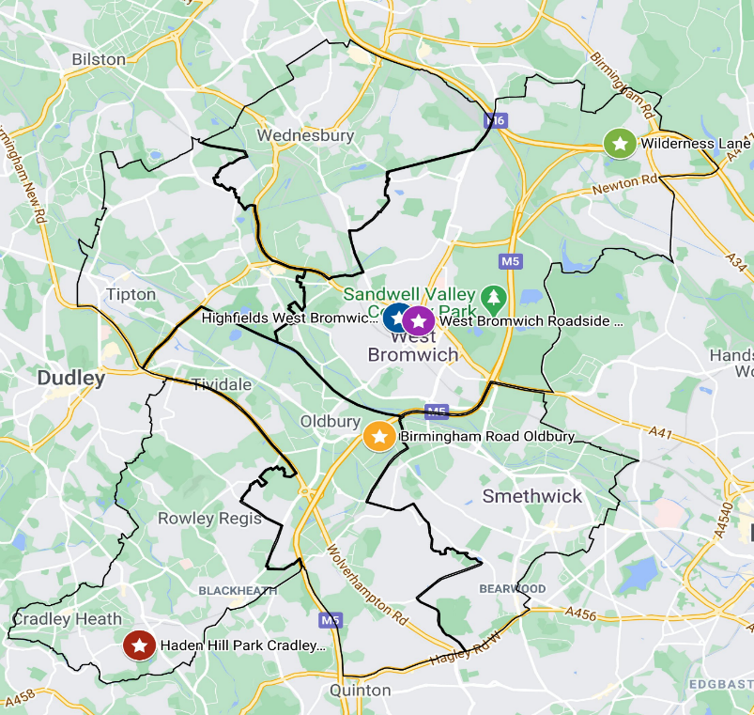
LEGENDND

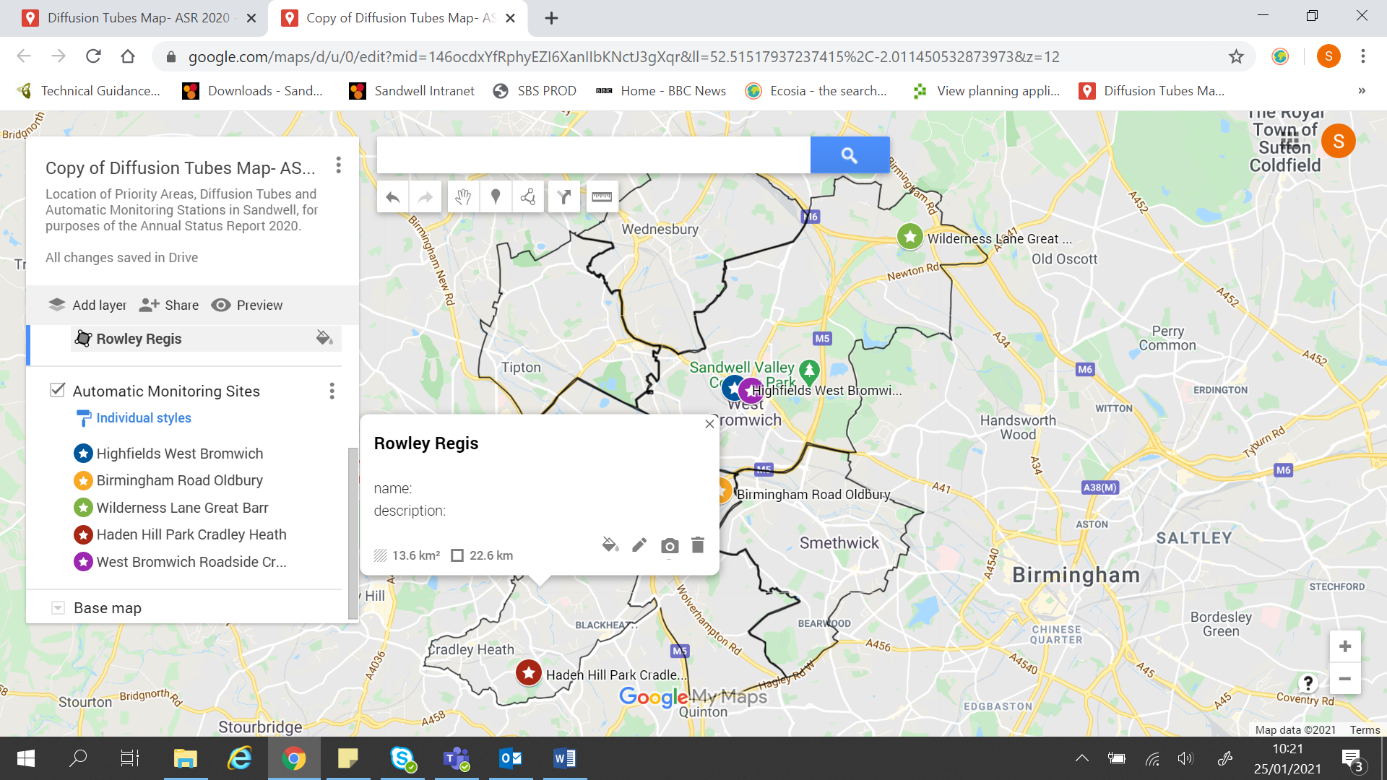

An interactive map of the automatic monitoring station network in Sandwell is available via this link.

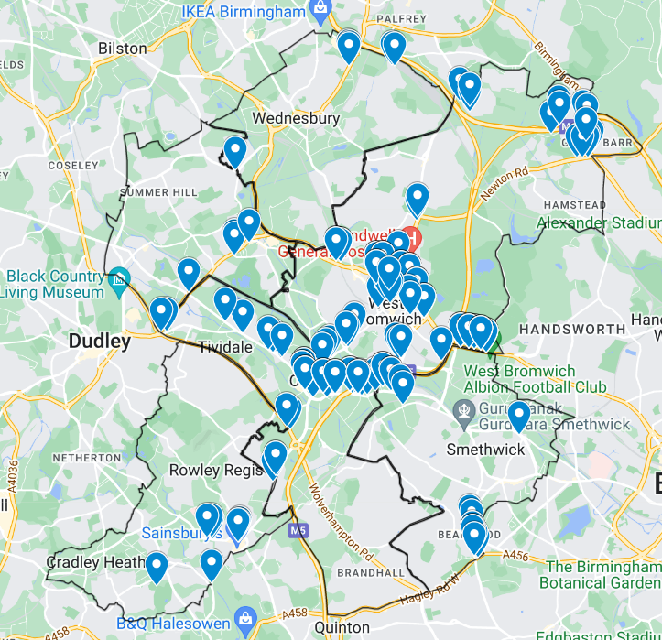
Figure D 2 - Map of NO2 Diffusion Tube Monitoring Sites in Sandwell
LEGEND


An interactive map of all the nitrogen dioxide diffusion tube sites in Sandwell is available via this link.
Location of a Nitrogen Dioxide Diffusion Tube

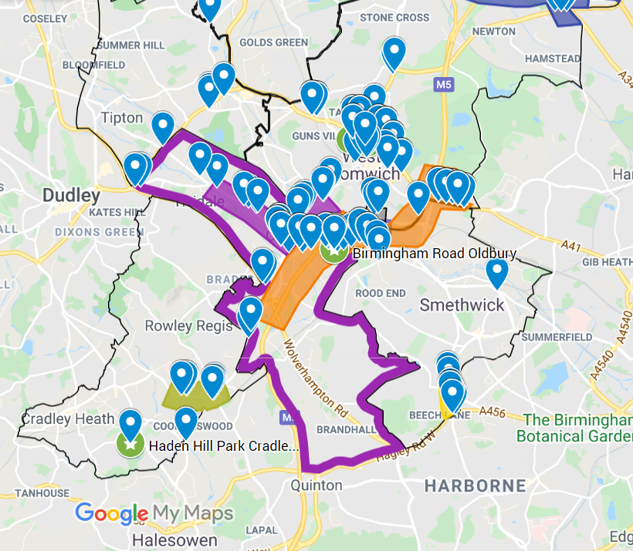
Figure D 3- Map of Diffusion Tube Sites, Air Quality Monitoring Stations and Air Quality Priority Zones in Oldbury


An interactive map of the automatic monitoring stations and the nitrogen dioxide diffusion tube monitoring sites can be viewed via this link

LEGEND

Nitrogen Dioxide Diffusion Tube
Continuous monitoring station

Figure D 4 Map of Diffusion Tube Sites, Air Quality Monitoring Stations and Air Quality Priority Zones, Rowley Regis
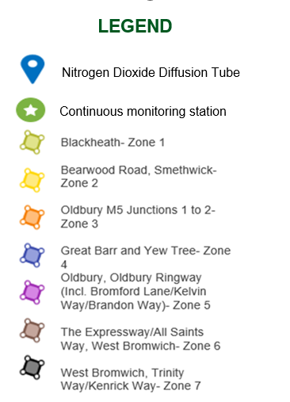
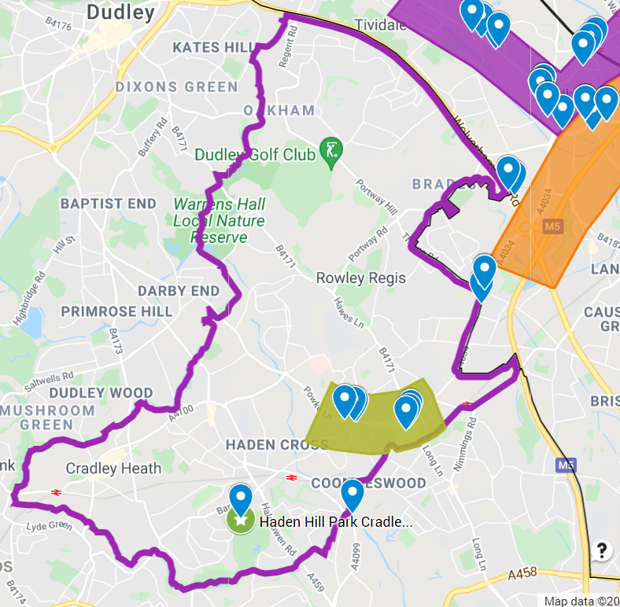
An interactive map of the automatic monitoring stations and the nitrogen dioxide diffusion tube monitoring sites can be viewed via this link.
.

Figure D 5 - Map of Diffusion Tube Sites and Air Quality Priority Zones in Smethwick in Smethwick, Sandwell
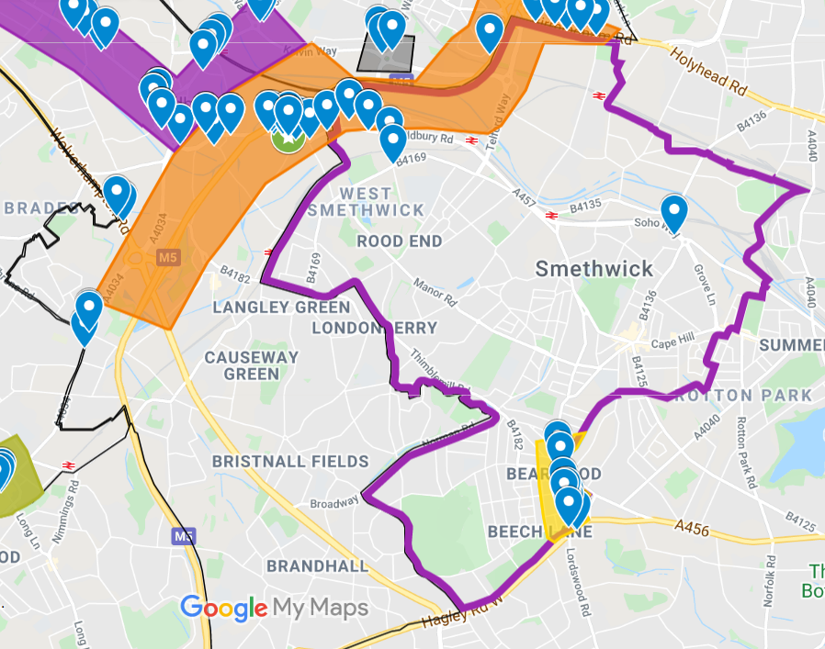
An interactive map of the automatic monitoring stations and the nitrogen dioxide diffusion tube monitoring sites can be viewed via this link.

Figure D 6 - Map of Diffusion Tube Sites, Automatic Air Quality Monitoring Stations and Air Quality Priority Zones in West Bromwich
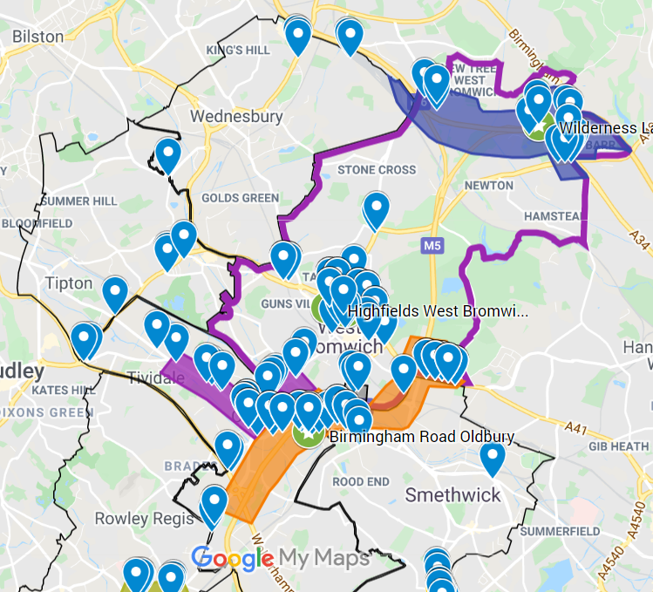

An interactive map of the automatic monitoring stations and the nitrogen dioxide diffusion tube monitoring sites can be viewed via this link.

Figure D 7 - Map of Diffusion Tube Sites and Air Quality Priority Zone in Wednesbury, Sandwell
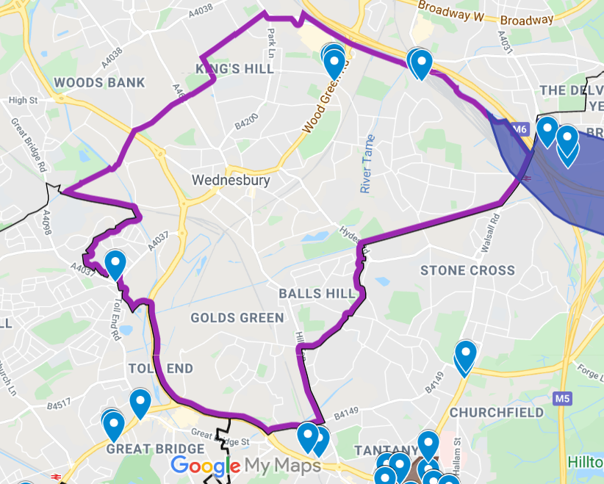

An interactive map of the automatic monitoring stations and the nitrogen dioxide diffusion tube monitoring sites can be viewed via this link.

Figure D 8 - Map of Diffusion Tube Locations, Tipton
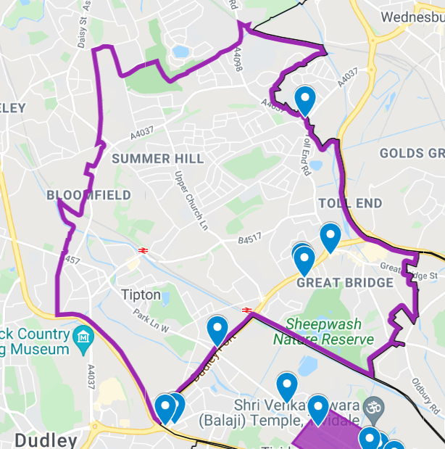
LEGEND

An interactive map of all the nitrogen dioxide diffusion tube monitoring site in Sandwell is available by clicking on this link.

Nitrogen Dioxide Diffusion tube

Figure D 9 - Maps of Air Quality Priority Zones 1 & 2
Bearwood Road, Smethwick – Zone 2
Blackheath – Zone 1
LEGEND
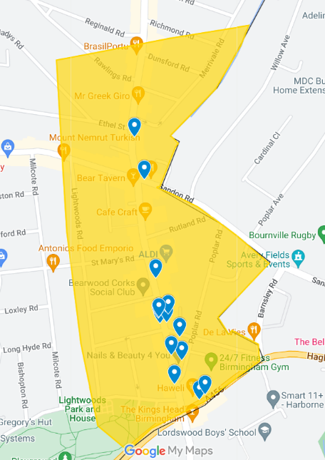
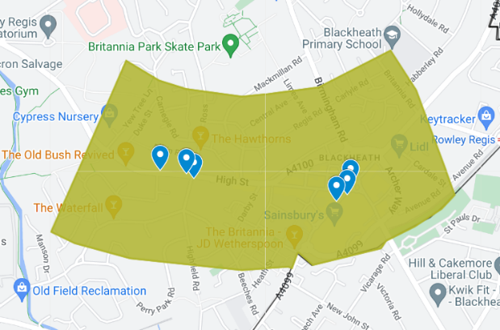
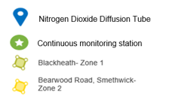

An interactive map of all the nitrogen dioxide diffusion tube monitoring sites in Sandwell is available by clicking on this link.

Figure D 10- Map of Air Quality Priority Zone 3
Oldbury M5, Junctions 1 to 2 – Zone 3

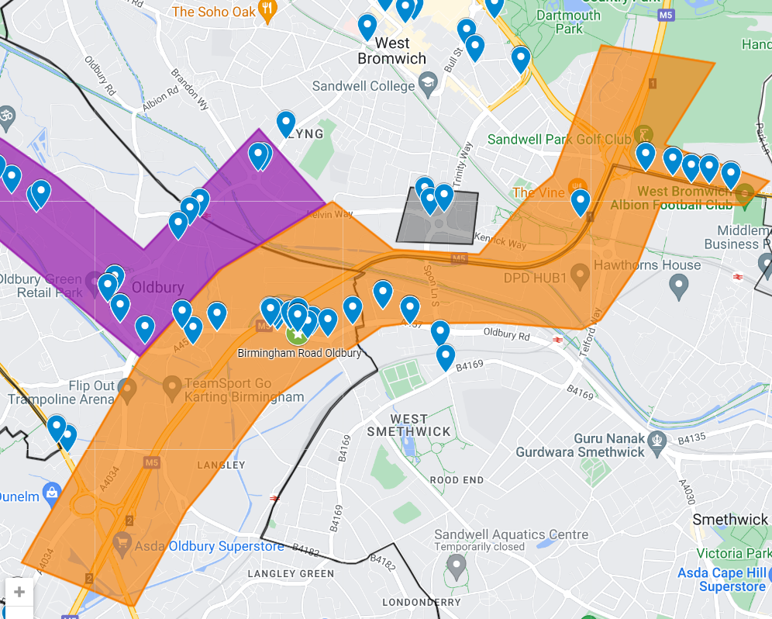
LEGEND
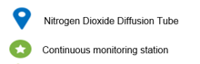

An interactive map of all the nitrogen dioxide tubes and air quality monitoring stations in Sandwell is available by clicking on this link.

Figure D 11 - Map of Air Quality Priority Zone 4
LEGEND
Great Barr and Yew Tree– Air Quality Priority Zone 4

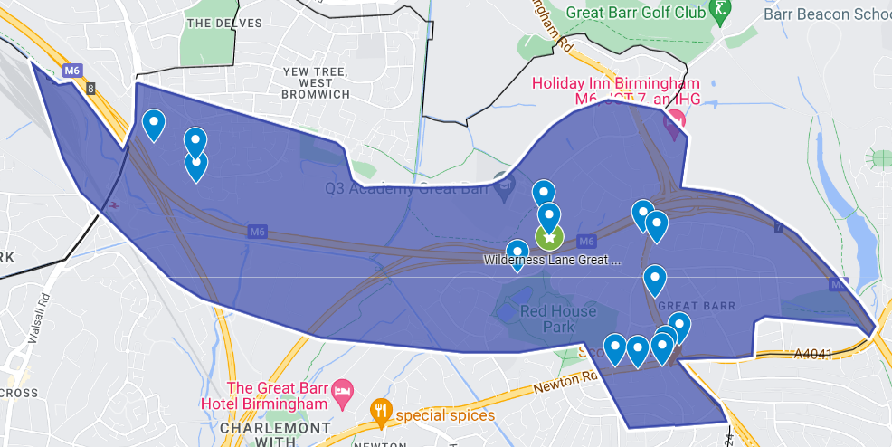

An interactive map of all the nitrogen dioxide tube monitoring sites and air quality monitoring stations in Sandwell is available via this link

Figure D 12 - Map of Air Quality Priority Zone 5
LEGEND

An interactive map of all the nitrogen dioxide tube monitoring sites and air quality monitoring stations in Sandwell is available via this link.

Oldbury Ringway (including Bromford Lane, Kelvin Way and Brandon Way) – Zone 5

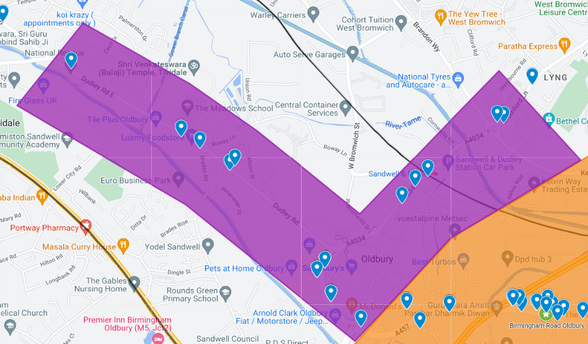

Figure D 13 - Maps of Air Quality Priority Zones 6 and 7

The Expressway / All Saints Way, West Bromwich – Zone 6
LEGEND
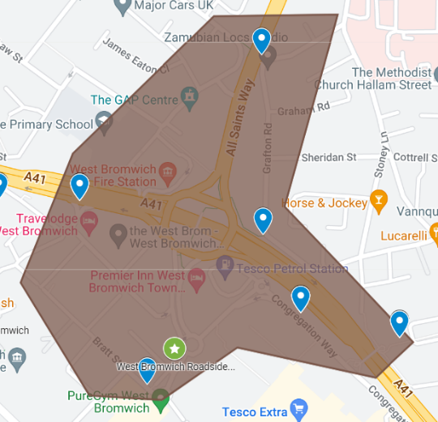
Trinity Way / Kenrick Way – Zone 7

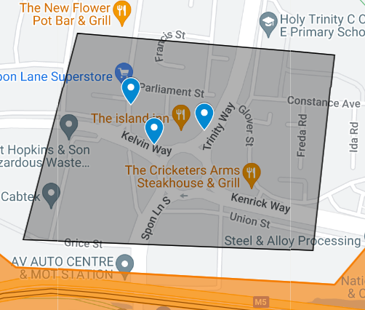


An interactive map of all the nitrogen dioxide tube monitoring sites and air quality monitoring stations in Sandwell is available via this link.

Appendix E: Summary of Air Quality Objectives in England
Table E.1 – Air Quality Objectives in England
Pollutant | Air Quality Objective: Concentration | Air Quality Objective: Measured as
Nitrogen Dioxide (NO₂) | 200µg/m³ not to be exceeded more than 18 times a year | 1-hour mean
Nitrogen Dioxide (NO₂) | 40µg/m³ | Annual mean
Particulate Matter (PM₁₀) | 50µg/m³, not to be exceeded more than 35 times a year | 24-hour mean
Particulate Matter (PM₁₀) | 40µg/m³ | Annual mean
Sulphur Dioxide (SO₂) | 350µg/m³, not to be exceeded more than 24 times a year | 1-hour mean
Sulphur Dioxide (SO₂) | 125µg/m³, not to be exceeded more than 3 times a year | 24-hour mean
Sulphur Dioxide (SO₂) | 266µg/m³, not to be exceeded more than 35 times a year | 15-minute mean

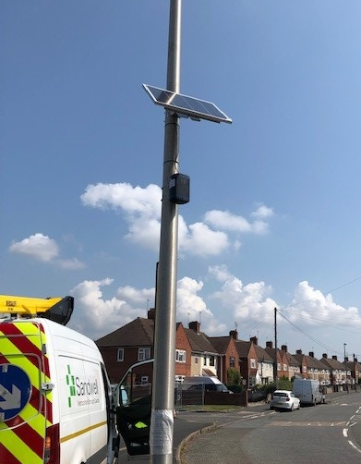
Appendix F: Zephyr Air Quality Data Summary 2023


Summary of Zephyr Air Quality Monitoring
Reporting on Data Collected in 2023
TABLE OF CONTENTS
Introduction 3
- Why air pollution matters 3
- Zephyr® Sensors 3
- Retrieval of gas concentrations 3
- Retrieval of particulates 3
- Summary of Zephyr Monitoring in Sandwell - 2023 4
- Location of the 21 ‘Zephyr’ air quality monitors across Sandwell in 2023 6
- Data Capture 2023 7
- Zephyr Data Monitoring Results 2023 8
- Annual Mean NO₂ Monitoring Results (μg/m³) 8
- Annual Mean PM₁₀ Monitoring Results (μg/m³) 9
- Annual Mean PM_{2.5} Monitoring Results (μg/m³) 10

Introduction

Why air pollution matters
Air pollution is a leading health emergency, in the West Midlands alone, air pollution causes up to 2300 early deaths each year. Every resident of the West Midlands, lives in an area exceeding the World Health Organisation's air quality guidelines. It is estimated that meeting the WHO targets would bring £3.2bn in economic benefits through the reduced health burden.

Zephyr® Sensors
The Zephyr sensors play a crucial role in providing data for informed decision-making to better manage urban air quality. Each Zephyr sensor is designed to retrieve specific pollutants relevant to urban environments, such as Nitrogen Dioxide (NO₂), Ozone (O₃), Nitrogen Oxide (NO), and various sizes of Particulate Matter (PM1, PM_{2.5}, and PM₁₀). Its compact size allows for easy deployment on street furniture, with power options including internal battery, mains power, or solar panel. In Sandwell all sensors were powered by solar panels. The sensor's capability to create a high-density network and record data at short intervals with minimal latency enables near-real time air pollution monitoring. In Sandwell, the focus is on reducing NO₂, PM₁₀, and PM_{2.5} levels, so the results from each Zephyr for these pollutant species are summarised in this report.

Retrieval of gas concentrations
Electrochemical Sensors (EC) are used in the Zephyr® sensor for NO2, O3 and NO. The analogue response that is converted to a digital signal is affected by the concentration of the gas of interest as well as other interfering gases (the specific gases and the severity is unique for each EC) and environmental conditions. The retrieved concentration has these effects accounted for, which is validated by both long-term studies and a sensor validation period prior to delivery to the client. Total Volatile Organic Compounds (TVOCs) are retrieved using a photo ionisation detector (PID) which has corrections for environmental conditions. A self-correcting algorithm to ensure a common background is maintained has been applied to this data. This algorithm is presently being written into standard operational protocols, and as such is not presently available on MyAir®.

Retrieval of particulates
An Optical Particle Counter (OPC) is used in the Zephyr® sensor to retrieve a mass concentration for PM₁, PM_{2.5} and PM₁₀. This has been found to produce very good agreement with reference methods in the UK. A hygroscopic factor is included in the retrieval to correct for humidity interactions with aerosol.

Summary of Zephyr Monitoring in Sandwell - 2023
Zephyr Number | Site Name | Site Type | X OS Grid Ref (Easting) | X OS Grid Ref (Northing) | Pollutants Monitored | Distance to Relevant  Exposure (m) | Distance to kerb of nearest road (m) | Inlet Height (m)
Z315 | Highfields Registry Office, West Bromwich | Background | 400222 | 291612 | NO2, NO, O3, PM1, PM2.5 & PM10 | 41.18 | 33.28 | 4.5
Z778 | Gospel Oak Road, Tipton | Roadside | 397373 | 293866 | NO2, NO, O3, PM1, PM2.5 & PM10 | 26.22 | 2.85 | 4
Z1289 | Bull Street, West Bromwich | Roadside | 400831 | 291081 | NO2, NO, O3, PM1, PM2.5 & PM10 | 3.29 | 1.33 | 4
Z864 | All Saints Way,  West Bromwich | Roadside | 400690 | 292131 | NO2, NO, O3, PM1, PM2.5 & PM10 | 6.84 | 12.36 | 4
Z884 | Bearwood Primary,  Smethwick | Roadside | 402106 | 286669 | NO2, NO, O3, PM1, PM2.5 & PM10 | 7.54 | 1.04 | 4
Z887 | MET Hospital, Smethwick | Roadside | 403493 | 288344 | NO2, NO, O3, PM1, PM2.5 & PM10 | 6.12 | 1.81 | 4
Z888 | Halesowen Street, Oldbury | Roadside | 398941 | 289415 | NO2, NO, O3, PM1, PM2.5 & PM10 | 7.23 | 2.85 | 4
Z893 | Scotts Arms, Great Barr | Roadside | 404527 | 294360 | NO2, NO, O3, PM1, PM2.5 & PM10 | 14.53 | 1.96 | 4
Z898 | Highbury Road, Smethwick | Roadside | 400723 | 289200 | NO2, NO, O3, PM1, PM2.5 & PM10 | 8.35 | 2.45 | 4
Z935 | Aquatics Centre, Smethwick | Roadside | 400841 | 287811 | NO2, NO, O3, PM1, PM2.5 & PM10 | 5.4 | 3.36 | 4
Z1019 | Ferndale Primary School, Wednesbury | Background | 404509 | 293460 | NO2, NO, O3, PM1, PM2.5 & PM10 | 23.37 | 1.82 | 4
Z781 | High Street, Rowley Regis | Roadside | 397418 | 286388 | NO2, NO, O3, PM1, PM2.5 & PM10 | 9.68 | 2.65 | 4
Z870 | Langley Primary, Oldbury | Roadside | 399124 | 288234 | NO2, NO, O3, PM1, PM2.5 & PM10 | 8.14 | 10.2 | 4
Z931 | Holy Trinity Church, Smethwick | Roadside | 402103 | 288616 | NO2, NO, O3, PM1, PM2.5 & PM10 | 4.52 | 1 | 4
Z892 | Tipton Masjid and Muslim Community Centre, Tipton | Roadside | 396409 | 291867 | NO2, NO, O3, PM1, PM2.5 & PM10 | 2.6 | 2.16 | 4

Zephyr Number | Site Name | Site Type | X OS Grid Ref (Easting) | X OS Grid Ref (Northing) | Pollutants Monitored | Distance to Relevant  Exposure (m) | Distance to kerb of nearest road (m) | Inlet Height (m)
Z1359 | Centre for Oneness, Wednesbury | Roadside | 398356 | 294624 | NO2, NO, O3, PM1, PM2.5 & PM10 | 15.68 | 2.21 | 4
Z916 | Cradley Heath Community Link, Cradley Heath | Roadside | 394452 | 285985 | NO2, NO, O3, PM1, PM2.5 & PM10 | 5.18 | 1.77 | 4
Z835 | The Salvation Army, Cradley Heath | Roadside | 394846 | 286316 | NO2, NO, O3, PM1, PM2.5 & PM10 | 7.46 | 1.67 | 4
Z920 | Jamia Masjid, Oldbury | Roadside | 400572 | 289425 | NO2, NO, O3, PM1, PM2.5 & PM10 | 18.76 | 3.66 | 4
Z931 | Guru Har Rai Sahib Ji, West Bromwich | Roadside | 400863 | 290864 | NO2, NO, O3, PM1, PM2.5 & PM10 | 4.52 | 1 | 4
Z881 | Wednesbury Baptist Church, Wednesbury | Roadside | 399192 | 295428 | NO2, NO, O3, PM1, PM2.5 & PM10 | 3.84 | 1.4 | 4

Location of the 21 ‘Zephyr’ air quality monitors across Sandwell in 2023

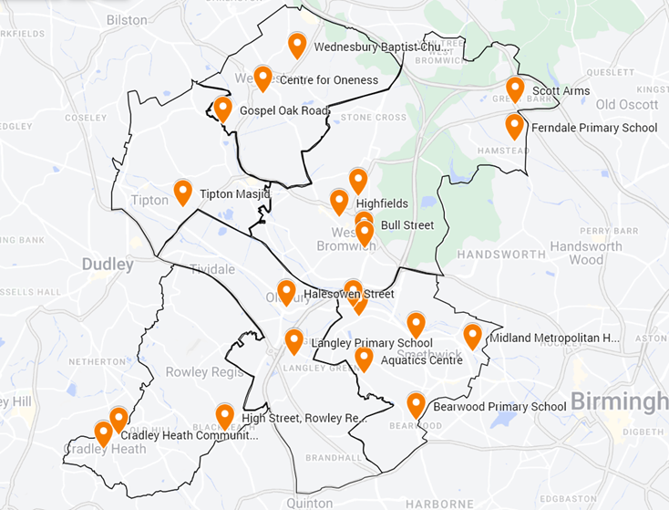
Legend

An interactive version of this map is available via this link.


Location of Zephyr Air Quality Monitor

Data Capture 2023

Data capture stats have been calculated on the period monitored, which in some cases was less than a year.
‘Z’ Number | Site Name | NO2 | O3 | PM2.5 | PM10
Z315 | Highfields Registry Office, West Bromwich | 100 | 100 | 100 | 100
Z778 | Gospel Oak Road, Tipton | 98.1 | 98.1 | 98.1 | 98.1
Z1289 | Bull Street, West Bromwich | 98 | 97.9 | 98.3 | 98.3
Z864 | All Saints Way,  West Bromwich | 98.7 | 98.7 | 98.7 | 98.7
Z884 | Bearwood Primary,  Smethwick | 74.3 | 77 | 86.7 | 86.7
Z887 | MET Hospital, Smethwick | 100 | 100 | 100 | 100
Z888 | Halesowen Street, Oldbury | 98.8 | 98.9 | 98.8 | 98.8
Z893 | Scotts Arms, Great Barr | 97 | 97 | 97 | 97
Z898 | Highbury Road, Smethwick | 99.2 | 99.2 | 99.2 | 99.2
Z935 | Aquatics Centre, Smethwick | 98.2 | 98.6 | 98.6 | 98.6
Z1019 | Ferndale Primary School, Wednesbury | 99.9 | 99.9 | 100 | 100
Z781 | High Street, Rowley Regis | 98.1 | 98.2 | 95 | 95
Z870 | Langley Primary, Oldbury | 98.2 | 98.2 | 98.4 | 98.4
Z931 | Holy Trinity Church, Smethwick | 95.9 | 96.0 | 96.1 | 96.1
Z892 | Tipton Masjid and Muslim Community Centre, Tipton | 95.9 | 91.7 | 99.0 | 97.4
Z1359 | Centre for Oneness, Wednesbury | 99.9 | 69.8 | 99.9 | 99.9
Z916 | Cradley Heath Community Link, Cradley Heath | 96.8 | 89.9 | 97.2 | 97.2
Z835 | The Salvation Army, Cradley Heath | 95.2 | 88.4 | 95.2 | 95.2
Z920 | Jamia Masjid, Oldbury | 64.8 | 60.4 | 99.9 | 99.0
Z931 | Guru Har Rai Sahib Ji, West Bromwich | 91.3 | 91.4 | 98.5 | 98.5
Z881 | Wednesbury Baptist Church, Wednesbury | 99.0 | 86.2 | 99.0 | 99.0

Annual Mean NO₂ Concentrations 2023 (μg/m³)
‘Z’ Number | Site Name | Valid Data Capture (%) | Annual Mean  μg/m³ | Defra Air Quality Objective (AQO) (μg/m³) | Pollutant Concentration within Limit?
Z315 | Highfields Registry Office, West Bromwich | 100 | 15.3 | 40 | Y
Z778 | Gospel Oak Road, Tipton | 98.1 | 17.8 | 40 | Y
Z1289 | Bull Street, West Bromwich | 98 | 21.7 | 40 | Y
Z864 | All Saints Way,  West Bromwich | 98.7 | 18.7 | 40 | Y
Z884 | Bearwood Primary,  Smethwick | 74.3 | 10.8 | 40 | Y
Z887 | MET Hospital, Smethwick | 100 | 17.2 | 40 | Y
Z888 | Halesowen Street, Oldbury | 98.8 | 21.7 | 40 | Y
Z893 | Scotts Arms, Great Barr | 66.08 | 27.5 | 40 | Y
Z898 | Highbury Road, Smethwick | 65.37 | 12.3 | 40 | Y
Z935 | Aquatics Centre, Smethwick | 100.00 | 19.5 | 40 | Y
Z1019 | Ferndale Primary School, Wednesbury | 60.62 | 12.5 | 40 | Y
Z781 | High Street, Rowley Regis | 100.00 | 27.6 | 40 | Y
Z870 | Langley Primary, Oldbury | 100.00 | 20.9 | 40 | Y
Z931 | Holy Trinity Church, Smethwick | 95.9 | 29.6 | 40 | Y
Z892 | Tipton Masjid and Muslim Community Centre, Tipton | 95.9 | 17.9 | 40 | Y
Z1359 | Centre for Oneness, Wednesbury | 99.9 | 6.6 | 40 | Y
Z916 | Cradley Heath Community Link, Cradley Heath | 96.8 | 24.0 | 40 | Y
Z835 | The Salvation Army, Cradley Heath | 95.2 | 12.0 | 40 | Y
Z920 | Jamia Masjid, Oldbury | 64.8 | 17.9 | 40 | Y
Z931 | Guru Har Rai Sahib Ji, West Bromwich | 91.3 | 29.4 | 40 | Y
Z881 | Wednesbury Baptist Church, Wednesbury | 99.0 | 17.0 | 40 | Y
Zephyr Data Monitoring Results 2023

Annual Mean PM₁₀ Concentrations 2023 (μg/m³)
‘Z’ Number | Site Name | Valid Data Capture (%) | Annual Mean  μg/m³ | Defra Air Quality Objective (AQO) (μg/m³) | Pollutant Concentration within Limit?
Z315 | Highfields Registry Office, West Bromwich | 100 | 12.3 | 40 | Y
Z778 | Gospel Oak Road, Tipton | 98.1 | 14.5 | 40 | Y
Z1289 | Bull Street, West Bromwich | 98 | 13.4 | 40 | Y
Z864 | All Saints Way,  West Bromwich | 98.7 | 11.7 | 40 | Y
Z884 | Bearwood Primary,  Smethwick | 74.3 | 12.1 | 40 | Y
Z887 | MET Hospital, Smethwick | 100 | 10.9 | 40 | Y
Z888 | Halesowen Street, Oldbury | 98.8 | 13.1 | 40 | Y
Z893 | Scotts Arms, Great Barr | 66.08 | 11 | 40 | Y
Z898 | Highbury Road, Smethwick | 65.37 | 9.3 | 40 | Y
Z935 | Aquatics Centre, Smethwick | 100.00 | 10.7 | 40 | Y
Z1019 | Ferndale Primary School, Wednesbury | 60.62 | 11.3 | 40 | Y
Z781 | High Street, Rowley Regis | 100.00 | 7.7 | 40 | Y
Z870 | Langley Primary, Oldbury | 100.00 | 11.3 | 40 | Y
Z931 | Holy Trinity Church, Smethwick | 95.9 | 11.6 | 40 | Y
Z892 | Tipton Masjid and Muslim Community Centre, Tipton | 95.9 | 10.3 | 40 | Y
Z1359 | Centre for Oneness, Wednesbury | 99.9 | 8.9 | 40 | Y
Z916 | Cradley Heath Community Link, Cradley Heath | 96.8 | 11.9 | 40 | Y
Z835 | The Salvation Army, Cradley Heath | 95.2 | 10.5 | 40 | Y
Z920 | Jamia Masjid, Oldbury | 64.8 | 10.3 | 40 | Y
Z931 | Guru Har Rai Sahib Ji, West Bromwich | 91.3 | 11.7 | 40 | Y
Z881 | Wednesbury Baptist Church, Wednesbury | 99.0 | 11.7 | 40 | Y

Annual Mean PM_{2.5} Concentrations 2023 (μg/m³)
‘Z’ Number | Site Name | Valid Data Capture (%) | Annual Mean  μg/m³ | UK Target Level (2040))  μg/m³ | Pollutant Concentration within Limit?
Z315 | Highfields Registry Office, West Bromwich | 100 | 6.1 | 10 | Y
Z778 | Gospel Oak Road, Tipton | 98.1 | 7.5 | 10 | Y
Z1289 | Bull Street, West Bromwich | 98 | 6.7 | 10 | Y
Z864 | All Saints Way,  West Bromwich | 98.7 | 5.2 | 10 | Y
Z884 | Bearwood Primary,  Smethwick | 74.3 | 6.1 | 10 | Y
Z887 | MET Hospital, Smethwick | 100 | 6.7 | 10 | Y
Z888 | Halesowen Street, Oldbury | 98.8 | 6.7 | 10 | Y
Z893 | Scotts Arms, Great Barr | 66.08 | 7.5 | 10 | Y
Z898 | Highbury Road, Smethwick | 65.37 | 6.2 | 10 | Y
Z935 | Aquatics Centre, Smethwick | 100.00 | 6.7 | 10 | Y
Z1019 | Ferndale Primary School, Wednesbury | 60.62 | 5.7 | 10 | Y
Z781 | High Street, Rowley Regis | 100.00 | 3.3 | 10 | Y
Z870 | Langley Primary, Oldbury | 100.00 | 6.8 | 10 | Y
Z931 | Holy Trinity Church, Smethwick | 95.9 | 7.2 | 10 | Y
Z892 | Tipton Masjid and Muslim Community Centre, Tipton | 95.9 | 6.7 | 10 | Y
Z1359 | Centre for Oneness, Wednesbury | 99.9 | 5.7 | 10 | Y
Z916 | Cradley Heath Community Link, Cradley Heath | 96.8 | 7.5 | 10 | Y
Z835 | The Salvation Army, Cradley Heath | 95.2 | 7.1 | 10 | Y
Z920 | Jamia Masjid, Oldbury | 64.8 | 6.6 | 10 | Y
Z931 | Guru Har Rai Sahib Ji, West Bromwich | 91.3 | 7.3 | 10 | Y
Z881 | Wednesbury Baptist Church, Wednesbury | 99.0 | 6.9 | 10 | Y

Glossary of Terms
Abbreviation | Description
AQAP | Air Quality Action Plan - A detailed description of measures, outcomes, achievement dates and implementation methods, showing how the local authority intends to achieve air quality limit values’
AQMA | Air Quality Management Area – An area where air pollutant concentrations exceed / are likely to exceed the relevant air quality objectives. AQMAs are declared for specific pollutants and objectives
ASR | Annual Status Report
Defra | Department for Environment, Food and Rural Affairs
DMRB | Design Manual for Roads and Bridges – Air quality screening tool produced by National Highways
EU | European Union
FDMS | Filter Dynamics Measurement System
FIDAS | Fine Dust Analysis System
LAQM | Local Air Quality Management
NHS (ICB) | National Health Service – Integrated Care Board
NO₂ | Nitrogen Dioxide
NO_{x} | Nitrogen Oxides
PM₁₀ | Airborne particulate matter with an aerodynamic diameter of 10µm or less
PM_{2.5} | Airborne particulate matter with an aerodynamic diameter of 2.5µm or less
QA/QC | Quality Assurance and Quality Control
ORCS | On-Street Residential Charge Schemes
OZEZ | Office for Zero Emission Vehicles
SO₂ | Sulphur Dioxide
TfWM | Transport for West Midlands
WHO | World Health Organisation
WMCA | West Midlands Combined Authority

References
- Local Air Quality Management Technical Guidance LAQM.TG22. August 2022. Published by Defra in partnership with the Scottish Government, Welsh Assembly Government and Department of the Environment Northern Ireland.
- Local Air Quality Management Policy Guidance LAQM.PG22. August 2022. Published by Defra in partnership with the Scottish Government, Welsh Assembly Government and Department of the Environment Northern Ireland.
- Chemical hazards and poisons report: Issue 28. June 2022. Published by UK Health Security Agency
- Air Quality Strategy – Framework for Local Authority Delivery. August 2023. Published by Defra.
- Defra. Air quality and social deprivation in the UK: an environmental inequalities analysis, 2006.
- Census 2011. https://www.sandwelltrends.info/population-change-interactive-chart/
- The World Health Organisation – Global Air Quality Guidelines https://iris.who.int/bitstream/handle/10665/345329/9789240034228-eng.pdf
- Environmental Improvement Plan 2023, January 2023. Published by Defra https://www.gov.uk/government/publications/environmental-improvement-plan
- The Road to Zero: Next steps towards cleaner road transport and delivering our Industrial Strategy, July 2018. Published by the Department for Transport. https://assets.publishing.service.gov.uk/media/5b968e3ee5274a13859deed2/road-to-zero.pdf
- Emissions of air pollutants in the UK. Published by Defra. https://www.gov.uk/government/statistics/emissions-of-air-pollutants/emissions-of-air-pollutants-in-the-uk-particulate-matter-pm10-and-pm25
- Sandwell MBC ‘Smoke Control Area’. Published on Sandwell MBC’s website: https://www.sandwell.gov.uk/consumer-advice/air-quality/4
- Sandwell MBC Interactive Cycle Map. Published on Sandwell MBC’s website: https://sandwell.activemap.co.uk/
- Go Jaunty Website: https://www.gojauntly.com/sandwell
- Sandwell MBC ‘Travelwise’. Published on Sandwell MBC’s website: https://www.sandwell.gov.uk/info/200284/roads_travel_and_parking/1830/travelwise_in_sandwell
- Sandwell MBC ‘Resilient Residents’. Published on Sandwell MBC’s website: https://www.sandwell.gov.uk/resilientresidents
- Sandwell MBC Cycling and Walking Infrastructure plan 2020. Published on Sandwell MBC’s website. https://www.sandwell.gov.uk/downloads/download/351/sandwell-cycling-and-walking-infrastructure-plan
- Sandwell MBC ‘Healthy Sandwell’. Published on Sandwell MBC’s website: https://www.healthysandwell.co.uk/
- Sandwell MBC ‘Report a bonfire problem’. Published on Sandwell MBC’s website. https://www.sandwell.gov.uk/info/200274/pollution/3188/report_a_bonfire_problem
- Sandwell MBC ‘Bins and Recycling’. Published on Sandwell MBC’s website https://www.sandwell.gov.uk/info/200160/bins_and_recycling/2194/composting
- Strategies for Climate Change and Air Quality in Sandwell. Published on Sandwell MBC’s website. https://www.sandwell.gov.uk/info/200274/pollution/4402/climate_change_and_air_quality_in_sandwell
- Sandwell MBC’s Tree Preservation Orders and Urban Tree Policy. Published on Sandwell MBC’s website. https://www.sandwell.gov.uk/info/200248/parks_and_green_spaces/4916/trees
- The Woodland Trust: https://www.woodlandtrust.org.uk/
- The Black Country Low Emission Vehicle Programme. Published by Black Country Transport. http://www.blackcountrytranspot.org.uk/projects/ultra-low-emission-vehicle-programme.html
- Sandwell Eco Bus. Published on Litter Watch’s website. https://www.litterwatch.org.uk/#404
- Government Boiler Upgrade Scheme. Published by Gov.UK. https://www.gov.uk/apply-boiler-upgrade-scheme
- Which? Review of Eco Provider Energy Companies: https://www.which.co.uk/news/article/which-eco-provider-energy-companies-revealed-for-2023-a9TV10S2OHel
- Details on Workplace Electric Vehicle Charging Scheme. Published by the Office for Zero Emission Vehicles. https://www.find-government-grants.service.gov.uk/grants/workplace-charging-scheme-2
- West Midlands Combined Authority Air Quality Framework – Reference Document, November 2023. https://www.wmca.org.uk/documents/environment-energy/air-quality-framework-reference-document/
- AECOM All Saints Way Speed Reduction Modelling Forecast Report 2023. Published on Sandwell MBC’s website: Air quality | Sandwell Council
- Sandwell’s Air Quality Action Plan 2020-2025. Published on Sandwell MBC’s website. https://www.sandwell.gov.uk/downloads/file/31636/aqap_2020_2025_-_adopted
- Public Health Outcomes Framework. Published by the Office for Health Improvement and Disparities. https://fingertips.phe.org.uk/profile/public-health-outcomes-framework
- Emissions of Air Pollutants in the UK (PM10 and PM2.5). Published by Defra: https://www.gov.uk/government/statistics/emissions-of-air-pollutants/emissions-of-air-pollutants-in-the-uk-particulate-matter-pm10-and-pm25
- Diffusion Tube Data Processing Tool. Published by Defra. https://laqm.defra.gov.uk/air-quality/air-quality-assessment/diffusion-tube-data-processing-tool/
- Interactive Smoke Control Area Map. Published by Defra. https://uk-air.defra.gov.uk/data/sca/
- Interactive Map of Air Quality Monitoring Networks in the UK. Published by Defra. https://uk-air.defra.gov.uk/networks
- Nitrogen dioxide diffusion tube monitoring calendar of suggested exposure periods 2023. Published by Defra. https://laqm.defra.gov.uk/air-quality/air-quality-assessment/diffusion-tube-monitoring-calendar/

UK Health Security Agency. Chemical Hazards and Poisons Report, Issue 28, 2022.
Defra. Air quality and social deprivation in the UK: an environmental inequalities analysis, 2006
https://www.sandwelltrends.info/population-change-interactive-chart/
The Joint Air Quality Unit is a joint unit of the Department for Transport (DfT) and the Department for Environment, Food and Rural Affairs (Defra)
The World Health Organisation – Global Air Quality Guidelines https://iris.who.int/bitstream/handle/10665/345329/9789240034228-eng.pdf
Defra. Environmental Improvement Plan 2023, January 2023
Defra. Air Quality Strategy – Framework for Local Authority Delivery, August 2023
DfT. The Road to Zero: Next steps towards cleaner road transport and delivering our Industrial Strategy, July 2018
https://uk-air.defra.gov.uk/data/sca/
Defra: Emissions of air pollutants in the UK https://www.gov.uk/government/statistics/emissions-of-air-pollutants/emissions-of-air-pollutants-in-the-uk-particulate-matter-pm10-and-pm25
https://sandwell.activemap.co.uk/
https://www.gojauntly.com/sandwell
https://www.sandwell.gov.uk/info/200284/roads_travel_and_parking/1830/travelwise_in_sandwell
https://www.sandwell.gov.uk/resilientresidents
https://www.sandwell.gov.uk/downloads/download/2500/sandwell_cycling_and_walking_infrastructure_plan
https://www.sandwell.gov.uk/consumer-advice/air-quality
https://www.healthysandwell.co.uk/
https://www.sandwell.gov.uk/consumer-advice/air-quality/4
https://www.sandwell.gov.uk/info/200274/pollution/3188/report_a_bonfire_problem
https://www.sandwell.gov.uk/info/200160/bins_and_recycling/2194/composting
https://www.sandwell.gov.uk/info/200274/pollution/4402/climate_change_and_air_quality_in_sandwell
https://www.sandwell.gov.uk/info/200248/parks_and_green_spaces/4916/trees
https://www.woodlandtrust.org.uk/search/?q=sandwell
http://www.blackcountrytransport.org.uk/projects/ultra-low-emission-vehicle-programme.html
https://www.litterwatch.org.uk/
https://www.gov.uk/apply-boiler-upgrade-scheme
https://www.which.co.uk/news/article/which-eco-provider-energy-companies-revealed-for-2023-a9TV10S2OHel
https://www.find-government-grants.service.gov.uk/grants/workplace-charging-scheme-2
https://www.facebook.com/walkandcyclesandwell/
West Midlands Combined Authority Air Quality Framework – Reference Document, November 2023-https://www.wmca.org.uk/documents/environment-energy/air-quality-framework-reference-document/
https://www.wmca.org.uk/news/1-million-to-improve-air-quality-across-the-west-midlands/#:~:text=The%20%C2%A31%20million%20for,%C2%A311%20million%20this%20year .
https://www.sandwell.gov.uk/downloads/file/2595/all-saints-way-a4031-modelled-impact-of-speed-reduction-on-air-quality
https://www.sandwell.gov.uk/downloads/file/1595/sandwell-electric-vehicle-charging-points-proposals-map
Defra. Air Quality Strategy – Framework for Local Authority Delivery, August 2023
https://www.gov.uk/government/statistics/emissions-of-air-pollutants/emissions-of-air-pollutants-in-the-uk-particulate-matter-pm10-and-pm25
https://uk-air.defra.gov.uk/networks
https://www.sandwell.gov.uk/downloads/file/2595/all-saints-way-a4031-modelled-impact-of-speed-reduction-on-air-quality
https://laqm.defra.gov.uk/air-quality/air-quality-assessment/diffusion-tube-monitoring-calendar/
The units are in microgrammes of pollutant per cubic metre of air (µg/m³).
University of Birmingham, Published May 2024 https://www.birmingham.ac.uk/news/2024/

