

CCTV and Concierge Service Annual Report 2025-2026

Working collaboratively to reduce crime and anti-social behaviour in Sandwell. Keeping Sandwell safe by being the ‘Eyes and Ears’ of the community – providing reassurance, monitoring, response and evidence.

Sandwell Council’s CCTV control room provides CCTV and Concierge services to the residents of Sandwell, this report captures some of the teams’ outcomes and results.

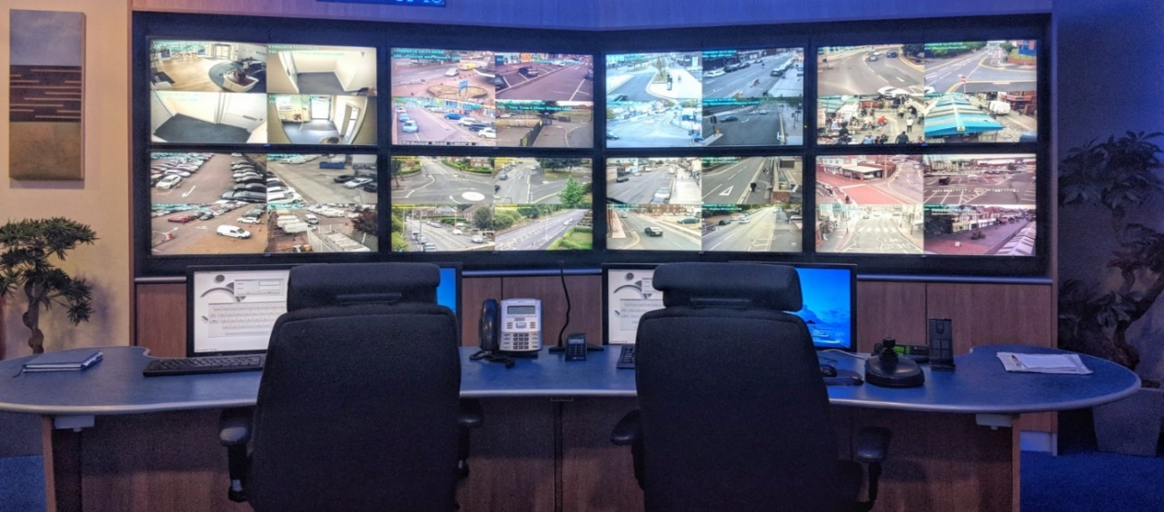

The CCTV control room is expected to comply with all relevant legislation, to offer assurances to our customers SMBC continues to comply with the requirements of the Protection of Freedoms Act and the Biometrics and Surveillance Commissioner’s Code of Practice – a key regulator in relation to CCTV systems.

The Commissioner states that compliance with the Code enables organisations to demonstrate that the systems they operate comply with the provisions of the Commissioners Code of Practice. The commissioner further states that by proactively engaging with the Code, an organisation, and more importantly the public, may be reassured that surveillance camera systems which intrude upon their privacy are being demonstrably operated ethically and legitimately to an appropriate standard.

More information about how Sandwell Council’s CCTV control room is operated and the standards it works to is detailed in a local Code of Practice that can be found on the council website and should be read in conjunction with this output report.

http://www.sandwell.gov.uk/downloads/file/4932/cctv_code_of_practice

Introduction

This report highlights the work the CCTV and Concierge team do which contributes to keeping Sandwell residents safe. Control room staff have continued to deliver excellent services to some of our most vulnerable customers, having helped to reassure and comfort tenants that receive Concierge services whilst continuing to work with partners offering CCTV evidence in relation to crime and anti-social behaviour.

Sandwell Council’s CCTV operators deliver services to Sandwell residents, partners and colleagues as a vital community safety resource with a team of 27 control room staff working around the clock 24 hours a day to ensure services are delivered in an efficient and effective manner.

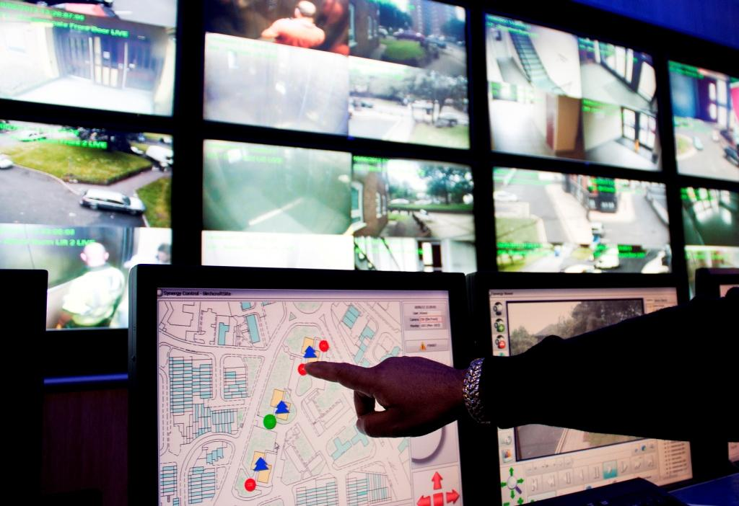

Control room staff monitor over 580 cameras across the Borough covering 27 high-rise blocks of flats, as well as some of our busiest town centres and high streets such as Bearwood, West Bromwich and Wednesbury.

The service is also responsible for monitoring the council’s deployable camera stock. These cameras can be located across the Borough to help reduce ASB, crime and environmental crime in identified hotspots.

This financial year the team have monitored and responded to 6714 incidents of crime, ASB and tenancy breaches and a further 1926 tenant queries that include requests for council services such as repairs. 55% of all incidents were proactively managed by CCTV Operators where CCTV footage is interrogated and saved as evidence with the remaining being acted on by way of passing information on to other agencies or by us making intercom calls in response to matters such as noise nuisance.

Staff work with a wide range of partners including West Midlands Police, Community Safety colleagues, Anti-Social Behaviour Officers, Tenancy Management staff, Taxi Licencing, Environmental Health and other teams such as caretaking and cleaning services, counter fraud teams and the councils Environmental Protection Team.

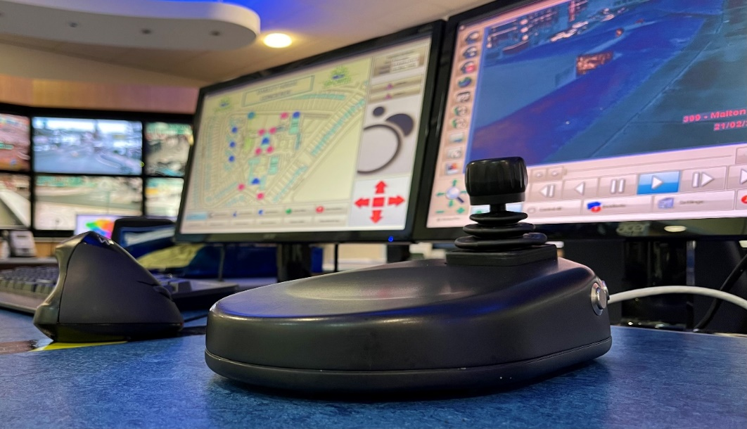

CCTV monitoring

Where possible Control Room Operators will resolve incidents at the time by carrying out a series of actions. Such actions may include issuing warnings and/or advice as appropriate via tenant intercoms; reporting litter, rubbish and dumped household items for removal; passing information onto police colleagues for response or intelligence or to environmental protection officers and other partner agencies to support the CCTV services with pro-active patrols where appropriate.

Incidents are also passed on to council teams and partners for further appropriate action. Information can be passed on for intelligence-gathering purposes and control room staff play a key role in several multi-agency groups that make full use of the information gathered so issues can be identified and dealt with appropriately.

Within the control room, several types of incidents are monitored including reports of vandalism; vehicle nuisance; drugs; alcohol-related issues; violence; misuse of communal areas in high-rise blocks; litter and fly-tipping; animal nuisance and noise.

More serious incidents are also monitored and CCTV of evidential quality has been provided to West Midlands Police in relation to crimes such as assault, weapons offences, robbery, murder, drug dealing, sexual assault, firearms offences and burglary on over 196 occasions.

Information provided by the control room has been used to carry out arrests and secure convictions, tenancy warnings have been issued and ASB enforcement action undertaken. Control Room interventions have also helped put fraudulently used council properties back into proper use, ensuring they are available to offer those in housing need. Staff have also reported domestic abuse and worked with teams to safeguard vulnerable tenants as well as being on hand to offer advice and reassurance to tenants through the Concierge Service.

Concierge services

The Control Room offers intercom and concierge services to over half of the council’s high-rise tenants. Intercoms located on the front door panel of blocks allow Operators to control access whilst handsets in the tenant’s flats allow them to have 24-hour contact with our Concierge service that they can use to report a range of issues.

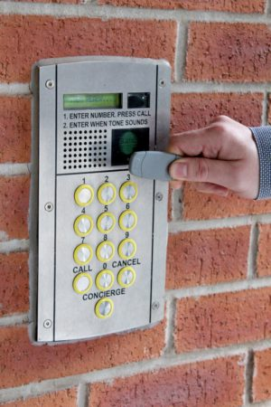

The team oversee the physical security of Sandwell Council’s high-rise and low-rise blocks. The council has contracts in place to maintain door entry systems covering over 350 low-rise blocks as well as 54 high-rise blocks of flats. We will process requests for maintenance, repairs and servicing of the door entry systems as required.

Operators will contact tenants to issue warnings about their behaviour where appropriate and intercoms are also used to make reassurance calls to tenants or to contact them to advise them that an issue they have reported has been dealt with.

Access systems have the facility to put blocks on ‘control’ allowing door entry calls to be re-routed through to the Control Room, this means nuisance callers can’t disturb tenants during quieter hours.

With the tenant’s permission, systems can be enabled where operators can take control of tenant’s calls when they have been identified as being vulnerable and needing additional help in terms of vetting calls to them where they otherwise may be coerced or bullied into letting undesirable visitors into the blocks.

This year control room operators have dealt with 166,990 intercom calls from the Control Room. This figure includes over 34,030 calls that were made or received directly to or from tenant’s flats.

New schemes and technology updates

Technology continues to move forward and while the control room is in its 15th year, regular maintenance programmes have ensured systems have remained in working order. Significant upgrades have been carried out recently to ensure that the infrastructure remains up to date and fit for purpose as well as being future proofed. This work has seen networks, hardware, software and recording systems renewed which will allow Sandwell Council to continue to provide and expand its services.

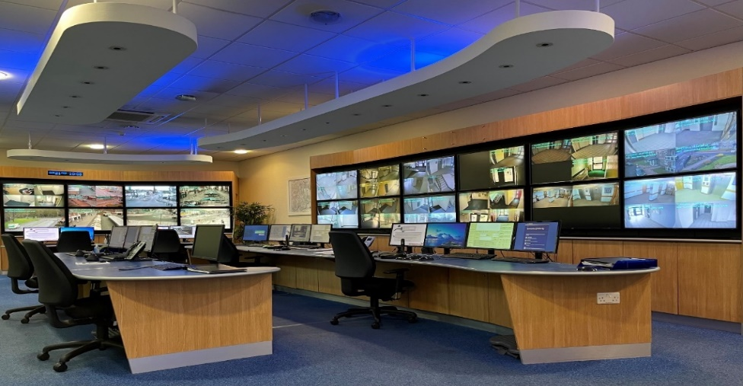

Sandwell Council currently provide a CCTV and Concierge service to half of the high-rise blocks [27 of 54]. The Council has listened to requests from residents residing in the blocks without this service and following completion of the control room upgrade Sandwell council is planning to expand this provision to all high-rise customers.

Work is now underway to install CCTV cameras and door entry upgrades to high-rise blocks not receiving these services currently. Customers have been consulted and work is underway which will ensure that all of Sandwell Council’s high-rise residents receive a CCTV and Concierge service. Tenants and residents will be updated as this work progresses.

The Control Room has expanded in other areas too. Having procured and commissioned the installation of 12 new cameras in Bearwood High Street in 2023 as well as further improvements to public safety through a range of initiatives, including enhanced CCTV provision in Wednesbury town centre and Friar Park in 2024.

2025 saw further investment with a full upgrade completed to the West Bromwich town centre CCTV scheme where old cameras and outdated infrastructure have been updated to a new state of the art system. Upgrades to the council’s deployable camera stock is also underway and will be in place by the time this report is released.

These schemes are continuing to yield results and have provided CCTV evidence that has helped deter crime and anti-social behaviour. Businesses, the public and partners continue to comment positively on the impact of the improved CCTV schemes.

Information sharing and compliance.

Control Room staff continue to play a key part in local tasking groups to ensure that information that has been collated is used to forecast patterns and trends that will help improve operator responses to identified issues. The current partnership approach is being used to inform the tasking of control room operators and cameras.

The Council also continues to develop and train staff so excellent services continue to be provided. Ongoing reviews of operating procedures, Control Room performance and outcomes are carried out regularly and continuous improvements made by way of training and staff development.

Sandwell council’s commitment to compliance with all relevant CCTV legislation continues. This includes the Data Protection Act, the General Data Protection Regulations, the Human Rights Act and the Regulatory Investigatory Powers Act. The Control Room also remains compliant with the Protection of Freedoms Act and the Biometrics and Surveillance Commissioners Code of Practice.

Work has been completed and is regularly reviewed to evidence that all CCTV systems owned and operated by council staff meet these requirements. This includes CCTV not monitored in the control room but managed locally in offices and other locations where the public may attend. Sandwell Council’s Surveillance Governance group ensures that all CCTV systems are operating to the same standards.

Sandwell Council continues to utilise its deployable camera stock in response to identified problems. A process is already in place that recognises locations that require further support from the CCTV team and its partners and these locations are identified through town tasking as anti-social behaviour and crime hot spots which would benefit from deployable camera provisions to tackle these concerns and environmental crime such as fly-tipping.

In short, Sandwell Council’s Control Room is delivering a proactive service alongside colleagues and partners. Control Room Operators continually monitor the Council’s CCTV cameras and are available to residents through the concierge service where this is currently provided 24 hours a day 7 days a week.

Further information about our services and outcomes can also be found at the following webpage:

www.sandwell.gov.uk/cctv

Examples of Sandwell Council’s CCTV control room outputs can also be found on the following pages.

Sandwell Council’s CCTV Control Room outcome summary 2025-26

- Control room staff continue to be excellent at the basics and turn out some commendable outputs, this is shown in our year-to-date figures showing a total of over 8600 instances of crime, antisocial behaviour, breaches of tenancy and requests for assistance from tenants being captured and dealt with by control room staff.

- There have been a range of responses to these incidents such as warnings being issued via intercoms, rubbish and fly tipping reported for removal, EPO's and emergency services have been called on to respond to some of the more serious issues.

- We have passed on information and evidence to police, colleagues and partners on a daily basis - we also continue to be a key player in Town Tasking and other partnership meetings, passing on and using information to ensure best use of our services.

- As well as day to day interaction with police colleagues we have sent them on their way with CCTV of evidential quality to be used in relation to criminal investigations on 196 occasions.

- The service is a lifeline to some residents who make regular use of our 24-hour Concierge service as we continue to receive calls from vulnerable tenants seeking our assistance and we have also assisted with several safeguarding incidents that has seen extremely vulnerable people removed from their perpetrators and made safe.

- Staff will make regular welfare calls to vulnerable tenants to check on their well-being. Operators have also assisted colleagues by making intercom calls to flats where tenants have been uncontactable and have helped arrange gas visits, welfare visits and repairs access for other council departments.

- Interventions using deployable cameras in areas flagged as hotspots for crime or anti-social behaviour has seen incident rates decrease. Staff have used deployable camera stock to monitor hot spots and respond to incidents including street drug dealing, vehicle nuisance, youth violence, anti-social behaviour and firearms incidents.

- The team continue to offer public assistance in relation to CCTV queries and requests. Regular calls are received from people seeking assistance in retrieving CCTV evidence for a range of reasons. Where appropriate and following recognised procedures, the team have assisted in dozens of these requests.

- Control Room staff have assisted the Environmental Protection team in identifying incidents of fly-tipping across the Borough resulting in £400 fines being issued to perpetrators and have also passed on footage about dog fouling to support breaches of the Councils Public Space Protection Order.

- Control Room Operators have worked with the police Locate Team and have used CCTV cameras to assist in searching for missing persons.

- CCTV control room staff continue to provide a joined-up response to crime in our town centres. CCTV evidence is provided on a regular basis in our continued response to crime in town centres. Police colleagues have stated how valued our service is and how helpful our operators are when alerting police to incidents on our High Streets that they were then able to disrupt.

- Operators have assisted police with ‘action days’ across the Borough where CCTV has been used to compliment police activities on the ground. This has resulted in drugs being removed from the streets, knives being found and confiscated as well as arrests being made for a range of crimes.

- Police colleagues regularly pass on their thanks and praise the team for their excellent camera work where we have captured images of individuals responsible for crime. When retrieving footage from the CCTV team police colleagues are very complimentary about the work operators do and how helpful operators are when reviewing and preparing footage for release.

- The CCTV Control Room continues to tackle nuisance being caused at some high-rise blocks where rough sleepers are misusing communal areas. Through captured images, individuals are identified and partnership work takes place to ensure the relevant support is put in place to support rough sleepers and eliminate the misuse of these communal areas.

- The team have supported the Boroughwide Nuisance Bikes Action Plan with breach of tenancy action taken after CCTV footage was shared with colleagues in the anti-social behaviour team showing bikes being ridden in a dangerous and anti-social manner.

- CCTV footage has been used to bring together prosecutions under Operation Hercules – the police and Council response to car cruising and street racing. Our CCTV evidence also helped Sandwell Council in being successful in renewing the cross-council car cruising injunction.

- Positive comments and feedback have also been received from colleagues in the Counter Fraud Team for assistance provided in relation to investigations into subletting, right to buy fraud and abuse of the single person rent discount. The information provided has been vital in helping to prove a series of frauds that had been committed against the council.

These are just a few examples of the work carried out by the CCTV Control Room Team, that demonstrates the impact and contribution made to enhancing community safety.

Further details of control room outputs during the year are below:

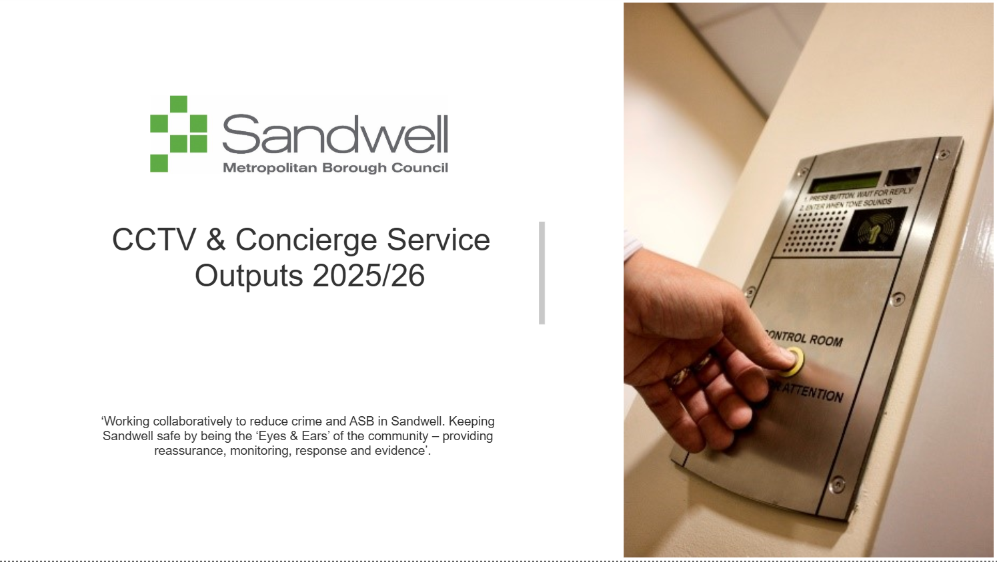

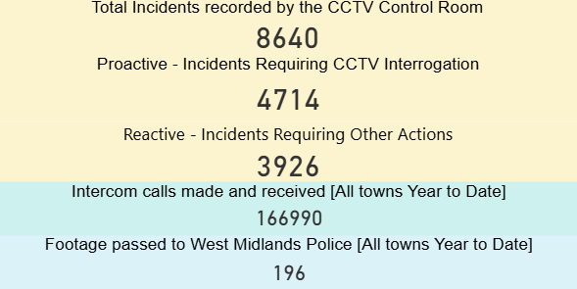

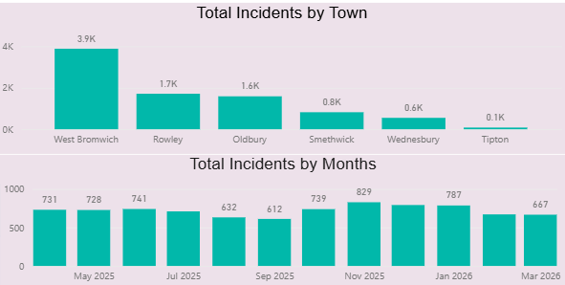

Incidents by catagory

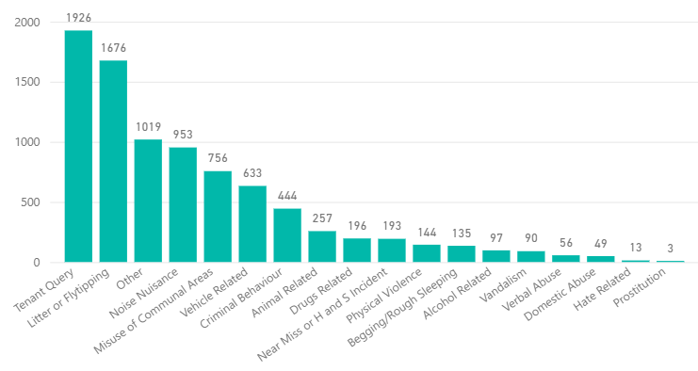

CCTV footage shared with West Midlands Police
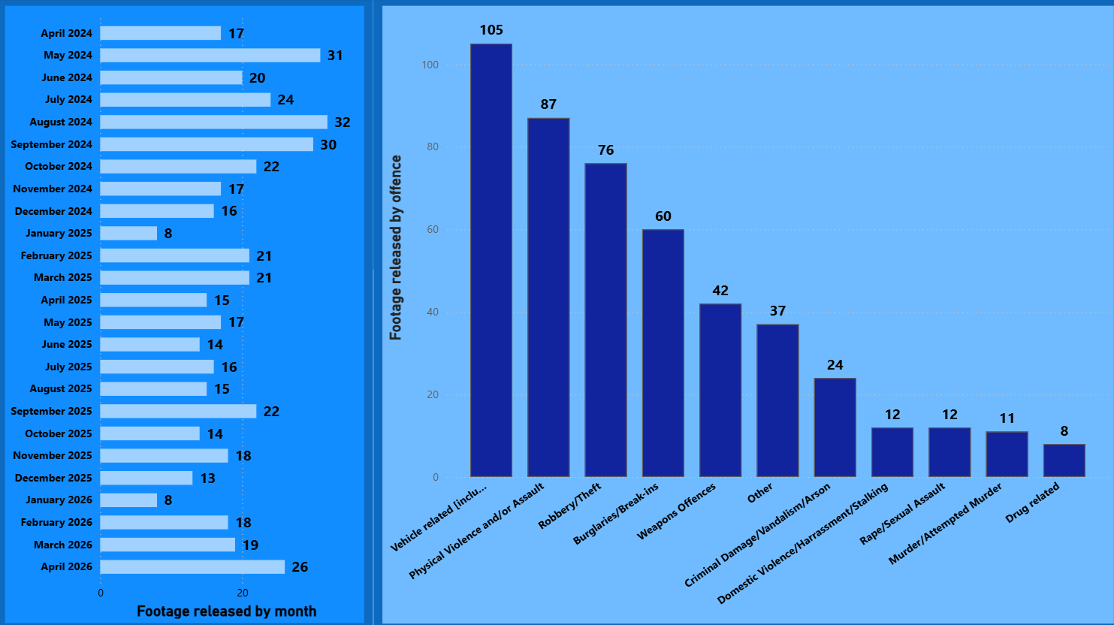

Control Room Responses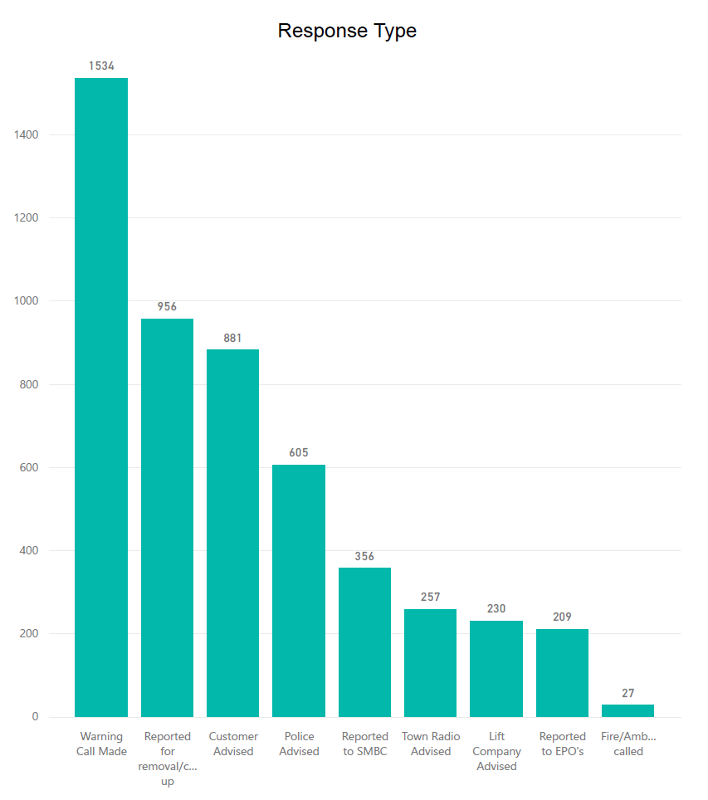

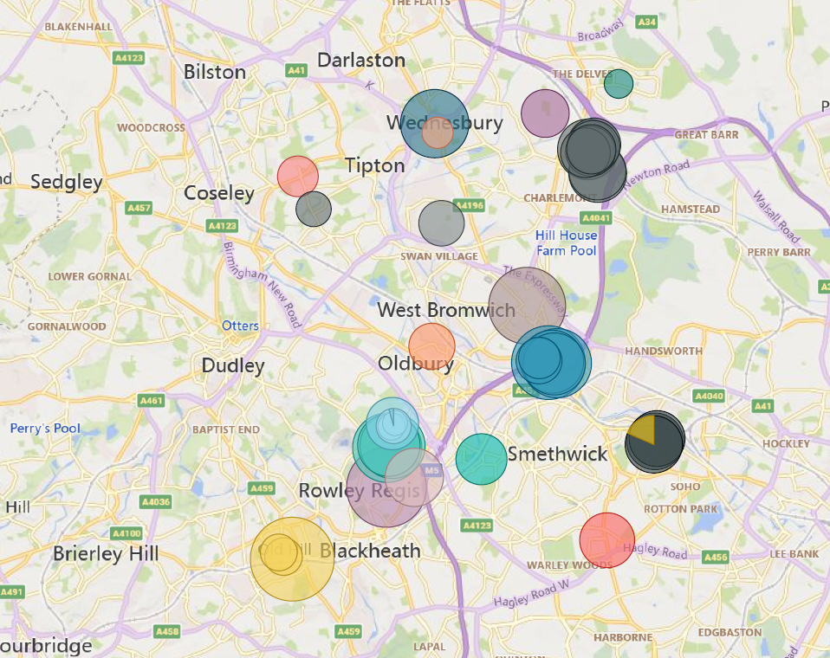
Mapping Detail

Contact Details in relation to this document

CCTV Control Room Manager - 0121 368 1166

www.sandwell.gov.uk/cctv

Updated – April 2026



