# SMBC.jpg

# CCTV advice and guidance document

# Wherever we go about our daily business in Sandwell these days, it appears that we will never be too far away from a CCTV camera. For most law-abiding citizens, this rarely presents a problem, we have come to recognise CCTV as almost part and parcel of our daily lives.

# In fact, many people welcome CCTV on our streets and in our towns and the fact is it is a vital tool in the fight against crime and Anti-Social Behaviour and is becoming an increasingly used tool for a range of agencies.

# Sandwell Metropolitan Borough Council (SMBC) is one of those that utilises CCTV to assist us in certain areas, but we use CCTV in a controlled and considerate manner.

# In all cases SMBC will ensure any use of CCTV meets the required regulatory and legislative standards and that our systems are fit for purpose. Council officers will carry out assessments that ensure the following:

* **P**roportionality - is CCTV the appropriate solution, as a solution is it proportionate to the problem.
* **L**egal - is it lawful? Has all relevant legislation been referred to, considered and abided by?
* **A**ccountability – as the Data Controllers we will have processes in place, we will state our purposes and follow a Code of Practice
* **N**ecessity – is CCTV actually required, what other measures have been tried, what needs analysis has been made?
* **S**ubsidiary – There will not be a sole reliance on CCTV. Any system will form part of a package of measures utilised to combat ASB and crime.

As Data Controllers we must ensure all our CCTV systems and users adhere to the relevant national codes of practice. This document is designed to offer advice and guidance in relation to questions you may have regarding CCTV.

More information can be found on the following websites;

<https://ico.org.uk/>

<https://www.gov.uk/government/organisations/biometrics-and-surveillance-camera-commissioner>

https://www.sandwell.gov.uk/cctv

#### Contents

#### Requests for installations of permanent CCTV – page 3.

#### Requests for installations of deployable CCTV – page 4.

#### Information relating to CCTV installations in your home – page 5.

#### CCTV in council offices – page 7.

#### CCTV monitored by the councils 24-hour CCTV control room – page 9.

#### Laws relating to CCTV and contact details – Page 10.

#### 

#### Requests for permanent CCTV installations

If, in future, funding streams are identified and made available for CCTV installations there are two codes of practice that must be looked at prior to installing CCTV systems. Both the Information Commissioner and the Surveillance Camera Commissioner have codes of practice that aim to reduce sole reliance on CCTV or to avoid installations where they are not justified and where they are not a proportionate response to the problem.

The council have to have regard for the Codes of Practice and ensure that requests for CCTV take account of these. Proposed installations that don’t meet all the criteria detailed in the Codes of Practice, CCTV should not be considered.

To proceed there would need to be a gathering of supporting evidence to justify the use of CCTV, Data Protection Impact Assessments would need to be carried out and operational requirements would need to be drawn up that clearly prescribe the requirement for CCTV.

Costs will vary and a full assessment of these on a site by site basis would need to be carried out before CCTV can be considered. These would vary depending on requirements such as, location, lighting, camera numbers, recording and monitoring requirements as well as data storage.

Our current response to any request for CCTV installations is that at present the council do not have any plans to carry out isolated CCTV installations. The Council have a number of deployable cameras to be used across the borough where CCTV is deemed to be a part of a solution to a set of problems - further information relating to these cameras can be found on the next page.

The relevant codes of practice can be found at the following website;

<https://www.gov.uk/government/publications/update-to-surveillance-camera-code>



#### Requests for deployable CCTV installations

Sandwell Council receives regular requests for CCTV installations. At present the council do not have any plans or funds to carry out isolated CCTV installations. The current response to requests for CCTV installations centres on the use of deployable cameras that can be deployed to deal with ASB or crime hotspots providing the relevant criteria is met.

It is important that all those that are likely to be affected by the deployment of the Council’s deployable cameras and those who are likely to request their deployment have a clear understanding as to the circumstances in which the cameras can be deployed. Requests should normally cover one or more of the following circumstances;

* To assist in policing special events or Police operations
* To respond to crime or ASB hotspots that affect the residents of Sandwell
* To assist in the detection and arrest of perpetrators of a spate of particular crime(s)/ASB
* To assist in the detection and prosecution of “environmental crime” e.g. fly-tipping
* For emergency planning incidents (or exercises)

All applications for the installation of deployable CCTV cameras must take into consideration the Council’s responsibilities under the Data Protection Act, the Human Rights Act, the Regulation of Investigatory Powers Act and existing CCTV Codes of Practice. There must be specified objectives to be achieved by the camera deployment.

The deployment of CCTV must be justifiable - there must be adequate evidence to show that the cameras are an appropriate response. This will usually be shown by records of repeated complaints of past incidents, either to the police via 101, reports to SMBC, serious complaints including complaints of Hate Crime or harassment, or intelligence on future incidents or events.

Our deployable cameras are used in line with a CCTV protocol that ensures proper and proportionate use via the Town Tasking model – a multi-agency response where hotspots are identified and discussed in monthly meetings and agreements are reached as to the suitability of a camera deployment.

To aid this process, our response in the first instance to requests for camera installations will be to advise that incidents are reported through the correct channels – either to the police or the council. This will allow for a proportionate and fair response to requests for our deployable camera stock.

<https://www.sandwell.gov.uk/community-safety/report-anti-social-behaviour/2>

<https://west-midlands.police.uk/incident-report>

1. **CCTV – Installations in the home**

There are laws and tenancy conditions that govern the installation and use of CCTV in your home.

**If you want to install CCTV in your property, there are rules you need to be aware of**.

#### The first consideration should be whether CCTV is required. There could be better or cheaper ways for the security of a property to be enhanced – better fencing or improved lighting for example.

#### Advice should be sought prior to purchasing a CCTV system. If you have concerns about crime or anti-social behaviour near your home, local police or council officers should be consulted, they may be able to help resolve your concerns.

**Before you install CCTV cameras in a council property you must get written permission from your Landlord**. You must also consider where you want to install them, your CCTV should only cover your own property and should not see over your boundary into a neighbor’s property unless they have given you their permission.

Your cameras also can’t be installed on other people’s property, this includes public buildings, trees, lampposts or other street furnishings. **If you don’t get permission from your landlord, you may be asked to take it down.**

**If you choose to install CCTV that only covers your property, such as your own driveway, pathway or private gardens and you have had permission from your landlord, you can proceed with the installation and you don’t have to do anything else.**

**If you are granted permission to install CCTV and your installation goes on to pick up any public areas beyond the boundaries of your property you must be aware of your responsibilities in relation to the Data Protection Act/GDPR**.

The Information Commissioners Office [ICO] governs CCTV that covers public areas and they can take action against you if you do not follow their guidelines on domestic CCTV use.

The ICO guidelines state that **you must have a clear and justifiable reason for installing CCTV that covers beyond your own property**. You will need to think why you need these images. If asked by the ICO you will need to be able to explain your reasons, so you should write them down now. You should also write down why you think capturing the images is more important than invading the privacy of your neighbours and passers-by.

**Some guidelines now follow, if you fail to comply with these guidelines, you may be subject to enforcement action by the ICO. This could include a fine. You may also be subject to legal action by affected individuals.**

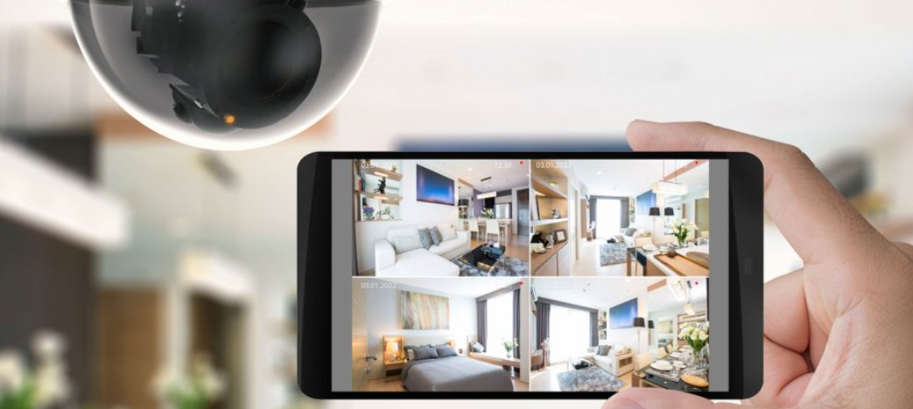

**If installing CCTV in your home, you will need to do the following;**

* *Let people know you are using CCTV by putting up signs saying that recording is taking place, and why. Also ensure the security of the footage you capture – in other words, holding it securely and making sure nobody can watch it without good reason.*
* *Only keep the footage for as long as you need it – delete it regularly, and when it is no longer needed.*
* *Ensure the CCTV system is only operated in ways you intend and ensure it can’t be misused for other reasons.*
* *Anyone you share your property with, such as family members who could use the equipment, needs to know the importance of not misusing it.*

**You also need to make sure you respect the data protection rights of the people whose images you capture. You will need to be aware of the following things:**

* *Individuals have a right to the personal data you hold if they are identifiable on the images captured. They can ask you verbally or in writing. You must respond to any request within one month and give them a copy of the data.*
* *Deleting footage of people if they ask you to do so. You should do this within one month. You can refuse to delete it if needed for a genuine legal reason but you will need to specify what that reason is as part of your response to the requester.*
* *You will need to consider any objection you get from people about capturing their image with your CCTV and justify your response to them.*
* *You should again think whether you need to record images beyond your property boundary and be able to respond to any challenge by the ICO – particularly if your system is capturing images of a neighbour’s home or garden.*

<https://ico.org.uk/your-data-matters/domestic-cctv-systems-guidance-for-people-using-cctv/>

<https://ico.org.uk/your-data-matters/domestic-cctv-systems-guidance-for-people-being-filmed/>

##### CCTV in Council offices

We have CCTV systems located in and around our public buildings and offices such as the Council Houses, libraries, museums, the Development Centre at Roway Lane and our local housing centres. The regulations regarding CCTV footage being made available as well as the regulations required for proper usage, requests for the removal of footage and the rules relating targeted surveillance still apply

# The purpose of CCTV in SMBC offices is primarily to assist in safeguarding the health and wellbeing of employees and tenants, staff management, reducing crime / ASB and assisting in controlling and monitoring access to premises.

# Local processes and procedures are in place and monitored to ensure compliance with Legislation detailed in this document.

#### CCTV footage can be classed as personal data under the Data Protection Act/GDPR, depending on what is recorded and stored. Discussing or sharing anything recorded by cameras or contained in stored footage is just as controlled under law as is allowing unauthorised access to any other data system.

#### Council officers who may find themselves in receipt of queries from tenants or members of the public have received advice and guidance in relation to their responsibilities under Data Protection & GDPR when it comes to discussing or releasing CCTV images.

All cameras are overt and as far as is consistent with the purpose of the scheme are placed in public view. Clear printed signs that CCTV is in operation are displayed at key points throughout the schemes.

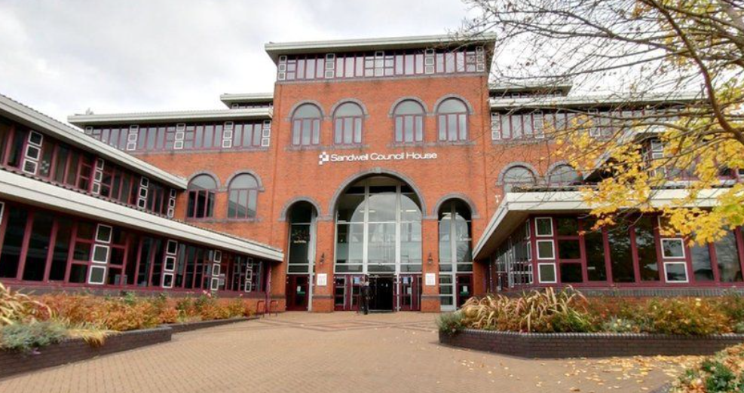

# Where there is a CCTV system within a council office there are persons identified who will have access to CCTV systems for use and application, there will be at least one designated person who has overall responsibility for the CCTV system.

# This person would normally be the manager of the premises or building. The following requirements are met in each office.

# They include the requirement to;

* Have a designated trained person/s who can understand and operate the equipment
* To have the system checked regularly**,** and any faults must be rectified – records must be kept
* The system will be maintained periodically – records will be kept
* Footage will not be made available to third parties unless the correct procedure has been followed
* Records will be kept of any CCTV footage made available to or released to others
* Cameras will not be intrusive or directed towards any individuals or private property
* The system will only be used for the purposes stated by the Information Commissioner
* Access to the system will be restricted to authorised users – a list of authorised users will be kept
* Viewing of images will be restricted to authorised users – a list of authorised users will be kept
* Our central CCTV team are kept informed of any changes to CCTV systems, so a central database can be kept updated

We have a local code of practice in place that details how we as a council will retain or release information and how it will be stored and managed. This can be found at the following location;

#### <https://www.sandwell.gov.uk/downloads/download/446/cctv-document-downloads>

### Sandwell Council’s CCTV control room

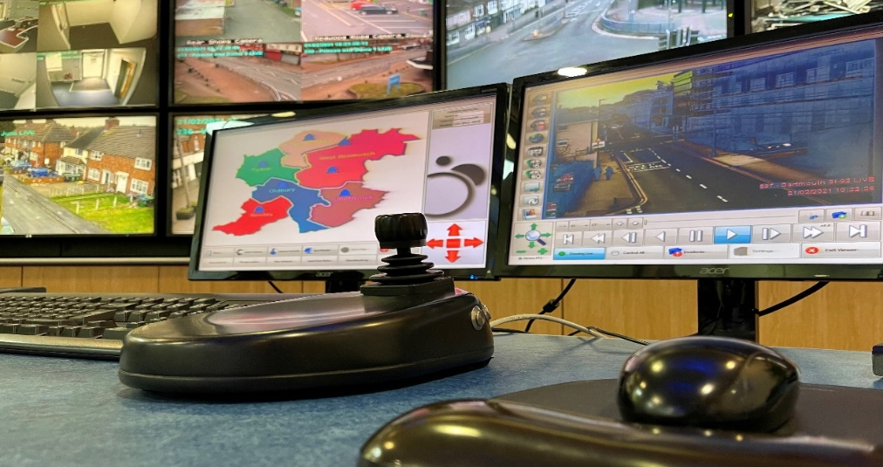

CCTV systems installed on flatted estates and town centres are monitored from the CCTV and Concierge Control Room at Roway Lane. The main reasons for the use of cameras are:

* Improving the perception of safety amongst the public.
* To assist in the detection & prevention of crime and/or breaches of tenancy conditions.
* To facilitate the apprehension & prosecution of offenders in relation to crime, public disorder and/or breaches of tenancy conditions
* Deterring, discouraging and reducing the incidence of crime, disorder and relevant aspects of anti-social behaviour including environmental crime
* Assisting in the management of Town Centres and public spaces
* Assisting in premise management
* To assist in safeguarding the health, safety and wellbeing of our tenants and employee’s

The main purposes of our monitored CCTV systems is to help colleagues and partners detect, deter and prevent crime, disorder and anti-social behaviour and to help identify, apprehend and prosecute offenders.

Some examples of how we use your data are provided below; (this is not an exhaustive list)

* providing evidence in criminal proceedings
* providing evidence in civil proceedings
* the prevention and reduction of crime and anti-social behaviour
* the investigation and detection of crime and anti-social behaviour
* identification of those committing crime or anti-social behaviour
* providing evidence to enforce tenancy conditions

More information can be found at the following link;

<https://www.sandwell.gov.uk/cctv>

**The Laws Relating To CCTV**

There are several pieces of legislation governing the use of CCTV, listed below are some and how they impact CCTV users.

The **Data Protection Act** (DPA) is an act of Parliament is one of the main pieces of legislation that governs the protection of personal data in the UK. The Act defines data protection principles that could affect the use of CCTV,

The **General Data Protection Regulation** (**GDPR**) is a [regulation](https://en.wikipedia.org/wiki/Regulation_(European_Union)) in [EU law](https://en.wikipedia.org/wiki/EU_law) on [data protection](https://en.wikipedia.org/wiki/Data_protection) and privacy for all individuals within the [European Union](https://en.wikipedia.org/wiki/European_Union). It addresses the export of personal data outside the EU and aims primarily to give control to citizens and residents over their personal data. These regulations will affect and guide the processes for retaining and using CCTV footage. This is unaffected by Brexit as the UK has adopted it into law.

The **Human Rights Act** is an act of Parliament that makes it unlawful for any public body to act in a way which is incompatible with the Convention. In relation to CCTV, Article 8 of the European Convention on Human Rights is relevant as it provides a right to respect for one's ‘private and family life’.

**The Regulation of Investigatory Powers Act** (**RIP** or **RIPA**) is an act of Parliament, regulating the powers of public bodies to carry out surveillance and investigation, RIPA can be invoked by government officials specified in the Act on the grounds of national security, and for the purposes of preventing or detecting crime, preventing disorder, public safety, protecting public health, or in the interests of the economic well-being of the United Kingdom.

**The Protection of Freedoms Act** is an act introduced that was designed primarily to protect people in England and Wales ‘from unwarranted state intrusion in their private lives’. The act covers various issues but in relation to CCTV introduces regulation that lays down a Code of Practice by the Surveillance Commissioner that CCTV Control Rooms must have regard for.

**Contact Details in relation to this document**

CCTV control room manager - 0121 368 1166

[www.sandwell.gov.uk/cctv](http://www.sandwell.gov.uk/cctv)

[CCTV_team@sandwell.gov.uk](mailto:CCTV_team@sandwell.gov.uk)

Updated – April 2025