SANDWELL
DESIGN CODE
Stage 1 Findings

Sandwell Council
and
Allies and Morrison
with Phil Jones Associates
November 2025

Part A – The Design Code project with engagement overview

[Page showing selection of photos from across the borough showing the diversity of buildings and spaces, from red brick Victorian buildings in Oldbury and Smethwick to historic industrial buildings in Rowley Regis, 20th century shopping parades in Cradley Heath, and more modern infill developments in West Bromwich.]
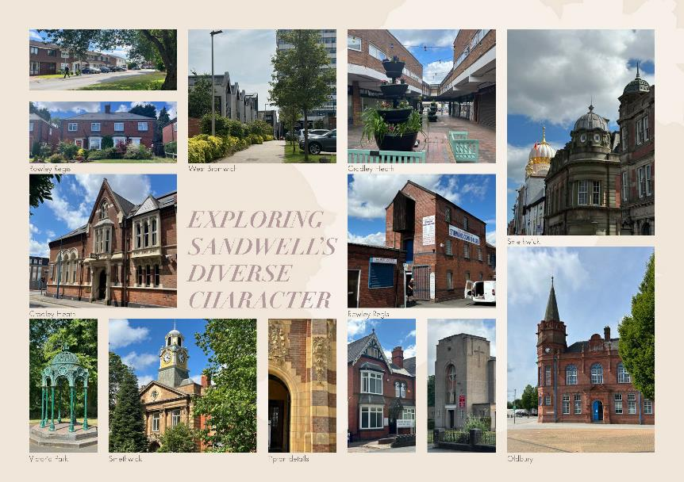

Introduction

First phase of work
Sandwell is a multi-centred and highly urbanised metropolitan borough. Each town is a place in its own right, and set strongly within the Black Country, but with an increasing influence of Birmingham and Wolverhampton. There is a history of strong local communities focused around key industries. Communities have seen significant population change over last 50 years, bringing with it new vibrancy and activities.
There is significant pressure and desire for growth in Sandwell – for both industry and homes. Sandwell Council has commissioned a team led by Allies and Morrison to prepare a Design Code for the borough. A Design Code is a planning document that includes a set of design requirements for the physical development of an area. It will include a review and replacement of the existing Residential Design Guide Supplementary Planning Document. The Design Code is to be shaped by a deep understanding of the borough and led by community priorities on design. Its aim is to raise the quality bar for design in the borough and ensure new development is context-led.
Stage 1 of the work has been focused on gathering data, knowledge, information and views on the character of the borough. This analysis has generated three outputs:
- A Baseline Report - which focuses on character analysis, data and mapping, and review of the current context.
- An Engagement Report - which summarises the events and activities undertaken to draw in local knowledge and views to help inform the priority themes for the Design Code.
- A Conclusions Summary - which outlines the common threads between the baseline analysis and the engagement inputs (this document).

This Conclusions Summary identifies the common themes across the whole of Stage 1 work - so the correlating themes that came out strongly through both the community engagement and the baseline analysis. It is very much about summarising the headline issues to be addressed in an easily digestible form. Please do consult the more detailed reports for further information.

Engagement

Outreach
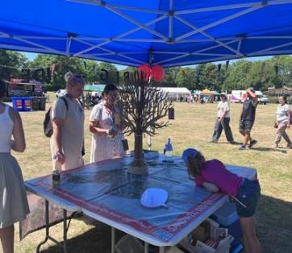
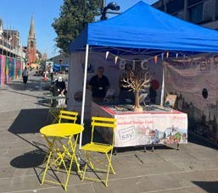
The team has undertaken extensive engagement, both with local communities and internally with various departments in the Council. Between the end of June and mid September the team took a pop-up market stall to a host of local events including the SHAPE Youth Festival and local community days such as the Brasshouse Community Open Day. A mix of in-person and online discussions have also been had with local community interest groups. An online survey on the Council’s Design Code website was also promoted for further input. All these activities have been invaluable in feeding the project with detailed local knowledge and a sense of the priority issues to be addressed.

A selection of key statistics from the Stage 1 engagement period include:
- 7 in person events
- Stage 1 engagement ran from July to September
- Over 700 comments from members of the public
- 4 online workshops
- 46 online survey responses

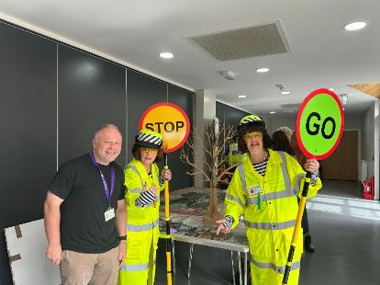

Engagement aims
The engagement for the Sandwell Design Code seeks to meaningfully involve the community throughout the process, helping to shape a collaborative strategy that reflects local insight, history, and lived experience The core aims of the engagement are to:
- Reach a broad and diverse range of people by combining in-person and digital engagement, offered in varied formats, locations, days, and times.
- Build on existing local knowledge and feedback, establishing a bottom-up, community-led approach.
- Listen with empathy and openness to
- understand the full range of perspectives.
- Start the conversation early, creating space for open dialogue and keeping stakeholders well-informed throughout.
- Be inclusive by offering multiple ways for people to take part, regardless of age, background, or ability.

A selection of key comments from Stage 1 engagement:
- We love trees, but just don’t like big trees
- Parking needs sorting
- The surrounding industry is a positive. But we need more trees between the two!
- Young people need activities and places to go
- The real strengths of our area are the parks and canals
- We have nice traditional buildings and homes in Sandwell
- Places need to feel safer, especially for kids
- Streets aren’t safe to cycle
- New builds are built quickly and the quality is lower
- Protect our green spaces

Wide outreach
The choice of events and community meetings was driven by two key objectives:
- to gain inputs from all parts of the borough to cover each of the six towns of Sandwell; and
- to reach a wide spectrum of lived experiences that reflect the demographic of the borough and represent as many protected characteristics as possible.
The table details the protected characteristics which have been used to steer the engagement and shows how the events in Stage 1 address the characteristics so far:
Age | Young people | SHAPE Youth Festival
Age | Young people | King's Church / Oak Tree Centre Community Day
Age | Young people | Brasshouse Community Day
Age | Older people | Blackheath Library
Age | Older people | Smethwick Local History Society questionnaire
Age | Older people | Tipton Civic Society
Age | All ages | West Bromwich Market
Disability |  | Access officer and his contacts questionnaire
Disability |  | Wednesbury Wellbeing Group
Gender reassignment
Marriage and civil partnership
Pregnancy and maternity |  | Brasshouse Community Day
Race |  | Sandwell Faith Sector Network
Race |  | West Bromwich Market
Religion or belief | Four main faiths | Sandwell Faith Sector Network
Religion or belief | Christian | King's Church / Oak Tree Centre Community Day
Sex |  | Brasshouse Community Day
Sex |  | King's Church / Oak Tree Centre Community Day
Sexual orientation
Carer Low income groups Veterans/Armed Forces Community Other | Carers | SHAPE Youth Festival
 | Carers | King's Church / Oak Tree Centre Community Day
 | Low income | Brasshouse Community Day
 |  | Wednesbury Wellbeing Group
 |  | King's Church / Oak Tree Centre Community Day
Teams that we have engaged with internally include Development Management team, Highways team, and Planning committee. In addition, questionnaires have been filled out by all relevant Council teams.

Range of comments
The team asked local communities two prompt questions to start discussions: what they thought was special about their neighbourhood; and what they would like new development to respond to. This generated insightful conversations and comments that the team transcribed and analysed. They covered a host of topics from trees to community centres, and shopfronts to bin storage.
Some of the issues raised are aspects that are well within the scope of a design code to address, others can less easily be impacted by a design code but provide valuable context for informing priorities. The team identified which comments could be addressed through a design code or design guidance and those that could not. For each event the team prepared graphs to show the themes under which the comments fell and for each theme illustrated the proportion that could be addressed by a design code.
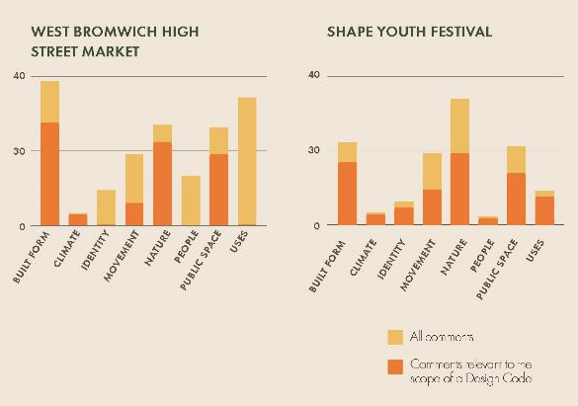

Wider community event – West Bromwich High Street Market
Headline messages for the Design Code included:
- Improve safety
- Improving housing quality and offer
- More community / youth spaces
- More and better quality green space
- Improve pedestrian access

Top comments and statistics from the engagement included:
- Need spaces for young people
- Don’t want high rise is West Brom. Want to feel safe and that scale makes it tricky
- We need way more in the way of green spaces
- 181 comments in total
- 87 of which are relevant to design
- 25% of comments fell under the theme of nature, 51& of which wanted to see more green space protected
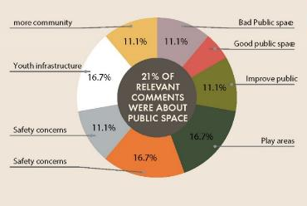

Wider community event – Shape Youth Festival
Headline messages for the Design Code included:
- Protect green spaces
- More green spaces and trees
- Better parking provision
- More indoor and outdoor spaces for young people
- Better quality housing to address needs
- Improve pedestrian access

Top comments and statistics from the engagement included:
- Need spaces for young people
- Large parks are really great
- Parking needs thinking about
- 132 comments in total
- 81 of which related to design
- 21% of comments related to bult form, 63% of which related to housing
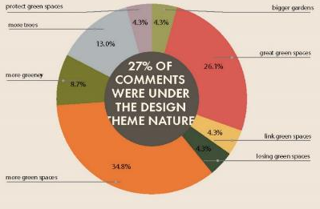

External community events – Group event discussions
Headline messages from the Faith Network included:
- More community spaces
- Better quality and more affordable housing
- Wider range of residential typologies to better address local needs (particularly larger homes)
- Involve young people
- Better strategy to manage parking whilst encouraging walking and cycling

Headline messages from the Tipton Civic Society included:
- Better quality design, informed by local character
- Celebrate and revitalise heritage assets
- Better range of residential typologies
- Improve tree management
- Better transport/highways infrastructure

Headline messages from the Wednesbury Wellness Group included:
- More community facilities
- Provide housing to meet local needs (particularly affordable housing)
- Better parking provision
- New development should blend into existing local character more

Wider community event – Brasshouse Community Day
Headline messages for the Design Code included:
- Improve housing quality and range of typologies
- Improve safety
- More community spaces
- More green links and improved green space
- Better pedestrian routes and more public transport

Top comments and statistics from the engagement included:
- 78 comments in total, 43 of which relate to design
- 13% of comments related to green space, 69% of comments wanted to see better green links and improved accessibility
- 38% of comments were about built form, 38% of which related to housing typologies

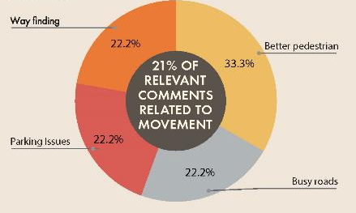

External stakeholders – Oaktree Community Centre Day
Headline messages for the Design Code included:
- Better housing typologies to address local needs
- Improve safety
- Improve housing quality
- More community spaces
- More local green spaces

Top comments and statistics from the engagement included:
- More parks closer would be great, need them in walking distance
- Need cameras to make parks safe
- For the kids there is nothing, just the parks
- Houses with gardens for families
- 63 total comments, 38 related to design
- 18% of comments related to movement, 42% of which related to cycling

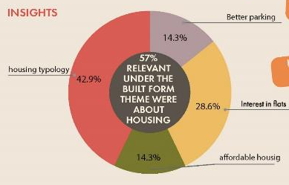

External stakeholders – Blackheath Library
Headline messages for the Design Code included:
- More housing typologies (particularly for independent living)
- More green spaces
- Improved maintenance
- Better parking provision
- More trees (but smaller species)
- Improve design quality
- Better integration of bin storage
a
Top comments and statistics from the engagement included:
- Houses are needed, particularly bungalows
- More spaces required for bin storage
- More green spaces and areas to dwell
- Need more parking spaces, people constantly blocking drives
- 85 comments in total, 59 relate to design
- 15% of comments relate to nature, 36% of these relate to trees

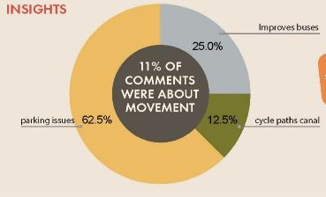

Online survey responses
What did people respond when asked ‘How would you rate the quality of recent developments in your area?’
- 32.6% rated it poorly
- 43.5% rated it fair
- 23.9% rated it good

Top comments and statistics from the engagement included:
- 52% of responses said there was no example of new development they liked in their local area
- 16% of comments wanted to see new development blend in and respect local character
- 23% of responses mentioned green spaces or parks
- Most people responded from West Bromwich, with Oldbury, Rowley Regis, Smethwick, Tipton receiving a similar amount of feedback. Wednesbury was considerably lower.

Common threads
Across all the engagement inputs there are some common themes that have emerged. The five listed here were the most popular topics of conversation. Within these themes are a wealth of detailed views and also differences in opinion. All the findings from the engagement have been looked at alongside the baseline data and site survey analysis to identify correlating themes, and to help prioritise the issues that the future Sandwell Design Code should address. The following section summarises these.

The five most popular topics raised were:
- Green spaces and trees
- Safety
- Community infrastructure
- Housing and new development
- Transport infrastructure

Part B – Correlating themes

vehicular infrastructure

Car dominance
The average speeds of vehicles on most of Sandwell’s highway network are below 20mph, but speeding is a common concern. Despite improvements in access to public transport, the dominance of private vehicles continues to grow.
Top comments included:
- The road round Victoria Park experiences speeding issues
- Cars drive too fast around my estate
- Stop speeding cars!
- Speed measures make spaces safer
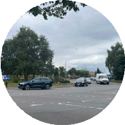
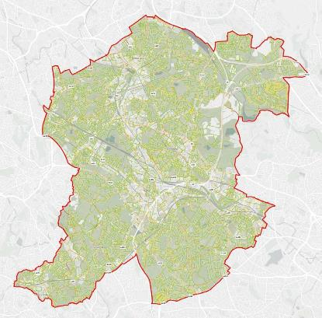

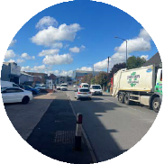

Collisions
Collision data has been plotted on a map for the years 2019 to 2023. The collision data is broken down into three categories: slight, serious and fatal. There are some clusters of accidents - mostly on main roads, but also on local streets with lots of activity. In the development of the design code, this data can be used to inform street design and movement parameters.
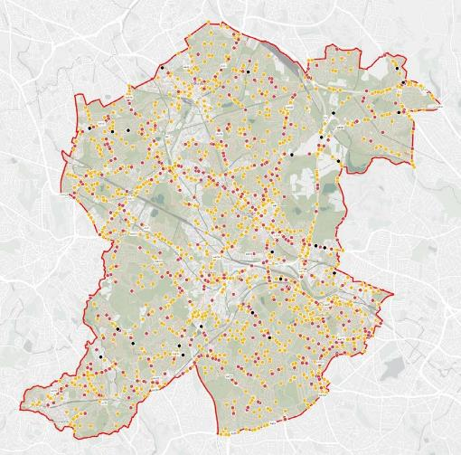

Car ownership
The average car ownership across Sandwell has increased over the last two decades, this includes across all parts of the borough, and is increasing at a faster rate than elsewhere in the West Midlands and UK.
Top concerns stated that parking is starting to dominate streets.

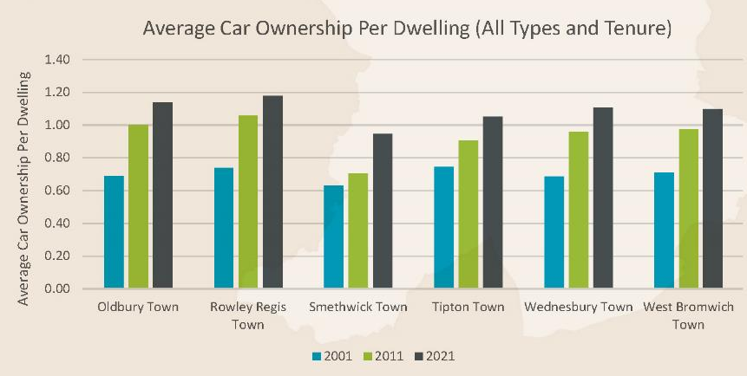

Parking issues
Workshops and site visits have highlighted parking to be a real challenge across the borough leading to the loss of front gardens and extensive pavement parking. Parking is a high priority but it is a divisive topic. Many residents want better provision. Informal and formal parking can lead to a reduction in soft landscape amongst other issues.
Top engagement comments and statistics included:
- Pavement parking is a real issue. Sometimes I have to go on the grass with my mobility scooter to get around
- Households use t have 1 car, now each has 2 or 3
- More parking, drives are blocked
- Boundary treatments have been lost to parkig, we need to reinforace identity
- I dislike the lack of parking
- 30% of comments under the theeme movement were about parking
- 93% of these were issues to do with poor parking provison
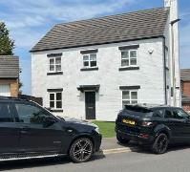
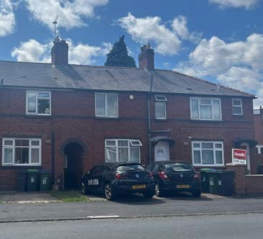
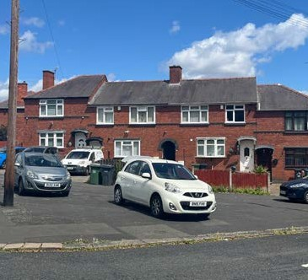
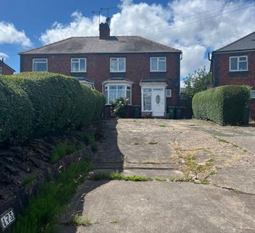
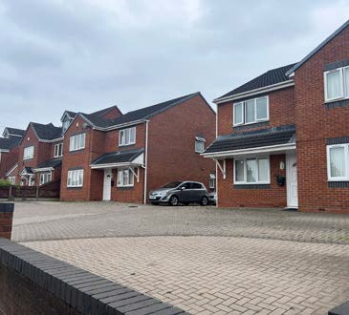
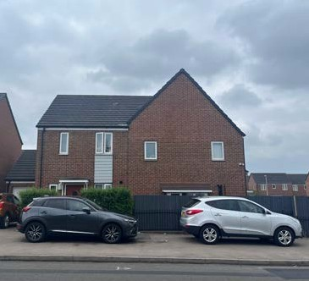

Health

Air pollution from vehicles
Air pollution from vehicles is a driver of health deprivation in the borough. The presence of major roads as well as high volumes of vehicles on local roads feeds this.
Top comments included:
- Main roads are always busy
- Need to focus on improving peoples mental health
- Streets aren’t safe for cycling
- Rubbish dumps in the area – sulphurs in the air
- Most streets prioritise vehicles
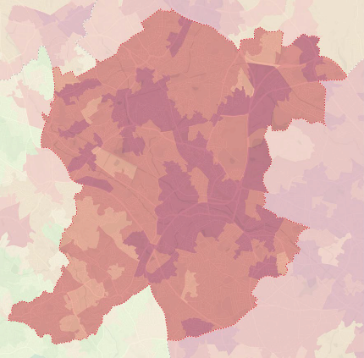

Particulate air pollution
Particulate matter air pollution is particularly high in Sandwell. This is measured both as fine grained PM2.5 and coarser grain PM10. Both PM2.5 and PM10 are inhaled by humans. PM2.5 is able to travel into and deposit on the surface of the deeper parts of the lung, while PM10 generally deposits on the surfaces of the larger airways of the upper region of the lung.
Of all of the common air pollutants, PM2.5 is associated with the greatest proportion of adverse health effects related to air pollution, both in the UK and world-wide (World Health Organization’s Global Burden of Disease Project). “Ambient fine particulate matter (PM2.5) is the world’s leading environmental health risk factor.” (McDuffie et al, 2021, https://www.nature.com/ articles/s41467-021-23853-y).
Whilst the maps suggest PM10 levels are higher and more concerning for the borough, it is also clear that PM2.5 levels are markedly higher in the borough than areas outside.
The primary contributing factors in the borough are likely to be industrial combustion activities and vehicle engines and movements. Measures that reduce vehicle use and movements and limit pollution from industrial processes will have an important impact.

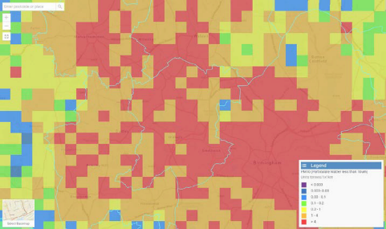
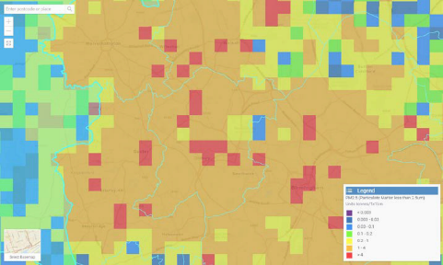

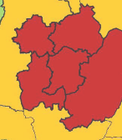
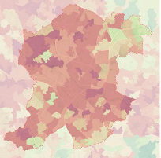
The Health Deprivation and Disability decile is an important contributor to Sandwell’s overall Index of Multiple Deprivation (IMD) score. Local communities in many parts of the borough including Cradley Heath, Tipton and East Smethwick have some of the poorest health in the country.

The percentage of physically active adults is low in Sandwell (50.7%), which means almost half the adult population is inactive. This follows a pattern in the sub-region but Sandwell’s figure is the starkest.

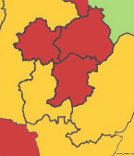

The percentage of overweight adults is high in the borough with 71.6% of adults classified as overweight. This emphasises the need to provide infrastructure to support healthy lifestyle choices including safe and attractive active travel routes and green spaces for recreation.

Active travel and cycling infrastructure
The goal of the Sandwell Local Walking and Cycling Infrastructure Plan (LCWIP) is to make these modes of transport more accessible, safe, and enjoyable for all users.
Top comments included:
- Cycle paths are not used enough
- Cycle routes along the canal area great
- Everyone should be able to walk to a park like mine
- Walking routes are not very pedestrian friendly
- We need more cycle routes
- Putting in cycle paths is not needed
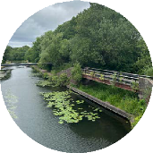
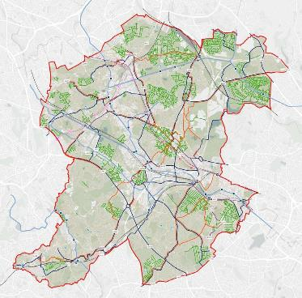

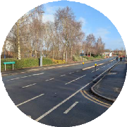
Accessibility – Cycling times to town centres
Cycling isochrones around town centres provide an indication of the distance a cyclist can travel to or from the town centre within a given time period. Town centres offer areas of employment, retail and other civic uses - all of which are important for a vibrant local community. Access to town centres by cycling is varied. The majority of Sandwell is within a 15 minute cycle to a town centre, but there are also significant areas which are more than 20 minutes cycle time. While cycling journey times to and from town centres provide an indication of accessibility in terms of journey times, they do not provide an indication of the quality of the cycle infrastructure.
- 90% of comments on cycling wanted to see cycling infrastructure improved

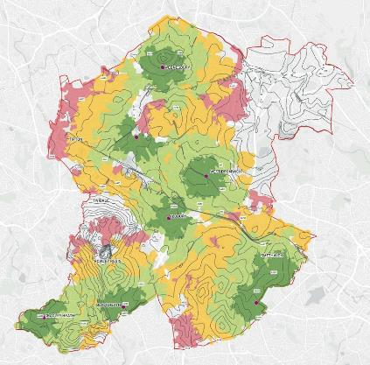

Green infrastructure and tree planting

Air pollution from vehicles
The overall impression is of a green borough with a great mix of spaces. This is a feature that is highly valued by local people.
Top comments and statistics included:
- A strong positive for the area is the sense that you could be in the countryside in some of the green spaces
- Protect our green spaces
- The real strengths of our area are the parks are the canals
- Warley Woods is really good, bring that energy to other parks
- 12% of all comments related to green spaces
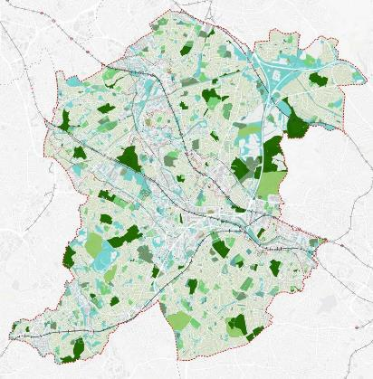

Public access
Access to open space varies across the borough, with some neighbourhoods having limited options. Communities want parks to be safe spaces.
Top comments and statistics included:
- The park is a long way, would be good if it was closer
- Everyone should be able to walk to a park like mine
- We need to raise the bar on quality of green spaces provided in new residential developments
- Love the pockets of green, could we link after?
- Need to make parks safer. In some green spaces the drug dealers are taking over
- 29% of spaces have limited access
- 67% of comments under the design theme nature were about green spaces
- 31% of these wanted to see more green spaces

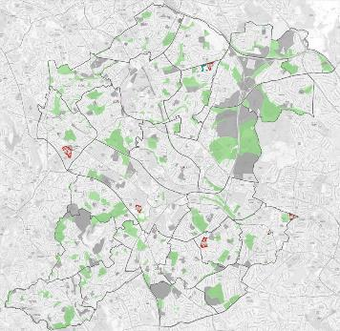

Overall greenery
Access to open space varies across the borough, with some neighbourhoods having limited options. Communities want parks to be safe spaces.
Top comments and statistics included:
- Need to plant trees to help protect areas of grass
- Where are the trees?
- Trees push up the pavement and drop leaves
- We love trees but just don’t like big trees. Need to think hard about the types of trees planted and how big they will get
- 12% of comments on nature were about trees
- 57% of these comments were about wanting to see more trees
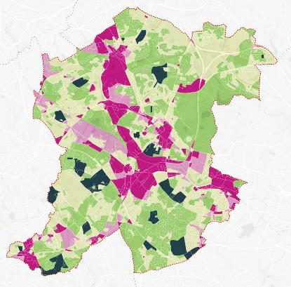

The canal network

The need to celebrate
Local people really love the canals and are keen to seem them celebrated more, including the historic buildings around them, and opportunities to bring new frontage and activity realised.
Top comments and statistics included:
- Canals are a key part of the character and should be seen as arterial parks
- There is not enough signage to the waterways
- The Boat Gauging House is at real risk, we need to give new life to these great buildings linked to the canal
- It would be great to have canal-side cafes to create vibrancy
- Cycle routes along the canal are great
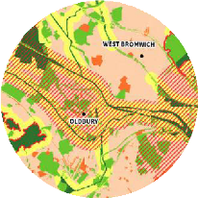
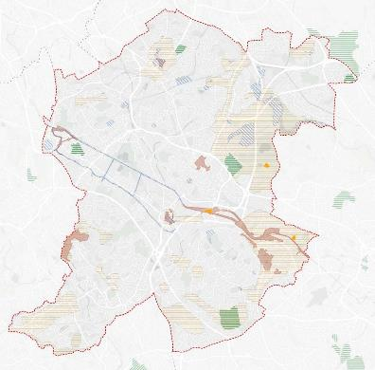

Accessibility issues
The reality is that the canal network is in some parts good for cycling and walking, but in others pretty bad. Access points are limited and the continuity of routes is patchy. There are also long stretches with no frontage or activity overlooking the canal, many of which are in deep cuttings.
Top comments and statistics included:
- Canal is really key. We need to avoid over development
- The walking route from Upper Church Lane to Central Avenue along the old line of the canal is a good example of what can be done

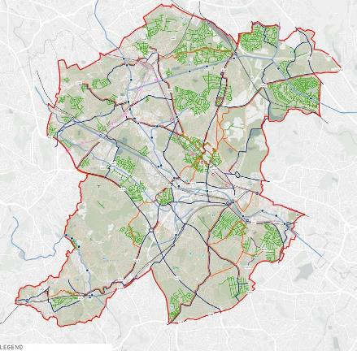
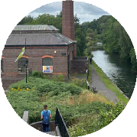

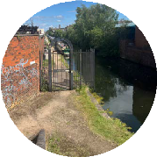

Safety and the fear of crime

Crime levels
Crime statistics show the crime rate is generally low in the borough. Local people have contrasting views - some find it very safe, others see it as a top priority for improvement. For the Design Code the priorities on safety look to be provision of community infrastructure as part of new development, and well-defined spaces with well-positioned entrances to buildings. An important role for the Design Code is to balance Secured by Design principles and measures to support improved perception of safety.
Top comments and statistics included:
- Low crime and good schools, I enjoy where I live
- It is safe on my street and feels happy, not angry
- There is antisocial behaviour around the canals
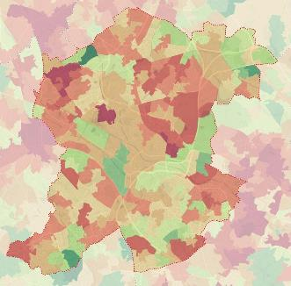
- Lots of drug issues makes me concerned about safety
- Poorly lit parks make them feel unsafe
- Places need to feel safer for my kids
- Bus stops can be intimidating with antisocial behaviour
- 5% of all comments related to safety
- Groups of kids are intimidating. Too many people hanging around.
- Wednesbury feels safe, some good new development
- Better shared entries to flats – would feel safer
- Safety and crime are a top priority

public spaces and community infrastructure

Lack of quality public spaces
Overall, there is a desire to see more quality public spaces, both in town centres and nearer to local neighbourhoods.
Top comments and statistics included:
- What’s missing – seating and relaxation spaces where people can just sit in greenery
- Young people must feel safe, we should make spaces for them to feel connected again
- Young people need activities and places to go
- New Square West Brom is good
- 8% of the comments under nature wanted to see more play areas
- 12% of the comments related to safety concerns
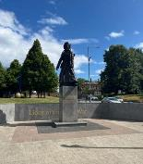
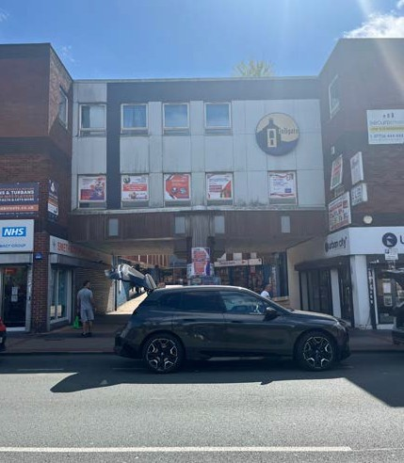
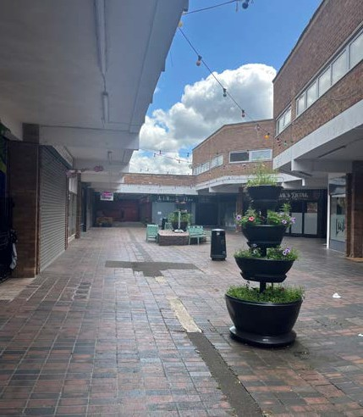
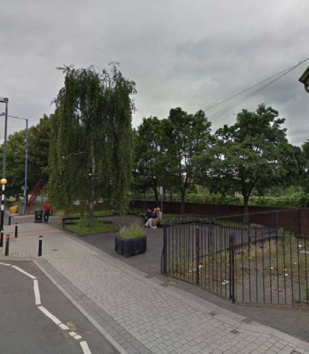

Lack of community infrastructure
Sandwell’s community infrastructure is shaped by educational and religious facilities that serve as social anchors throughout the borough.
Top comments and statistics included:
- Community stuff and infrastructure is needed. This church does a lot – but there’s so much more needed.
- Lots of concern about the loss or lack of community facilities. Everyone agreed there was a big need for community spaces.
- Community infrastructure is key. Need more spaces in the community.
- 45% of comments on public space were about wanting more community space
- 38% of these were about spaces specifically for young people
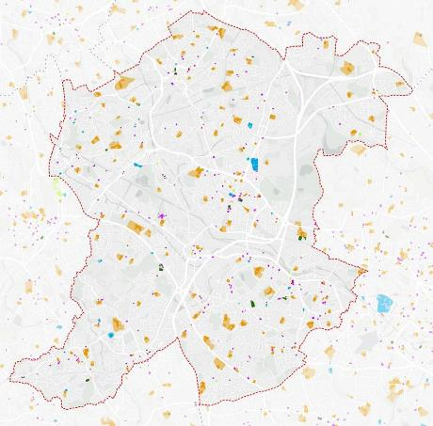

Reliance on places of worship
The borough’s multi-faith character is reflected in its varied religious facilities, with Christianity representing the largest group at 39.9% of residents, followed by those with no religious affiliation at 26.1%. The Muslim community (13.4%) and Sikh population (11.5%) contribute to a rich tapestry of religious buildings and community centres. Smaller communities (Hindu (2.8%), Buddhist (0.3%), and Jewish (0.1%)) also help create a comprehensive network of faith-based infrastructure.

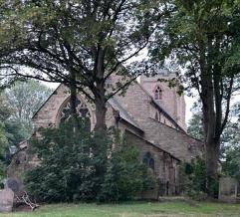
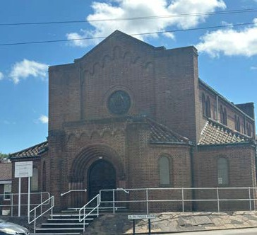
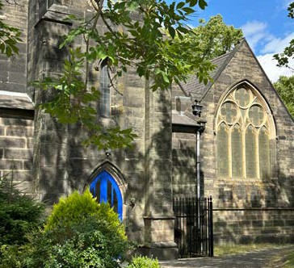
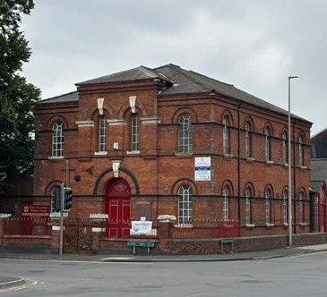
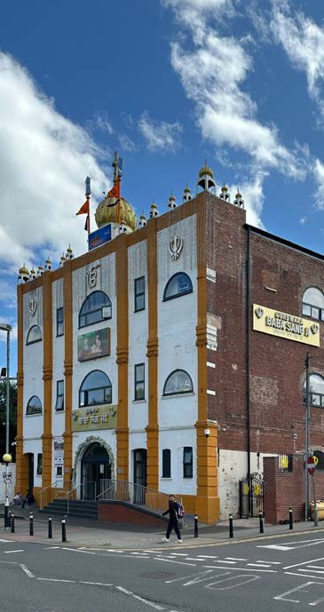

housing mix

Suburban housing dominates
A cross the borough’s residential areas the vast majority is suburban housing - commonly semi- detached or garden city style. Local people have a preference for houses over flats, a view that is driven by concerns that flats don’t support families and aren’t good quality. The Design Code will need to explore the demand for a range of types and sizes of accommodation to meet local needs, achieve high quality design that creates an uplift in quality where needed, and improve accessibility by sustainable transport. Suburban housing is the dominant housing typology, but future growth needs to be in denser forms and will need to challenge local communities whose preference is for houses.
Top comments and statistics included:
- We have nice traditional buildings and homes in Sandwell
- We need to be building houses not flats
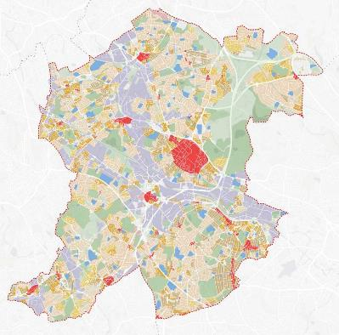

Intergenerational living and the polarised needs
New housing must deliver better homes at the extremes to address local needs - this means good quality flatted schemes that work for families as well as single people, and the integration of more innovative designs to support multi-generational living.
Top comments and statistics included:
- More need for assisted/ independent living. Not enough properties to downsize. Not enough independent bungalows / flats / communal spaces.
- …interested in high rise…. we should not be frightened of 3 or 4 floors. More European attitude to living….People may have to behave, sharing common spaces.
- Bigger homes for intergenerational living means more expensive? How can we make it affordable?
- 12% of the comments under the theme built form were about needing a wider range of housing typologies
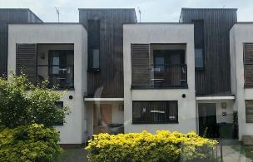
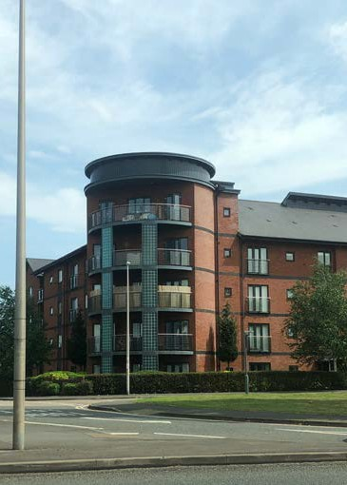
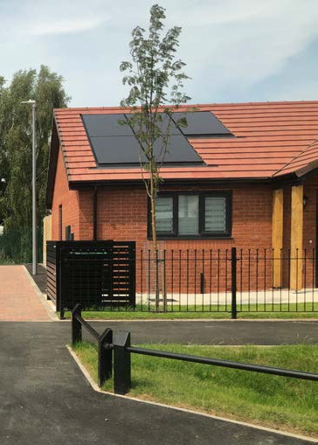

Design quality

Lack of richness in facade design
Façades tend to lack contemporary design and the material palette is limited, with materials weathering badly. Car space provision also plays a role in lower quality.
Top comments and statistics included:
- The new houses that are being built are so plain. No richness, just brick. But if you look across the road, you see much more rich design
- More robust materials – no buff bricks
- Quality of materials is key for visual “enrichment” – doorways / entrances / sills / arches quality lost.
- New builds are built quickly and the quality is lower
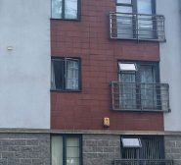
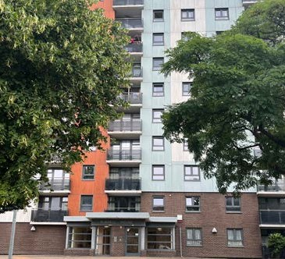
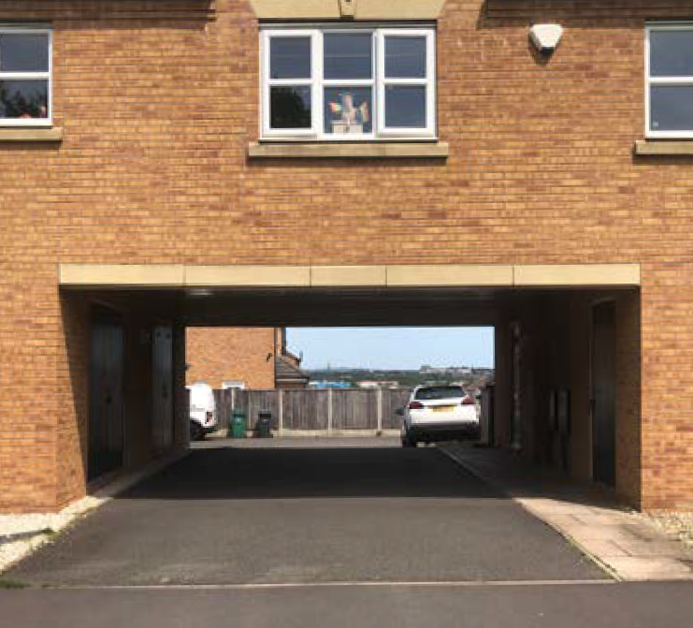
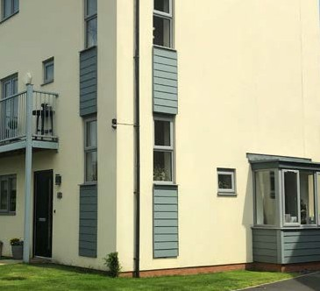
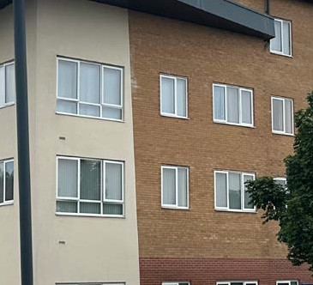
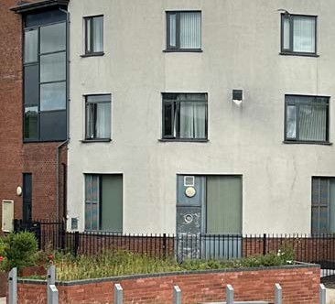

Standard provision
The borough has seen extensive housing development in recent decades but there have been limited examples where the quality of design has stepped beyond basic provision. Viability is a concern and there is a need to establish design quality thresholds that raise the bar without making developments unviable. The approach to new builds is similar throughout the borough with a low range of tenure option and only basic standard forms selected.
Top comments and statistics included:
- New development not great, after a few years don’t look great at all.
- New development – same standard everywhere, it needs be better.
- Sites have been developed without enough parking – and so now there are cars all over the pavement.
- The flatted development where I live was really thought about in it ’s design – it is lovely
- 12% of the comments under the built form theme were about wanting to see better quality of materials and design
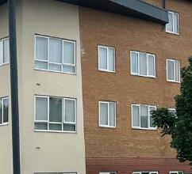
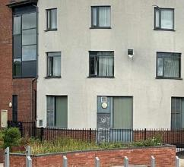
- 52% of survey respondents said that there were no good examples of new development in their area
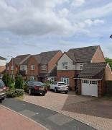
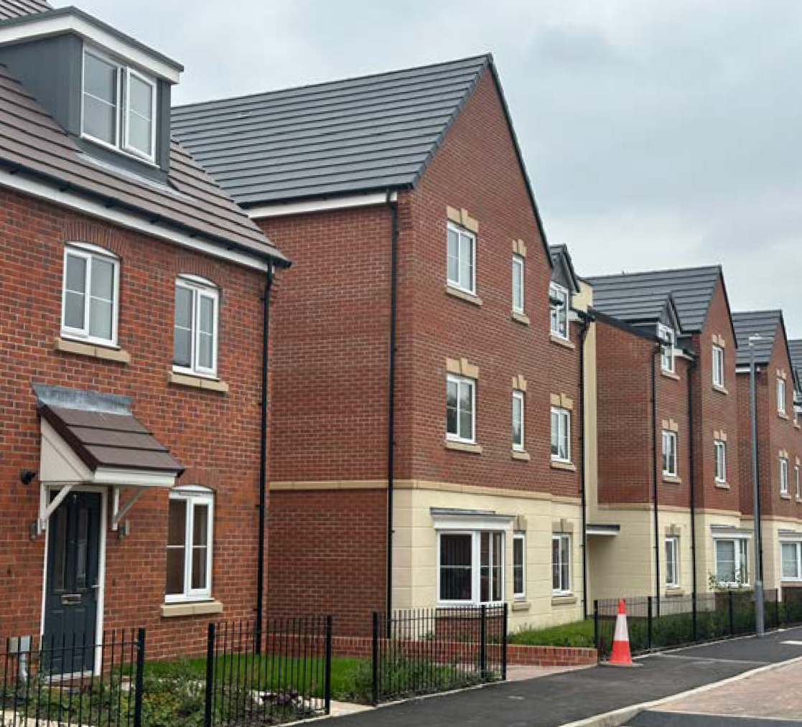
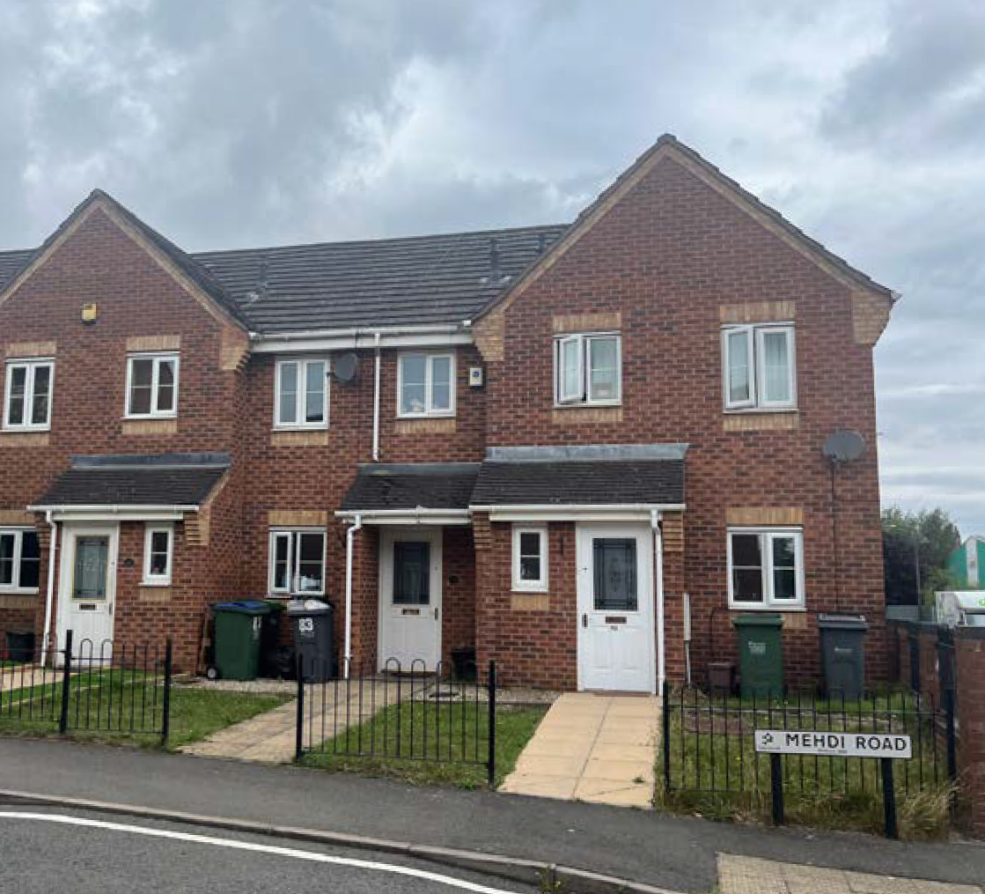
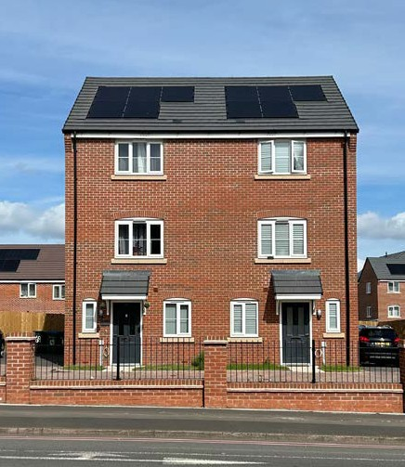

Housing – related negative perceptions
The general low quality design is evident and recognised by local people. At its worse this can result in residents feeling unsafe.
Top comments and statistics included:
- Not flats – nothing too tall
- Flats make sense for crisis, want more detached houses but we need lots of houses.
- New apartment block – are they stupid? Who wants to live there?
- New developments – such as the top of Rowley by the church look like they’d be really noisy flats and therefore difficult to live in. Noise insulation – need to make sure developments stick to the rules on insulation to make flats liveable.
- 9% expressed negative comments about housing stock and quality

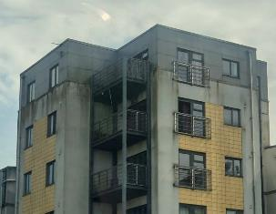
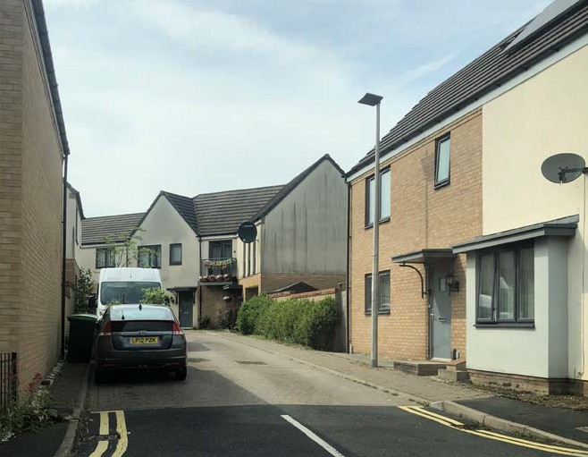

Boundary treatments

Indicator of quality
A lack of boundary treatments has been revealed as a real indicator of poor quality more generally. The lack of clarity between public and private space generates lots of problems. There is range of different boundary treatment across the borough, with cultural influences further diversifying the approach. Some, whilst clearly defining public and private space, can feel oppressive.
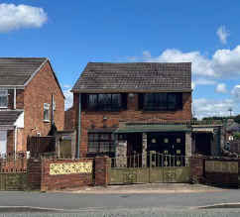
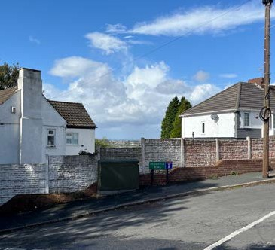
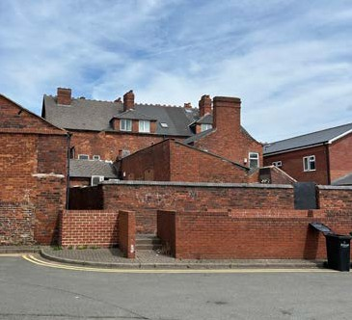
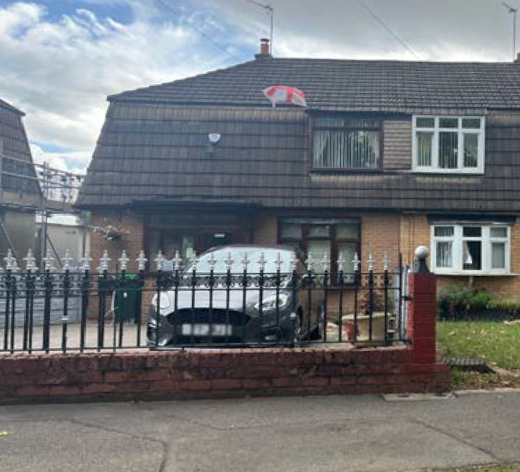
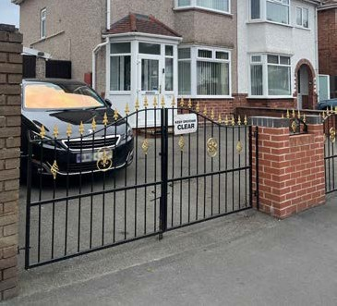
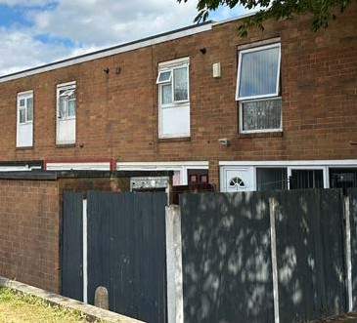

spatial severance

Transport severance
Easy movement by vehicle and train is prioritised over connections by foot between neighbourhoods. New developments need to help increase permeability where possible.
Top comments and statistics included:
- We’re really lucky with all the buses - great service
- Safety and crime are a top priority.
- Dudley port area – buses aren’t great, area feels disconnected from Sandwell. Even though there’s lots of big parks… they’re so hard to get to.
- Happy with buses, frequent and a few choices to get to main depots
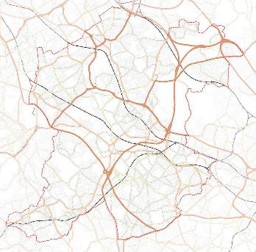
- 9% of comments on movement were negative about bus provision

The need for improved connections
Whilst there is some hesitancy in the short term about investment and use of cycle routes, all the evidence points towards the expansion of this being key to Sandwell’s future.
Top comments and statistics included:
- Canals should be seen as arterial parks
- Cycle routes – really need these, look to other countries as examples of what we should be doing
- Putting in cycling path not needed
- Cycle route along canal is good.
- Cycle paths are not used enough.
- New cycle infrastructure is opening up connections
- Access opportunities onto canal network are resisted by developers
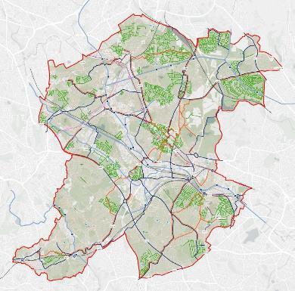

industry

A physical barrier
Industrial areas contribute to the fragmented character of the borough, but it’s important they are supported in situ to enable economic viability. The industrial areas align with the railways and canals and together they combine to reduce permeability in central parts of the borough.
Top comments and statistics included:
- Canals are a key part of the industrial character.
- Sandwell has a wonderful sense of evolution – continually changing. It allows things to fail and try again. A space for piloting things. The big presence of industry is a key part of this
- Significant presence of large format sheds
- Older finer grain fabric supports diverse businesses
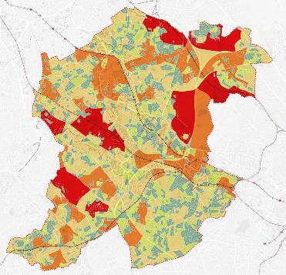

Relationship to housing
The historic evolution of industry in the borough means most industrial areas are cheek by jowl with residential neighbourhoods. This means many streets have homes on one side and the backs of industrial sheds on the other. The presence and proximity of industry is valued, but there is a desire to soften the transitions to enhance the adjacent residential experience.
Top comments and statistics included:
- The surrounding industry is a positive. But we need more trees between the two!
- Within the industrial areas we want to see some planting within the parking courts.
- The legacy of the industry is part of Sandwell but it makes it tough
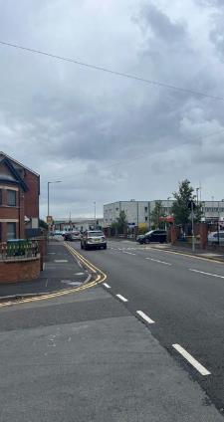
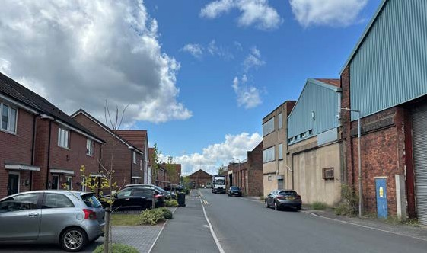
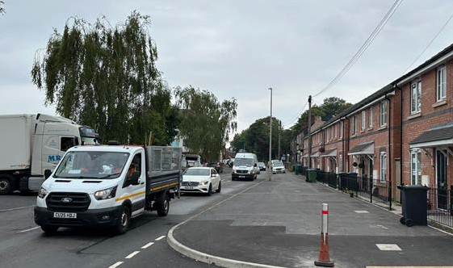
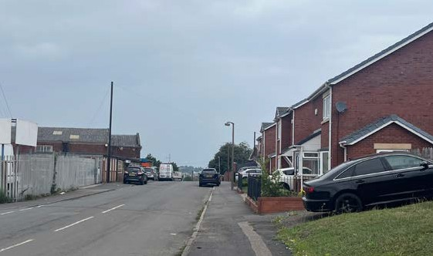

Approach to retrofit
The surviving historic buildings in industrial areas have strong architectural character and opportunities for retrofit should be maximised where possible. New designs should also reference their design in terms of scale, form and materiality. There is strong support for re-using old buildings. Climate ambitions point towards a retrofit first approach, but viability will continue to be a constraint in some instances.
Top comments and statistics included:
- Improve and recycle buildings!
- Need creative new uses for these old buildings
- Developers need to look at retrofit options first.
- Creative re-use of historic industrial buildings exists in the borough

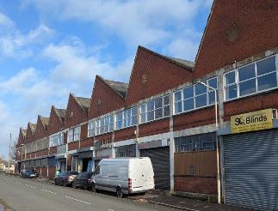
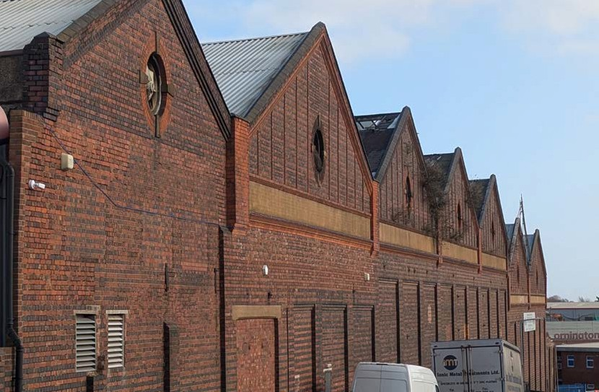

Part C – Next steps

Regional landscape character
The Black Country Historic Landscape Characterisation Assessment, which was completed in 2019, identified a number of areas which have distinct landscape characters. The Local Character Areas for Sandwell are set out below and identified on the plan.

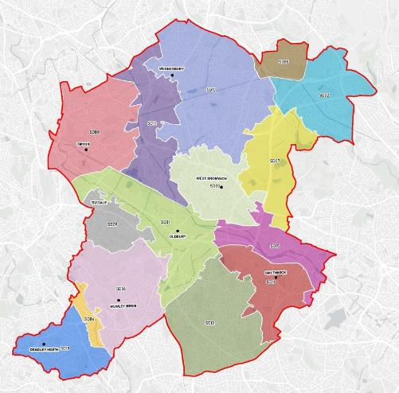

Sandwell’s six towns
Sandwell Character Areas have been overlaid with Sandwell’s six town areas to highlight common characteristics. There is a strong synergy between the two which suggests the six town boundaries make a sensible starting point for defining character areas. An understanding of local character will be central to informing any area-specific codes or rules that need to vary between different parts of the borough.
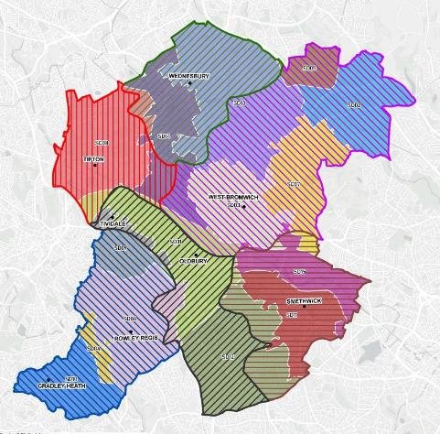

Towards area types
Stage 1 has involved extensive analysis and community engagement. The conclusions from bringing together the baseline analysis and the engagement findings here will steer the early thinking on the scope and focus for design guidance and rules that will emerge through the next stages of work. Stage 2 will involve identifying the design vision for the borough and key places within it. As part of this an important task is to identify area types. These are essentially character informed typologies that define where design codes will apply. This plan shows an initial iteration of existing characters that will inform future area types.

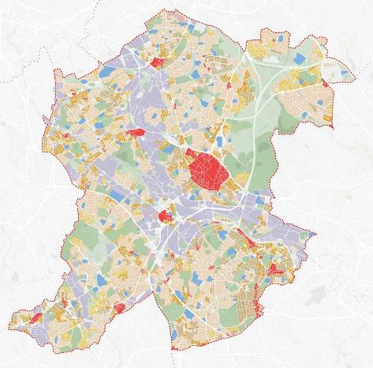

Alongside the area types refinement in Stage 2 will also be decisions about which parts of the borough should be subject to area-specific design codes and which parts can be subject to boroughwide guidance and rules. Early work in preparation for Stage 1 suggested that the borough’s four regeneration zones will be the focus for area-specific design codes. These are outlined on the plan here.

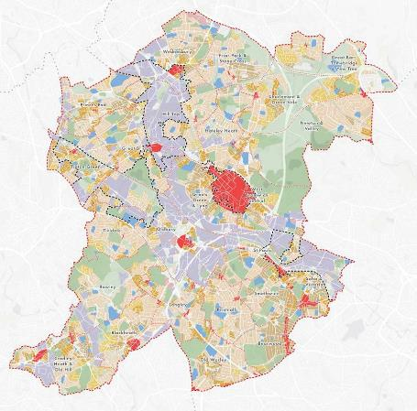
Wednesbury Regeneration Zone
West Bromwich & Carters Green
Regeneration Zone
Dudley Port & Tipton Regeneration Zone
Smethwick Regeneration Zone

Stage two and onwards

