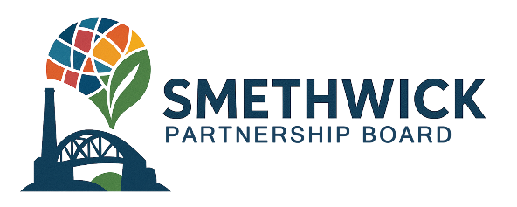
Smethwick Partnership Board
Young Persons Recruitment
Closing Date: 23 September 2025

Personal Details
 | Full Name:
 | Age:
 | Email Address:
 | Contact Number:
 | Connection to Smethwick
 | What is your connection to Smethwick? (Tick all that apply and apply details where asked)
 | ☐ | I live in Smethwick and my postcode is:
 | ☐ | I work in Smethwick and my workplace postcode is:
 | ☐ | I study in Smethwick
 | ☐ | Other – please specify:
 | If you study in Smethwick, please provide the full address of your school/ college/ learning facility and contact details:
 | Address:
 | Name:
 | Email (if known):
Your application
 | What interests you about joining the Smethwick Partnership Board?
What skills would you bring to the Board?
 | Is there any support you would need to help you in your role as a Board member?
 | If you have any previous experience of representing young people e.g. as part of a School Council or Youth Group, please tell us about this. Note: Previous experience is not required.
What date/ time would you prefer meetings to take place?
The Partnership Board will look to set a dedicated day and time for future meetings to work around school/ college/ study and placement schedules.

 | Days: |  |  | ☐ | Tuesdays |  | ☐ |  | Thursdays
 | Times: |  |  | ☐ | Between 9am and 12noon
 |  |  |  | ☐ | Between 12noon and 4pm
 |  |  |  | ☐ | Between 4pm and 6pm
 | Date:
 | Signature:
Please submit your completed application form to Smethwick_PFN@sandwell.gov.uk

Key Information about Board Meetings
Meetings of the Board take place every three months at a minimum. However, monthly meetings are scheduled over the next six months to develop the Regeneration Plan for the Neighbourhoods Programme and to design the applications process.

Applicants should note that project delivery funding will be received in April 2026, subject to Government approving the Regeneration Plan for Smethwick and that the Board is currently focused on setting up the necessary processes and drafting the plan.

Meetings are held in person at a venue in Smethwick and online via Microsoft Teams, however in-person attendance is encouraged.

Key information about applicants
The minimum age of applicants is 14 years old. The maximum age of applicants is 25 years old.

Applicants must not be Elected Members, Council Officers, or Co-opted or independent members of any current council committees.

Successful applicants will be required to sign the Councillor Code of Conduct which is based on the Seven Principles of Public Life (Nolan Principles) and will be required complete a register of interest setting out any private interests which may conflict, or may be perceived to conflict, with their board duties. Please see the Smethwick Partnership Board Terms of Reference for further details. You will be given help to understand these documents and to complete them.

If you need support with completing this application form, or would like to ask any questions, please contact: Smethwick_pfn@sandwell.gov.uk.

