Social Value Toolkit

Section 1 - Sandwell’s 4 Pillars of Social Value

Social Value is defined through the Public Services (Social Value) Act 2012, which came into force in January 2013. This requires public sector organisations and their suppliers to look beyond the financial cost of a contract and consider how the services they commission and procure may improve the economic social and environmental wellbeing of their region.
Sandwell Councils ethos is to help maximise community benefits in all areas recognised as a social value.
We use 4 Pillars of Social Value to help describe what social value means to Sandwell -
Employment & Skills - Opportunities for local people – Work Experience / Trials, Apprenticeships, Jobs...
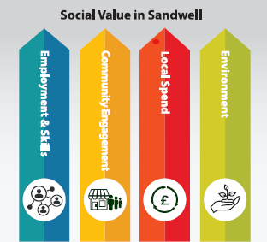
Environment – Reduce, Re-use, Re-cycle. Reduction of carbon, landfill waste, energy
Local Spend – the use of local suppliers & supply chain within 10/20 /30 miles.
Community Engagement – Schools / Colleges / Community Groups & Charities – Inspirational talks / activities, sharing skills, expertise, repairs, donations to food banks or of time or financial support…

For further information and to find our full social value policy –
Social value in Sandwell - Sandwell Business Growth
Case studies - Sandwell Business Growth

Further guidance on what we are looking for -
Employment & Skills -
What are you already doing? - identify and demonstrate how many of the workforce live within 10, 20 miles of Sandwell or the specific project location.
Capturing this enables us to show additional value / impact the contract partner is having on the local employment and economy.

*As a consequence of winning this contract can you offer new opportunities for work experience, apprenticeships, employment for local residents?

*Can you support our care experience young people, work with youth justice, support long term unemployed or residents with support needs...?
We can support finding local people for work experience, apprenticeships, employment and have services that can support you and the individuals.

Community Engagement -
Can you carry out any activities with local schools, colleges, community or more vulnerable groups? Help with repairs and maintenance or make donations, give time / expertise, food, clothing, digital equipment to any of our children’s services, local charities, food banks, clothing banks, community centres / groups, youth centres, care experienced young people…?
We have links and knowledge of schools/colleges, various community needs and initiatives so can help set up a range of activities.
Local Spend –
Are you using any local sub-contractors, suppliers within 10, 20, 30 miles of Sandwell or the specific project location.
At the end of the project let us know your local spend for these distances and provide a list of sub-contractors and suppliers you have used.
Capturing this enables us to show additional value / impact the contract partner is having on the local economy.

Environmental –
How will you reduce… waste to landfill, carbon emissions, energy consumption? Can you offer to share best practise, take part in any green initiatives, support any green spaces in the area, get involved in litter pick in the local area, recycle/donate materials…?
This is great evidence of being a considerate contract partner. Again, we can help set up any activities and promote.

NB - We find a lot of contract partners are already adding social value, but it is not being recorded. Therefore, a good starting point is capturing what additional social value is already being achieved then adding from there. For example, you might already employ some local people and spend money in the area so if we can capture that and then add a work experience placement or an inspirational talk at a school or a site visit or support of a local community need… it adds further value and builds further evidence of a social value impact.
We can help record and promote the social value achievements and often put good news stories together to go on social media, in local newspapers and on our website.
Case studies - Sandwell Business Growth.

We will build a social value portfolio / report for each project or contract which can be used in future evaluations and tenders to demonstrate previous history of delivering social value outcomes across our 4 pillars.

Section 2 – Example Social Value Question
Q) Please answer the following to demonstrate how you would achieve social value outcomes if awarded this contract. Please note that potential suppliers should include their commitments and targets for the local area for this particular contract. Previous examples can be included as evidence of good practise but a proposal of what is planned for this contract will be needed.
Our expectations will be proportionate to the value, duration, and type of contract activity.

Employment & Skills -
Please Identify current local work force and any new work experience, apprenticeship, and employment opportunities for the local area as consequence of this contract.
Community Engagement -
What support can you offer to a local school, college and/or community or charitable need within the local area?
Local Spend –
How will you engage and utilise local suppliers and supply chain and spend locally where possible?
Environmental –
Please explain the proposed environmental strategy for yourselves and any partners / sub-contractors in terms of reducing energy use, carbon footprint and re-using, recycling where possible.

Section 3 - Social Value Delivery Plan (SVDP)

Once a contract is awarded as per our social value policy level 3 contracts will require a social value delivery plan. Level 1 and Level 2 will be recorded by the project lead.

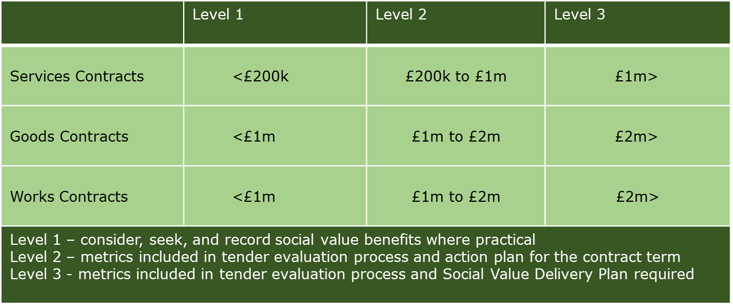
For further information and to find our full social value policy –
Social value in Sandwell - Sandwell Business Growth

The social value delivery plan is calculated against an estimate of cost, duration and type or works / contract and sets out the Key Performance Indicators (KPI’s) for the contract. When the contract is awarded the social value team will have a pre-contract commencement meeting to go through and agree on final KPI’s with the contract partner and establish how it will be achieved and monitored. Support will be offered to help achieve the targets as we hope to work as a team on achieving outcomes.

Example SVDP -

Contract / Project Name…
Proposed £( )m….. (insert contract type and associated works). ( ) week build/contract programme and proposes potential community benefits and employment/skills opportunities as follows:

 | Employment & Skills Key Performance Indicators | Potential outcome  units | Measure in weeks
1 | Meaningful Work Experience Placements -  Ideally paid at NMW for anything above two weeks. If two weeks or less expenses to be given at end of each week to cover travel costs… |  | weeks
2 | New Apprenticeship Starts – will be recognised as local resident employed as an apprentice or paid trainee. This is measured as individual starts and person-weeks. The individual can either be employed as an apprentice working towards a L2,3,4 apprenticeship or employed as trainee looking to aspire toward an apprenticeship. |  | weeks
3 | Existing / Safeguarded Apprentices – a local resident working on the project / contract as an apprentice who is already employed working towards a qualification |  | weeks
4 | New Jobs created – the creation of new job opportunities for local residents. Ideally creating opportunities for unemployed, vulnerable groups. This is measured as individual starts and person-weeks. |  | weeks
5 | Existing / Safeguarded Employees – a local resident working on the project / contract. Can be direct employee of main contractor or their supply chain. |  | weeks
6 | Graduates or equivalent taken on as consequence of the programme. (BTEC, C&G, NVQ, HNC). |  | weeks

 | Community Engagement Key Performance Indicators | Potential outcome  units | Measure in hrs
6 | School or College Engagement –  This target is to look at individual engagement in school / college activities such as project presentations, career talks, site visit, supporting events, STEM program activities…  This is measured in number of activities and hours. |  | hrs
7 | Community Engagement –  This target is to look make a difference to the area or works or to Sandwell working with local community groups, supporting local community needs.  Can include - supporting a youth club, community building or project. Repairs and maintenance. Digital donations. Food or clothing bank donations. Giving time or expertise. Support for NEET’s/ long term unemployed, care experienced, ex-offenders, ex-military, people with physical or mental disabilities or support needs etc…  This is measured in number of activities and hours.  We would like to capture and promote good news stories. | 0 | hrs
 | Local Spend Key Performance Indicator | Potential outcome  units | Type of  measure
8 | Local Spend –  This target is to encourage where possible to use local supply chain  or suppliers.  Please let us know which suppliers and supply chain you have used  and a total spend in monetary value and as a  percentage of the spend on the project.  Measured against 10 / 20 / 30 miles radius to Sandwell or from the  project location. We would like to capture and will promote good  practise. | % and  Total  spent £ | minimum  60%
 | Environmental Key Performance Indicator
9 | Environmental –  Reduce, Reuse, Recycle. Carbon emission reduction, landfill waste reduction, energy saving.  Added support to a local Environmental/Recycling/Green /Biodiversity and sustainable initiatives promoted.  Measured by capturing data and good practise and with beginning and end of contract reporting. |  | %

As well as reporting social value outcomes to senior managers, leaders, and elected members. We will be promoting good practise and outcomes on social media such as LinkedIn and on the following websites –
Case studies - Sandwell Business Growth
Regenerating Sandwell

We will build a social value portfolio / report for each project or contract which can be used in future evaluations and tenders to demonstrate previous history of delivering social value outcomes across our 4 pillars.

Section 4 - Social Value Monitoring

We currently use a monitoring sheet (see example below) to monitor and capture outcomes with our contract partners with photos, videos and case studies saved in a company/contract file. We have recently procured a social value online platform which we will be introducing gradually starting with our larger pipeline projects.

